Q-ContextSync v2.0 (TCL-BC): Full Handover Blueprint

1. Synopsis
Q-ContextSync v2.0 is a next-generation quantum-classical hybrid architecture designed to solve a fundamental flaw in modern artificial intelligence. By leveraging Topological Continual Learning via Berry Curvature (TCL-BC), this system mathematically separates memory preservation from active learning within a quantum manifold. This document provides a complete blueprint, problem statement, dual-resolution solution, and a phase-by-phase execution strategy to build the architecture from scratch.

2. Detailed Problem Statement: The Core Flaw of AI
For an AI to survive and operate in the real world (such as Large Language Models managing long, multi-user shared threads), it needs to learn continuously, just like a human does. However, AI systems suffer from a fundamental flaw called the Stability-Plasticity Dilemma. The dilemma is a tug-of-war: if the AI's brain is too flexible, it forgets everything; if it is too stable, it freezes and stops learning.

The Two Halves of the Dilemma:
1. The Stability Failure (Catastrophic Forgetting): When an AI learns a brand-new task, it violently overwrites the internal connections it used to solve previous tasks. It effectively gets 'amnesia' for everything it learned in the past. In the context of LLMs, when new users dump massive new datasets or domain-shifting prompts into a conversation, the model overwrites the foundational system rules and architectural guidelines established at the very beginning of the thread. The AI completely forgets how to follow the original instructions.
2. The Plasticity Failure (Loss of Plasticity / Context Saturation): If we force the AI to remember everything to fix the amnesia, its internal weights grow out of control until they freeze up. To stop the LLM from forgetting the baseline rules, practitioners try locking the system prompt or forcing strict constraints. Eventually, the classical context window saturates and paralyzes the system's ability to adapt. It can no longer process new prompts because its memory space is completely locked up.

The Specific Challenge in Quantum AI & Flaw in Current Solutions
Recent breakthroughs have proven that Quantum Neural Networks (QNNs) naturally solve the 'plasticity' half of the dilemma. Because quantum mechanics operate on strict physical limits (bounded rotations), a quantum AI's weights can never grow out of control, meaning it never loses its ability to learn new things. However, the 'stability' half is still completely broken: quantum models still suffer from catastrophic forgetting.
The current best attempts to stop this forgetting try to 'lock' the quantum parameters that earned the AI high scores or rewards in the past. But this blind, reward-based approach is dangerous. The AI cannot tell the difference between a parameter that earned a bonus point and a parameter that stopped it from crashing into a wall. Furthermore, these current fixes require massive, slow math calculations (like matrix inversions) that bring real-time learning to a grinding halt.

3. The Dual Solution (TCL-BC & Q-SafeSync)
Our project introduces a fast, physics-aware solution inspired by the human brain. By mapping the data to a 9-Qubit Variational Quantum Circuit (VQC) and calculating the Quantum Geometric Tensor (QGT), we mathematically decouple memory from learning.

Part 1: Solving Stability (The Berry Curvature & Astrocyte)
To achieve Infinite Stability, the system maps the foundational LLM rules to the Berry Curvature (the Imaginary part of the QGT). The Berry Curvature represents a topological phase, which is globally protected against local adversarial noise. We introduce a lightweight, brain-inspired 'Astrocyte' tracker that works in the background. It constantly calculates a 'Safety Score' (S-FIM) for every single quantum connection. If a connection is critical for keeping the system safe (holding the core rules), the Astrocyte locks it down so it cannot be forgotten.

Part 2: Solving Plasticity (The Metric Tensor & Orthogonal Projections)
To achieve Infinite Plasticity, the system uses the Quantum Metric Tensor (the Real part of the QGT) to calculate learning gradients for new user inputs. If a connection is not safety-critical, the Astrocyte leaves it completely free to learn new behaviors. When the network updates, the new learning gradients are forced to project orthogonally (at a 90-degree mathematical angle) away from the S-FIM constraints. The Result: By actively splitting the quantum brain into 'locked for safety' and 'free to learn' zones, we guarantee that the AI will never forget how to survive, while maintaining its quantum ability to learn new things forever.

4. Professional Block Architecture
The block format architecture diagram below illustrates the complete end-to-end flow from classical ingestion to topological decoupling:
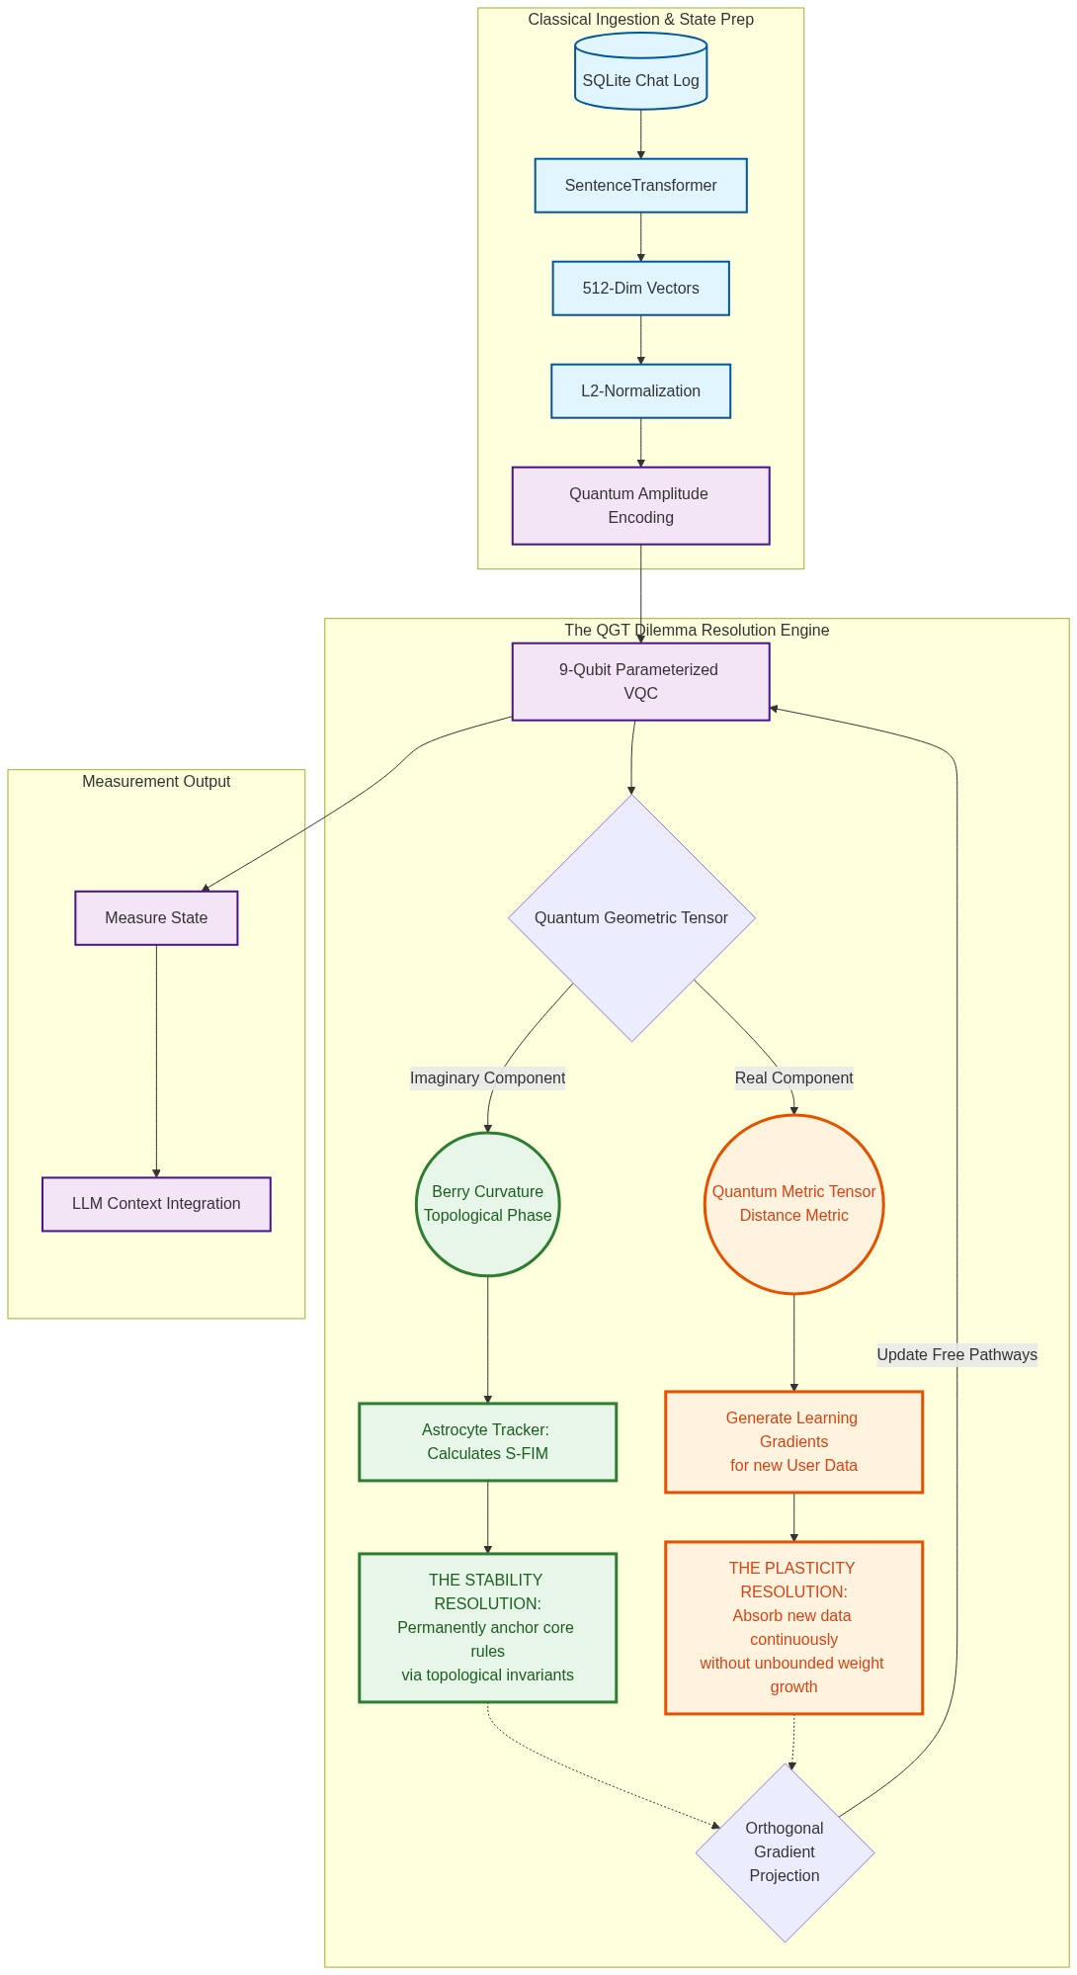

5. The Approach: The Dataset (CAMS)
Instead of chaotic datasets like ShareGPT, this project requires a highly structured 50-turn Curated Adversarial Multi-Turn Sequence (CAMS) to mathematically prove continual learning:
- Turns 1-5 (Core Context): Strict architectural rules (e.g., 'Always output JSON format').
- Turns 6-15 (Standard Queries): Normal, everyday prompts.
- Turns 16-30 (Adversarial Dumps): Massive, irrelevant text injections to force catastrophic forgetting.
- Turns 31-50 (Evaluation Prompts): Final queries to test if the Core Context survived.

6. Full Scratch Execution Roadmap (Phase by Phase)

Phase 1: Environment & Dataset Scaffolding
- Task 1.1: Install core dependencies (PennyLane, PyTorch, sentence-transformers, pandas, sqlite3).
- Task 1.2: Design the 50-turn CAMS dataset logically splitting the Core Context and Adversarial Dumps.
- Task 1.3: Generate the SQLite Database (q_contextsync.db) and insert the 50 turns.

Phase 2: Semantic Manifold Mapping (Classical)
- Task 2.1: Initialize the HuggingFace SentenceTransformer (distiluse-base-multilingual-cased-v1).
- Task 2.2: Extract the raw_text from the database and pass it into the transformer.
- Task 2.3: Generate 512-dimensional continuous semantic vectors.
- Task 2.4: Apply strict L2-Normalization across the vectors (quantum probabilities must sum to 1).
- Task 2.5: Export the tensors to quantum_ready_tensors.npy.

Phase 3: Quantum Architecture & State Preparation
- Task 3.1: Initialize a 9-qubit quantum simulator device.
- Task 3.2: Execute Quantum Amplitude Encoding to load the normalized vectors directly into the 2^9 amplitudes.
- Task 3.3: Construct the Variational Quantum Circuit (VQC) using a hardware-efficient parameterized ansatz.
- Task 3.4: Define the trainable weights shape and initialize them.

Phase 4: The Quantum Geometric Tensor (QGT) Decoupling
- Task 4.1: Compute the full complex Quantum Geometric Tensor (QGT).
- Task 4.2: Extract the Real Component (Fubini-Study Metric Tensor) for learning tracking.
- Task 4.3: Extract the Imaginary Component (Berry Curvature) for topological phase anchoring.
- Task 4.4: Tie the Core Context inputs strictly to the Berry Curvature invariants.

Phase 5: The Astrocyte-Gated Learning Mechanism
- Task 5.1: Initialize the classical Astrocyte Tracker.
- Task 5.2: Program the tracker to monitor the Berry Curvature and calculate the Safety Fisher Information Metric (S-FIM).
- Task 5.3: Generate a threshold masking array to dynamically identify locked quantum pathways.

Phase 6: Orthogonal Continual Learning Loop
- Task 6.1: Initialize the quantum optimizer.
- Task 6.2: Feed the Adversarial Dumps into the network and calculate raw learning gradients.
- Task 6.3: Apply Orthogonal Gradient Projection: mathematically project the raw gradient at a strict 90-degree angle away from the S-FIM constraints.
- Task 6.4: Execute the VQC parameter update using the projected gradients.

Phase 7: Measurement, Decoherence, & LLM Re-Integration
- Task 7.1: Execute quantum measurement over the Pauli-Z basis for all 9 qubits.
- Task 7.2: Collapse the state and extract the classical probability distribution vector.
- Task 7.3: Decode these output probabilities and map them into LLM context weights.
- Task 7.4: Pass the Evaluation Prompts into a classical LLM utilizing the new quantum-weighted context.
- Task 7.5: Validate that the LLM perfectly outputs JSON data despite the adversarial recipe dumps.

