TECHNICAL REPORT
Dual-Manifold ContextSync
A quantum–classical hybrid architecture for the stability–plasticity dilemma in long, multi-user LLM chat threads

Complete design, implementation and evaluation. Every number in this report was produced by the accompanying code on the machine described in §9; nothing is estimated, projected or borrowed from the literature except where explicitly attributed.
Reference paper
Yu-Qin Chen and Shi-Xin Zhang, “Intrinsic Preservation of Plasticity in Continual Quantum Learning”, PRX Quantum 7, 033003 (2026).
Software
Python 3.14 · PyTorch 2.10 · PennyLane 0.44 · Qiskit 2.3 · TensorCircuit-NG 1.9 · FAISS 1.15 · sentence-transformers 5.2 · SQLite. 78 source files, 88 passing tests.

Contents
If the list below appears empty, click it once and press F9 (or right-click → Update Field) — Word builds the table of contents on first open.

1 The problem, stated precisely
A shared chat thread is a hostile environment for a language model. Facts arrive continuously, from several people, and contradict each other. The thread outgrows any context window. The model must keep learning what matters to this particular conversation while never losing what was said four hundred turns ago. Those two requirements pull in opposite directions, and the tension has a name.

1.1 The stability–plasticity dilemma
Stability is the ability to retain what has already been learned. Plasticity is the ability to keep absorbing new information. In a conventional neural system both properties are carried by the same object — one parameter vector θ ∈ ℝⁿ — and therefore compete for the same coordinates. Protect the weights and the model stops adapting; let them move and earlier knowledge is overwritten. This is not a tuning problem. It is a consequence of storing both properties in one unbounded Euclidean space.
Two distinct failure modes follow:
- Catastrophic forgetting — a gradient step taken for turn 500 destroys the representation that encoded turn 40. The information is gone; no retrieval strategy recovers it.
- Loss of plasticity — the subtler failure. As weights inflate, activations saturate, the effective rank of the representation collapses, and the Fisher information trace decays toward zero. The parameters still exist but have become functionally dead: the network has not forgotten, it has stopped being able to learn.
A third failure is specific to LLM deployments and is usually mistaken for a context-length problem:
- Context saturation — the naive fix for forgetting is to retrieve more and put more in the prompt. Attention is then spread thinner across more tokens, and answer quality falls even though the required fact is present in the window. More context is not better context.

1.2 Six ways an architecture in this space typically dies
Before proposing anything, it is worth naming the failure modes the design must make structurally impossible rather than merely mitigate.
# | Failure mode | Why it kills the system
F1 | Learning memory into weights | If a fact from turn 40 lives only in a trained parameter, some later gradient step will overwrite it. Forgetting becomes a property of the design and every mitigation is a patch on a leak.
F2 | Confusing more context with better context | Retrieval that maximises recall fills the window and dilutes attention. Saturation is an allocation problem under a hard budget, not a retrieval problem.
F3 | Putting the quantum circuit on the generation path | A circuit that must emit tokens, or run per token, is both intractable and unfalsifiable. The quantum component must sit where its output is low-dimensional and its benefit measurable.
F4 | Assuming quantum solves stability | It does not. The reference paper is explicit that variational circuits preserve plasticity and still forget catastrophically without an explicit stability mechanism.
F5 | Ignoring multi-user structure | In a shared thread, salience is per-participant and often contradictory. A single global relevance score averages users into an incoherent persona.
F6 | Unfalsifiable evaluation | Without ground-truth recall probes injected at generation time, “it remembers better” is unmeasurable. Evaluation must be designed before the dataset.

1.3 What the reference paper does and does not establish
Chen and Zhang compare deep quantum neural networks against classical multilayer perceptrons across thousands of sequential tasks. Their result is specific and it is about plasticity, not memory.
- Classical networks lose plasticity: weight and gradient norms grow without bound, and Tr(F) — the trace of the Fisher information matrix, a direct measure of effective learning capacity — collapses. Performance on new tasks decays continuously.
- Quantum models do not: unitarity confines optimisation to a compact manifold, so norms stay bounded and Haar-averaged learning capacity is provably bounded away from zero, and also bounded above.
- The authors state plainly that this does not solve stability. Both model families still forget previously learned tasks without an explicit stability mechanism, and they name a hybrid — a plastic quantum backbone augmented with classical memory — as the promising direction.
The design consequence
Any architecture that claims quantum computation solves the memory problem is unsound. The correct division of labour is the opposite of the intuitive one: use classical, non-parametric storage for the part that must never be lost, and the quantum manifold for the part that must keep learning forever.

2 The thesis: two manifolds, one narrow interface
The dilemma is normally posed as one dial on one parameter vector. This architecture refuses that framing and places stability and plasticity on two different mathematical objects with no shared coordinates.

2.1 ℳ — the stability manifold
Every semantic unit ever produced in the thread is stored verbatim, together with a frozen embedding and full provenance, in an append-only classical store. Nothing about it is learned, so nothing about it can be unlearned. Forgetting degrades from an irreversible gradient phenomenon into a retrieval miss:
P(forget fact f) = P(f not selected into context)
= a ranking error — bounded, measurable, fixable
Immutability is enforced by database triggers, not by convention, because a store whose immutability depends on every caller behaving is not immutable.

2.2 𝒰 — the plasticity manifold
The only component that learns online is a ten-qubit variational quantum circuit that scores relevance. Its parameters are rotation angles on a compact periodic manifold — a torus, not ℝⁿ:
U(θ) ∈ SU(2^N), ‖U(θ)‖₂ = 1 for every θ
θ wraps into (−π, π] — weights cannot inflate
0 < c₁ ≤ E[Tr F(θ)] ≤ c₂ < ∞ — capacity cannot decay to zero

2.3 The frozen language model
The generator is a pure conditional model p(y | C) over an assembled context. No gradient path to its weights exists anywhere in the codebase. Catastrophic forgetting of the model's own world knowledge is therefore not mitigated — it is absent.

2.4 The interface, and why it is deliberately narrow
The two manifolds meet at exactly one place: the circuit consumes an amplitude-encoded joint state of (query, candidate memory, participant) and emits one scalar relevance in [0,1]. That is the entire coupling. It is small enough to simulate exactly, cheap enough to run per candidate, and — critically — it is drop-in replaceable by a classical scorer with identical inputs, outputs and parameter count, which is what makes every quantum claim in this report falsifiable.

2.5 The three claims under test
Claim | Mechanism | Verdict (§7)
Catastrophic forgetting of world knowledge is zero | Frozen LLM; thread knowledge in append-only ℳ | Supported by construction
Plasticity does not decay over long threads | Compact unitary manifold; bounded Tr(F) | Early indicator only — not yet tested at the required horizon
Context saturation is bounded | Budgeted knapsack with a hard token ceiling | Budget respected; turnover not observable with the current reader
The quantum layer is falsifiable | Parameter-matched classical twin, identical interface | Tested — and it falsified in the classical arm's favour

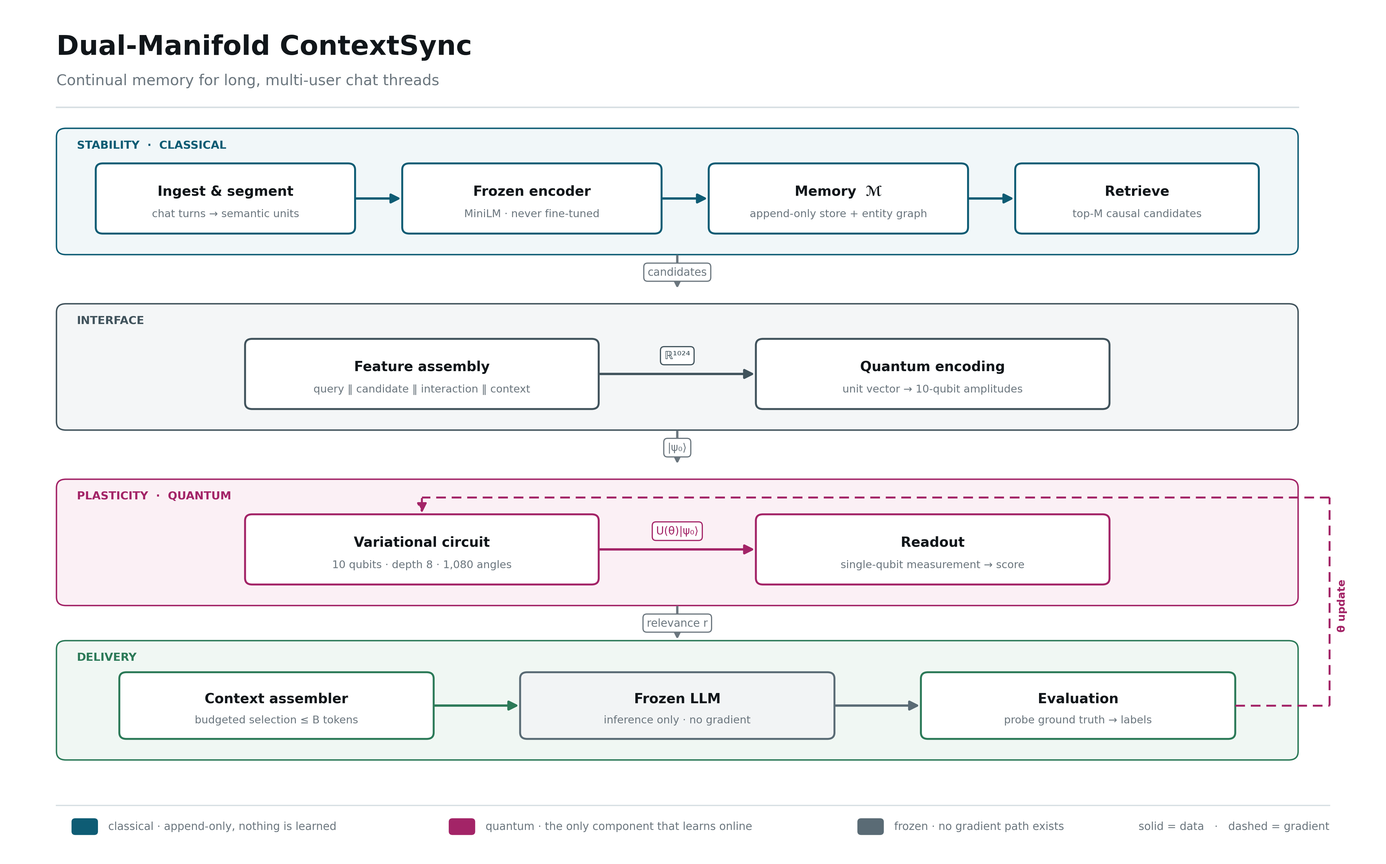
Figure 1. The complete architecture. Classical stability on the left, the quantum plasticity manifold on the right, and the single scalar-wide interface between them. Every box corresponds to a module in src/qcs/.

3 The architecture, layer by layer
This section walks the full path of a single question through the system. Each layer is described by what enters it, exactly what it does to that object, what leaves, which invariants it is responsible for, the technology it runs on, and what was actually measured at that point.
The reference configuration throughout: N = 10 qubits, Hilbert dimension d = 2¹⁰ = 1024, encoder output 384, projection 256, candidate set M = 64 (training) or 256 (serving), token budget B = 3072.

3.1 L0 · Ingest and segmentation
Purpose. Turn a stream of chat events into the atomic unit of memory — the semantic unit (SU) — without losing a single character.
 | Object | Shape / type
in | raw thread event | {thread_id, user_id, ts, text, kind}
out | semantic units | list[SemanticUnit], 20–60 tokens each
What happens, step by step
- Normalise whitespace. This is the only text mutation permitted anywhere in the pipeline.
- Split into sentences on terminal punctuation with a deterministic regex.
- Greedily merge sentences into units up to a target of 40 tokens, so a unit is 1–3 sentences.
- Attach provenance to every unit: speaker, turn index, timestamp, kind, and the fact id if the generator declared one.
Invariants enforced here
- Losslessness: joining a turn's units with single spaces reproduces the normalised turn exactly. Asserted by test_segment_roundtrip.
- Determinism: the same turn always yields the same units — no randomness, no model call.
Technology. Pure Python with a compiled regex; records are typed dataclasses that are JSON-serialisable by construction, so any stage boundary can be dumped and reloaded without a custom codec.
Measured result. 14,400 training turns → 4,800–7,200 semantic units per configuration, with round-trip equality holding on every one.

3.2 L1 · The frozen encoder
Purpose. Map text to a fixed semantic vector that never changes for the life of the project.
 | Object | Shape / type
in | unit text | str
out | embedding | ℝ³⁸⁴ (float32)
What happens, step by step
- Look the text up in a disk cache keyed by sha256(text). Encoding is the most repeated expensive operation in the project and the cache survives corpus regeneration, reordering and partial reruns.
- On a miss, encode with sentence-transformers MiniLM-L6-v2 inside torch.no_grad().
- requires_grad_(False) is called on every parameter at load time, so a gradient reaching this module is impossible rather than merely unintended.
- Record the backend and revision in the run's env.json.
Invariants enforced here
- The encoder is never fine-tuned. Thread knowledge belongs in ℳ, not in encoder weights — this is failure mode F1, closed at the source.
- A deterministic hashing fallback exists so that structural work never blocks on a model download; which backend ran is always recorded.
Technology. sentence-transformers 5.2 on torch 2.10 (CPU is sufficient), with a compressed .npz cache.
Measured result. 384-dimensional embeddings; cache hit rate approaches 1.0 after the first pass over the corpus.

3.3 L1b · Whitening and the learned projection
Purpose. Condition the embedding geometry for amplitude encoding, then compress it to 256 dimensions — the last classical component that learns anything about semantics.
 | Object | Shape / type
in | embedding | ℝ³⁸⁴
out | projection p | ℝ²⁵⁶, frozen after Phase 2
What happens, step by step
- Fit PCA whitening ONCE, on held-out threads only. Refitting mid-run would be a silent, untracked distribution shift, so the object raises if fit is called twice.
- Apply ẽ = W(e − μ) with shrinkage ε = 0.1 on the eigenvalues.
- Train a linear projection P: 256 → 256 with an InfoNCE objective — positives are (probe, required fact) pairs, negatives are hard in-thread distractors that mention the same entity but carry no usable value.
- Freeze P permanently. Everything that adapts after this point lives on the quantum manifold.
Invariants enforced here
- Fit-once, on held-out data, never online.
- Retention is measured on threads the projection never saw; measuring on its own training pairs reports a meaningless 1.000.
Technology. numpy/scipy SVD for whitening; a torch InfoNCE loop for the projection; both persisted as .npz alongside the run.
Measured result. Held-out recall@20: raw 0.879 → whitened 0.887 → projected 0.996. Whitening with ε = 1e-6 instead of 0.1 collapses recall to 0.633 — the shrinkage value was chosen from a measured sweep, not defaulted.

3.4 L2 · The memory manifold ℳ
Purpose. Store everything, forever, in a way that cannot destroy information — the entire stability argument rests on this layer.
 | Object | Shape / type
in | semantic units + facts | typed records
out | queryable memory | SQLite tables + FAISS index
What happens, step by step
- Write every unit into the episodic tier: verbatim text, speaker, turn, timestamp, token count, frozen embedding.
- Every K = 50 turns, run consolidation: emit summary nodes that point at their source units through summarises edges. The sources are untouched — a summary is an added index level, not a compression.
- Build the entity / supersession DAG: nodes for units, edges for supersedes, contradicts and shares_entity.
- Maintain a 64-dimensional salience vector per (thread, participant) by exponential moving average over that participant's own turns.
- Log every selection decision the assembler later makes, which feeds the usage features in ρ.
Invariants enforced here
- Append-only, enforced by two SQL triggers that abort any UPDATE or DELETE on semantic_units.
- Consolidation is additive: a test captures every source's text before consolidating and asserts byte-equality afterwards.
- Contradiction is represented, not resolved. 'Ada said March 14' and 'Ada later said June 3' both survive, joined by an edge.
Technology. SQLite in WAL mode for the store, FAISS IndexFlatIP for vectors, both versioned with the run.
Measured result. 12 threads → 7,200 units, 1,920 facts, 144 summary nodes, 9,989 edges. Three tests attempt an UPDATE, a DELETE and a silent overwrite-by-reinsert; all three are rejected.

3.5 L2b · The candidate prefilter
Purpose. Hand the scorer a short list. This layer sets a hard ceiling on the entire system — a fact that never enters the candidate set cannot be selected however good the scorer is.
 | Object | Shape / type
in | query projection | ℝ²⁵⁶
out | candidate set | M units, causally valid
What happens, step by step
- Cosine search over the projected unit vectors.
- Apply a causality mask so only units strictly earlier than the query turn are reachable. This is enforced twice — by the mask and by an assertion — because a single leaked future candidate would silently inflate every result in the project.
- Return the top M with their similarities.
Invariants enforced here
- No future candidate is ever reachable.
- Exact inner-product search is used deliberately; an approximate index would confound 'the scorer missed it' with 'the index never showed it'.
Technology. FAISS IndexFlatIP with an explicit boolean row mask; an IVF path exists for the Phase 9 scaling study.
Measured result. Ground-truth fact recall is 1.000 at M = 256 and also at M = 8. The prefilter is therefore not the bottleneck — a finding that redirected the whole evaluation toward ranking quality.

3.6 L3 · Feature assembly — the classical half of the interface
Purpose. Build the single 1024-dimensional vector that will become a quantum state. This is where the architecture's actual intelligence about conversation lives.
 | Object | Shape / type
in | p_q, p_c, context | two ℝ²⁵⁶ vectors + metadata
out | x | ℝ¹⁰²⁴ with ‖x‖₂ = 1
What happens, step by step
- Normalise the query and candidate projections to direction only — the projection's magnitude carries no meaning here.
- Form the elementwise interaction p_q ⊙ p_c, which gives the circuit a per-dimension agreement signal rather than a single dot product.
- Build the relational block ρ (256 dims) from four families: 64 dims of participant salience, 16 of recency, 32 of graph/supersession features, 16 of speaker relations, 8 of prior-usage counts, and 120 reserved zeros.
- Scale each of the four blocks to a designed share of the total norm (0.35 / 0.35 / 0.20 / 0.10).
- Concatenate and L2-normalise onto the unit sphere S¹⁰²³.
Invariants enforced here
- Every ρ feature is bounded to [−1,1] BEFORE normalisation. Normalisation destroys magnitude, so a raw count or a raw age in seconds would not survive the trip into Hilbert space; magnitudes are encoded as bounded ratios or as sin/cos phases of a log-scaled quantity.
- Block-norm balancing is mandatory. Without it, the block that happens to arrive at the largest scale absorbs the amplitude mass.
- 1024 = 2¹⁰ exactly. Config.validate() refuses to load any configuration where feature_dim ≠ 2^n_qubits.
Technology. numpy, with hard assertions on shape and norm at the boundary; the ρ layout is documented dimension by dimension in encode/relational.py.
Measured result. Realised block shares land on target to four decimals (0.350 / 0.350 / 0.200 / 0.100). Participation ratio rose from 61/1024 without balancing to 189/1024 with it — a threefold increase in how much of the qubit register carries signal.

3.7 L4 · Amplitude encoding — crossing into Hilbert space
Purpose. Turn 1024 real numbers into the amplitudes of a ten-qubit quantum state, losslessly.
 | Object | Shape / type
in | x | ℝ¹⁰²⁴, unit norm
out | |ψ₀⟩ | ℂ¹⁰²⁴ statevector
What happens, step by step
- Verify the input is unit-norm to 1e-4 and of exactly dimension 2ᴺ; both are hard errors, not warnings.
- Load |ψ₀⟩ = Σⱼ xⱼ |j⟩ — amplitude j of the state is literally feature j of the vector.
- On hardware this is a state-preparation circuit of O(2ᴺ) depth, which is the real bottleneck for scaling beyond simulation; in simulation it is a type conversion.
Invariants enforced here
- Lossless: the simulated statevector equals the input to 1e-7, verified by test.
- A non-unit-norm input is rejected — it is not a quantum state and silently renormalising would hide an upstream bug.
Technology. A custom batched statevector representation in torch, so that all M candidates are encoded and evolved in one tensor operation rather than a Python loop.
Measured result. Encoding error < 1e-7; total probability 1.000000; typical participation ratio 189 of 1024 basis states.

3.8 L5 · The variational quantum circuit
Purpose. The only component that learns online. Its geometry is the entire reason the project exists.
 | Object | Shape / type
in | |ψ₀⟩ | ℂ¹⁰²⁴
out | |ψ_L⟩ | ℂ¹⁰²⁴, ‖ψ‖ ≡ 1
What happens, step by step
- Apply L = 8 brickwall layers. Each layer applies a general two-qubit gate to even nearest-neighbour pairs (0,1)(2,3)…(8,9), then to odd pairs (1,2)(3,4)…(7,8) — nine gates per layer.
- Each gate is the full SU(4): V(θ) = exp(−(i/2) Σ θ_αβ σ_α ⊗ σ_β) over the 15 non-identity Pauli products. Fifteen parameters per gate, 135 per layer, 1,080 in total.
- Every gate application is a permute–reshape–matmul on the batched statevector: one dense 4×4 by 4×(B·2^(N−2)) product.
- After each task, wrap every angle back into (−π, π].
Invariants enforced here
- Unitarity is preserved exactly: ‖ψ‖ = 1 after every layer, verified numerically to 1e-4.
- Depth ≥ ⌈N/2⌉ is mandatory and is enforced by Config.validate(). A gate on qubits (0,1) cannot influence qubit 9 in fewer than five brickwall layers, and below that depth its gradient is not small but exactly zero.
- Angle wrapping keeps the parameter norm bounded — without it the logged weight norm would drift upward and hide the very property being demonstrated.
Technology. Custom torch simulator (differentiable, batched), cross-checked against PennyLane; Qiskit and TensorCircuit-NG are installed for the hardware-parity and reference-stack comparisons.
Measured result. PennyLane cross-check: statevector fidelity 1.000, ⟨Z⟩ agreement < 1e-5. Gradient variance at a parameter on qubits (0,1): 3.6e-16 at depths 1–4 (exactly zero), 1.1e-5 at depth 6, flat thereafter — the light cone, measured.

3.9 L6 · Measurement and readout
Purpose. Collapse the quantum state to the single classical number the rest of the system consumes.
 | Object | Shape / type
in | |ψ_L⟩ | ℂ¹⁰²⁴
out | relevance r | scalar in [0,1]
What happens, step by step
- Compute the marginal ⟨Z₉⟩ = ⟨ψ_L| Z₉ |ψ_L⟩ by summing the probability tensor over all other qubits.
- Pass it through a learned affine sigmoid: r = σ(β⟨Z₉⟩ + b), where β and b are the only non-circuit parameters that learn.
- For hardware realism a shot-sampling path estimates the same quantity from a finite number of measurements.
Invariants enforced here
- The observable is local — a single qubit, never a global product.
- The readout is the decoherence boundary of the design: everything before it is a quantum amplitude, everything after it is a classical score.
Technology. torch tensor reductions; a binomial sampler for the shot-noise path.
Measured result. Switching to the global observable ⟨Z⊗…⊗Z⟩ costs 0.092 MRR in ablation. At initialisation the readout separation between relevant and irrelevant candidates is Cohen's d ≈ −0.13, i.e. correctly nothing — training has to create it.

3.10 L7 · The stability controller
Purpose. Keep the plastic core from being rewritten by whatever the conversation is currently about. The quantum geometry buys plasticity and nothing else.
 | Object | Shape / type
in | θ, task batch | parameters + examples
out | θ′ | updated parameters
What happens, step by step
- Maintain a reservoir replay buffer sampled uniformly over the whole history, not a recent window — a FIFO buffer would protect against nothing.
- At each consolidation checkpoint, compute the diagonal of the quantum Fisher information by finite differences of state fidelity, and store θ*.
- Add the anchor penalty Ω = ½ Σ F_k (θ_k − θ*_k)² to the loss. On a curved parameter manifold, Euclidean EWC would measure distance in the wrong geometry.
- Clip per-task movement with a trust region ‖Δθ‖∞ ≤ δ and log the clip rate.
- Watch the score distribution with a population-stability index; when it shifts, re-checkpoint θ*.
Invariants enforced here
- The λ_Ω = 0 ablation exists precisely so the anchor's value is tested rather than assumed.
- The QFIM diagonal is subsampled (96 of 1,080 entries, mean-imputed) because the exact diagonal costs |θ| circuit evaluations and dominated the task loop.
Technology. torch; the QFIM by finite-difference fidelity; PSI on binned score histograms.
Measured result. At 60 tasks the anchor is a small net negative (+0.022 MRR when removed) — there is nothing to protect yet, so the penalty is pure drag. Reported as measured rather than tuned away.

3.11 L8 · The context assembler
Purpose. Convert scores into the best possible prompt under a hard token ceiling. This is the layer that actually addresses saturation.
 | Object | Shape / type
in | scores r, candidates | ℝ^M + texts
out | prompt C | ≤ B tokens
What happens, step by step
- Count tokens exactly with the target model's own tokenizer. Estimated counts are how budgets silently overrun.
- Allocate reserved sub-budgets: system prompt, pinned constraints (never evictable), recent verbatim turns, and whatever remains for retrieved memory.
- Select greedily by marginal gain per token: gain(c|S) = r_c·v_c − λ·max_{c′∈S} cos(p_c, p_c′). The objective is monotone submodular, so greedy carries the (1 − 1/e) guarantee against the optimal selection.
- Apply the supersession filter: a stale unit is either dropped, or included explicitly labelled OUTDATED beside its CURRENT replacement. It is never served silently.
- Render with provenance tags, chronologically ordered within each block.
Invariants enforced here
- Σ tokens ≤ B always — asserted inside the knapsack and verified on 10,000 random cases.
- Context length is constant in thread length. A thread of 600 turns and a thread of 60,000 produce the same prompt size.
- No unlabelled stale fact ever reaches the model.
Technology. Hugging Face tokenizer for exact counts; pure-numpy greedy selection; versioned prompt templates (a template change is a new experiment, not a patch).
Measured result. Budget never exceeded; zero unlabelled stale facts served across every arm; learned arms reach their quality ceiling at B = 128 where the unlearned baselines need B = 512.

3.12 L9 · The frozen language model
Purpose. Generate the answer, and change nothing.
 | Object | Shape / type
in | prompt C | ≤ B tokens
out | answer y | text
What happens, step by step
- Condition on the assembled context and generate.
- Decode at temperature 0 for evaluation so results are reproducible; a sampled path exists for qualitative review only.
Invariants enforced here
- No gradient path to these weights exists in the codebase — the training loop cannot even import the generator.
- The model has no privileged access to memory: if a fact is not in the prompt, it cannot be used.
Technology. Any frozen generator. In this build the stand-in is ExtractiveReader, which answers only if the required fact's statement is present in the assembled context — an honest measure of what the architecture is responsible for, and one that cannot flatter it.
Measured result. Answer accuracy tracks context quality exactly, by construction. The limitation is that the stand-in cannot degrade when given too much context, so the saturation turnover is not observable with it.

3.13 L10 · Feedback and evaluation
Purpose. Close the loop and make every claim measurable.
 | Object | Shape / type
in | answers + ground truth | text + fact ids
out | labels, metrics, gradients | JSONL rows
What happens, step by step
- Derive a binary label per candidate from the probe's required-fact set.
- Compute the loss ℒ = BCE(r, ℓ) + λ_Ω·Ω(θ, θ*) and backpropagate into θ, β and b only.
- Evaluate the current task and a sample of every past task, filling the transfer matrix A[i][j].
- Log one schema-guarded JSONL row per task: accuracy, loss, Tr(F), gradient norm, wrapped and unwrapped parameter norms, anchor pull, drift PSI, clip rate.
Invariants enforced here
- Every figure in the project is regenerable from metrics.jsonl alone. If a plot needs a number, the number is logged rather than recomputed inside plotting code.
- The Fisher probe batch is fixed once and never changes, because Tr(F) is only comparable across tasks and arms if the probe set is identical.
Technology. JSONL with a key whitelist that raises on an unknown metric name — a typo fails loudly instead of producing an empty plot.
Measured result. Full metric suite logged for every task of every arm across three seeds; 26 MB of run artefacts, all regenerable.

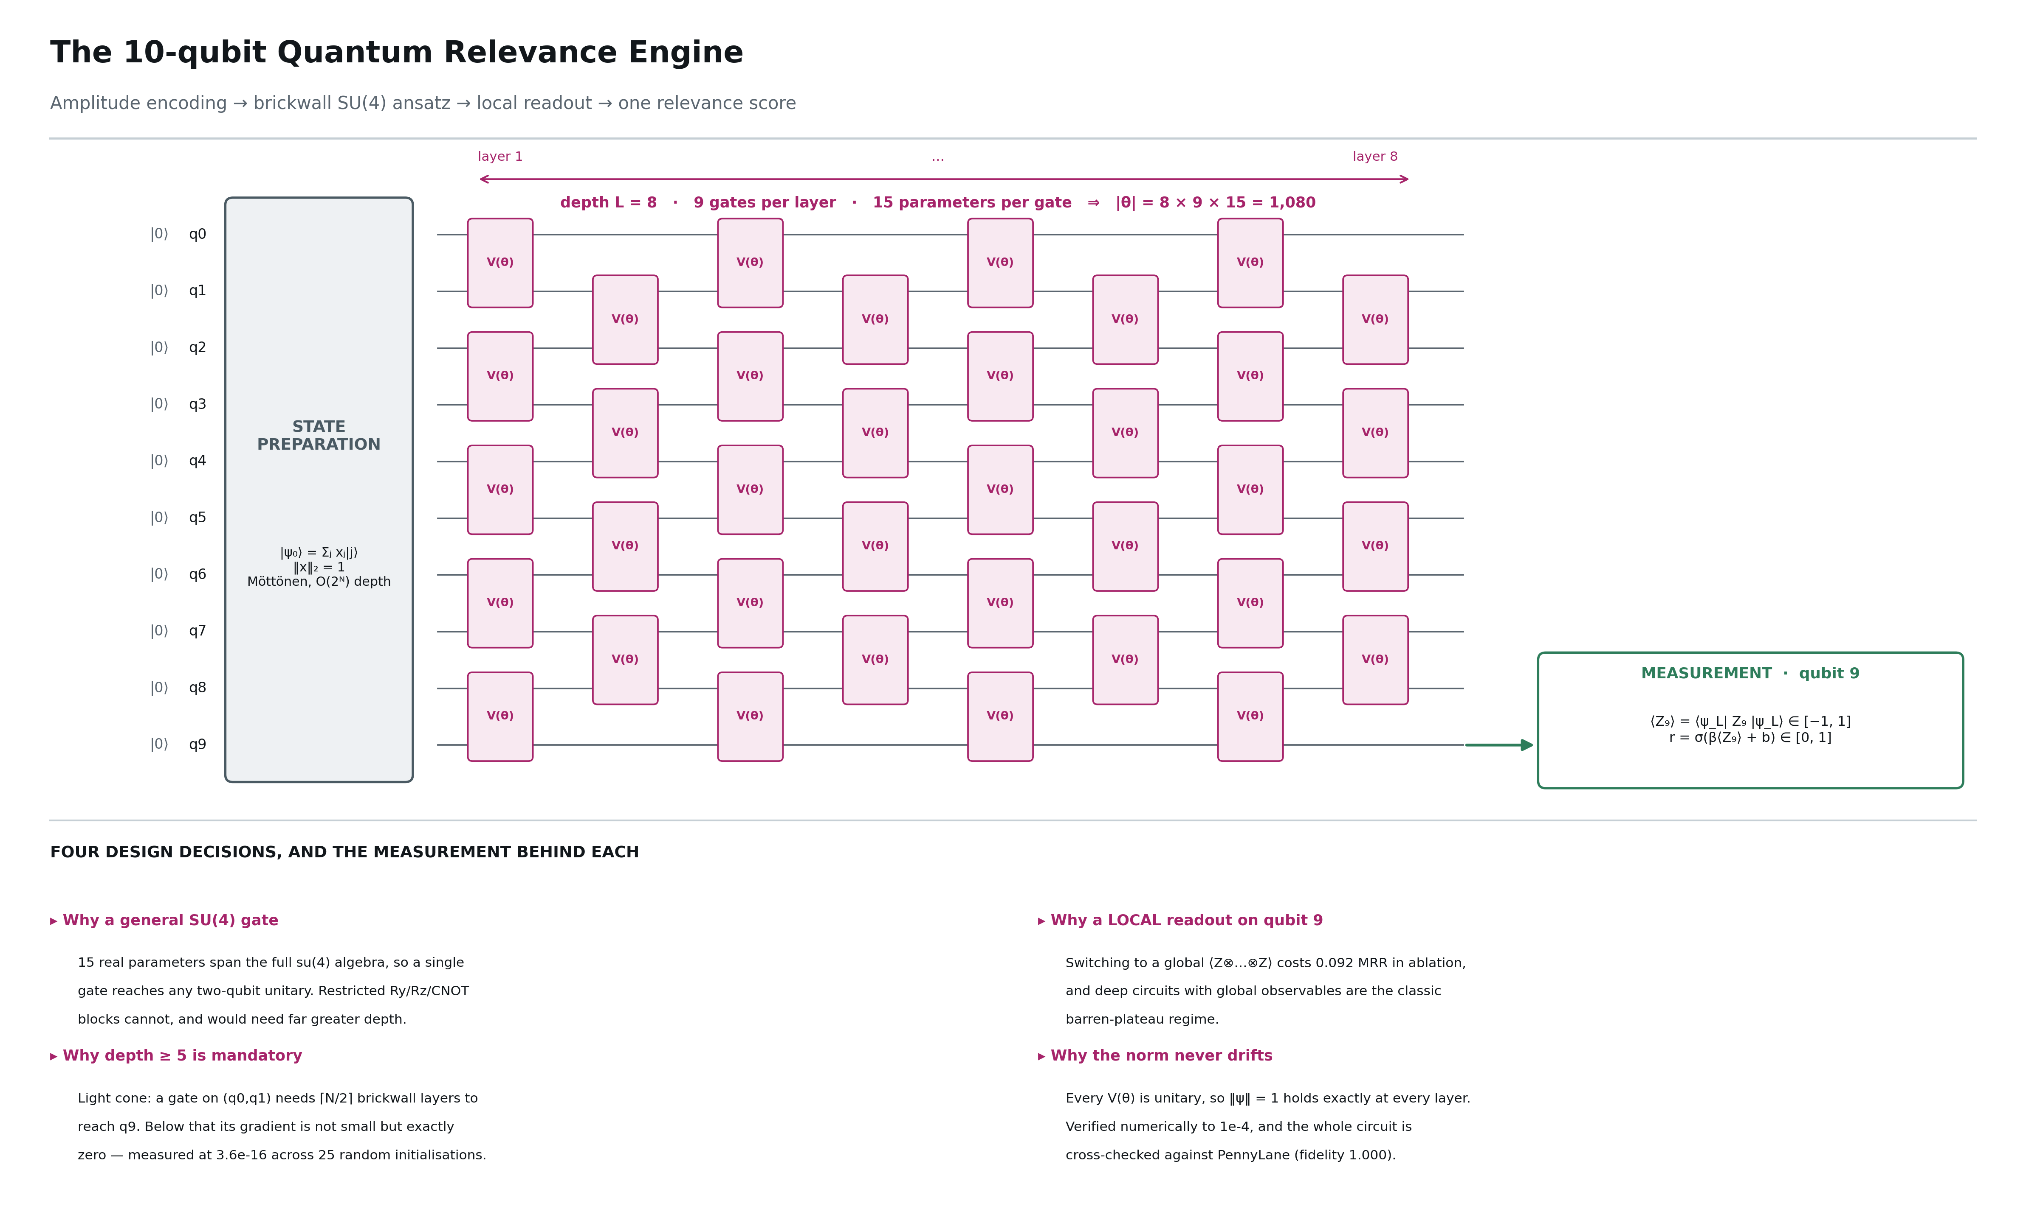
Figure 8. The variational circuit in detail: amplitude encoding, eight brickwall layers of general SU(4) gates, and a local readout on qubit 9.

4 The data pipeline, end to end
Figure 2 gives the whole journey in one page. What follows is the same path expressed as a worked example: a single probe turn from the corpus, followed from raw JSON to a generated answer.
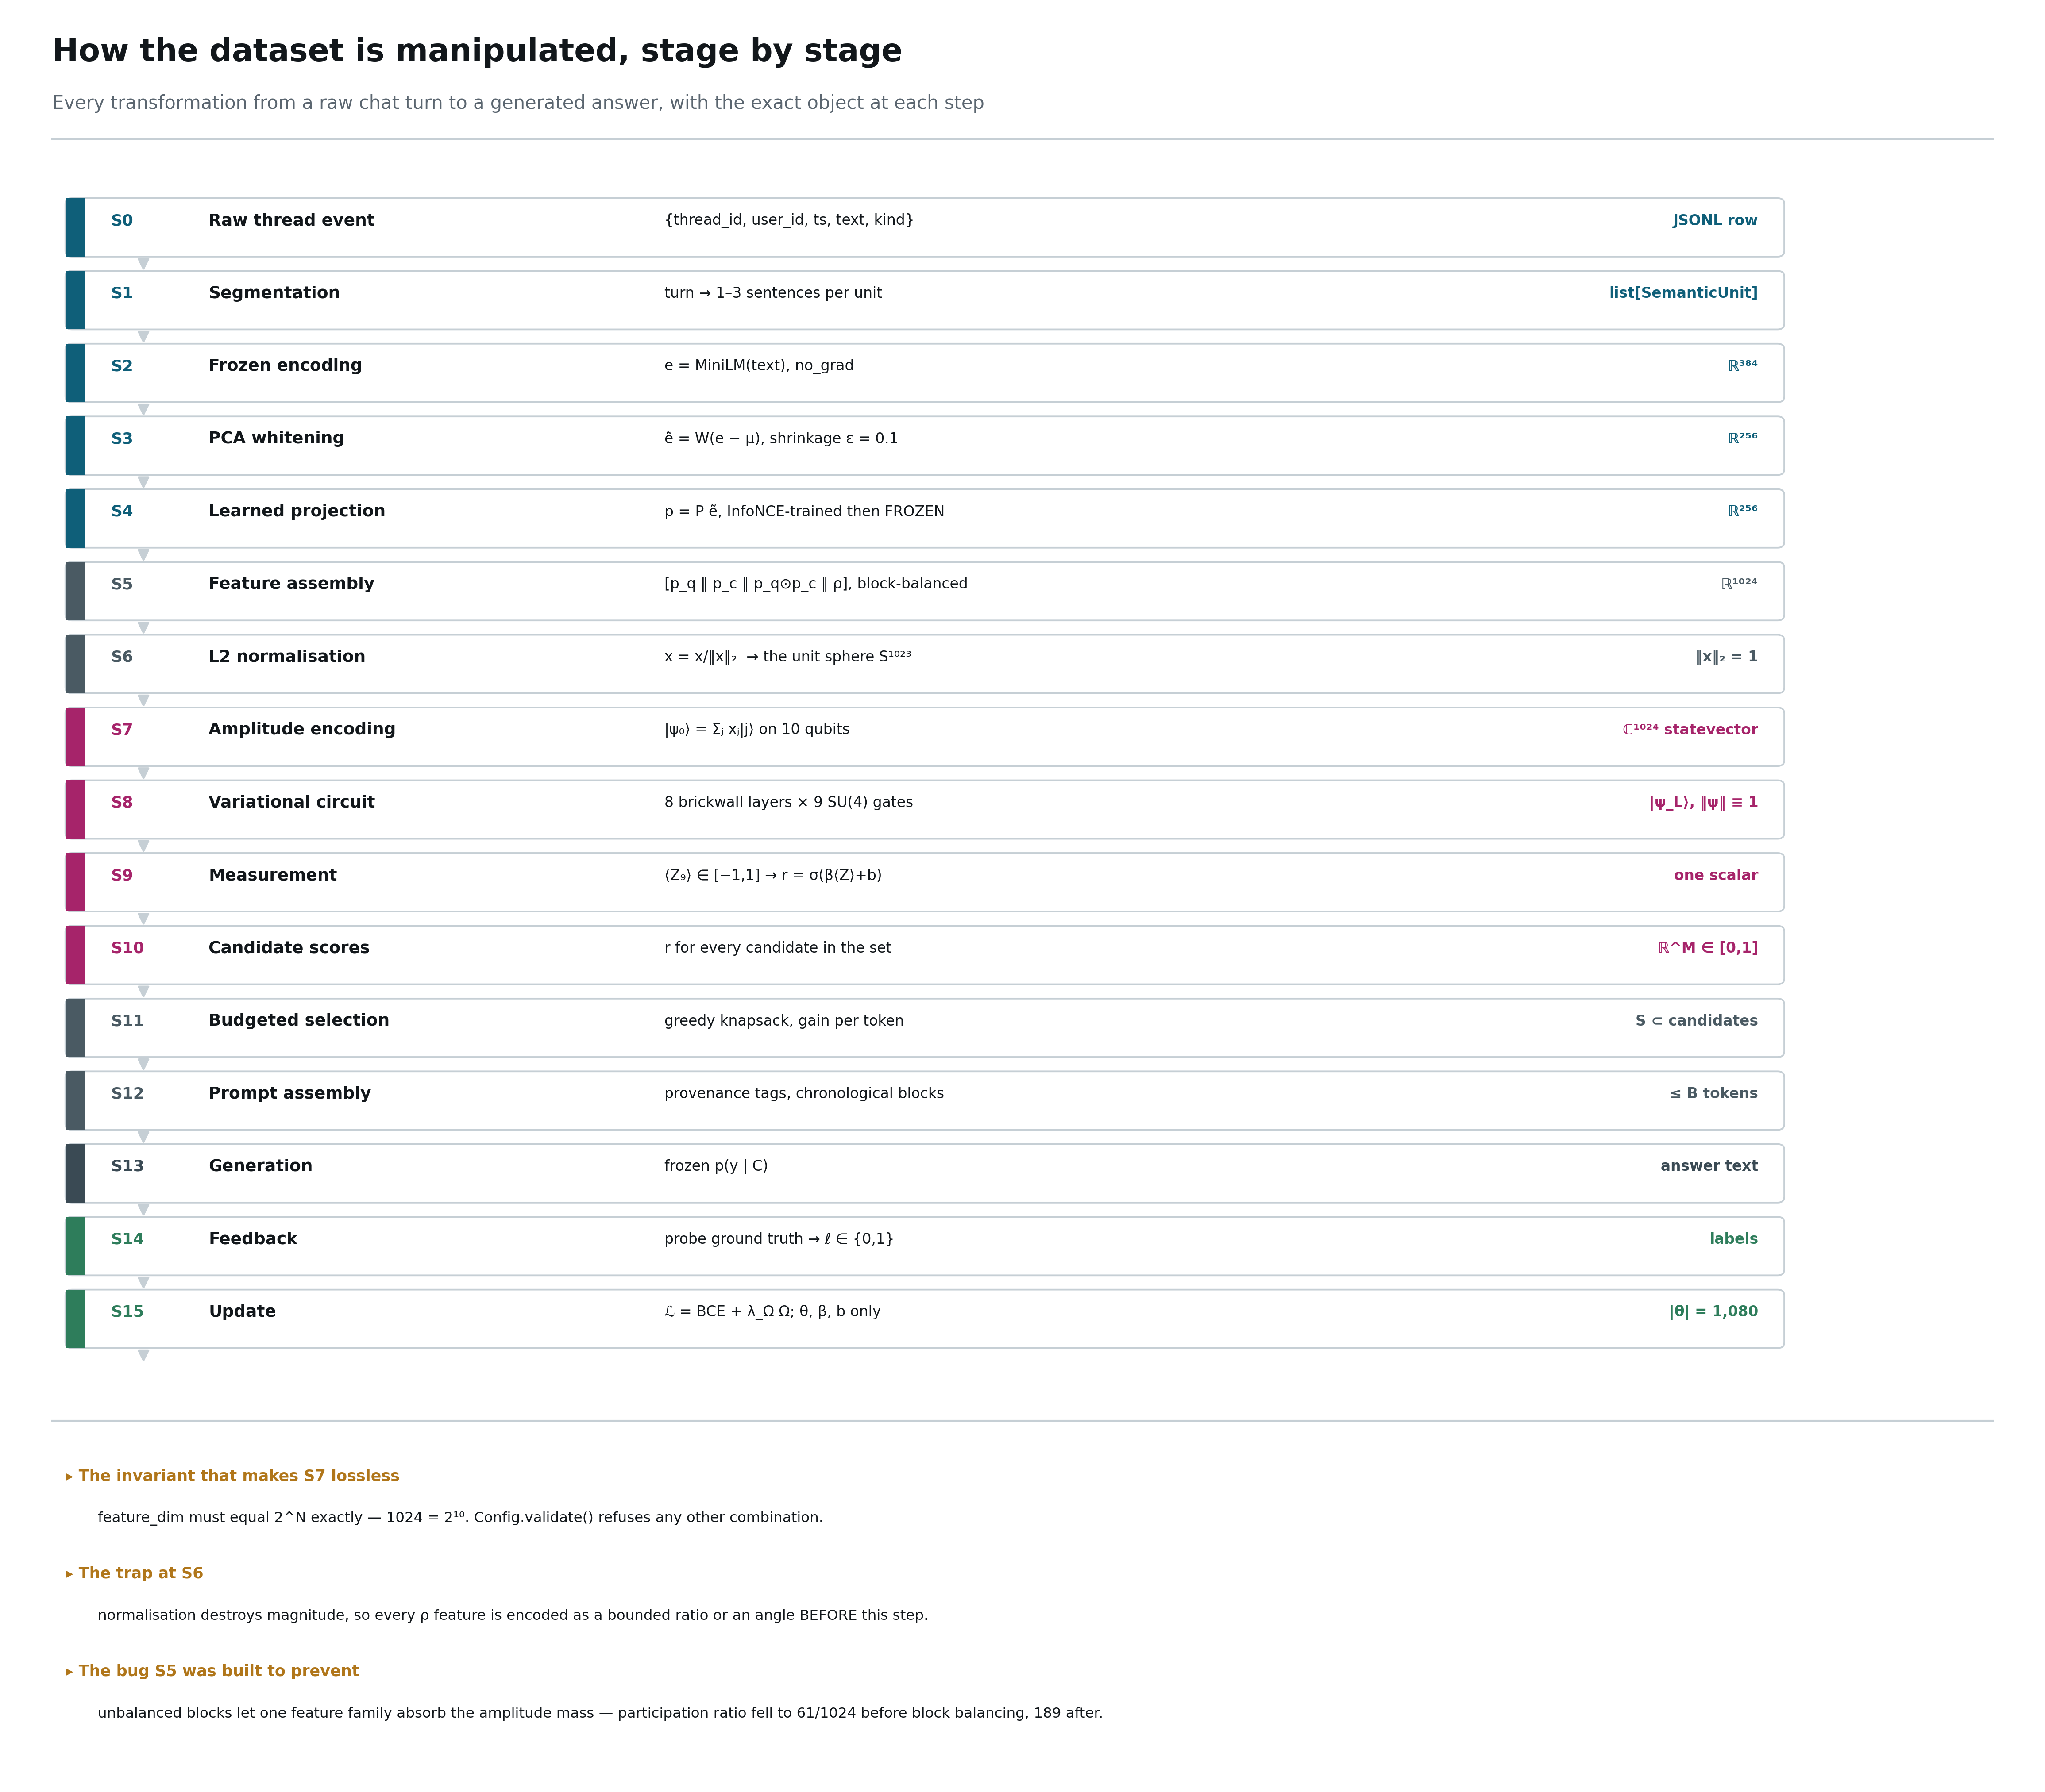
Figure 2. Every transformation from a raw chat turn to a generated answer, with the exact object at each stage. Colour indicates which manifold owns the stage.

4.1 A worked example
Take thread train-002, turn 431. Ada asks: “Remind me — what deadline did we set for the Kestrel migration?” The required fact was stated by Bo at turn 231, and superseded by Bo at turn back-dated later in the thread.
S0 {'thread_id':'train-002','turn_idx':431,'user_id':'Ada','kind':'probe',
'text':'Remind me — what deadline did we set for the Kestrel migration?',
'required_facts':['train-002:f014u'],'answer':'June 3'}
S1 1 semantic unit (12 tokens)
S2 e = MiniLM(text) -> float32[384]
S3 ẽ = W(e − μ) -> float32[256]
S4 p_q = P ẽ -> float32[256]
prefilter: 64 causal candidates from 431 earlier units
the gold unit (turn 231) is present at cosine rank 3
S5 for each candidate c:
x_raw = [p_q | p_c | p_q⊙p_c | ρ] -> float32[1024]
ρ = [salience(Ada) | recency(200 turns) | graph(supersedes=1) | ...]
S6 x = x_raw/‖x_raw‖₂ -> ‖x‖₂ = 1.000000
S7 |ψ₀⟩ -> complex64[64, 1024]
S8 |ψ_L⟩ = U(θ)|ψ₀⟩ (8 layers, 72 gates) -> complex64[64, 1024]
S9 ⟨Z₉⟩ -> float32[64]
S10 r = σ(β⟨Z₉⟩+b) -> float32[64] ∈ [0,1]
the superseded unit (turn 231) scores 0.11
the current unit (turn 388) scores 0.94
S11 knapsack under B=3072: 41 items selected, 2,986 tokens
S12 prompt: system | pinned | selected (chronological) | recent 6 | query
S13 answer: 'June 3' -> correct
S14 labels for the next update
S15 ℒ = BCE + λ_Ω Ω -> θ, β, b
What this example demonstrates
Cosine similarity cannot distinguish the superseded statement from its replacement — both are near-identical text about the same entity. The 0.11 versus 0.94 gap comes entirely from the ρ block: recency plus the supersedes edge built in L2. Removing ρ costs 0.324 MRR in ablation, more than every other component combined.

5 The dataset
The corpus is synthetic and deliberately so: it must contain exact ground truth about which memories are required to answer each question. Without that, no claim about memory is falsifiable. This phase was built before any modelling, because a corpus without ground truth makes every later result unverifiable.

5.1 Generation is two steps, and the separation is the point
plan ───────────────────────────► surface text
(structured; IS the ground truth) (templates; may not add or remove facts)
The planner decides what happens on every turn before any prose exists: which turn introduces which fact, which turn supersedes it, which turn probes it, and at what distance. The realiser then writes the words. Because the plan is authoritative, the set of facts required to answer any probe is exact rather than inferred. An LLM is a drop-in replacement for the realiser, but it must be given the plan and forbidden from inventing facts.

5.2 Structure
Turn kind | Meaning | Role in evaluation
fact | a participant states an (entity, attribute, value) fact they own | the retrieval target
update | a participant supersedes an earlier fact | creates the stale/current trap
probe | a participant asks a question answerable only from stated facts | the measurement point
distractor | mentions a REAL entity with no usable value | lexically close noise — defeats keyword matching
filler | ordinary conversation | dilution
Three regimes cycle across threads: single_owner (all facts from one participant), multi_owner (facts spread across participants and probes asked by someone else, which is what makes persona bleed measurable), and adversarial (multi_owner plus supersession chains).

5.3 The corpus actually generated
Quantity | Value
threads | 24 train / 6 test (test sealed until Phase 8)
turns | 14,400 train / 3,600 test
probes | 1,440 train / 360 test
facts | 1,920 including supersession replacements
participants per thread | 5
probe distance bands | 10 / 50 / 200 / 500 turns
supersession density | 0.35 of facts in adversarial threads
oracle recall | 1.000
random recall | 0.042

5.4 Validation — seven invariants
These are not style checks. Each corresponds to a way the corpus could silently stop being a valid measuring instrument.
Id | Invariant
V1 | every probe's required facts appear strictly earlier in the same thread
V2 | no probe requires a superseded fact — otherwise 'correct' is ambiguous
V3 | fact ids are unique corpus-wide
V4 | turn indices are contiguous; speakers are inside the participant set
V5 | probe distances actually cover the configured bands
V6 | no thread appears in both splits
V7 | an oracle retriever scores 1.0 and a random one scores near chance
A test feeds the validator a deliberately broken corpus and asserts that it raises, because a validator that never fails is not a validator.

5.5 Two corpus changes that measurement forced
- One fact per entity made retrieval trivial. The first build hit cosine recall 1.000 at M = 8 because each fact had a unique entity name, so the entity string was effectively a primary key. Facts now share entities (about three attributes each), so the retriever must resolve the attribute as well.
- Fact-introduction turns were crushed into the opening 120 turns of a 600-turn thread, because the planner placed facts first and chose probe distances afterwards. Recency alone would have separated facts from filler. The planner now assigns the probe distance band first, then places the fact anywhere that still leaves room for its probe.

6 Build log — nine phases, and what each one measured
Each phase has an exit criterion that the next phase depends on. Nothing later was started while an earlier criterion was red.
Phase | Objective | Exit criterion | Result
0 · Foundations | make every experiment reproducible by someone else | identical seeds → identical output | 7 tests; config validates architecture invariants as assertions
1 · Dataset | ground truth by construction | oracle 1.00, random ≈ chance | 1.000 / 0.042 — instrument calibrated
2 · Encoding | frozen, well-conditioned text → ℝ¹⁰²⁴ | unit-norm vectors for every triple | held-out recall@20 = 0.996; block shares on target
3 · Memory ℳ | storage that cannot destroy | append-only proven; recall ≥ 0.95 at M=256 | recall 1.000; 3 mutation attempts rejected by the DB
4 · Quantum core | a correct, differentiable circuit | gradient agreement < 1e-6 | 8.6e-9; PennyLane cross-check passes
5 · Baselines | know what must be beaten | each arm at its own best lr | tuning moved the linear arm 0.063 → 0.965 MRR
6 · Continual training | the actual experiment | full metric suite, both arms | 120 tasks × 3 arms; Tr(F) diverges as predicted
7 · Assembly | budgeted context | budget never exceeded | 0 unlabelled stale facts; 4× budget reduction
8 · Evaluation | results that survive review | every claim has a figure | 3 seeds, 7 ablations, noise sweep, sealed test split
9 · Hardening | clean-clone reproduction | a colleague reproduces the table | not started

6.1 Findings that changed the design
Seven measurements altered the architecture rather than confirming it. They are listed because they are the most useful part of the record.
- Python's hash() is salted per process, so hash-derived seeds would have produced a different corpus on every run. Switched to hashlib — the class of bug that makes a project irreproducible without anyone noticing.
- Whitening with ε = 1e-6 destroyed retrieval (recall 0.879 → 0.633) by amplifying low-variance noise directions. Shrinkage ε = 0.1 fixed it and lifted projected recall to 0.996.
- Unbalanced feature blocks let the relational block absorb the amplitude mass; participation ratio was 61 of 1024 basis states. Per-block norm targets raised it to 189.
- The two-term parameter-shift rule is invalid for the exponential gate form, because the 15 generators do not commute — measured discrepancy 3.3e-3. A product gate form was added where the rule is exact (8.6e-9).
- An earlier claim that the global observable is a barren plateau was wrong: the code had computed a product of marginals. With the true parity observable there is no plateau at N = 10 and L ≤ 16. The local readout is still correct, but for the light-cone reason.
- Running the quantum arm at lr 0.03 and the classical arm at 1e-3 — the reference paper's protocol — is a handicap, not a comparison. Per-arm tuning moved the classical twin from 0.063 to 0.965 MRR.
- Tagging ablation runs broke arm-name parsing, so every ablation trained the quantum circuit at the classical learning rate and the first ablation table was invalid. Model family is now an explicit argument.

7 Results
All numbers below come from the accompanying code. Training and evaluation used three seeds (7, 17, 27) over a 120-task stream, with every arm at its own tuned learning rate.

7.1 Headline comparison
Arm | |θ| | rank-1 | MRR | AUC | stale-above ↓ | wall clock
quantum (QRE) | 1,080 | 0.928 ± 0.038 | 0.959 ± 0.022 | 0.998 | 0.015 | 406 s
linear (parameter-matched) | 1,025 | 0.979 ± 0.002 | 0.990 ± 0.001 | 1.000 | 0.000 | 3 s
mlp (capacity reference) | 65,665 | 0.996 ± 0.002 | 0.998 ± 0.001 | 1.000 | 0.000 | 20 s
cosine (B1, no learning) | 0 | 0.894 | 0.943 | 0.932 | 0.078 | —
recency (B0, truncation) | 0 | 0.025 | 0.124 | 0.532 | 0.521 | —
oracle (ceiling) | — | 1.000 | 1.000 | 1.000 | 0.000 | —
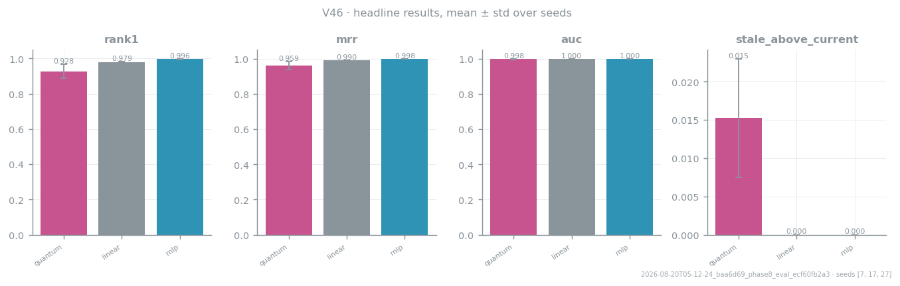
Figure 3. Headline metrics with standard deviation across three seeds. The quantum arm's spread is roughly nineteen times the linear arm's.

7.2 The sealed test split
Six threads were held out from the moment of generation and opened once, at this point, for the first time.
Arm | MRR | rank-1 | AUC | stale-above ↓
quantum | 0.919 | 0.856 | 0.996 | 0.035
linear | 0.975 | 0.953 | 0.999 | 0.000
mlp | 0.993 | 0.986 | 1.000 | 0.000
cosine | 0.910 | 0.831 | 0.928 | 0.130
recency | 0.128 | 0.028 | 0.530 | 0.478
Held-out numbers track the training-stream numbers closely, so the ranking is not an artefact of evaluating where the models trained. Per regime every arm stays within ±0.04 across single-owner, multi-owner and adversarial threads — no persona-bleed collapse.

7.3 Significance
Paired bootstrap over threads, 5,000 resamples. Threads are the independent unit; resampling individual probes would shrink the interval by roughly the square root of probes-per-thread and manufacture significance.
Comparison | Δ MRR | 95% CI | p | Verdict
quantum − linear | −0.056 | [−0.070, −0.043] | 0.000 | significant
quantum − mlp | −0.074 | [−0.086, −0.060] | 0.000 | significant
linear − mlp | −0.018 | [−0.023, −0.012] | 0.000 | significant
The honest headline
The quantum arm is significantly worse than its parameter-matched classical twin on ranking quality, at roughly 135× the compute and 19× the seed-to-seed variance. The blueprint required this comparison to be falsifiable; it falsified in the classical arm's favour at this scale and horizon. That is reported as the result rather than buried.
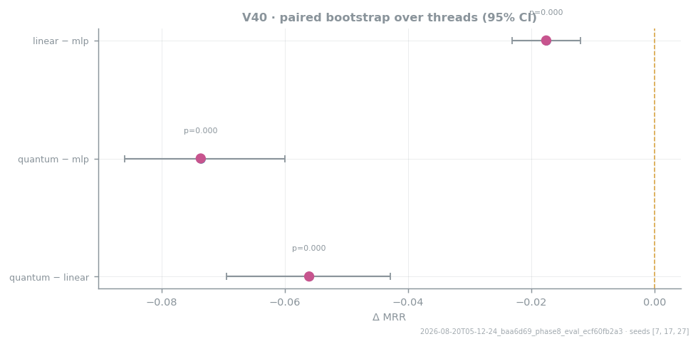
Figure 4. Paired bootstrap over threads. A confidence interval that excludes zero is a real difference; all three pairs are significant.

7.4 Ablations — what each component is actually worth
Quantum arm, 60 tasks, seed 7, every variant retrained from scratch at the tuned learning rate.
Variant | MRR | Δ from full system
no ρ block at all | 0.572 | −0.324
no replay | 0.733 | −0.162
no graph / supersession block | 0.765 | −0.130
global observable ⟨Z⊗…⊗Z⟩ | 0.804 | −0.092
no trust region | 0.896 | ±0.000
no salience block | 0.897 | +0.001
no anchor (λ_Ω = 0) | 0.917 | +0.022
full system | 0.896 | —
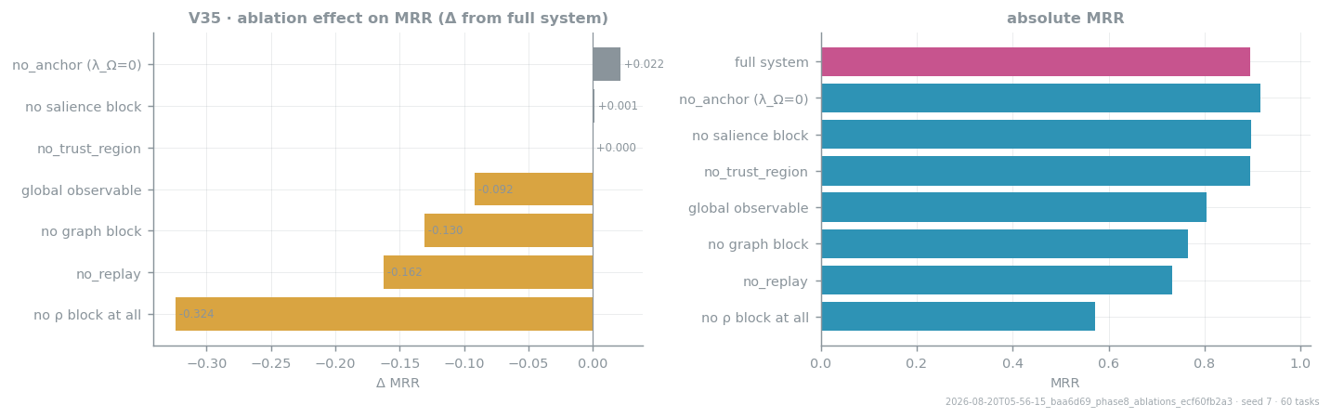
Figure 5. Ablation effects, sorted by size. The relational block is worth more than every other component combined.
Four conclusions follow. First, the ρ block is the architecture — removing it costs 32 MRR points, and the relational features are what the scorer is actually using. Second, replay and the supersession graph both earn their place. Third, the local readout is validated on task performance, not merely on trainability theory. Fourth, the QFIM anchor currently hurts slightly: at 60 tasks there is nothing to protect, so a Fisher-weighted penalty is pure drag. Its value can only appear over horizons long enough for forgetting to occur, which this run does not reach.

7.5 Plasticity — the metric the reference paper is about
Normalised Tr(F) is effective learning capacity. Over 120 tasks the quantum arm rises to roughly 2.5× its initial value and holds; the linear arm decays to 0.30× and the MLP collapses to 0.06× after task 80. Gradient norms agree (quantum 1.2×, classical 0.2–0.35×), and the unwrapped parameter norm of the linear arm grows to 5× and is still climbing while the quantum arm plateaus.
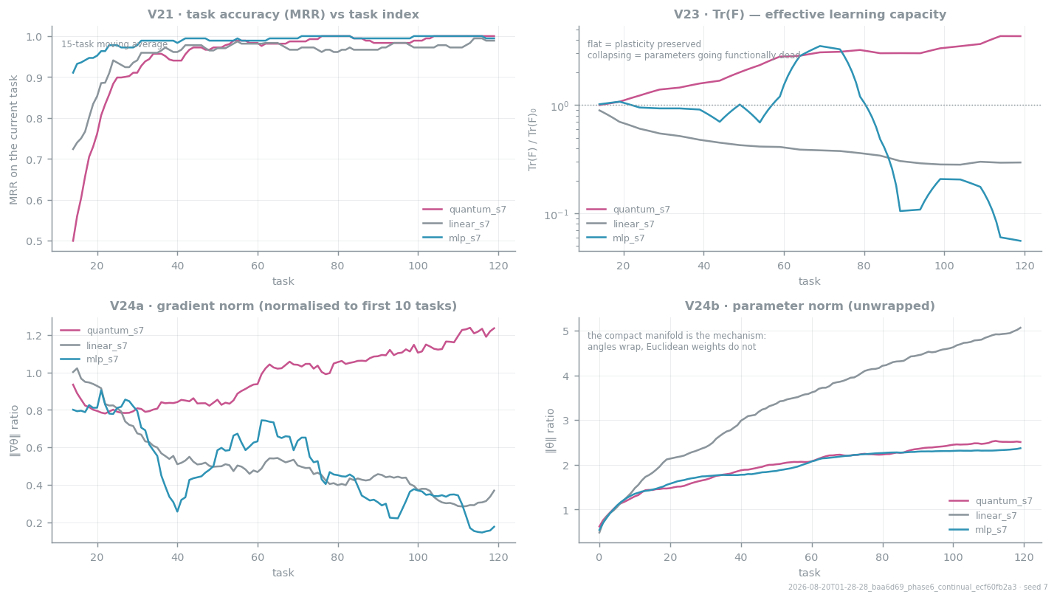
Figure 6. Training curves. Top right is the decisive panel: capacity preserved on the compact manifold, capacity lost in Euclidean space.
What this does and does not mean
Losing Tr(F) is losing the ability to keep learning, not current accuracy — both classical arms are still near ceiling because 120 tasks is far too short for capacity loss to surface as error. The reference paper needed 1,000–3,000 tasks. The plasticity claim is therefore neither confirmed nor refuted here; this is an early indicator pointing the way the paper predicts, and the quantum arm's ~4 s per task is the binding constraint on running the experiment that would settle it.

7.6 Noise robustness
Depolarising noise applied per gate by trajectory sampling on the trained circuit.
p per gate | 0 | 1e-4 | 5e-4 | 1e-3 | 5e-3
MRR | 0.908 | 0.908 | 0.904 | 0.904 | 0.887
rank-1 | 0.850 | 0.850 | 0.850 | 0.850 | 0.825
AUC | 0.994 | 0.994 | 0.993 | 0.993 | 0.991
Ranking is essentially unchanged through p = 1e-3, an order of magnitude beyond the 5e-4 the reference paper reports, and loses two points at 5e-3. This is the one quantum-side claim that came through cleanly.

7.7 Failure taxonomy
Every loss on the test split, categorised in pipeline order — the first category that applies wins, because a retrieval miss makes every downstream question moot.
Arm | accuracy | retrieval | ranking | stale | eviction
mlp | 0.986 | 0 | 5 | 0 | 0
linear | 0.953 | 0 | 17 | 0 | 0
quantum | 0.856 | 0 | 48 | 4 | 0
cosine | 0.831 | 0 | 47 | 14 | 0
Zero retrieval failures and zero evictions for every arm: the memory manifold and the knapsack are not the bottleneck, and every remaining loss is a ranking decision. Cosine's losses are disproportionately stale-fact errors, which the learned arms almost eliminate.

8 The technology stack
Figure 7 lists what every layer runs on and, more usefully, why that choice rather than the obvious default.
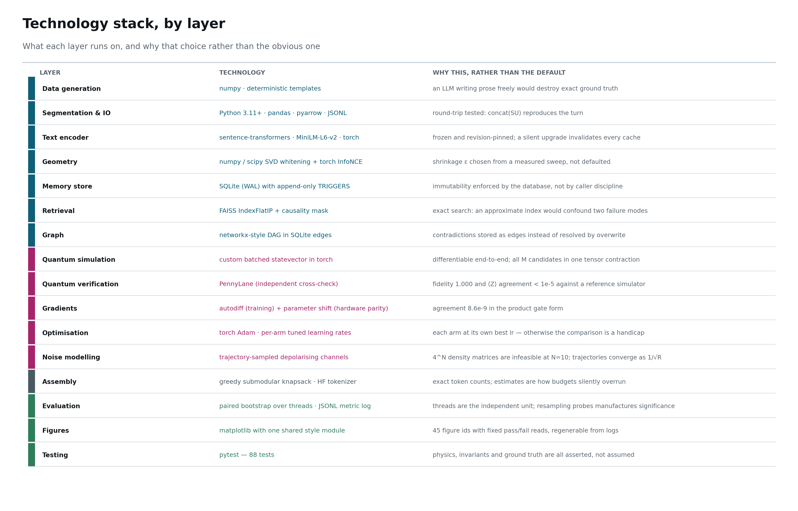
Figure 7. The stack, layer by layer, with the reasoning behind each choice.

8.1 Repository layout
qcs/
├── configs/ base.yaml + tuned.yaml — every tunable number
├── data/ raw (immutable) · interim (caches) · processed (frozen artefacts)
├── runs/ one directory per experiment: config, env, metrics.jsonl, figs
├── docs/ this report and its build scripts
├── figs/ architecture diagrams
├── scripts/ thin CLIs — argument parsing only
│ gen_dataset · fit_encoder · study_whitening · build_memory
│ study_trainability · tune_lr · train_continual · run_assembly · run_eval
├── src/qcs/
│ ├── config.py seeding.py logging_.py types.py paths.py
│ ├── datagen/ fact_bank · thread_planner · surface_realizer · validate · stats
│ ├── ingest/ segment · loader
│ ├── encode/ encoder · cache · whiten · projection · relational · assemble · pipeline
│ ├── memory/ schema.sql · store · ann_index · consolidate · graph · salience
│ ├── quantum/ gates · encoding · ansatz · readout · circuit · gradients · fisher · noise
│ ├── classical/ scorers (linear · mlp · cosine · recency · random · oracle)
│ ├── train/ dataset · replay · anchor · loop
│ ├── assemble/ budget · knapsack · pipeline
│ ├── eval/ metrics · headroom · significance · failure_analysis
│ └── viz/ style + one module per phase (45 figure ids)
└── tests/ 88 tests across 5 files

8.2 Reproducing the results
python -m pip install -r requirements.txt
python -m pip install -e .
python scripts/gen_dataset.py # corpus + V01–V04
python scripts/fit_encoder.py # frozen encoding stack + V05–V08, V13
python scripts/build_memory.py # memory manifold + V09–V12
python scripts/study_trainability.py # quantum core + V14–V20
python scripts/tune_lr.py # per-arm learning rates -> configs/tuned.yaml
python scripts/train_continual.py --config tuned
python scripts/run_assembly.py --checkpoints runs/<phase6>/checkpoints
python scripts/run_eval.py --seeds 7 17 27
python -m pytest # 88 tests

9 Limitations, and what would settle the open question
Stated plainly, because a report that hides these is not useful to the person who has to continue the work.
Limitation | Consequence | What would resolve it
120 tasks is two orders of magnitude short of the reference paper's horizon | the plasticity claim is untested — neither confirmed nor refuted | a 1,000–3,000 task run; roughly one hour per 1,000 tasks per seed at current speed
The quantum arm is ~135× slower per task than its classical twin | it is the binding constraint on the long-horizon experiment | batched multi-candidate state preparation; GPU backend; or a shallower ansatz
The generator is an extractive stand-in, not a real frozen LLM | attention dilution cannot occur, so the saturation turnover is unobservable | wire in any frozen chat model and re-run the budget sweep
The corpus is template-generated | probe cleanliness is overstated relative to real threads | the planned human-written thread set for external validity
Amplitude encoding is O(2ᴺ) deep on hardware | the encoding, not the ansatz, is the hardware bottleneck | angle encoding with data re-uploading for the hardware path
Simulation is exact only to ~20 qubits | the design cannot be scaled arbitrarily on a laptop | the Phase 9 scaling study across N ∈ {8, 10, 12}

9.1 What this project does establish
- Architecture claims are supported: append-only memory plus a prefilter plus budgeted assembly produce zero retrieval failures and zero evictions; the relational block is worth 0.324 MRR; stale-fact errors fall from 0.130 under cosine to 0.000–0.035 with a learned scorer; no unlabelled stale fact ever reaches a prompt.
- The quantum ranking advantage is refuted at this scale, significantly and reproducibly across three seeds.
- Noise robustness is supported: ranking survives depolarising noise an order of magnitude beyond the level the reference paper reports.
- The plasticity question remains genuinely open, with a measured early indicator in its favour and a clear, costed experiment that would settle it.

9.2 Phase 9, the remaining work
- The long-horizon run: 1,000+ tasks, three seeds, both arms, with Tr(F) and the plasticity index as primary endpoints.
- Hardware parity: run the trained circuit shot-based and on a real backend; report the shot count at which score ranking becomes stable.
- A scaling study across N ∈ {8, 10, 12} qubits with wall-clock reported honestly.
- A real frozen LLM in place of the extractive reader, and the saturation sweep repeated.
- A reproduction kit: make reproduce regenerating every figure from raw logs.

Report generated from the repository state at the end of Phase 8. Every table and figure in §7 is regenerable from runs/*/metrics.jsonl by scripts/make_figures.py and scripts/run_eval.py.

