[Pandas](https://pandas.pydata.org/" \t "_blank) is a powerful library in a toolbox for every Machine Learning engineer. It provides two main data structures: [Series](https://pandas.pydata.org/pandas-docs/stable/generated/pandas.Series.html) and [DataFrame](https://pandas.pydata.org/pandas-docs/stable/generated/pandas.DataFrame.html" \t "_blank).

Series is a one-dimensional array of values. Under the hood, it uses [NumPy](https://www.numpy.org/" \t "_blank) [ndarray](https://www.numpy.org/devdocs/reference/arrays.ndarray.html).

Series object has only “axis 0” because it has only one dimension.

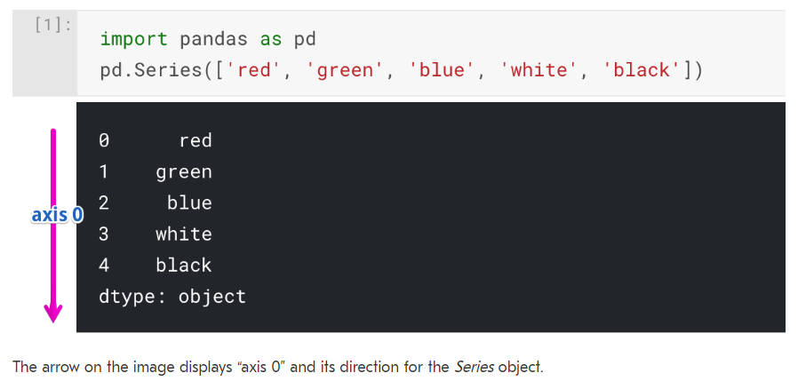

Usually, in Python, one-dimensional structures are displayed as a row of values. On the contrary, here we see that Series is displayed as a column of values.

DataFrame is a two-dimensional data structure. It has columns and rows. Its columns are made of separate Series objects.

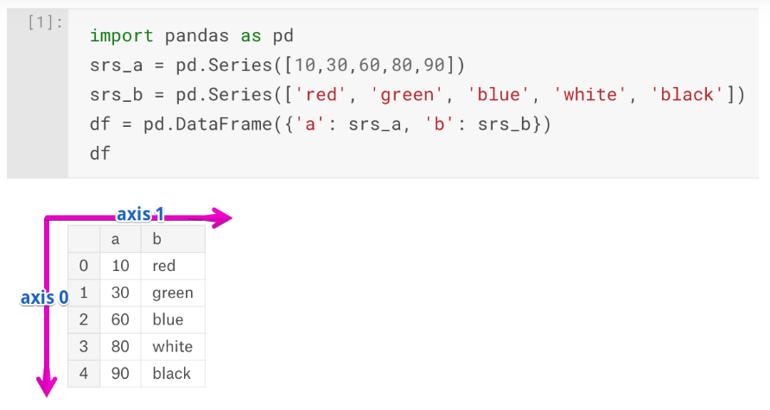

A DataFrame object has two axes: “axis 0” and “axis 1”. “axis 0” represents rows and “axis 1” represents columns.