

**Sri Lanka Institute of Information Technology**

Lockdown Emergency Service Bill System

**Report**

**Software Architecture Assignment 01**

**2020**

**Submitted by:**

1. IT18144772: NIROSHAN K.
2. IT18001976: VARNIAH K.
3. IT18068610: PIRATHIKARAN V.
4. IT18152074: SANGEETH RAJ A.

**GROUP ID: 67**

TABLE OF CONTENT

* PROJECT DESCRIPTION …………………………………………… 3
* FLOW CHART DIAGRAM …………………………………………… 4
* IMPLEMENTATION SCREENSHOTS …………………………………. 5-7
* SYSTEM SCREENSHOTS …………………………………………… 8-10
* MANIFEST SCREENSHOTS ……………………………………………. 12-13
* GROUP CONTRIBUTION …………………………………………… 14

PROJECT DESCRIPTION

INTRODUCTION

We have implemented a Lockdown Emergency Bill Service System using Eclipse Equinox OSGI Framework. Let us explain this briefly, the system comprises of three producers: Gas service management, Mobile Reload Service Management, Transport Service Management and One Consumer. The purpose of having one customer is that if more than one consumer bundles are implemented, all the consumer bundles will be having in the same way which will be duplicate implementation of consumer bundles. The IDE used was Eclipse written on Java programming language. We decided to choose this system by considering the current lockdown situation of our country. This billing system will help the small scale business people and local people to make sure the get the service at right price and the bill will be an evidence of their purchase or the service charge, this will reduce business frauds.

IMPLEMENTATION

Foremost, when the consumer bundle is started, the system will prompt the user interface (UI) to select the service by giving its number which he or she needs to get. There will be 3 producer bundle, namely Gas service, Reload service and Transport service. Once the user selects the service which he or she need it will be prompt to the user. When user chooses a service, he or she is asked to give the required parameter by giving the particular numbers to get the services. For example, under gas service there will be two types of cylinders with four different sizes. The User has to select the type and size by giving the correct number for them. Then a display will be prompted requesting whether the user wants to continue the service or not. If the user accepts to continue the service, the service will be in the same producer bundle or else if the user decline to continue then the bill for the service will be displayed and also user will be asked to select another service or to exist the system. If he or she need to get another service, they can give yes and able to continue to other services or else if the user doesn’t want to get another service then he or she can select no, and the system will be terminated. If the user got more than one service, the final bill will be displayed before termination. Each service has different types and options. User has to select the options under the selected service to continue and to get that service otherwise they are not able to continue the services.

FOR BETTER UNDERSTANDING, A FLOW CHART DIAGRAM FOR THE SYSTEM HAS BEEN ATTACHED UNDER IMPLEMENTATION.

FLOW CHART DIAGRAM

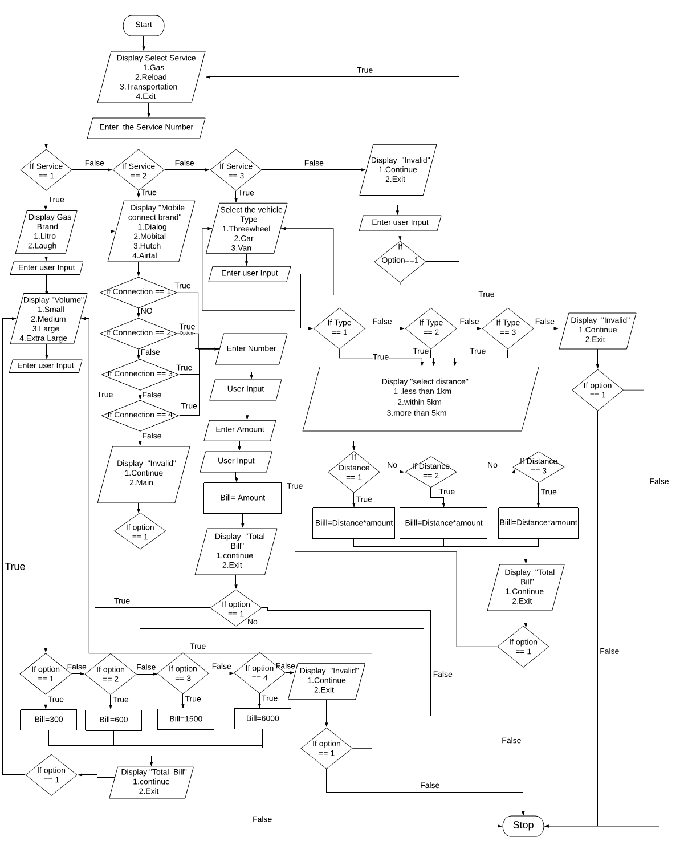

IMPLEMENTATION SCREENSHOTS

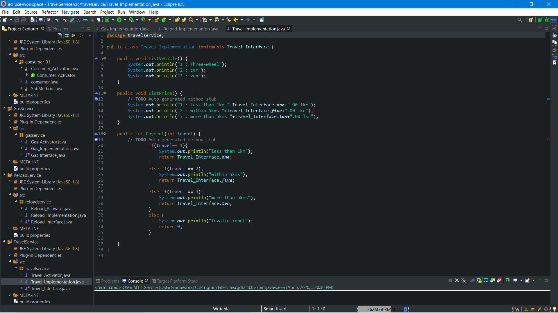

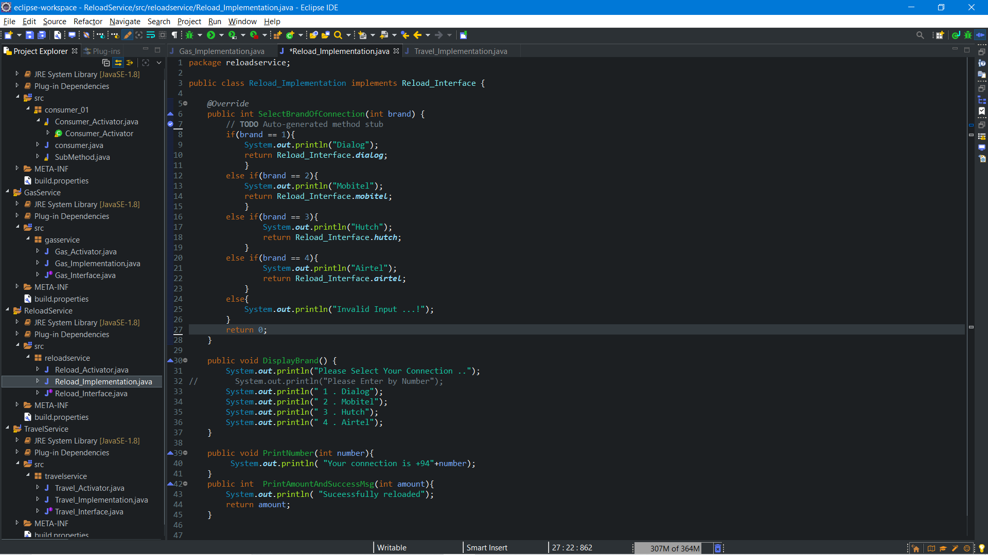

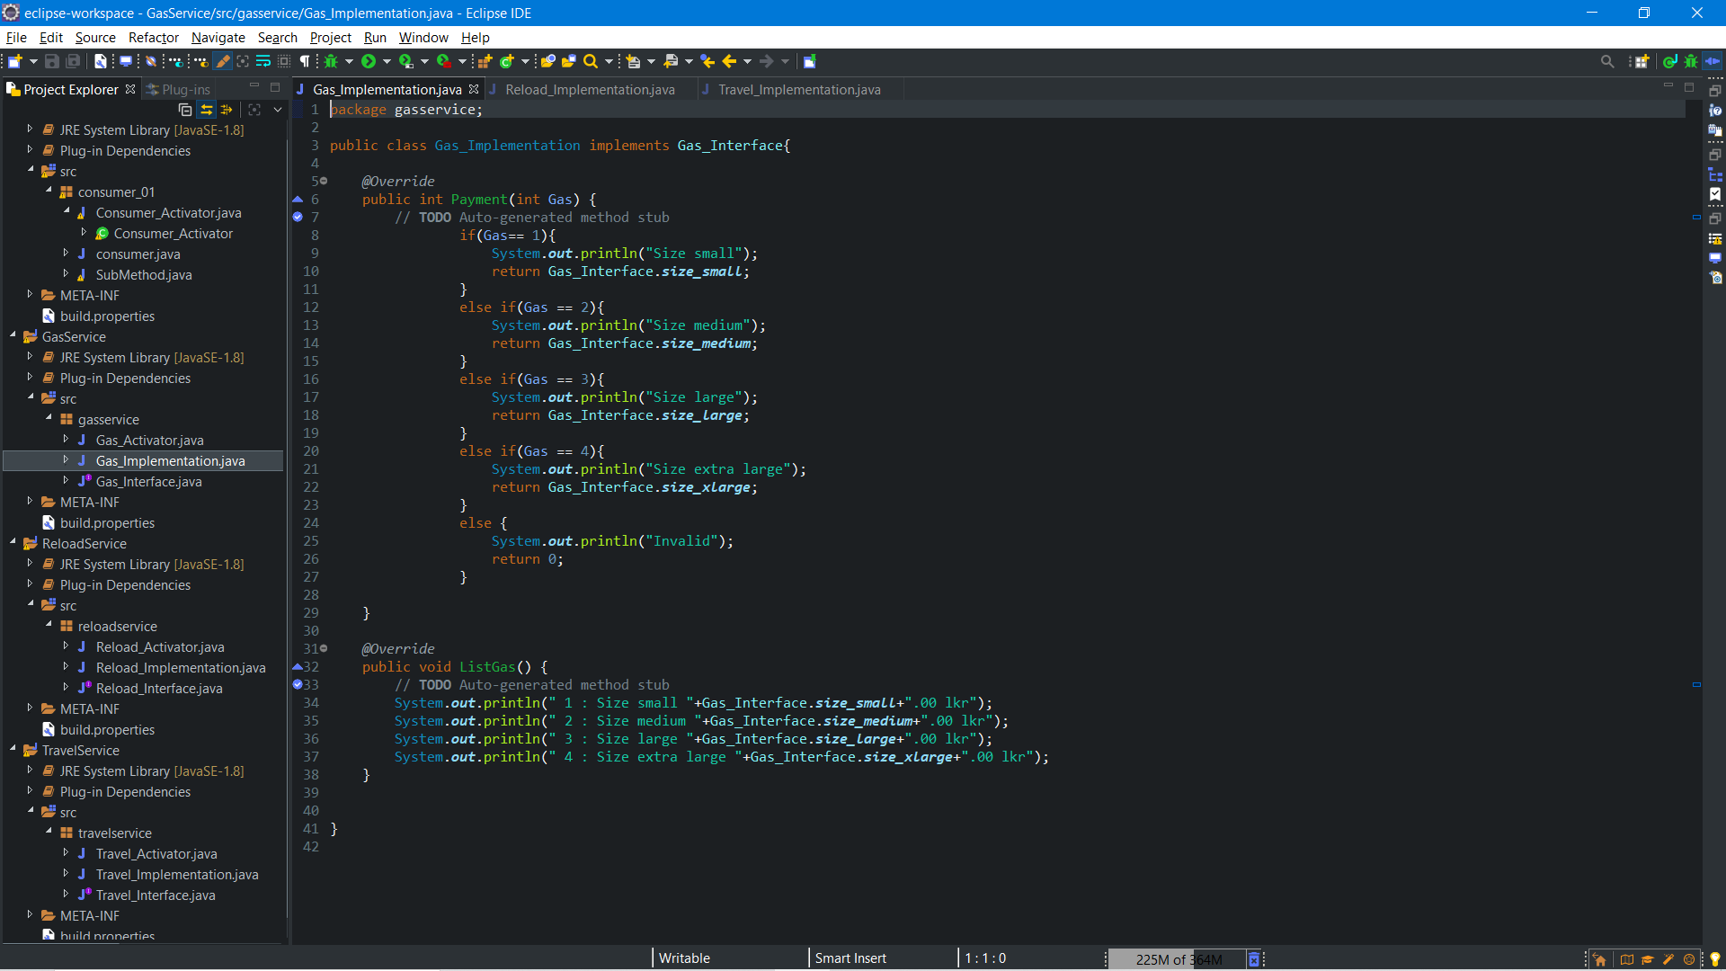

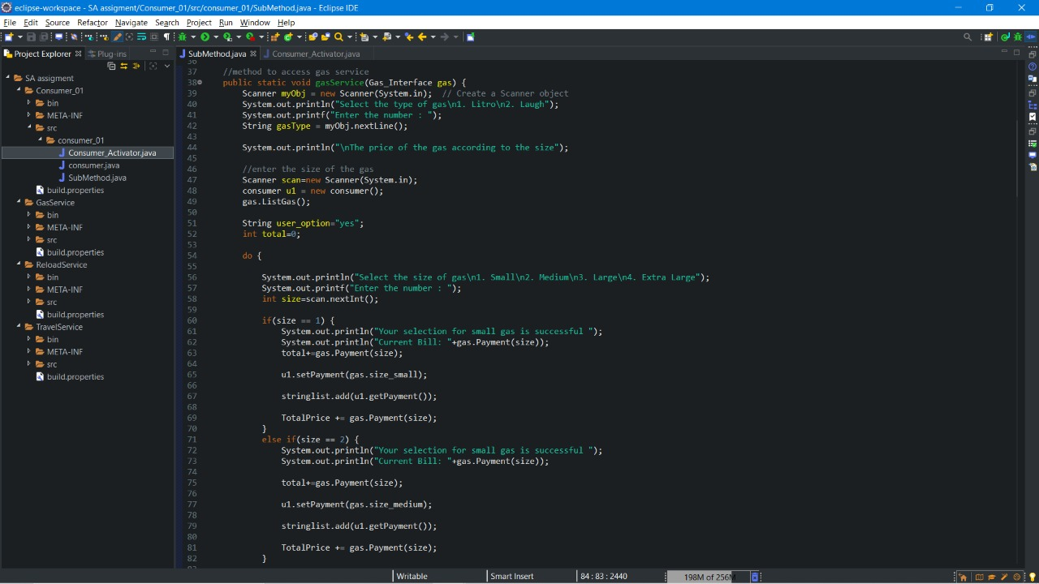

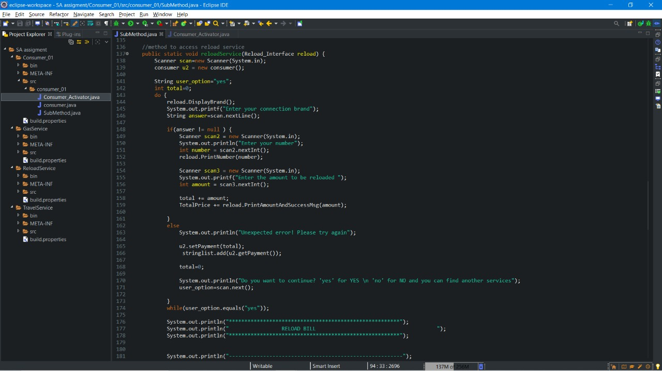

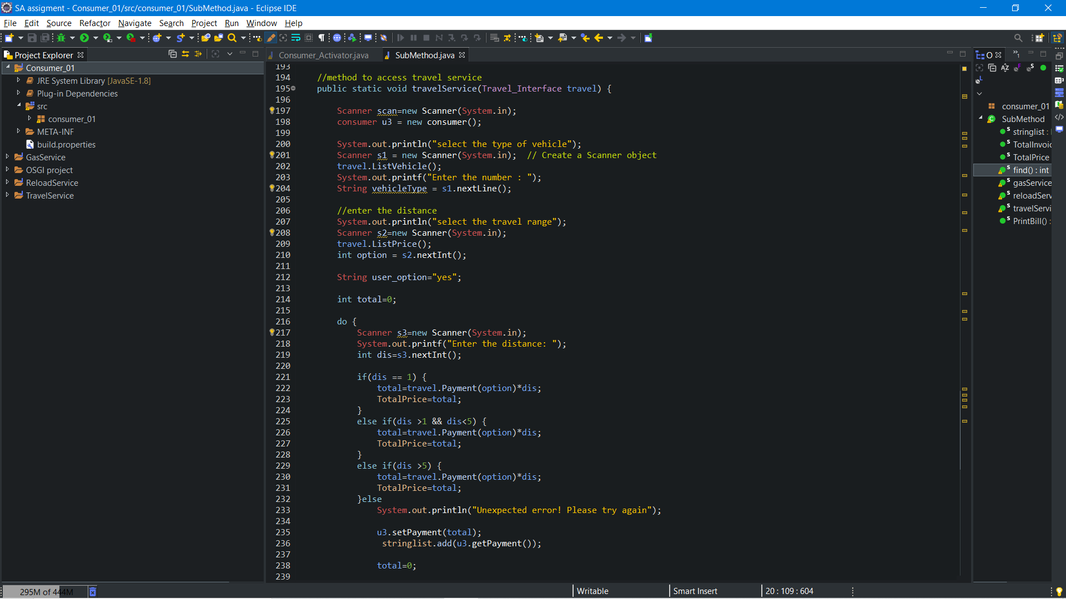

ACTIVITY SCREENSHOTS

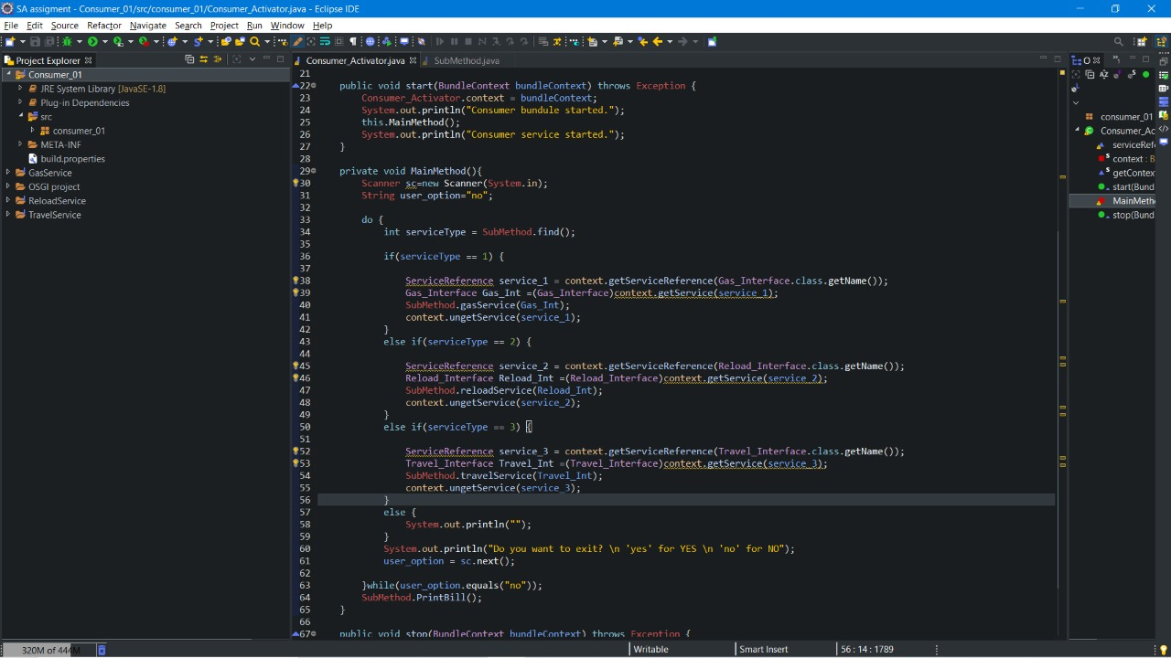

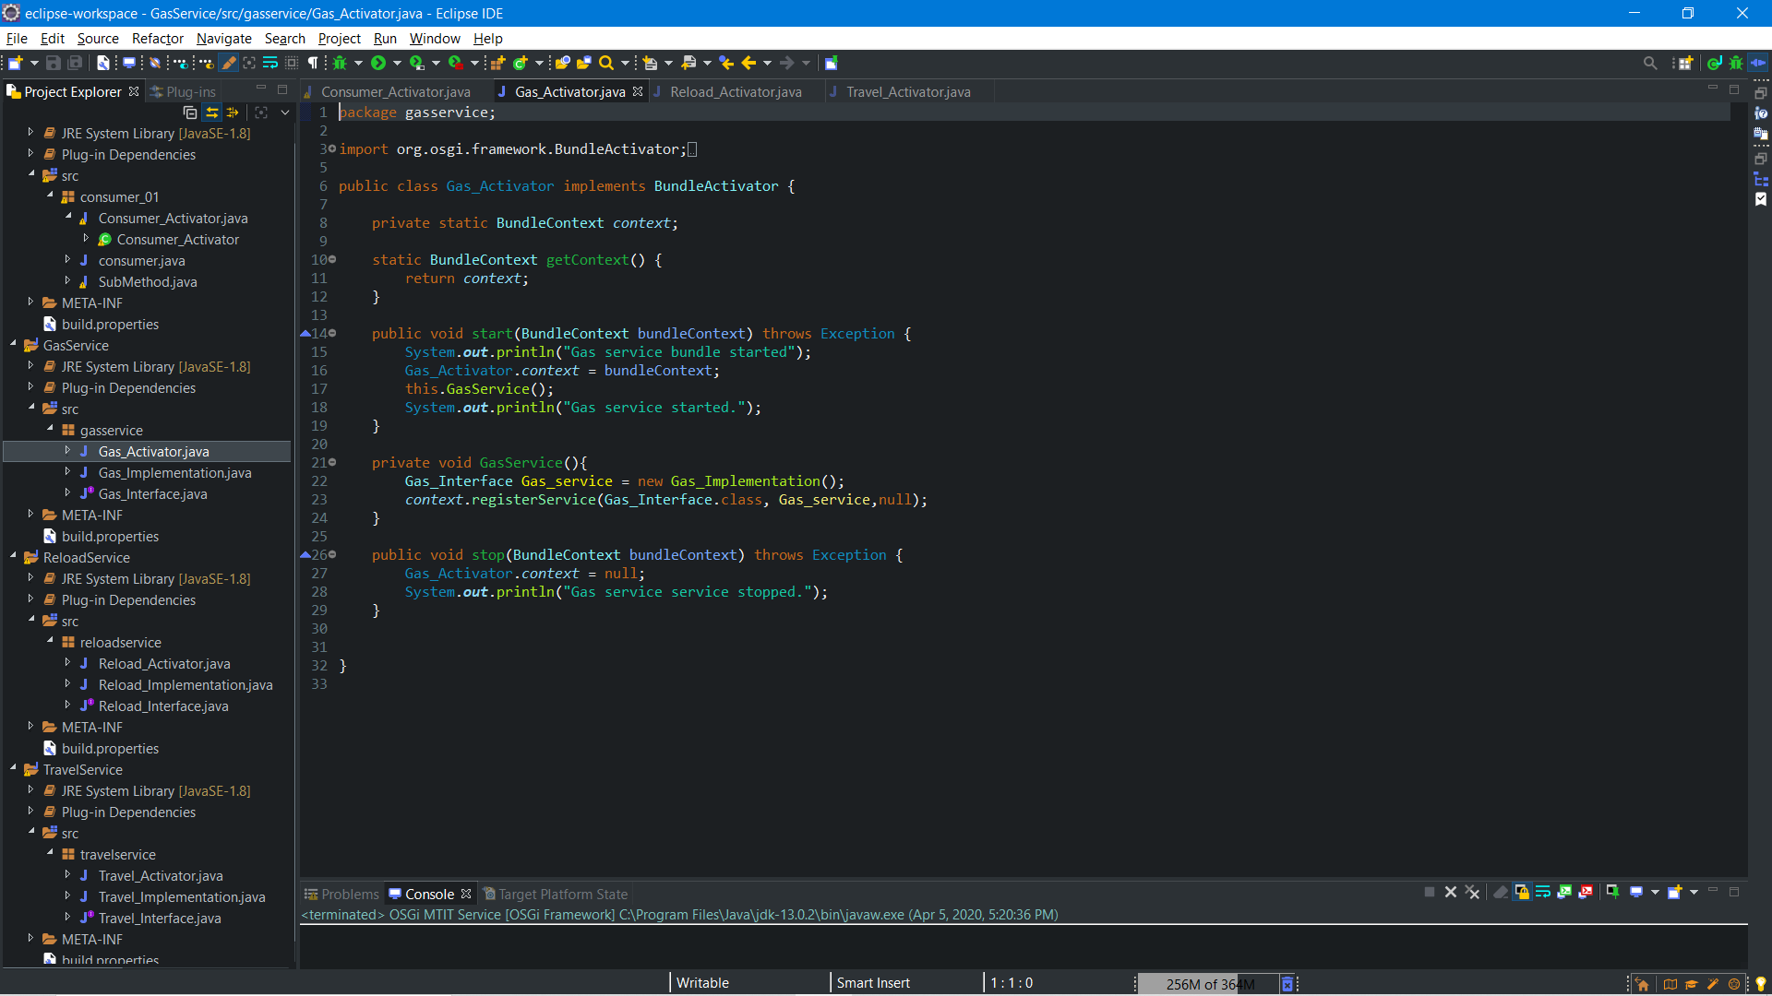

FINAL OUTPUT SCREENSHOT

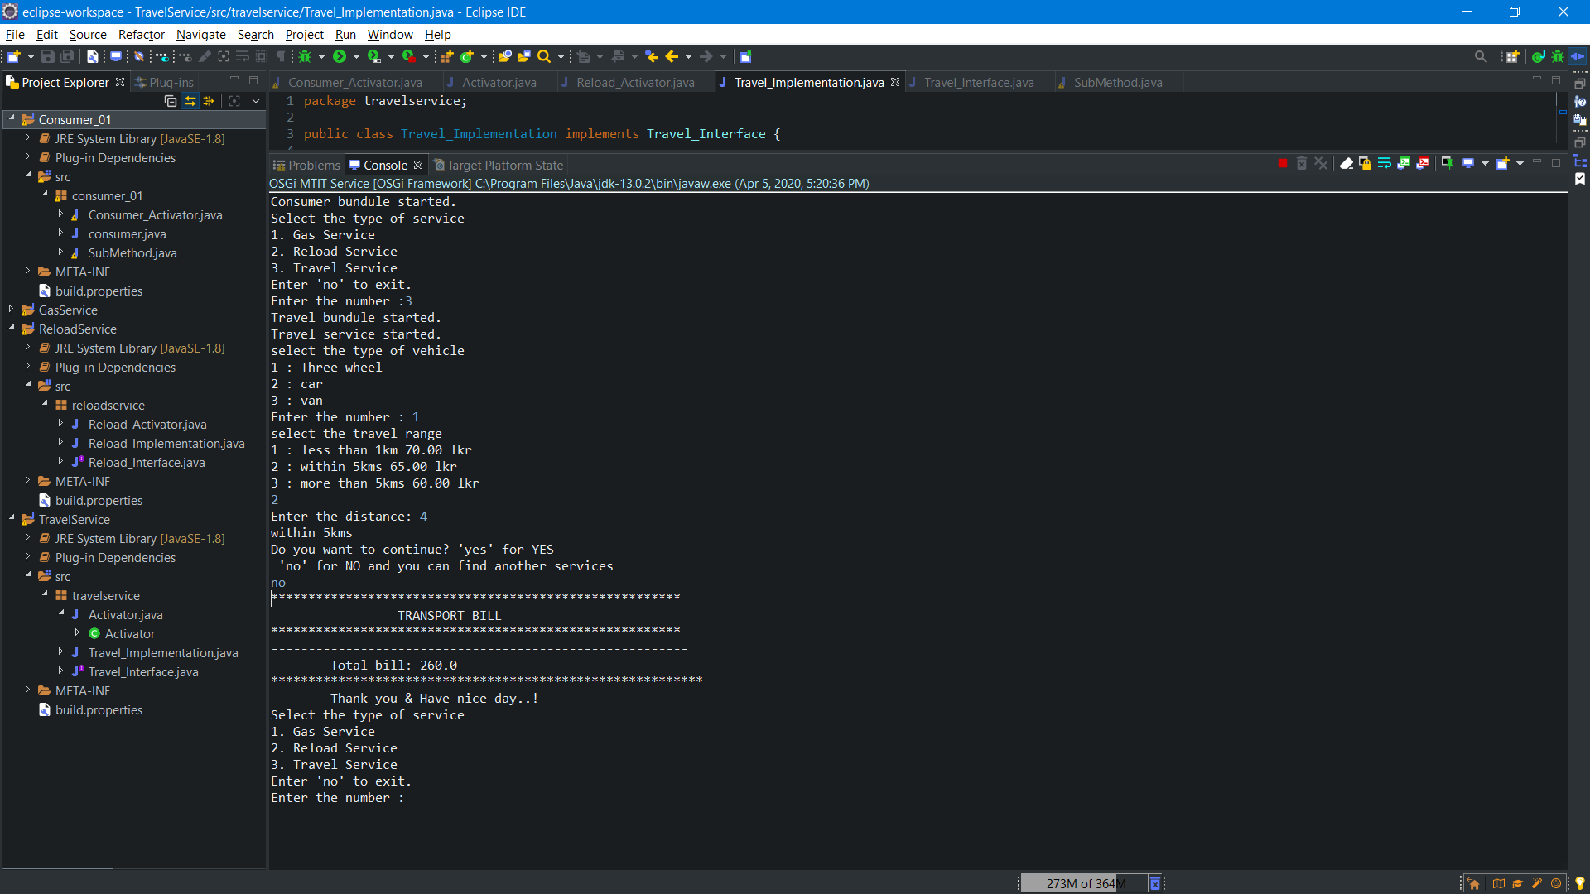

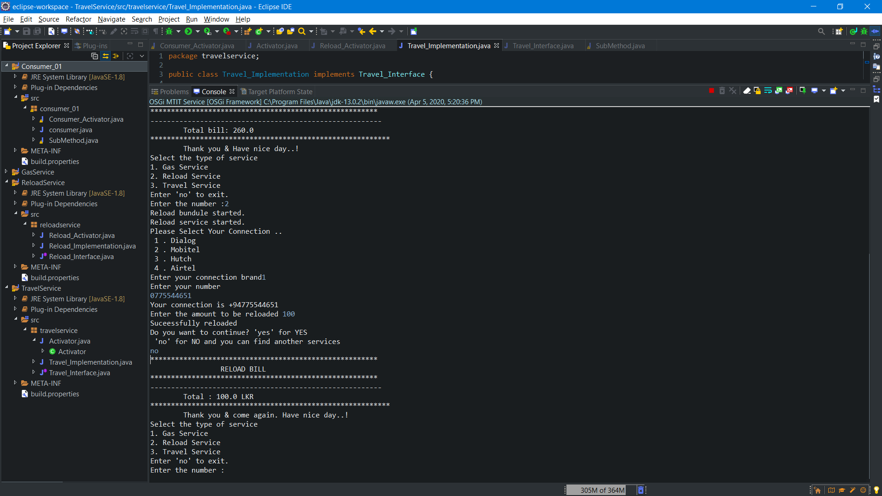

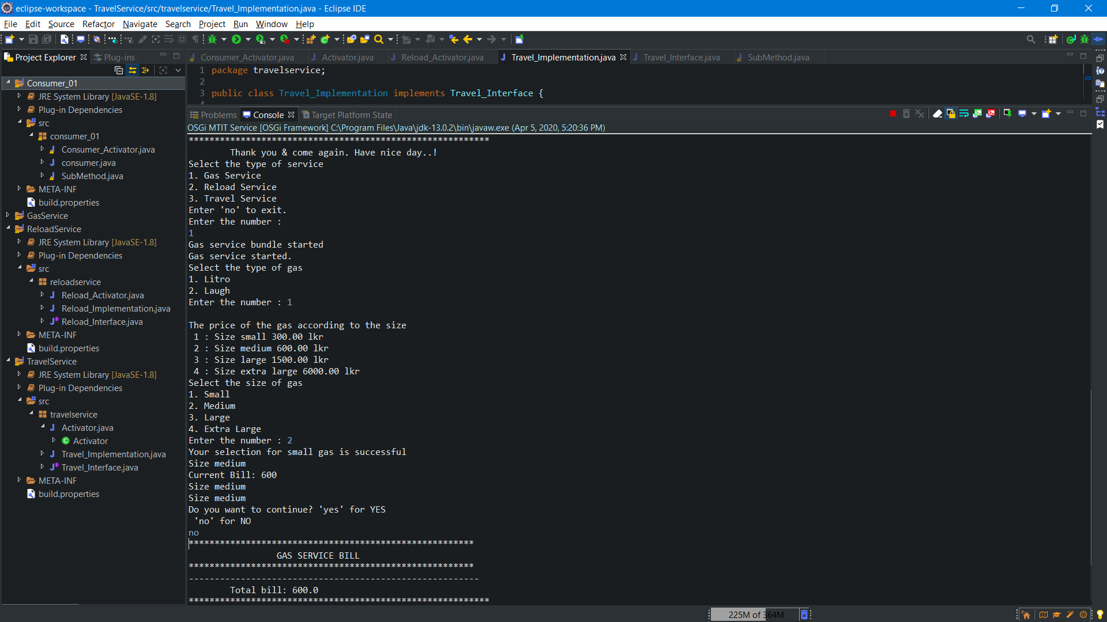

MANIFEST SCREENSHOT

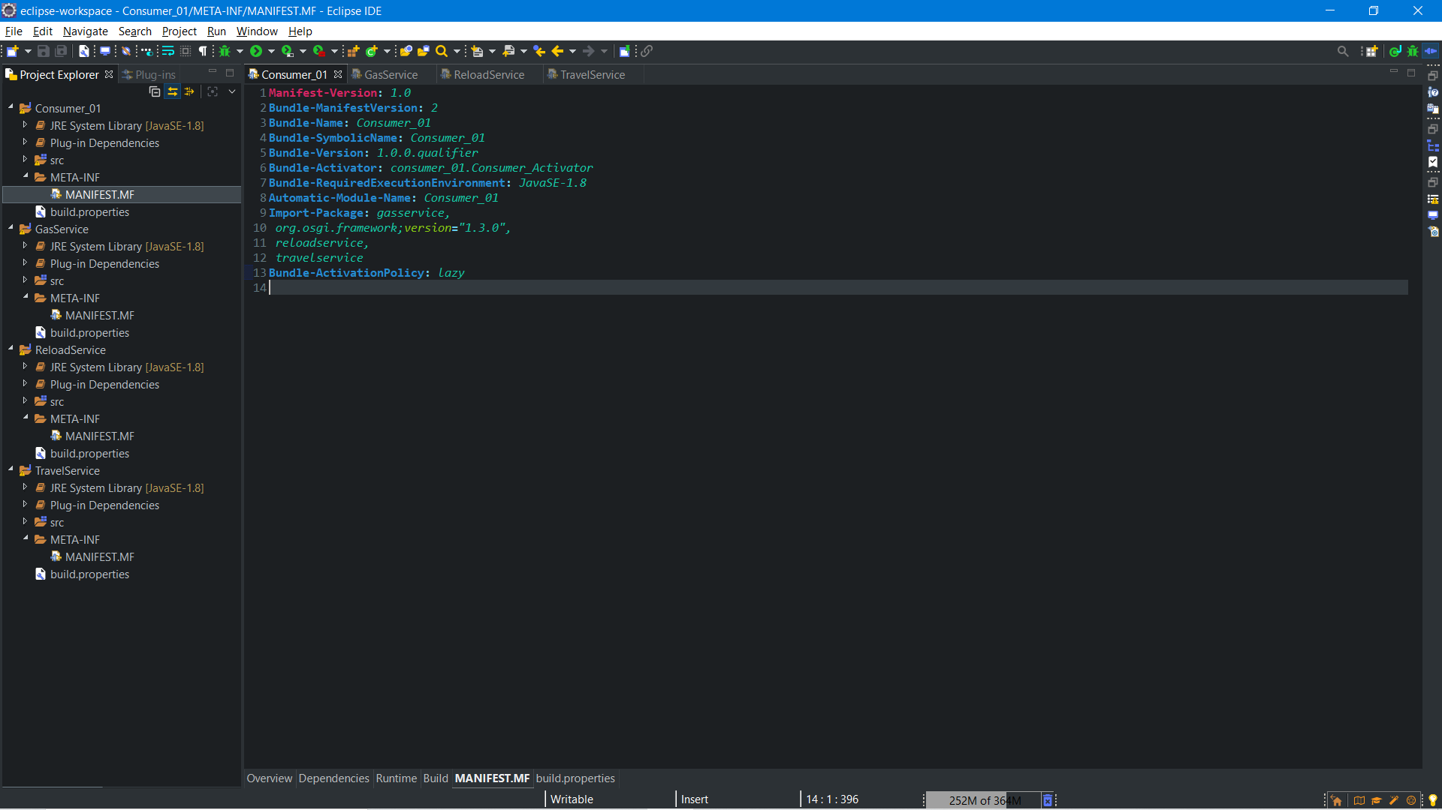

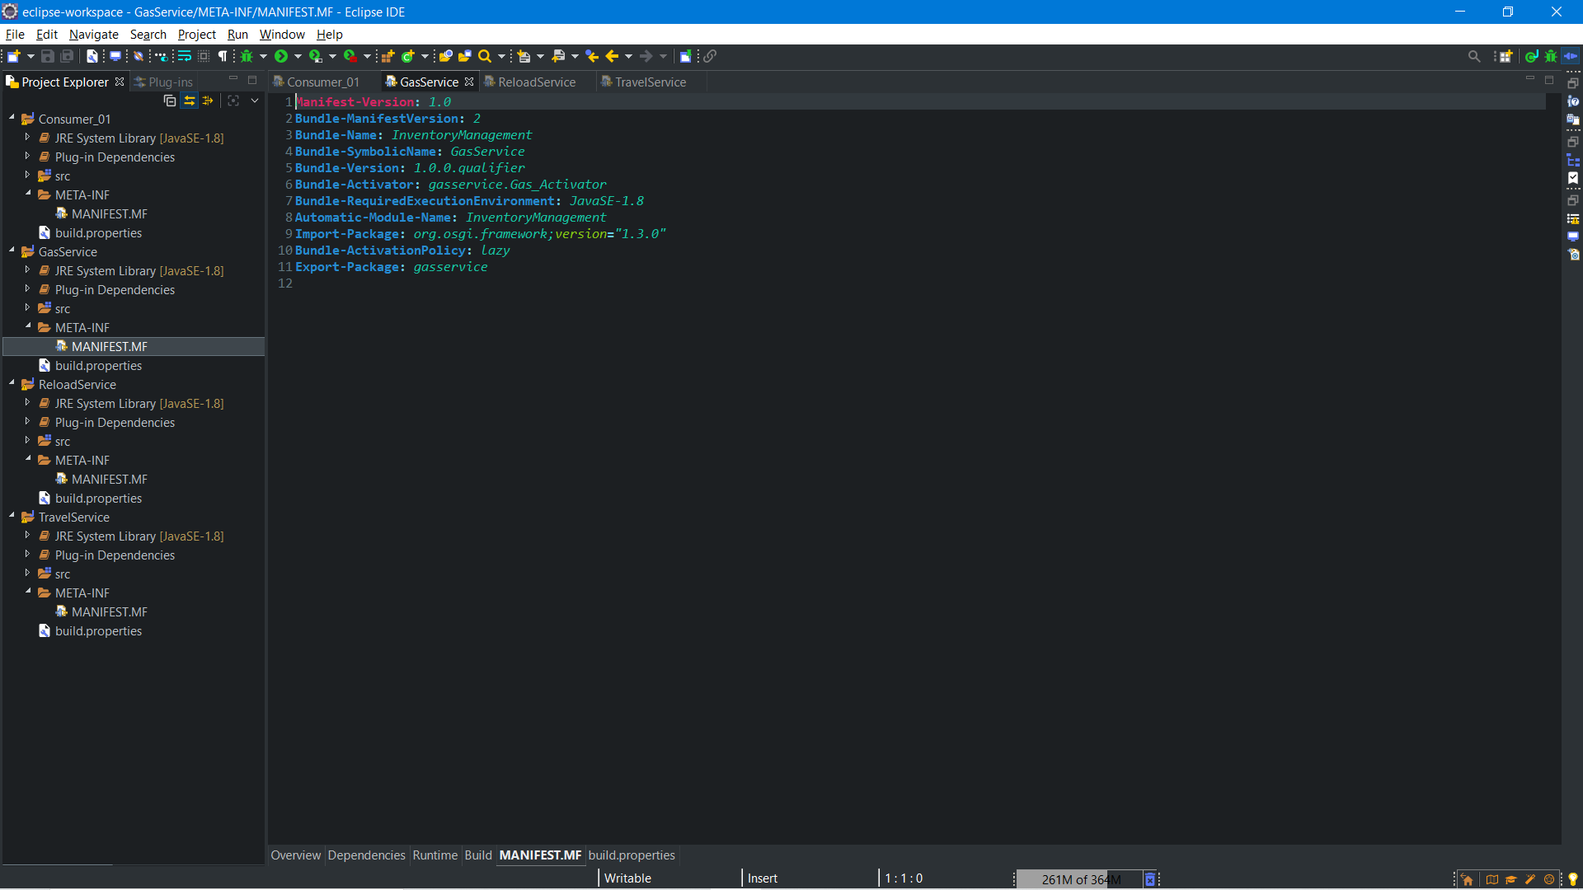

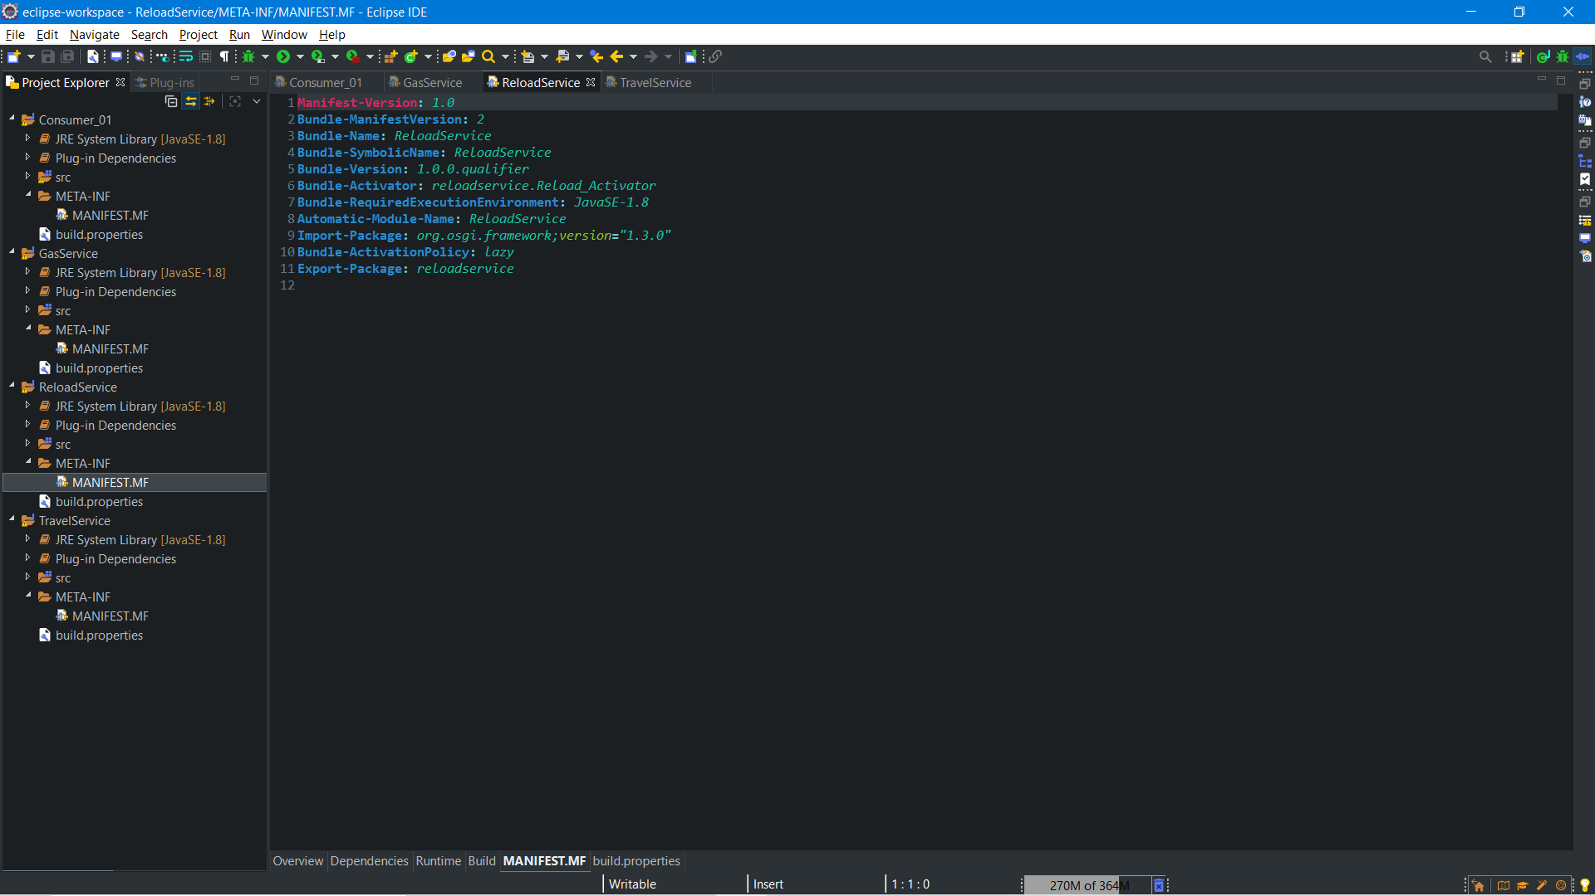

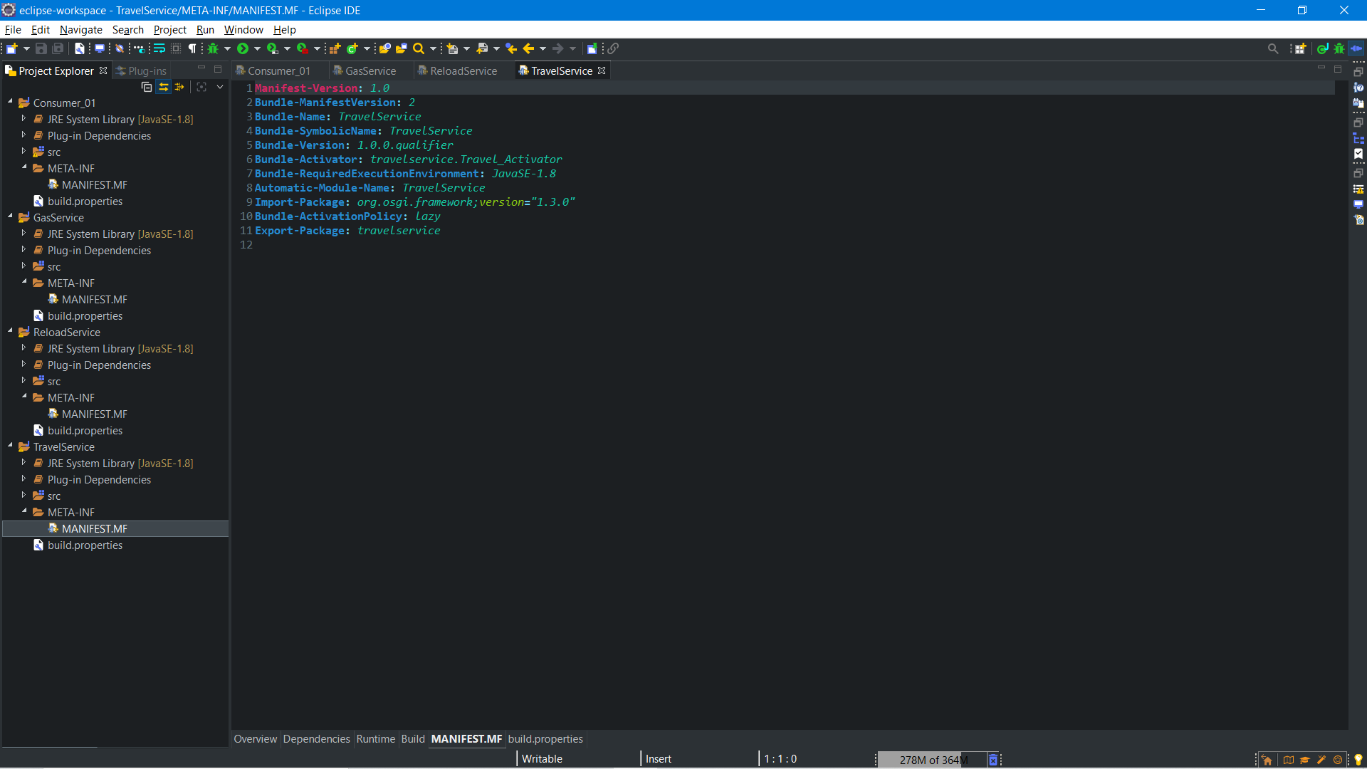

1. IT18144772: NIROSHAN K. –

Producer implementation(gas service bill) and jar bundle export

1. IT18001976: VARNIAH K. –

Complete Report and preparation of flow chart diagram

1. IT18068610: PIRATHIKARAN V. –

Scenario developed and producer implementation (transport service bill)

1. IT18152074: SANGEETH RAJ A. –

consumer implementation and producer implementation (reload service bill)