TITANIC SURVIVAL ANALYSIS
AND PREDICTIVE MODELLING

Week 5 Final Project Report

Data Science with Python Internship
Python | Pandas | Seaborn | Scikit-learn

Prepared as an end-to-end machine learning and data analysis study

1. Executive Summary
This project presents an end-to-end analysis of the Titanic passenger dataset, combining exploratory data analysis, feature engineering, machine learning, model evaluation, and interpretation. The primary objective is to understand the factors associated with passenger survival and develop predictive models that can classify whether a passenger survived.
The dataset contains 891 passenger records and uses 'Survived' as the target variable. The analysis examines demographic and travel-related variables including passenger class, gender, age, fare, family relationships, embarkation port, and engineered features such as FamilySize, IsAlone, Title, and FarePerPerson.
Two supervised learning approaches were developed: Logistic Regression and Random Forest. Both models were implemented through preprocessing pipelines to ensure that missing values, numerical scaling, and categorical encoding were handled consistently without data leakage.
Model performance was evaluated using Accuracy, Precision, Recall, F1-score, ROC-AUC, confusion matrices, and 5-fold stratified cross-validation. The best test-set model according to F1-score was identified as Logistic Regression.
The overall survival rate in the dataset was approximately 38.4%. The analysis demonstrates that survival was not evenly distributed across passenger groups, with gender and passenger class showing particularly important relationships with survival.
Beyond predictive performance, the project focuses on interpreting the results and discussing their practical meaning, limitations, data-quality considerations, and opportunities for improving future models.

2. Project Objectives
1. Understand the structure and characteristics of the Titanic dataset.
2. Identify missing values, data-quality issues, and important variables.
3. Perform exploratory data analysis to identify survival patterns.
4. Create meaningful engineered features to improve predictive modelling.
5. Build Logistic Regression and Random Forest classification models.
6. Evaluate models using multiple performance metrics.
7. Validate model reliability using stratified 5-fold cross-validation.
8. Interpret important predictors and discuss their practical significance.
9. Identify limitations and provide actionable recommendations for future analysis.

3. Dataset Description
The Titanic dataset contains information about passengers aboard the RMS Titanic. The target variable, Survived, indicates whether a passenger survived the disaster (1 = survived, 0 = did not survive). The dataset provides demographic, family, ticket, and fare-related information that can be used for both statistical analysis and supervised machine learning.
Variable | Description | Role
Survived | Passenger survival status | Target
Pclass | Passenger class | Predictor
Sex | Passenger gender | Predictor
Age | Passenger age | Predictor
SibSp | Siblings/spouses aboard | Predictor
Parch | Parents/children aboard | Predictor
Fare | Passenger ticket fare | Predictor
Embarked | Port of embarkation | Predictor
FamilySize | Total family size aboard | Engineered
IsAlone | Whether passenger travelled alone | Engineered
Title | Title extracted from passenger name | Engineered
FarePerPerson | Fare divided by family size | Engineered

The analysis dataset contains 891 rows and 12 original columns. The target variable is binary, making this a supervised binary classification problem.

4. Data Quality Assessment
Before modelling, the dataset was examined for missing values, data types, duplicate records, and consistency. This step is important because poor data quality can reduce model reliability and introduce misleading patterns.
Column | Missing Values | Missing %
Age | 177 | 19.87%
Cabin | 687 | 77.10%
Embarked | 2 | 0.22%

A total of 0 duplicate rows were identified in the dataset. Duplicate observations should be reviewed because repeated records may give certain passenger patterns disproportionate influence during analysis.

4.1 Target Variable Distribution
The target variable contains 342 survivors and 549 non-survivors. The resulting overall survival rate is 38.4%.
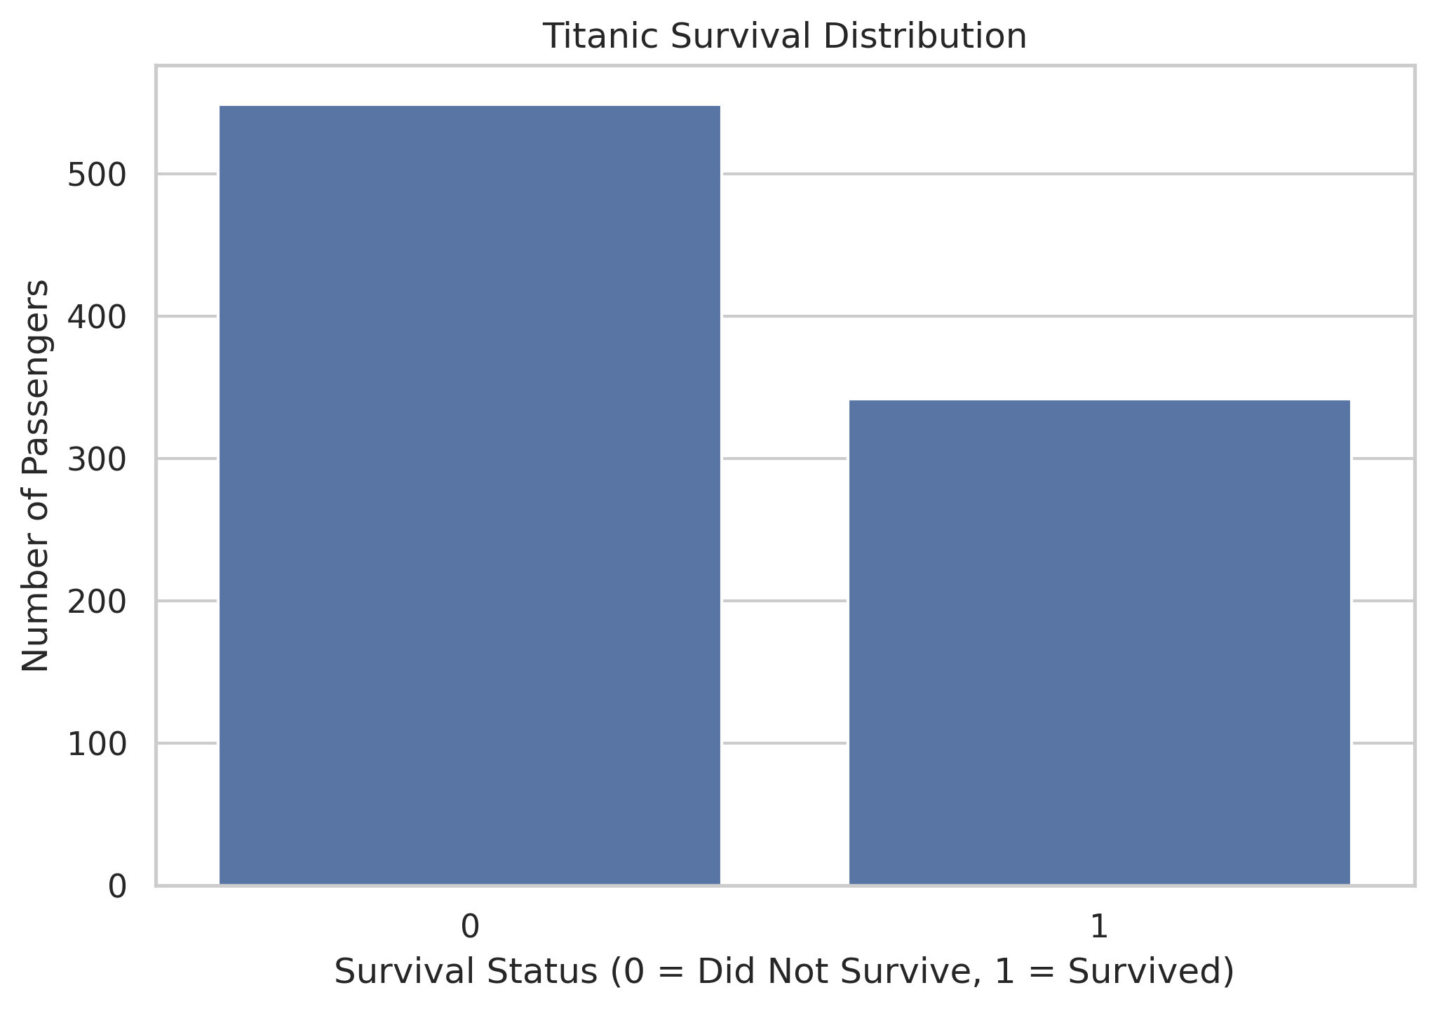

4.2 Data Preprocessing Strategy
- Numerical missing values were handled using median imputation.
- Categorical missing values were handled using the most-frequent category.
- Numerical variables were standardized for Logistic Regression.
- Categorical variables were converted using one-hot encoding.
- Unknown categorical values were safely handled using handle_unknown='ignore'.
- Preprocessing was integrated into Scikit-learn pipelines to prevent data leakage.
- The dataset was divided into 80% training data and 20% testing data using stratification.

5. Exploratory Data Analysis
Exploratory Data Analysis (EDA) was performed to understand the relationships between passenger characteristics and survival. The analysis focuses on gender, passenger class, age, fare, and family size because these variables provide different perspectives on passenger survival.

5.1 Survival by Gender
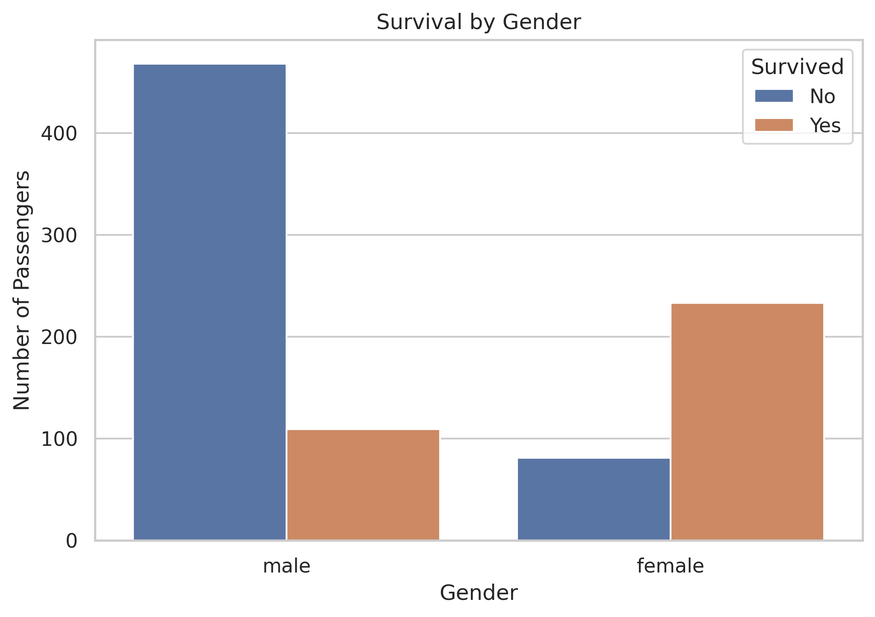
Gender shows one of the clearest survival differences in the Titanic dataset. The observed survival rate for female passengers was approximately 74.2%, compared with approximately 18.9% for male passengers.
This difference suggests that gender was a highly informative predictor. Historically, evacuation procedures and the 'women and children first' principle likely contributed to the observed difference. However, this relationship should be interpreted as an association in the dataset rather than proof of causation.

5.2 Survival by Passenger Class
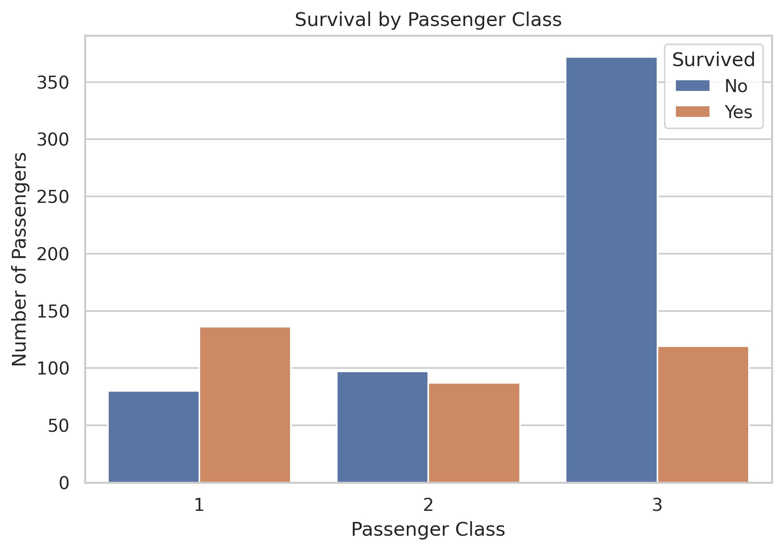
Passenger class also demonstrates a substantial survival gradient. The calculated survival rates by class are shown below.
Passenger Class | Survival Rate
1 | 63.0%
2 | 47.3%
3 | 24.2%
Class Pclass 1.00
Passengers 216.00
Survivors 136.00
Survival Rate (%) 62.96
Name: 0, dtype: float64 recorded the highest survival rate among the passenger classes. The pattern indicates that socioeconomic position and location within the ship may have influenced access to lifeboats and evacuation routes.

5.3 Age Distribution
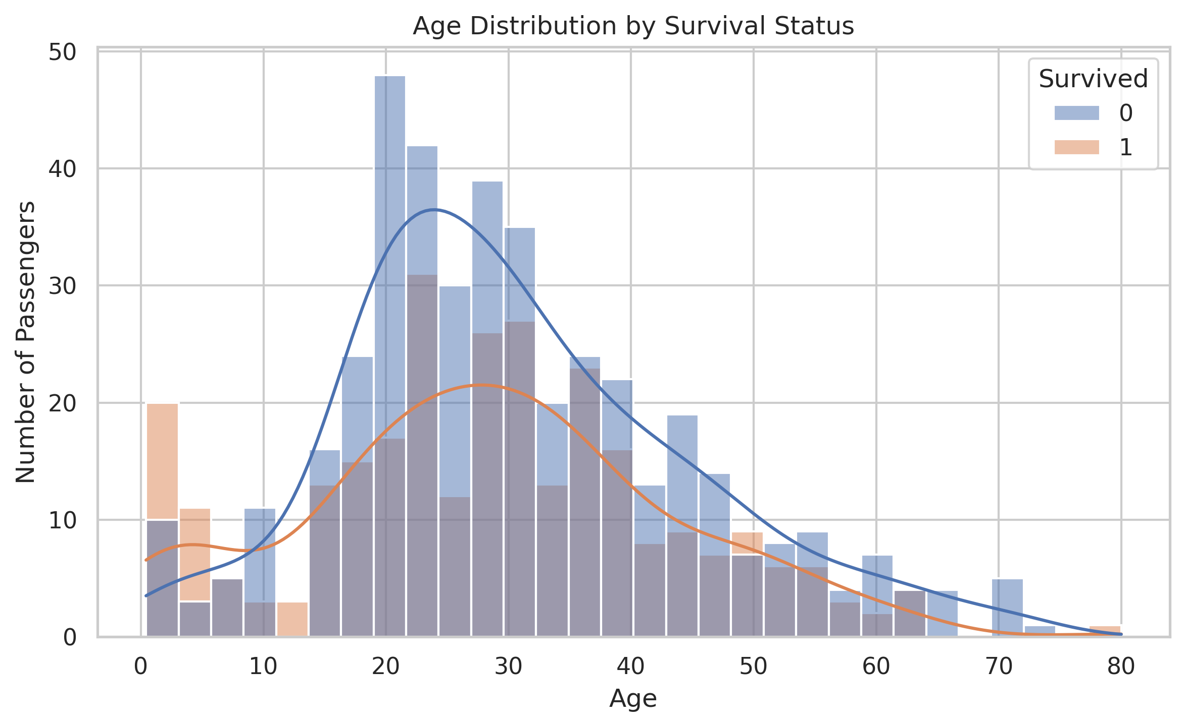
Age provides an additional demographic dimension. The distribution shows that passengers represented a wide range of ages, while missing age observations required preprocessing before machine learning.
Age may interact with both gender and passenger class. For example, children could have received evacuation priority, while older passengers may have had different mobility or access constraints. Therefore, age should not be examined in isolation.

5.4 Fare and Survival

5.4 Fare and Survival
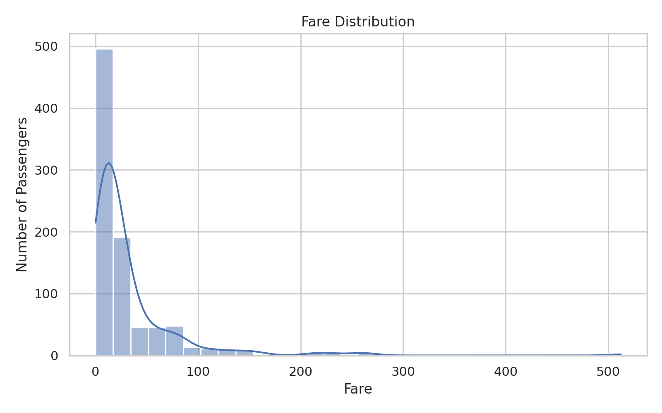
Fare provides an indirect indication of passenger class and economic position. The distribution is uneven, with a smaller number of passengers paying substantially higher fares.
The average fare paid by survivors was approximately 48.40, compared with 22.12 for passengers who did not survive.
Higher fares are associated with higher passenger classes, so fare should not be interpreted independently of Pclass. The observed relationship may partly reflect differences in socioeconomic position and access to different areas of the ship.

5.5 Family Size and Survival
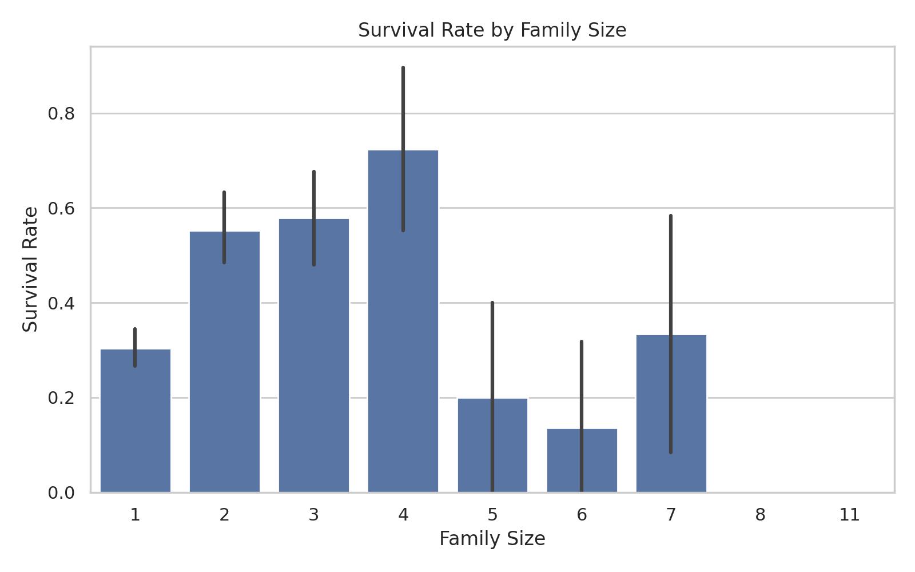
FamilySize was created by combining SibSp and Parch with the passenger themselves. This feature provides a direct representation of the size of the travelling group.
Family Size | Passengers | Survival Rate
1 | 537 | 30.4%
2 | 161 | 55.3%
3 | 102 | 57.8%
4 | 29 | 72.4%
5 | 15 | 20.0%
6 | 22 | 13.6%
7 | 12 | 33.3%
8 | 6 | 0.0%
11 | 7 | 0.0%
The results indicate that travelling-group size was related to survival, but the relationship was not necessarily linear. Small family groups may have benefited from mutual assistance, whereas very large groups could have faced difficulties coordinating during evacuation.

6. Feature Engineering
Feature engineering was performed to create variables that capture useful relationships that may not be fully represented by the original columns. The objective was to improve interpretability and provide the machine learning models with meaningful passenger-level information.
Engineered Feature | Calculation / Method | Purpose
FamilySize | SibSp + Parch + 1 | Represents total travelling-group size
IsAlone | FamilySize == 1 | Identifies passengers travelling alone
Title | Extracted from Name | Captures social/demographic information
FarePerPerson | Fare / FamilySize | Normalizes fare according to group size
The Title feature was simplified by grouping uncommon titles into a 'Rare' category. This reduces the number of sparse categories while retaining useful demographic information.

7. Machine Learning Methodology
The Titanic survival problem was formulated as a binary classification task. The target variable was Survived, while demographic, family, fare, class, and embarkation variables were used as predictors.

7.1 Train-Test Split
The dataset was divided into training and testing subsets using an 80:20 split. Stratification was applied to preserve approximately the same survival-class distribution in both subsets. A fixed random state of 42 was used to make the experiment reproducible.

7.2 Preprocessing Pipeline
- Numerical variables: median imputation followed by standardization.
- Categorical variables: most-frequent imputation followed by one-hot encoding.
- Unknown categorical values are ignored during transformation.
- All preprocessing is fitted only on the training data through Scikit-learn pipelines.

7.3 Models Selected
Model | Type | Reason for Selection
Logistic Regression | Linear classification | Provides a simple and interpretable baseline model.
Random Forest | Ensemble tree model | Captures nonlinear relationships and feature interactions.
Using two different modelling approaches provides a meaningful comparison between a relatively simple linear classifier and a nonlinear ensemble method. This helps determine whether additional model complexity provides a measurable performance advantage.

8. Model Performance Evaluation
Both classification models were evaluated on the previously unseen test set. Multiple metrics were used because accuracy alone may not provide a complete picture of classification performance.

8.1 Test-Set Performance
Model | Accuracy | Precision | Recall | F1 Score | ROC-AUC
Logistic Regression | 0.8436 | 0.8254 | 0.7536 | 0.7879 | 0.8792
Random Forest | 0.8268 | 0.7794 | 0.7681 | 0.7737 | 0.8511

Accuracy represents the overall proportion of correct predictions. Precision measures how many predicted survivors were actually survivors. Recall measures how many actual survivors were successfully identified. F1-score balances precision and recall, while ROC-AUC measures the model's ability to distinguish between the two classes across classification thresholds.
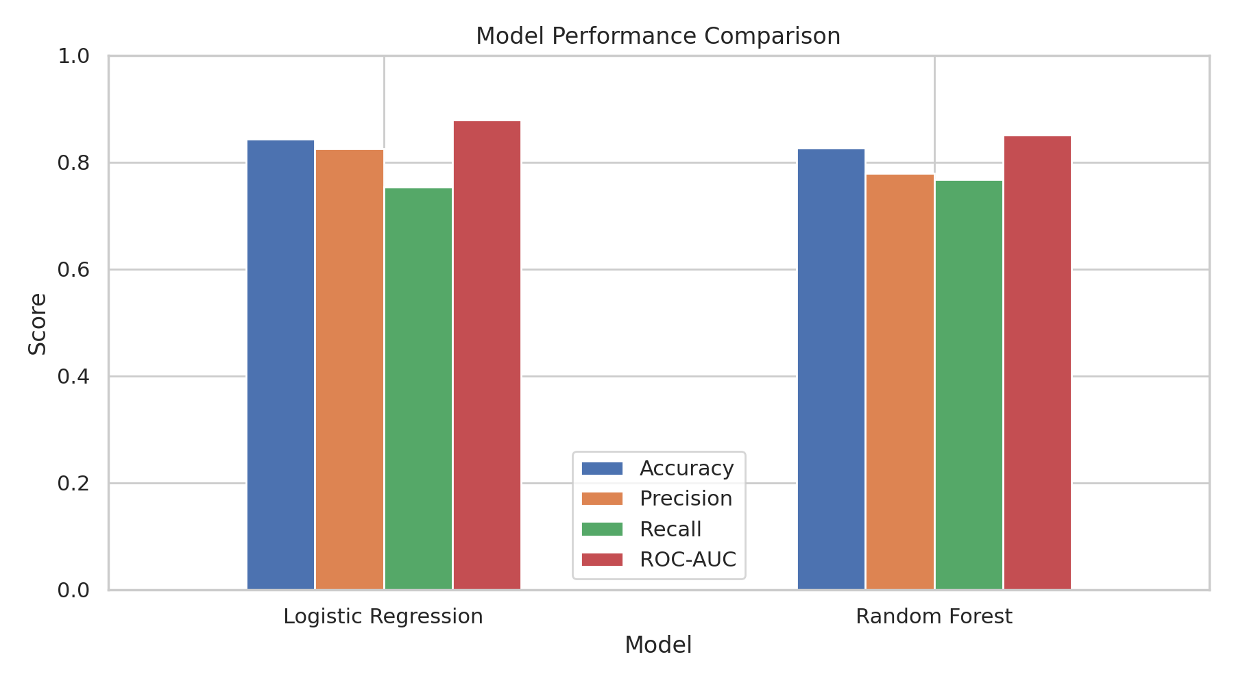

8. Model Performance Evaluation
The trained classification models were evaluated using the independent test dataset. Multiple evaluation metrics were considered to provide a more complete assessment of predictive performance.
Model | Accuracy | Precision | Recall | F1 Score | ROC-AUC
Logistic Regression | 0.8436 | 0.8254 | 0.7536 | 0.7879 | 0.8792
Random Forest | 0.8268 | 0.7794 | 0.7681 | 0.7737 | 0.8511
Accuracy measures the overall proportion of correct predictions. Precision indicates how reliable positive predictions are, while recall measures the proportion of actual positive cases correctly identified. F1-score combines precision and recall into a single balanced metric. ROC-AUC evaluates the model's ability to distinguish between the two classes.


8.2 Best Performing Model
Based on the F1-score, Logistic Regression produced the strongest balance between precision and recall, achieving an F1-score of 0.7879.
The comparison demonstrates why multiple evaluation metrics are useful. A model with high accuracy may still perform differently in terms of precision, recall, and F1-score. Therefore, model selection should consider the overall pattern of evaluation results rather than relying on a single metric.

9. Confusion Matrix and Error Analysis
A confusion matrix provides a detailed view of the classification results by showing correct and incorrect predictions for each class. This is useful for understanding the types of errors made by the selected model.
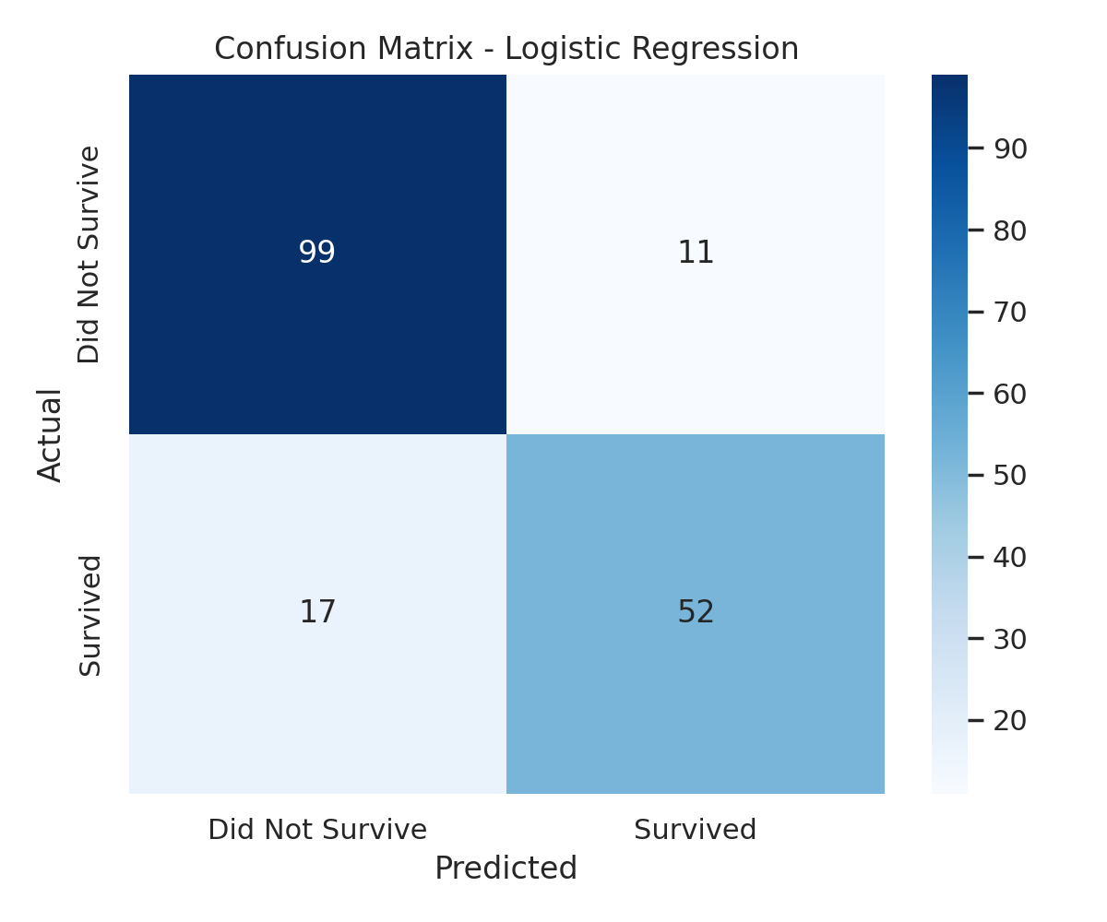
Prediction Type | Count | Interpretation
True Negative | 99 | Correctly predicted non-survivors
False Positive | 11 | Predicted survival when the passenger did not survive
False Negative | 17 | Predicted non-survival when the passenger survived
True Positive | 52 | Correctly predicted survivors

9.1 Interpretation of Classification Errors
The model correctly identified 52 survivors and 99 non-survivors. It produced 11 false-positive predictions and 17 false-negative predictions.
False negatives are particularly important when the objective is to identify passengers who survived, because these represent actual survivors that the model failed to recognize. False positives represent passengers predicted as survivors when they actually did not survive.
The confusion matrix therefore provides information that cannot be obtained from accuracy alone. Examining both types of classification error helps determine whether the model is appropriately balanced or whether a different classification threshold or modelling strategy may be beneficial.

10. Cross-Validation and Model Reliability
To assess whether model performance was consistent across different subsets of the training data, stratified 5-fold cross-validation was performed. Stratification preserves the approximate proportion of survivors and non-survivors in each fold.

10.1 Five-Fold Cross-Validation Results
Model | CV Accuracy Mean | CV Accuracy Std | CV Precision Mean | CV Recall Mean | CV F1 Mean | CV ROC-AUC Mean
Logistic Regression | 0.8283 | 0.0078 | 0.7938 | 0.7483 | 0.7695 | 0.8718
Random Forest | 0.8339 | 0.0114 | 0.7914 | 0.7746 | 0.7809 | 0.8747

The cross-validation analysis identified Random Forest as the strongest model based on the calculated validation results.
Cross-validation provides a more reliable estimate of model stability because each observation in the training set is used for validation in one fold while contributing to model training in the remaining folds. Consistent performance across folds suggests that the model is less dependent on a particular train-test split.
However, cross-validation does not eliminate all sources of uncertainty. Performance can still depend on the available sample, selected features, model configuration, and the representativeness of the historical dataset.

11. Feature Importance and Key Findings
Random Forest feature importance was examined to identify which input variables contributed most strongly to the model's predictive decisions. Feature importance should be interpreted as a measure of predictive contribution rather than proof of causal influence.
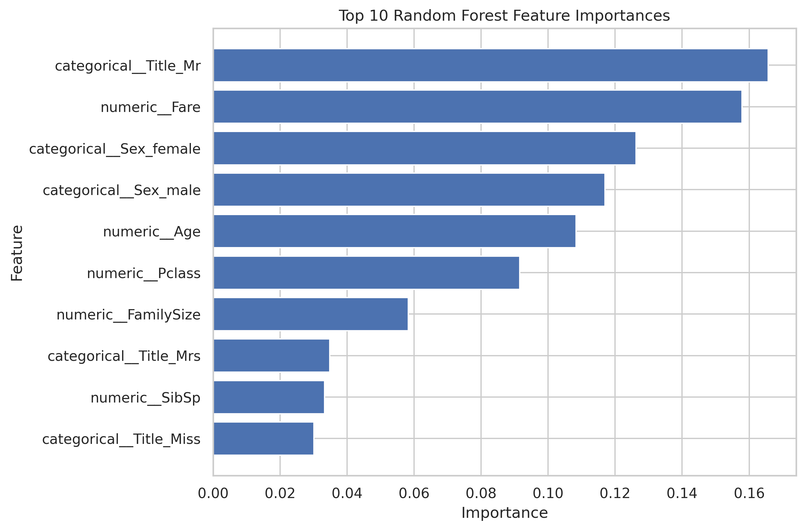

11.1 Most Important Predictors
Feature | Importance
categorical__Title_Mr | 0.1657
numeric__Fare | 0.1579
categorical__Sex_female | 0.1262
categorical__Sex_male | 0.1170
numeric__Age | 0.1083
numeric__Pclass | 0.0915
numeric__FamilySize | 0.0583
categorical__Title_Mrs | 0.0348
numeric__SibSp | 0.0333
categorical__Title_Miss | 0.0301

11.2 Key Analytical Findings
- The overall survival rate in the dataset was approximately 38.4%.
- Sex female
Passengers 314
Survivors 233
Survival Rate (%) 74.2
Name: 0, dtype: object passengers recorded the highest survival rate when survival was grouped by gender.
- Passenger class showed a substantial relationship with survival, with Class Pclass 1.00
Passengers 216.00
Survivors 136.00
Survival Rate (%) 62.96
Name: 0, dtype: float64 having the highest observed rate.
- Family size showed different survival patterns across travelling-group sizes.
- Fare was associated with survival, although part of this relationship is likely connected to passenger class.
- Logistic Regression achieved the strongest test-set F1-score among the evaluated models.
- Random Forest achieved the strongest cross-validation result according to the selected validation metric.
Overall, the analysis indicates that Titanic survival was influenced by a combination of demographic, socioeconomic, and travelling-group characteristics rather than by a single variable.

12. Critical Discussion
The analysis demonstrates that passenger survival was strongly associated with demographic and socioeconomic characteristics. Gender and passenger class showed particularly clear differences in survival rates. These patterns are consistent with the historical context of the Titanic, where evacuation access and social conventions affected different passenger groups.
The machine learning results demonstrate that predictive modelling can capture these relationships from passenger-level information. However, predictive performance should not be interpreted as evidence that the model has discovered causal relationships. For example, passenger class may act as a proxy for socioeconomic status and physical location on the ship.
The comparison between Logistic Regression and Random Forest also illustrates the trade-off between interpretability and model complexity. Logistic Regression provides a relatively transparent baseline, while Random Forest can represent nonlinear relationships and interactions. The better-performing model should therefore be selected based not only on accuracy but also on the intended application and the cost of different prediction errors.

12.1 Limitations
- The dataset represents a historical event and may not generalize to modern passenger or emergency scenarios.
- Some passenger attributes contain missing information, requiring imputation.
- The dataset contains a limited number of observations compared with modern machine learning datasets.
- Passenger class, fare, and other variables may be correlated, making individual effects difficult to isolate.
- Feature importance indicates predictive contribution and should not be interpreted as causal evidence.
- Model performance may change with different train-test splits, feature sets, or hyperparameter configurations.
- The analysis does not include potentially relevant external factors such as exact cabin location, evacuation timing, or lifeboat proximity.

12.2 Actionable Recommendations
- Use stratified cross-validation when comparing future models to obtain more stable performance estimates.
- Perform systematic hyperparameter tuning to determine whether model performance can be improved.
- Evaluate additional algorithms such as Gradient Boosting, XGBoost, or Support Vector Machines for comparison.
- Investigate interaction effects between gender, passenger class, age, and family size.
- Use probability calibration and threshold analysis when the cost of false positives and false negatives differs.
- Perform feature-importance analysis together with permutation importance or SHAP-based interpretation for stronger explainability.
- Document data preprocessing and model configurations so that the complete experiment remains reproducible.

13. Conclusion
This project successfully implemented a complete data science and machine learning workflow using the Titanic passenger dataset. The work covered data inspection, quality assessment, exploratory analysis, feature engineering, preprocessing, model development, evaluation, cross-validation, and interpretation.
The exploratory analysis identified clear differences in survival across gender and passenger class, while age, fare, and family characteristics provided additional information for understanding passenger outcomes.
Two classification models, Logistic Regression and Random Forest, were developed and evaluated. Based on the selected test-set criterion, Logistic Regression provided the strongest overall predictive performance. Cross-validation was additionally used to assess model reliability across multiple training and validation folds.
The project demonstrates that effective data science involves more than building a model. Data quality, appropriate preprocessing, feature engineering, evaluation metrics, validation, interpretation, limitations, and clear communication are all essential components of a reliable analytical workflow.

14. Reproducibility and Implementation
The analysis was implemented in Python using Pandas and NumPy for data handling, Matplotlib and Seaborn for visualization, and Scikit-learn for preprocessing, modelling, evaluation, and cross-validation.
- Dataset: Titanic passenger training dataset.
- Train-test split: 80% training and 20% testing.
- Random state: 42.
- Validation: Stratified 5-fold cross-validation.
- Models: Logistic Regression and Random Forest.
- Categorical encoding: One-hot encoding.
- Numerical preprocessing: Median imputation and standardization.
- Visualizations and report were generated programmatically using Python.

15. Project Deliverables
The completed project produces the following key outputs:
- Cleaned and feature-engineered Titanic analysis dataset.
- Exploratory data analysis visualizations.
- Machine learning preprocessing pipelines.
- Logistic Regression model.
- Random Forest model.
- Test-set evaluation metrics.
- Confusion matrix analysis.
- 5-fold cross-validation results.
- Random Forest feature-importance analysis.
- Final DOCX project report.

