WEEK 4 MACHINE LEARNING PROJECT
Machine Learning Model Development and Evaluation
Titanic Survival Prediction using Logistic Regression
Python • Scikit-learn • Data Preprocessing • Classification • Model Evaluation
Prepared as part of the Week 4 Machine Learning Internship Task
September 2026

1. Executive Summary
This report documents an end-to-end machine learning workflow for predicting passenger survival using the Titanic dataset. The project was designed to demonstrate sound data preparation, justified algorithm selection, reproducible model training, quantitative evaluation, error analysis, and critical discussion of model limitations. Logistic Regression was selected as the primary classifier because it is a strong baseline for binary classification, produces interpretable probability estimates, trains efficiently, and provides a useful reference point before moving to more complex algorithms.
The dataset contains 891 observations and 12 columns. The target variable is Survived, where 0 represents non-survival and 1 represents survival. An 80/20 stratified train-test split was used with random_state=42. Numerical variables were median-imputed and standardized, while categorical variables were mode-imputed and one-hot encoded. Irrelevant or high-cardinality identifiers such as PassengerId, Name, Ticket, and Cabin were excluded from the baseline feature set.
On the held-out test set, the model achieved 80.45% accuracy, 79.31% precision, 66.67% recall, 72.44% F1-score, and an ROC-AUC of 0.843. The confusion matrix contained 98 true negatives, 12 false positives, 23 false negatives, and 46 true positives. Five-fold stratified cross-validation produced a mean accuracy of 79.69% and mean ROC-AUC of 0.851, indicating that the test result is broadly consistent with repeated validation.
The key conclusion is that the model provides useful predictive discrimination but is not sufficiently accurate for unquestioned real-world deployment. Recall is lower than precision, and the model makes more false-negative than false-positive errors. Further improvement could be achieved through systematic feature engineering, hyperparameter tuning, comparison with tree-based models, threshold optimization, and repeated cross-validation.

2. Project Objectives and Success Criteria
- Prepare the Titanic dataset for supervised machine learning.
- Identify and address missing data without leaking test-set information into training.
- Select a simple and defensible binary classification algorithm.
- Train the model using a reproducible pipeline.
- Evaluate performance using accuracy, precision, recall, F1-score, ROC curve, and ROC-AUC.
- Use visualizations to communicate model performance clearly.
- Analyse false positives and false negatives rather than relying on accuracy alone.
- Check model stability using stratified five-fold cross-validation.
- Discuss potential overfitting, underfitting, sources of error, limitations, and practical improvements.
The success criterion for this academic exercise is not simply obtaining the highest possible accuracy. A strong machine learning workflow must also be reproducible, appropriately validated, transparent about limitations, and able to justify why particular preprocessing and evaluation choices were made.

3. Dataset Description
Item | Value | Interpretation
Rows | 891 | Passenger observations
Columns | 12 | Original variables including target
Target | Survived | Binary outcome: 0 = no, 1 = yes
Train set | 712 | 80% of data
Test set | 179 | 20% held-out data
Split method | Stratified | Preserves class proportions
Random state | 42 | Supports reproducibility
The target distribution contains 549 non-survivors (61.6%) and 342 survivors (38.4%). The classes are therefore not perfectly balanced. Stratification was used so that the training and test partitions maintain approximately the same survivor/non-survivor proportions.
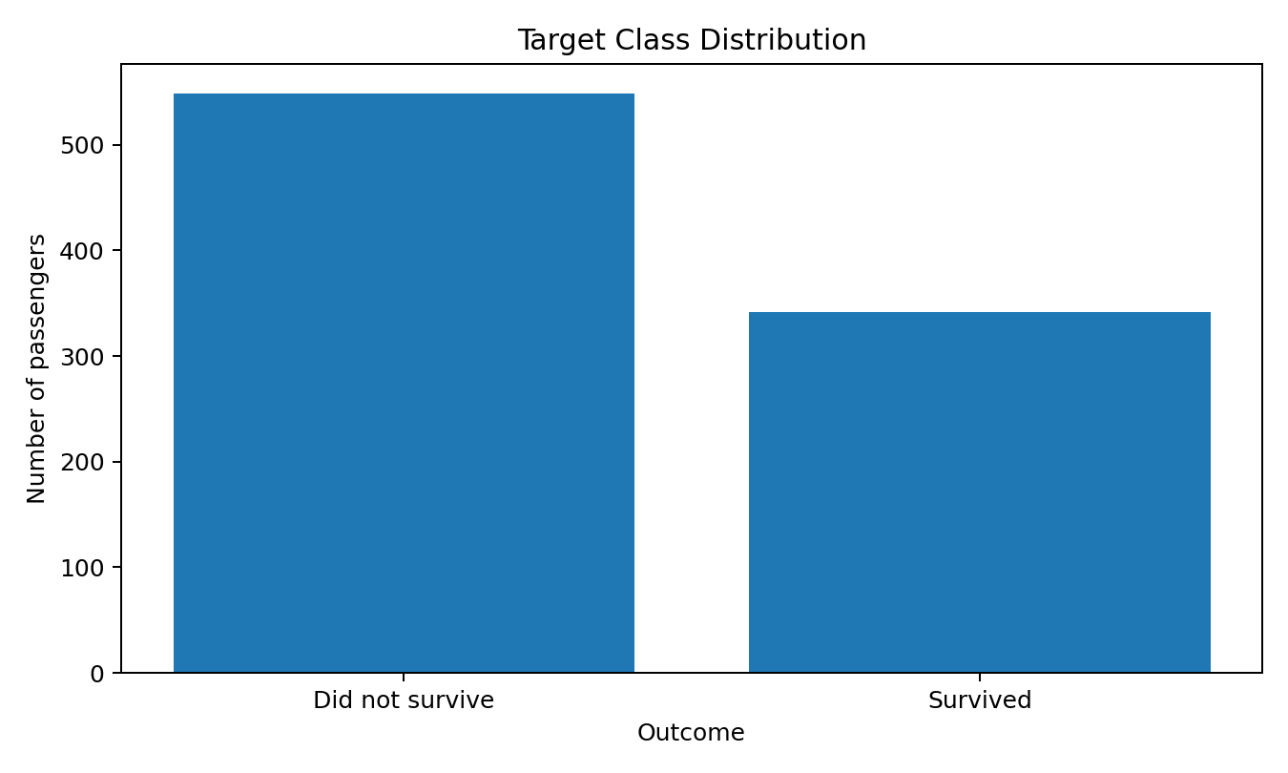
Figure 1. Target class distribution in the complete dataset.

3.1 Initial Data Quality Assessment
Feature | Missing values | Missing percentage
Age | 177 | 19.87%
Cabin | 687 | 77.10%
Embarked | 2 | 0.22%
Age has a substantial amount of missing information, while Cabin has very high missingness. Dropping every row with a missing value would unnecessarily reduce the training data, especially because Cabin is missing for most observations. Instead, the modelling pipeline imputes Age using its training-set median and categorical missing values using the most frequent category. Cabin is excluded from the baseline model because its missingness is extensive and its raw values are high-cardinality cabin identifiers.
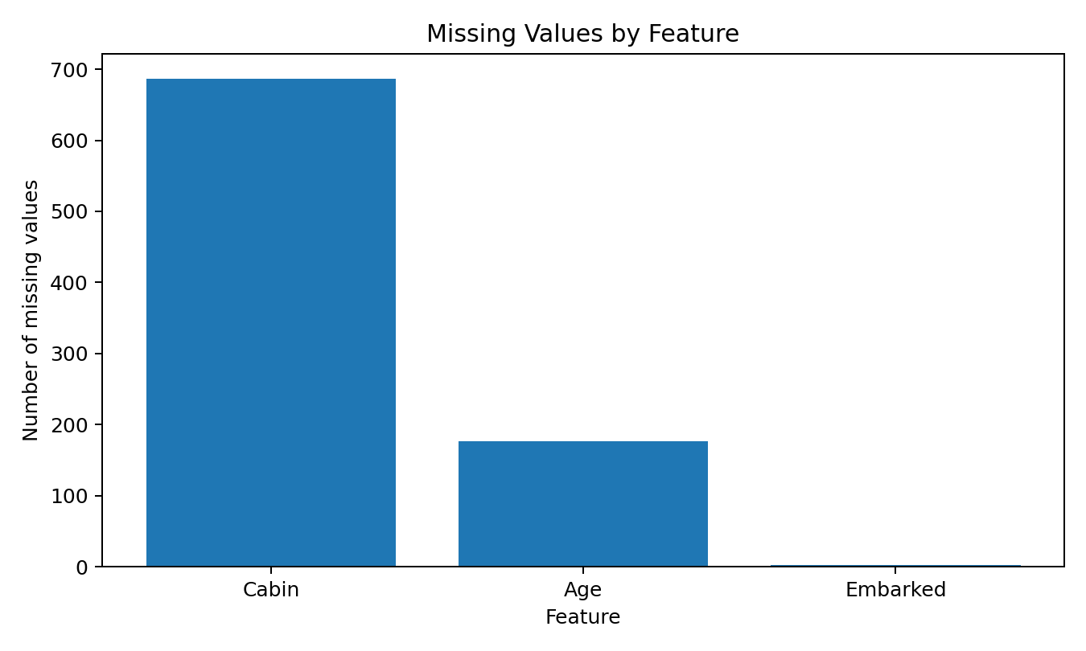
Figure 2. Missing-value profile used to guide preprocessing decisions.

4. Exploratory Findings Relevant to Modelling
Exploratory analysis is included here only where it helps justify modelling decisions. It should not be confused with causal analysis: differences in historical survival rates do not prove that a single feature caused survival.
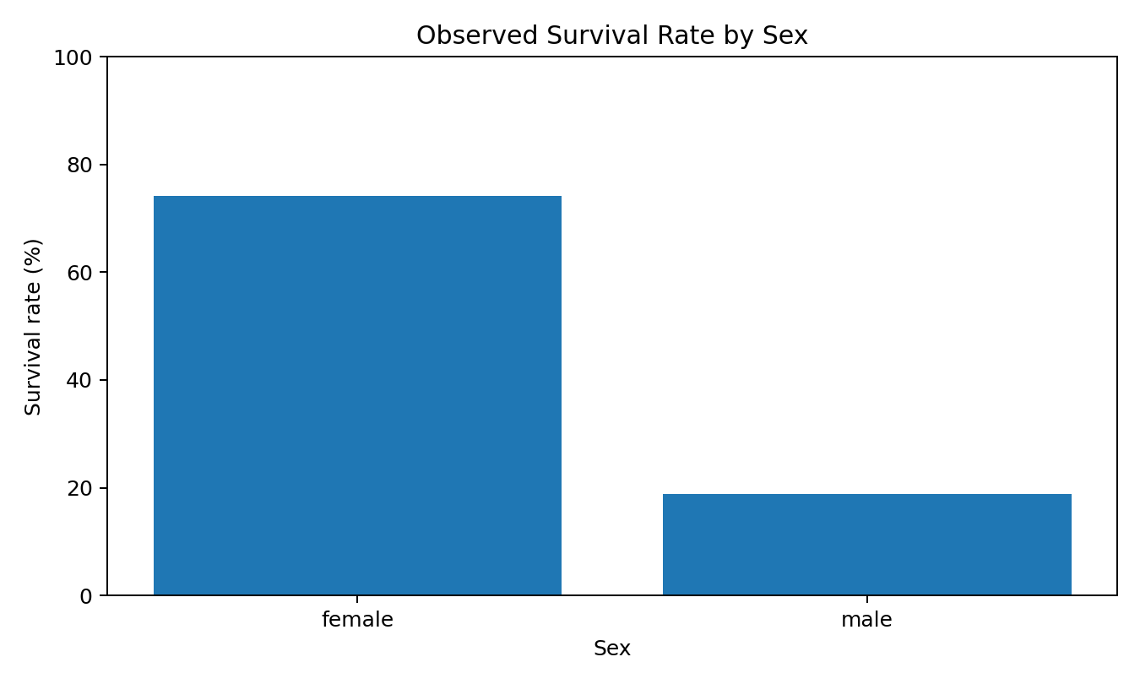
Figure 3. Observed survival rate by sex.
The dataset shows a strong difference in observed survival rates by sex: approximately 74.2% for female passengers versus 18.9% for male passengers. This makes Sex a potentially informative predictor and provides a substantive reason to retain it in the baseline model.
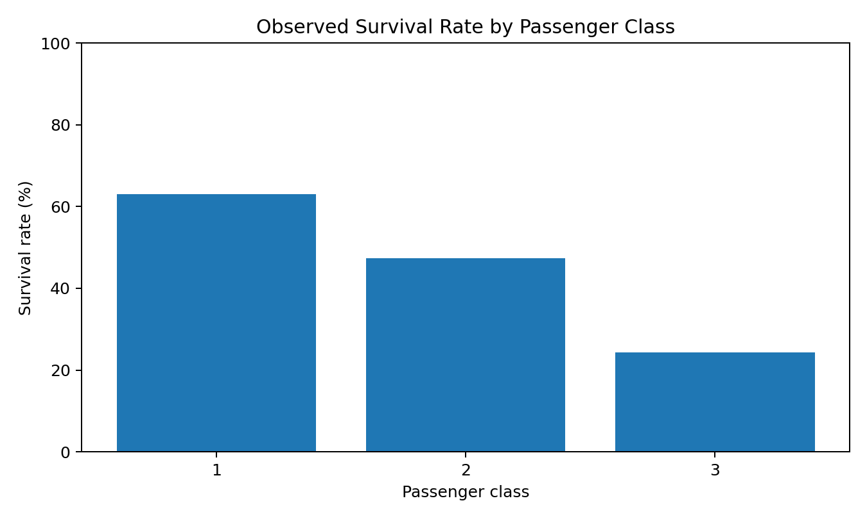
Figure 4. Observed survival rate by passenger class.
Passenger class also displays different observed survival rates. This suggests that Pclass may carry useful predictive information. However, these relationships can interact with other variables, so the model uses multiple predictors jointly rather than making predictions from one feature alone.

5. Data Preparation and Preprocessing

5.1 Feature Selection
Feature group | Variables | Treatment | Reason
Numerical | Age, SibSp, Parch, Fare | Median imputation + standardization | Retain useful numeric information while handling missing Age
Categorical | Pclass, Sex, Embarked | Most-frequent imputation + one-hot encoding | Convert categories to model-ready numerical indicators
Excluded identifiers | PassengerId, Name, Ticket, Cabin | Removed from baseline | Avoid IDs/high-cardinality text and extreme Cabin missingness
Target | Survived | No preprocessing | Binary label to predict
The preprocessing operations are placed inside a scikit-learn Pipeline and ColumnTransformer. This is an important methodological choice because it prevents preprocessing statistics from being calculated using the held-out test set. In particular, the median used for Age imputation and the scaling parameters are learned from the training data during fitting.
Standardization is applied to numerical features because Logistic Regression is optimized using numerical coefficients and regularization; bringing numerical variables to comparable scales can make optimization more stable. One-hot encoding is used for categorical variables because the categories do not have a natural numeric ordering suitable for direct integer coding.

6. Model Selection and Justification

6.1 Logistic Regression
Logistic Regression was selected as the baseline classifier. The task is binary classification, and Logistic Regression directly models the probability of belonging to the positive class. It is computationally efficient, widely used, and relatively easy to interpret. It is therefore appropriate for demonstrating the fundamental machine learning development cycle before introducing more complex models.
A more complex algorithm is not automatically better. Starting with an interpretable baseline allows later models such as Decision Trees, Random Forests, or gradient boosting methods to be compared against a known reference. If a complex model provides only a small improvement while being substantially harder to explain, the simpler model may remain preferable for an academic baseline.

6.2 Why Other Approaches Were Not the Baseline
- Decision Trees can capture non-linear relationships but may overfit without careful depth and pruning controls.
- Random Forests can improve predictive power but introduce greater model complexity and reduce direct interpretability.
- K-Means clustering is unsupervised and therefore does not directly match the labelled survival prediction objective.
- A simple Logistic Regression model provides a transparent benchmark against which these alternatives can later be evaluated.

7. Model Training Methodology
Step | Configuration
Data split | 80% training / 20% testing
Stratification | Yes
Random state | 42
Classifier | LogisticRegression(max_iter=1000, random_state=42)
Numeric preprocessing | Median imputation + StandardScaler
Categorical preprocessing | Most-frequent imputation + OneHotEncoder
Pipeline | ColumnTransformer → Logistic Regression
The model was fitted only on the training partition. The test partition was held back until the final evaluation stage. This separation provides a more realistic estimate of how the trained model behaves on previously unseen records.

8. Model Evaluation and Calculations
Five evaluation metrics are reported because no single metric completely describes a binary classifier. Accuracy measures overall correctness, precision measures the reliability of positive predictions, recall measures how many actual positives are detected, F1 balances precision and recall, and ROC-AUC measures discrimination across classification thresholds.
Metric | Formula | Test result
Accuracy | (TP + TN) / (TP + TN + FP + FN) | 80.45%
Precision | TP / (TP + FP) | 79.31%
Recall | TP / (TP + FN) | 66.67%
F1-score | 2 × Precision × Recall / (Precision + Recall) | 72.44%
ROC-AUC | Area under ROC curve | 0.843
Using the confusion-matrix counts, accuracy can be verified as (46 + 98) / (46 + 98 + 12 + 23) = 0.8045, or 80.45%. Precision is 46 / (46 + 12) = 0.7931, while recall is 46 / (46 + 23) = 0.6667. These calculations confirm that the reported metrics are consistent with the test-set predictions.

8.1 Results at a Glance
Metric | Training | Test | Interpretation
Accuracy | 81.04% | 80.45% | Overall classification correctness
Precision | 77.60% | 79.31% | Reliability of positive predictions
Recall | 71.06% | 66.67% | Ability to detect survivors
F1-score | 74.19% | 72.44% | Balance of precision and recall
ROC-AUC | 0.859 | 0.843 | Overall ranking/discrimination ability

9. Confusion Matrix and Error Analysis
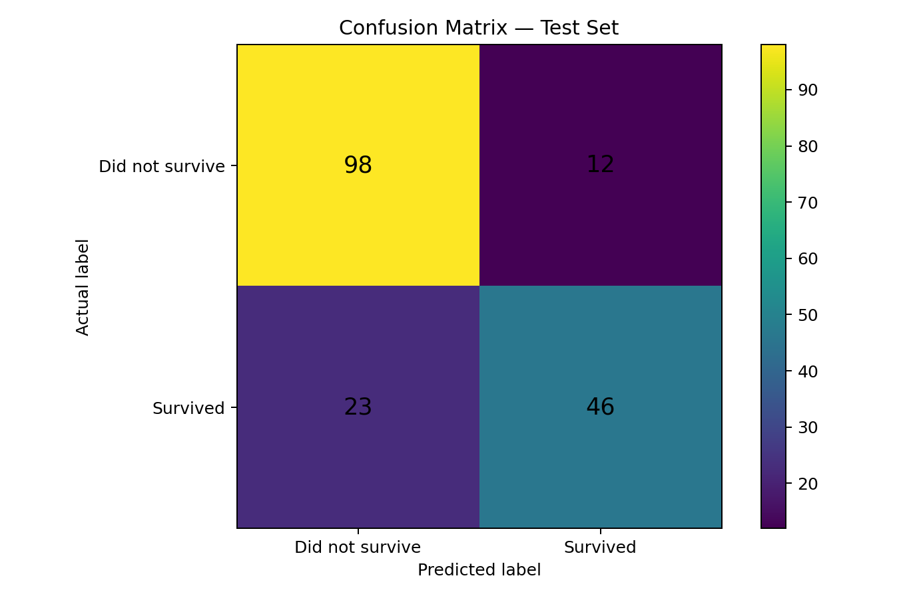
Figure 5. Confusion matrix for the held-out test set.
Actual / Predicted | Did not survive | Survived
Did not survive | 98 | 12
Survived | 23 | 46
The model correctly classified 98 non-survivors and 46 survivors. It incorrectly classified 12 non-survivors as survivors (false positives) and 23 survivors as non-survivors (false negatives). The number of false negatives is 11 higher than the number of false positives.
The recall of 66.67% is particularly important here. It means the classifier identified approximately two-thirds of the passengers who actually survived. Conversely, approximately 33.33% of actual survivors were missed by the positive prediction rule. This demonstrates why accuracy alone should not be used to judge the model.
For this historical dataset, false negatives do not represent a direct safety or operational consequence. However, the same error-analysis principle would matter strongly in applications such as medical screening or fraud detection, where the relative cost of different errors can determine the appropriate decision threshold.

10. ROC Curve and AUC Analysis
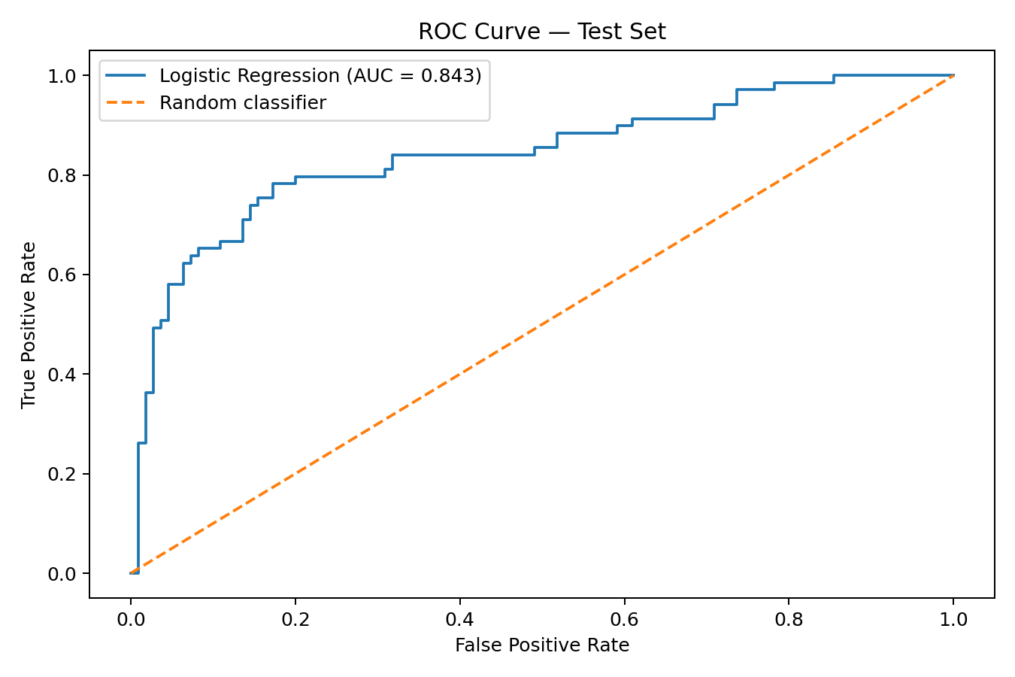
Figure 6. ROC curve for the Logistic Regression model on the test set.
The ROC-AUC is 0.843. An AUC of 0.5 represents random ranking, while values closer to 1.0 indicate stronger discrimination between the two classes. The obtained value therefore indicates that the model has meaningful ability to rank survivors above non-survivors across thresholds.
The ROC curve also illustrates an important modelling trade-off: lowering the decision threshold generally increases the number of positive predictions and can improve recall, but may increase false positives. Therefore, a threshold of 0.5 should be treated as a baseline choice rather than a universally optimal value.

11. Cross-Validation and Generalization Check
Metric | 5-fold mean | Variation (std.)
Accuracy | 79.69% | ± 1.46%
Precision | 75.47% | ± 3.34%
Recall | 70.16% | ± 4.01%
F1-score | 72.58% | ± 2.09%
ROC-AUC | 0.851 | ± 0.022
Five-fold stratified cross-validation was used as an additional reliability check. Each fold maintains the class distribution, and the model is retrained on four folds and evaluated on the remaining fold. This reduces dependence on one particular train/test split and provides a distribution of validation scores.
The cross-validation mean accuracy is 79.69% with a standard deviation of 1.46 percentage points. The mean ROC-AUC is 0.851 with a standard deviation of 0.022. The relatively small variation suggests that the baseline model is reasonably stable across folds.
The training accuracy is 81.04% compared with a test accuracy of 80.45%, a gap of 0.59 percentage points. This small gap does not provide strong evidence of severe overfitting in this baseline. Nevertheless, a single model configuration cannot rule out all forms of bias or instability.

12. Critical Discussion: Errors, Bias, and Limitations

12.1 Potential Sources of Error
- Missing Age values require imputation, which introduces estimates rather than observed measurements.
- Cabin is heavily incomplete and therefore excluded from the baseline; potentially useful information may be lost.
- Name, Ticket, and Cabin may contain latent information that could be engineered more intelligently instead of simply discarded.
- The model assumes a relatively simple relationship between transformed predictors and the log-odds of survival.
- Historical passenger records may contain biases that are reflected in the target and predictors.
- The test set is finite, so measured performance has sampling uncertainty.
- The default 0.5 classification threshold may not maximize the metric that a specific application would value most.

12.2 Overfitting and Underfitting
Overfitting occurs when a model learns patterns that are specific to the training data and fails to generalize. Underfitting occurs when the model is too simple to capture important structure. The small training-test accuracy gap of 0.59 percentage points suggests that severe overfitting is not evident in this baseline. However, the moderate recall and F1-score indicate that the model may still be limited by its assumptions and feature representation. This is better described as a potential capacity/feature-engineering limitation than as proven underfitting.

12.3 Data and Modelling Limitations
The Titanic dataset is a historical benchmark rather than a modern operational dataset. Its purpose here is educational: it allows the complete modelling lifecycle to be demonstrated. The resulting performance should not be interpreted as evidence that Logistic Regression would perform similarly on unrelated datasets.

13. Model Improvement Strategy
Priority | Improvement | Expected benefit | How to evaluate
High | Feature engineering such as family size and title extraction | Capture useful interactions and latent information | Compare CV F1/AUC against baseline
High | Compare Logistic Regression with Random Forest / Gradient Boosting | Capture non-linear relationships | Same folds and metrics
High | Hyperparameter tuning with cross-validation | Optimize regularization and model complexity | Grid/Randomized SearchCV
Medium | Threshold optimization | Improve recall or F1 depending on objective | Precision-recall / threshold analysis
Medium | Repeated stratified cross-validation | Reduce dependence on one CV partition | Mean and variation across repeats
Medium | Alternative treatment of Cabin | Recover information from cabin deck/presence | Ablation study
The strongest next step is not simply to replace Logistic Regression with a more complicated algorithm. A controlled comparison should keep the same data split and validation protocol so that any improvement can be attributed to the modelling change rather than a change in evaluation conditions.

14. Reproducibility and Project Structure
The workflow uses random_state=42, a fixed stratified split, and a scikit-learn Pipeline. These choices make the baseline results reproducible when the same dataset and software environment are used.
Recommended GitHub project structure:
- week4-machine-learning-model/
- ├── titanic_train.csv
- ├── week4_titanic_ml.py
- ├── Week_4_Machine_Learning_Report_Titanic_Strong.docx
- ├── README.md
- └── assets/
- ├── confusion_matrix.png
- ├── roc_curve.png
- ├── missing_values.png
- ├── target_distribution.png
- ├── survival_by_sex.png
- └── survival_by_class.png

15. Complete Python Implementation
import pandas as pd

from sklearn.model_selection import train_test_split, StratifiedKFold, cross_validate
from sklearn.compose import ColumnTransformer
from sklearn.pipeline import Pipeline
from sklearn.impute import SimpleImputer
from sklearn.preprocessing import StandardScaler, OneHotEncoder
from sklearn.linear_model import LogisticRegression
from sklearn.metrics import (
accuracy_score, precision_score, recall_score,
f1_score, roc_auc_score, confusion_matrix,
classification_report, roc_curve
)

# Load data
df = pd.read_csv("titanic_train.csv")

# Separate target and predictors
X = df.drop(columns=["Survived"])
y = df["Survived"]

# Remove high-cardinality identifiers / extremely incomplete field
X = X.drop(columns=["PassengerId", "Name", "Ticket", "Cabin"])

# Define features
numeric_features = ["Age", "SibSp", "Parch", "Fare"]
categorical_features = ["Pclass", "Sex", "Embarked"]

# Numerical pipeline
numeric_transformer = Pipeline([
("imputer", SimpleImputer(strategy="median")),
("scaler", StandardScaler())
])

# Categorical pipeline
categorical_transformer = Pipeline([
("imputer", SimpleImputer(strategy="most_frequent")),
("onehot", OneHotEncoder(handle_unknown="ignore"))
])

# Combine preprocessing
preprocessor = ColumnTransformer([
("num", numeric_transformer, numeric_features),
("cat", categorical_transformer, categorical_features)
])

# Model pipeline
pipeline = Pipeline([
("preprocessor", preprocessor),
("model", LogisticRegression(max_iter=1000, random_state=42))
])

# Train-test split
X_train, X_test, y_train, y_test = train_test_split(
X, y,
test_size=0.20,
random_state=42,
stratify=y
)

# Train
pipeline.fit(X_train, y_train)

# Predict
y_pred = pipeline.predict(X_test)
y_prob = pipeline.predict_proba(X_test)[:, 1]

# Evaluation
print("Accuracy :", accuracy_score(y_test, y_pred))
print("Precision:", precision_score(y_test, y_pred))
print("Recall :", recall_score(y_test, y_pred))
print("F1-score :", f1_score(y_test, y_pred))
print("ROC-AUC :", roc_auc_score(y_test, y_prob))

print("\nConfusion Matrix:")
print(confusion_matrix(y_test, y_pred))

print("\nClassification Report:")
print(classification_report(y_test, y_pred))

# 5-fold stratified cross-validation
cv = StratifiedKFold(n_splits=5, shuffle=True, random_state=42)

scores = cross_validate(
pipeline, X, y, cv=cv,
scoring=["accuracy", "precision", "recall", "f1", "roc_auc"]
)

for metric in ["accuracy", "precision", "recall", "f1", "roc_auc"]:
print(metric, scores["test_" + metric].mean())

16. Conclusion
This project successfully implemented a complete supervised machine learning workflow for Titanic survival prediction. The Logistic Regression baseline achieved 80.45% test accuracy and an ROC-AUC of 0.843. The model demonstrated useful discrimination, while the 66.67% recall and 72.44% F1-score show that there is room for improvement, especially in identifying all positive cases.
Error analysis identified 23 false negatives and 12 false positives. The small training-test accuracy gap of 0.59 percentage points, together with five-fold cross-validation accuracy of 79.69% ± 1.46%, suggests that the baseline is reasonably stable rather than severely overfit to one split.
The most important lesson from the project is that model development is not complete when a prediction score is produced. A reliable workflow requires careful preprocessing, leakage prevention, justified model selection, multiple evaluation metrics, visual error analysis, cross-validation, and an explicit discussion of limitations. Future work should compare tuned tree-based models, engineer additional features, and optimize the classification threshold according to the chosen objective.

17. References
- Scikit-learn documentation — Logistic Regression, preprocessing, pipelines, model evaluation, and cross-validation.
- Scikit-learn User Guide — ColumnTransformer, Pipeline, SimpleImputer, StandardScaler, OneHotEncoder.
- Titanic passenger survival dataset — commonly used benchmark dataset for binary classification and educational machine learning.
- Python documentation — pandas and standard data-processing functionality.

18. Submission Checklist
- DOCX report contains the full machine learning methodology.
- Dataset preparation and preprocessing are documented.
- Algorithm selection is justified.
- Accuracy, precision, recall, F1-score and ROC-AUC are reported.
- Confusion matrix and ROC curve are included.
- Five-fold cross-validation is included.
- Overfitting/underfitting and model limitations are critically discussed.
- Specific improvement strategies are provided.
- Complete Python implementation is included.
- GitHub structure is documented for reproducibility.

