**Bug Report for Covid-19 Tracker-India Page**

**View Issue details**

|  |  |
| --- | --- |
| **Bug ID** | **01** |
| **Project Name** | **Covid-19 Tracker** |
| **Module Name** | **Covid-19 Tracker –India web Page** |
| **Reporter** | **Sangeetha Sathyan** |
| **Date** | **07-09-2024** |
| **Platform** | **OS** |
| **Severity** | **Medium** |
| **Priority** | **High** |
| **Reproducibility** | **Always** |
| **Summary** | **Data boxes for Total Cases, Recovery, Active Cases, and Deaths have the same colour code and inconsistent sizes.** |
| **Expected Result** | 1. Each data box should have a distinct colour code to differentiate categories (Total Cases, Active Cases, Recovered, Deaths). 2. The size of each data box should be consistent for uniformity and better user experience. |
| **Actual Result** | 1. All the data boxes have the same colour, 2. The data boxes are inconsistently sized, some boxes are larger than others creating an unbalanced layout. |
| **Steps to Reproduce** | 1. Open the COVID-19 Tracker - India page. 2. Select “State” from the dropdown list. 3. Observe the colour code and size of data boxes for Total Cases, Active Cases, Recovered, and Deaths. |
| **Status** | **Open** |
| **Assigned To** |  |

**Attachments**

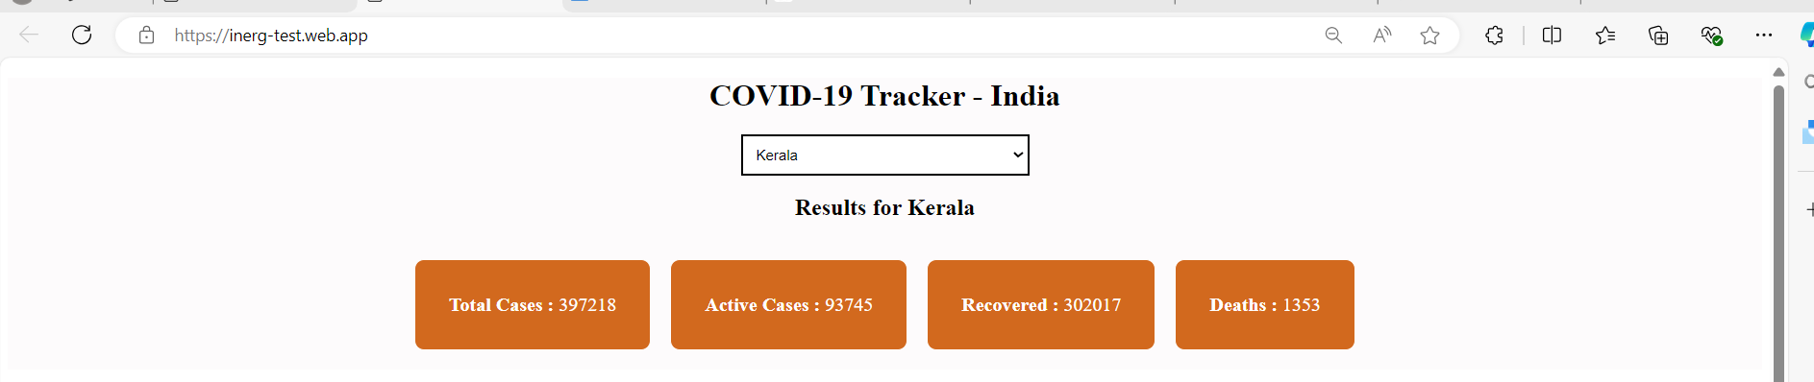

|  |  |
| --- | --- |
| **Bug ID** | **02** |
| **Project Name** | **Covid-19 Tracker** |
| **Module Name** | **Covid-19 Tracker –India web Page** |
| **Reporter** | **Sangeetha Sathyan** |
| **Date** | **07-09-2024** |
| **Platform** | **OS** |
| **Severity** | **Critical** |
| **Priority** | **High** |
| **Reproducibility** | **Always** |
| **Summary** | **Incorrect Total Case Count displayed on the COVID-19 Tracker page**. |
| **Description** | * The **Total Case Count** displayed on the COVID-19 Tracker page is inaccurate. * The total number of COVID-19 cases does not match the actual number derived from the sum of the individual categories (Active Cases, Recovered, and Deaths), leading to misleading and incorrect information for users. |
| **Expected Result** | The **Total Case Count** displayed should accurately reflect the sum of the Active Cases, Recovered, and Deaths values. |
| **Actual Result** | The displayed **Total Case Count** is incorrect and does not match the sum of the individual categories (Active Cases, Recovered, and Deaths) for the selected state.  For example: select state a Kerala.  **Displayed Total Cases:** 397,218  **Manually Calculated Total:**   * + Active Cases: 93,745   + Recovered: 302,017   + Deaths: 1,353   + **Correct Total:** 397,115 |
| **Steps to Reproduce** | * + 1. Open the COVID-19 Tracker - India page.     2. Select “State” from the dropdown list. (Kerala).     3. Note the Total Case Count displayed.     4. Manually calculate the total number of cases by adding Active Cases, Recovered, and Deaths.     5. Compare the manually calculated total with the displayed Total Case Count. |
| **Status** | **Open** |
| **Assigned To** |  |

**Attachments**

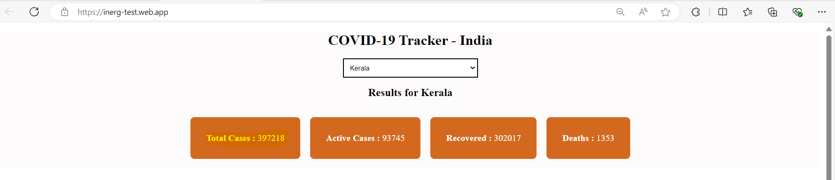

|  |  |
| --- | --- |
| **Bug ID** | **03** |
| **Project Name** | **Covid-19 Tracker** |
| **Module Name** | **Covid-19 Tracker –India web Page** |
| **Reporter** | **Sangeetha Sathyan** |
| **Date** | **07-09-2024** |
| **Platform** | **OS** |
| **Severity** | **Low** |
| **Priority** | **Medium** |
| **Reproducibility** | **Always** |
| **Summary** | **Insufficient space between the data boxes and the pie chart** |
| **Description** | * The COVID-19 Tracker page shows Insufficient spacing between the statistics boxes (Total Cases, Active Cases, Recovered, Deaths) and the Pie Chart. * This issue affects the overall look of the page and makes it less user-friendly. |
| **Expected Result** | There should be sufficient spacing between the statistical data and the pie chart for better readability and presentation. **Clear separation** between different sections of the page. |
| **Actual Result** | The statistical data boxes and pie chart are compressed together without sufficient space, It appears too compressed. |
| **Steps to Reproduce** | * + 1. Open the COVID-19 Tracker - India page.     2. Select “State” from the dropdown list. (Kerala).     3. Note the Total Case Count displayed.     4. Manually calculate the total number of cases by adding Active Cases, Recovered, and Deaths.     5. Observe the space between the statistical data boxes and the pie chart. |
| **Status** | **Open** |
| **Assigned To** |  |

**Attachments:**

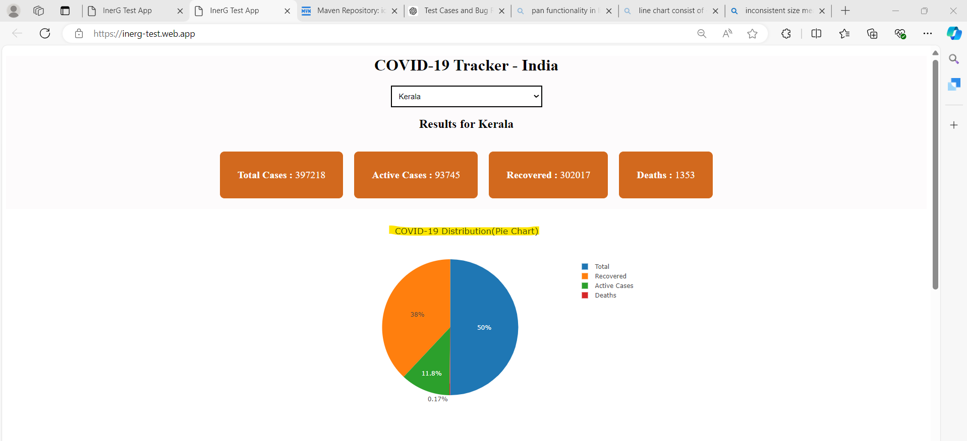

|  |  |
| --- | --- |
| **Bug ID** | **04** |
| **Project Name** | **Covid-19 Tracker** |
| **Module Name** | **Covid-19 Tracker –India web Page** |
| **Reporter** | **Sangeetha Sathyan** |
| **Date** | **07-09-2024** |
| **Platform** | **OS** |
| **Severity** | **Low** |
| **Priority** | **Medium** |
| **Reproducibility** | **Always** |
| **Summary** | **Number Formatting (Commas) was missing** |
| **Description** | The COVID-19 Tracker - India page displays numerical data for Total Cases, Active Cases, Recovered, and Deaths without the use of commas separators. Makes it difficult for users to quickly interpret the numbers. |
| **Expected Result** | Numbers should be formatted with commas for better readability (e.g., 397,218 instead of 397218). |
| **Actual Result** | Numbers are displayed without separators, making them harder to readable (e.g., 397218 instead of 397,218). |
| **Steps to Reproduce** | 1. Open the COVID-19 Tracker - India page. 2. Select “State” from the dropdown list. (Kerala). 3. Observe the numbers displayed for Total Cases, Active Cases, Recovered, and Deaths. |
| **Status** | **Open** |
| **Assigned To** |  |

**Attachments:**

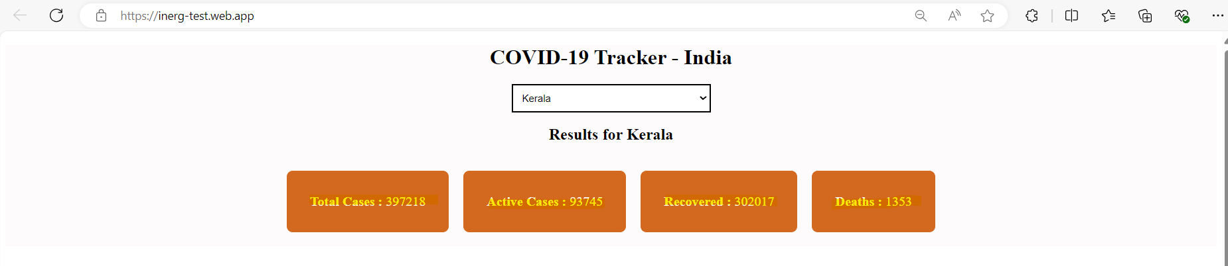

|  |  |
| --- | --- |
| **Bug ID** | **05** |
| **Project Name** | **Covid-19 Tracker** |
| **Module Name** | **Covid-19 Tracker –India web Page** |
| **Reporter** | **Sangeetha Sathyan** |
| **Date** | **07-09-2024** |
| **Platform** | **OS** |
| **Severity** | **Critical** |
| **Priority** | **High** |
| **Reproducibility** | **Always** |
| **Summary** | **Incorrect Segments in Pie Chart** |
| **Description** | The pie chart for COVID-19 data visualization currently includes a "Total Cases" segment, which should not be present. The pie chart should only display segments for "Recovered," "Active," and "Death." |
| **Expected Result** | The pie chart should display three segments: Recovered ,Active & Death |
| **Actual Result** | The pie chart displays four segments: Recovered, Active, Death & Total Cases (incorrectly included) |
| **Steps to Reproduce** | 1. Open the COVID-19 Tracker - India page. 2. Select “State” from the dropdown list. (Kerala). 3. Observe the pie chart displaying the data segments. |
| **Status** | **Open** |
| **Assigned To** |  |

**Attachment:**

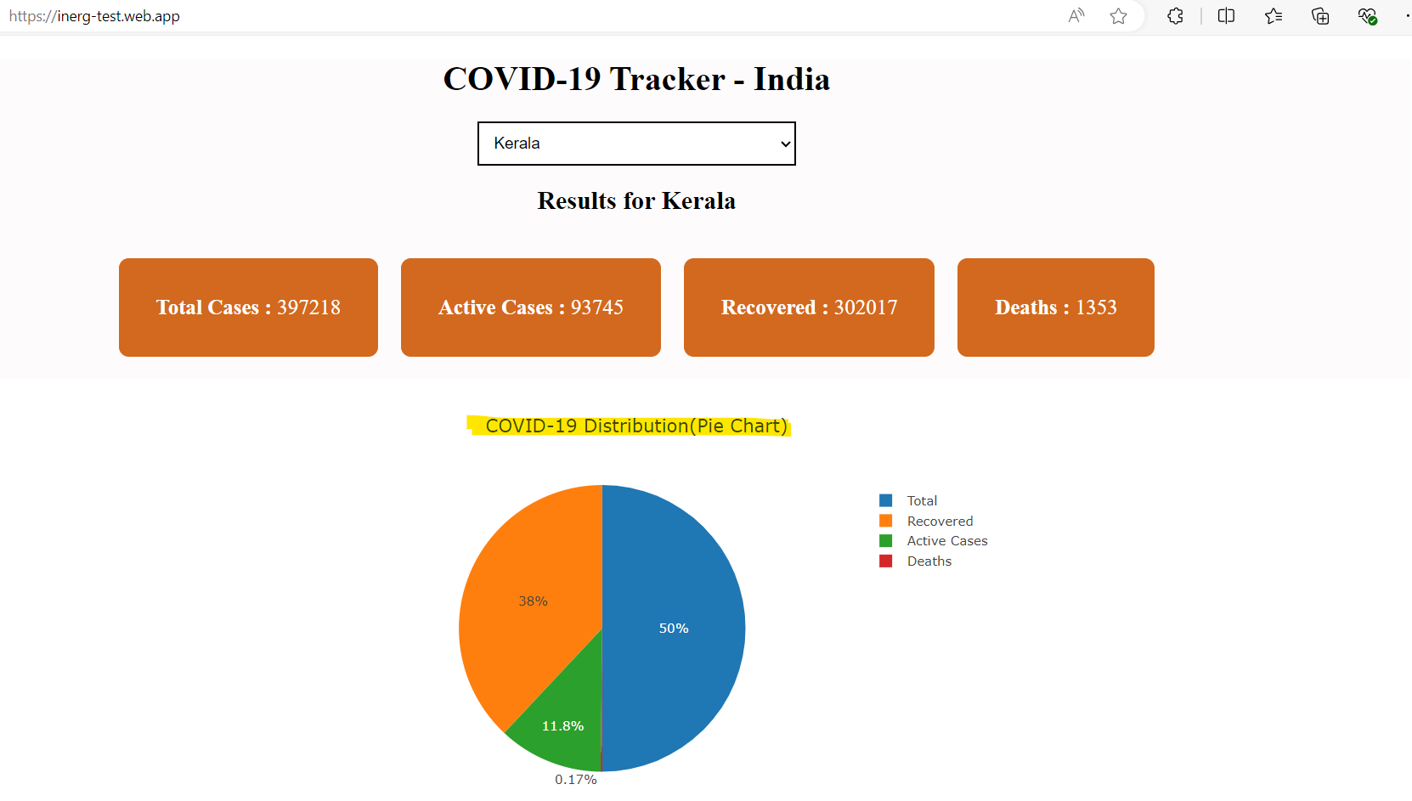

|  |  |
| --- | --- |
| **Bug ID** | **06** |
| **Project Name** | **Covid-19 Tracker** |
| **Module Name** | **Covid-19 Tracker –India web Page** |
| **Reporter** | **Sangeetha Sathyan** |
| **Date** | **07-09-2024** |
| **Platform** | **OS** |
| **Severity** | **Critical** |
| **Priority** | **High** |
| **Reproducibility** | **Always** |
| **Summary** | **Incorrect Percentages in Pie Chart Segments** |
| **Description** | The pie chart for COVID-19 data visualization displays incorrect percentages for all segments (Recovered, Active, and Death). Additionally, the pie chart does not accurately reflect the proportions of these categories. |
| **Expected Result** | The pie chart should accurately display the percentages for: Recovered, Active & Death. The sum of these percentages should total 100%, accurately reflecting their proportions relative to each other |
| **Actual Result** | The Pie Chart displays incorrect percentages for the selected state. For example: Select state from the dropdown (Kerala).   * Recovered: 38% * Active: 11.8%, * Death: 0.17%,->Total =49.97 * Total cases: 50% (incorrectly included).   The total of these percentages should not be 50%, indicating a miscalculation. These percentages do not accurately sum to 100% and misrepresent the data distribution among the three critical segments. |
| **Steps to Reproduce** | 1. Open the COVID-19 Tracker - India page. 2. Select “State” from the dropdown list. (Kerala). 3. Observe the pie chart displaying the data segments and their percentages. |
| **Status** | **Open** |
| **Assigned To** |  |

**Attachments:**

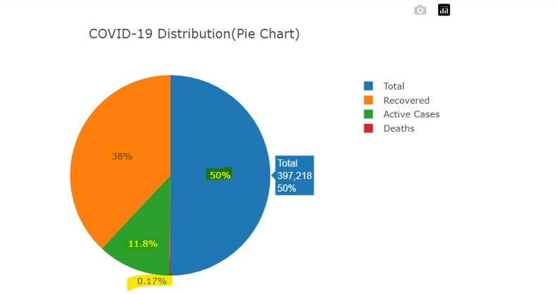

|  |  |
| --- | --- |
| **Bug ID** | **07** |
| **Project Name** | **Covid-19 Tracker** |
| **Module Name** | **Covid-19 Tracker –India web Page** |
| **Reporter** | **Sangeetha Sathyan** |
| **Date** | **07-09-2024** |
| **Platform** | **OS** |
| **Severity** | **Medium** |
| **Priority** | **High** |
| **Reproducibility** | **Always** |
| **Summary** | **Incorrect Download Icon and Non-Unique File Names for downloaded files.** |
| **Description** | In the Pie chart section & Line Chart representation section: The "Download Plot as PNG" icon is incorrect, and the downloaded file does not have a unique file name, causing confusion and overwriting of files. |
| **Expected Result** | 1. The "Download Plot as PNG" icon should clearly indicate its function. 2. The downloaded file should have a unique file name. |
| **Actual Result** | 1. The "Download Plot as PNG" icon is incorrect or misleading. 2. The downloaded file has a generic name (e.g., "newplot.png") and is not unique, leading to potential file overwriting. |
| **Steps to Reproduce** | 1. Open the COVID-19 Tracker - India page. 2. Select “State” from the dropdown list. (Kerala). 3. Locate the "Download Plot as PNG" icon. 4. Click on the icon to download the plot. |
| **Status** | **Open** |
| **Assigned To** |  |

**Attachments:**

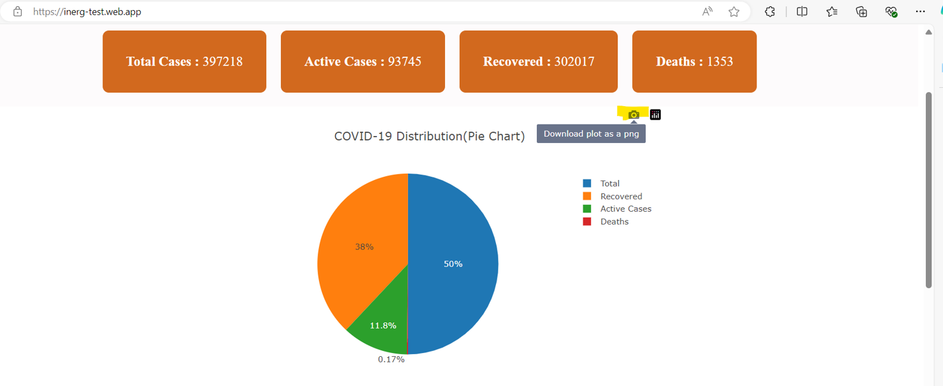

**After clicking the icon**

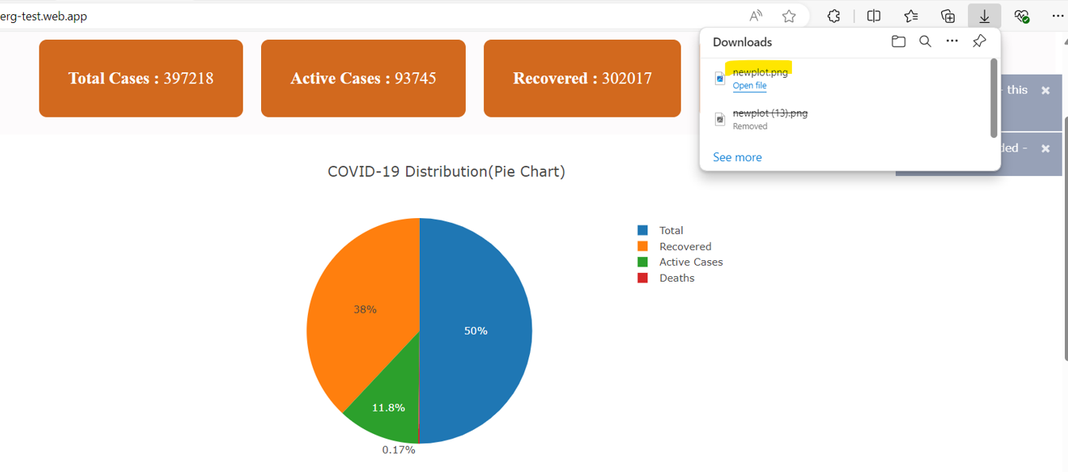

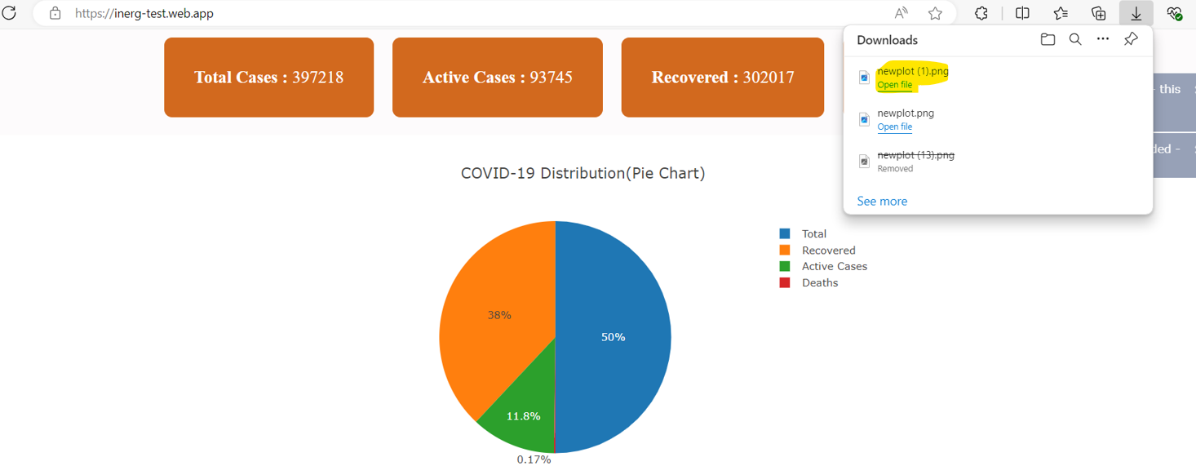

**Line chart**

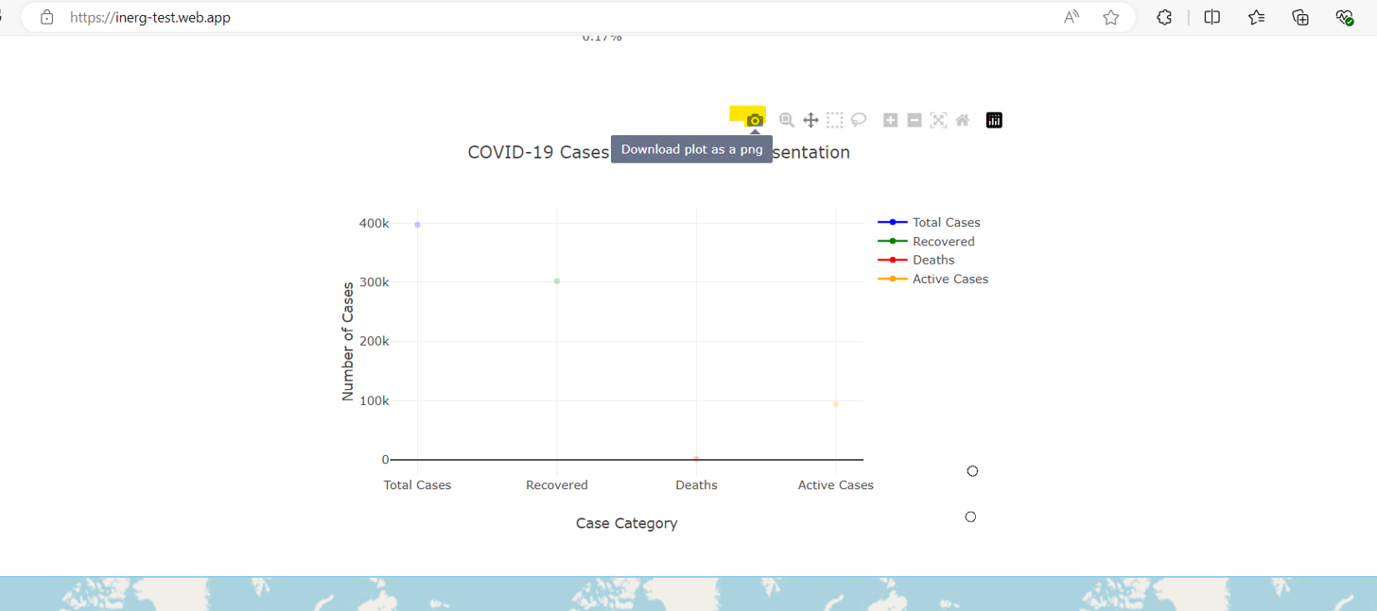

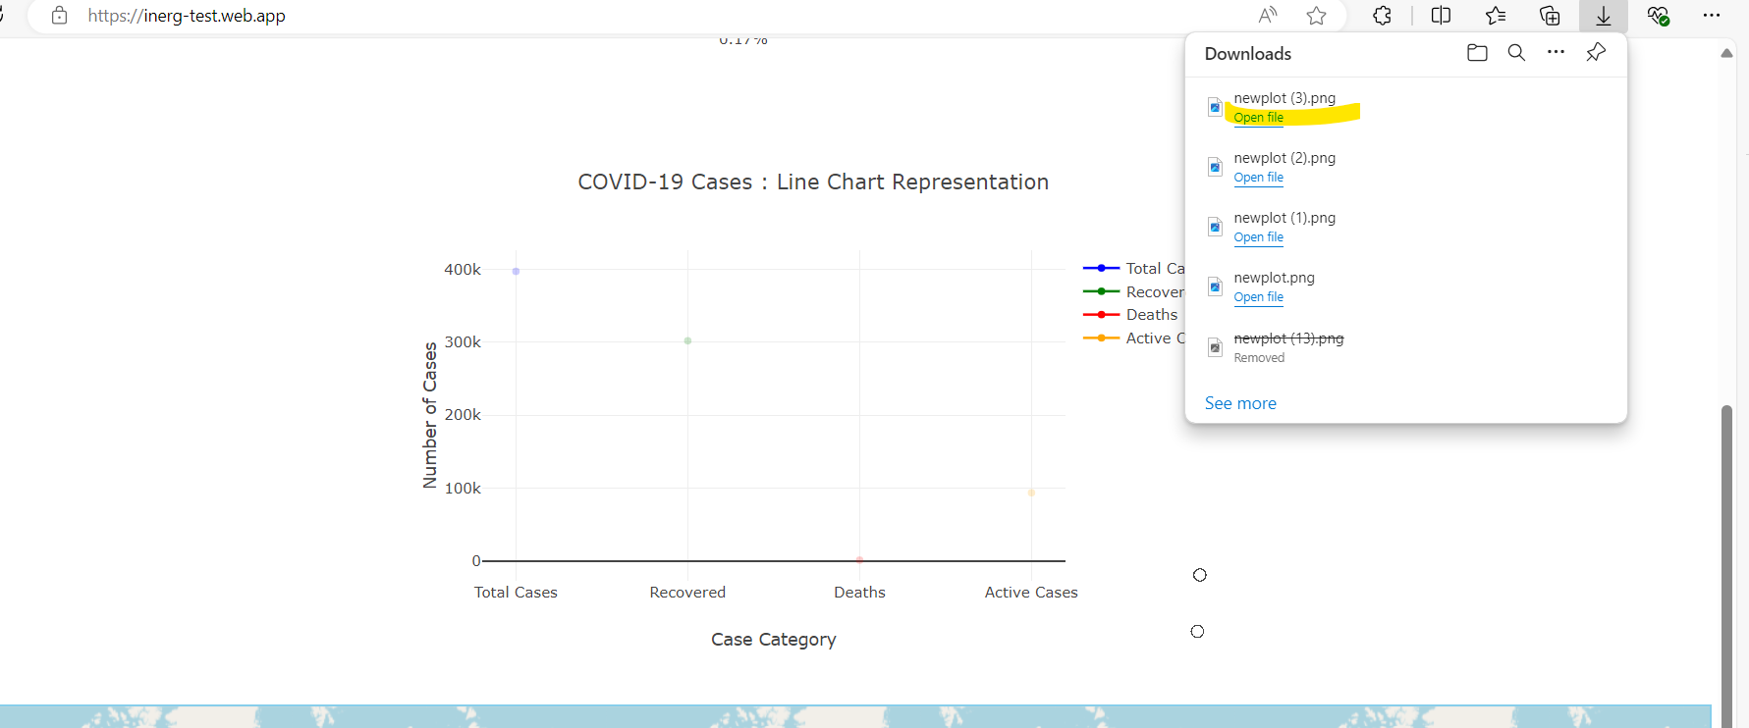

|  |  |
| --- | --- |
| **Bug ID** | **08** |
| **Project Name** | **Covid-19 Tracker** |
| **Module Name** | **Covid-19 Tracker –India web Page** |
| **Reporter** | **Sangeetha Sathyan** |
| **Date** | **07-09-2024** |
| **Platform** | **OS** |
| **Severity** | **Low** |
| **Priority** | **Medium** |
| **Reproducibility** | **Always** |
| **Summary** | **Unintended Redirection to Plotly Website** |
| **Description** | * In the Pie Chart & Line Chart Representation Section -> Clicking the "Produced with Plotly" icon in the application redirects the user to [plotly.com](http://plotly.com). * This behaviour is unexpected and may confuse users who do not intend to visit the external website. |
| **Expected Result** | Clicking the "Produced with Plotly" icon should not redirect the user to an external website, or it should provide a clear explanation of its purpose. |
| **Actual Result** | Clicking the "Produced with Plotly" icon redirects the user to [plotly.com](http://plotly.com) without any prior warning or explanation. |
| **Steps to Reproduce** | 1. Open the COVID-19 Tracker - India page. 2. Select “State” from the dropdown list. (Kerala). 3. Click on the "Produced with Plotly" icon on the pie chart/linechart |
| **Status** | **Open** |
| **Assigned To** |  |

**Attachments:**

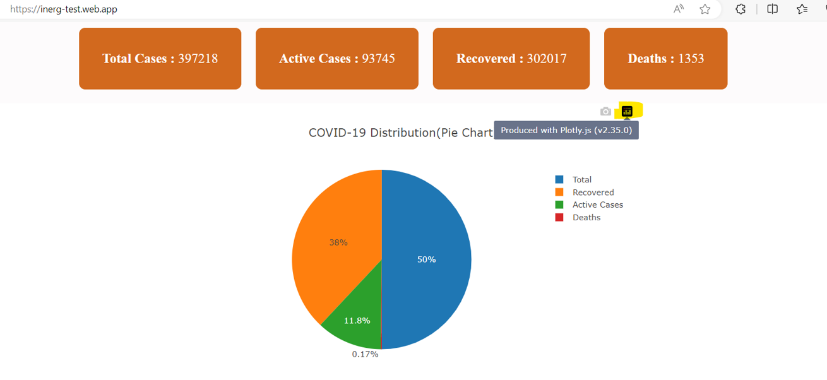



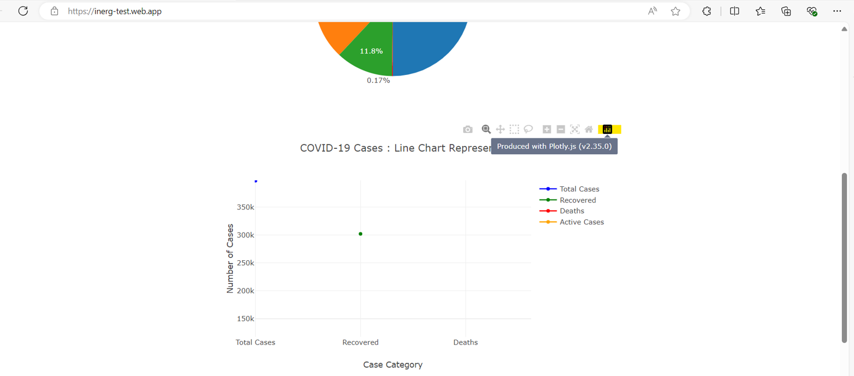



|  |  |
| --- | --- |
| **Bug ID** | **09** |
| **Project Name** | **Covid-19 Tracker** |
| **Module Name** | **Covid-19 Tracker –India web Page** |
| **Reporter** | **Sangeetha Sathyan** |
| **Date** | **07-09-2024** |
| **Platform** | **OS** |
| **Severity** | **Critical** |
| **Priority** | **High** |
| **Reproducibility** | **Always** |
| **Summary** | **Line Graph Representation UI Issues - Alignment, Overlapping, Insufficient Space, and Disconnected Line Chart** |
| **Description** | The graph displays multiple UI issues including alignment, overlapping elements, insufficient space for labels, and a line chart that is not connected for corresponding categories (Total cases, Active, recovered, Death). |
| **Expected Result** | The graph should display correctly with:   * All elements should be properly aligned * No overlapping of labels or data points. * Sufficient space for all labels to be clearly readable. * The line chart should have connected lines for each corresponding category. |
| **Actual Result** | The graph displays the following issues:   * Misalignment of elements and Text while Zooming. * Overlapping of labels and data points. * Insufficient space for labels, resulting in truncated text. * The line chart is not connected for categories (Total Cases, Active, Recovery, and Death). * Graph is not stable. |
| **Steps to Reproduce** | * + 1. Open the COVID-19 Tracker - India page.     2. Select “State” from the dropdown list. (Kerala).     3. Observe the alignment of elements, spacing, and the connectivity of the line chart. |
| **Status** | **Open** |
| **Assigned To** |  |

**Attachments:**

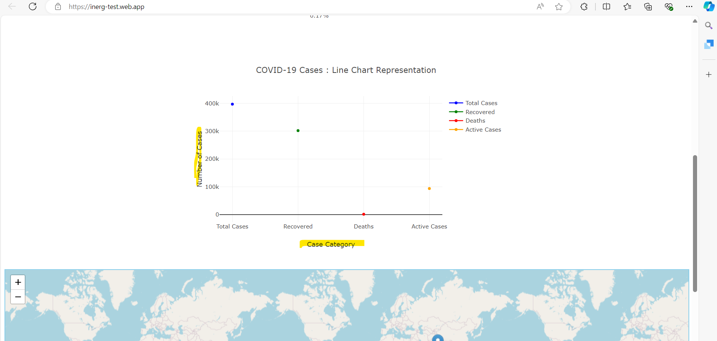

**Zoom out**

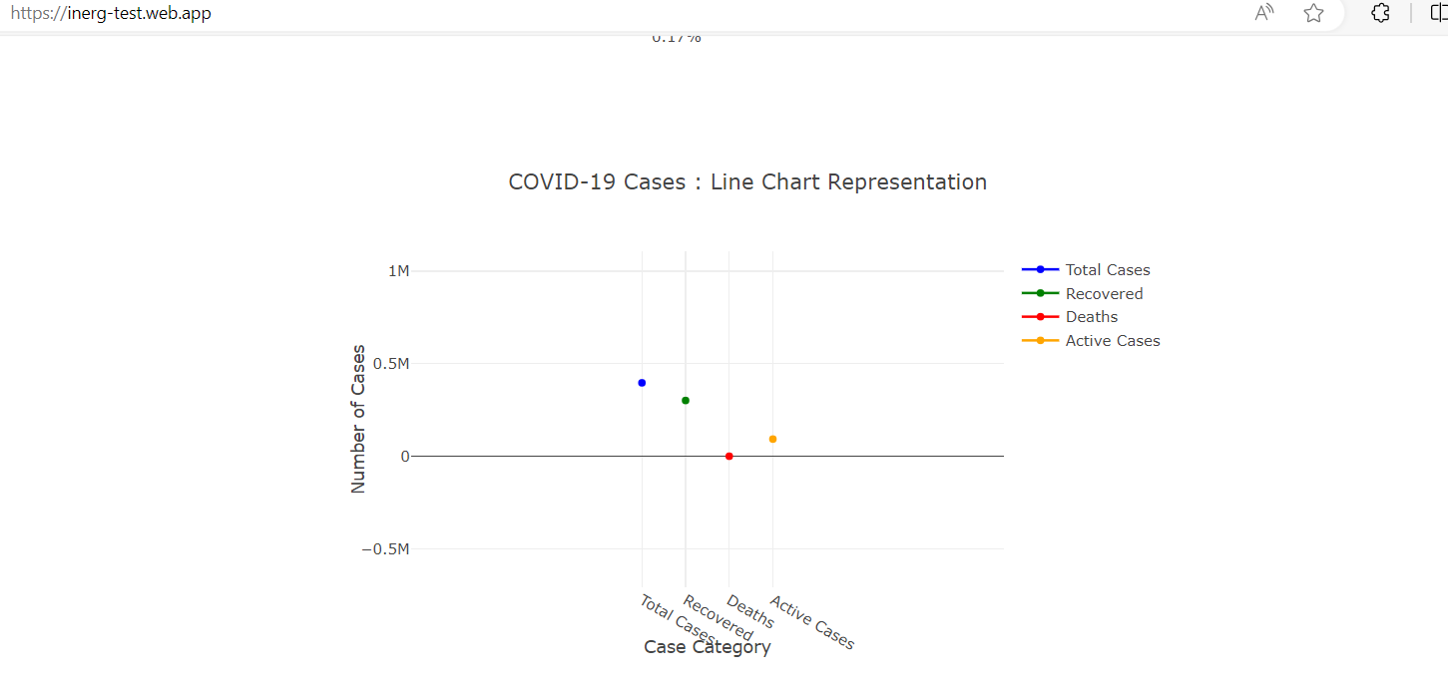

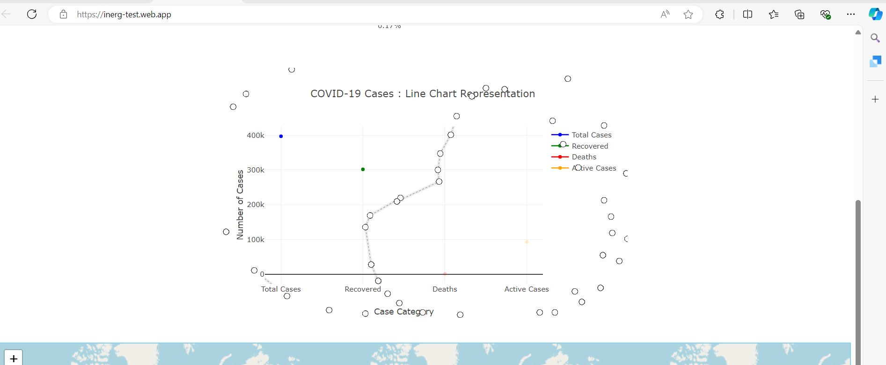

|  |  |
| --- | --- |
| **Bug ID** | **10** |
| **Project Name** | **Vaccine Finder -Indian vaccine web app** |
| **Module Name** | **Vaccine Finder** |
| **Reporter** | **Sangeetha Sathyan** |
| **Date** | **01-09-2024** |
| **Platform** | **OS** |
| **Severity** | **Low** |
| **Priority** | **Medium** |
| **Reproducibility** | **Always** |
| **Summary** | **Unnecessary Tools in Line Chart** |
| **Description** | The line chart visual representation currently includes tools such as box select, lasso select, and pan which are not necessary for the intended use of the chart. These tools can confuse users. |
| **Expected Result** | The line chart should only include relevant tools that enhance the user experience and the chart's functionality, without unnecessary options. |
| **Actual Result** | 1. The line chart includes the following unnecessary tools like Box select, Lasso select, Pan. 2. The presence of unnecessary tools Users might be confused by the additional options, leading to a potential misuse of the chart. 3. These tools do not add value to the line chart representation and can detract from the primary |
| **Steps to Reproduce** | 1. Open the COVID-19 Tracker - India page. 2. Select “State” from the dropdown list. (Kerala). 3. Observe the tools available on the line chart. |
| **Status** | **Open** |
| **Assigned To** |  |

**Attachments:**

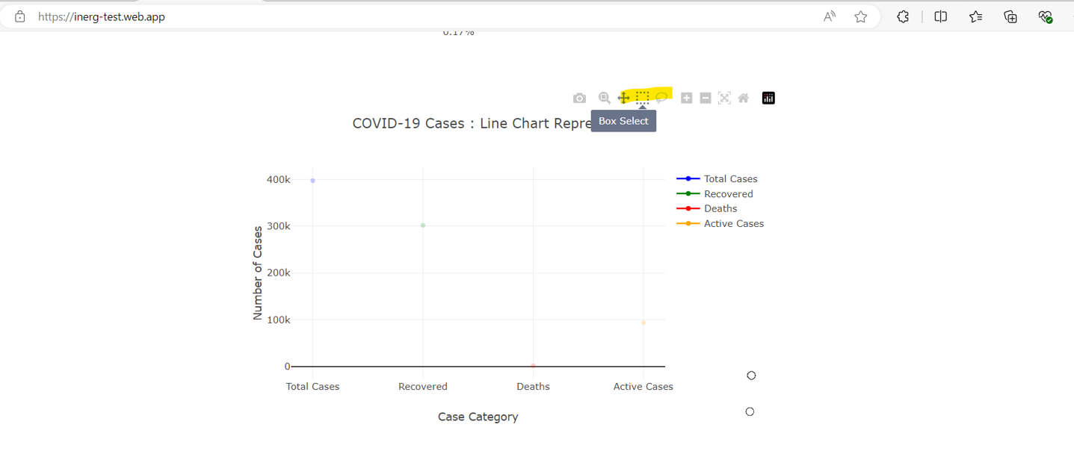

|  |  |
| --- | --- |
| **Bug ID** | **11** |
| **Project Name** | **Vaccine Finder -Indian vaccine web app** |
| **Module Name** | **Vaccine Finder** |
| **Reporter** | **Sangeetha Sathyan** |
| **Date** | **01-09-2024** |
| **Platform** | **OS** |
| **Severity** | **Low** |
| **Priority** | **Medium** |
| **Reproducibility** | **Always** |
| **Summary** | **Missing Heading for Map Representation and Insufficient Space for Line Chart** |
| **Description** | 1. Missing Heading for Map Representation: There is no proper heading or title for the map representation, which affects user understanding and context. 2. Insufficient Space for Line Chart: The line chart lacks adequate space, leading to a cluttered appearance and difficulty in interpreting the data. |
| **Expected Result** | 1. The map should have a clear and descriptive heading or title that provides context about the displayed data. 2. The line chart should have sufficient space around it to ensure clarity and prevent clutter. |
| **Actual Result** | 1. There is no heading or title displayed for the map representation. 2. The line chart is displayed in a Congested area, making it difficult to read and interpret the data. |
| **Steps to Reproduce** | 1. Open the COVID-19 Tracker - India page. 2. Select “State” from the dropdown list. (Kerala). 3. Observe the heading for the map and the layout of the line chart. |
| **Status** | **Open** |
| **Assigned To** |  |

**Attachments:**

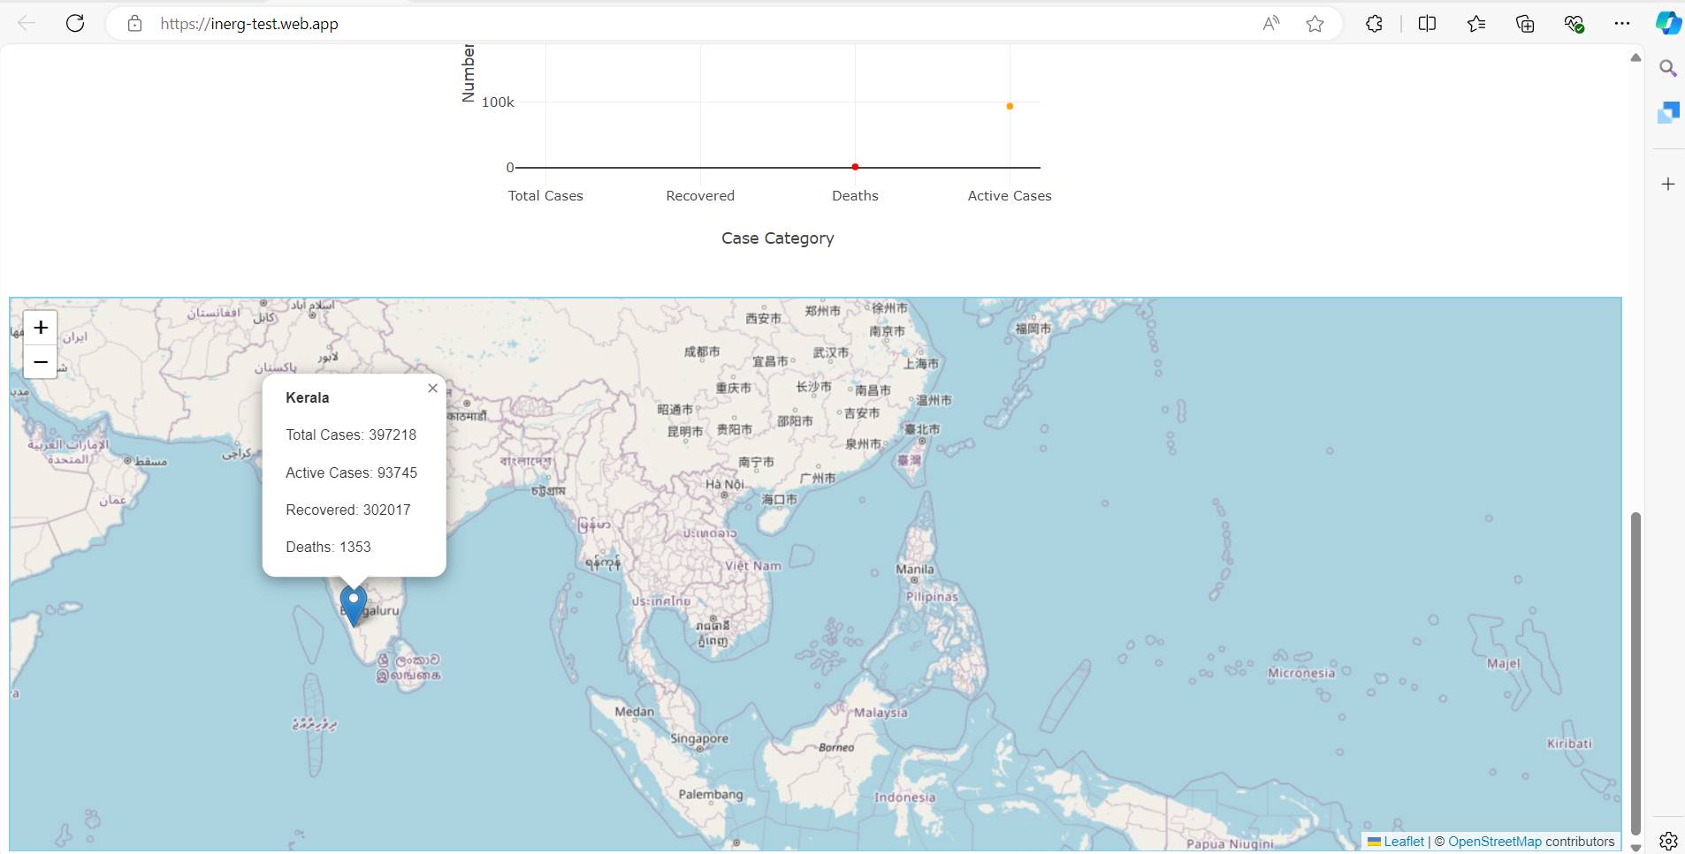

|  |  |
| --- | --- |
| **Bug ID** | **12** |
| **Project Name** | **Vaccine Finder -Indian vaccine web app** |
| **Module Name** | **Vaccine Finder** |
| **Reporter** | **Sangeetha Sathyan** |
| **Date** | **01-09-2024** |
| **Platform** | **OS** |
| **Severity** | **Major** |
| **Priority** | **High** |
| **Reproducibility** | **Always** |
| **Summary** | **Map Location Not Updating on Default State Selection in COVID Tracker** |
| **Description** | * When a state is selected from the drop-down in the COVID tracker, the total cases, recovered cases, active cases, and death cases are displayed correctly on the map. * However, when the user re-selects the default state option (select a state), the map location and the details corresponding to the previous state selection do not update, causing a mismatch between the map location and displayed details. |
| **Expected Result** | The map location and details should reset to either a default/blank state |
| **Actual Result** | The map still shows the location and details of the previously selected state, despite the drop-down showing 'Select a state' as the chosen option. |
| **Steps to Reproduce** | 1. Open the COVID-19 Tracker - India page. 2. Select “State” from the dropdown list. (Kerala). 3. Observe that the map updates with details (total cases, recovered cases, active cases, death cases) corresponding to the selected state. 4. Then reselect default state option (Select a state). 5. Observe that the map updates or not. |
| **Status** | **Open** |
| **Assigned To** |  |

**Attachments:**

