**Bug Report for Vaccine Finder Page**

**View Issue details**

|  |  |
| --- | --- |
| **Bug ID** | **01** |
| **Project Name** | **Vaccine Finder -Indian vaccine web app** |
| **Module Name** | **Vaccine Finder** |
| **Reporter** | **Sangeetha Sathyan** |
| **Date** | **01-09-2024** |
| **Platform** | **OS** |
| **Severity** | **Critical** |
| **Priority** | **High** |
| **Reproducibility** | **Always** |
| **Summary** | **State and District Dropdown Lists Not Populating** |
| **Description** | 1. Both the state and district dropdown lists on the Vaccine Finder page are not populating with any data. This issue prevents users from selecting their location, thereby blocking them from searching for vaccination centers. 2. The absence of these dropdown options renders the core functionality of the Vaccine Finder page completely inoperative. 3. No name /text to identify the textboxes like State / District. |
| **Steps to Reproduce** | 1. Open the Vaccine Finder App. 2. Navigate to the "Vaccine Finder" page. 3. Select “State” from the dropdown list. 4. Observe that the state dropdown is empty or does not display any options. 5. Attempt to interact with the district dropdown list, which should also remain empty or unresponsive. |
| **Status** | **Open** |
| **Assigned To** |  |

**Attachments**

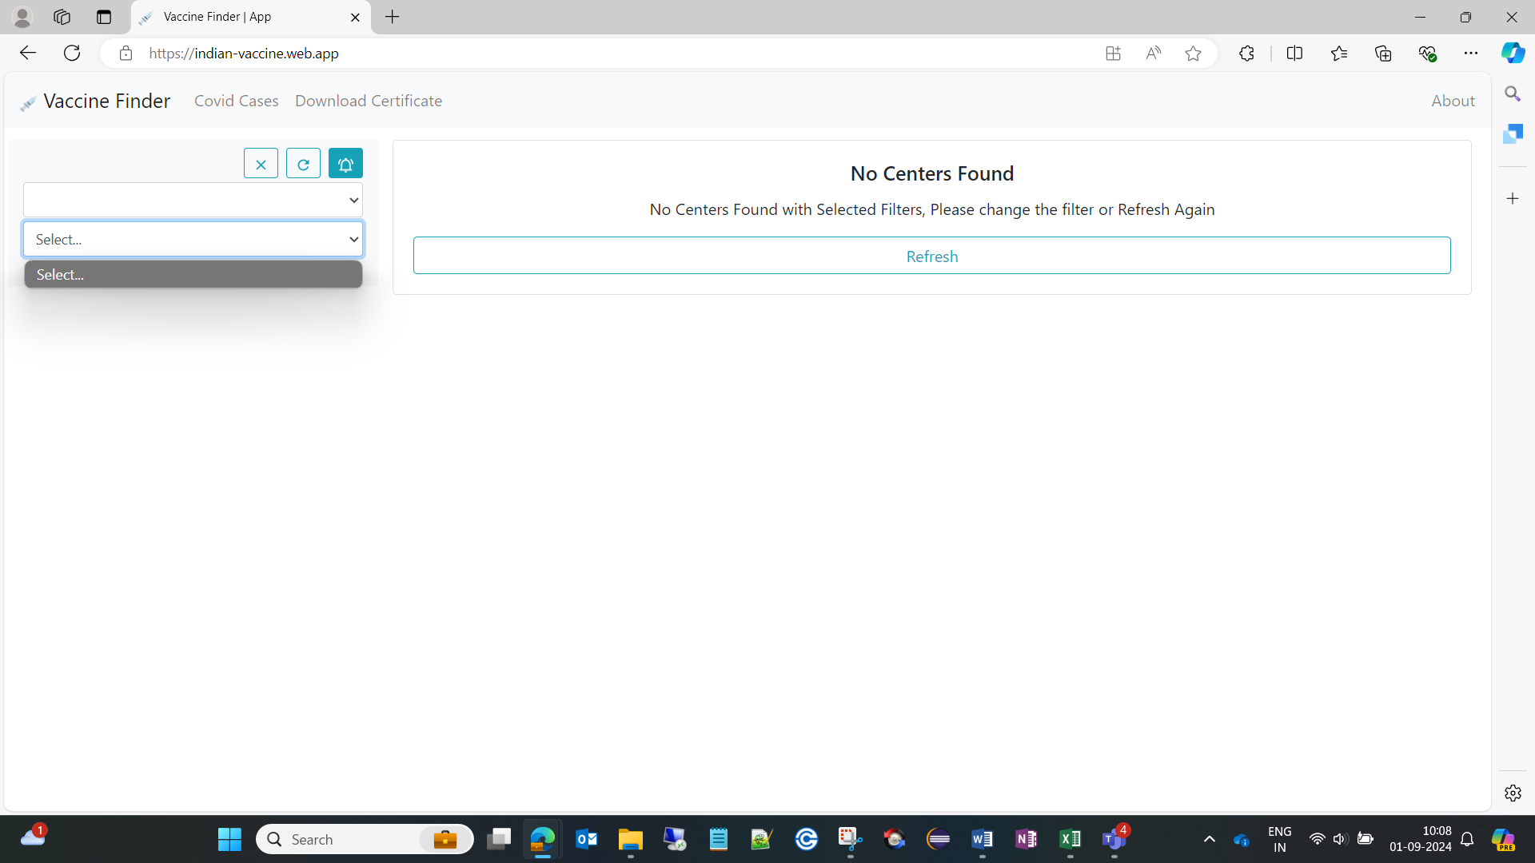 

|  |  |
| --- | --- |
| **Bug ID** | **02** |
| **Project Name** | **Vaccine Finder -Indian vaccine web app** |
| **Module Name** | **Vaccine Finder** |
| **Reporter** | **Sangeetha Sathyan** |
| **Date** | **01-09-2024** |
| **Platform** | **OS** |
| **Severity** | **Critical** |
| **Priority** | **High** |
| **Reproducibility** | **Always** |
| **Summary** | **Search Button Missing in Filter Section for Filtering Vaccine Centers** |
| **Description** | 1. The "Search" button, which is essential for initiating the search after applying filters in the Vaccine Finder page, is missing from the filter section. 2. Without this button, users are unable to filter and search for vaccine centers based on their selected criteria, rendering the filtering feature ineffective. |
| **Steps to Reproduce** | 1. Open the Vaccine Finder App. 2. Navigate to the "Vaccine Finder" page. 3. "Search" button is not added in the filter section to execute the search based on the selected filters. |
| **Status** | **Open** |
| **Assigned To** |  |

**Attachments**

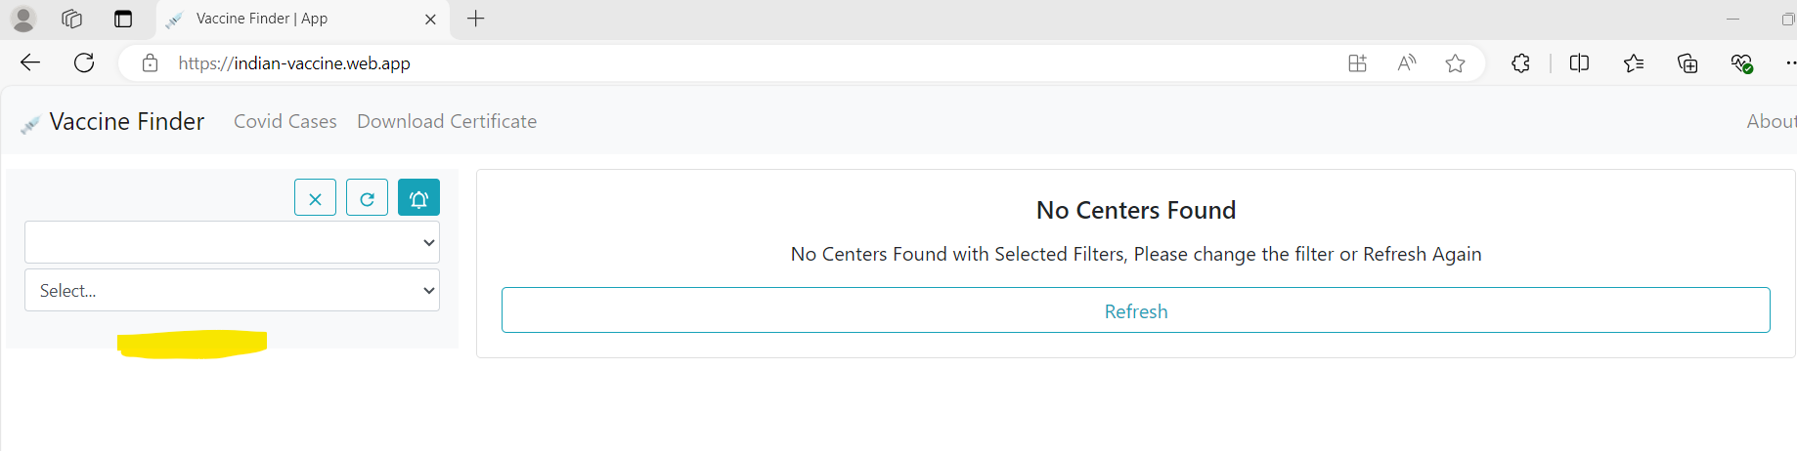

|  |  |
| --- | --- |
| **Bug ID** | **03** |
| **Project Name** | **Vaccine Finder -Indian vaccine web app** |
| **Module Name** | **Vaccine Finder** |
| **Reporter** | **Sangeetha Sathyan** |
| **Date** | **01-09-2024** |
| **Platform** | **OS** |
| **Severity** | **Minor** |
| **Priority** | **High** |
| **Reproducibility** | **Always** |
| **Summary** | Missing Alert Message for "No Data Found" while Selecting State and District in Dropdowns |
| **Description** | When a user selects a state / district from the dropdown lists on the Vaccine Finder page and no data are available in the State/District Dropdowns, the application fails to display an alert message indicating that no data was found. |
| **Steps to Reproduce** | 1. Open the Vaccine Finder App. 2. Navigate to the "Vaccine Finder" page. 3. Select the state/District dropdown list. 4. If no data in the dropdown system fails to show an alert Message. |
| **Status** | **Open** |
| **Assigned To** |  |

**Attachments:**

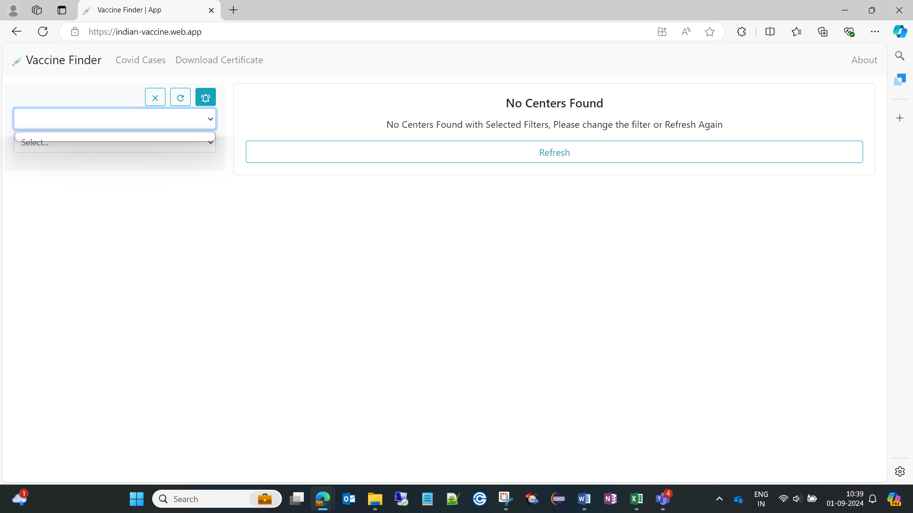

|  |  |
| --- | --- |
| **Bug ID** | **04** |
| **Project Name** | **Vaccine Finder -Indian vaccine web app** |
| **Module Name** | **Vaccine Finder** |
| **Reporter** | **Sangeetha Sathyan** |
| **Date** | **01-09-2024** |
| **Platform** | **OS** |
| **Severity** | **Major** |
| **Priority** | **High** |
| **Reproducibility** | **Always** |
| **Summary** | Refresh Functionality Not Working on Vaccine Finder Page |
| **Description** | When users click the refresh button, the page should not reload and not triggering any action of the page |
| **Steps to Reproduce** | 1. Open the Vaccine Finder App. 2. Navigate to the "Vaccine Finder" page. 3. Click on the refresh button. 4. Ensure that the page does not refresh, and the displayed data remains the same. |
| **Status** | **Open** |
| **Assigned To** |  |

|  |  |
| --- | --- |
| **Bug ID** | **05** |
| **Project Name** | **Vaccine Finder -Indian vaccine web app** |
| **Module Name** | **Vaccine Finder** |
| **Reporter** | **Sangeetha Sathyan** |
| **Date** | **01-09-2024** |
| **Platform** | **OS** |
| **Severity** | **Major** |
| **Priority** | **High** |
| **Reproducibility** | **Always** |
| **Summary** | Delete Icon in Filter Section Fails to Display Alert Message Without Dropdown Data Selection |
| **Description** | 1. The delete icon ("X") in the Filter section does not trigger an alert message when no data is selected from the dropdown menu. 2. While Hovering the Delete Icon incorrect name /text as displayed "Notification” |
| **Steps to Reproduce** | 1. Open the Vaccine Finder App. 2. Navigate to the "Vaccine Finder" page. 3. No data is selected from the dropdown menu. 4. Click on the delete icon next to any filter (if any are applied) or attempt to clear a filter. 5. Ensure that no alert message or confirmation is displayed. |
| **Status** | **Open** |
| **Assigned To** |  |

|  |  |
| --- | --- |
| **Bug ID** | **06** |
| **Project Name** | **Vaccine Finder -Indian vaccine web app** |
| **Module Name** | **Vaccine Finder** |
| **Reporter** | **Sangeetha Sathyan** |
| **Date** | **01-09-2024** |
| **Platform** | **OS** |
| **Severity** | **Major** |
| **Priority** | **High** |
| **Reproducibility** | **Always** |
| **Summary** | Refresh Icon in Filter Section Not Working |
| **Description** | When User Clicking the refresh icon. The page should not reload and not triggering any action of the page |
| **Steps to Reproduce** | 1. Open the Vaccine Finder App. 2. Navigate to the "Vaccine Finder" page. 3. Click on the refresh icon in the Filter section. 4. Observe that the page reloading or not. |
| **Status** | **Open** |
| **Assigned To** |  |

|  |  |
| --- | --- |
| **Bug ID** | **07** |
| **Project Name** | **Vaccine Finder -Indian vaccine web app** |
| **Module Name** | **Vaccine Finder** |
| **Reporter** | **Sangeetha Sathyan** |
| **Date** | **01-09-2024** |
| **Platform** | **OS** |
| **Severity** | **Major** |
| **Priority** | **High** |
| **Reproducibility** | **Always** |
| **Summary** | Notification Icon Not Working |
| **Description** | The notification icon not functioning as expected. When user Clicking the notification icon does not trigger any action or display notifications, which prevents users from receiving important updates or alerts. |
| **Steps to Reproduce** | 1. Open the Vaccine Finder App. 2. Navigate to the "Vaccine Finder" page. 3. Click on the Notification icon in the Filter section. 4. Ensure that no notifications are displayed or any expected action is triggered. |
| **Status** | **Open** |
| **Assigned To** |  |