A MAJOR PROJECT REPORT ON
SpiralSense : Parkinson’s Disease Detection Using Spiral Hand Drawings

Submitted in partial fulfilment for the award of the degree of
BACHELOR OF TECHNOLOGY
In
Artificial Intelligence and Machine Learning
By
BARLA SANGEETHA BALA VALLI (23A81A6105)
MUDUNURI NAGA SAI SRINIVAS (23A81A6142)
NIMIDITALLI CHAITANYA KISHORE (23A81A6144)
CHADALAWADA JAIKIRAN (23A81A6110)

Under the Esteemed Supervision of

Mrs. RADHA VALLABHANENI, M.Tech
Sr. Assistant Professor, CSE(AI)



Department of Artificial Intelligence and Machine Learning
SRI VASAVI ENGINEERING COLLEGE(Autonomous)
(Affiliated to JNTUK, Kakinada)
Pedatadepalli, Tadepalligudem-534101, A.P
2026-27

SRI VASAVI ENGINEERING COLLEGE (Autonomous)
Department of Artificial Intelligence and Machine Learning
Pedatadepalli, Tadepalligudem



This is to certify that the Project Report entitled “SpiralSense : Parkinson’s Disease Detection Using Spiral Hand Drawings” submitted by B. Sangeetha Balavalli (23A81A6105), M. Naga Sai Srinivas (23A81A6142), N. Chaitanya Kishore (23A81A6144), Ch. Jaikiran (23A81A6110) for the award of the degree of Bachelor of Technology in the Department of Artificial Intelligence and Machine Learning during the academic year 2026-27.

Project Guide  Mrs. Radha Vallabhaneni, M.Tech  Sr. Assistant Professor | Head of the Department  Dr. G. Loshma, B.E., M.Tech, Ph.D.  Professor & HOD

External Examiner
DECLARATION
We hereby declare that the project report entitled “SpiralSense : Parkinson’s Disease Detection Using Spiral Hand Drawings” submitted by us to Sri Vasavi Engineering College(Autonomous), Tadepalligudem, affiliated to JNTUK Kakinada in partial fulfilment of the requirement for the award of the degree of B.Tech in Department of Artificial Intelligence and Machine Learning is a record of Bonafide project work carried out by us under the guidance of Mrs. Radha Vallabhaneni, M.Tech, Sr. Assistant Professor. We further declare that the work reported in this project has not been submitted and will not be submitted, either in part or in full, for the award of any other degree in this institute or any other institute or University.

Project Associates

B. Sangeetha Balavalli (23A81A6105)
M. Naga Sai Srinivas (23A81A6142)
N. Chaitanya Kishore (23A81A6144)
Ch. Jaikiran (23A81A6110)

ACKNOWLEDGEMENT

First and foremost, we sincerely salute to our esteemed institute Sri Vasavi Engineering College, for giving us this golden opportunity to fulfill our warm dream to become an engineer.
Our sincere gratitude to our project guide Mrs. Radha Vallabhaneni, M.Tech, Sr. Assistant Professor, Department of Computer Science (Artificial Intelligence), for her timely cooperation and valuable suggestions while carrying out this project.
We express our sincere thanks and heartful gratitude to Dr. G. Loshma, Professor & Head of the Department of Artificial Intelligence and Machine Learning, for permitting us to do our project.
We express our sincere thanks and heartful gratitude to Dr. Ch. Rambabu, Principal, for providing a favourable environment and supporting us during the development of this project.
Our special thanks to the management and all the teaching and non-teaching staff members, Department of Artificial Intelligence and Machine Learning, for their support and cooperation in various ways during our project work. It is our pleasure to acknowledge the help of all those respected individuals.
We would like to express our gratitude to our parents, friends who helped us to complete this project.

Project Associates

B. Sangeetha Balavalli (23A81A6105)
M. Naga Sai Srinivas (23A81A6142)
N. Chaitanya Kishore (23A81A6144)
Ch. Jaikiran (23A81A6110)

ABSTRACT

The proposed system is an AI-powered Parkinson’s disease screening framework designed to identify Parkinsonian motor abnormalities from hand-drawn spiral images and to improve the reliability and interpretability of image-based detection. The system uses deep learning to analyse spiral handwriting patterns that may contain visual characteristics associated with tremor, irregular movement and reduced motor control. An existing deeplearning-based spiral classification approach is first reproduced as a baseline, in which spiral images undergo preprocessing and augmentation before being analysed by a convolutional neural network-based model for Parkinson’s disease classification.
To address limitations of conventional classification systems, the proposed framework incorporates explainable artificial intelligence (Grad-CAM) to identify and visualise the regions of spiral drawings that contribute to model predictions. The system also integrates uncertainty estimation to determine the reliability of individual predictions and to distinguish confident predictions from ambiguous samples. To improve the reliability of experimental results, patient-level data splitting and comprehensive evaluation using accuracy, precision, recall, specificity, F1-score, ROC-AUC and confusion matrices are considered. The framework will be evaluated against the reproduced baseline through comparative and ablation experiments to determine the contribution of preprocessing, explainability, uncertainty estimation and robust evaluation strategies. By combining deep-learning-based spiral analysis with interpretable and reliability-aware prediction, the proposed system aims to provide a more transparent and robust computer-aided screening framework for Parkinson’s disease while supporting further research in handwriting-based neurological assessment.
Keywords:
Parkinson’s Disease, Spiral Handwriting, Hand-Drawn Spiral Images, Deep Learning, Convolutional Neural Network, EfficientNetV2 -S, Explainable Artificial Intelligence, Grad-CAM, Uncertainty Estimation, Medical Image Analysis, Computer-Aided Screening, Patient-Level Evaluation.
TABLE OF CONTENTS
S.NO | TITLE | PAGE NO.
 | ABSTRACT | iii
1 | CHAPTER: 1 INTRODUCTION | 1
1 | 1.1 INTRODUCTION | 2
1 | 1.2 MOTIVATION | 2-3
1 | 1.3 SCOPE | 3
1 | 1.4 PROJECT OUTLINE | 4
2 | CHAPTER: 2 LITERATURE SURVEY | 6-9
2 | 2.1 RESEARCH GAPs | 9
2 | 2.2 SUMMARY OF LITERATURE SURVEY | 9-10
3 | CHAPTER: 3 SYSTEM STUDY AND ANALYSIS | 11
3 | 3.1 PROBLEM STATEMENT | 12
3 | 3.2 EXISTING SYSTEM | 12-13
3 | 3.3 DRAWBACK OF EXISTING SYSTEM | 13
3 | 3.4 PROPOSED SYSTEM | 13-14
3 | 3.5 ADVANTAGES OF PROPOSED SYSTEM | 14-15
3 | 3.6 FUNCTIONAL REQUIREMENTS | 15-16
3 | 3.7 NON-FUNCTIONAL REQUIREMENTS | 16
3 | 3.8 SYSTEM REQUIREMENTS | 17
4 | CHAPTER: 4 SYSTEM DESIGN | 18
4 | 4.1 SYSTEM ARCHITECTURE | 19-20
4 | 4.2 SYSTEM WORKFLOW | 20-21
4 | 4.3 MODULE DESCRIPTION | 22
5 | CHAPTER: 5 DATA DESCRIPTION | 23
5 | 5.1 DATASET NAME | 24
5 | 5.2 DATASET SIZE | 24-25
5 | 5.3 DESCRIPTION | 25-26
5 | 5.4 DIVISION OF IMAGES | 26
5 | 5.5 SAMPLE IMAGES IN THE DATASET | 27
6 | CHAPTER: 6 TECHNOLOGIES | 28
6 | 6.1 PYTHON | 29
6 | 6.2 TENSORFLOW AND KERAS | 30
6 | 6.3 EFFICIENTNETV2-S | 31
6 | 6.4 REQUIRED LIBRARIES | 32-33
6 | 6.5 FLASK | 33
6 | 6.6 GRAD-CAM AND UNCERTAINITY ESTIMATION | 34-35
6 | 6.7 FRONTEND TECHNOLOGIES | 35-36
6 | 6.8 DEVELOPMENT TOOLS | 36-37
7 | CHAPTER: 7 IMPLEMENTATION | 38
7 | 7.1 DEVELOPMENT ENVIRONMENT | 39-40
7 | 7.2 DATASET PREPARATION | 40
7 | 7.3 IMAGE PREPROCESSING | 41-42
7 | 7.4 MODEL CONSTRUCTION | 42-44
7 | 7.5 MODEL TRAINING | 44-46
7 | 7.6 MODEL EVALUATION | 46-49
7 | 7.7 GRAD-CAM EXPLAINABILITY | 50-51
7 | 7.8 UNCERTAINITY ESTIMATION | 51-53
7 | 7.9 FLASK WEB APPLICATION | 54-57
8 | CHAPTER: 8 SCREENSHOTS | 58-62
9 | CHAPTER: 9 CONCLUSION | 63
9 | 9.1 CONCLUSION | 64
9 | 9.2 FUTURE WORK | 64-65
9 | 9.3 REFERENCES | 65-66

LIST OF FIGURES
FIG NO. | TITLE | PAGE
4.1 | System Architecture of SpiralSense | 20
4.2 | System Workflow of SpiralSense | 21
5.4 | Sample Images in the Dataset | 27
8.1 | SpiralSense Dashboard (Initial Interface) | 59
8.2 | Spiral Image Upload and Preview | 59
8.3 | Prediction Results | 60
8.4 | Grad-CAM Visualization | 60
8.5 | Grad-CAM Interpretation and Activation Scale | 61
8.6 | About SpiralSense | 61
8.7 | Project Knowledge Base | 62
8.8 | Project Technical Documentation and FAQ | 62

LIST OF TABLES
TABLE NO. | TITLE | PAGE
5.1 | Dataset Class Distribution | 25
5.2 | Image Characteristics | 25
5.3 | Division of Images in the Dataset | 26
5.4 | Sample Images in the Dataset | 27

CHAPTER-1
INTRODUCTION

- INTRODUCTION
  - Introduction
Parkinson’s disease (PD) is a chronic neurodegenerative disorder that primarily affects the central nervous system and the motor function of the body. Its motor symptoms include tremor, stiffness and slowed movement known as bradykinesia, and they are associated with a shortage of dopamine. Because tasks such as drawing spirals and waves demand precise coordination and fine motor control, irregularities in the quality of a person’s drawing can reflect disturbances in motor function.
Hand tremor and difficulty in controlling hand movements can cause noticeable changes in handwriting and spiral drawings. A spiral drawing is a simple and non-invasive way of capturing such motor abnormalities. This project applies deep learning and computer vision techniques to handdrawn spiral images in order to identify visual patterns that may be associated with Parkinson’s disease, with the aim of supporting computer-aided screening.
The work described in this report is a research-oriented screening prototype. It is not a clinically validated diagnostic product, and handwriting or drawing analysis is not presented here as a definitive test for Parkinson’s disease. Any output of the proposed system is intended to support further research and, in future, to be interpreted only under appropriate clinical supervision.
  - Motivation
Diagnosing Parkinson’s disease in its early stages is difficult. Current diagnosis relies on clinical assessment, which is time-consuming and requires human experts, and the disease can be misdiagnosed because its symptoms resemble those of other disorders such as multiple system atrophy and progressive supranuclear palsy . Early identification is considered important for keeping symptoms under control . These observations motivate the study of simple, low-cost drawing tasks as a source of research signals for computer-aided screening.
Deep neural classifiers are frequently described as “black box” techniques, because it is difficult to see how an input is associated with the output . In a medical setting, accuracy alone is therefore not sufficient. A screening aid should also indicate which parts of a drawing influenced its prediction, how reliable an individual prediction is, and whether the reported performance was obtained under an evaluation protocol that avoids data leakage between training and test data. These three concerns, explainability, reliability and patient-level evaluation, form the motivation for the present project.
Problem statement (summary): The review of existing work carried out for this project indicates that many spiral-drawing classifiers concentrate on classification accuracy, offer limited insight into the regions of a drawing that drive a prediction, and do not state how confident or ambiguous an individual prediction is. A detailed problem definition is given in Section 3.1.
1.3 Scope
The project focuses on developing an explainable and uncertainty-aware deep-learning approach for Parkinson’s disease screening using spiral hand drawings. It aims to analyze drawing patterns and identify visual characteristics associated with Parkinson’s disease through image classification.
The scope of the project is restricted to spiral drawing images and binary classification into Healthy and Parkinson’s categories. It incorporates EfficientNetV2-S for feature extraction and classification, Grad-CAM for visual interpretation, and uncertainty estimation to assess the reliability of predictions.
The project also emphasizes patient-level data separation to minimize data leakage and uses standard evaluation metrics to assess model performance. The proposed system is intended to provide a transparent and reliable computer-aided screening approach for research purposes. It is not intended to replace clinical examination or provide a definitive medical diagnosis.
The system provides a user-friendly interface where users can upload spiral drawing images and receive screening results along with confidence scores and visual explanations. It aims to support early identification of potential Parkinson’s-related patterns while maintaining transparency about prediction uncertainty.

1.4 Project outline
This project report is organized into eleven chapters. Chapter 1 introduces the project, including the problem statement, objectives, scope, and project outline. Chapter 2 presents the literature survey, reviewing existing research related to Parkinson’s disease detection using spiral drawings. Chapter 3 discusses the system study and analysis, including the existing system, its limitations, and the requirements of the proposed system. Chapter 4 explains the system design, architecture, and workflow. Chapter 5 describes the dataset, preprocessing techniques, data augmentation, and proposed methodology. Chapter 6 introduces the technologies, programming languages, frameworks, and libraries used in the project. Chapter 7 explains the implementation of the EfficientNetV2-S model, Grad-CAM visualization, uncertainty estimation, and web application. Chapter 8 covers the testing procedures and system validation. Chapter 9 presents the experimental results, performance evaluation, model comparisons, and discussion. Chapter 10 concludes the project by summarizing the work and its outcomes, while Chapter 11 discusses the future enhancements and possible extensions of the proposed system.

CHAPTER-2
LITERATURE SURVEY

2. LITERATURE SURVEY

A. Multiscale Attention and Bayesian–Genetic Optimization for Parkinson’s Disease Assessment [1]
Rezaee and Fakhrabadi (2026) proposed a deep-learning approach using multiscale attention and Bayesian–Genetic Optimization to analyze spiral, meander, and wave drawings for Parkinson’s disease assessment. Their work focuses on identifying relevant features from different types of drawing patterns. This study is relevant to the present project because it demonstrates the potential of deep-learning techniques for extracting meaningful information from drawing images. However, the available literature summary does not report the dataset details and indicates limitations related to optimization and generalization testing.
B. CNN-Based Classification of Archimedean SpiralImages Using HandPD and NewHandPD Datasets [2]
Bensefia et al. (2025) investigated a convolutional neural network (CNN) for classifying static Archimedean spiral images using the HandPD and NewHandPD public datasets. Their study demonstrated the potential of CNN-based image classification for Parkinson’s disease screening. This work is relevant to the present project because it supports the use of deep-learning techniques to identify patterns in spiral drawings. However, specific limitations were not available in the reviewed literature summary.
C. Parkinson’s Disease Detection Using Wave-Signal Processing on Spiral Drawing Tests[3]
Sasirekha et al. (2025) presented a Parkinson’s disease detection approach based on wave-signal processing applied to spiral drawing tests. Their method focuses on analyzing signal characteristics derived from drawing patterns to identify features associated with the disease. This study highlights the importance of spiral drawing analysis as a potential screening approach. It provides a complementary perspective to image-based classification methods. However, the available literature summary does not provide detailed dataset information or quantitative performance metrics.
D. Vision Transformer-Based Classification of Archimedean Spiral Drawings [4]
Benséfia et al. (2025) explored a Vision Transformer (ViT) architecture for classifying static Archimedean spiral drawings. The study used five-fold cross-validation on the HandPD dataset and evaluated the model on NewHandPD. The reported accuracy of 93.09% on unseen data indicates the potential of transformer-based architectures for generalizing to different datasets. This research is relevant to the present project because it demonstrates the importance of evaluating model performance on data beyond the training dataset. However, specific limitations were not reported in the available literature summary.
E. Parkinson’s Disease Classification Using DenseNet121 and InceptionV3 with Transfer Learning [5]
Shanthappa et al. (2025) investigated transfer-learning approaches using DenseNet121 and InceptionV3 for image classification. The dataset was divided into training and testing sets, and both models reportedly achieved an accuracy of 98.44%. These results highlight the potential of pretrained deep-learning architectures for extracting useful features from images. This work provides a basis for considering transfer learning in medical image analysis, particularly when training data are limited. However, the available literature summary does not specify the dataset composition or detailed limitations, making further verification of the reported results necessary..
F. Parkinson’s Disease Assessment Using a Hybrid 1D-CNN and BiGRU Architecture [6]
Wu (2025) proposed a hybrid architecture combining a one-dimensional convolutional neural network (1D-CNN) and a bidirectional gated recurrent unit (BiGRU) for analyzing finger-drawn spirals on smartphone screens. The study explored smartphone-based drawing interactions as a potential tool for Parkinson’s disease assessment. This approach is relevant because it extends drawing-based analysis beyond static images to digitally captured drawing data. The combination of convolutional and recurrent networks may support the analysis of features that vary over time. However, quantitative performance metrics were not reported in the available metadata.
G. Frame-Level Handwriting Embeddings for Neurodegenerative Disease Detection [7]
Laouedj et al. (2025) investigated frame-level handwriting embeddings for detecting neurodegenerative diseases. Their approach focuses on representing handwriting information through learned embeddings that may capture patterns associated with neurological conditions. This work supports the broader use of handwriting analysis and learned representations in computer-assisted disease screening. It is relevant to the present project because feature representations can help machine-learning models identify patterns in handwriting and drawing data. However, the available literature summary does not specify the dataset or provide detailed information about the method’s performance and limitations.
H. Parkinson’s Disease Detection Using Hybrid Deep Learning, Machine Learning, and Architecture-Aware Data Augmentation [8]
Khedimi et al. (2024) explored a hybrid deep-learning and machine-learning approach for Parkinson’s disease detection, incorporating architecture-aware data augmentation. The study emphasizes the potential benefits of combining different learning techniques and adapting data augmentation to the model architecture. This is relevant to the present project because data augmentation and model design can influence classification performance when working with medical drawing datasets. Appropriate augmentation may also help models learn more robust visual representations. However, the available literature summary does not report detailed dataset information or specific limitations.
I. Parkinson’s Disease Assessment Using VGG19 with an Attention Mechanism [9]
Reddy et al. (2024) investigated a VGG19-based architecture incorporating an attention mechanism for spiral and wave drawing analysis. The approach aims to enhance the extraction of relevant image features through attention-based processing. This research is related to the present project because it demonstrates the application of convolutional neural networks and attention mechanisms to drawingbased Parkinson’s disease assessment. It also provides a reference for exploring methods that emphasize informative image regions during classification. However, the available literature summary does not specify the dataset details or provide sufficient information about quantitative performance and limitations.
J. Unsupervised Feature Learning from Spiral and Wave Drawings Using Convolutional Autoencoders [10]
Kasab et al. (2024) proposed the use of convolutional autoencoders (CAEs) for unsupervised feature learning from spiral and wave drawings. The study used a dataset containing 102 drawings and explored the ability of autoencoders to learn useful representations without relying entirely on labeled data. This work is relevant because learned representations can support the identification of patterns in drawing images and may complement supervised classification approaches. Unsupervised feature learning may also provide an alternative for extracting image characteristics when labeled examples are limited. However, the available literature summary does not provide detailed information about the dataset composition or specific limitations of the approach.

2.1 Research Gap
The reviewed studies mainly focus on detecting Parkinson’s disease using handwriting patterns and deep-learning-based image classification. However, there is a need for a framework that combines accurate classification with visual explainability and prediction uncertainty. The proposed system, SpiralSense, focuses on addressing this gap by integrating EfficientNetV2-S for classifying spiral drawings, Grad-CAM for highlighting important image regions, and uncertainty estimation for assessing prediction reliability. The intended contribution is this combination of classification, explainability, and uncertainty awareness rather than claiming that each individual technique is new.

2.2 Summary of Literature Survey
The literature indicates that deep-learning techniques, particularly convolutional neural networks, can learn relevant features from spiral hand drawings for Parkinson’s disease screening. Different architectures have been explored for image classification, while Grad-CAM helps visualize the regions influencing model predictions and uncertainty estimation provides an indication of prediction reliability. Based on these approaches, SpiralSense combines EfficientNetV2-S, Grad-CAM, and uncertainty estimation to develop an explainable and uncertainty-aware Parkinson’s disease screening system with a user-friendly web interface.

CHAPTER-3
SYSTEM STUDY AND ANALYSIS

- SYSTEM STUDY AND ANALYSIS

3.1 Problem Statement
Existing Parkinson’s disease detection systems mainly focus on classification accuracy with limited information about model decisions. Deep learning models can behave as black-box systems, making it difficult to understand important regions of the spiral drawing. Prediction confidence may not always indicate whether a result is reliable or ambiguous. Improper data splitting can also lead to data leakage and overly optimistic results, while uncertain samples may still be forced into one of the available classes.

3.2 Existing System
The existing systems for Parkinson’s disease detection using spiral drawings primarily focus on analysing handwriting patterns to identify characteristics associated with the disease. Traditional image analysis techniques examine manually extracted features such as shape, curvature, tremors, and drawing irregularities. These features are used to identify differences between healthy individuals and individuals with Parkinson’s disease.
With the advancement of deep learning, Convolutional Neural Networks (CNNs) have been introduced to automatically extract meaningful features from spiral drawing images and classify them into Healthy and Parkinson’s categories. Transfer learning approaches also use pretrained architectures to extract image features and improve classification performance by adapting existing models to spiral drawing datasets.
However, many existing prediction systems provide only classification labels or probability scores without explaining the important image regions responsible for the prediction. They also offer limited information about prediction uncertainty, making it difficult to assess the reliability of individual results. These limitations highlight the need for an explainable and uncertainty-aware approach such as SpiralSense, which aims to provide visual explanations and additional information about prediction reliability.

3.3 Drawbacks of Existing System
- Limited interpretability: many systems concentrate on classification accuracy and give limited information about how the model reaches a prediction. Deep models can behave as black boxes, so it is hard to see which parts of a spiral contribute to a result.
- Confidence is not reliability: a prediction score alone does not show whether a result is reliable or ambiguous
- Risk of data leakage: improper data splitting, for example placing images of the same participant in both training and test sets, can lead to overly optimistic results.
- Limited data: published drawing datasets are often small, which restricts generalisation.

3.4 Proposed System
The proposed system, SpiralSense, uses a pretrained EfficientNetV2-S architecture with transfer learning to extract meaningful features from spiral drawing images and classify them into Healthy and Parkinson’s categories. The dataset is divided at the patient level into training, validation, and testing sets to minimize the risk of data leakage and ensure a reliable evaluation of model performance.
To improve the transparency of predictions, SpiralSense incorporates Gradient-weighted Class Activation Mapping (Grad-CAM), which highlights important regions of the spiral image that influence the model's classification. The system also uses Monte Carlo Dropout to estimate prediction uncertainty and identify potentially ambiguous results. This helps provide additional information about the reliability of individual predictions.
Furthermore, SpiralSense applies temperature scaling for confidence calibration, improving the reliability of the predicted probabilities. A selective prediction mechanism is also incorporated to identify uncertain predictions and avoid forcing potentially unreliable classification decisions. By combining classification, explainability, uncertainty estimation, confidence calibration, and selective prediction, SpiralSense aims to provide a more transparent and reliable computer-aided screening approach for Parkinson’s disease.

3.5 Advantages of Proposed System
- Explainability: Grad-CAM (Gradient-weighted Class Activation Mapping) generates visual heat maps that highlight the important regions of a spiral drawing that influence the model's prediction. These visual explanations help users understand which image regions contribute to the classification and improve the transparency of the system.
- Reliability Awareness: SpiralSense uses Monte Carlo Dropout to estimate prediction uncertainty by performing multiple predictions with dropout enabled. It analyses the variation between these predictions to identify potentially ambiguous samples and indicate when the model's output may be less reliable.
- More Reliable Evaluation: The system follows patient-level data splitting, where images belonging to the same participant are kept within a single dataset partition. This reduces the possibility of data leakage between training, validation, and testing sets and helps provide a more realistic assessment of the model's performance on unseen participants.
- Confidence Calibration: Temperature scaling is applied to adjust the predicted probabilities produced by the classification model. It helps improve probability calibration so that the confidence scores better represent the model's actual prediction reliability. This provides users with more meaningful confidence information.
- Non-Invasive Input: The proposed system uses simple hand-drawn spiral images as input for screening. It does not require complex medical equipment or invasive procedures to collect the input data. This makes the image submission process simple and convenient for research and computer-aided screening purposes.
- Automated Feature Extraction: EfficientNetV2-S automatically learns and extracts meaningful visual features from spiral drawing images through its deep convolutional layers. It can identify patterns and irregularities in the drawings without depending entirely on manually designed features, supporting the classification of images into Healthy and Parkinson's categories.
- User-Friendly Interface: SpiralSense provides a web-based interface that allows users to upload spiral drawing images and obtain screening results conveniently. The interface displays the predicted classification, confidence score, uncertainty information, and Grad-CAM visualization, making the system easier to access and understand without requiring users to interact directly with the underlying deep-learning model.

3.6 Functional Requirements

- Image Upload:
The system shall allow users to upload hand-drawn spiral images in supported image formats such as PNG, JPG, JPEG, BMP, and WEBP.
- Image Preprocessing:
The system shall preprocess the uploaded images by resizing them to the required dimensions and preparing them for model prediction.
- Image Classification:
The system shall use the trained EfficientNetV2-S model to classify spiral images into Healthy and Parkinson’s categories.
- Prediction Results:
The system shall display the predicted class along with the corresponding confidence score.
- Grad-CAM Visualization:
The system shall generate Grad-CAM heat maps to highlight the important regions of the spiral image that influence the prediction.
- Uncertainty Estimation:
The system shall use Monte Carlo Dropout to estimate prediction uncertainty and identify potentially ambiguous results.
- Confidence Calibration:
The system shall apply temperature scaling to improve the reliability of predicted probabilities.

- Selective Prediction:
The system shall identify uncertain predictions based on the configured decision criteria rather than forcing an unreliable classification.
- Result Display:
The system shall present prediction results, confidence information, uncertainty estimates, and visual explanations through a web-based interface.

3.7 Non-Functional Requirements

Performance: The system should process uploaded spiral images and generate prediction results within a reasonable time.
- Accuracy: The trained model should provide reliable classification performance when evaluated using appropriate testing data and performance metrics.
- Usability: The web interface should be simple, user-friendly, and easy to navigate, allowing users to upload images and understand the displayed results.
- Reliability: The system should produce consistent outputs for valid inputs and handle uncertain predictions appropriately.
- Maintainability: The system should have a modular structure so that the model, preprocessing methods, Grad-CAM implementation, and web interface can be updated independently.
- Security: The application should validate uploaded image files, restrict unsupported formats, and prevent invalid file uploads.
- Interpretability: The system should provide visual explanations and uncertainty information to make model predictions more transparent.
- Portability: The application should be capable of running on other compatible systems after installing the required dependencies and configuring the trained model files.

System Requirements:

Hardware Requirements:
- Processor: Intel Core i5 or higher.
- GPU: Available system graphics processor.
- RAM:Minimum 8 GB.
- Storage: Minimum 256 GB SSD for storing datasets, trained models, and project files.

Software Requirements:
- Operating System: Windows 64-bit.
- Programming Language: Python 3.11.
- Deep Learning Framework: TensorFlow and Keras.
- Libraries: NumPy, OpenCV, Pillow, Scikit-learn.
- IDE/Editor: VS Code.
- Deep Learning Model: EfficientNetV2-S.
- Python Package Manager: pip for installing packages.
- Web Framework: Flask.

CHAPTER-4
SYSTEM DESIGN

4. SYSTEM DESIGN

4.1 System Architecture
The system architecture of SpiralSense describes the overall structure and functioning of the proposed Parkinson’s disease screening system. It explains how spiral drawing images are collected, processed, classified, and analysed to generate prediction results. The architecture integrates EfficientNetV2-S for image classification, Grad-CAM for visual explanations, Monte Carlo Dropout for uncertainty estimation, temperature scaling for confidence calibration, and selective prediction for handling uncertain results.
The process begins when a user uploads a hand-drawn spiral image through the web application. The uploaded image undergoes preprocessing, including grayscale conversion, resizing to 224 × 224 pixels, and normalization. During model training, data augmentation techniques such as rotation, flipping, zooming, shifting, and noise addition are applied. The dataset is divided into training, validation, and testing sets at the patient level to reduce the possibility of data leakage. The preprocessed images are then passed to the trained EfficientNetV2-S model, which extracts meaningful visual features and classifies them into Healthy and Parkinson’s categories.
After classification, Grad-CAM generates heat maps to highlight important regions influencing the model's prediction. Monte Carlo Dropout performs multiple stochastic predictions to estimate uncertainty, while temperature scaling adjusts predicted probabilities to improve confidence calibration. The selective prediction module analyses the classification and uncertainty information to determine whether to accept the prediction or mark it as uncertain. Finally, the Flask-based web application displays the predicted category, confidence score, uncertainty estimate, and Grad-CAM visualization, providing an explainable and uncertainty-aware screening approach.

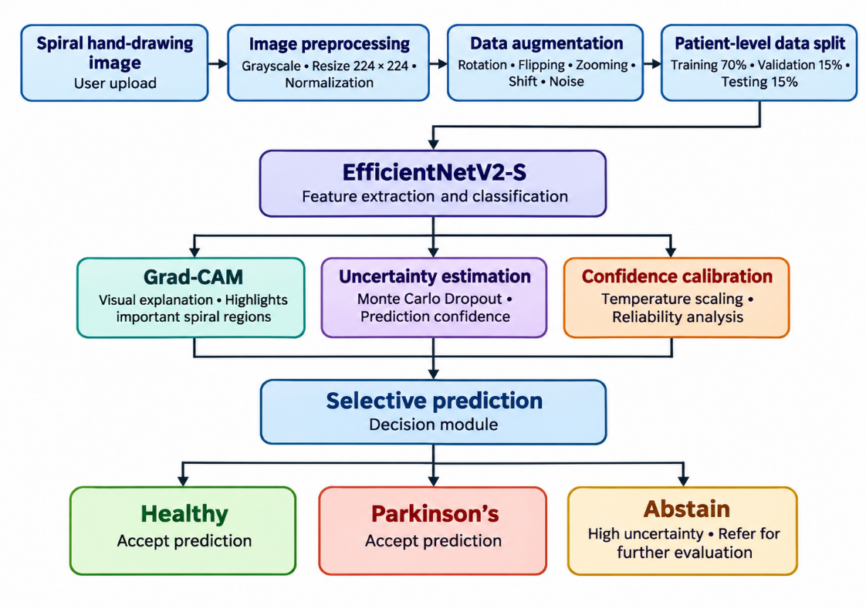
Fig. 4.1: System Architecture of SpiralSense

4.2 System Workflow
- The user uploads a hand-drawn spiral image through the SpiralSense web application.
- The system validates the uploaded image and performs preprocessing, including grayscale conversion, resizing to 224 × 224 pixels, and normalization.
- During model training, data augmentation techniques such as rotation, flipping, zooming, shifting, and noise addition are applied to improve the model's generalization.
- The dataset is divided into training, validation, and testing sets at the patient level to reduce the possibility of data leakage.
- The preprocessed spiral images are passed to the trained EfficientNetV2-S model for feature extraction and classification into Healthy and Parkinson’s categories.
- The Grad-CAM module generates heat maps to highlight important regions of the spiral image that influence the model's prediction.
- The uncertainty estimation module uses Monte Carlo Dropout to analyse prediction variations, while temperature scaling is applied to calibrate the predicted probabilities.
- The selective prediction module analyses the classification results and uncertainty information to accept a Healthy or Parkinson’s prediction or abstain when uncertainty is high.
- The Flask-based application displays the final prediction, confidence score, uncertainty estimate, and Grad-CAM visualization through the user interface.

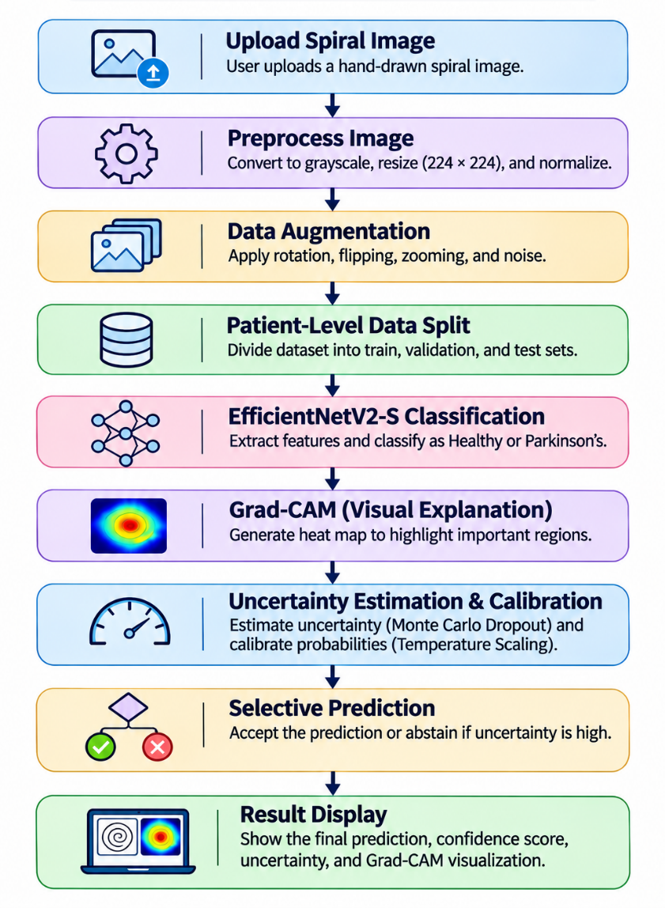
Fig. 4.2: System Workflow of SpiralSense.

4.3 Module Description

The proposed SpiralSense system is divided into the following modules, each performing a specific function in the Parkinson’s disease screening process.
- Spiral-Image Input Module: Receives hand-drawn spiral images uploaded by users through the web application. It validates the uploaded image and prepares it for further processing.
- Dataset and Label Verification Module: Checks whether the spiral images have the correct Healthy or Parkinson’s labels and verifies participant identifiers wherever available. This helps maintain dataset consistency.
- Preprocessing Module: Performs image preprocessing operations such as grayscale conversion, resizing images to 224 × 224 pixels, and normalization to make them suitable for model input.
- Patient-Level Splitting Module: Divides the dataset into training, validation, and testing partitions based on participant identity. This prevents images from the same participant from appearing in different partitions and reduces data leakage.
- EfficientNetV2-S Classification Module: Uses the pretrained EfficientNetV2-S architecture with transfer learning to extract meaningful features from spiral images and classify them into Healthy or Parkinson’s categories.
- Grad-CAM Explanation Module: Generates visual heat maps using Gradient-weighted Class Activation Mapping (Grad-CAM) to highlight important regions of the spiral image that influence the model's prediction.
- Uncertainty Estimation Module: Uses Monte Carlo Dropout to estimate prediction uncertainty by performing multiple forward passes. It helps identify ambiguous predictions and assess their reliability.
- Evaluation and Reporting Module: Evaluates the model using accuracy, precision, recall, sensitivity, specificity, F1-score, ROC-AUC, and confusion matrix. It provides a comprehensive assessment of the model's classification performance.

CHAPTER-5
DATA DESCRIPTION

- DATA DESCRIPTION

Dataset Name
The proposed SpiralSense: Explainable and Uncertainty-Aware Deep Learning for Parkinson’s Disease Screening Using Spiral Hand Drawings uses spiral hand-drawing images to identify visual patterns associated with Parkinson’s disease. The dataset referenced in the project documentation is the Parkinson’s Drawings Dataset (Spiral and Wave), available through Kaggle under the name kmader/parkinsons-drawings. It contains drawings collected from healthy individuals and individuals diagnosed with Parkinson’s disease.
The project specifically focuses on spiral drawing images because changes in fine motor control may affect the smoothness, consistency, curvature, and shape of hand-drawn spirals. These visual characteristics can be analysed using deep-learning techniques to distinguish between Healthy and Parkinson’s categories.
The project initially considered 102 primary spiral images, consisting of 51 Healthy images and 51 Parkinson’s images. The dataset was subsequently expanded during project development. The implementation documentation records an expanded dataset containing 330 images. The NewHandPD dataset is also referenced as a supplementary dataset for external evaluation. The main classification task in SpiralSense is restricted to two categories: Healthy and Parkinson’s.

5.2 Dataset Size
The expanded dataset used in the project documentation consists of 330 spiral drawing images belonging to two different classes. The dataset contains 191 Healthy images and 139 Parkinson’s images. These images provide the input data required for training, validation, and testing the proposed EfficientNetV2-S model.
The dataset includes a greater number of Healthy images compared with Parkinson’s images. Therefore, the class distribution is not perfectly balanced. To address the effect of this imbalance during model training, class weighting is incorporated into the training process so that the model gives appropriate importance to both categories.
Class | Number of Images | Percentage
Healthy | 191 | 57.88%
Parkinson’s | 139 | 42.12%
Total | 330 | 100%

Table 5.1: Dataset Class Distribution

Description
Dataset division is an important stage in developing a deep-learning-based classification system. The available images are separated into three partitions: training, validation, and testing. Each partition performs a different role in the development and evaluation of the proposed SpiralSense model.
The training dataset is used to train the EfficientNetV2-S model by allowing it to learn relevant visual features from spiral drawings. The validation dataset is used to monitor model performance during training and support model selection and parameter tuning. The testing dataset is kept for evaluating the final model using images not used during model training.

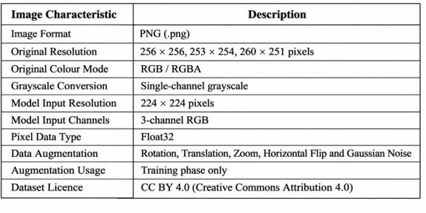
Table 5.2: Image Characteristics
The training partition contains 137 images, the validation partition contains 95 images, and the testing partition contains 98 images. The division provides separate datasets for model learning, validation, and final performance assessment.
During dataset preparation, filename-based grouping and SHA-256 duplicate checks are documented to help organize the images and identify duplicate files. Participant-level separation is important in this project because images from the same participant appearing in multiple partitions could lead to data leakage and overly optimistic evaluation results. Therefore, the final split should be verified against participant identifiers before claiming that complete patient-level separation has been achieved.

.

Division of Images

Table 5.3: Division of Images in the Dataset

Dataset Partition | Healthy Images | Parkinson’s Images | Total Images | Percentage
Training | 76 | 61 | 137 | 41.52%
Validation | 56 | 39 | 95 | 28.79%
Testing | 59 | 39 | 98 | 29.69%
Total Primary Dataset | 191 | 139 | 330 | 100%
External Evaluation (NewHandPD) | 140 | 124 | 264 | External

Sample Images in the dataset

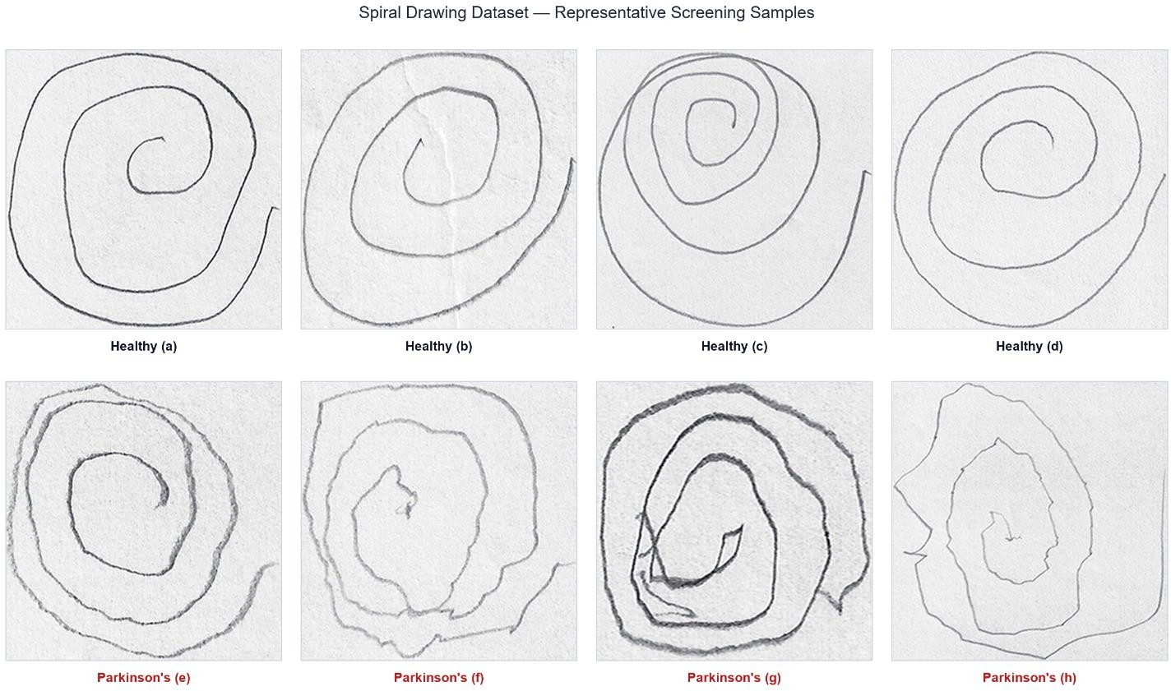

Fig 5.4: Sample Images in the Dataset

CHAPTER-6
TECHNOLOGIES

6. TECHNOLOGIES

6.1 Python
Python is a high-level, interpreted programming language widely used for software development, data processing, machine learning, and artificial intelligence applications. It is known for its simple syntax, readability, flexibility, and extensive collection of libraries. Python makes application development easier because its code is understandable and can be maintained without unnecessary complexity. It also provides a wide range of frameworks and tools that support deep learning, image processing, and backend development.
In SpiralSense, Python is used as the primary programming language for developing the Parkinson’s disease screening system. It handles the major operations involved in processing spiral hand-drawing images and generating classification results. When a user uploads a spiral drawing through the web application, Python-based backend logic manages the uploaded image, performs the required preprocessing operations, and passes the processed image to the trained deep learning model.
Python also plays an important role in developing and executing the model training pipeline. It supports operations such as dataset loading, image preprocessing, data augmentation, model construction, training, validation, and performance evaluation. The collected spiral images are processed and converted into a suitable format before being provided as input to the classification model.
Another important application of Python in SpiralSense is the integration of explainability and uncertainty estimation techniques. Python is used to implement Grad-CAM visualizations, Monte Carlo Dropout-based uncertainty estimation, and temperature scaling for confidence calibration. These techniques provide additional information about the model's predictions and help make the screening system more informative.
Python also supports backend development through the Flask framework. It connects the trained deep learning model with the web interface and manages communication between the user and the prediction system. Its flexibility and extensive ecosystem make Python a suitable programming language for developing the complete SpiralSense application.

6.2 TensorFlow and Keras
TensorFlow is an open-source machine learning and deep learning framework developed by Google. It provides tools and libraries for building, training, and deploying machine learning models. TensorFlow supports numerical computation, tensor operations, automatic differentiation, and GPU acceleration on supported platforms. It is widely used for developing neural networks and image classification applications.
Keras is a high-level deep learning API that provides a convenient way to construct and train neural network models. It offers different layers, activation functions, optimizers, loss functions, and training utilities. Keras simplifies the development process by allowing developers to define complex neural network architectures using an organized and easy-to-understand structure.
In SpiralSense, TensorFlow and Keras are used to develop the deep learning model for classifying spiral hand-drawing images into Healthy and Parkinson’s categories. They provide the required environment for loading the EfficientNetV2-S architecture, configuring the classification layers, and preparing the model for training.
The framework also supports transfer learning and fine-tuning. A pretrained EfficientNetV2-S model is used as the feature extraction backbone, and additional classification layers are incorporated to perform the binary classification task. The model is trained using the prepared spiral image dataset and evaluated using separate training, validation, and testing partitions.
TensorFlow and Keras also support model saving and loading operations. The trained model can be saved as a Keras model file and loaded later during prediction. This avoids the need to train the model whenever a user uploads a new spiral image.

Overall, TensorFlow and Keras provide the deep learning environment required for model development, training, evaluation, and deployment in SpiralSense.

6.3 EfficientNetV2-S
EfficientNetV2-S is a convolutional neural network architecture designed for efficient image classification. It belongs to the EfficientNetV2 family of deep learning models and uses optimized network design techniques to improve the balance between model accuracy, computational requirements, and training efficiency. It is suitable for image-based classification tasks where meaningful visual features must be extracted from input images.
Convolutional neural networks automatically learn important visual patterns from images through multiple layers. These patterns may include edges, shapes, textures, curves, and more complex structures. In spiral drawing analysis, such features can help identify visual variations related to drawing smoothness, irregularities, and tremor-like patterns.
In SpiralSense, EfficientNetV2-S is used as the primary deep learning architecture for Parkinson’s disease screening using spiral hand drawings. The model receives preprocessed spiral images with an input resolution of 224 × 224 pixels. Its pretrained backbone extracts relevant visual features from the images, which are then passed through additional classification layers to predict the corresponding class.
Transfer learning is used to make use of previously learned visual representations. Instead of developing the entire network from the beginning, the pretrained backbone is adapted to the spiral drawing classification task. Additional dense layers and dropout are incorporated to support classification and reduce overfitting. The final output layer uses a sigmoid activation function to produce a probability for the binary classification task.
The model is trained and evaluated using the prepared dataset containing Healthy and Parkinson’s spiral images. During prediction, the output probability is used to determine the predicted category according to the configured decision threshold.
EfficientNetV2-S therefore acts as the main classification component of SpiralSense. It automatically extracts image features and performs binary classification, reducing the need for manually designed image features..

6.4 Required Libraries
Python libraries provide additional functionality required for developing and operating SpiralSense. They reduce the need to implement every operation from the beginning and make it easier to perform image processing, numerical computation, model evaluation, and visualization. Different libraries are used for specific operations within the project.
NumPy is a Python library used for numerical computation and array manipulation. It provides support for multidimensional arrays and mathematical operations. In SpiralSense, NumPy is useful for representing image data in array format, performing numerical calculations, and processing prediction outputs generated by the deep learning model.
Pandas is a data manipulation and analysis library used for organizing structured information. It provides DataFrame structures that help manage tabular data. In the project, Pandas can be used for handling dataset information, organizing evaluation results, and preparing performance-related records.
OpenCV is an open-source computer vision library used for image processing and computer vision operations. It provides functions for reading, resizing, manipulating, and visualizing images. In SpiralSense, OpenCV is used for image-related operations, particularly in preparing Grad-CAM heatmaps and combining them with the original spiral images to generate visual explanations.
Pillow is a Python imaging library used for opening, handling, and converting image files. It supports different image formats and provides image manipulation operations. In SpiralSense, Pillow supports image loading and handling during the image upload and preprocessing process.
Scikit-learn is a machine learning library that provides tools for model evaluation, data processing, and statistical analysis. It includes functions for calculating classification performance metrics. In SpiralSense, it is used to evaluate the model using measures such as accuracy, precision, recall, F1-score, and ROC-AUC. These metrics help understand the classification performance of the proposed model.
Together, these libraries provide the supporting functionality required for image processing, numerical operations, dataset management, visualization, and model evaluation in SpiralSense.

6.5 Flask
Flask is a lightweight Python web framework used for developing web applications and backend services. It provides the basic functionality required to handle HTTP requests, define application routes, process user inputs, and return responses. Its simple structure makes it suitable for applications that need to integrate Python-based processing with a web interface.
In SpiralSense, Flask is used to develop the backend of the Parkinson’s disease screening web application. It acts as the communication layer between the frontend interface and the trained EfficientNetV2-S model. When a user uploads a spiral hand-drawing image, Flask receives the uploaded file and passes it to the prediction component for further processing.
The backend validates the uploaded image and coordinates the required operations. These include image preprocessing, model prediction, confidence calculation, uncertainty estimation, and Grad-CAM visualization. After processing is completed, the application prepares the prediction results and makes them available to the frontend.
Flask also manages the application routes required for handling user interactions. For example, the prediction endpoint receives the uploaded image and returns the corresponding prediction information. The response can include the predicted category, confidence score, uncertainty value, and visualization details.
Another advantage of Flask is its flexibility. It can integrate different Python libraries and machine learning components within a single application. This makes it easier to connect the trained deep learning model with image-processing operations and explainability techniques.
Overall, Flask provides the backend environment for deploying the SpiralSense model as an interactive web application. It allows users to upload spiral images and view the generated screening results through a user-friendly interface.

6.6 Grad-CAM and Uncertainty Estimation
Grad-CAM (Gradient-weighted Class Activation Mapping) is an explainable artificial intelligence technique used to understand the regions of an input image that influence a deep learning model's prediction. It generates a visual heatmap by using gradient information associated with the selected class. The heatmap highlights important image regions and helps users understand which areas contributed to the model's classification decision.
In SpiralSense, Grad-CAM is used to generate visual explanations for the predictions produced by the EfficientNetV2-S model. When a spiral image is classified, Grad-CAM generates a heatmap that highlights the regions contributing to the prediction. This heatmap is combined with the original spiral image to create an overlay visualization. The resulting image provides a visual representation of the regions that influenced the model's decision.
Uncertainty estimation is another important component of the proposed system. A deep learning model may produce predictions even when the input image is unclear or contains patterns that are difficult to classify. Therefore, examining only the predicted class or confidence score may not provide sufficient information about the reliability of a prediction.
Monte Carlo Dropout is used in SpiralSense to estimate prediction uncertainty. It performs multiple stochastic forward passes through the model while dropout remains active. The predictions obtained from these repeated passes are analyzed to calculate the mean prediction and variation among the outputs. The variation, measured using standard deviation, provides an estimate of model uncertainty.
Temperature Scaling is a confidence calibration technique used to adjust the predicted probabilities of a classification model. It applies a learned temperature parameter to the model's output logits before converting them into probabilities. This helps improve the alignment between the model's predicted confidence and its observed prediction accuracy.
Selective prediction is also incorporated into SpiralSense to handle predictions associated with higher uncertainty. Based on the configured decision criteria, the system can provide a predicted category or indicate that the prediction requires caution when uncertainty is high. This approach helps communicate potentially unreliable predictions rather than presenting every result with the same level of confidence.
The combination of Grad-CAM, Monte Carlo Dropout, Temperature Scaling, and Selective Prediction makes SpiralSense more informative by providing visual explanations, uncertainty estimates, and calibrated confidence information alongside the classification result.

6.7 Frontend Technologies
Frontend technologies are used to develop the user interface of a web application. They define the structure, appearance, and interactive behaviour of the application. A well-designed frontend helps users access different features easily and improves the overall user experience. In SpiralSense, HTML, CSS, and JavaScript are used to develop the web interface through which users interact with the Parkinson’s disease screening system.
HTML (HyperText Markup Language) is the standard markup language used to create the structure of web pages. It defines elements such as headings, paragraphs, buttons, forms, input fields, and image containers. In SpiralSense, HTML is used to organize the different sections of the application, including the image upload area, prediction results, confidence information, and Grad-CAM visualization. It provides the basic structure required for users to interact with the screening system.
CSS (Cascading Style Sheets) is used to control the visual appearance and layout of web pages. It allows developers to apply colours, fonts, spacing, backgrounds, borders, and responsive layouts. In SpiralSense, CSS is used to design an attractive and organized interface. It helps improve the presentation of image upload sections, buttons, result displays, and visualization areas. It also maintains a consistent appearance throughout the application.
JavaScript is a scripting language used to add interactive functionality to web pages. It allows the application to respond to user actions and dynamically update displayed information. In SpiralSense, JavaScript is used to handle image upload interactions, communicate with the Flask backend, and display prediction results received from the deep learning model. It helps update the interface with the predicted category, confidence score, uncertainty information, and Grad-CAM visualization.
The combination of HTML, CSS, and JavaScript provides the frontend environment for SpiralSense. HTML defines the structure of the application, CSS manages its visual presentation, and JavaScript handles interactive operations. Together, these technologies create a user-friendly web interface that allows users to upload spiral hand-drawing images and view the screening results generated by the proposed deep learning model.
The frontend also helps improve the accessibility and usability of the SpiralSense application by providing clear instructions and organized interface elements. Users can easily identify the image upload option, submit their spiral drawings, and understand the information displayed on the results page. Proper arrangement of buttons, headings, and result sections makes the application easier to navigate and reduces unnecessary complexity during the screening process.
Another important aspect of frontend development is error handling and user feedback. The interface can display appropriate messages when an unsupported image format is uploaded, when an image is missing, or when the prediction process encounters an error. These messages help users understand the issue and take the necessary action. Providing clear feedback improves the interaction between users and the application and contributes to a smoother screening experience.

6.8 Development Tools
Development tools are software applications and utilities that help developers write, organize, execute, test, and maintain application code. They play an important role throughout the software development process. SpiralSense uses development tools to support model development, backend implementation, debugging, and source-code Visual Studio Code is a source-code editor used to develop and manage the project files. It supports Python programming and provides features such as syntax highlighting, code completion, integrated terminal access, and debugging support. These features help developers work with different Python modules, manage project folders, and execute application scripts.
Git is a version control system used to track changes made to the source code. It allows developers to maintain different versions of the project and review modifications over time. Git is useful for managing updates to model implementation, image-processing modules, and web application files.
GitHub is a platform used to host Git repositories and support collaborative software development. It provides a central location for storing project source code, maintaining development history, and sharing updates among team members. It also supports collaboration through branches, commits, and pull requests.
Windows is the operating system used as the development environment for the project. It provides the environment required to install Python, manage dependencies, execute scripts, and run the Flask web application. The integrated terminal and PowerShell can be used to execute commands and manage the project environment.
A web browser is used to access and test the SpiralSense application. It allows users to interact with the frontend, upload spiral images, and view the generated prediction results. Browser developer tools can also assist in identifying interface-related errors during testing.
Environment variables are used to manage sensitive configuration values and application settings. They help keep important configuration details separate from the main source code and reduce the risk of exposing sensitive information.
Overall, these development tools support the implementation, testing, debugging, and maintenance of SpiralSense. They provide an organized development environment for building and managing the complete Parkinson’s disease screening application.

CHAPTER-7
IMPLEMENTATION

- IMPLEMENTATION

7.1 Development Environment and Dependencies
The SpiralSense project is developed in a 64-bit Windows environment using Python 3.11. The development environment is configured with the required libraries and dependencies for deep learning, image processing, and web application development. TensorFlow and Keras are used for building and training the EfficientNetV2-S classification model. NumPy, OpenCV, Pillow, and Scikit-learn support image processing and model evaluation. Flask is used to integrate the trained model with the web application.
SpiralSense Environment Setup & Verified Imports:
python -m venv .venv311
.venv311\Scripts\activate # On Windows
pip install --upgrade pip
pip install tensorflow keras opencv-python pillow scikit-learn matplotlib flask pandasfrom flask import Flask, jsonify, render_template, request, url_for
Verified Module Imports:
import os
import cv2
import numpy as np
import pandas as pd
import tensorflow as tf
from tensorflow.keras.applications import EfficientNetV2S
from PIL import Image
import matplotlib.pyplot as plt

from sklearn.metrics import accuracy_score, roc_auc_score, confusion_matrix
from flask import Flask, request, jsonify

7.2 Dataset Preparation and Verification

The project uses 102 primary spiral images (51 Healthy and 51 Parkinson’s), divided into 72 training and 30 testing images. An expanded dataset of 330 images was also prepared, with 137 training, 95 validation, and 98 testing images. Filename-based grouping and SHA-256 hashing were used to check data overlap and duplicate images.
Dataset Verification and Partition Manifest Loading:
# Load corrected split manifest and verify participant leakage
import pandas as pd
from pathlib import Path
manifest_path = Path("data/processed/dataset_split_corrected.csv")
df = pd.read_csv(manifest_path)
train_df = df[df["split"] == "train"] # 137 images (76 Normal, 61 PD)
val_df = df[df["split"] == "validation"] # 95 images (56 Normal, 39 PD)
test_df = df[df["split"] == "test"] # 98 images (59 Normal, 39 PD)

# Verify filename-derived participant groupings have zero overlap
train_groups = set(train_df["group"])
test_groups = set(test_df["group"])
assert len(train_groups.intersection(test_groups)) == 0, \
"Data leakage detected!"

print(f"Verified {len(df)} total images partitioned across 3 disjoint subsets.")

7.3 Image Preprocessing and Data Augmentation
The image preprocessing pipeline prepares spiral hand-drawing images in a suitable format for the EfficientNetV2-S classification model. The input images are resized to 224 × 224 pixels and converted into three-channel RGB format to maintain compatibility with the model architecture. Image preprocessing helps maintain a consistent input size and representation during model training and prediction. Data augmentation techniques such as rotation, translation, zooming, horizontal flipping, and Gaussian noise are used to introduce variations in the training images. These augmentation operations are applied only during training to improve model generalization and reduce overfitting.
Code Snippet:
# Image preprocessing pipeline
import tensorflow as tf
def preprocess_image(image_bytes):
image = tf.io.decode_image(
image_bytes,
channels=1,
expand_animations=False
)
image = tf.image.resize(
image, (224, 224), method="bilinear"
)

image = tf.cast(image, tf.float32)
# Convert grayscale image to three-channel RGB
image = tf.image.grayscale_to_rgb(image)
return image

# Training-only data augmentation
augmentation_layer = tf.keras.Sequential([
tf.keras.layers.RandomRotation(0.04),
tf.keras.layers.RandomTranslation(0.04, 0.04),
tf.keras.layers.RandomZoom(0.08),
tf.keras.layers.RandomFlip("horizontal"),
tf.keras.layers.GaussianNoise(1.0)
], name="training_augmentation")

7.4 EfficientNetV2-S Model Construction
The SpiralSense project uses the EfficientNetV2-S architecture with pretrained ImageNet weights for spiral image classification. A custom classification head is added to the pretrained backbone using Global Average Pooling, dropout, and dense layers. The model accepts input images of size 224 × 224 pixels with three colour channels. The classification head contains a dense layer with 128 neurons and ReLU activation, followed by a dropout layer to reduce overfitting. Finally, a sigmoid activation function is used in the output layer to classify spiral drawings into Healthy and Parkinson’s categories.
EfficientNetV2-S Transfer Learning Model Construction:
import tensorflow as tf
from src.common import load_config
def build_model():
cfg = load_config()
size = tuple(cfg["image_size"])
inputs = tf.keras.Input(
shape=(*size, 3),
name="spiral_rgb_224"
)
backbone = tf.keras.applications.EfficientNetV2S(
include_top=False,
weights="imagenet",
input_shape=(*size, 3),
include_preprocessing=True
)
backbone.trainable = False
x = backbone(inputs, training=False)
x = tf.keras.layers.GlobalAveragePooling2D(
name="global_average_pooling"
)(x)
x = tf.keras.layers.Dropout(
cfg["dropout_rate"],
name="classifier_dropout"
)(x)
x = tf.keras.layers.Dense(
128,
activation="relu",
name="feature_dense"
)(x)
x = tf.keras.layers.Dropout(
cfg["dropout_rate"],
name="mc_dropout"
)(x)
outputs = tf.keras.layers.Dense(
1,
activation="sigmoid",
name="pd_probability"
)(x)

model = tf.keras.Model(
inputs, outputs,
name="parkinsons_efficientnetv2s"
)

return model, backbone

7.5 Model Training and Fine-Tuning
The EfficientNetV2-S model is trained using a two-phase transfer-learning approach. In the first phase, the pretrained backbone is kept frozen while the custom classification head is trained using the training dataset. In the second phase, the backbone is partially unfrozen, and the selected final layers are fine-tuned using a lower learning rate. Batch Normalization layers are kept frozen to maintain training stability on the relatively small dataset. Validation monitoring, early stopping, learning-rate reduction, and model checkpointing are used to monitor performance and preserve the best model based on validation AUC.
Two-Phase Transfer Learning and Model Fine-Tuning:
# Phase 1: Train classification head
backbone.trainable = False
model.compile(
optimizer=tf.keras.optimizers.Adam(
cfg["phase1_learning_rate"]
),
loss="binary_crossentropy",
metrics=[
tf.keras.metrics.BinaryAccuracy(name="accuracy"),
tf.keras.metrics.AUC(name="auc"),
tf.keras.metrics.Precision(name="precision"),
tf.keras.metrics.Recall(name="recall")
]
)
hist1 = model.fit(
train_ds,
validation_data=val_ds,
epochs=cfg["phase1_epochs"],
callbacks=callbacks
)
# Phase 2: Fine-tune selected backbone layers
backbone.trainable = True
n = max(1, int(cfg["fine_tune_last_layers"]))
for layer in backbone.layers[:-n]:
layer.trainable = False

for layer in backbone.layers:
if isinstance(layer, tf.keras.layers.BatchNormalization):
layer.trainable = False

model.compile(
optimizer=tf.keras.optimizers.Adam(
cfg["phase2_learning_rate"]
),
loss="binary_crossentropy",
metrics=[
tf.keras.metrics.BinaryAccuracy(name="accuracy"),
tf.keras.metrics.AUC(name="auc"),
tf.keras.metrics.Precision(name="precision"),
tf.keras.metrics.Recall(name="recall")
]
)

Model Evaluation and Checkpoint Saving
The trained EfficientNetV2-S model is saved in the artifacts/ directory for future evaluation and prediction. The model is evaluated using a separate testing dataset containing 98 spiral images, consisting of 59 Healthy and 39 Parkinson’s samples. A decision threshold of 0.50 is applied to classify the predicted probabilities into Healthy and Parkinson’s categories. The evaluation results are analyzed using a confusion matrix and performance metrics such as accuracy, precision, sensitivity, specificity, F1-score, and ROC-AUC. The model correctly classifies 41 Healthy samples and 38 Parkinson’s samples, with 18 false positives and 1 false negative. It achieves an accuracy of 80.61% and a sensitivity of 97.44%, demonstrating its ability to identify Parkinson’s samples.
Code Snippet:
import numpy as np
import tensorflow as tf
import matplotlib.pyplot as plt

from sklearn.metrics import (
confusion_matrix,
accuracy_score,
precision_score,
recall_score,
f1_score,
roc_auc_score,
ConfusionMatrixDisplay
)
# Load the trained model
model = tf.keras.models.load_model(
"artifacts/best_model.keras"
)
# Generate predictions
y_true = []
y_prob = []

for images, labels in test_ds:
predictions = model.predict(images, verbose=0)

y_true.extend(labels.numpy().ravel())
y_prob.extend(predictions.ravel())

y_true = np.array(y_true)
y_prob = np.array(y_prob)

# Apply decision threshold
threshold = 0.58
y_pred = (y_prob >= threshold).astype(int)

# Calculate evaluation metrics
accuracy = accuracy_score(y_true, y_pred)
precision = precision_score(y_true, y_pred, zero_division=0)
recall = recall_score(y_true, y_pred, zero_division=0)
f1 = f1_score(y_true, y_pred, zero_division=0)
auc = roc_auc_score(y_true, y_prob)

# Generate confusion matrix
cm = confusion_matrix(y_true, y_pred)

print("Decision Threshold:", threshold)
print("Accuracy:", accuracy)
print("Precision:", precision)
print("Sensitivity:", recall)
print("F1 Score:", f1)
print("ROC-AUC:", auc)
print("Confusion Matrix:\n", cm)

# Save confusion matrix visualization
disp = ConfusionMatrixDisplay(
confusion_matrix=cm,
display_labels=["Healthy", "Parkinson's"]
)
disp.plot(cmap="Blues", values_format="d")
plt.title("Confusion Matrix (Threshold = 0.58)")
plt.savefig(
"artifacts/confusion_matrix_058.png",
dpi=300,
bbox_inches="tight"
)
plt.close()

7.7 Grad-CAM Explainability Implementation
Grad-CAM (Gradient-weighted Class Activation Mapping) is implemented in the src/gradcam_explain.py module to provide visual explanations for the predictions generated by the EfficientNetV2-S model. It uses gradients of the target class score with respect to the final convolutional feature maps of the model. The top_conv layer is used to identify important image regions that contribute to the prediction. The generated heatmap is normalized and converted into a colour representation using the OpenCV JET colour map. Finally, the heatmap is blended with the original spiral drawing using an opacity value of 0.40, allowing users to visualize the regions influencing the model's prediction.
Grad-CAM Overlay Generation:
# Create Grad-CAM overlay

original_array = (
np.asarray(
original_image,
dtype=np.float32
) / 255.0
)

colored_heatmap = plt.get_cmap("jet")(
heatmap_array
)[..., :3]

overlay = np.clip(
0.60 * original_array
+ 0.40 * colored_heatmap,
0.0,
1.0
)

plt.figure(figsize=(7, 7))
plt.imshow(overlay)
plt.axis("off")
plt.title("Grad-CAM: Parkinson's Screening")
plt.tight_layout()

plt.savefig(
overlay_path,
bbox_inches="tight",
dpi=200
)
plt.close()

7.8 Uncertainty Estimation
The SpiralSense project uses Monte Carlo (MC) Dropout in the src/predict.py module to estimate uncertainty in model predictions. The trained class-weighted EfficientNetV2-S model processes each input spiral image through 20 stochastic forward passes with dropout enabled in the classification head. The mean of these predictions represents the average probability, while variance and standard deviation measure the variation among the predictions. Temperature scaling is applied separately to calibrate the deterministic model probability using the saved temperature value from artifacts/temperature.json. The calibrated probability is compared with the decision threshold of 0.58 to determine the predicted class. These uncertainty measurements provide additional information about prediction variability and help identify potentially ambiguous drawings.
Monte Carlo Dropout and Temperature Calibration:
# Model configuration
MODEL_PATH = (
ROOT / "artifacts" /
"parkinson_effnetv2s_classweighted.keras"
)
TEMPERATURE_PATH = ROOT / "artifacts" / "temperature.json"
DEFAULT_THRESHOLD = 0.58
MC_DROPOUT_PASSES = 20

# Monte Carlo Dropout prediction
mc_predictions = []
for _ in range(MC_DROPOUT_PASSES):
probability = float(
mc_probe(image, training=False).numpy().squeeze()
)
mc_predictions.append(probability)
mc_mean = float(np.mean(mc_predictions))
mc_variance = float(
np.var(mc_predictions, ddof=0)
)
mc_std = float(
np.std(mc_predictions, ddof=0)
)
# Temperature calibration
temperature = load_temperature()
calibrated_probability = calibrate_probability(
raw_probability,
temperature
)

# Final classification
prediction = (
"PARKINSON'S"
if calibrated_probability >= threshold
else "HEALTHY"
)
7.9 Flask Web Application Integration
The SpiralSense system is integrated into a web application using the Flask framework. Flask provides backend functionality for handling image uploads and connecting the user interface with the trained EfficientNetV2-S model. When a user uploads a spiral drawing, the application validates the image format and processes it through the prediction pipeline. The system returns the predicted category, calibrated probability, uncertainty measurements, and decision threshold. Grad-CAM visualization is generated separately and its image path is included in the response. The results are returned in JSON format and displayed through the web interface.
Flask Web Application and Prediction Integration:
# Flask application configuration
app = Flask(__name__)
app.config["MAX_CONTENT_LENGTH"] = 10 * 1024 * 1024

ALLOWED_EXTENSIONS = {
"png", "jpg", "jpeg", "bmp", "webp"
}
BASE_DIR = Path(__file__).resolve().parent
UPLOAD_DIR = BASE_DIR / "uploads"
GRADCAM_DIR = BASE_DIR / "static" / "gradcam"
UPLOAD_DIR.mkdir(parents=True, exist_ok=True)
GRADCAM_DIR.mkdir(parents=True, exist_ok=True)

# Image upload validation
def allowed_file(filename):
return (
"." in filename
and filename.rsplit(".", 1)[1].lower()
in ALLOWED_EXTENSIONS
)

# Prediction endpoint
@app.post("/predict")
def predict():
if "image" not in request.files:
return jsonify({
"error": "Choose a spiral drawing image first."
}), 400

uploaded = request.files["image"]

if not uploaded or not uploaded.filename:
return jsonify({
"error": "Choose a spiral drawing image first."
}), 400

if not allowed_file(uploaded.filename):
return jsonify({
"error": "Supported formats: PNG, JPG, JPEG, BMP, WEBP."
}), 400

# Run the existing prediction pipeline
result = predict_image(
str(temp_path.resolve())
)

response_data = {
"prediction": result.get("prediction"),
"raw_pd_probability": result.get(
"raw_pd_probability"
),
"calibrated_pd_probability": result.get(
"calibrated_pd_probability"
),
"mc_dropout_mean": result.get("mc_dropout_mean"),
"mc_dropout_variance": result.get(
"mc_dropout_variance"
),
"mc_dropout_standard_deviation": result.get(
"mc_dropout_standard_deviation"
),
"decision_threshold": result.get(
"decision_threshold"
),
"temperature": result.get("temperature"),
"model": result.get("model"),
"gradcam_url": None,
"gradcam_error": None,
}

return jsonify(response_data)

CHAPTER-8
SCREENSHOTS

- SCREENSHOTS

Figure 8.1 – SpiralSense Dashboard (Initial Interface)
Initial dashboard with the image-upload section and empty preview.

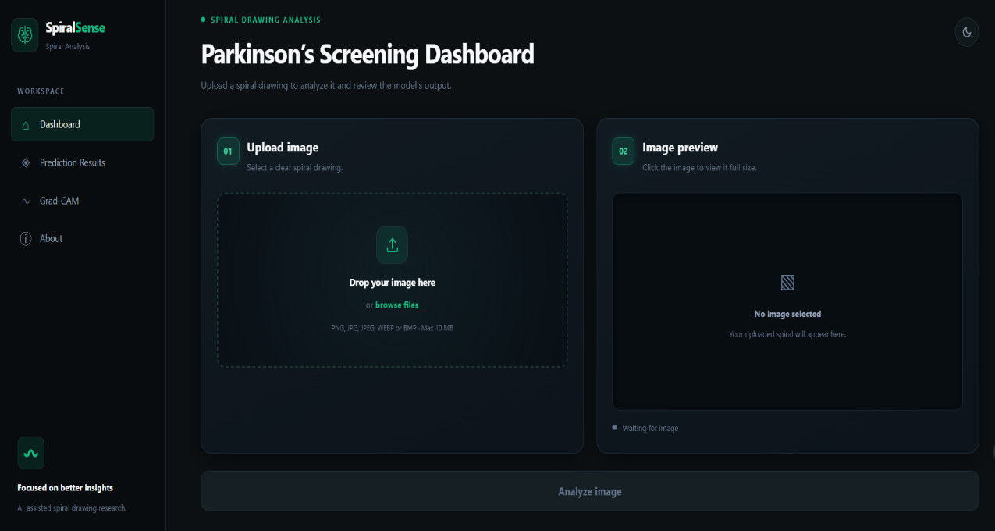

Figure 8.2 – Spiral Image Upload and Preview
Selected spiral image (V08PE01.png) displayed in the preview panel.

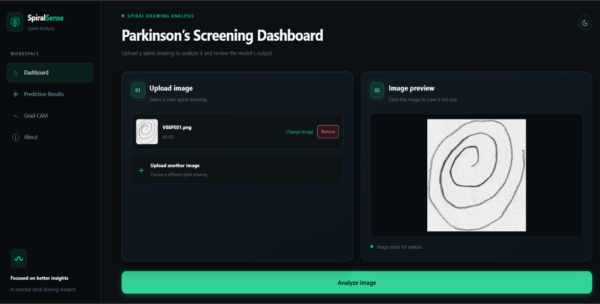

Figure 8.3 – Prediction Results

Model prediction, calibrated probability, uncertainty, and decision threshold of 0.58.

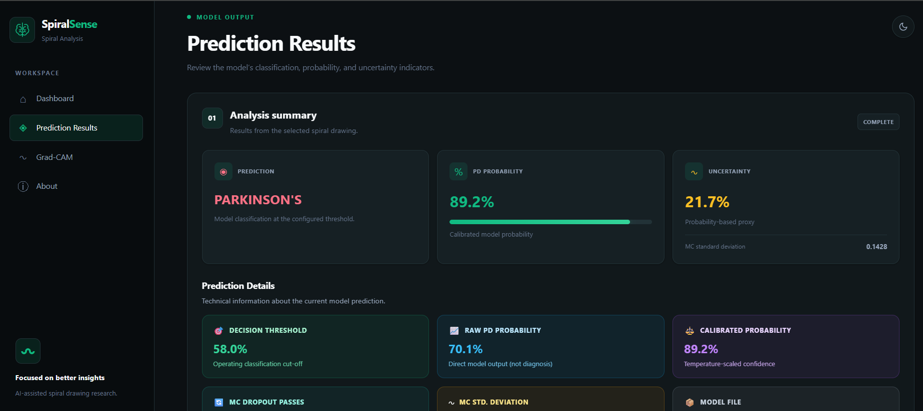

Figure 8.4 – Grad-CAM Visualization

Heatmap overlay highlighting image regions associated with the model output.

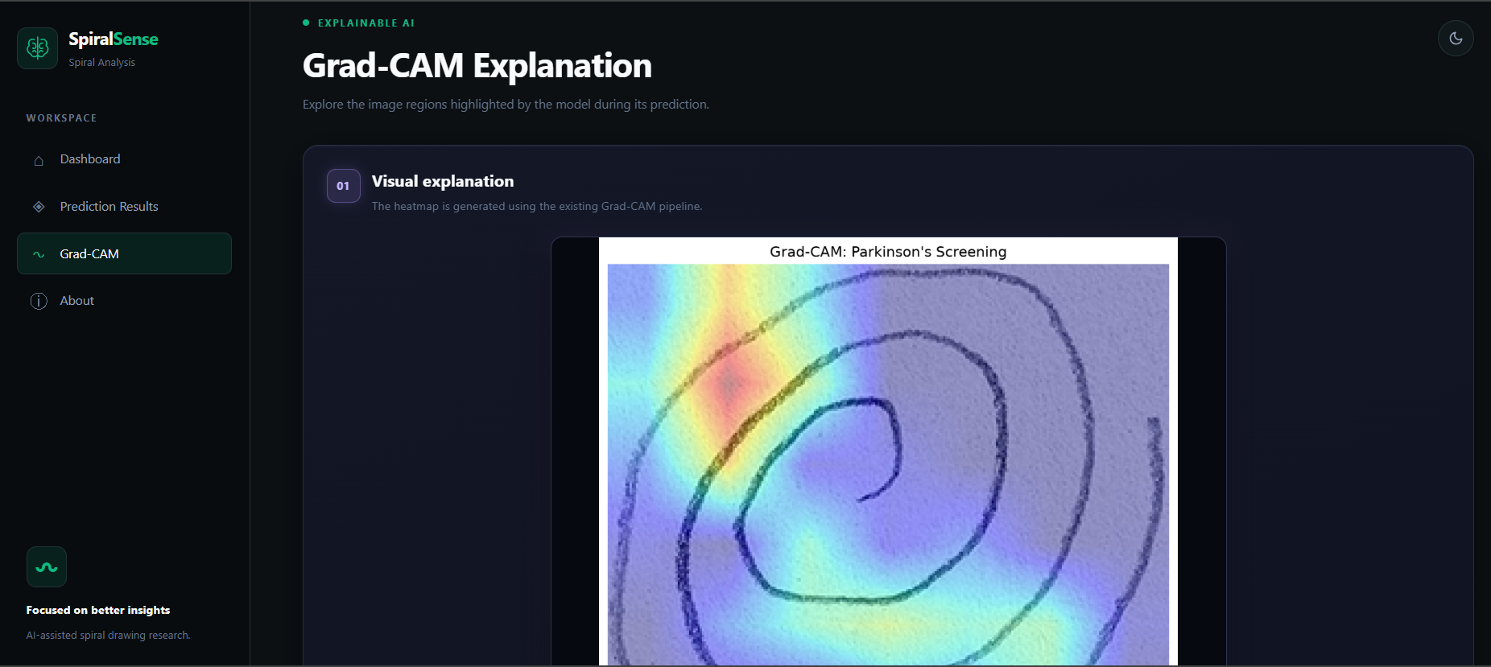

Figure 8.5 – Grad-CAM Interpretation and Activation Scale
Explanation of heatmap colours and relative activation levels.
. 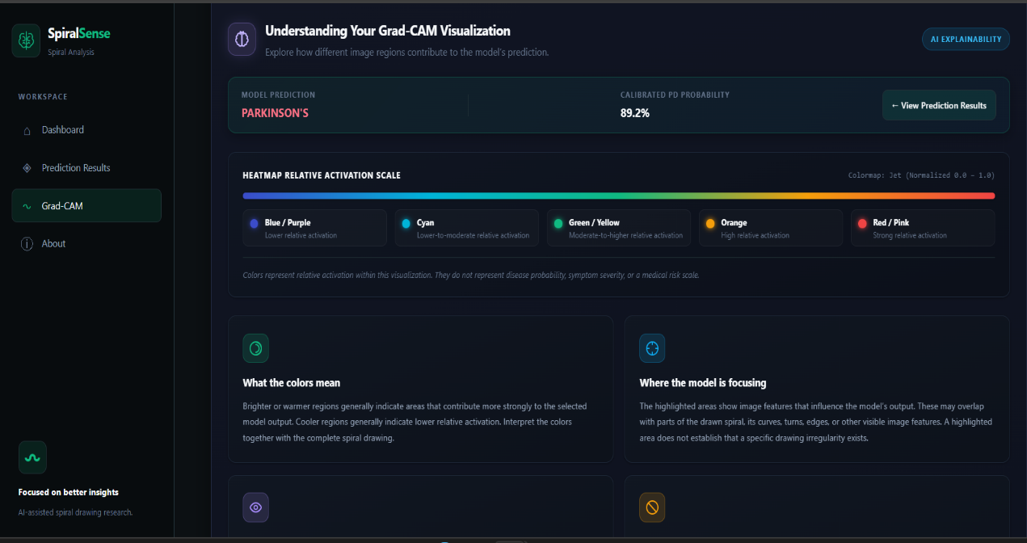

Figure 8.6 – About SpiralSense
Project overview, model approach, explainability, and responsible-use information.

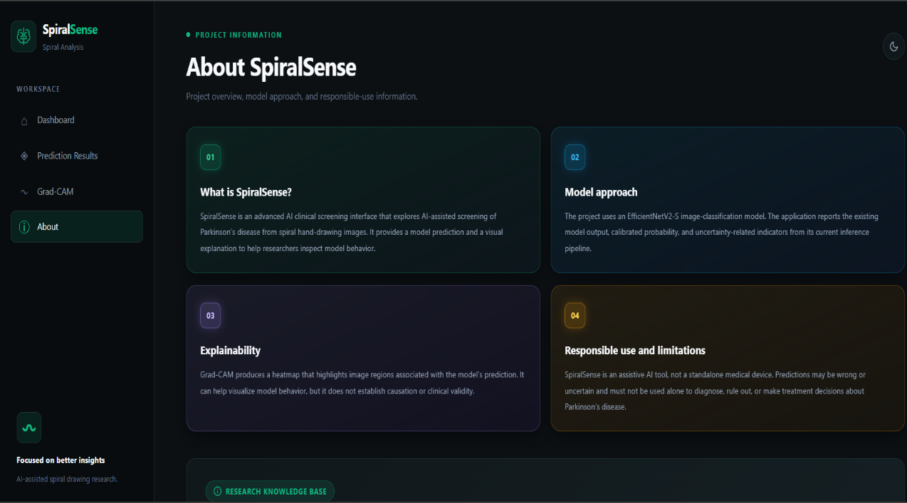

Figure 8.7 – Project Knowledge Base
Research knowledge base and FAQ categories.



Figure 8.8 – Project Technical Documentation and FAQ
Expanded FAQ showing project information and responsible-use details.

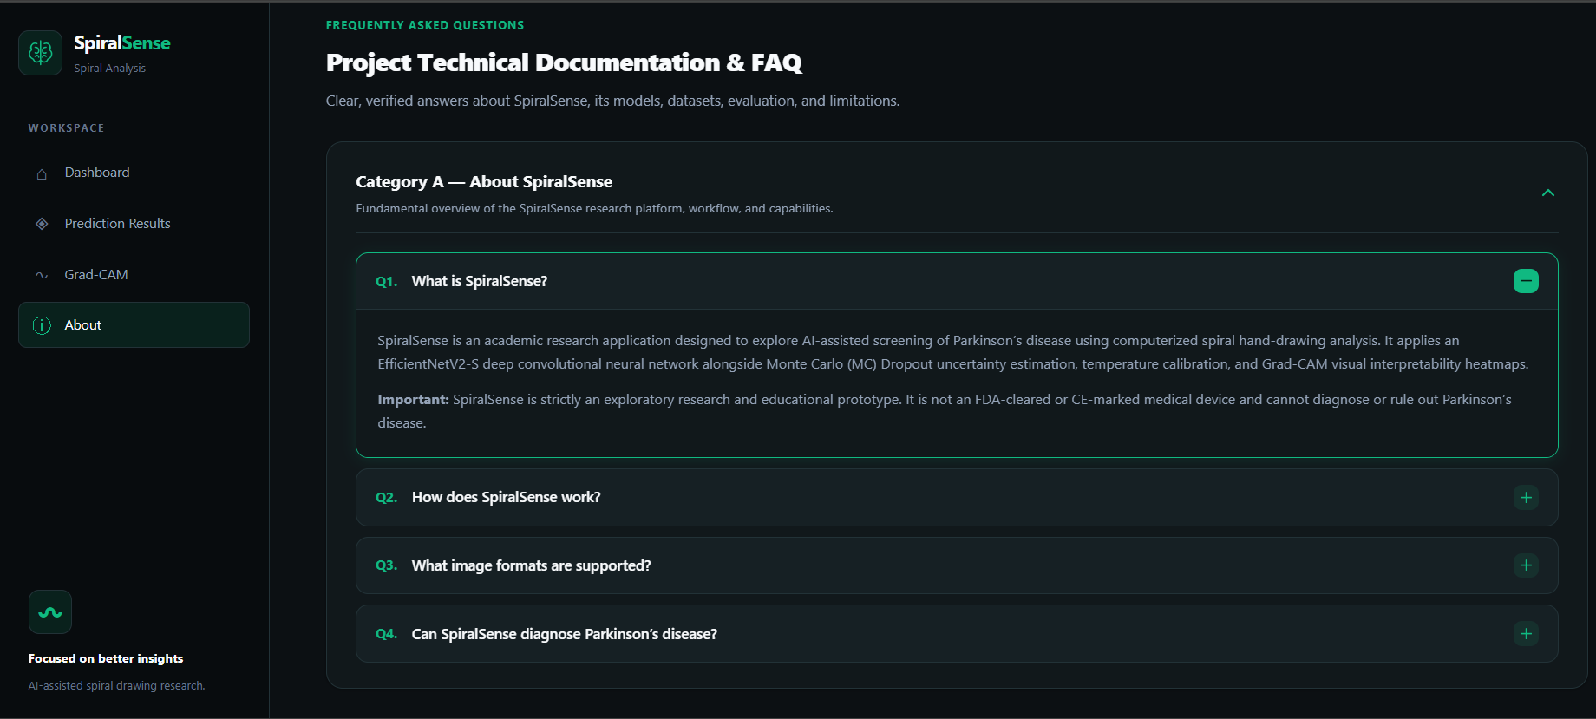

CHAPTER-9

CONCLUSION

9. CONCLUSION

9.1 Conclusion
SpiralSense is an explainable and uncertainty-aware deep-learning application developed for Parkinson’s disease screening using spiral hand drawings. It uses the EfficientNetV2-S architecture with transfer learning and fine-tuning to classify images into Healthy and Parkinson’s categories. Grad-CAM generates visual explanations through heatmaps, while Monte Carlo Dropout estimates prediction uncertainty. Temperature scaling calibrates the predicted probabilities, and a decision threshold of 0.58 is configured for classification.
SpiralSense also provides a Flask-based web interface for uploading spiral images and viewing predictions, calibrated probabilities, uncertainty information, and Grad-CAM visualizations. The model achieved 80.61% accuracy and 97.44% sensitivity on the evaluated test dataset. Overall, the application demonstrates the integration of deep learning, explainable AI, uncertainty estimation, and web technologies for spiral drawing analysis. Further evaluation using larger and more diverse datasets is required to improve reliability. SpiralSense is an academic research prototype and is not intended to replace professional medical diagnosis.

9.2 Future Work
- The dataset can be expanded by collecting more spiral hand drawings from participants belonging to different age groups and backgrounds to improve the model's ability to generalize to unseen samples.
- Advanced deep-learning architectures such as Vision Transformers, ConvNeXt, and other EfficientNet variants can be explored and compared to identify models that provide better classification performance.
- Different image preprocessing and augmentation techniques can be investigated to improve the quality and diversity of training samples and reduce overfitting.
- False-positive and false-negative predictions can be reduced through improved training strategies, class balancing techniques, and systematic decision-threshold optimization.
- The system can be extended to analyze different handwriting patterns, including spiral, wave, and other drawing-based tasks, to investigate additional motor-related characteristics.
- Further clinical evaluation can be conducted in collaboration with medical professionals to examine the practical relevance and limitations of the proposed screening approach.
- A multimodal learning approach can be developed by combining spiral drawings with handwriting samples, voice recordings, and other relevant data to provide a more comprehensive analysis.

9.3 References
[1] K. Rezaee and A. K. Fakhrabadi, “Clinically Deployable Handwriting Biomarkers of Parkinson’s Disease via Multiscale Attention and Bayesian-Genetic Optimization,” Brain and Behavior, 2026 https://doi.org/10.1002/brb3.71457.
[2] A. Bensefia, C. Djeddi, and A. Hannousse, “Parkinson Disease Detection via Handwriting Analysis,” in Proceedings of the International Conference on Machine Learning Technologies, pp. 510–514, May 2025 https://doi.org/10.1109/ICMLT65785.2025.11193333.
[3] S. P. Sasirekha, R. Shankar, and S. Duraisamy, “Parkinson’s Disease Detection Using Advanced Wave Signal Processing on Spiral Drawing Tests,” Communications in Computer and Information Science, Jan. 2025
https://doi.org/10.1007/978-3-031-86290-8_3.
[4] A. Benséfia, A. Zarrad, and N. A. Hashalamon, “Vision Transformer-Based Classification of Parkinson’s Disease Using Hand-Drawn Spiral Patterns,” pp. 25–30, Nov. 2025 https://doi.org/10.1109/ITT69610.2025.11352923.
[5] Shanthappa, Bayari, Abhilash, Gokul, and Ashish, “Parkinson’s Disease Detection Using InceptionV3: A Deep Learning Approach,” MethodsX, 2025 https://doi.org/10.1016/j.mex.2025.103333.
[6] E. Wu, “Finger Drawing on Smartphone Screens Enables Early Parkinson’s Disease Detection Through Hybrid 1D-CNN and BiGRU Deep Learning Architecture,” PLOS ONE, vol. 20, no. 7, July 2025 https://doi.org/10.1371/journal.pone.0327733.
[7] S. Laouedj, Y. Wang, J. Villalba, T. Thebaud, L. Moro-Velázquez, and N. Dehak, “Detecting Neurodegenerative Diseases Using Frame-Level Handwriting Embeddings,” arXiv preprint arXiv:2502.07025, Feb. 2025 https://arxiv.org/abs/2502.07025.
[8] Khedimi et al., “Architecture-Aware Augmentation: A Hybrid Deep Learning and Machine Learning Approach for Enhanced Parkinson’s Disease Detection,” Bioengineering, vol. 11, no. 12, 2024 https://doi.org/10.3390/bioengineering11121218.
[9] N. B. Reddy, P. Venkat, G. Rohith, and S. Murugaveni, “Enhancing Spiral and Wave Drawing Analysis for Parkinson’s Disease Diagnosis Using VGG19 with Attention Mechanism,” Apr. 2024 https://doi.org/10.1109/RAEEUCCI61380.2024.10547766.
[10] M. Kasab, N. A. Masri, and R. A. Moghrabi, “Detection of Parkinson’s Disease Through Spiral Drawings Using Convolutional Autoencoders,” pp. 1–5, Nov. 2024 https://doi.org/10.1109/IC2SPM62723.2024.10841337.

