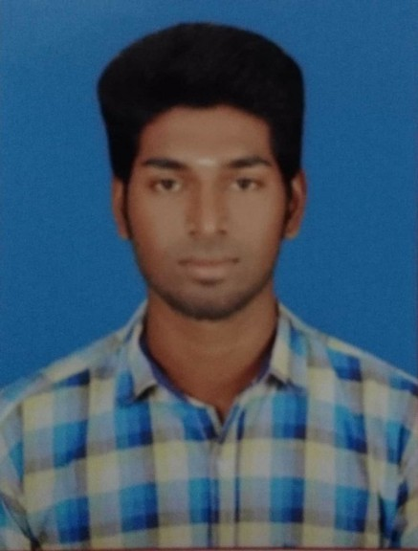  Address :  C/16 ,Upplipalayam Police quarters, Avinashi Road,  Coimbatore.  Phone:  - 7200626615  Email:  barrani1723@gmail.com  Specialties  - Site Engineer  - Quality Surveyor  Engineering Tools  - Operating System: Windows 7, 2007, XP  - MS Office  - Auto Cadd  - Revit Architecture  - 3d’s Max  - Staad Pro |  | BARRANI RAJA RS , BE  Civil Engineer Specializing in the Construction Industry  - BE-civil engineer with more than 2.5 years of experience in the design and management of complex development projects.  - Good extensive exposure in Multi Storied Building.  - Handling Coordination with drawings, Planning and Quantity Control and Monitoring the Execution work.  Professional Experience  V Gud Solution, Coimbatore  Civil Engineer, 05/17 to Present  - Recruited to provide civil engineering design and management of development projects  - Completed civil engineering initiatives that planning, executing of construction works  - Prepared construction and environmental compliance documents; developed grading plans, cost estimates and bid specifications; and provided construction oversight, environmental sampling and site reconnaissance.  - Ensured the safe, cost-effective and timely completion of all projects to meet or exceed client expectations.  - Maintained excellent relationships and stayed in constant contact with all clients, which proved instrumental in generating additional project work.  Sree Daksha Construction Pvt Ltd., Coimbatore  Site Engineer, 09/15 to 04/17  - Prepared construction and environmental compliance documents; developed grading plans, cost estimates and bid specifications; and provided construction oversight, environmental sampling and site reconnaissance  - Execution of Site work  - Deputation of Manpower  - Coordination with the client.  - Client Billing and Vendors Billing.  Education  Info Institute of Engineering, Coimbatore  BE in Civil Engineering , 2015  - Honors & Activities: Won First price in dance competition  - BE (Civil), Info Institute of Engineering, Coimbatore in 2015 with 58%  Siddhapudhur Hr. Sec School, 2011  - HSC passed from Siddhapudhur Hr. Sec School in year 2011 with 65%  Siddhapudhur Hr. Sec School, 2009  - SSLC from Siddhapudhur Hr. Sec School in year 2009 with 70 %.  Achievements  - Won and organized many Sports Events at the Zonal level  - Positive attitude with a goal, oriented approach & Innovative mind with, Cordial nature.  - Interested in Brain Games.
Personal Information
Date of Birth : 17/03/1994
Languages : Read: Tamil, English
Write: Tamil, English
Speak: Tamil, English

Date: Signature,
Place: Chennai
(Barrani Raja R S)

