ACKNOWLEDGEMENT

Our graceful thanks to Mr. Siddhant chothe for guidance in out project work.
I express my sincere appreciation to Mr. ,leave management system for providing us useful information for preparing this project.

ABSTRACT
This report is on “Student Management System” acts as a guideline to the user of the system as well as to all those who intend to obtain information about the system. The reader is suggested that if he finds difficulty in deciphering any part this report, he should refer to the description provided prior to that part.
This report consists of 11 major topics. Briefly explained as follows:
- INTRODUCTION :
It mention the details of the organization. The organization manage student who take admission for grade(course)
- SYSTEM ANALYSIS :
This topic includes fact finding techniques, feasibility study & software paradigm that are followed in proper running of the system.
- REQUIREMENT ANALYSIS AND DESIGN :
It deals with means of understanding the requirement of the system.
The techniques used are:
ERD (which shows the relationship between entities)
Usecase (which identifies the requirement of the client and its system)
Sequence Diagram, Collaboration Diagram, Activity Diagram
- TESTING :
It mentions about the plane used for testing the accuracy & usability of the system. Also the importance of proper data for testing and the type of data used has been mentioned.
- IMPLEMENTING PROCEDURE :
This chapter includes the processes followed during the implementation process.
- USER INTERFACE :
This process includes registering to the system. The functionality of various buttons on the screen.
- SCREEN AND VALIDATION :
This chapter includes various screens of the system and various validations applied to the screen.
- CONCLUSION :
It includes highlighting the various features and limitations of the proposed system.
- BIBLOGRAPHY :
It has been mentions the books that have been reffered while developing the system.
- REPORTS :
It contains all the reports that have been generated by the “Students Management System”.

TABLE OF CONTENTS
SR. NO | PARTICULAR | PAGE NO
CHAPTER 1 | INTRODUCTION
1.1 | Company Profile
1.2 | Existing System
1.3 | Need for System
1.4 | Objective Of The System
1.5 | Scope Of The System
1.6 | Operating Environment
CHAPTER 2 | SYSTEM ANALYSIS
2.1 | Feasibility Study
2.2 | ER Diagram
2.3 | Use case Diagram
2.4 | Sequence Diagram
2.5 | Activity Diagram
2.6 | Collaboration Diagram
2.7 | State-chart Diagram
CHAPTER 3 | SYSTEM DESIGN
3.1 | Database Design
CHAPTER 4 | USER INTERFACE
CHAPTER 5 | CONCLUSION
CHAPTER 6 | BIBLOGRAPHY
CHAPTER 7 | REPORTS

CHAPTER 1
INTRODUCTION

COMPANY PROFILE

EXISTING SYSTEM
Manual system is running in our unit. They take a lot of time, paper & man hour wastage. There is no computer based system are available in this unit. All are maintaining either register or working on the stand alone computer in the manual system there are lot of issues with the system & maintaining record.
The existing batches are conducted in a ad-hoc manner. The grade spans across long durations without following a schedule.

These are the problem with manual system :-
- Students records are being maintained in excel. But currently the batches are not planned and there’s no way to track the Grades’ batches.
- Creation of ad-hoc batches doesn’t allow tracking of batch conflicts.
- Thus it is difficult to maintain batch-wise student records.
- There’s no predefined schedule for a batch.
- Batches exceed timings as schedule is not being followed.
- Students attendance is not been tracked over sessions conducted per batch.
- The performance of students is being tracked manually which is getting difficult day-by-day.
NEED OF SYSTEM
These are the problem with manual system so we need Student Management System
- Students records are being maintained in excel. But currently the batches are not planned and there’s no way to track the Grades’ batches.
- Creation of ad-hoc batches doesn’t allow tracking of batch conflicts.
- Thus it is difficult to maintain batch-wise student records.
- There’s no predefined schedule for a batch.
- Batches exceed timings as schedule is not being followed.
- Students attendance is not been tracked over sessions conducted per batch.
- The performance of students is being tracked manually which is getting difficult day-by-day.
OBJECTIVES OF THE SYSTEM
The primary objective of the system is to reduce the paper work, reduce wastage of paper, save the time and man hour by available all status/ reports.
These are the objectives:
- Convert manual system into computerized system.
- Reduce the manual work and cost.
- Maintains the flexibility of the project.
- User friendly software.
- Provides graphical user interface.
- Higher accuracy while handling database.
- It reduces data redundancies.
- It gives faster query about inventory.

SCOPE OF THE SYSTEM

This project will be accessible to all, who have a valid ID and password.
This system provides the following facilities:
- It is multitendent application.
- Administrator invite student for take admission in grade.
- Administrator can assign batch to grade(course) .
- Administrator invite sponsors to sponsor student and trainer to teach subjects of batch.
- Administrator can update,create,modify and delete student,grade,batch.
- Trainer manage session for batch also conduct test.
- Trainer keep records of student based on their performance

OPERATING ENVIRONMENT

HARDWARE REQUIREMENT :

Processer | I5 x64 3 GHz
RAM | 4 Gb
Hard Disk | 320 Gb
Monitor | Supporting resolution of 1024 by 768
Keyboard | Regular QWERTY
Mouse | Optical Scroll
Printer | Inkjet/Lasor
UPS | 1 hour backup

SOFTWARE REQUIREMENT :
Operating System | Windows 7
Browser | Internet explorer 9/ Firefox 18
Ruby | 1.9.3
Rails | 3.2.12
Mysql | Distribution 5.5.8

Platform Used :
Front-End : Ruby On Rails
Back-End : Mysql

CHAPTER 2

SYSTEM ANALYSIS

Feasibility Study

The purpose of the feasibility study is to investigate deeply the recommended system. Feasibility study is carried out to describe and evaluate the proposed system. The system will justify whether the project is feasible or not and whether it is worthwhile to develop the system that has been proposed.
Therefore the feasibility study of the proposed system need to carried out in order to
- Provide better understanding the system.
- Describe the outputs
In order to test the technical, operational and economical feasibility, the system comparisons are carried out between the proposed system and the existing system, so that proposed system can be easily taken over.

Technical feasibility :
It deals with some facts such as:
- Is it proposed system technically feasible?
- Is it within state of art?
- What hardware and software will be required?
- Does the many company already have the hardware or software.
- Does it have to procure them?
The system does not require any additional hardware and software to be installed at the end user site, hence the system is technically feasible.

Economical Feasibility :
The economical feasibility of the system is evaluated on the basis of the proposed system. Costs included for the implementation of the proposed system are:
- Costs additional hardware and software.
- Stationary cost
This is important because the management must authorize the budget of the project. As resources of the system like hardware and software already available in the organization, this does not require any additional costs to be included for end users.
Opearational Feasibility :
The proposed system simplifies a no. of complex processes. It also substantially reduces the time taken to complete various processes, thereby improving the efficiency.
It improves the present working methods and easy to adapt and hence is acceptable by end users. The password features and permissions adds safety and security of the data. Also the proposed system has a good graphical user interface, which makes it very user friendly and easy to understand and operate.

Thus all the above feasibility study of the proposed system which were carried out led to the conclusion that the proposed system is economically, technically, operationally and socially feasible in nature.

ERD(Entity Relationship Diagram)

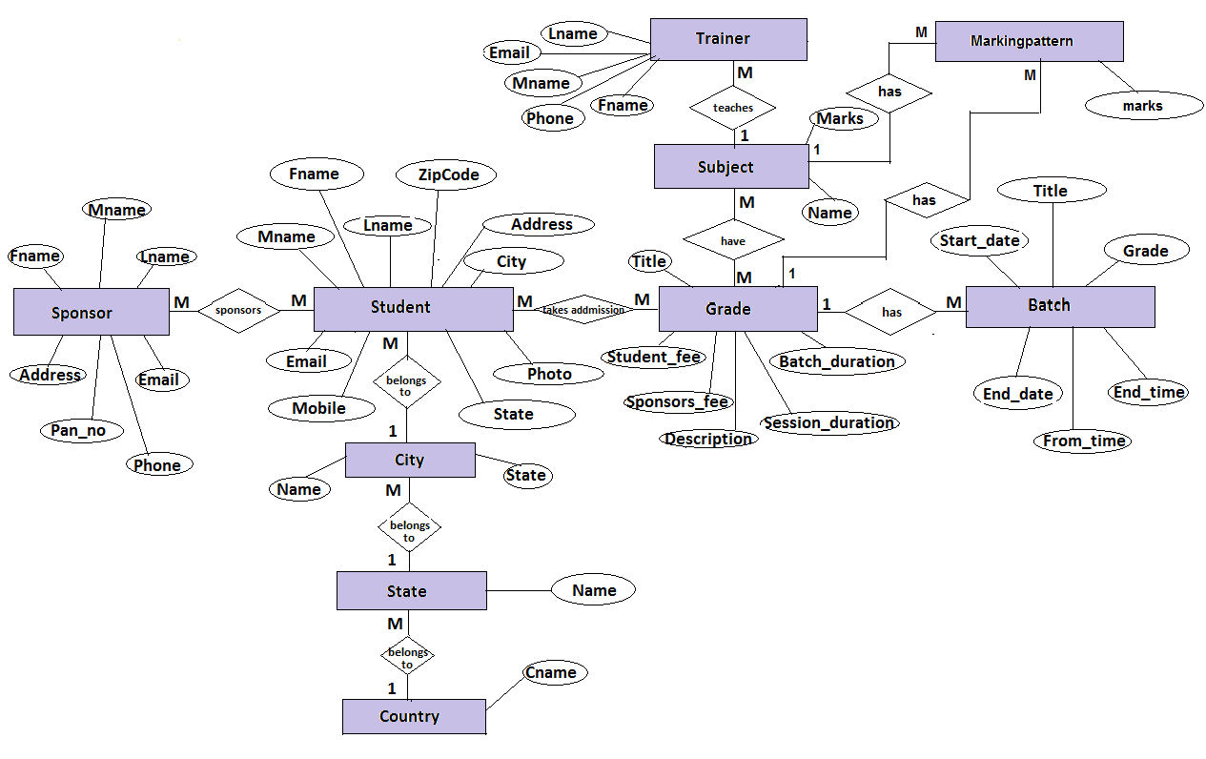

CLASS DIAGRAM

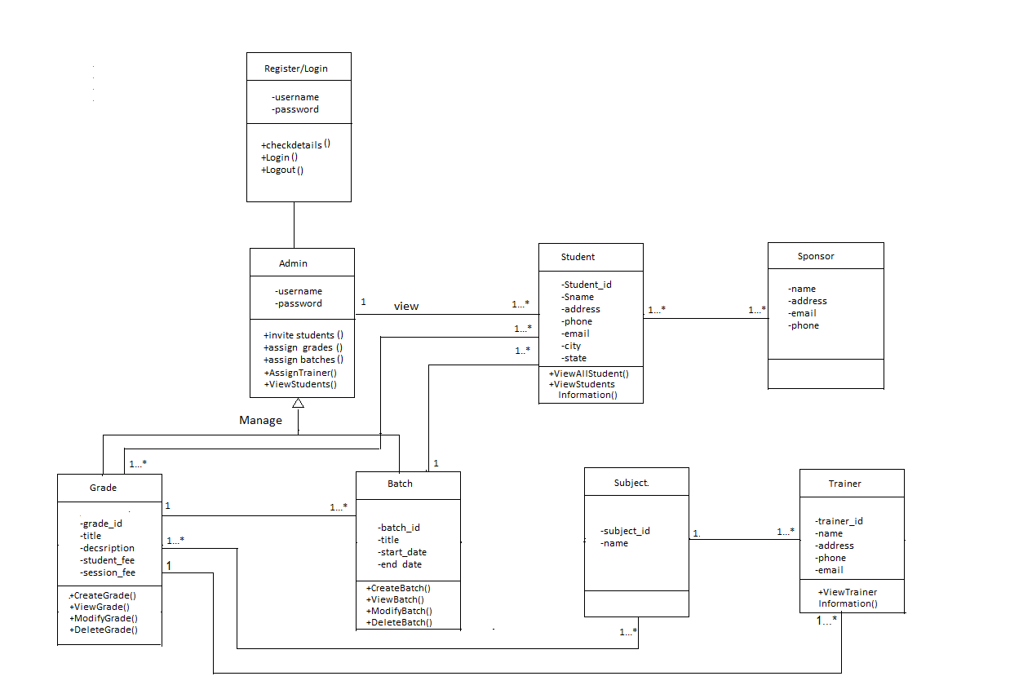

Usecase Diagram
1.Administrator Login
Registration

Login

Create Stat and City

Create Subject

Create Grades

Assign Batch to Grade

Administrator
Assign Subject to Grade
Assign Trainer to Batch

Invite Students

Logout
2.Student Registration

Student Admission
Student Enrollment
Assign Grade to Student
Assign Batch To student
Sponsor Sponsors Students

Administrator

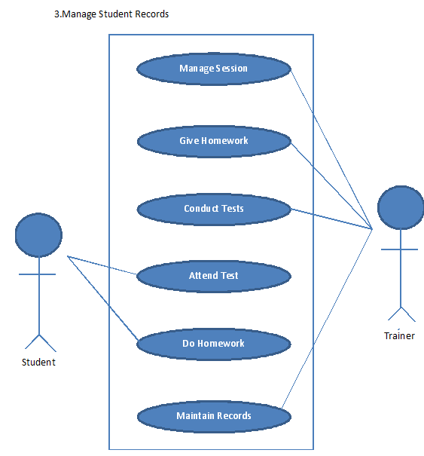

Sequence Diagram
1.Administrator Login
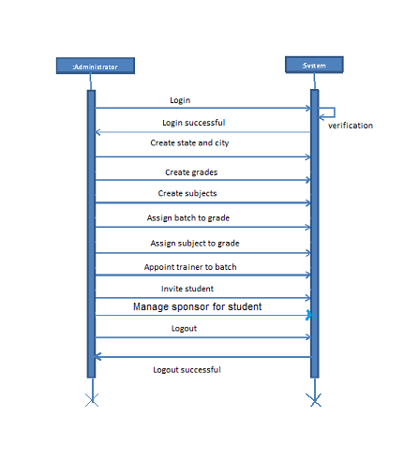

2. Student Registration

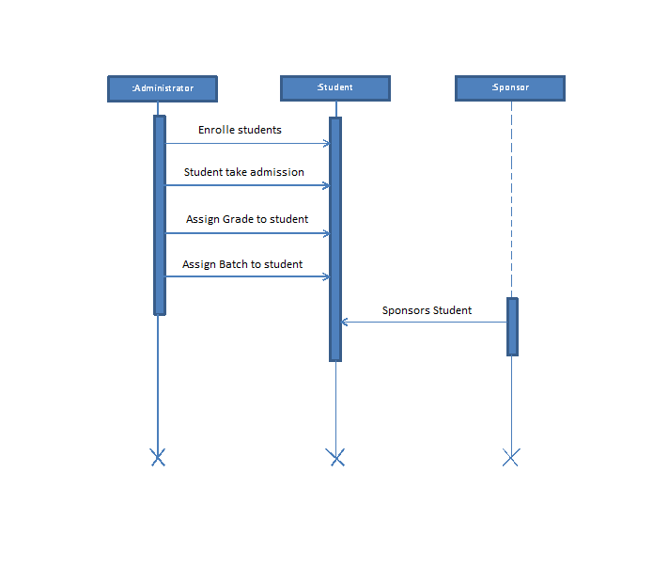

3.Manage Student Record:

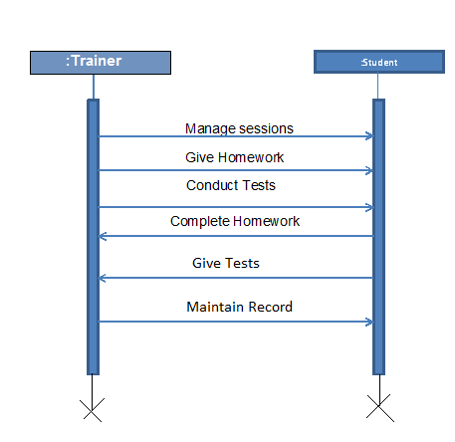

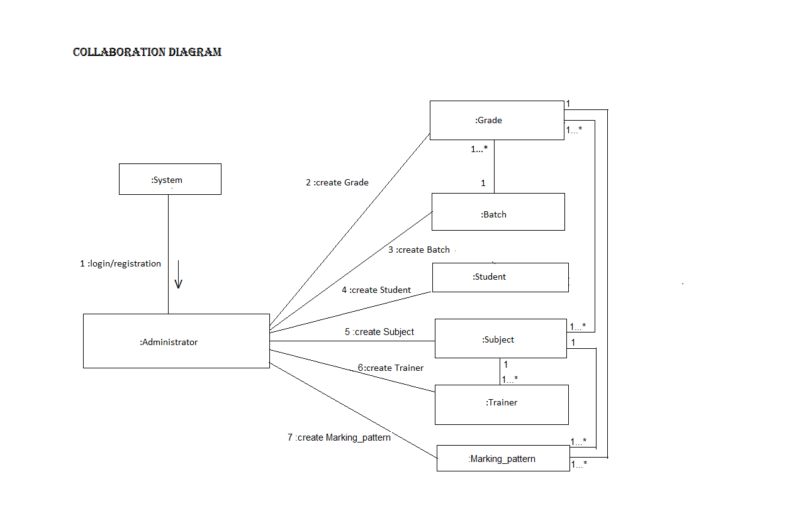

StateChart DiagraM

idle
Admin Register and Login
Create Grade and Batches
Appoint Trainer to Batch

Invite Sponsors to Sponsor Student
Initial state
Invite Student And Enroll Student

Assign Batch to student

Trainer manage session for student & conduct tests

Final state
According to Marking Pattern Student record is maintain by Trainer
Admin can update, modify, delete each model

CHAPTER 3

System DEsign

Database Design
Table name : Student

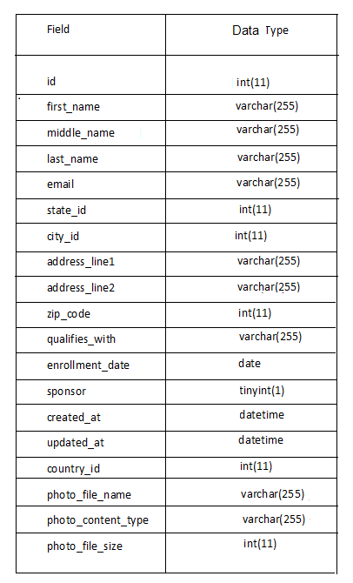

Table name : Grade
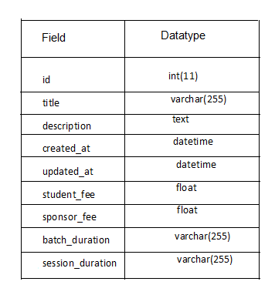

Table Name : City
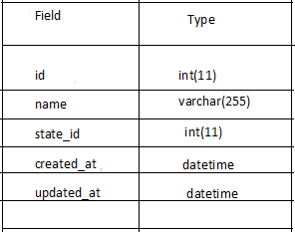

Table name : Batch
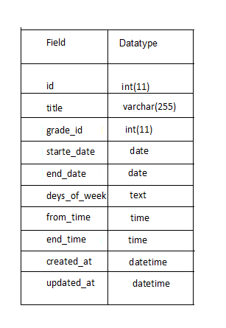
Table name :State

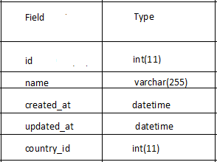

Table name: Subject
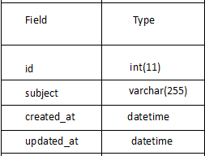

Table nae : Trainer

