EXPERIMENT: 1
OBJECTIVE:
To design and simulate a computer network of 5–16–24 computers using switches in a mesh topology, and to verify successful data communication along with the availability of alternate communication paths.

SOFTWARE USED:

CISCO PACKAGE TRAINER, DESKTOP

THEORY:

A computer network consists of interconnected devices that can communicate and exchange data. Switches enable efficient communication by forwarding data packets between devices. To ensure each computer can be uniquely identified on the network, static IP addresses are assigned to all systems. In this experiment, computers numbered 5, 16 and 24 are connected through switches to create a local network.

Advantages:
- Provides high reliability and fault tolerance
- Multiple paths ensure continuous communication
- Suitable for critical network applications

Drawbacks:
- Requires a large number of cables and connections
- Complex network design and maintenance
- Higher implementation cost as network size increases

CODE:

Not applicable

PRACTICAL:
1.With 5 computers:
Figure 1A :- Basic Diagram
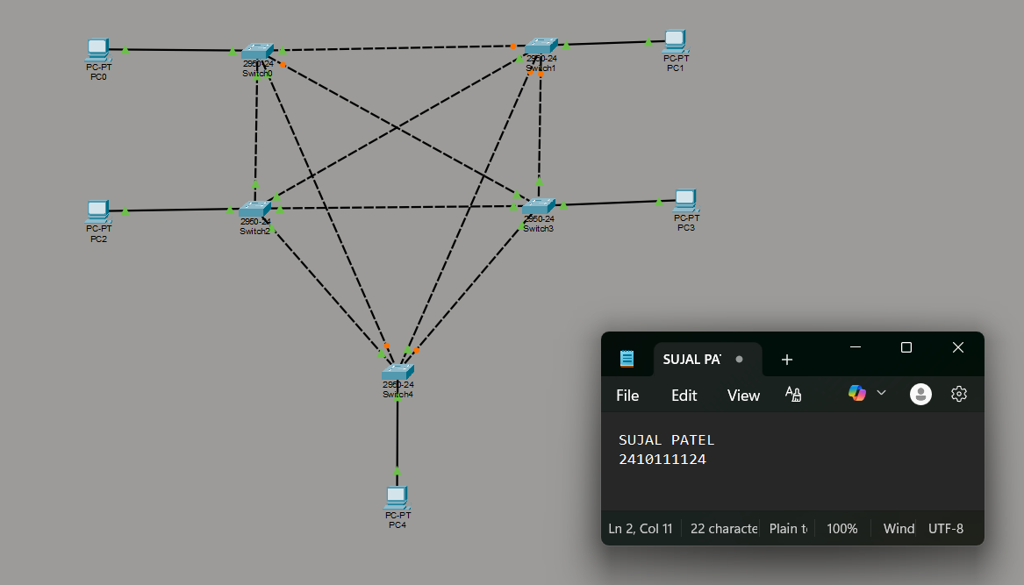
Figure 1B :- Simulation Diagram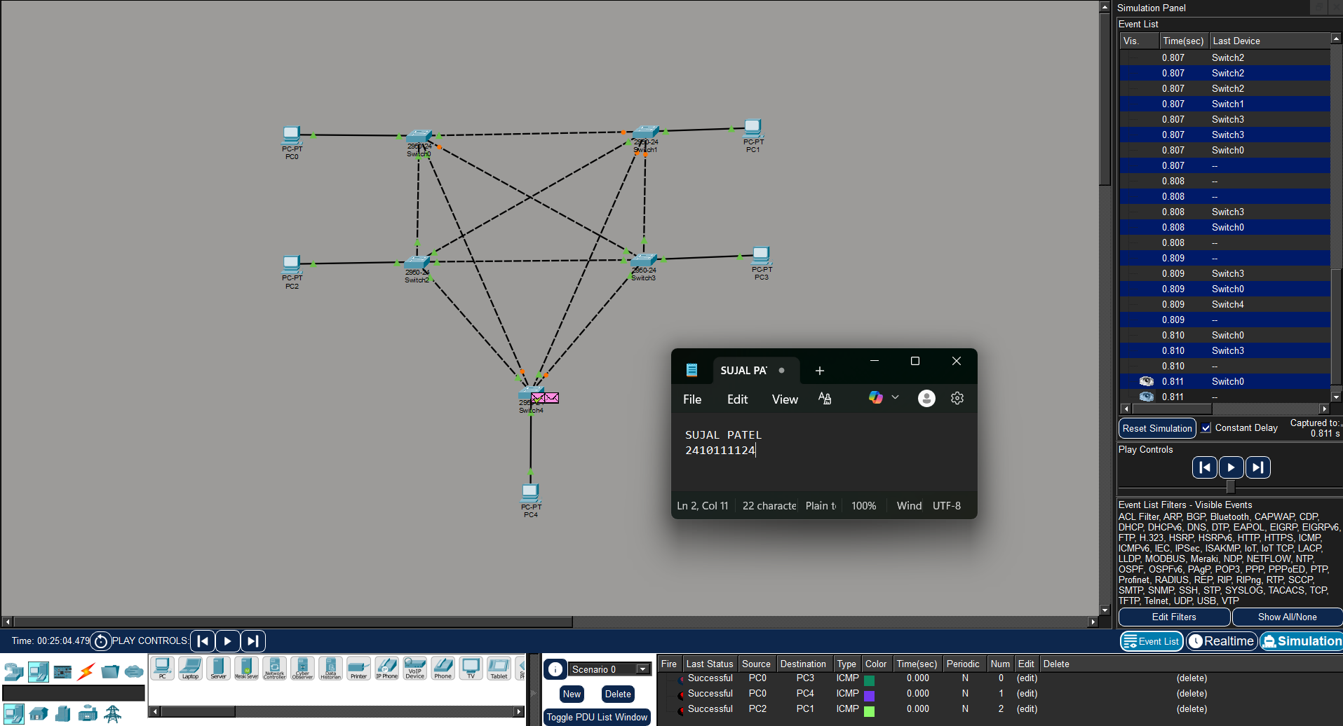

Figure 1C :- Analysis of message received
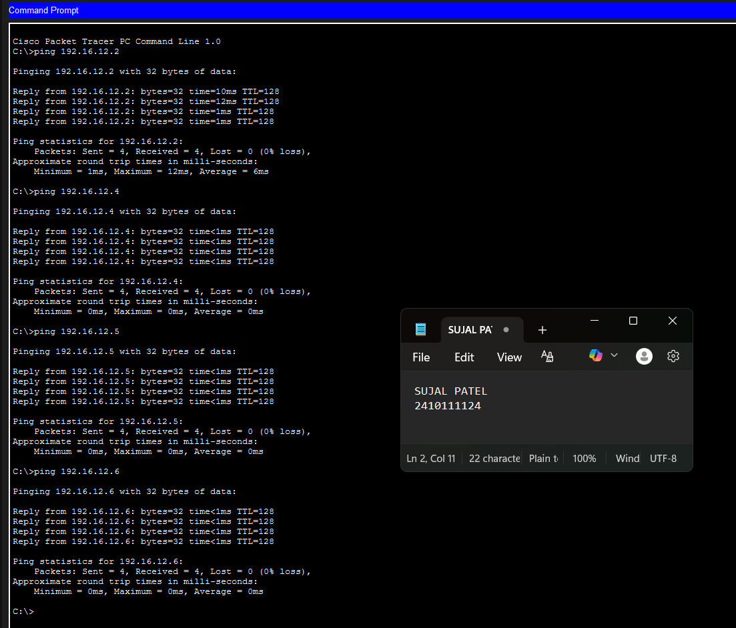

2.With 16 Computers :
Figure 2A :- Basic Diagram 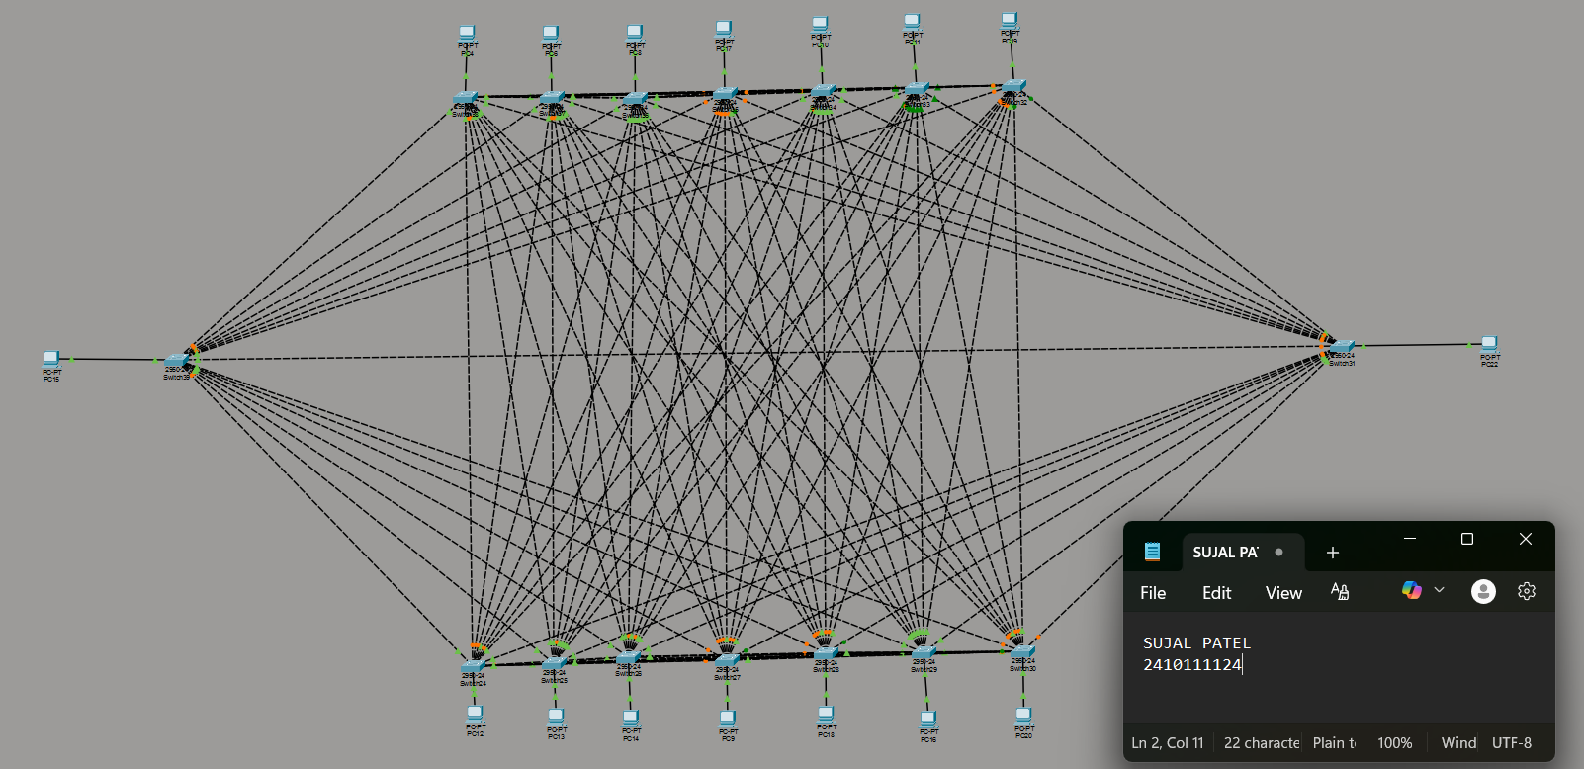
Figure 2B :- Simulation Diagram
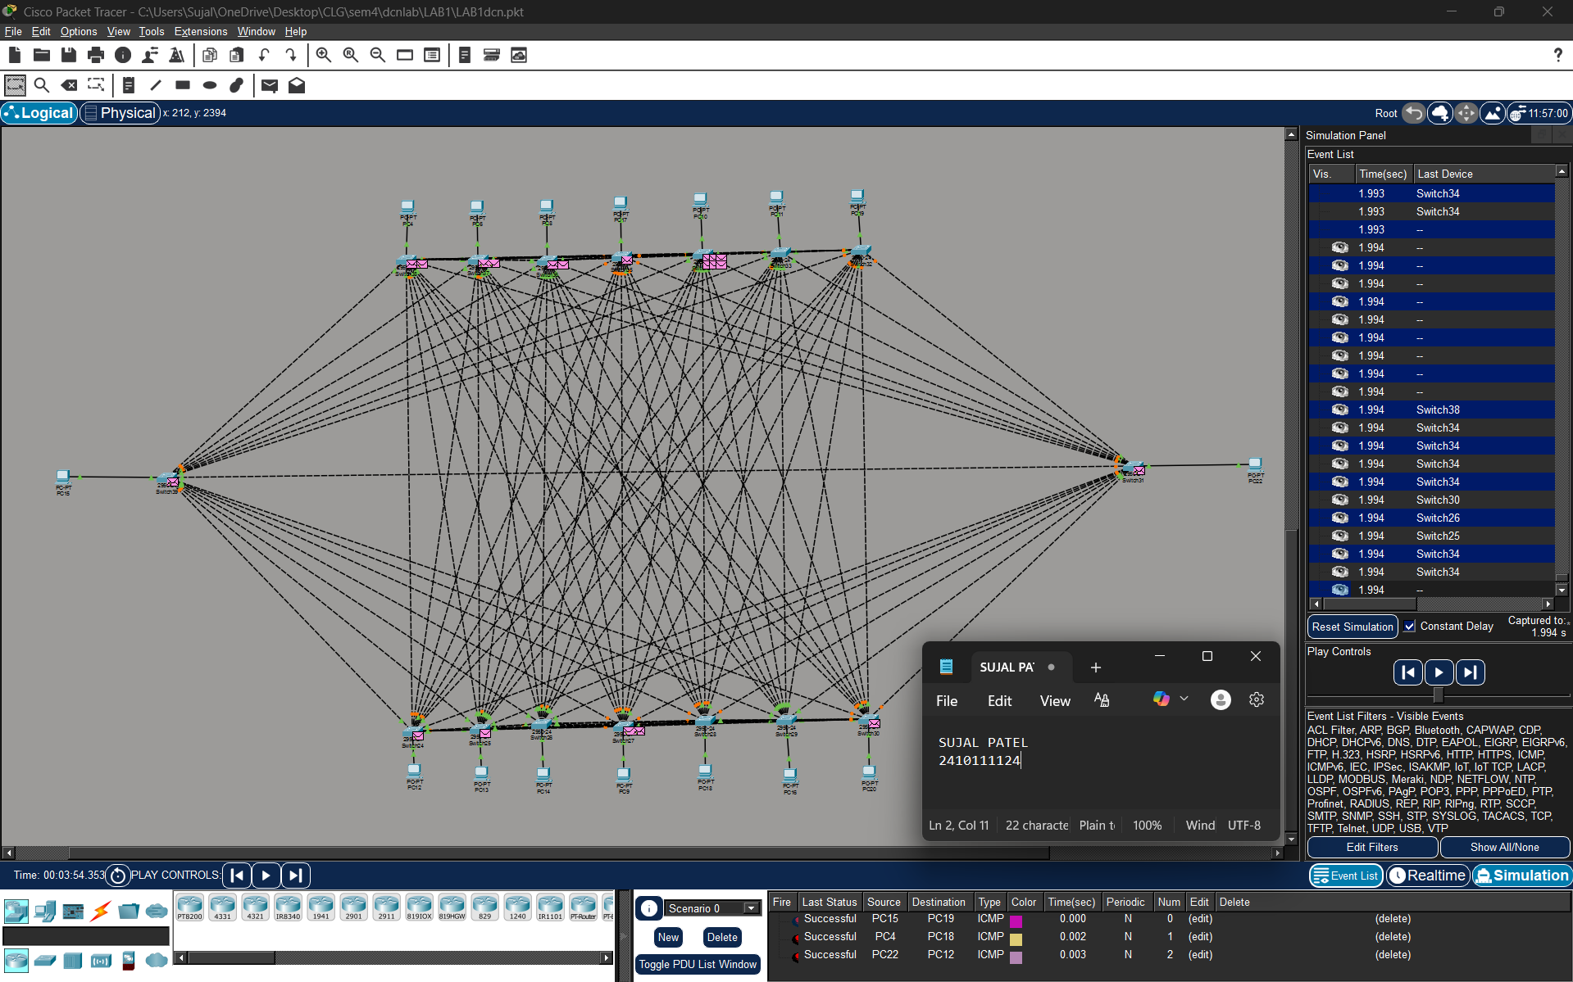
Figure 2C :- Analysis of message received 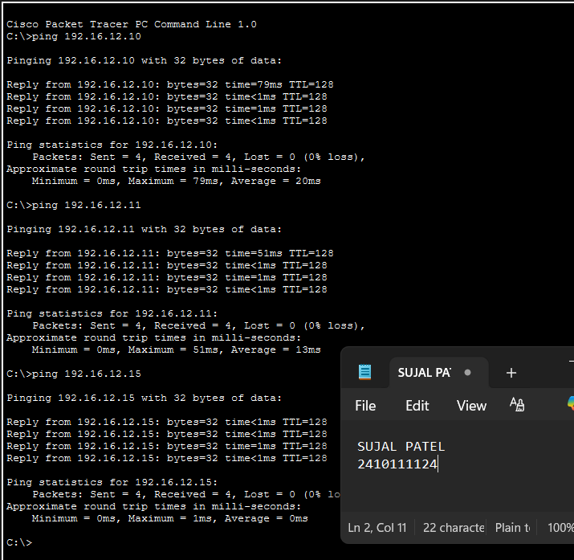

3.With 24 Computers
Level 3A :- Basic Diagram
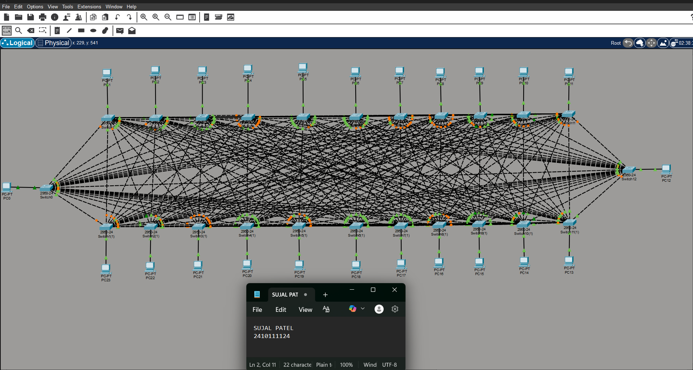
Level 3B : - Simulation Diagram 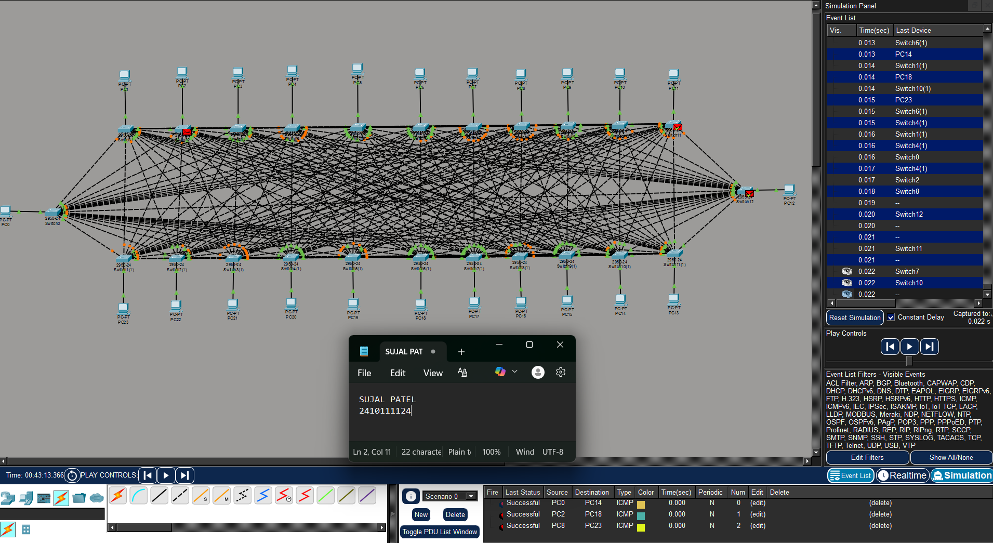

Level 3C :- Analysis of message received

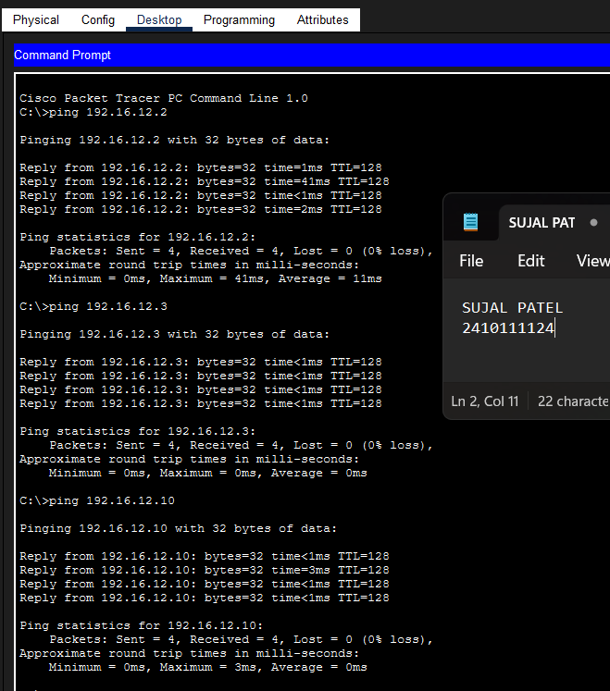

PROCEDURE:
- Cisco Packet Tracer was launched and a new project was created.
- The necessary number of PCs and switches were placed in the workspace.
- Each PC was connected to a switch using cables.
- The switches were linked together to create an alternative communication path.
- Static IP addresses within the same network were assigned to all PCs.
- The network was allowed to stabilize in real-time mode.
- Message transmission was verified using simulation mode.

RESULTS:
The network simulation was completed successfully with all computers communicating effectively. Analysis confirmed that messages were delivered correctly which shows proper configuration and data transmission across the network.

POSSIBLE SOURCES OF ERRORS:
  - Incorrect IP address or subnet mask configuration.
  - Entering IP address in the default gateway field instead of the IPv4 address field.
  - Improper cable connections between devices.
  - Testing the network before switch convergence was completed.

CONCLUSION:
A computer network was effectively designed and simulated using Cisco Packet Tracer. Reliable communication between all computers was achieved through proper switch connections and the use of static IP addressing. This experiment enhanced understanding of data communication, message transmission, and the significance of accurate network configuration.

PRECAUTIONS:
- Ensure each PC has a unique IP address within the same subnet.
- Use appropriate cable types for device connections.
- Leave the default gateway empty when no router is used.
4) Allow sufficient time for the network to stabilize before testing communication

