Adani University
Bachelor of Technology
Subject Name: Data Communication & Computer Networks
Subject Code: EICCI24203 Sem: 4th Date: 23-03-2026

URN. No. 2410111124 Name: Sujal Patel Sec : B

EXPERIMENT: 10
OBJECTIVE:
To implement HTTP protocol of application layer in Cisco Packet Tracer.

SOFTWARE USED:

CISCO PACKAGE TRACER, DESKTOP

THEORY:

Advantages
• Simple and easy to implement
• Widely supported by all web browsers
• Allows cross-platform communication between any client and server that understand the
protocol.
• Can transfer various data types (text, images, video) by indicating the content type in the
headers.
Disadvantages
• Not secure (data is transmitted in plain text)
• Since it doesn't remember previous requests, managing user sessions (like logging in) requires
extra overhead like cookies.
• Can experience delays due to the underlying TCP connection setup (three-way handshake)
required before sending HTTP requests.

CODE:

Not applicable

PRACTICAL:
1.With 6 computers:
Figure 1A :- Basic Diagram
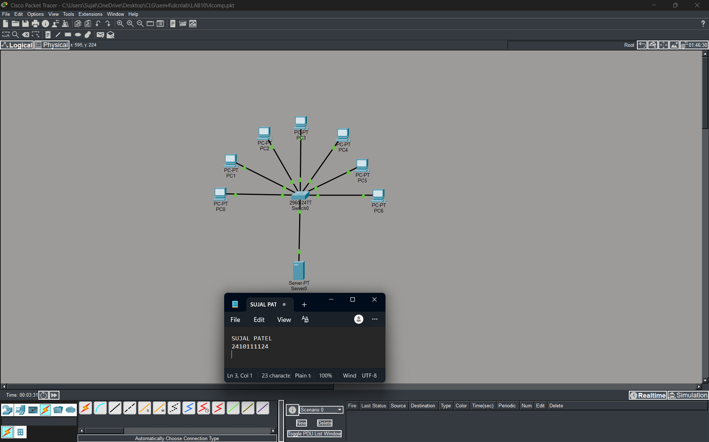

Figure 1B :- Simulation Diagram
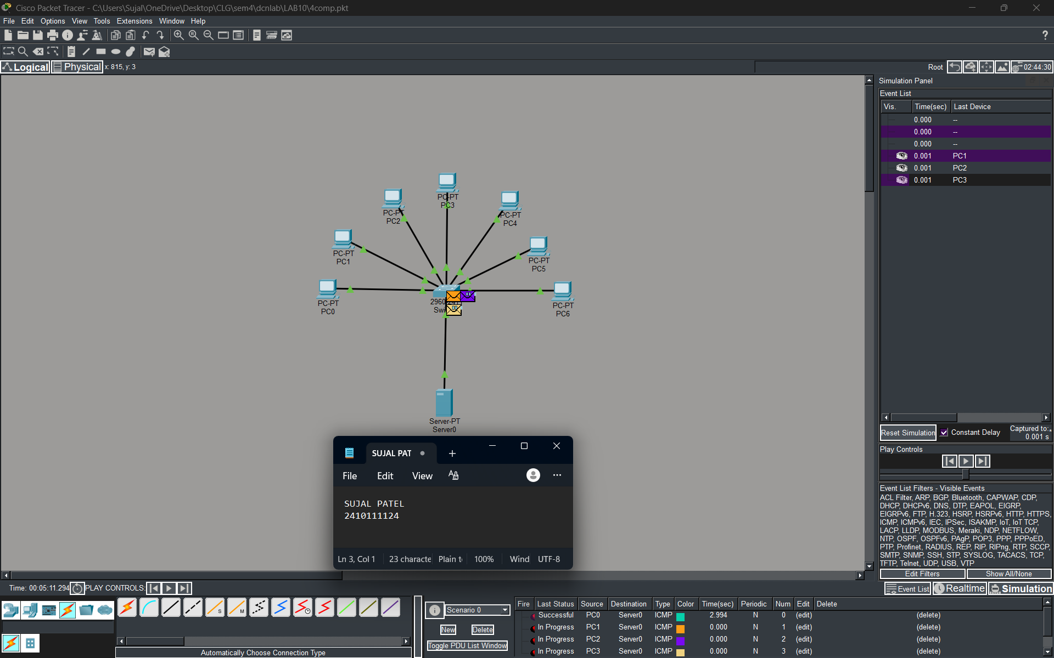
Figure 1C :- Analysis of message received
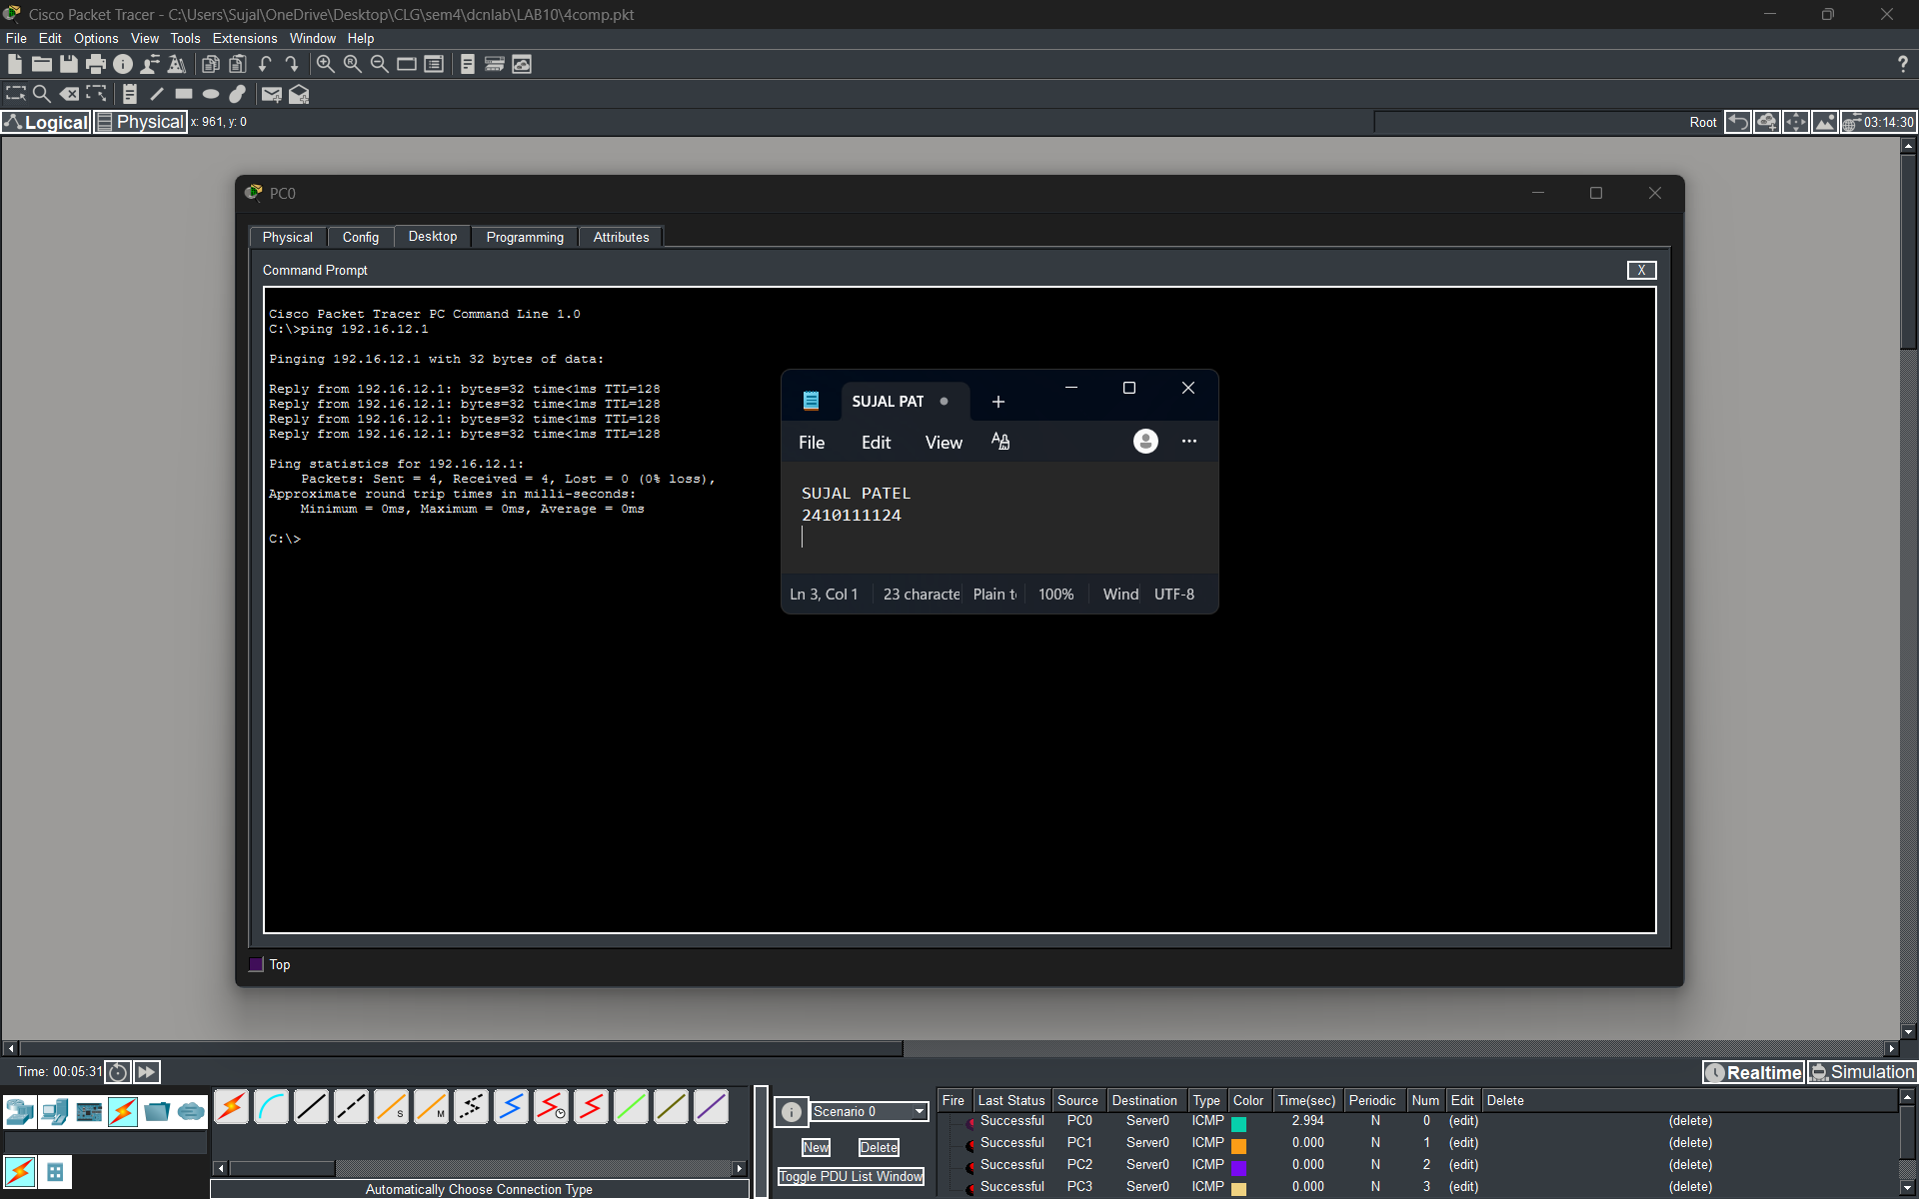
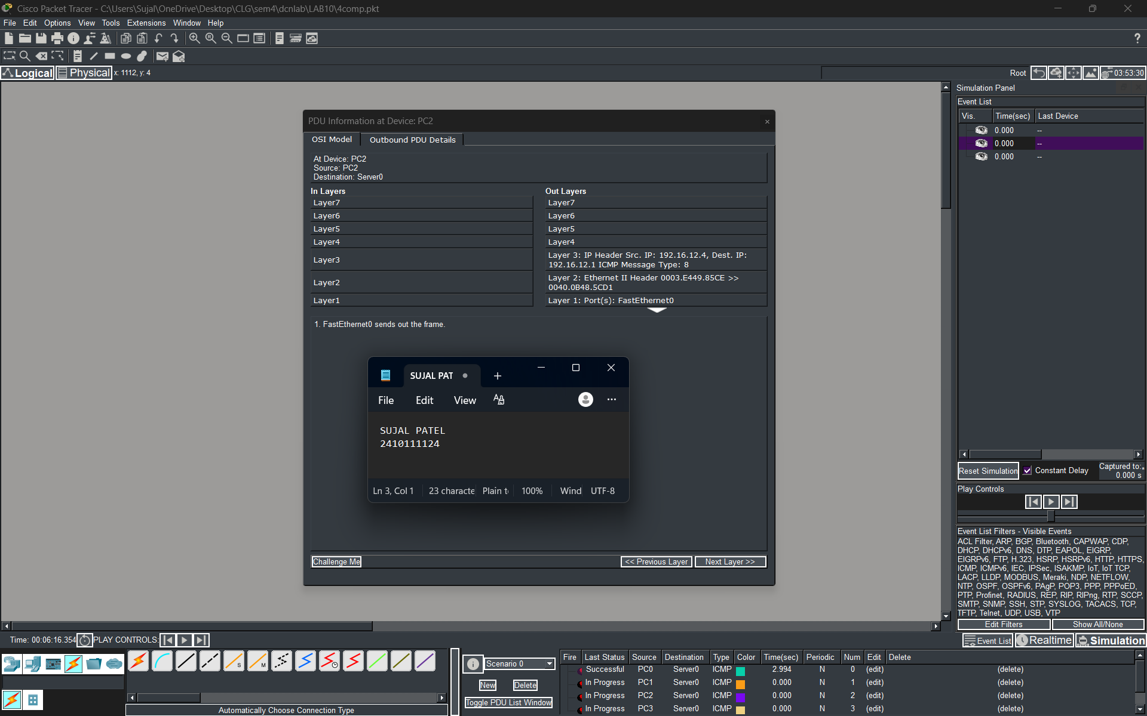
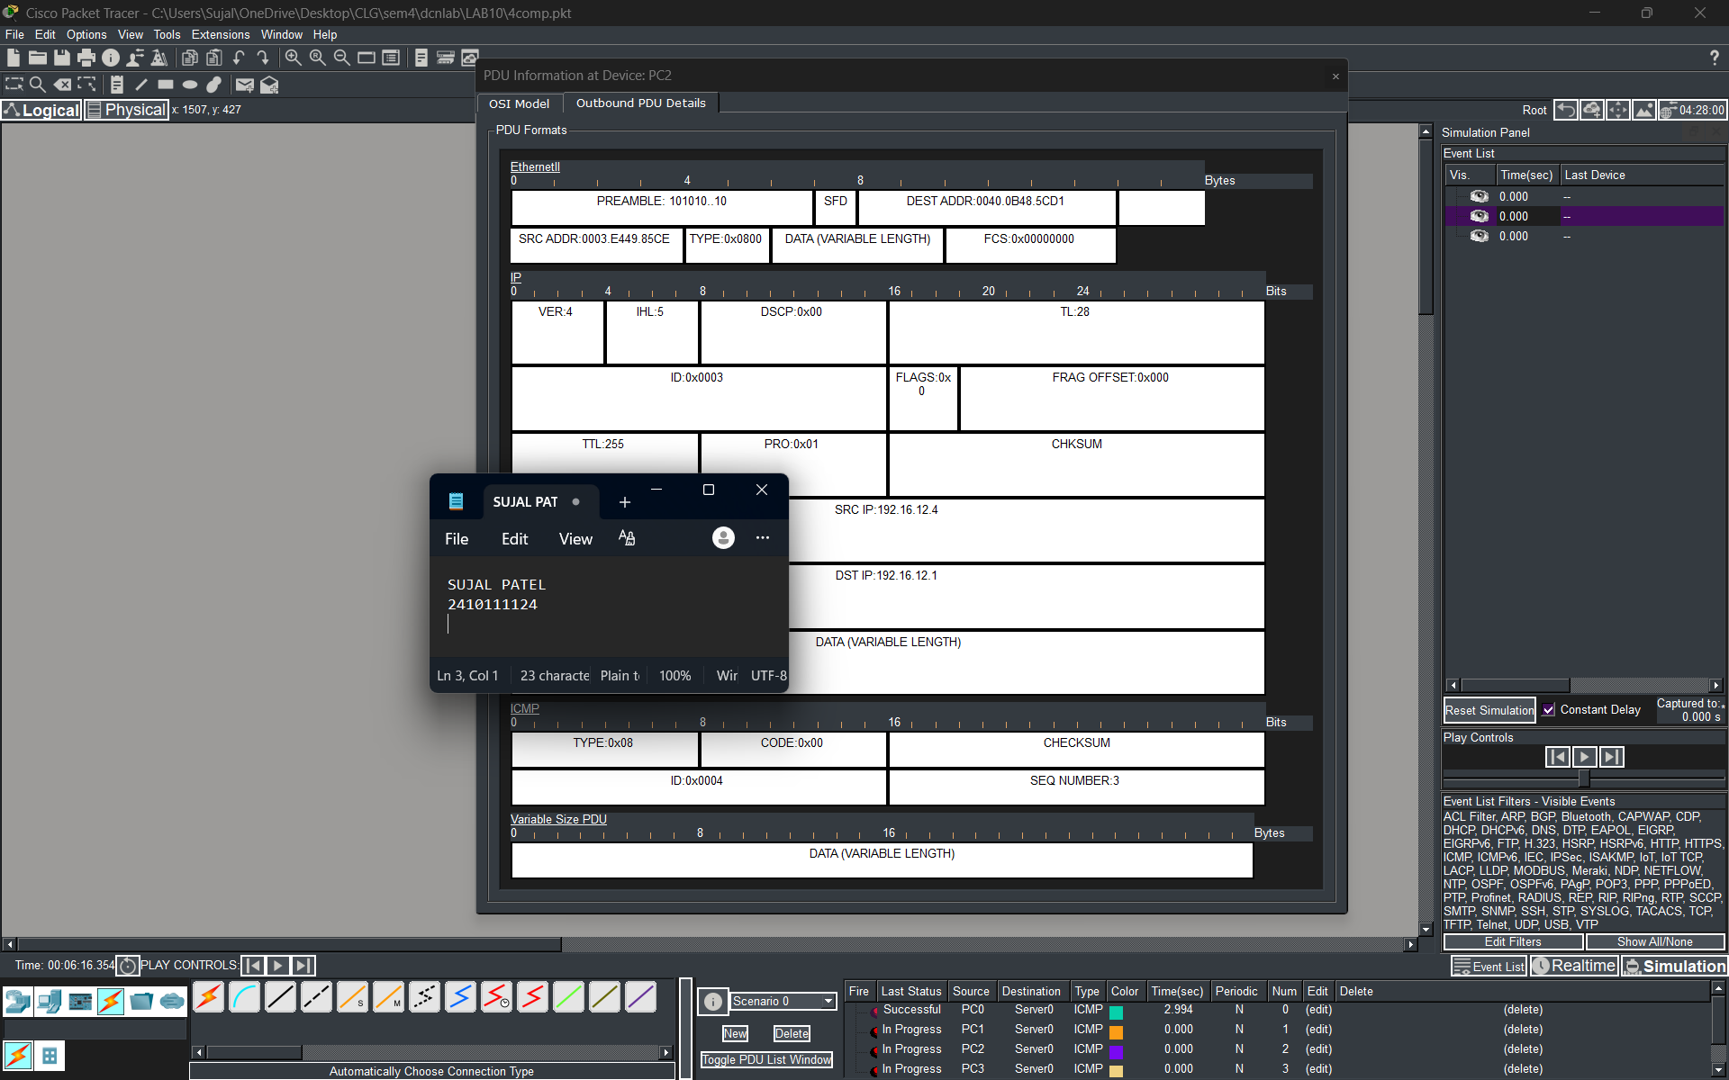
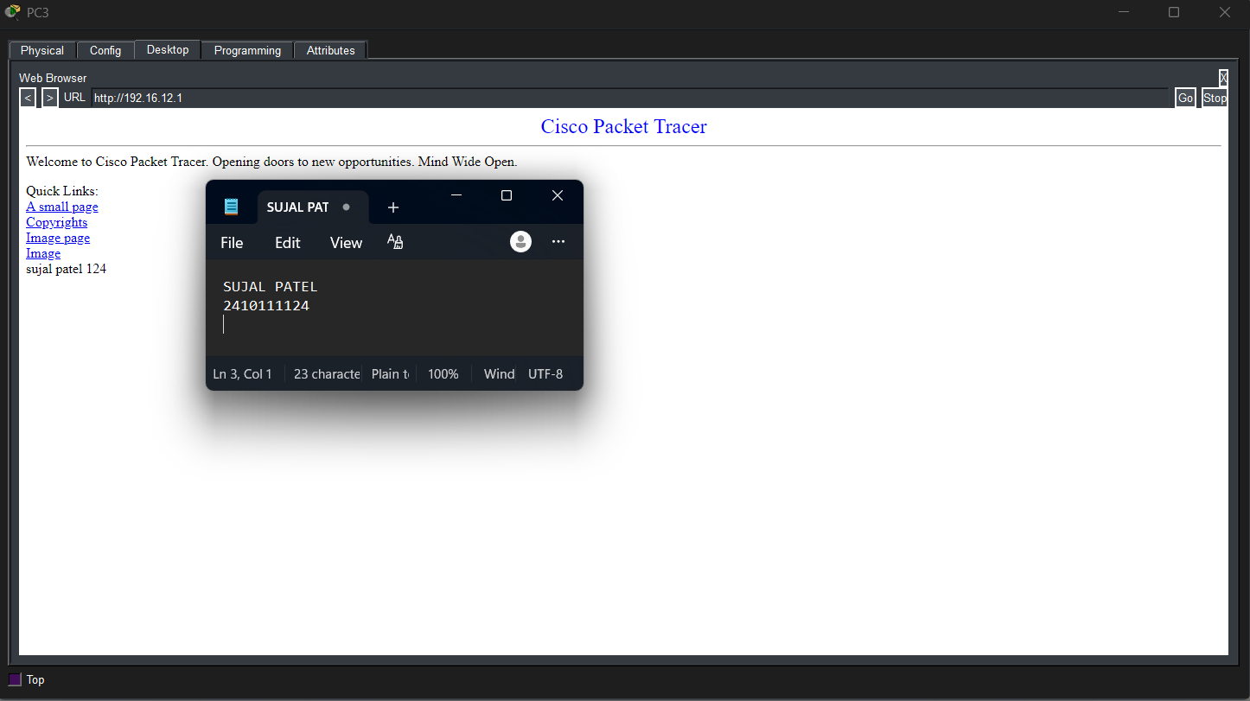

PROCEDURE:
- Cisco Packet Tracer was launched and a new project was created.
- The required devices such as one server, one PC, and one switch were placed in the workspace.
- The PC and server were connected to the switch through cables.
- Appropriate IP addresses were assigned to the PC and the server within the same network.
- The server was opened and the HTTP service was enabled from the services tab.
- A simple web page was created or verified on the server.
- The network was allowed to stabilize in real-time mode.
- The PC was opened and the web browser application was selected.
- The IP address of the server was entered in the browser URL field.
- Successful loading of the web page confirmed HTTP communication.

RESULTS:

The HTTP protocol was successfully implemented. The PC was able to access the web page hosted on the server using a web browser, confirming proper communication at the application layer.

POSSIBLE SOURCES OF ERROR:

- Incorrect IP address configuration
- HTTP service not enabled on server
- Wrong cable connection
- Devices not properly connected to the switch
- Typing wrong URL in browser

CONCLUSION:

The experiment successfully demonstrated the implementation of the HTTP protocol in Cisco Packet Tracer. It verified effective communication between client and server, enhancing understanding of application layer protocols and practical networking concepts.

LEARNING OUTCOME:
- Understanding of HTTP protocol
- Knowledge of client-server communication
- Practical exposure to application layer protocols
PRECAUTIONS:
- Ensure correct IP configuration for all device
- Always turn ON HTTP service on the server
- Enter correct URL in browser

