Adani University
Bachelor of Technology
Subject Name: Data Communication & Computer Networks
Subject Code: EICCI24203 Sem: 4th Date: 06-04-2026

URN. No. 2410111124 Name: Sujal Patel Sec : B

EXPERIMENT: 11
OBJECTIVE:
To design and analyse a mobile network in cisco packet tracer

SOFTWARE USED:

CISCO PACKAGE TRACER, DESKTOP

THEORY:

Advantages
• Users can stay connected while moving across different locations without needing a physical
wired connection.
• Cell towers can cover vast geographical areas
• Adding new devices to the network requires zero physical cabling
• Supports multiple types of data traffic, including voice, text, and high-speed internet data
(3G/4G/5G).
Disadvantages
• Wireless signals are susceptible to physical obstacles (buildings, mountains) which can
degrade signal quality.
• The wireless spectrum is shared among all users connected to a single tower, which can lead
to reduced speeds during peak traffic.
• Since data travels through the air, it is inherently easier to intercept than wired traffic,
requiring strong encryption protocols.
CODE:

Not applicable

PRACTICAL:
1.With 4 Smartphones:
Figure 1A :- Basic Diagram
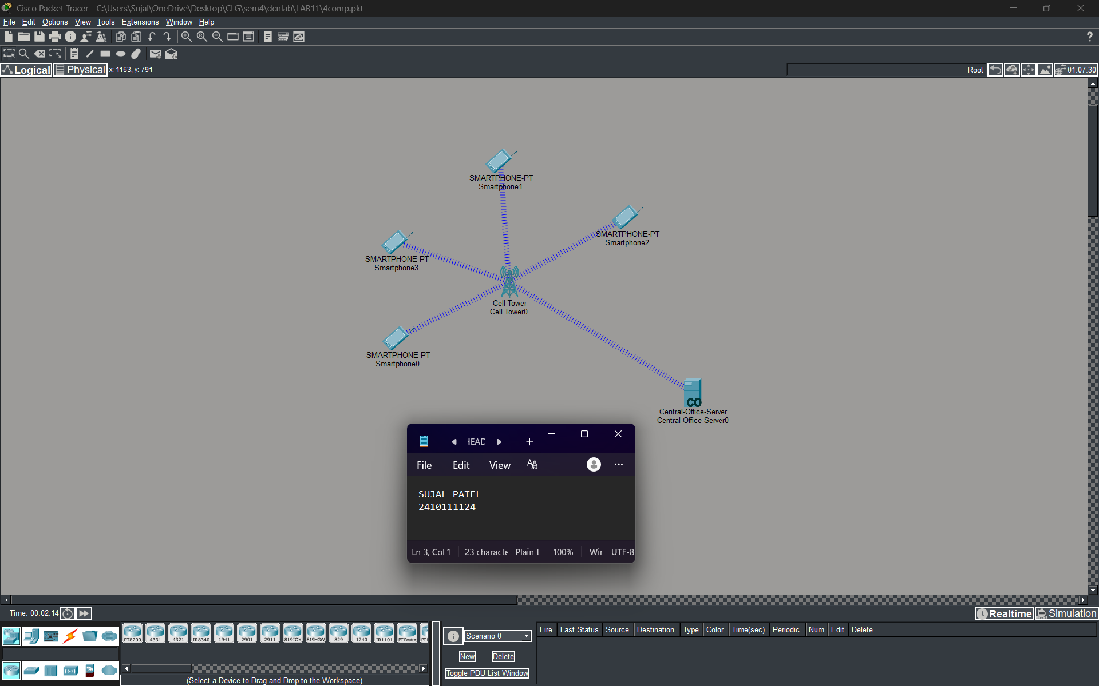

Figure 1B :- Simulation Diagram
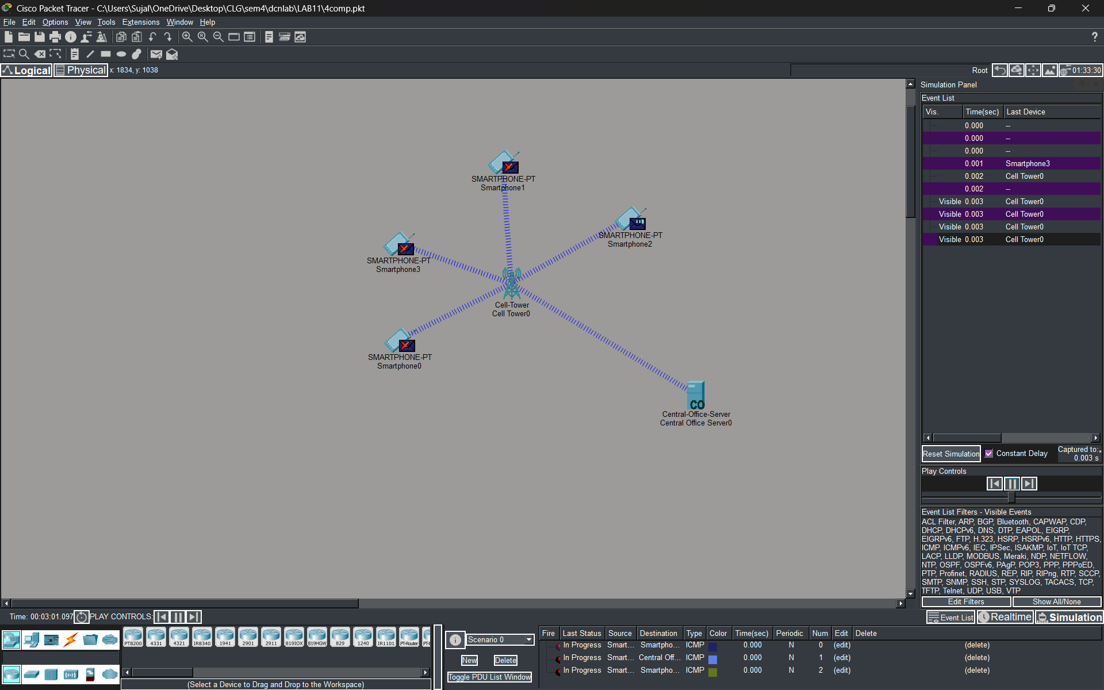
Figure 1C :- Analysis of message received
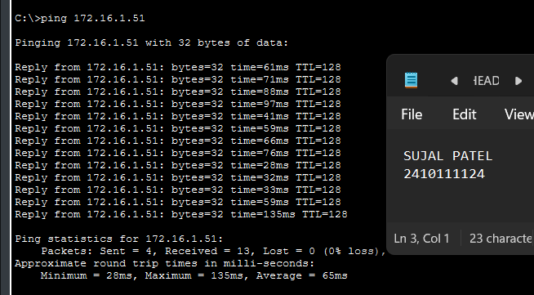

2.With 9 Smartphones:
Figure 2A :- Basic Diagram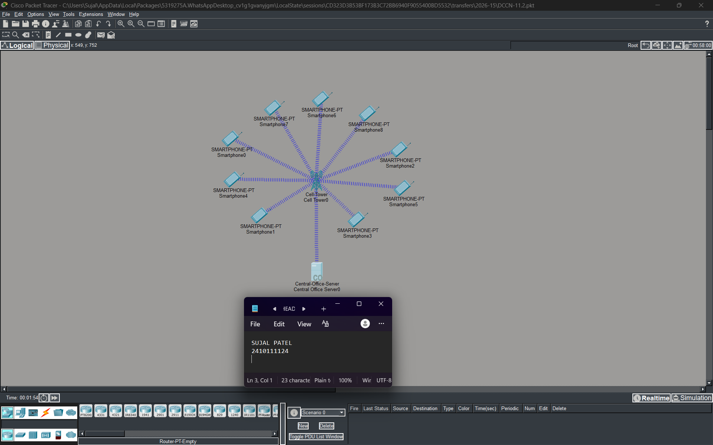
Figure 2B :- Simulation Diagram 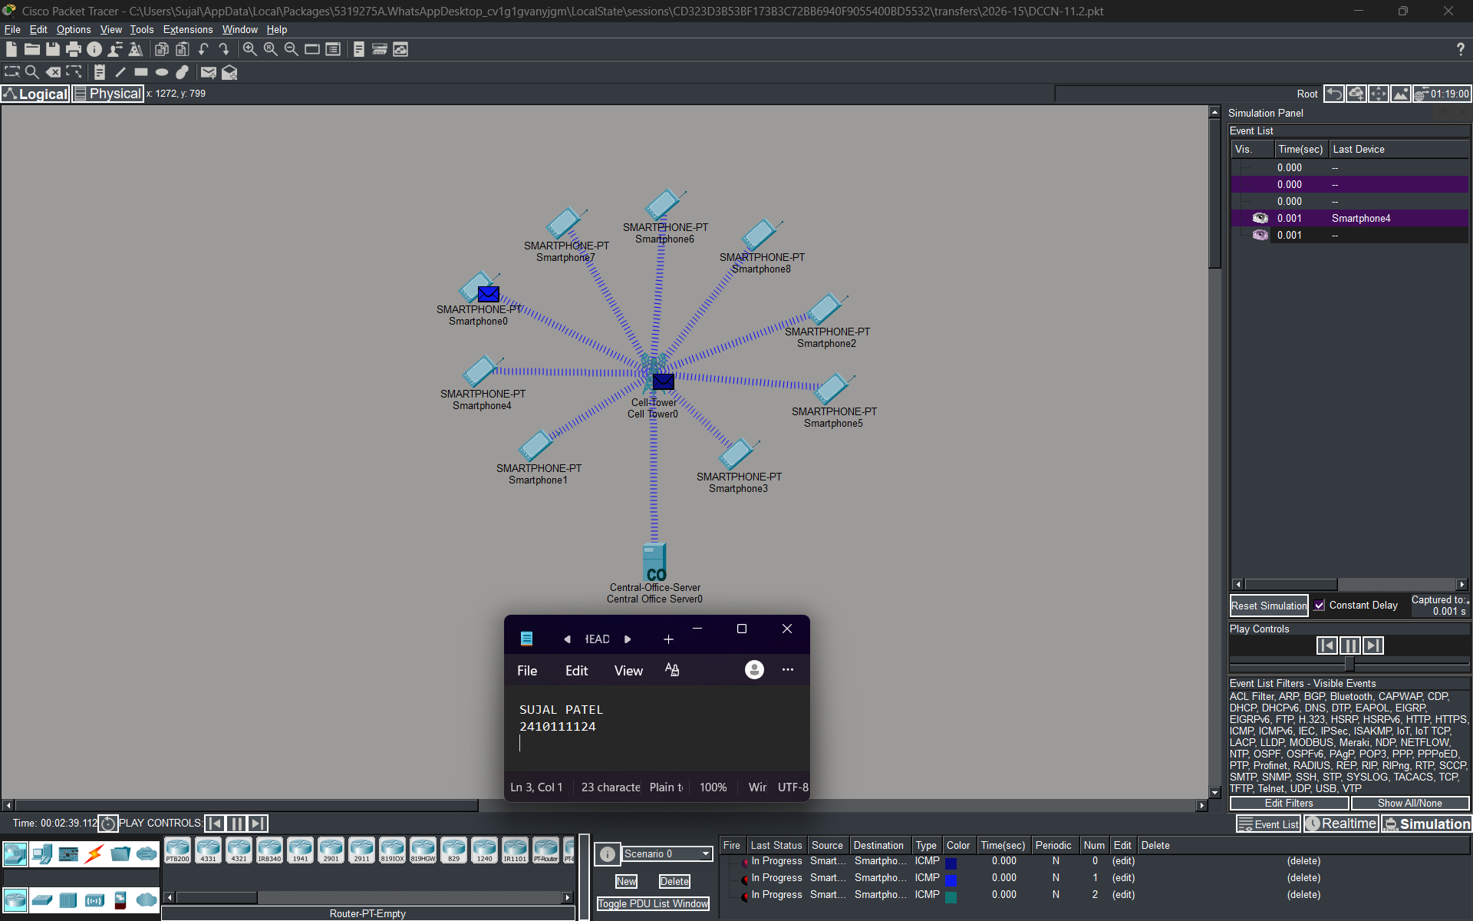

Figure 2C :- Analysis of message received 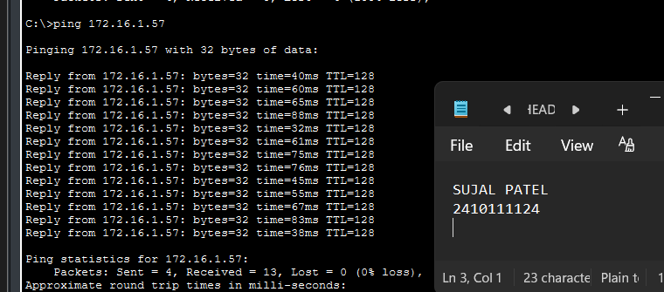

3.With 4 Smartphones:
Figure 3A :- Basic Diagram 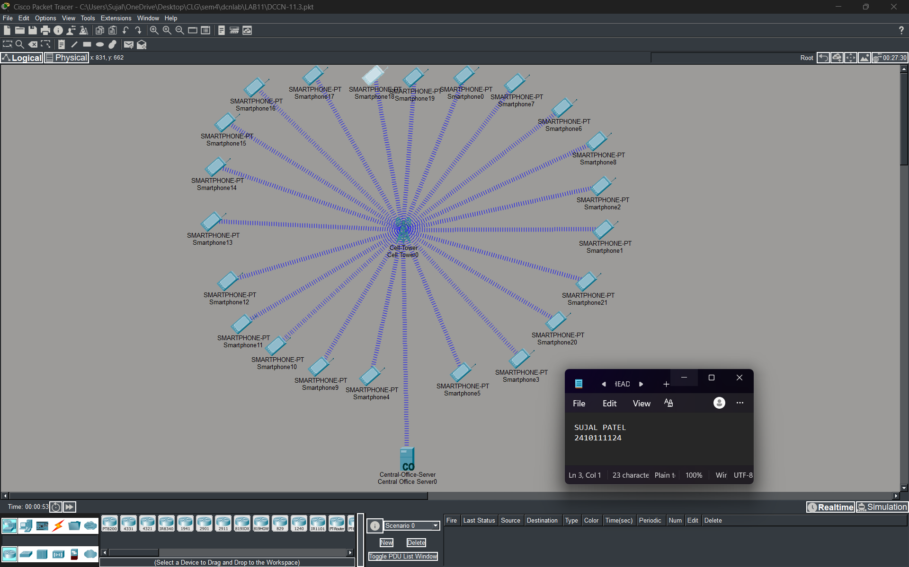 Figure 3B :- Simulation Diagram 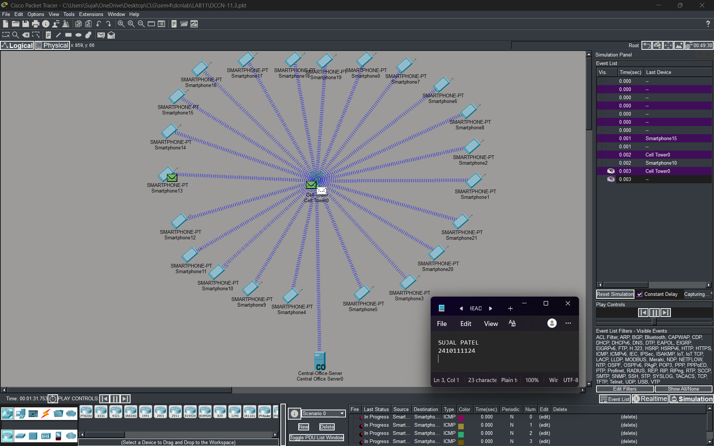

Figure 3C :- Analysis of message received
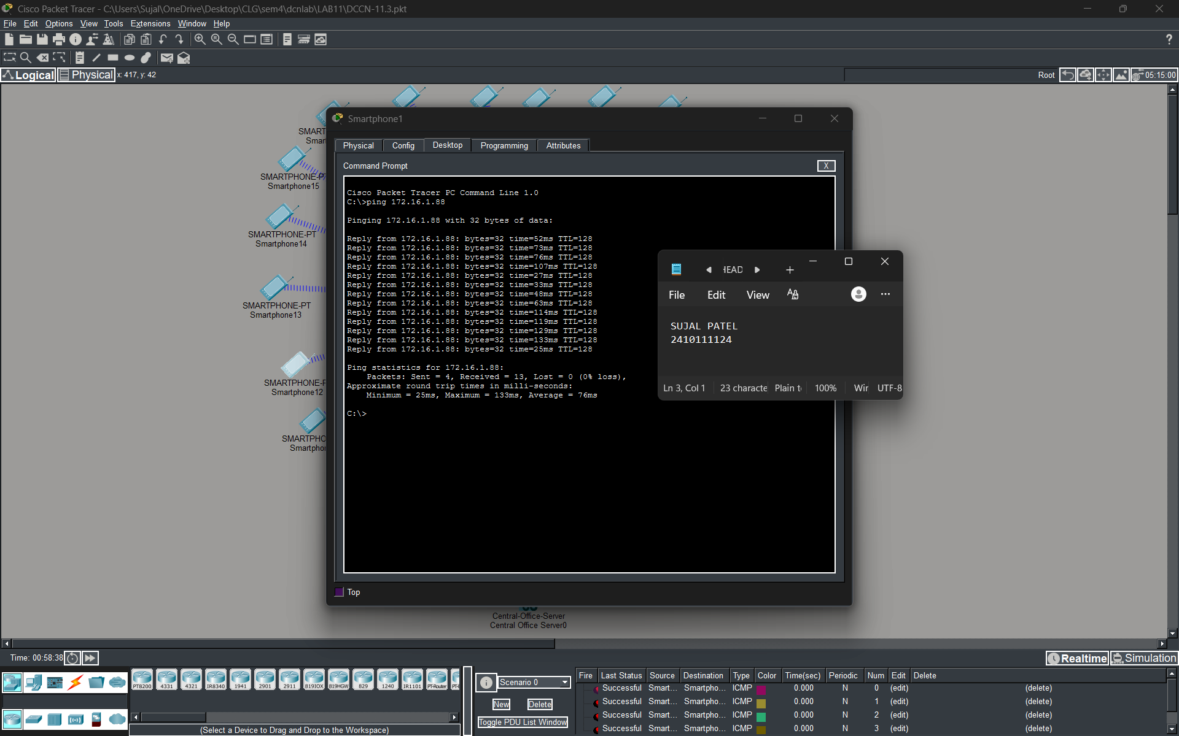

PROCEDURE:
- Open Cisco Packet Tracer Application and initialise a new project.
- From the devices menu, place a Cell Tower, a Central Office Server, and your desired number of Smartphones (e.g., 5) onto the workspace.
- Connect the Cell Tower to the Central Office Server using the appropriate cable (typically a Coaxial cable in Packet Tracer).
- Configure the Central Office Server to act as a DHCP server. Create a DHCP pool to automatically assign IP addresses to the connected smartphones.
- Access the configuration tab for each Smartphone, navigate to the cellular interface (3G/4G), and ensure it is turned on to allow them to connect to the Cell Tower wirelessly.
- The network was left in real-time mode to settle and allow the smartphones to acquire their IP addresses via DHCP.
- The communication of the network was verified in simulation mode by sending ICMP (Ping) packets from one smartphone to another.

RESULTS:

The mobile network implementation was successfully verified. Client smartphones were able to wirelessly connect to the cell tower and obtain dynamic IP addresses from the Central Office Server. Data transmission analysis in simulation mode confirmed that ICMP packets were correctly routed over the 3G/4G cellular interface, demonstrating proper configuration of the mobile network infrastructure.

POSSIBLE SOURCES OF ERROR:

- Forgetting to enable the 3G/4G cellular interface on the Smartphones.
- Failing to configure the DHCP service correctly on the Central Office Server, leaving the smartphones without IP addresses.
- Using the wrong type of cable (e.g., Copper Straight-Through instead of Coaxial) to connect the Cell Tower to the Central Office Server.
- Placing the smartphones too far away from the Cell Tower, causing them to fall out of the wireless coverage range.

CONCLUSION:

Mobile networks play a vital role in modern telecommunications by providing widespread, wireless connectivity. This simulation demonstrates that cellular communication operates through a hybrid model, where wireless radio access (between smartphones and cell towers) integrates smoothly with a wired backbone infrastructure (Central Office Server) to ensure reliable data transmission.
LEARNING OUTCOME:
- Designed and simulated a functional mobile cellular network using Cisco Packet Tracer.
- Understood how to deploy and configure Cell Towers, Central Office Servers, and Smartphone cellular interfaces.
- Analyzed the wireless flow of data packets over a 3G/4G network in simulation mode.
PRECAUTIONS:
- Always ensure the DHCP pool size on the server is large enough to accommodate all mobile devices on the network.
- Verify the physical cabling type between backbone infrastructure devices to prevent link failure before troubleshooting the wireless segment.
- Allow sufficient time for the wireless connections to associate and for the DHCP lease process to complete before testing connectivity.

