Adani University
Bachelor of Technology
Subject Name: Data Communication & Computer Networks
Subject Code: EICCI24203 Sem: 4th Date: 06-04-2026

URN. No. 2410111124 Name: Sujal Patel Sec : B

EXPERIMENT: 12
OBJECTIVE:
To design and implement transport layer protocols in TCP/IP reference model

SOFTWARE USED:

CISCO PACKAGE TRACER, DESKTOP

THEORY:

Advantages
• Reliability: Guarantees delivery of data. If packets are lost, TCP retransmits them.
• Ordered Delivery: Uses sequence numbers to ensure packets are reassembled in the exact
order they were sent.
• Flow and Congestion Control: Adjusts the transmission rate to prevent overwhelming the
receiver or the network.
• Can transfer various data types (text, images, video) by indicating the content type in the
headers.
Disadvantages
• High Overhead: The header is larger and acknowledgment packets consume extra bandwidth.
• Latency: Requires a Three-Way Handshake to establish a connection before any actual data is
sent, causing delays.

CODE:

Not applicable

PRACTICAL:
Figure 1A :- Basic Diagram
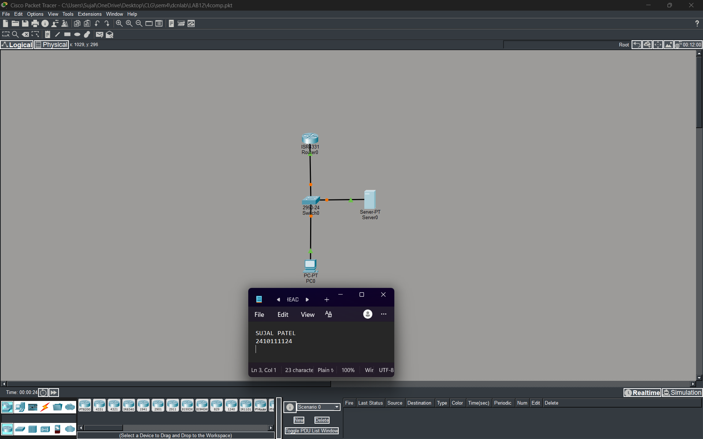

Figure 1B :- Simulation Diagram
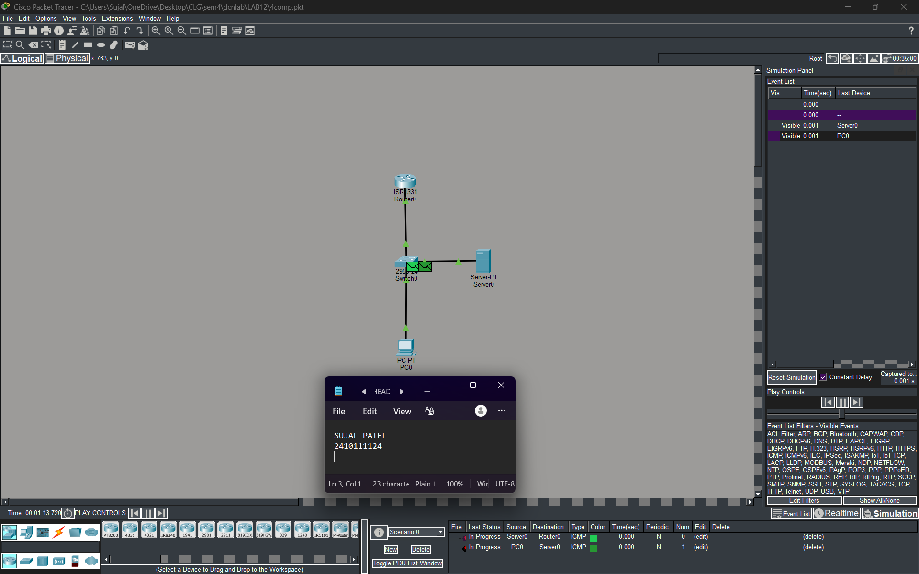
Figure 1C :- Analysis of message received
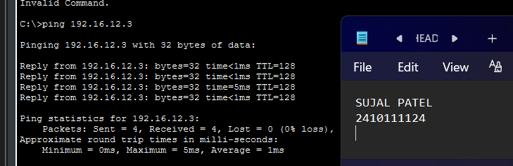
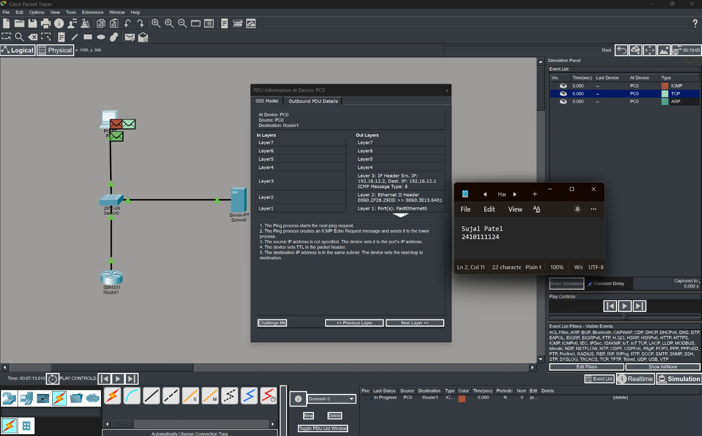
PROCEDURE:
- Cisco Packet Tracer was launched and a new project was created.
- Place multiple end devices (PCs) and a central Server on the workspace.
- Connect devices using cables.
- Assign static IP addresses and subnet masks to all PCs and the Server.
- On the Server, navigate to the Services tab. Enable the HTTP service (to test TCP) and the DNS service (to test UDP), ensuring a domain name is mapped to the Server's IP.
- Configure the PCs with the Server's IP address as their DNS Server.
- The network was allowed to stabilize in real-time mode.
- Switch from Realtime mode to Simulation mode. Edit the event filters to show only TCP, UDP, HTTP, and DNS packets.
- Click on the protocol data units (PDUs) in the simulation panel to inspect the Layer 4 headers.

RESULTS:

The implementation and analysis of Transport Layer protocols were successfully verified. Using Simulation Mode, the key differences between TCP and UDP were clearly observed. The TCP simulation illustrated connection establishment through the three-way handshake, along with sequencing and acknowledgment mechanisms during HTTP-based web communication.

POSSIBLE SOURCES OF ERROR:

- Incorrect IP address configuration
- Wrong cable connection
- Wrong protocol selection.
- Network device misconfiguration.

CONCLUSION:

The Transport Layer serves as a vital link between application processes and network routing. TCP and UDP fulfill different roles depending on application needs. TCP is used when reliability and accuracy are crucial, such as in web browsing and file transfers, while UDP is preferred for applications requiring speed and real-time communication, where some data loss is acceptable.

LEARNING OUTCOME:
- Designed a network topology in Cisco Packet Tracer to specifically generate Transport Layer traffic.
- Successfully captured and differentiated between TCP segments and UDP datagrams.
- Observed the TCP Three-Way Handshake in a simulated environment.
PRECAUTIONS:
- Ensure correct IP configuration.
- Verify connections before testing.
- Use correct protocol for testing.

