Adani University
Bachelor of Technology
Subject Name: Data Communication & Computer Networks
Subject Code: EICCI24203 Sem: 4th Date: 13-04-2026

URN. No. 2410111124 Name: Sujal Patel Sec : B

EXPERIMENT: 13
OBJECTIVE:
To design and implement Bluetooth network in cisco packet tracer.
SOFTWARE USED:

Cisco Packet Tracer, Laptop
THEORY:

Advantages:
- Wireless Convenience
- Low Power Consumption
- Universal Standard
- Cost – Effective
- Ease Of Use
- Supports Multiple Devices

Drawbacks:
- Limited Range
- Low Data Transfer Speed
- Security Risks
- Not Ideal for Networking
- Device Limitations

CODE:
Not Applicable

PRACTICAL:
Fig. 1a. Bluetooth music player with 2 speakers (OFF)
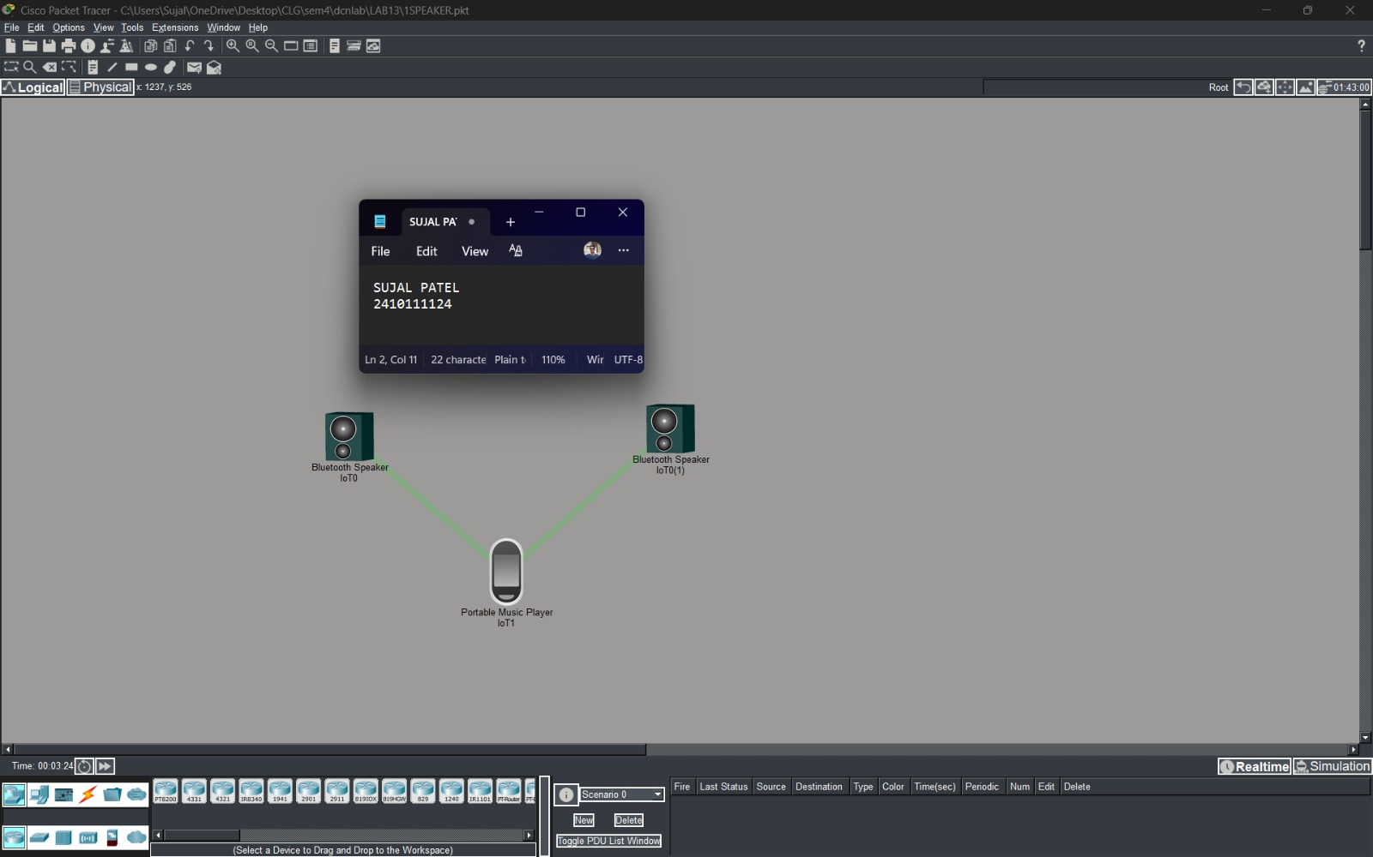
Fig. 1b. Bluetooth music player with 2 speakers (ON)
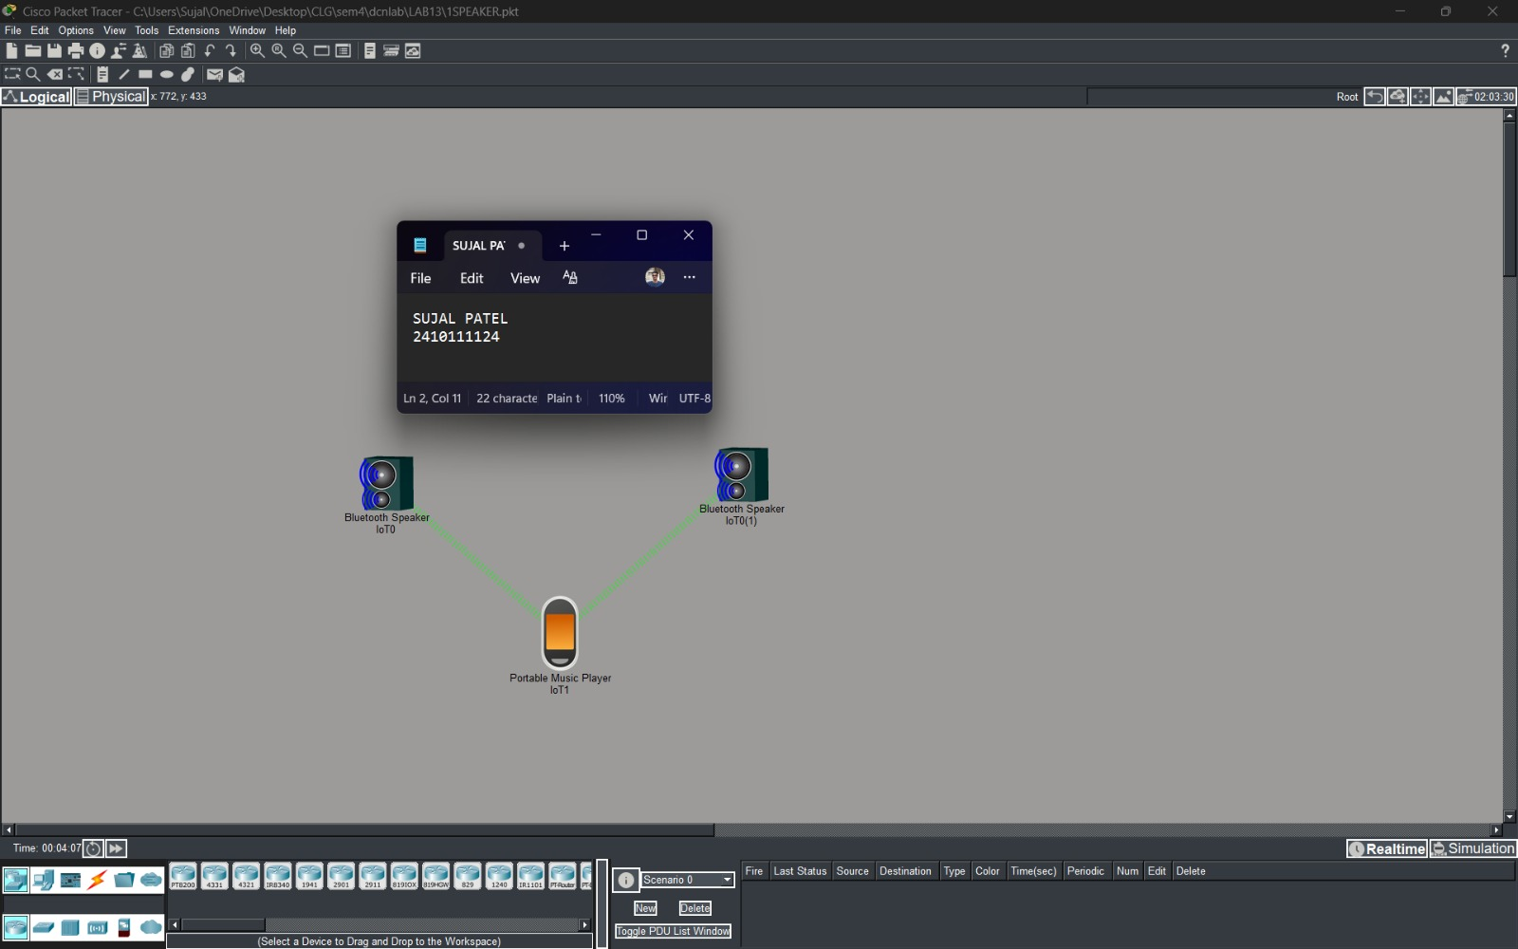

PROCEDURE:

- Open Cisco Packet Tracer Application and intialise a new project.
- Start placing multiple end devices (like Bluetooth Speakers & Portable Music Player) according to your convenience.
- Switch from wireless to Bluetooth network.
- Discover the end devices and pair them; if they are not connected, you can increase the range of end devices and then pair them.
- Verify the network by playing sound from Portable Music Player

RESULTS:

The implementation and analysis of Bluetooth network was verified successfully. The devices, Bluetooth speaker and music player, were successfully paired using Bluetooth in their desired range. Stable connections were achieved for audio streaming and file sharing, but performance degraded with multiple simultaneous connections.
POSSIBLE SOURCES OF ERRORS:

  - Overlap with Wi-Fi, microwaves, or other 2.4 GHz devices.
  - Physical barriers like walls or metal objects.
  - Low power in devices can cause unstable connections.
  - Misconfiguration, forgetting to enable Bluetooth visibility.

CONCLUSION:

Bluetooth networks are highly effective for short-range, low-power communication between personal devices. They are simple to set up, cost-efficient, and widely supported. However, they are limited by range, speed, and susceptibility to interference, making them unsuitable for high bandwidth or long-distance networking.

LEARNING OUTCOMES:
- Understood the advantages and limitations of Bluetooth compared to other wireless technologies.
- Gained practical experience in pairing, testing, and troubleshooting Bluetooth connections.
PRECAUTIONS:
- Minimize interference by operating in a low-traffic frequency environment, away from other wireless devices.
- Keep devices within the recommended range (≤ 10 m for classic Bluetooth) to ensure stable connectivity
- Regularly update firmware and so ware to the latest versions for improved performance and security.

