Adani University
Bachelor of Technology
Subject Name: Data Communication & Computer Networks
Subject Code: EICCI24203 Sem: 4th Date: 20-04-2026

URN. No. 2410111124 Name: Sujal Patel Sec : B

EXPERIMENT: 14
OBJECTIVE:
To study and analyze a Home Automation Network and understand communication between smart devices ensuring efficient and secure operation.
SOFTWARE USED:

Cisco Packet Tracer, Laptop
THEORY:

Advantages:
- Enables remote monitoring and control of home devices.
- Improves energy efficiency and automation.
- Enhances home security systems.
- Provides convenience and time saving.

Drawbacks:

- High installation cost.
- Dependency on internet connectivity.
- Security risks if not properly configured.
- Maintenance complexity.

CODE:
Not Applicable

PRACTICAL:
1. Basic Home Setup with Multiple Smart Devices :
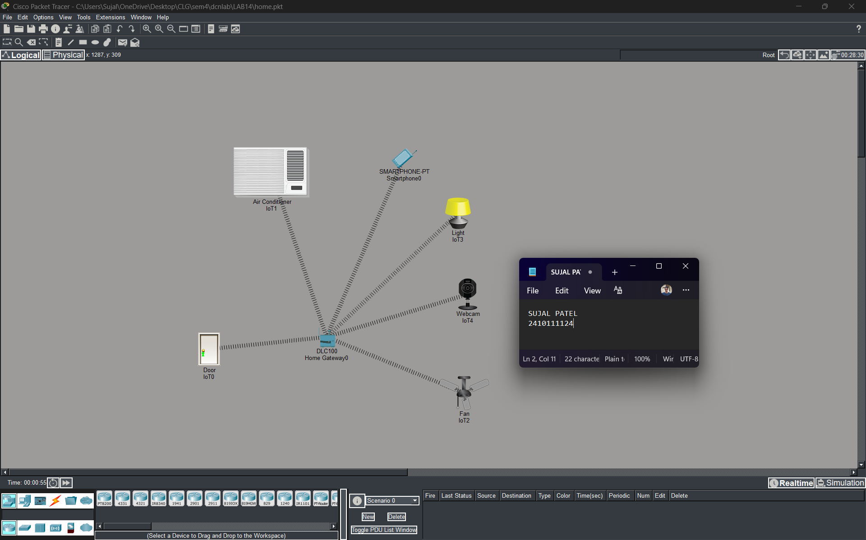
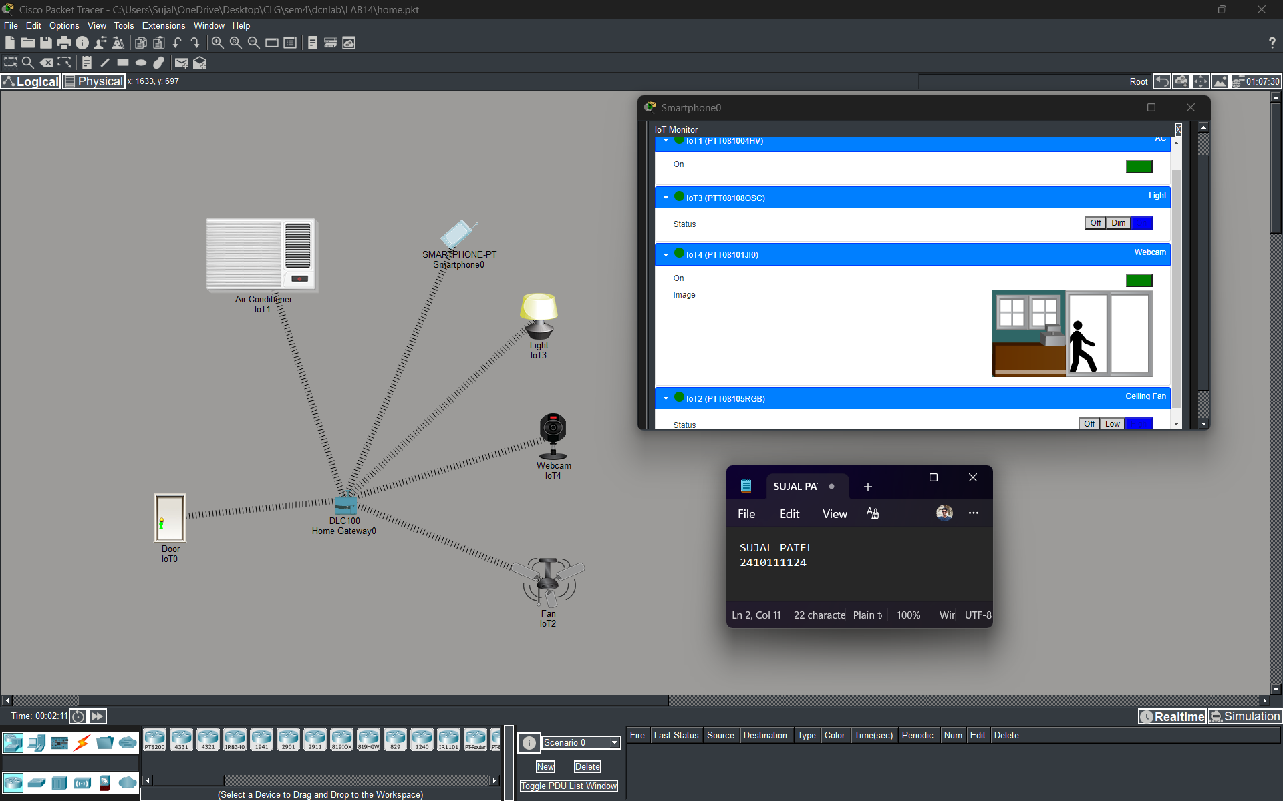

PROCEDURE:

- Cisco Packet Tracer was launched and a new project was created.
- Smart devices like sensors, controllers and actuators were added.
- Devices were connected using wireless/wired communication.
- IP addresses were configured properly.
- Network was simulated to observe communication.
- Data transfer and automation behavior were analyzed.

RESULTS:

The Home Automation Network was successfully studied and analyzed. Communication between smart devices was observed and verified. The system demonstrated automation, efficient data transmission and improved control over devices.

POSSIBLE SOURCES OF ERRORS:

- Incorrect device configuration.
- Network connectivity issues.
- Improper IP addressing.
- Security misconfigurations.
CONCLUSION:

The Home Automation Network case study demonstrated how smart devices communicate within a network. It showed efficient automation, improved security and better control of home systems.

LEARNING OUTCOMES:

- Understood working of Home Automation Networks.
- Learned about smart devices and communication.
- Observed automation and security features.

PRECAUTIONS:
- Ensure proper configuration of devices.
- Maintain secure network settings.
- Use correct IP addressing.
- Test network after full setup.

