Adani University
Bachelor of Technology
Subject Name: Data Communication & Computer Networks
Subject Code: EICCI24203 Sem: 4th Date: 02-02-2026

URN. No. 2410111124 Name: Sujal Patel Sec : B

EXPERIMENT: 2
OBJECTIVE:
To design and simulate a small computer network of 6-16-24 computers using switches and to verify successful data communication while ensuring availability of an alternative communication path. (With Ring Topology)

SOFTWARE USED:

CISCO PACKAGE TRAINER, DESKTOP

THEORY:

CODE:

Not applicable

PRACTICAL:

1.With 6 computers:
Figure 1A :- Basic Diagram
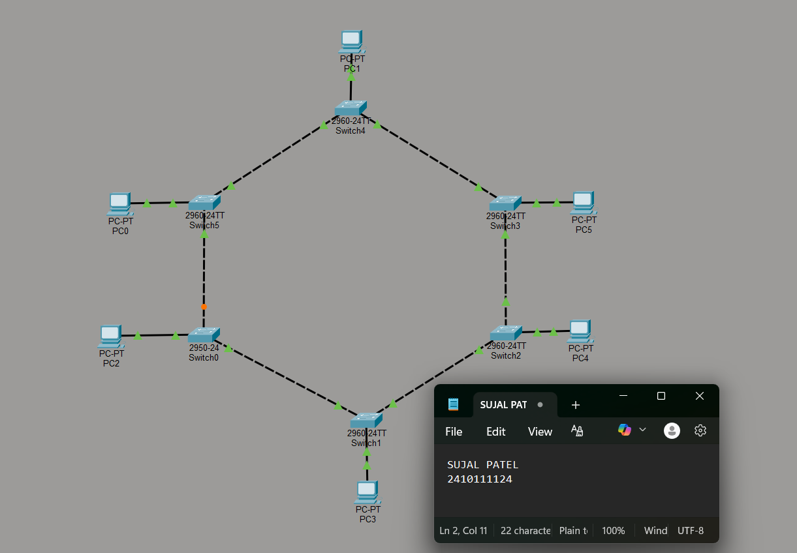

Figure 1B :- Simulation Diagram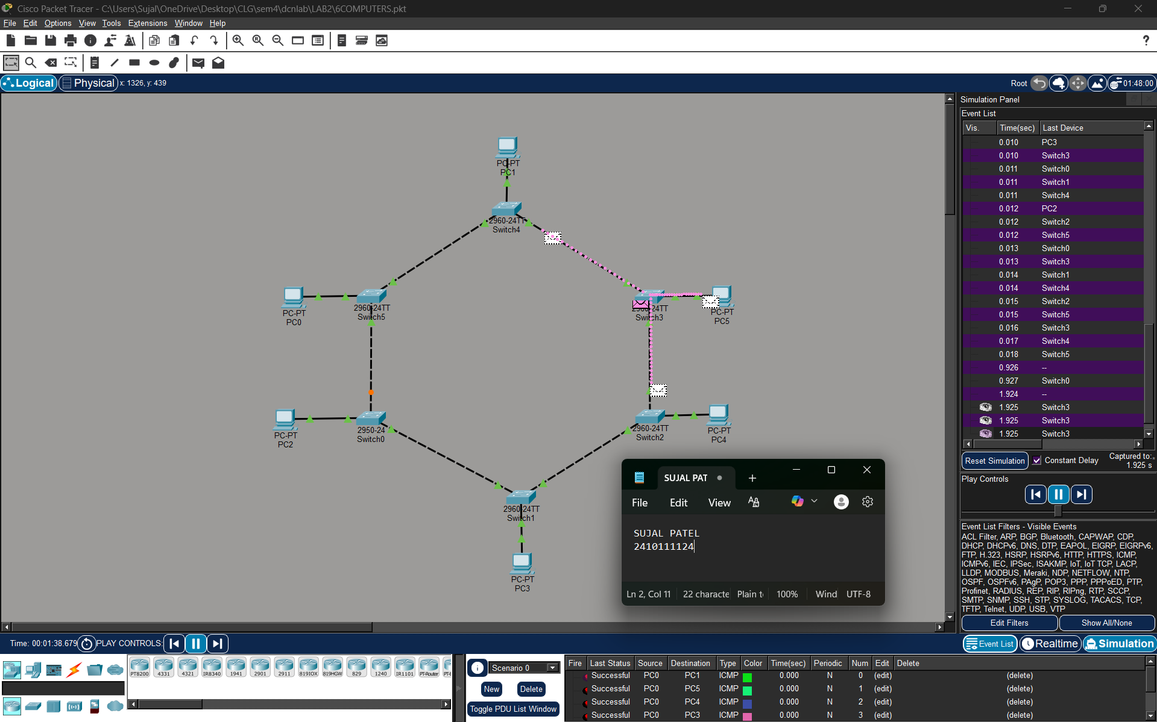

Figure 1C :- Analysis of message received
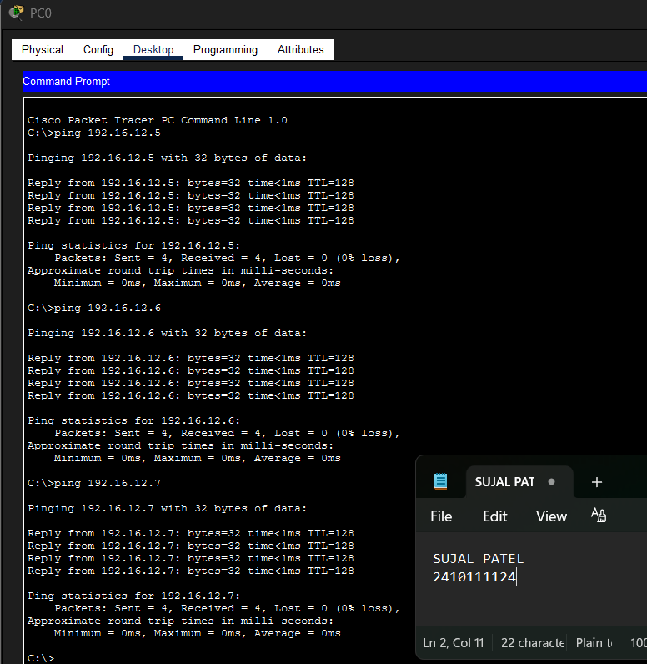

2.With 16 Computers :
Figure 2A :- Basic Diagram 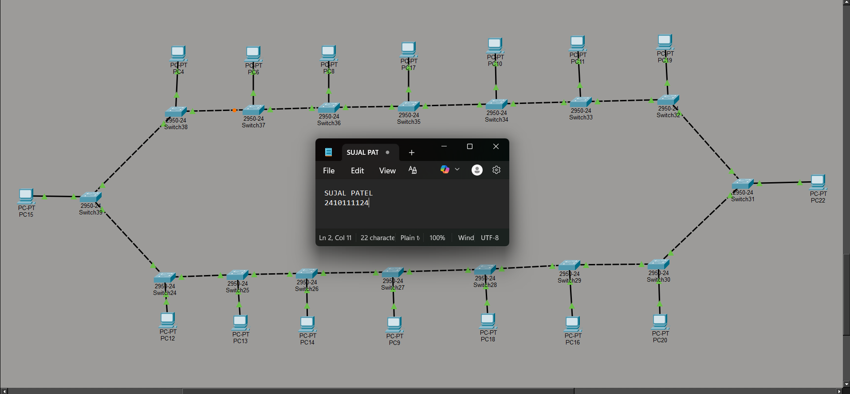
Figure 2B :- Simulation Diagram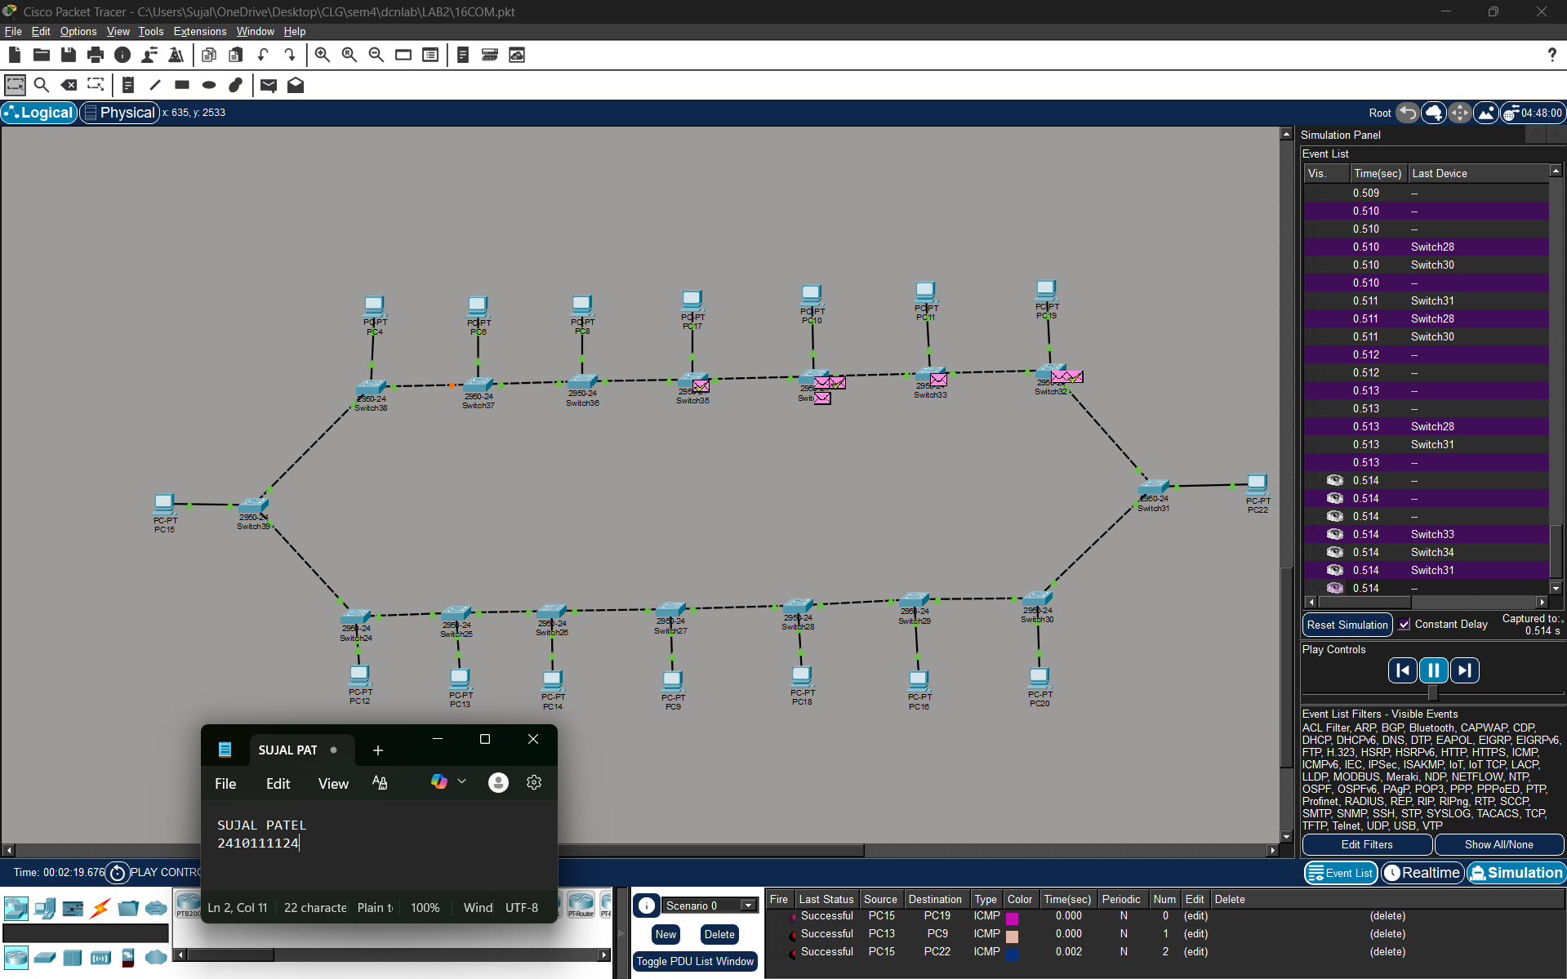

Figure 2C :- Analysis of message received 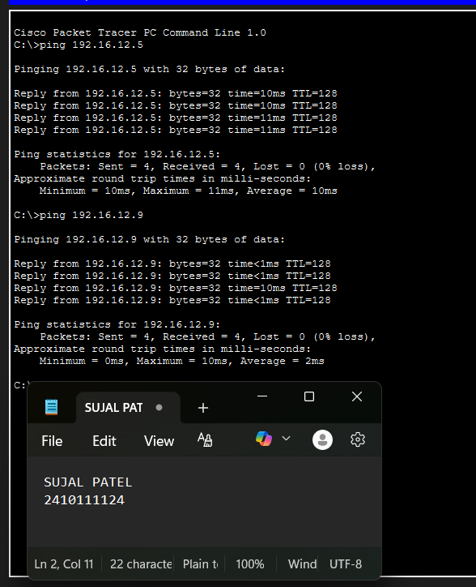

3.With 24 Computers
Level 3A :- Basic Diagram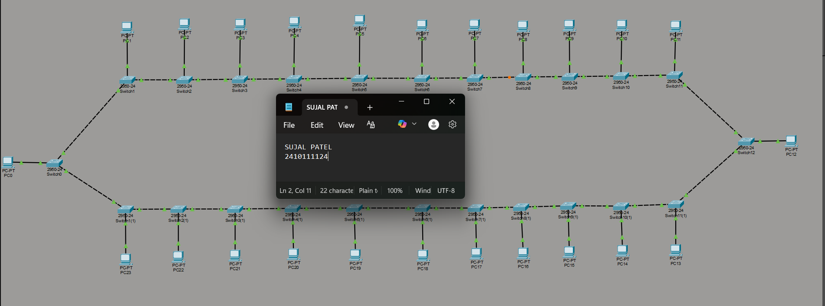

Level 3B : - Simulation Diagram 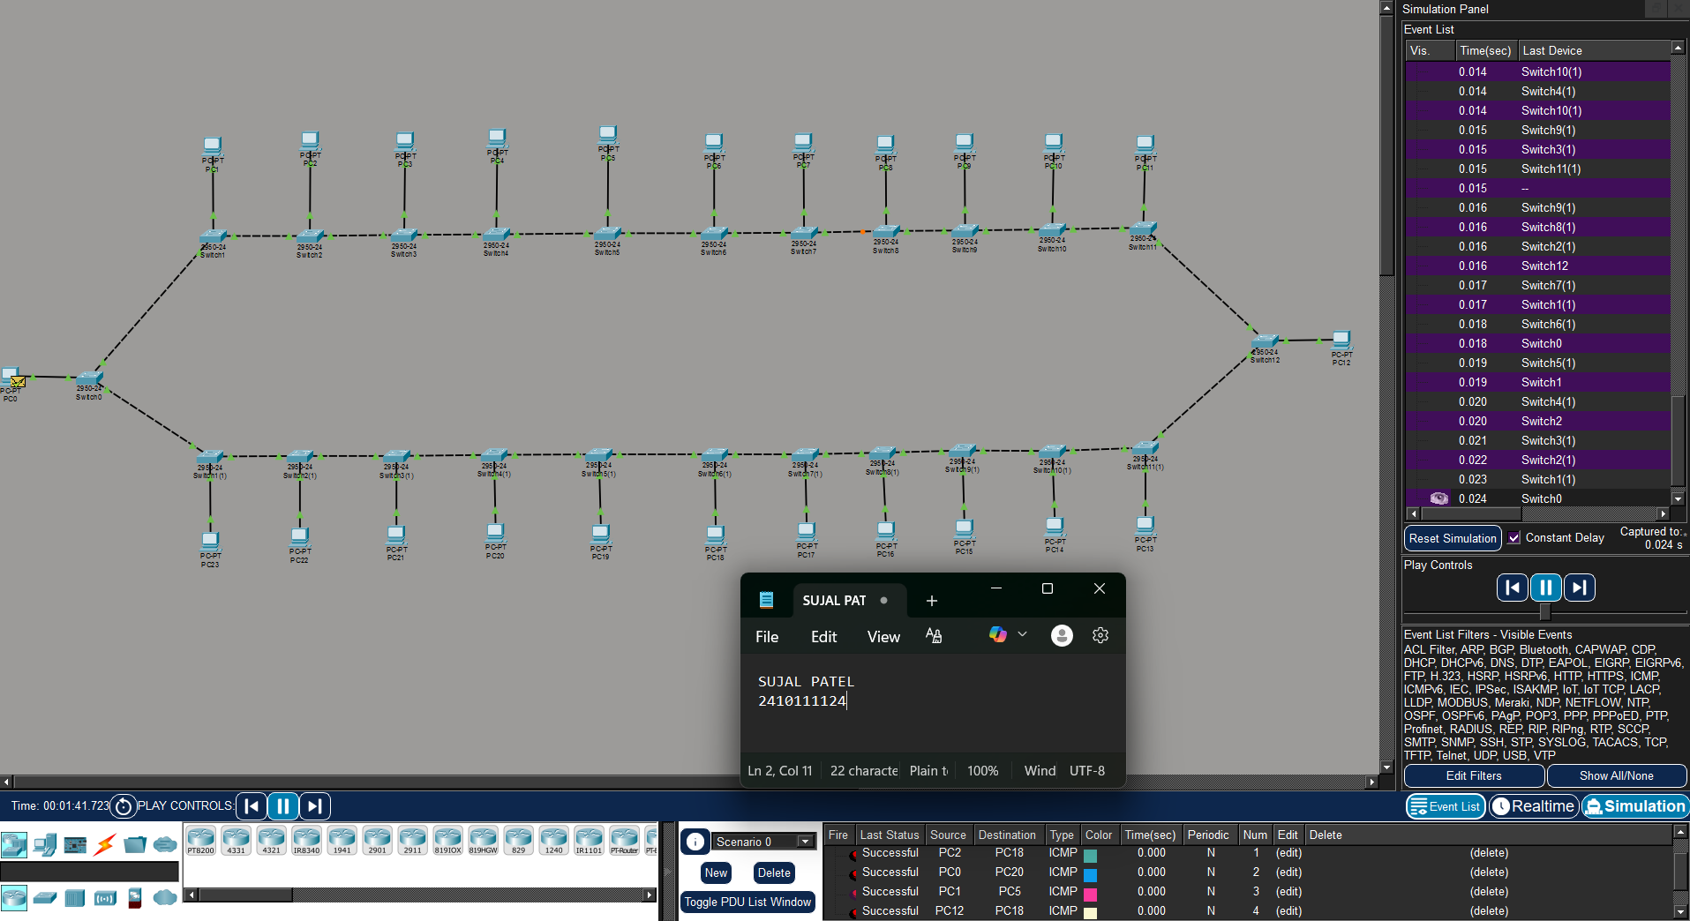

Level 3C :- Analysis of message received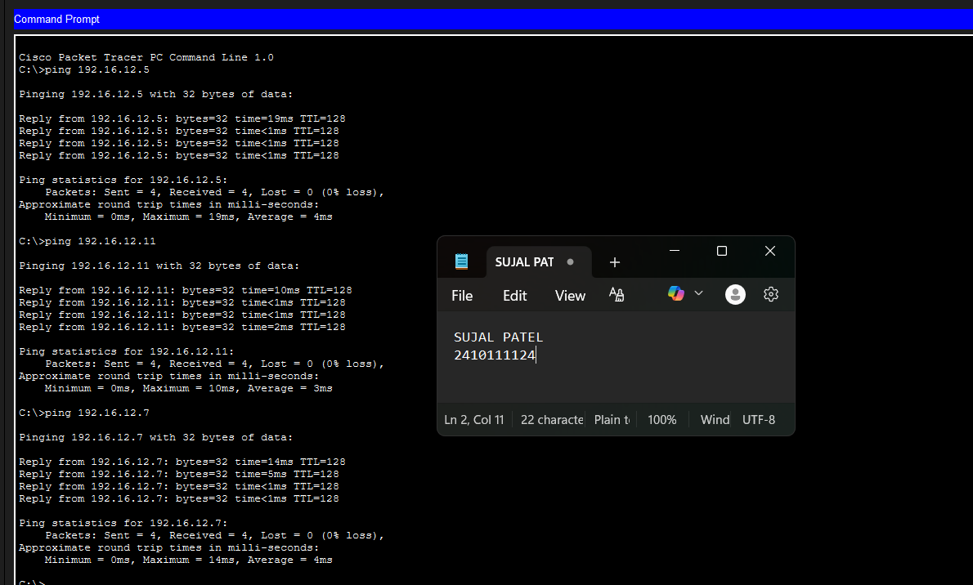

PROCEDURE:
- Cisco Packet Tracer was launched and a new project was created.
- The necessary number of PCs and switches were placed in the workspace.
- Each PC was connected to a switch using cables.
- The switches were linked together to create an alternative communication path.
- Static IP addresses within the same network were assigned to all PCs.
- The network was allowed to stabilize in real-time mode.
- Message transmission was verified using simulation mode.

RESULTS:

The ring topology network consisting of 6 / 16 / 24 computers interconnected using switches was successfully designed and simulated.
All computers were able to communicate with each other without data loss.
When a single link or node failure was introduced, data transmission continued through the alternative path, proving the fault tolerance and reliability of the ring topology.

POSSIBLE SOURCES OF ERRORS:
  - Incorrect IP address or subnet mask configuration.
  - Entering IP address in the default gateway field instead of the IPv4 address field.
  - Improper cable connections between devices.
  - Testing the network before switch convergence was completed.

CONCLUSION:

The experiment successfully demonstrated the design and simulation of a ring topology network using switches.
The network ensured successful data communication among all nodes and maintained connectivity even after a link failure by providing an alternative communication path.
Thus, ring topology is suitable for networks where reliability and redundancy are required.

LEARNING OUTCOME:
- How to design and simulate ring topology networks.
- Configuration of IP addressing in a LAN.
- Understanding of data transmission paths in ring topology.
- Importance of alternative paths for fault tolerance.
- How network topology affects performance and reliability.

PRECAUTIONS:
- Ensure each PC has a unique IP address within the same subnet.
- Use appropriate cable types for device connections.
- Leave the default gateway empty when no router is used.
4) Allow sufficient time for the network to stabilize before testing communication

