Adani University
Bachelor of Technology
Subject Name: Data Communication & Computer Networks
Subject Code: EICCI24203 Sem: 4th Date: 02-02-2026

URN. No. 2410111124 Name: Sujal Patel Sec : B

EXPERIMENT: 3
OBJECTIVE:
To design and simulate a small computer network of 6-16-24 computers using switches and to verify successful data communication while ensuring availability of an alternative communication path. (With Star Topology)

SOFTWARE USED:

CISCO PACKAGE TRAINER, DESKTOP

THEORY:

CODE:

Not applicable

PRACTICAL:

1.With 6 computers:
Figure 1A :- Basic Diagram
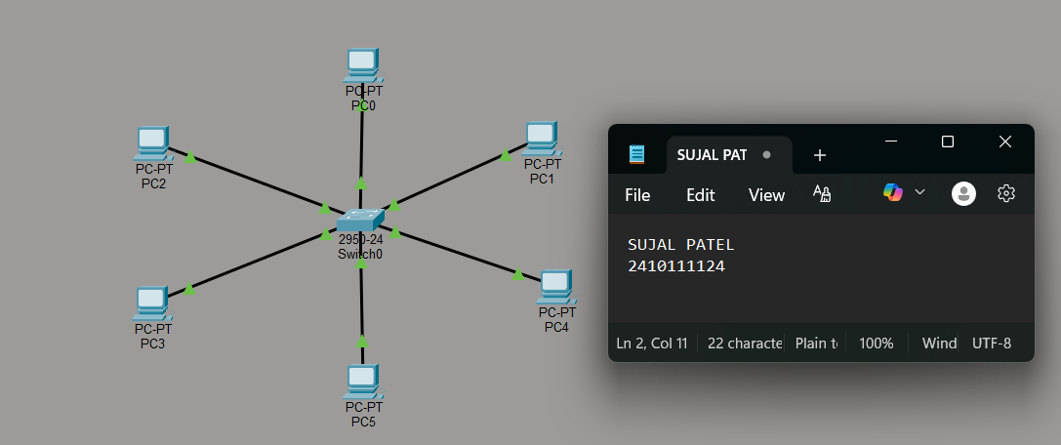

Figure 1B :- Simulation Diagram 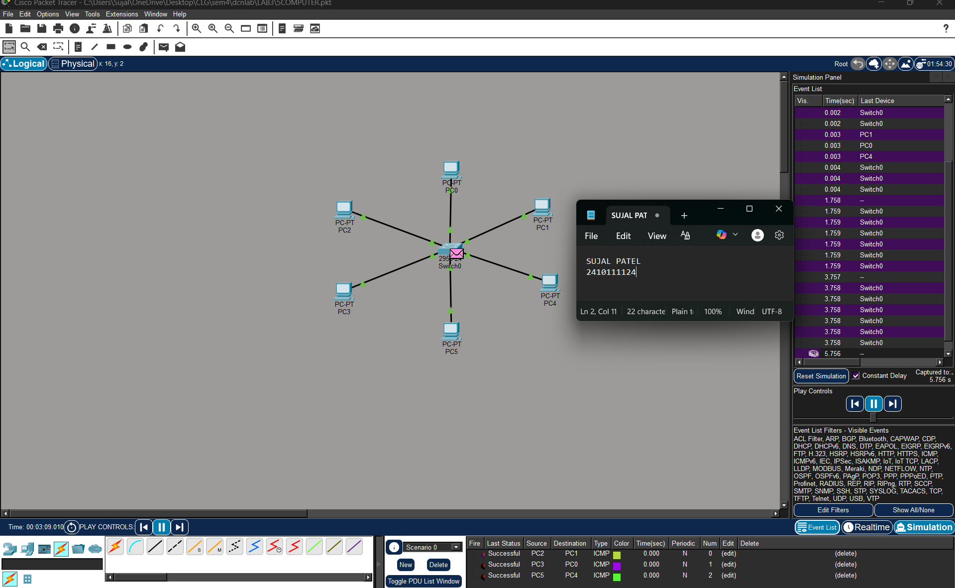

Figure 1C :- Analysis of message received
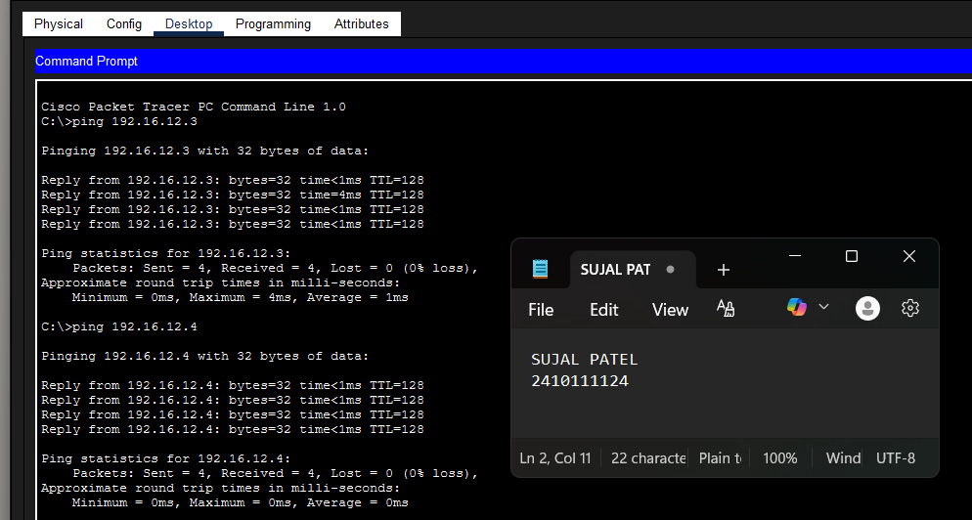

2.With 16 Computers :
Figure 2A :- Basic Diagram 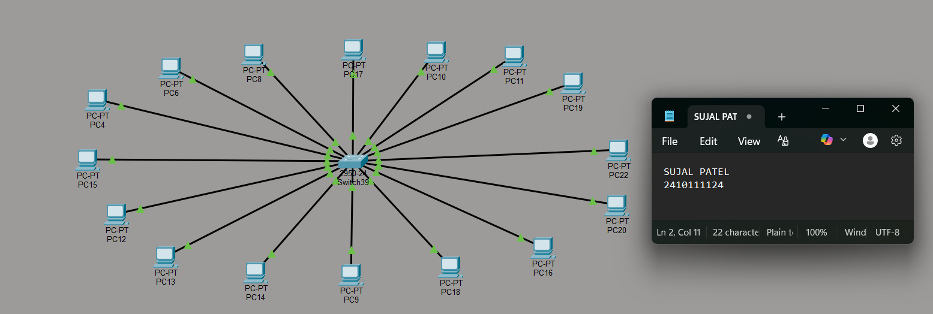
Figure 2B :- Simulation Diagram 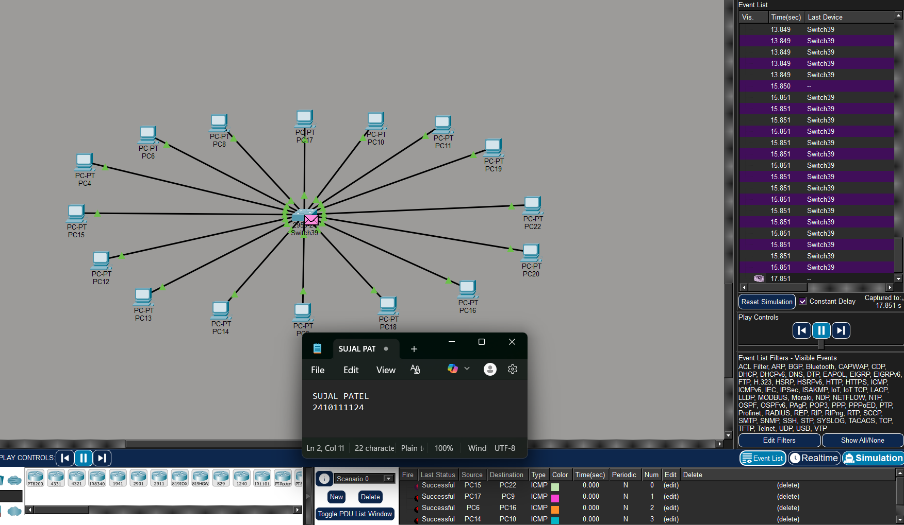

Figure 2C :- Analysis of message received 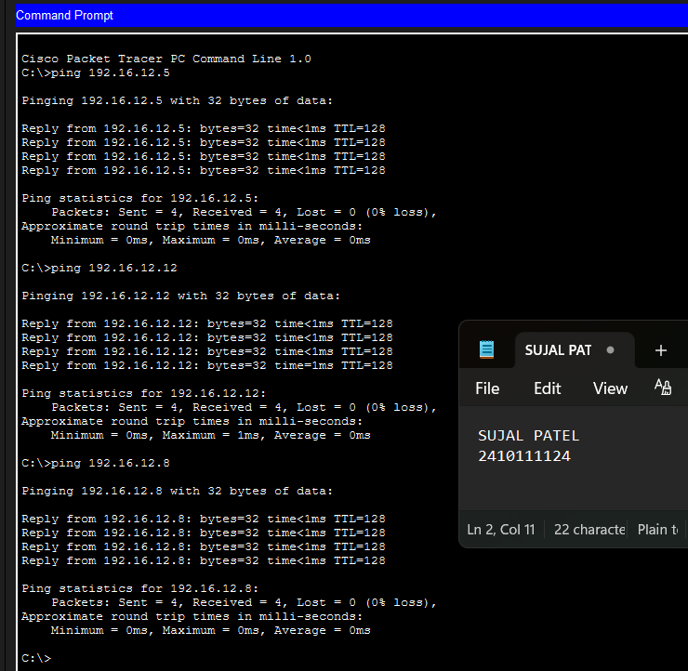

3.With 24 Computers
Level 3A :- Basic Diagram 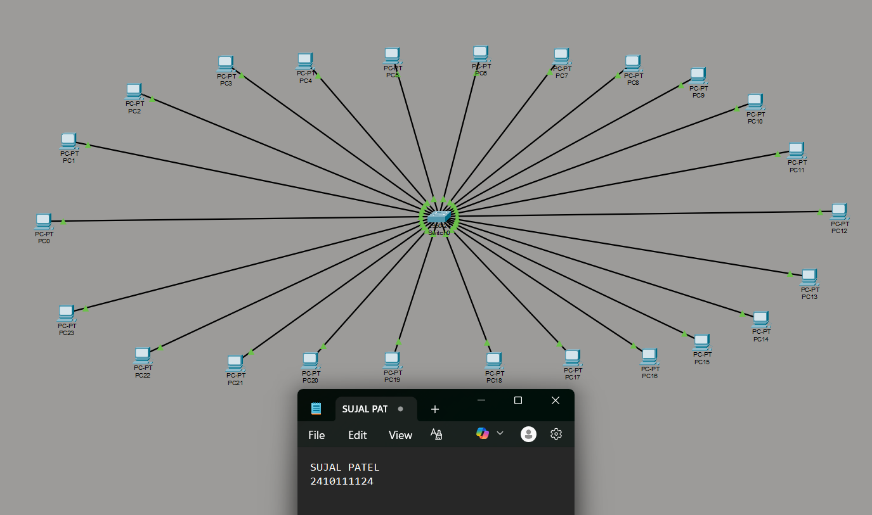
Level 3B : - Simulation Diagram 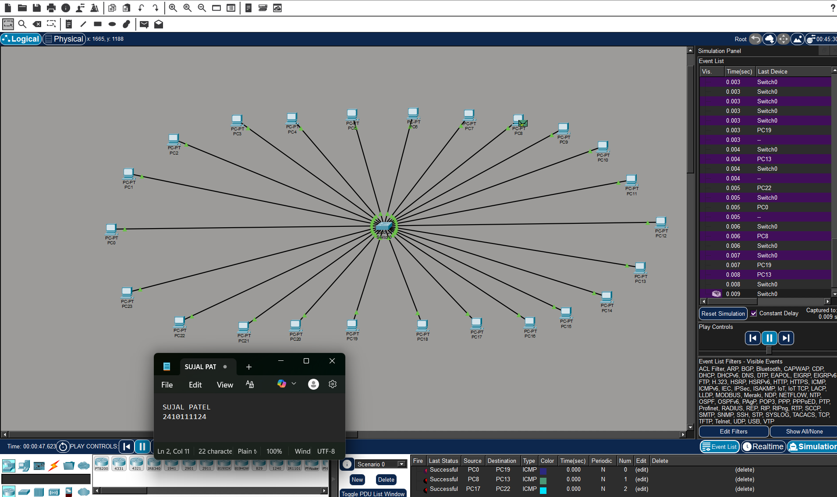

Level 3C :- Analysis of message received 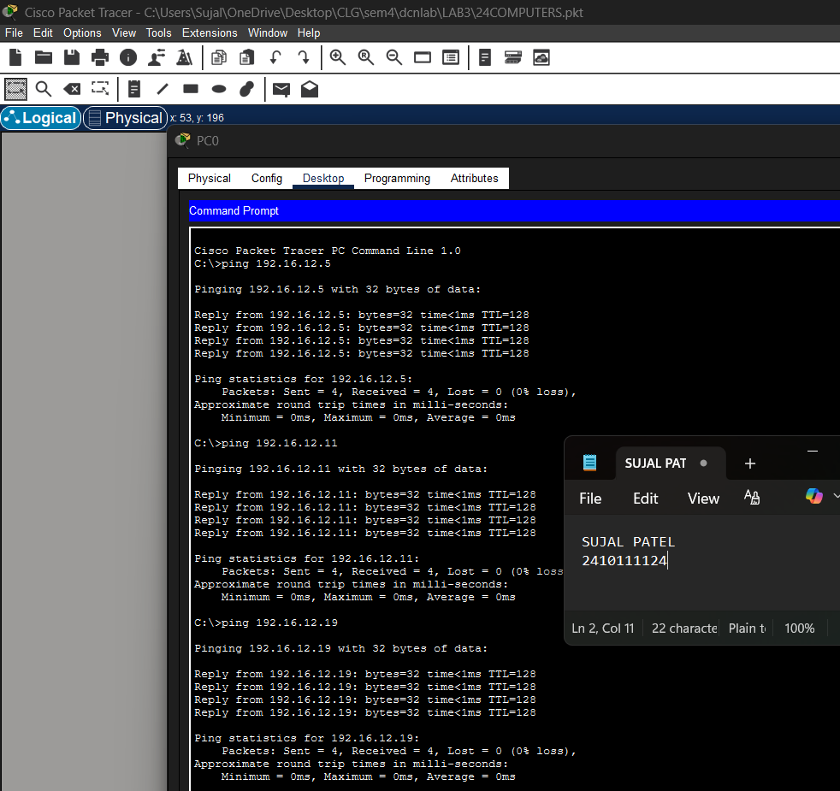

PROCEDURE:
- Cisco Packet Tracer was launched and a new project was created.
- The necessary number of PCs and switches were placed in the workspace.
- Each PC was connected to a switch using cables.
- The switches were linked together to create an alternative communication path.
- Static IP addresses within the same network were assigned to all PCs.
- The network was allowed to stabilize in real-time mode.
- Message transmission was verified using simulation mode.

RESULTS:

- The star topology network consisting of 6 / 16 / 24 computers connected using a central switch was successfully designed and simulated. All computers communicated successfully.
- If you disconnect one computer, only that specific node loses connection. The rest of the network remains 100% operational.

POSSIBLE SOURCES OF ERRORS:
  - If the central switch loses power or fails, the entire network goes down instantly.
  - Incorrect IP address or subnet mask configuration.
  - Entering IP address in the default gateway field instead of the IPv4 address field.
  - Improper cable connections between devices.
  - Testing the network before switch convergence was completed.

CONCLUSION:

The Star Topology proves to be an efficient and practical network design due to its scalability, simplicity, and ease of maintenance. The centralized structure allows for easy addition or removal of computers without affecting the overall network performance. Faults can be quickly identified and isolated to an individual cable or computer, ensuring minimal disruption to the remaining network. These characteristics make star topology a reliable and widely adopted architecture for local area network implementations.

LEARNING OUTCOME:
- Learned to design and simulate a Star Topology network using Cisco Packet Tracer.
- Understood how star topology provides fault isolation, where failure of a single cable affects only the connected computer and not the entire network.
- Learned the role of the central switch as the core component responsible for managing and directing data traffic within the network.
PRECAUTIONS:
- Ensure the central switch is properly connected and powered ON.
- Assign unique IP addresses to each computer.
- Verify all cable connections before testing.
- Avoid overloading the switch with unnecessary traffic.
- Save network configuration before testing failures.
- Use correct cable types and ports.

