Adani University
Bachelor of Technology
Subject Name: Data Communication & Computer Networks
Subject Code: EICCI24203 Sem: 4th Date: 09-02-2026

URN. No. 2410111124 Name: Sujal Patel Sec : B

EXPERIMENT: 4
OBJECTIVE:
To design and simulate a small computer network of 6-16-24 computers using switches and to verify successful data communication while ensuring availability of an alternative communication path. (With Bus Topology)

SOFTWARE USED:

CISCO PACKAGE TRACER, DESKTOP

THEORY:

Advantages:
- Simple and easy to install
- Cost effective
- Easy to expand
- No central hub required
- Good for small networks
Disadvantages:
- Main cable is the single point of failure
- Difficult troubleshooting
- Data collision and traffic reduce performance
- Limited cable length

CODE:

Not applicable

PRACTICAL:

1.With 6 computers:
Figure 1A :- Basic Diagram
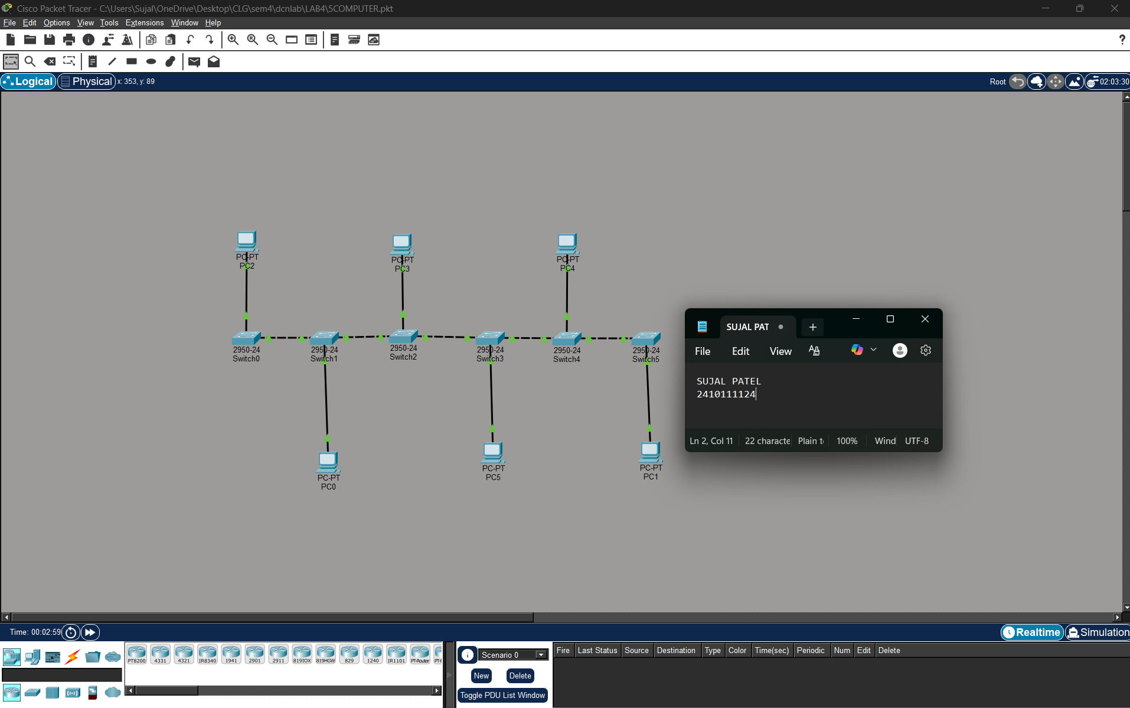

Figure 1B :- Simulation Diagram 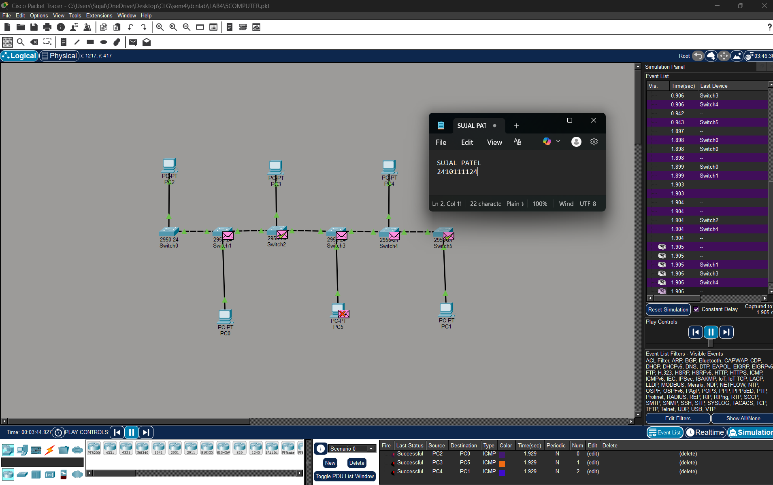

Figure 1C :- Analysis of message received
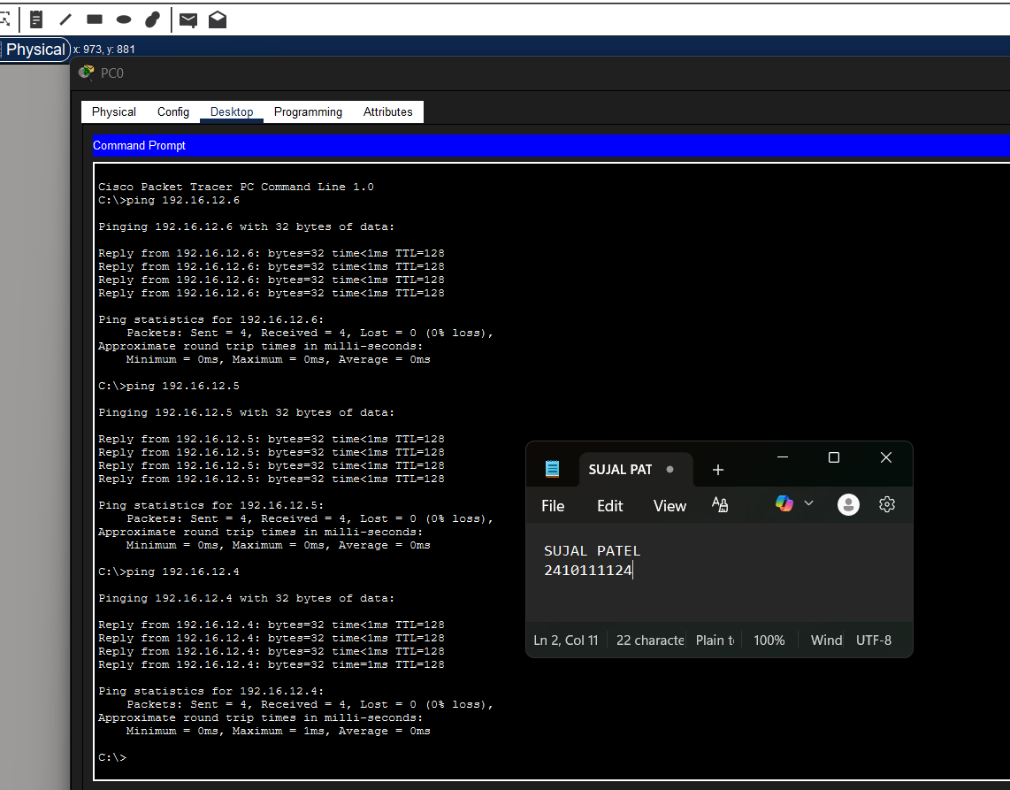

2.With 16 Computers :
Figure 2A :- Basic Diagram 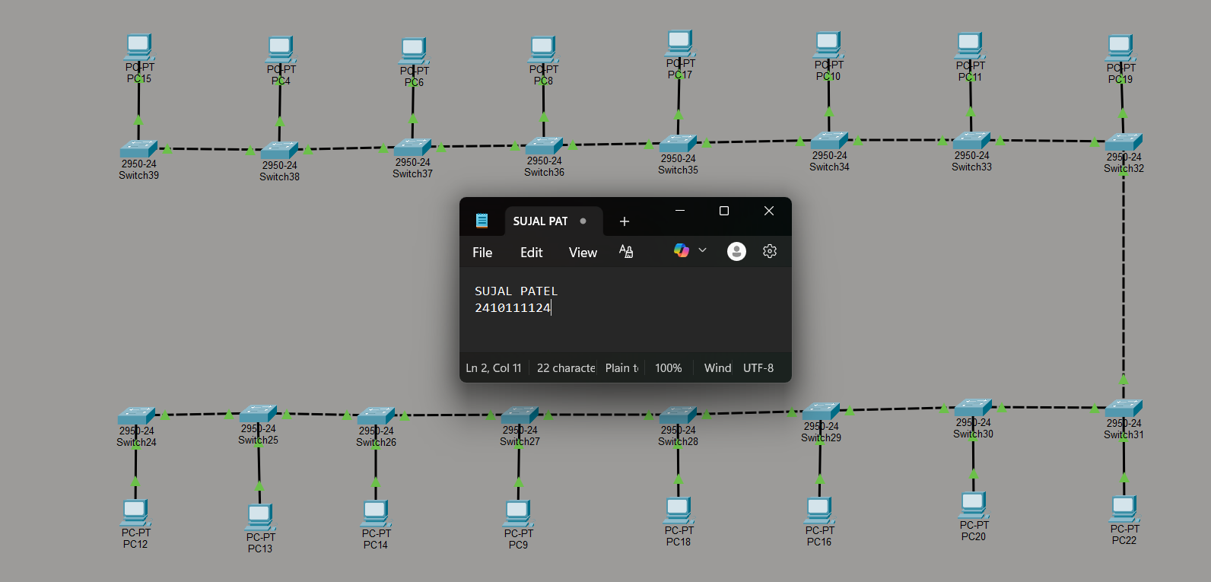
Figure 2B :- Simulation Diagram 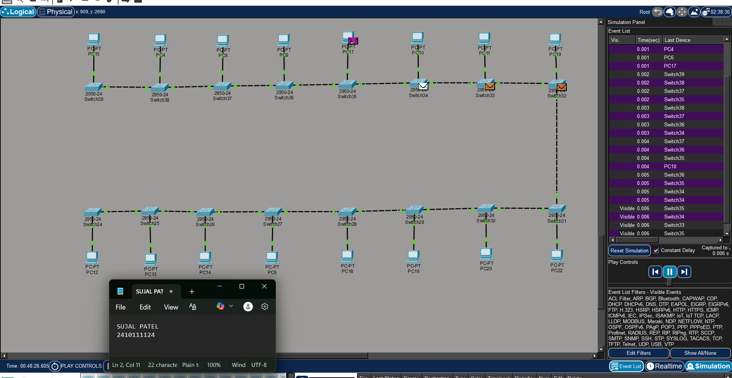

Figure 2C :- Analysis of message received 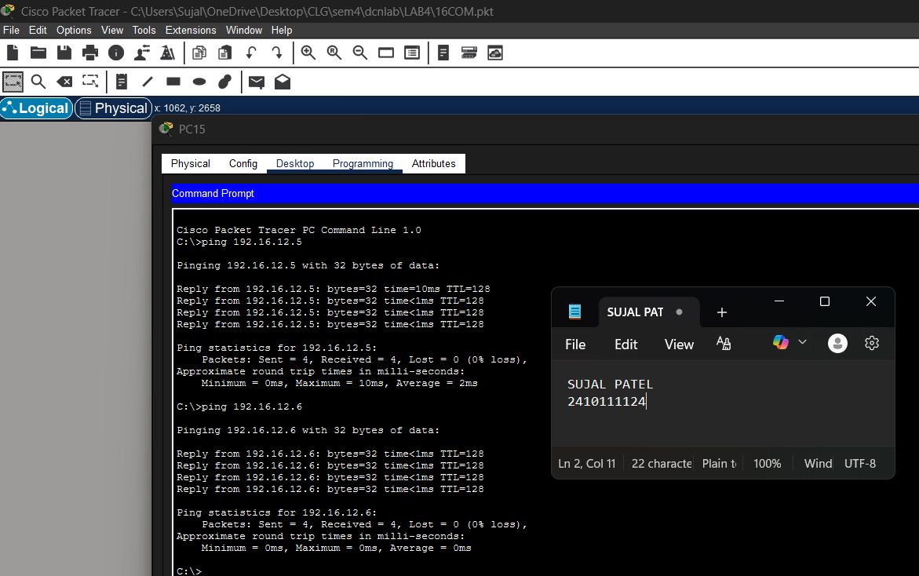

3.With 24 Computers
Level 3A :- Basic Diagram 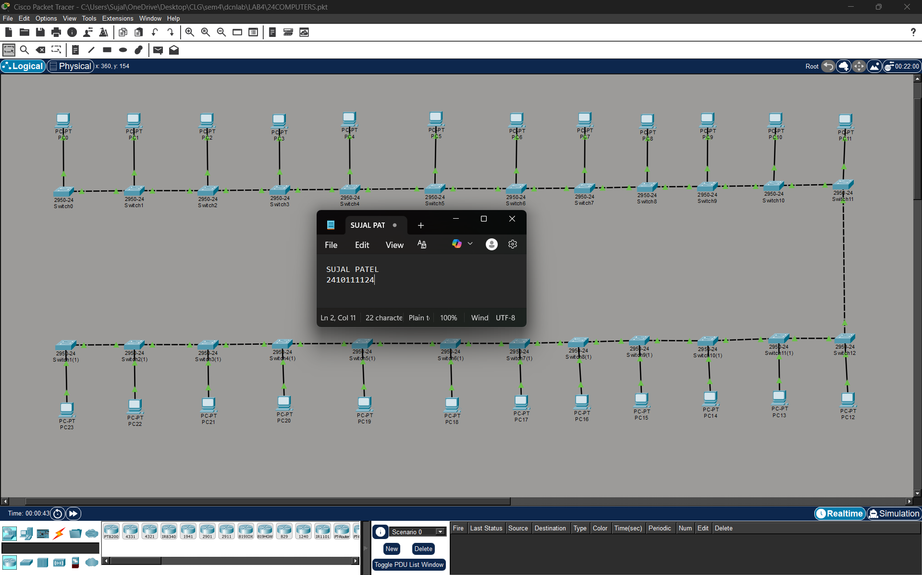
Level 3B : - Simulation Diagram 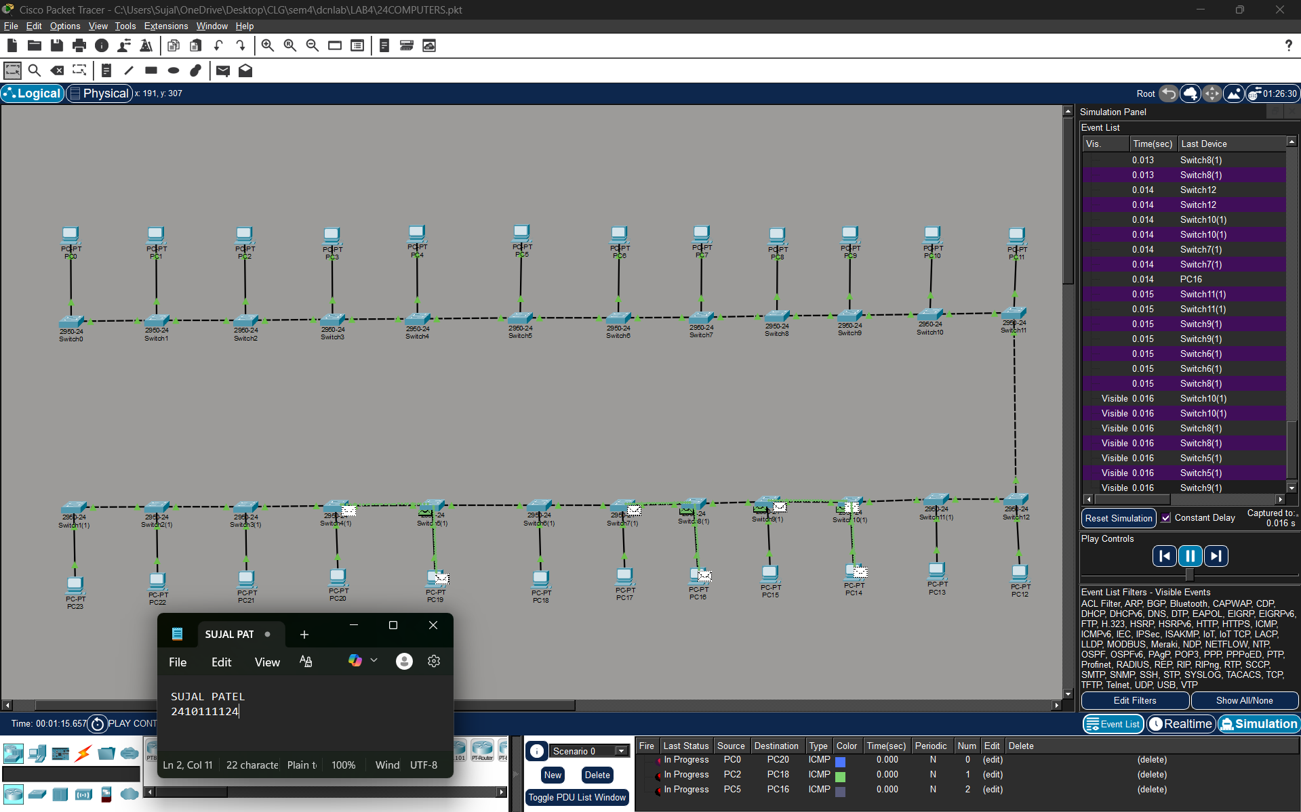

Level 3C :- Analysis of message received 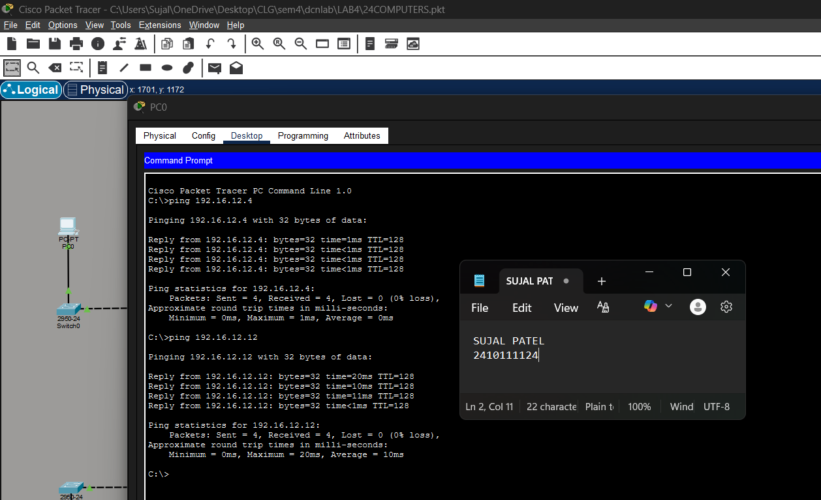

PROCEDURE:
- Cisco Packet Tracer was launched and a new project was created.
- The necessary number of PCs and switches were placed in the workspace.
- Each PC was connected to a switch using cables.
- The switches were linked together to create an alternative communication path.
- Static IP addresses within the same network were assigned to all PCs.
- The network was allowed to stabilize in real-time mode.
- Message transmission was verified using simulation mode.

RESULTS:

A Bus Topology network consisting of 6, 16, and 24 computers was successfully designed and simulated. All computers were connected through a single backbone cable, and successful data communication between the nodes was verified using ping tests. It was also observed that disconnection of an individual computer did not disrupt the entire network; however, failure of the main backbone cable resulted in complete network breakdown.

POSSIBLE SOURCES OF ERROR:

- Incorrect IP address or subnet mask configuration.
- Entering the IP address in the default gateway field instead of the IPv4 address field.
- Improper or loose cable connections between devices.
- Testing the network before the network devices were fully initialized and ready.

CONCLUSION:

The Bus Topology network consisting of 6, 16, and 24 computers was successfully designed and simulated. Data communication between all nodes was verified and found to be functioning correctly. The experiment demonstrated that bus topology is simple and cost-effective for small networks; however, as the number of connected devices increases, network traffic and collisions also increase, affecting overall performance. It was also observed that while failure of an individual computer does not disturb the network, failure of the main backbone cable results in complete network disruption.

LEARNING OUTCOME:
- Learned to design and simulate a Bus Topology network with 6, 16, and 24 computers.
- Understood the working principle of a single backbone cable as the main communication medium.
- Verified successful data transmission using ping testing between different nodes.
- Understood that failure of the backbone cable leads to complete network breakdown.
- Gained knowledge about collisions and data transmission issues in bus topology.
PRECAUTIONS:
- Ensure each PC has a unique IP address within the same subnet.
- Use appropriate cable types for device connections.
- Leave the default gateway empty when no router is used.
- Allow sufficient time for the network to stabilize before testing communication.

