Adani University
Bachelor of Technology
Subject Name: Data Communication & Computer Networks
Subject Code: EICCI24203 Sem: 4th Date: 09-02-2026

URN. No. 2410111124 Name: Sujal Patel Sec : B

EXPERIMENT: 5
OBJECTIVE:
To design and simulate a small computer network of 14-16-24 computers using switches and to verify successful data communication while ensuring availability of an alternative communication path. (With Hybrid Topology)

SOFTWARE USED:

CISCO PACKAGE TRACER, DESKTOP

THEORY:

Advantages:
- It can combine the benefits of different topologies to suit specific organizational needs.
- Fault detection and isolation are easier compared to simple topologies.
- It is easy to increase the size of the network by adding new sub-networks without disturbing the existing architecture.
- Heavy traffic in one part of the network does not necessarily impact other parts if structured properly.
- It provides better reliability and flexibility for medium and large networks.

Disadvantages:
- The design and configuration of the network are more complex compared to simple topologies.
- The overall cost is higher due to the requirement of multiple switches, cables, and networking devices.
- Troubleshooting can be difficult because of the complex structure.
- Maintenance requires skilled personnel for proper management.
- If the core backbone fails, a large portion of the network may be affected.

CODE:

Not applicable

PRACTICAL:

1.With 14 computers:(BUS+STAR)
Figure 1A :- Basic Diagram
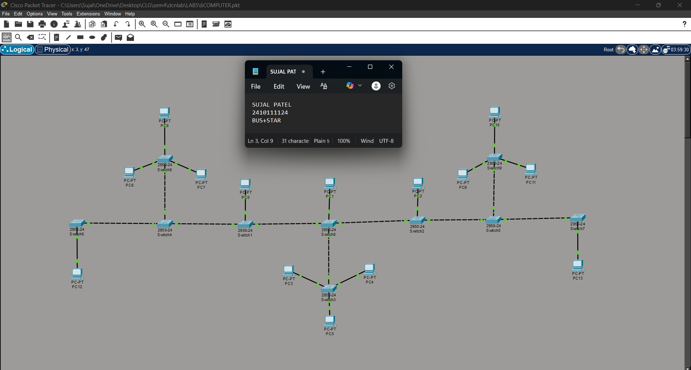

Figure 1B :- Simulation Diagram 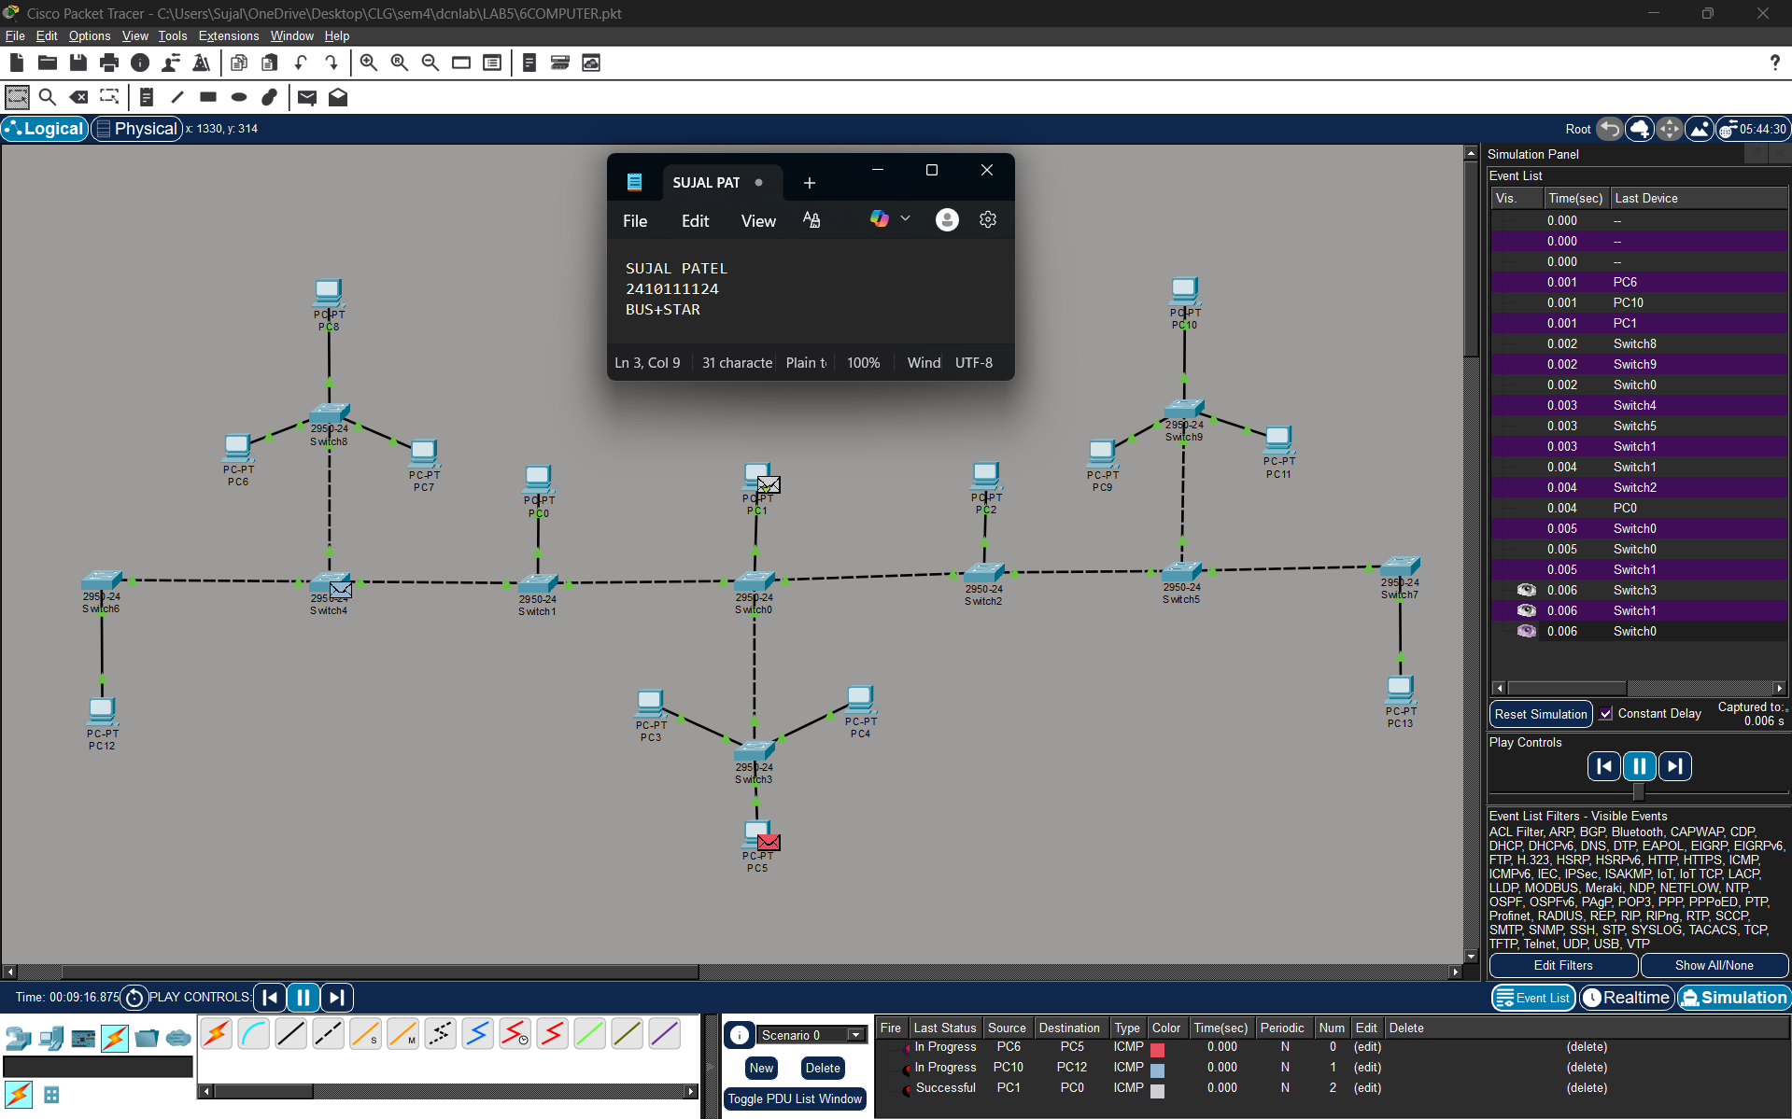

Figure 1C :- Analysis of message received
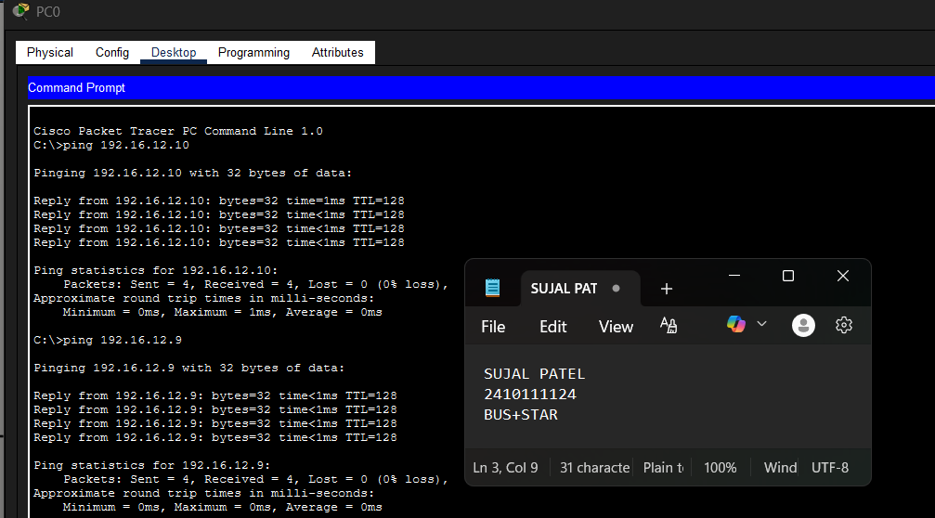
2.With 16 Computers : (RING+STAR)
Figure 2A :- Basic Diagram 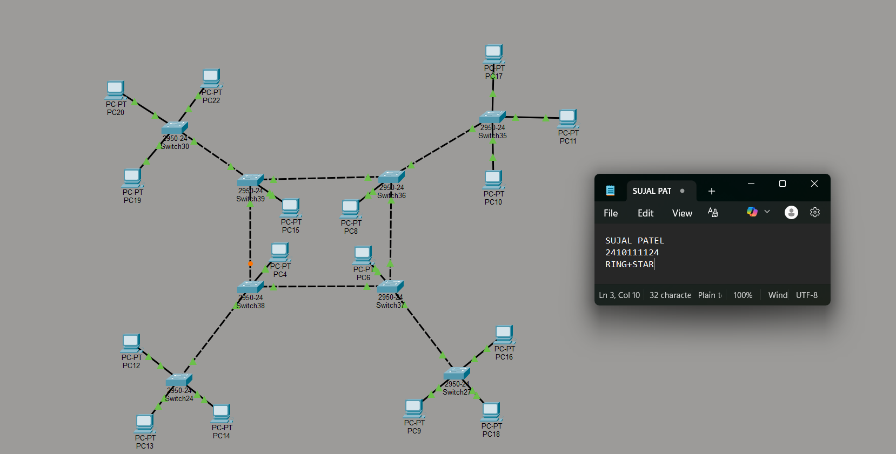
Figure 2B :- Simulation Diagram 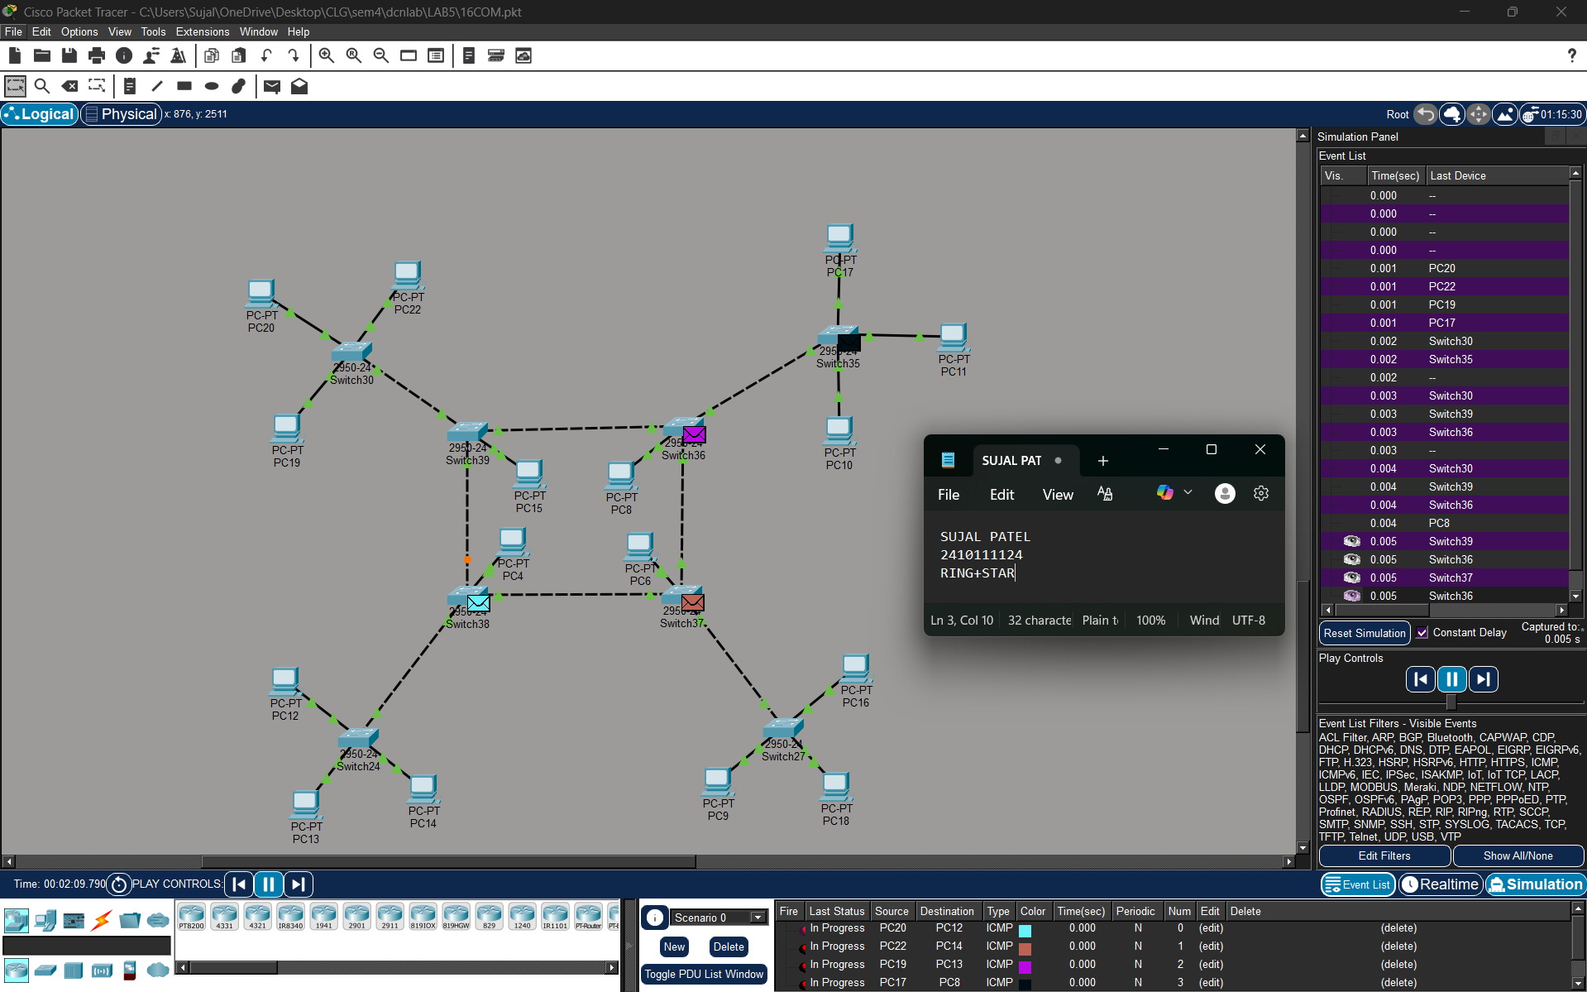

Figure 2C :- Analysis of message received 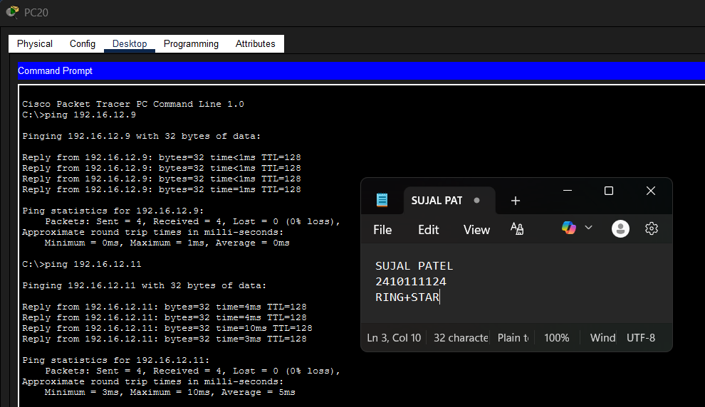

3.With 24 Computers (BUS+RING)
Level 3A :- Basic Diagram 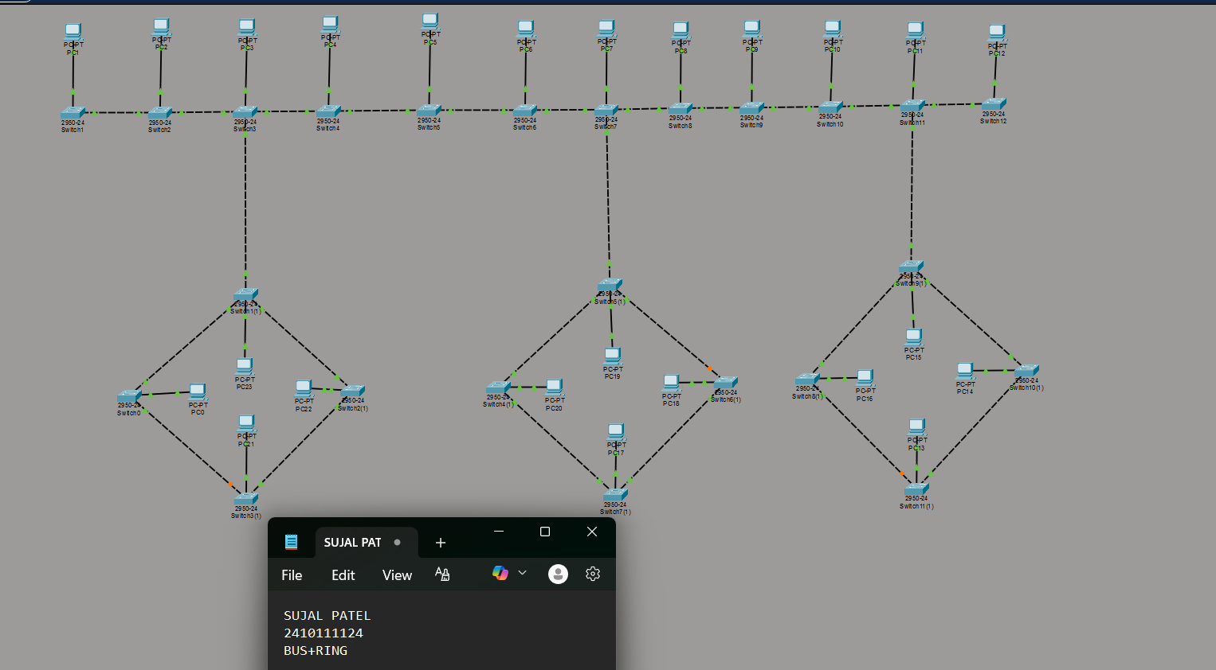
Level 3B : - Simulation Diagram 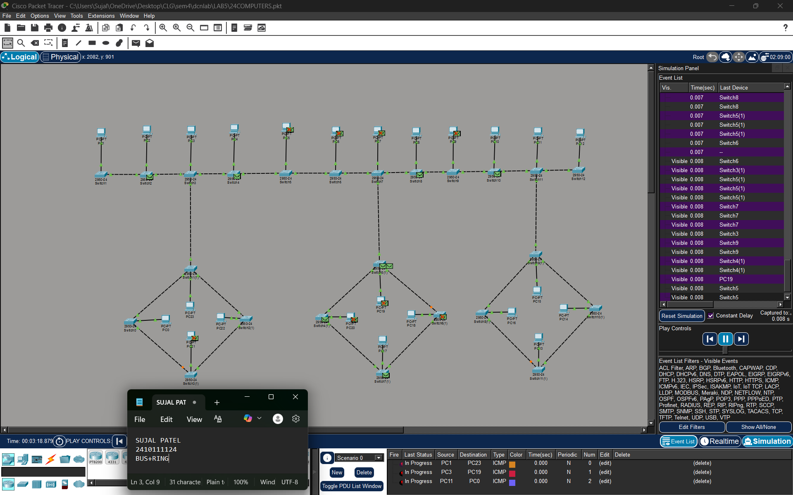

Level 3C :- Analysis of message received 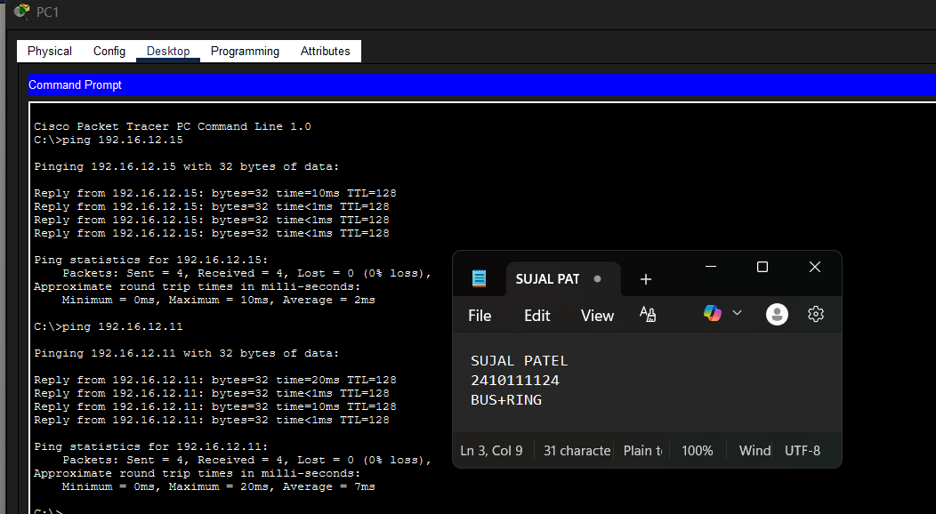

PROCEDURE:
- Cisco Packet Tracer was launched and a new project was created.
- The necessary number of PCs and switches were placed in the workspace.
- Each PC was connected to a switch using cables.
- The switches were linked together to create an alternative communication path.
- Static IP addresses within the same network were assigned to all PCs.
- The network was allowed to stabilize in real-time mode.
- Message transmission was verified using simulation mode.

RESULTS:

The Hybrid Topology networks consisting of 14, 16, and 24 computers were successfully designed and simulated using interconnected switches. Successful data communication between all nodes was verified through ping testing. It was observed that the hybrid design ensured stable communication by combining the advantages of multiple topologies. In the Ring-based sections, alternative communication paths were available during link failure, while the Bus backbone enabled structured interconnection of multiple switch groups. As the number of computers increased from 14 to 24, network traffic increased slightly, but communication remained functional and stable. The experiment demonstrated that hybrid topology provides better scalability, flexibility, and reliability for medium-sized networks.

POSSIBLE SOURCES OF ERROR:

- Incorrect IP address or subnet mask configuration.
- Entering the IP address in the default gateway field instead of the IPv4 address field.
- Improper or loose cable connections between devices.
- Testing the network before the network devices were fully initialized and ready.

CONCLUSION:

The hybrid topology was successfully created and tested using Cisco Packet Tracer by combining multiple star networks into a single network structure. This experiment showed how different network segments can be connected to build a scalable and efficient network. Proper switch configuration and IP addressing ensured reliable communication between computers in different clusters. The practical helped improve understanding of hybrid network design and its benefits in handling larger and more complex networks.

LEARNING OUTCOME:
- Learned to design and simulate a Hybrid Topology network combining different basic topologies.
- Understood how multiple topologies can be interconnected to improve scalability and flexibility.
- Verified successful data communication between 14, 16, and 24 computers using ping testing.
- Observed the impact of increasing the number of computers on network traffic and performance.
- Understood how hybrid topology can provide better fault tolerance and reliability compared to single topologies.
- Gained knowledge about switch interconnection and backbone network structure in medium-sized networks.
PRECAUTIONS:
- Ensure each PC has a unique IP address within the same subnet.
- Use appropriate cable types for device connections.
- Leave the default gateway empty when no router is used.
- Allow sufficient time for the network to stabilize before testing communication.

