Adani University
Bachelor of Technology
Subject Name: Data Communication & Computer Networks
Subject Code: EICCI24203 Sem: 4th Date: 16-02-2026

URN. No. 2410111124 Name: Sujal Patel Sec : B

EXPERIMENT: 6
OBJECTIVE:
To establish a network of computers using Domain Name System (DNS) server.

SOFTWARE USED:

CISCO PACKAGE TRACER, DESKTOP

THEORY:

Advantages:
- Instead of memorizing the IP addresses of different domains, DNS allows users to access websites and servers using easy-to-remember domain names.
- If the IP address of a server changes, the network administrator only needs to update the DNS record on the DNS server. Users can continue using the same domain name without changing any settings on their devices.
- DNS can help distribute incoming network traffic among multiple servers (load balancing), which improves performance and ensures better availability of services.
Disadvantages:
- If the DNS server fails or becomes unavailable, users may not be able to access websites or network services using domain names, even if the servers are running properly.
- DNS servers can be vulnerable to security threats such as DNS spoofing or DNS poisoning, which may redirect users to malicious or incorrect websites.
- A small delay may occur during the initial lookup while the domain name is being translated into an IP address.

CODE:

Not applicable

PRACTICAL:

1.With 6 computers:
Figure 1A :- Basic Diagram
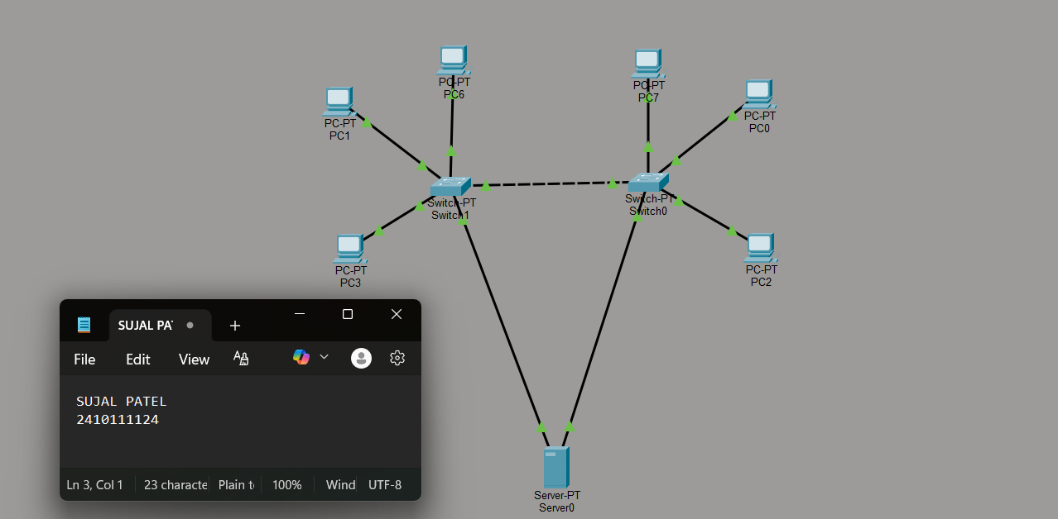

Figure 1B :- Simulation Diagram 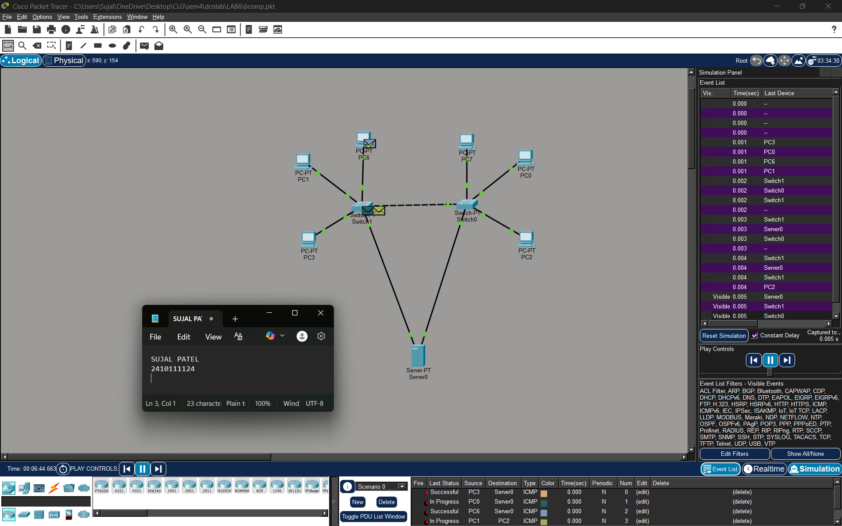

Figure 1C :- Analysis of message received
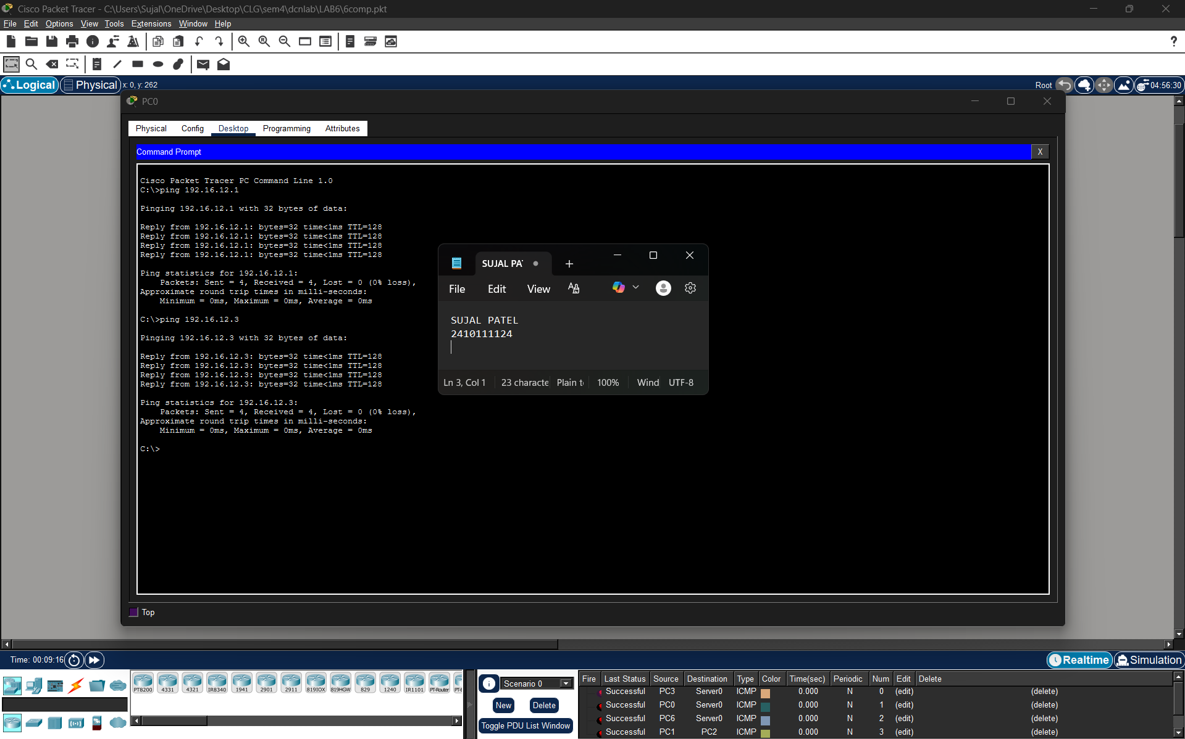
2.With 16 Computers :
Figure 2A :- Basic Diagram 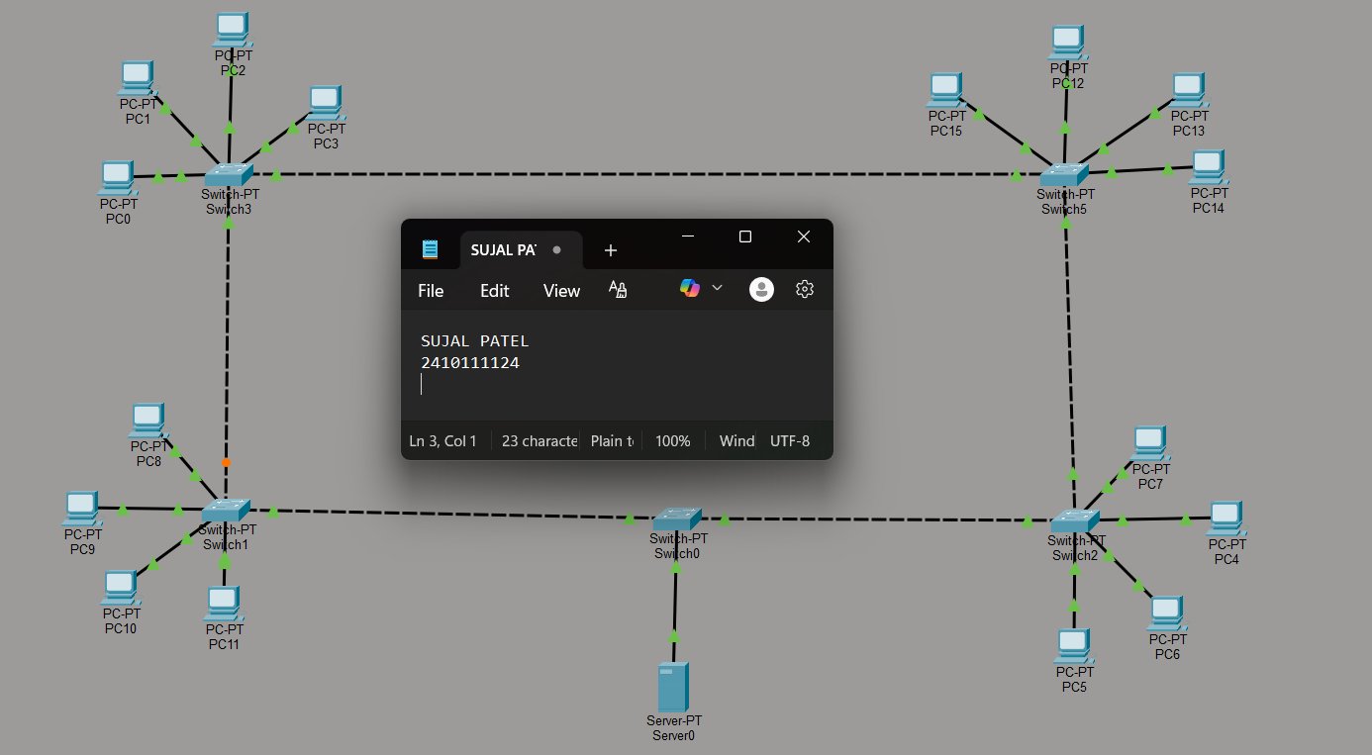
Figure 2B :- Simulation Diagram 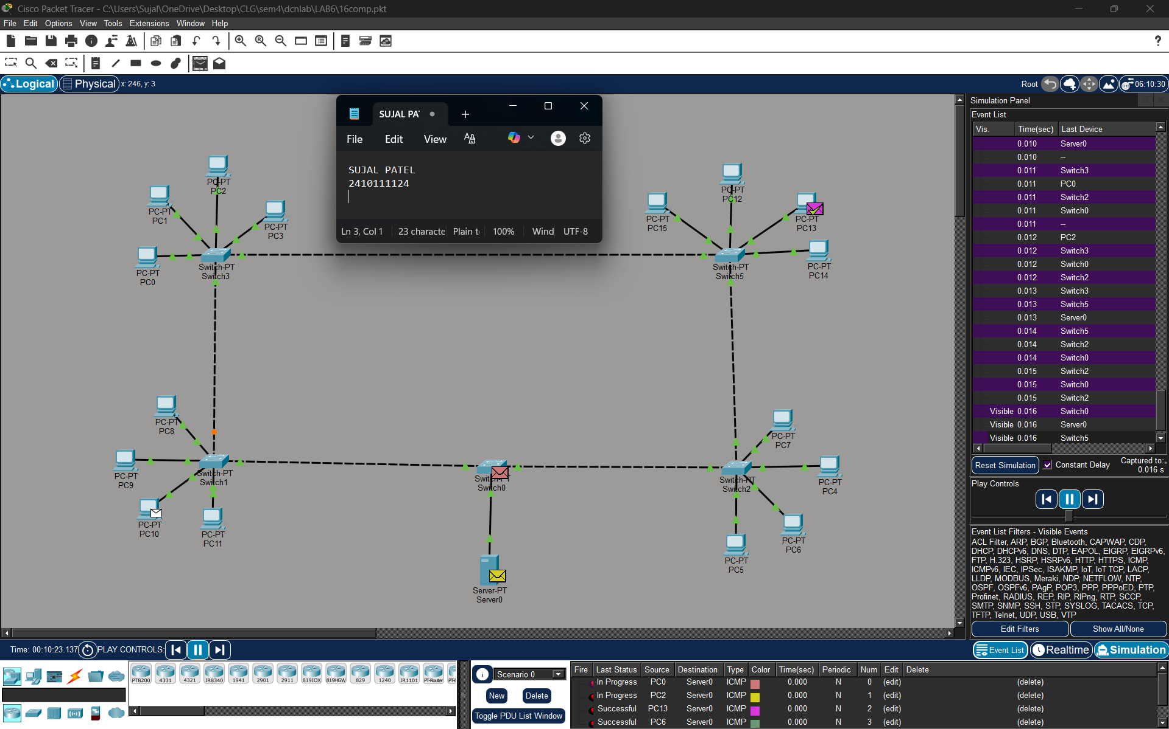

Figure 2C :- Analysis of message received 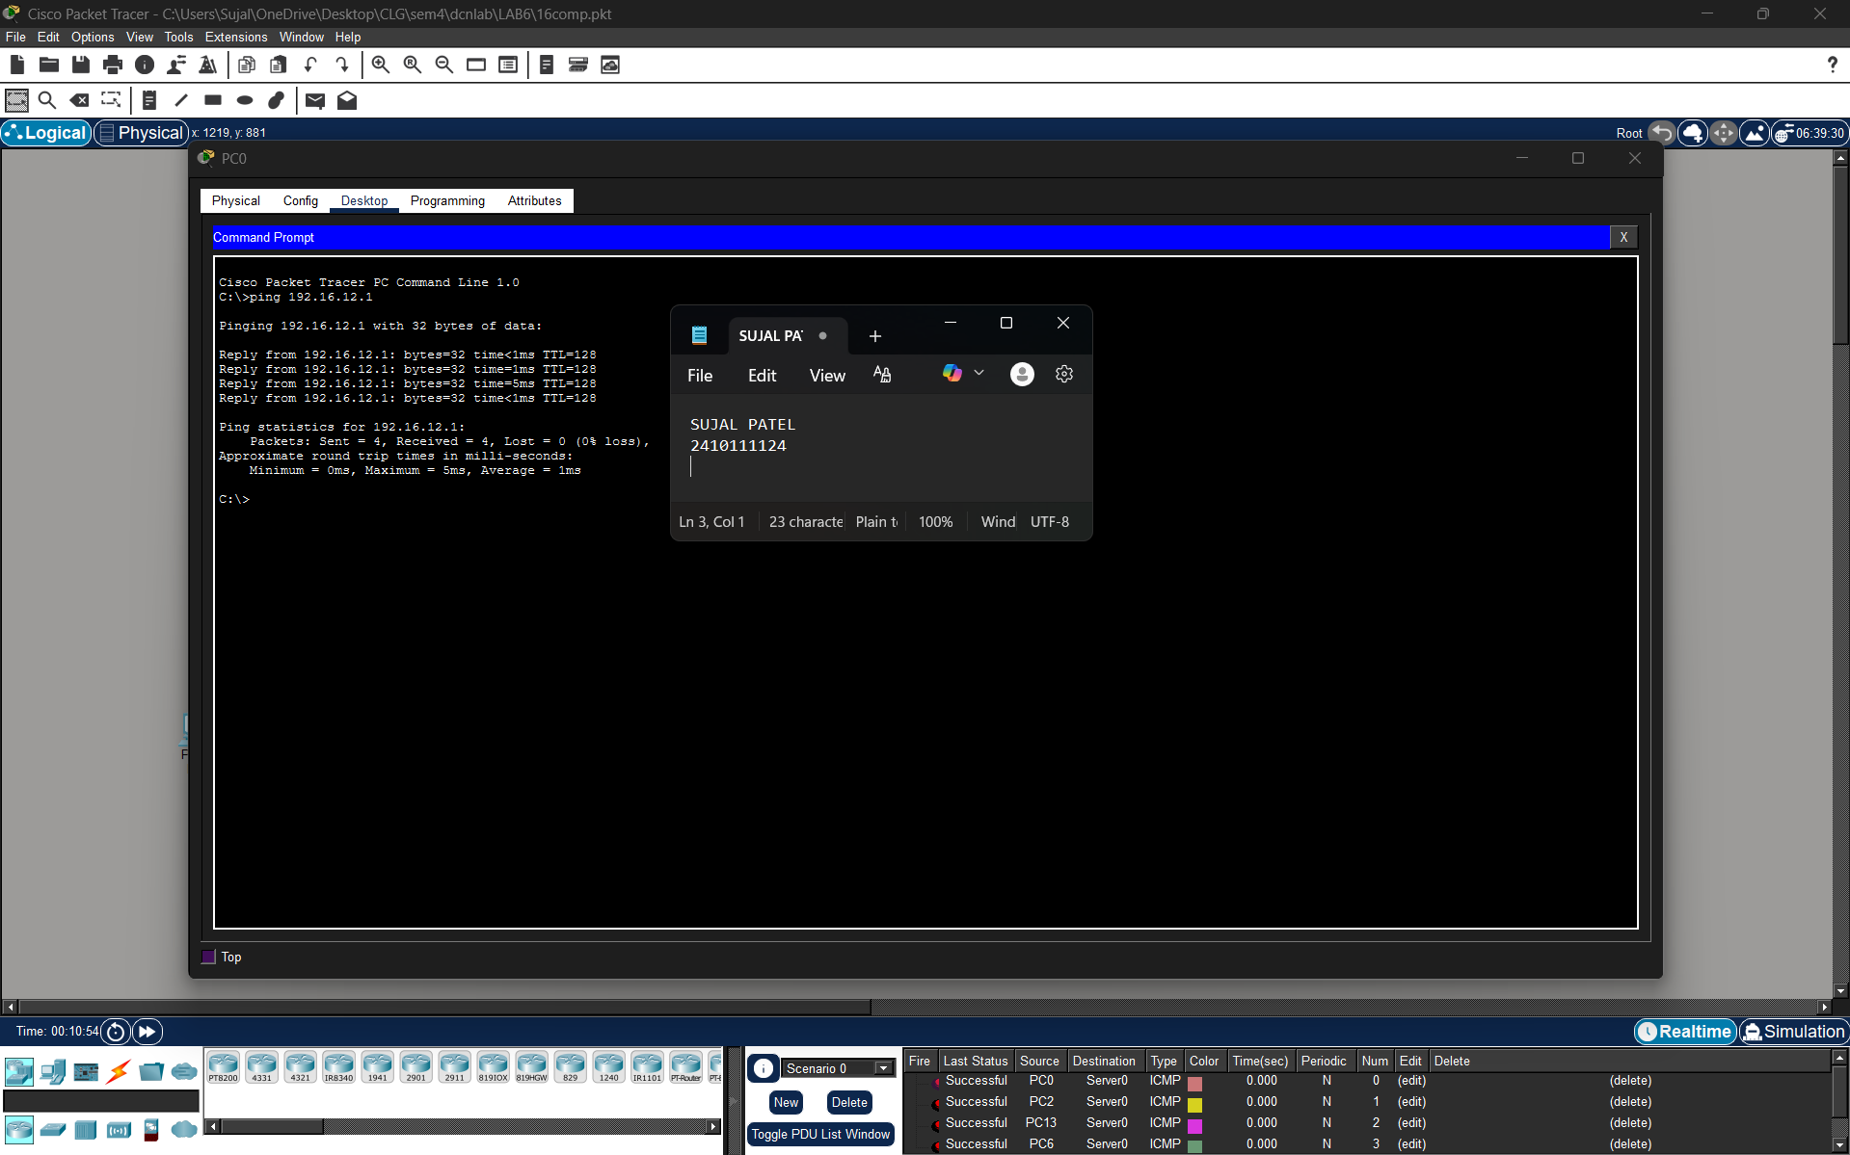

3.With 24 Computers
Level 3A :- Basic Diagram 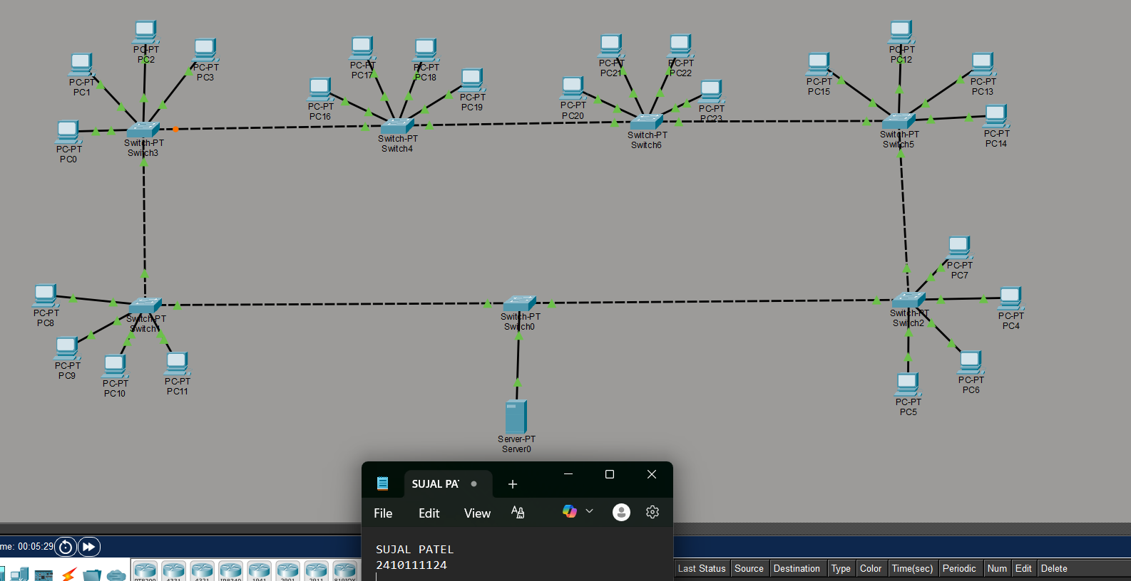
Level 3B : - Simulation Diagram 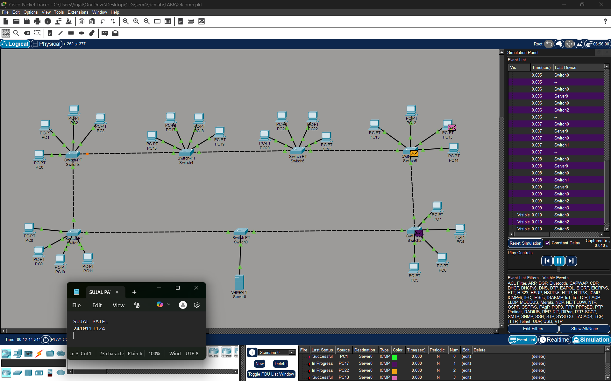

Level 3C :- Analysis of message received 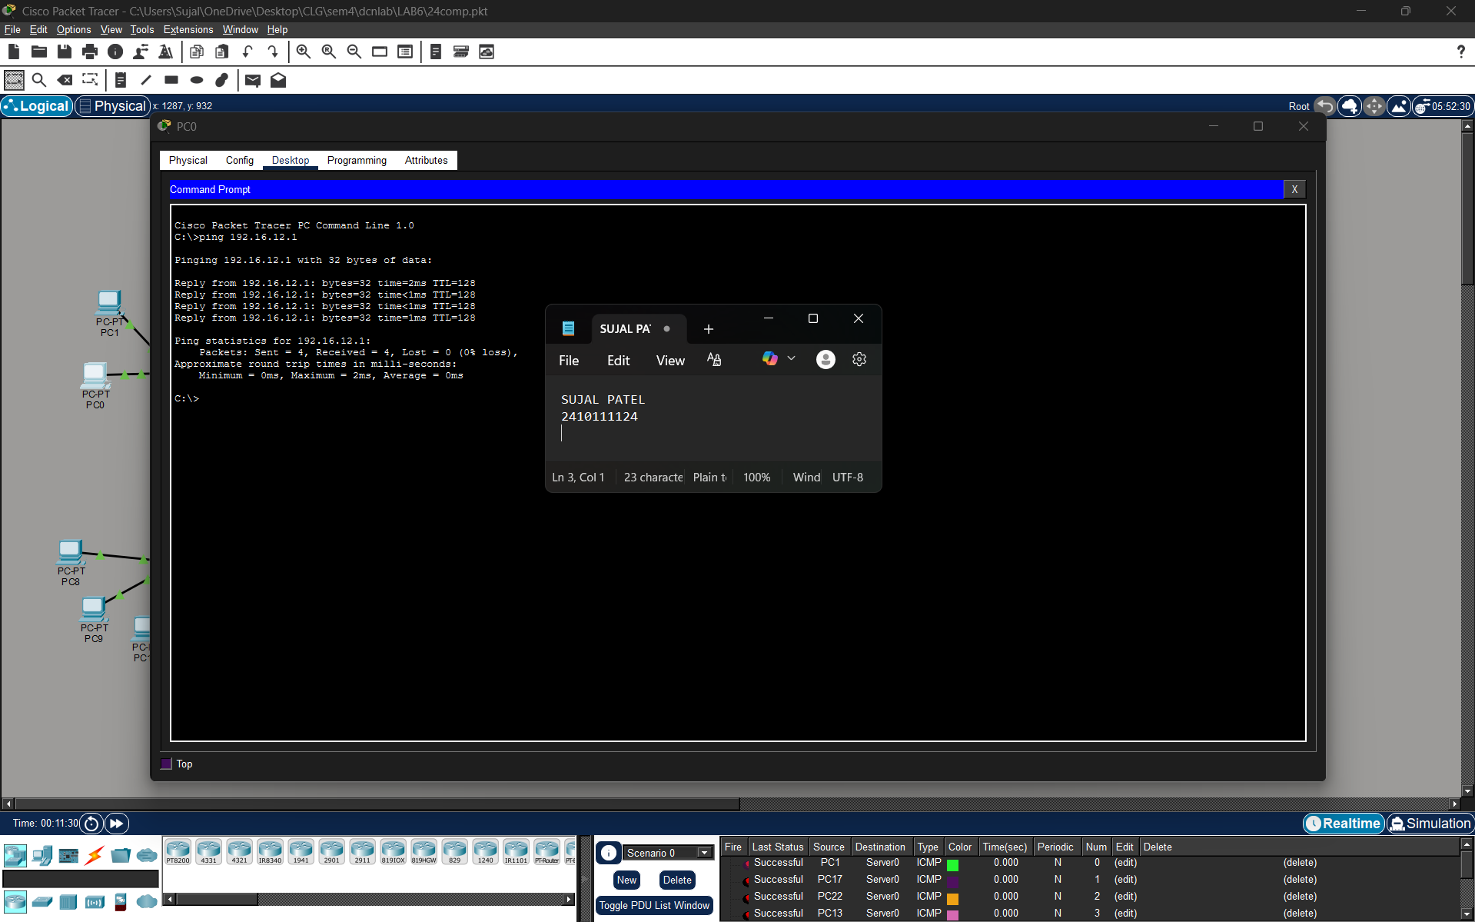

PROCEDURE:
- Cisco Packet Tracer was launched and a new project was created.
- The necessary number of PCs, switches and server were placed in the workspace.
- PCs were grouped and connected to a switch in a standard topology.
- A switch connected to the server for establishing communication.
- Static IP addresses and DNS address within the same network were assigned to all PCs.
- Static IP address is configured on the server.
- The network was allowed to stabilize in real-time mode. 8. Message transmission was verified using simulation mode.

RESULTS:

The implementation of the DNS configuration was verified successfully. When the domain name was entered into the web browser of the PCs, the DNS server correctly resolved the domain name to its corresponding IP address, enabling successful communication. Packet analysis in simulation mode confirmed the proper exchange of DNS Query and DNS Response messages. Thus, the network using the DNS server functioned as expected.

POSSIBLE SOURCES OF ERROR:

- Incorrect IP address or subnet mask configuration.
- Entering the IP address in the default gateway field instead of the IPv4 address field.
- Improper or loose cable connections between devices.
- Testing the network before the network devices were fully initialized and ready.

CONCLUSION:

The simulation of DNS server configuration was successfully completed using Cisco Packet Tracer. By configuring a centralized DNS server to resolve domain names, a functional network was established where resources could be accessed using user-friendly domain names instead of numerical IP addresses. The experiment highlighted the importance of DNS in modern network architecture, particularly in terms of scalability, centralized management, and ease of use.

LEARNING OUTCOME:
- Understood the working principle of the Domain Name System (DNS) in a computer network.
- Learned how to configure and manage a DNS server in Cisco Packet Tracer.
- Learned how to map logical Domain Names to physical IP addresses manually.

PRECAUTIONS:
- Ensure each PC has a unique IP address within the same subnet.
- Use appropriate cable types for device connections.
- Leave the default gateway empty when no router is used.
- Allow sufficient time for the network to stabilize before testing communication.

