Adani University
Bachelor of Technology
Subject Name: Data Communication & Computer Networks
Subject Code: EICCI24203 Sem: 4th Date: 23-02-2026

URN. No. 2410111124 Name: Sujal Patel Sec : B

EXPERIMENT: 7
OBJECTIVE:
To design and stimulate a Local Area Network (LAN) using PCs, Switches and Routers.

SOFTWARE USED:

CISCO PACKAGE TRACER, DESKTOP

THEORY:

Advantages
- Supports quick data transfer and communication among connected devices.
- Sharing resources such as printers and storage helps reduce overall costs.
- Allows centralized control and management of network devices.
- Scalable in nature, as new devices can be added easily.

Disadvantages
- Limited to a specific geographic area.
- Requires proper configuration to avoid IP conflicts and network issues.
- Security risks exist if the network is not properly secured.

CODE:

Not applicable

PRACTICAL:
1.With 6 computers:
Figure 1A :- Basic Diagram
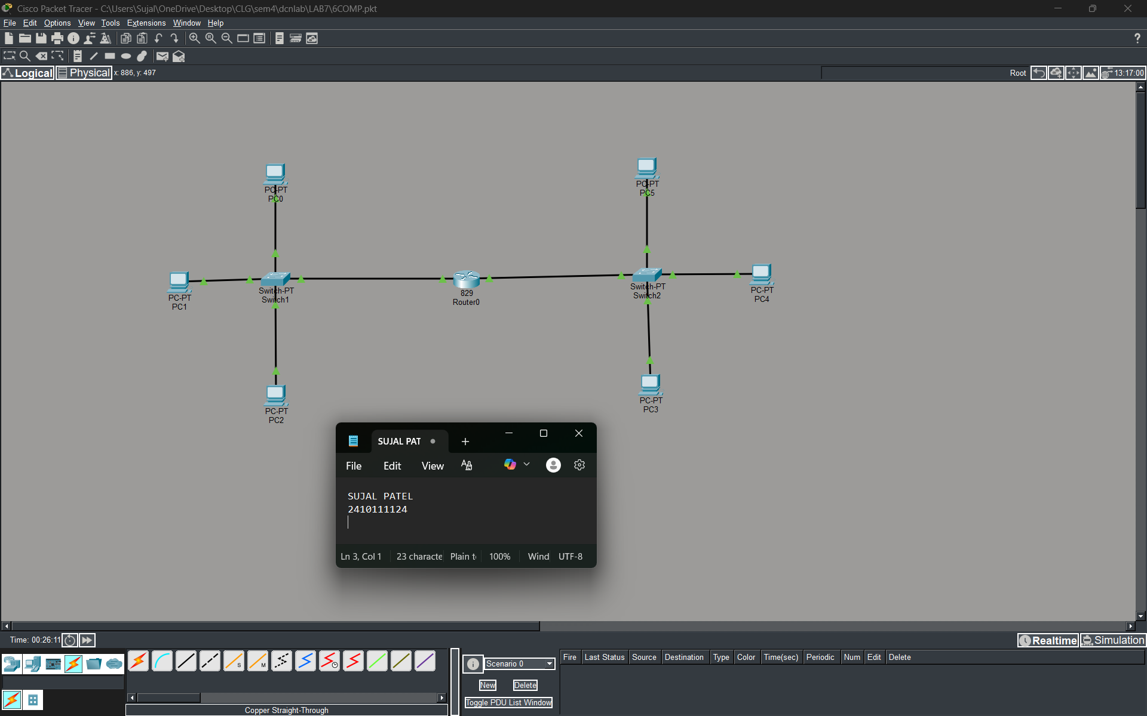

Figure 1B :- Simulation Diagram
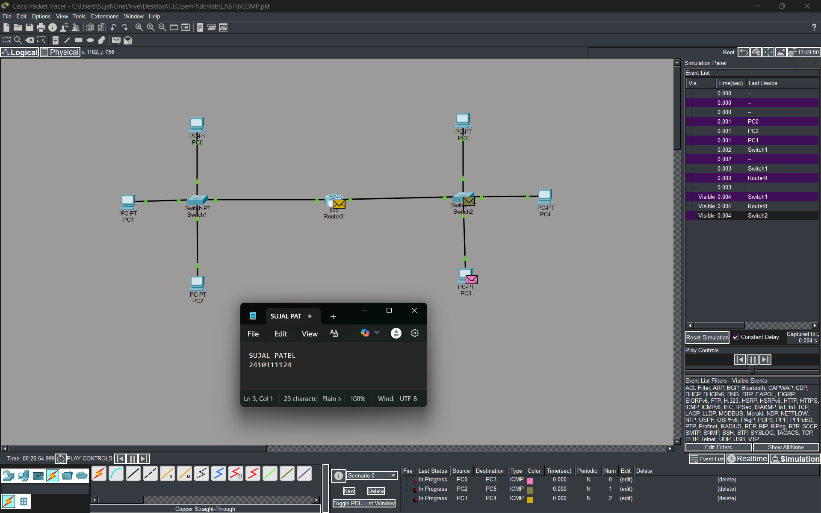
Figure 1C :- Analysis of message received
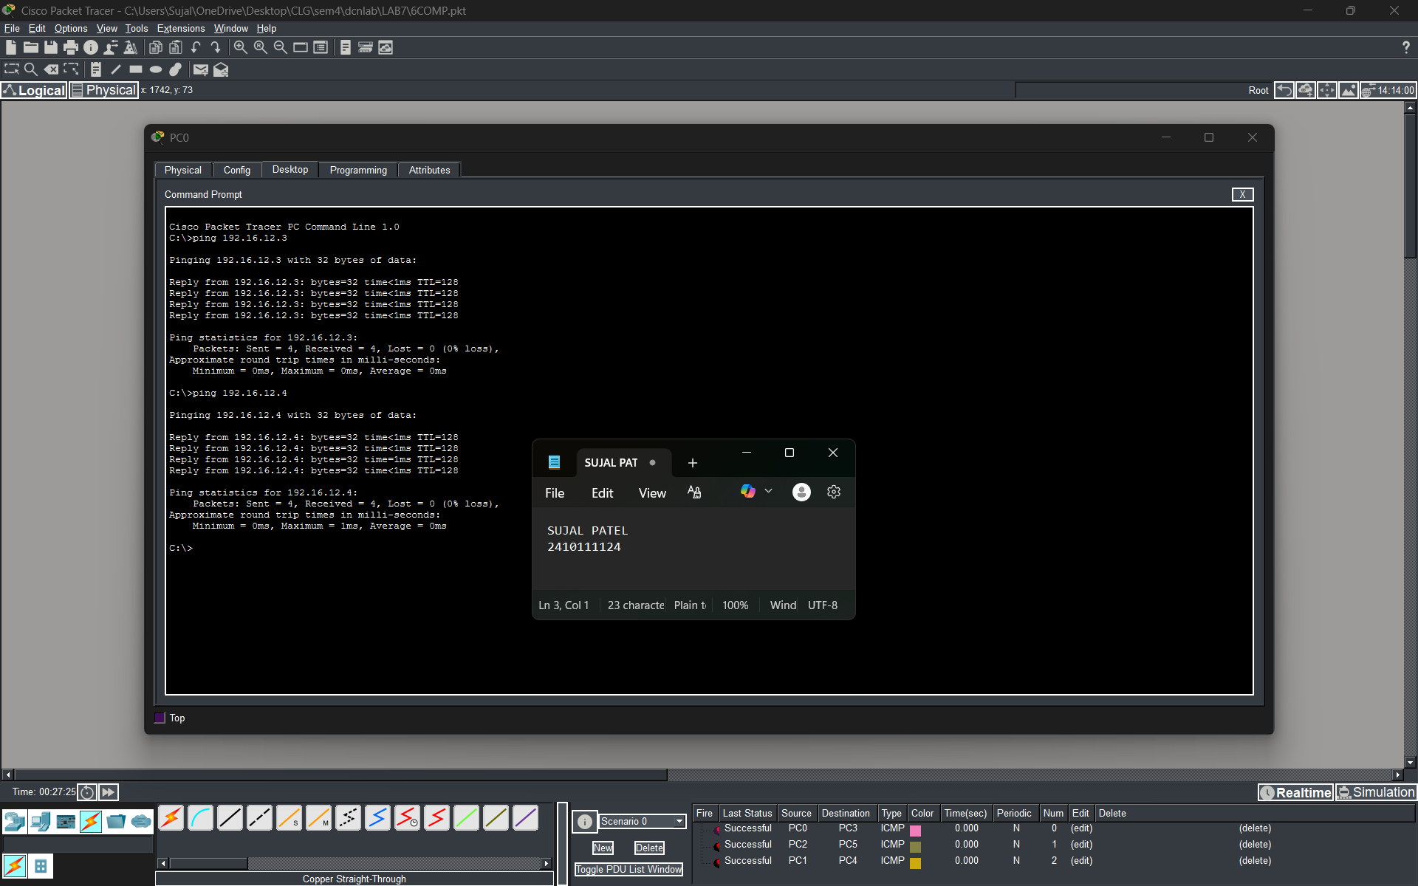
2.With 14 Computers :
Figure 2A :- Basic Diagram
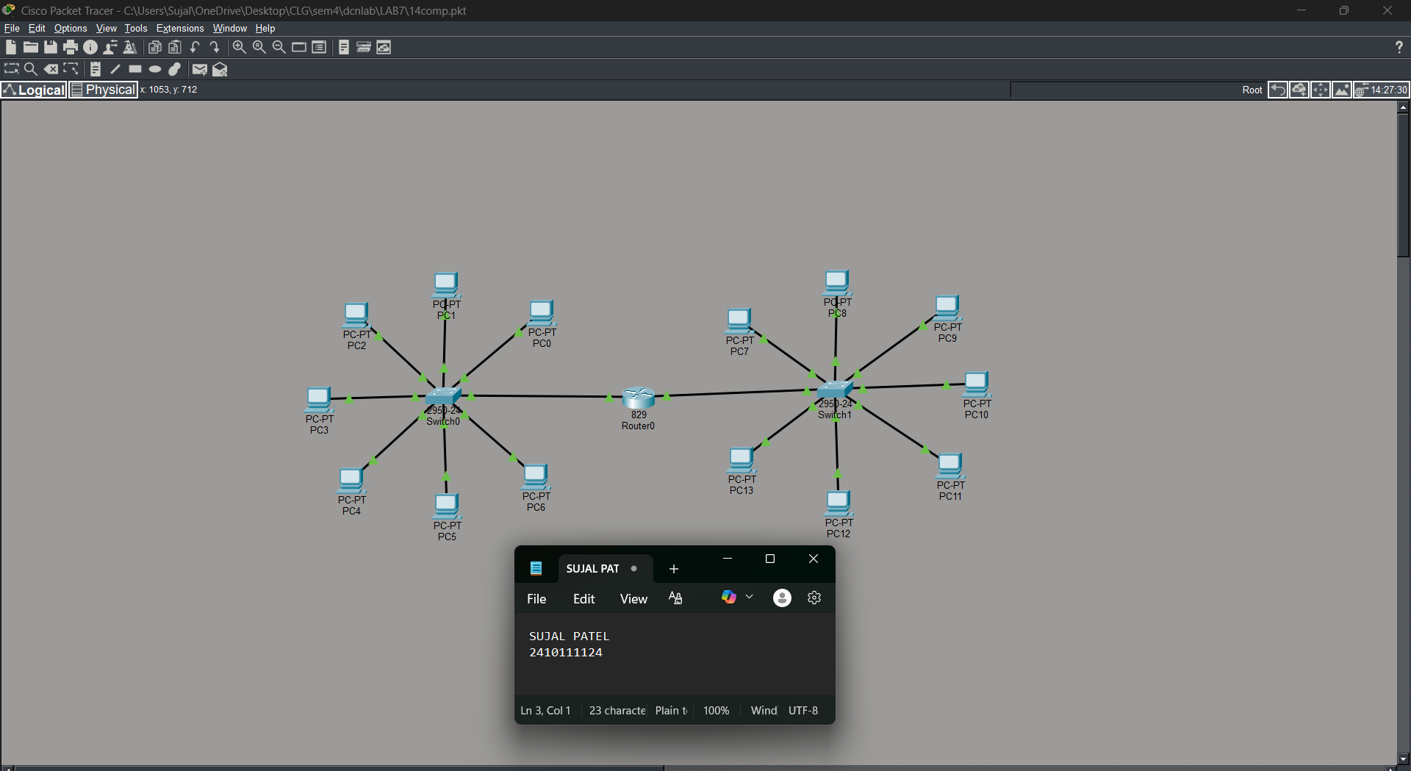
Figure 2B :- Simulation Diagram
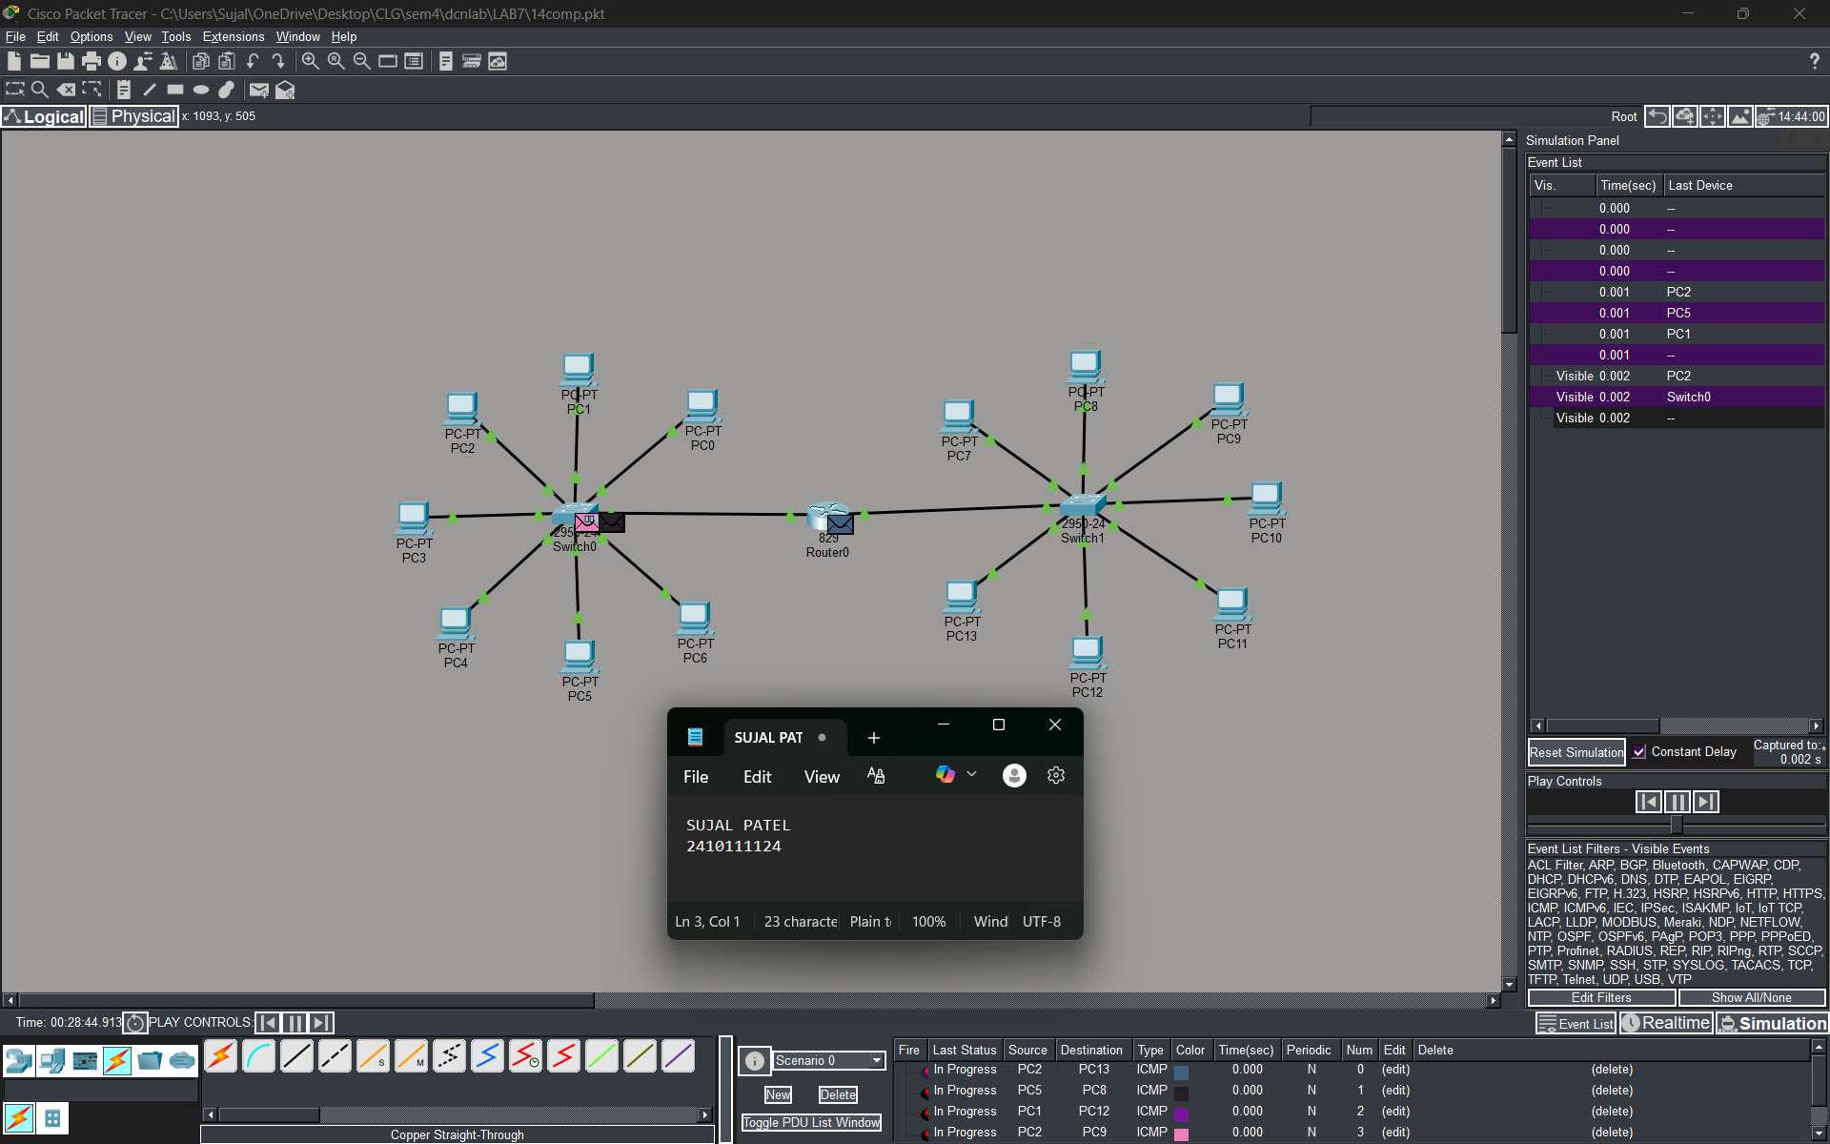
Figure 2C :- Analysis of message received
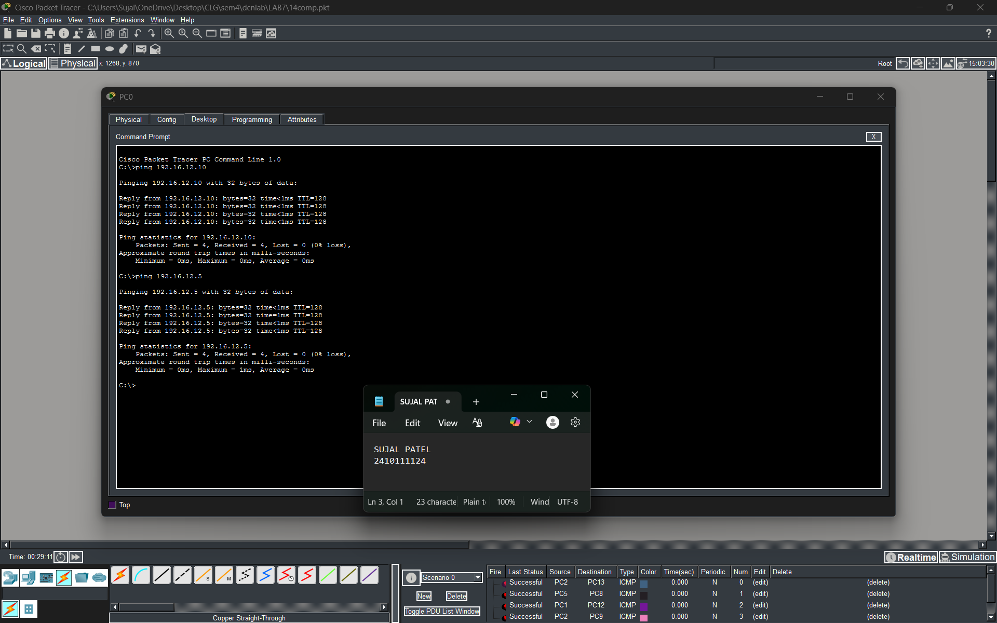
3.With 24 Computers
Level 3A :- Basic Diagram
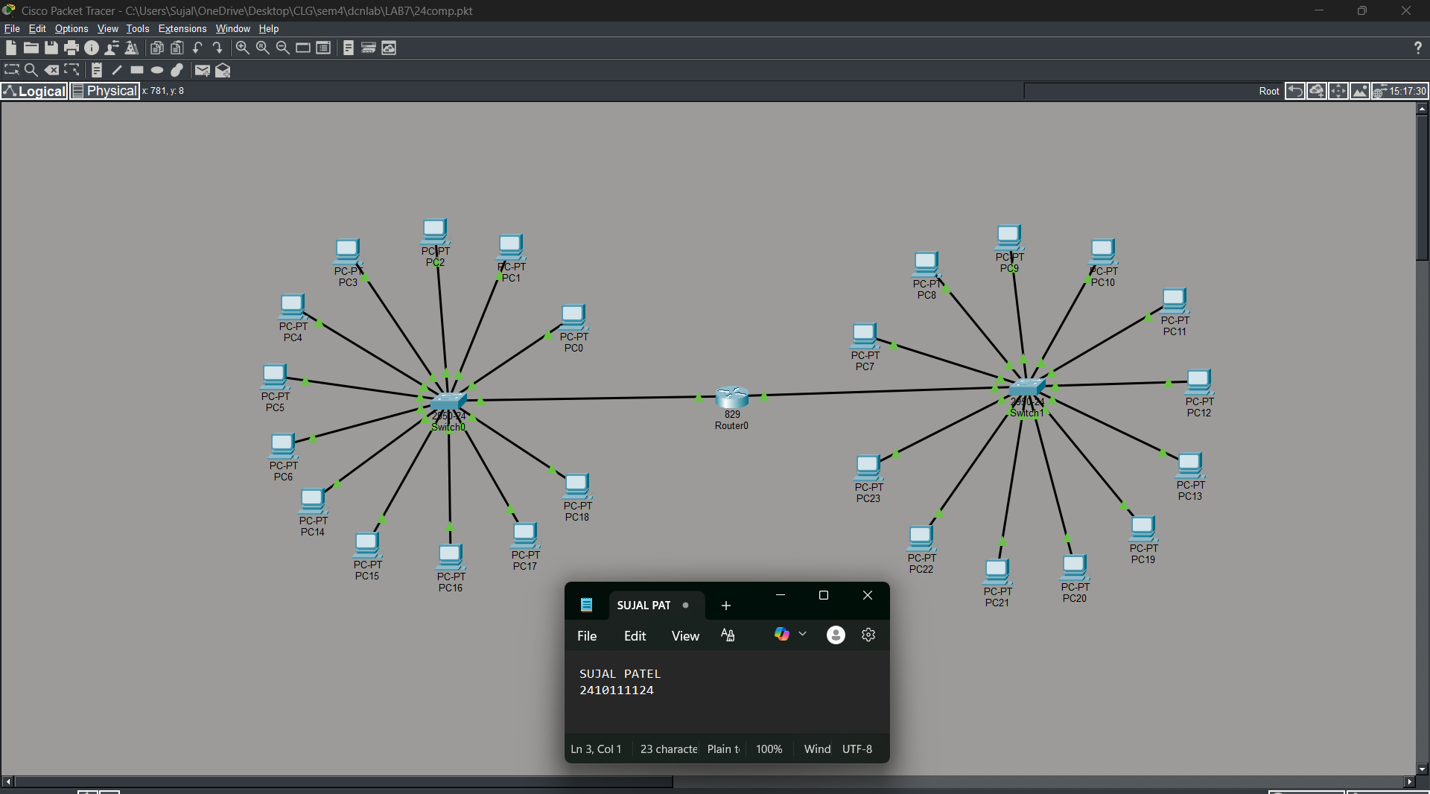
Level 3B : - Simulation Diagram
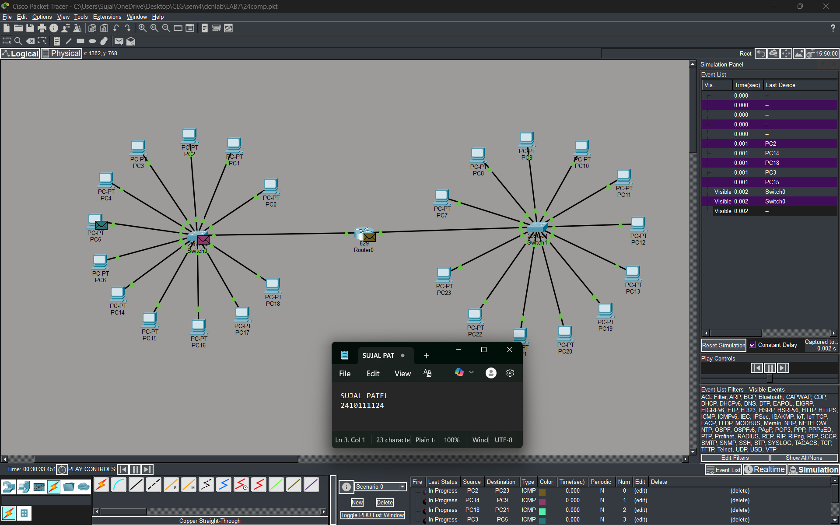
Level 3C :- Analysis of message received
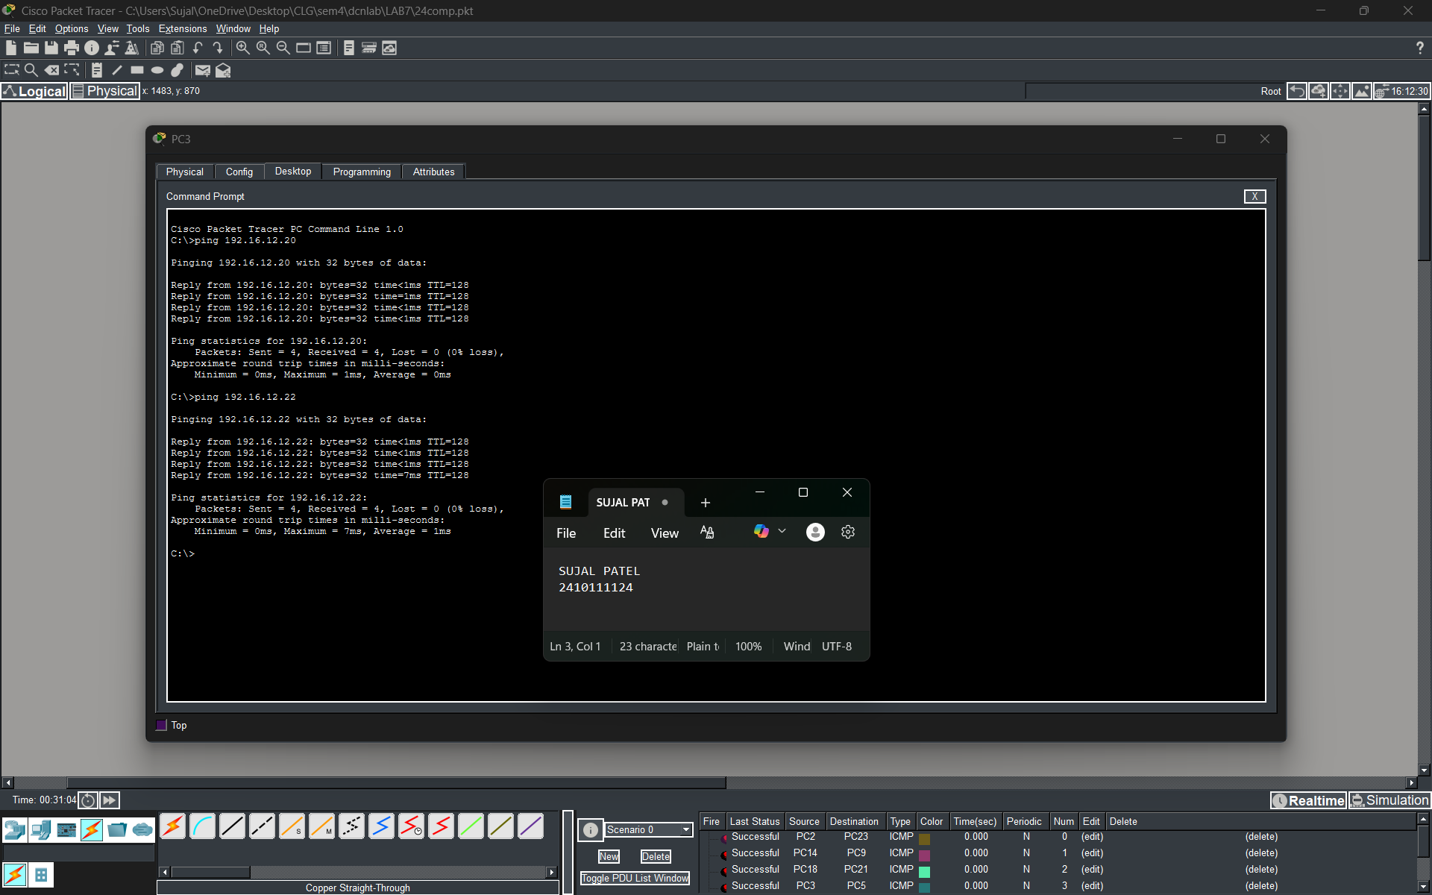
PROCEDURE:
- Cisco Packet Tracer was launched and a new project was created.
- The necessary number of PCs, switches and server were placed in the workspace.
- PCs were grouped and connected to a switch in a standard topology.
- A switch connected to the server for establishing communication.
- Static IP addresses and DNS address within the same network were assigned to all PCs.
- Static IP address is configured on the server.
- The network was allowed to stabilize in real-time mode.
- Message transmission was verified using simulation mode.

RESULTS:

The LAN architecture was successfully implemented and verified. Communication was achieved by entering the server’s IP address directly into the web browsers and command prompts of the client PCs. The switch efficiently forwarded data frames to the correct destination devices.

POSSIBLE SOURCES OF ERROR:

- Incorrect IP address or subnet mask configuration.
- Entering the IP address in the default gateway field instead of the IPv4 address field.
- Improper or loose cable connections between devices.
- Testing the network before the network devices were fully initialized and ready.

CONCLUSION:

The Local Area Network (LAN) simulation was successfully carried out in Cisco Packet Tracer. A centralized switch was configured to connect multiple workstations and a server, creating a functional intranet where resources were accessed using direct IP addressing. This experiment strengthened the understanding of Layer 2 and Layer 3 communication, showing how data is encapsulated and transmitted within a private subnet.
LEARNING OUTCOME:
- Understood the physical and logical configuration of a local network using PCs and switches.
- Learned how to manually assign and manage a private IP addressing scheme to avoid address conflicts.
PRECAUTIONS:
- Ensure each PC has a unique IP address within the same subnet.
- Use appropriate cable types for device connections.
- Leave the default gateway empty when no router is used.
- Allow sufficient time for the network to stabilize before testing communication.

