Adani University
Bachelor of Technology
Subject Name: Data Communication & Computer Networks
Subject Code: EICCI24203 Sem: 4th Date: 09-03-2026

URN. No. 2410111124 Name: Sujal Patel Sec : B

EXPERIMENT: 9
OBJECTIVE:
To implement a network using static routing for two routers in Cisco Packet Tracer.

SOFTWARE USED:

CISCO PACKAGE TRACER, DESKTOP

THEORY:

Advantages
• Increased network security
• Reduced CPU/bandwidth overhead
• Predictable, consistent, and reliable traffic routing.
• It is ideal for small, stable, or stub networks where routing changes rarely occur, eliminating
the need for complex, resource-intensive routing protocols.
Disadvantages
• Poor scalability
• High administrative overhead
• Lack of automatic failover, making it unsuitable for large or frequently changing networks.
• Because routes are configured manually, it is highly prone to human error and requires
manual reconfiguration whenever the network topology changes.

CODE:

Not applicable

PRACTICAL:
1.With 6 computers:
Figure 1A :- Basic Diagram
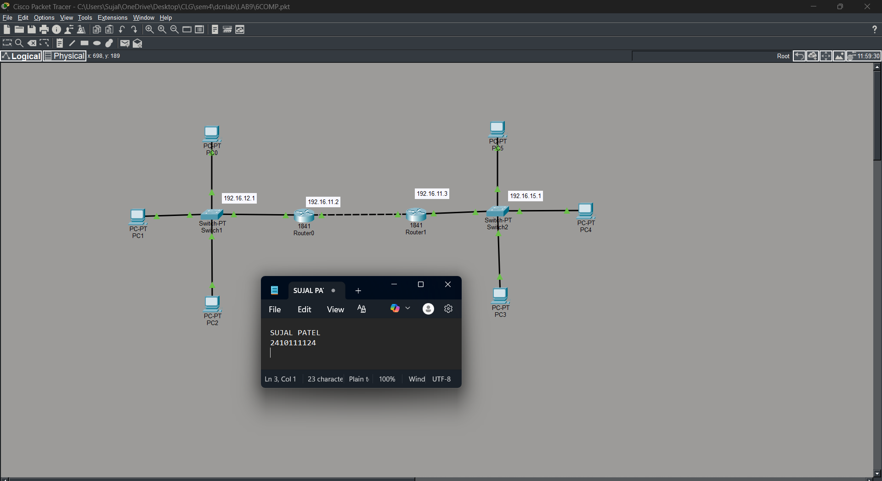

Figure 1B :- Simulation Diagram
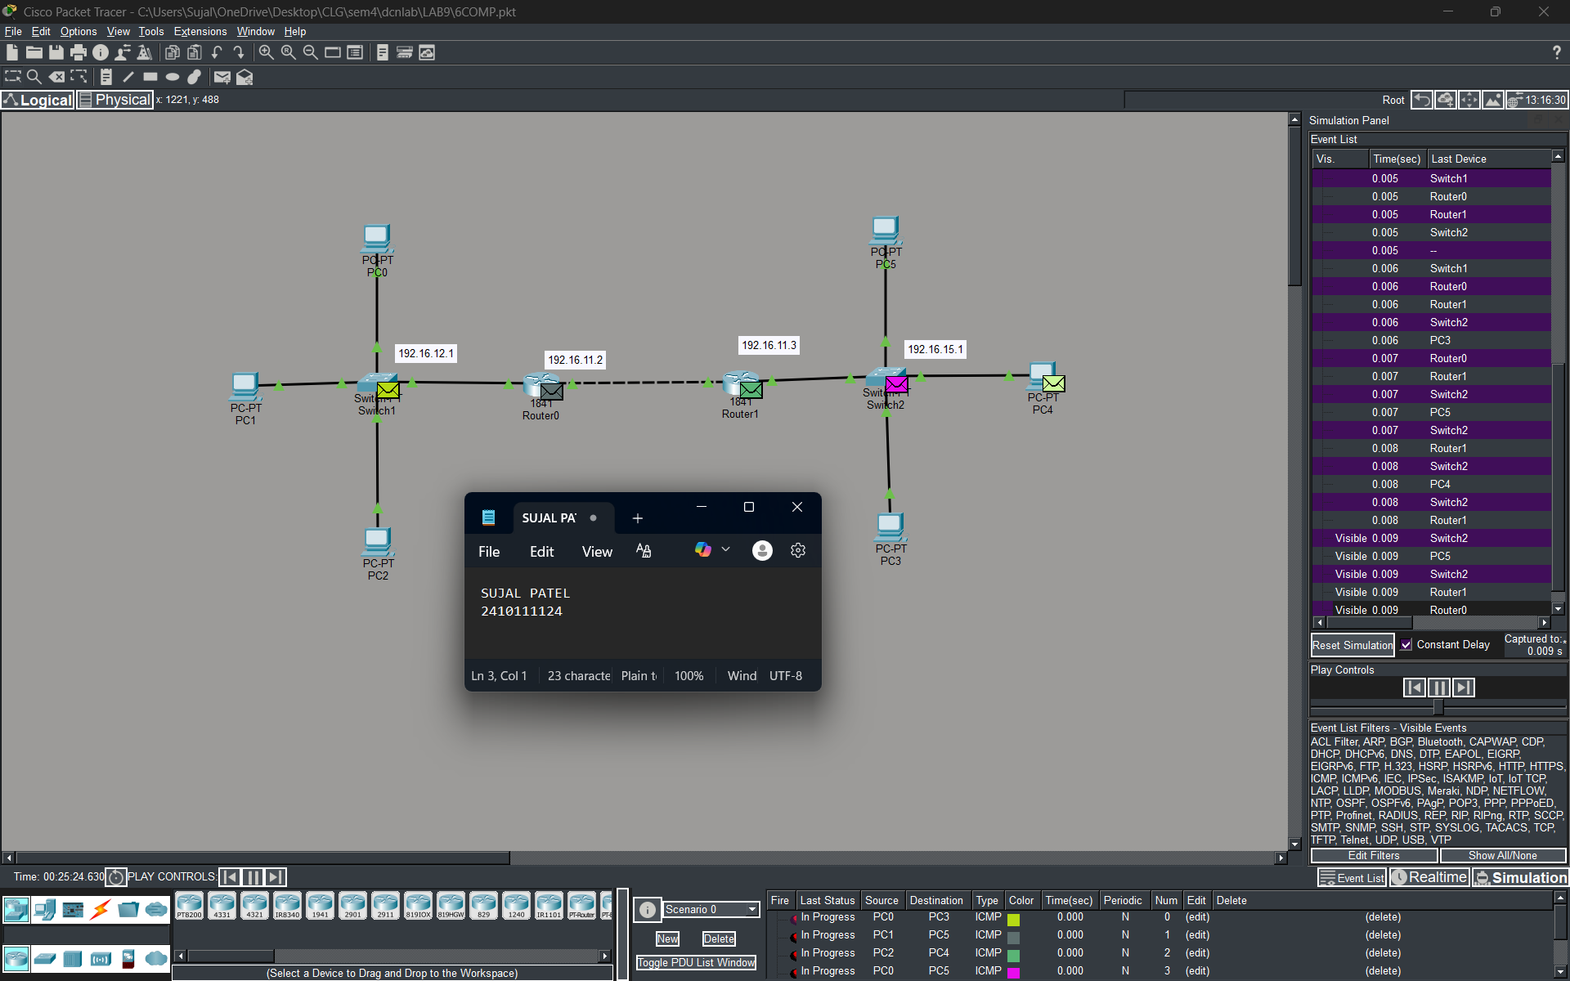
Figure 1C :- Analysis of message received
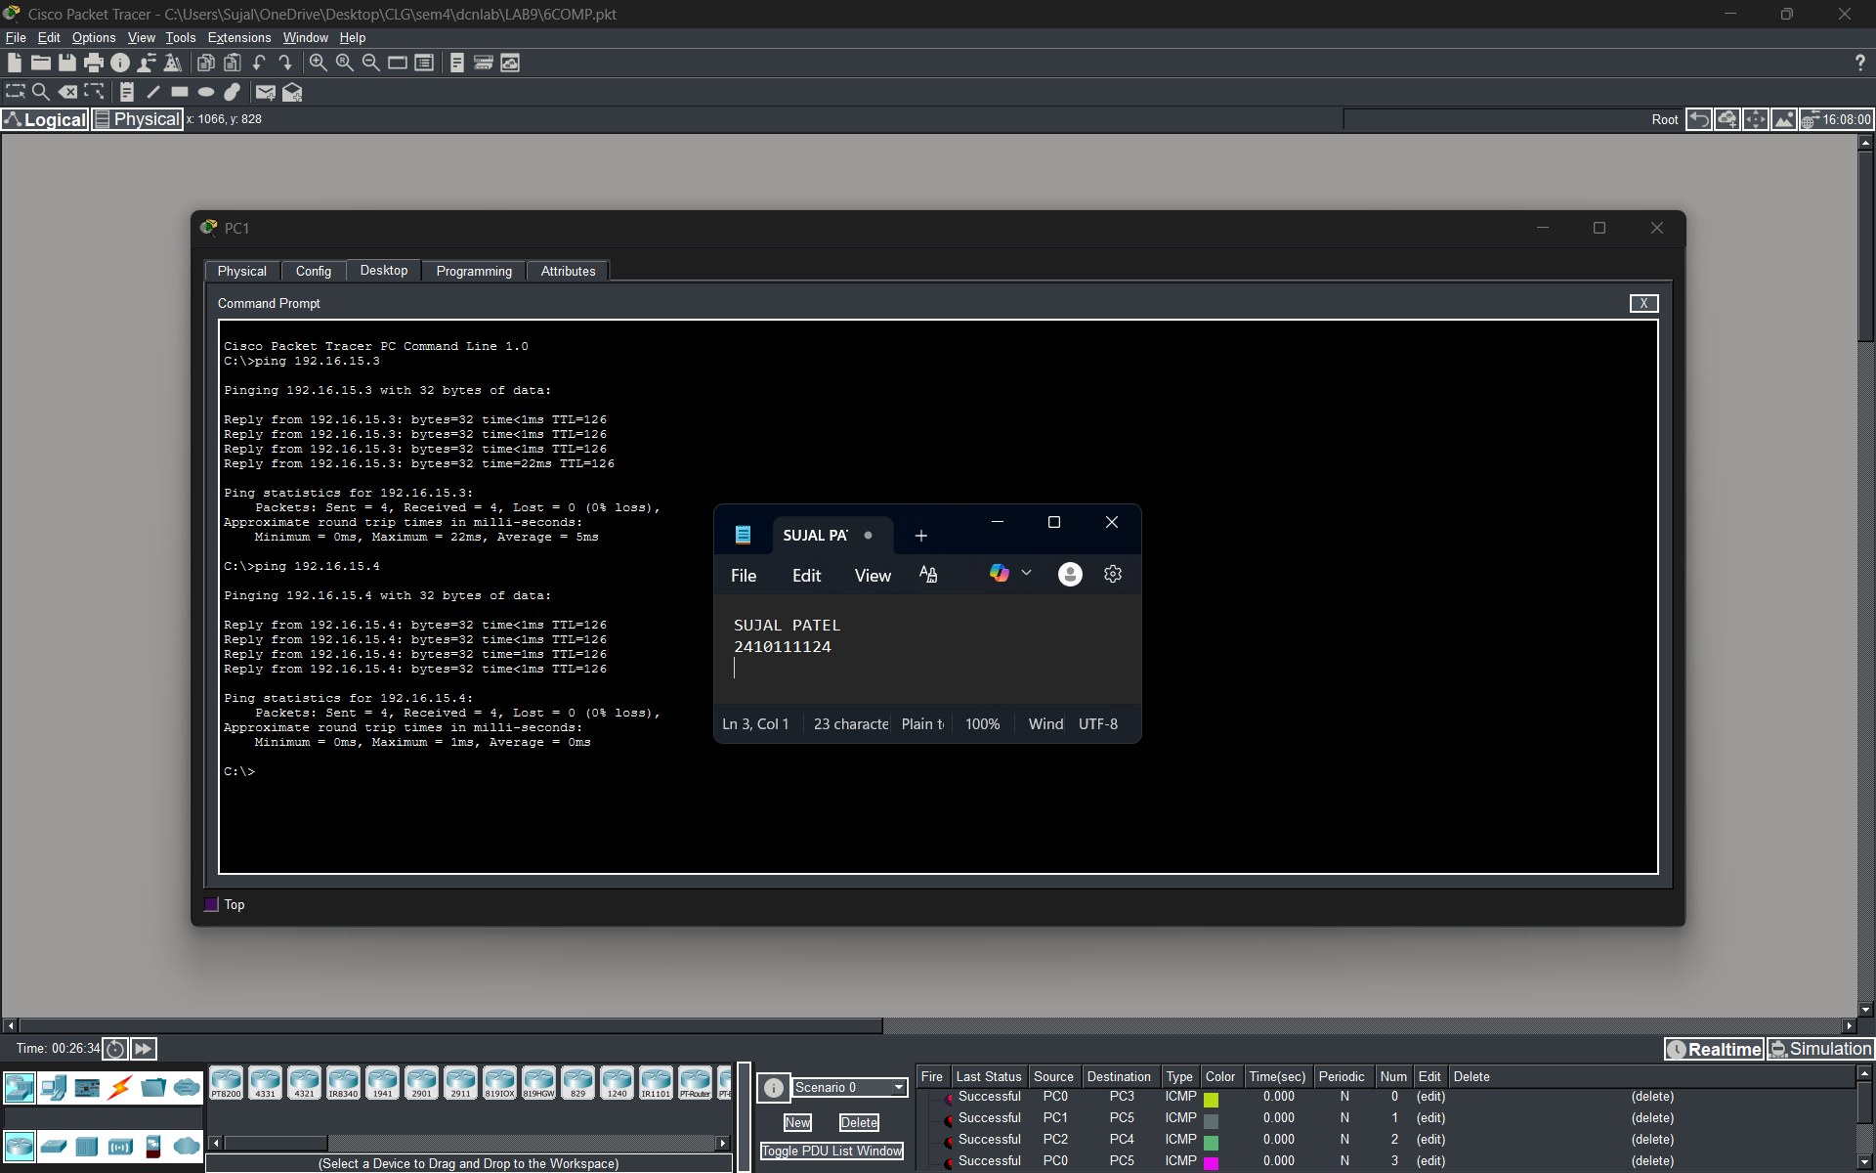
2.With 14 Computers :
Figure 2A :- Basic Diagram
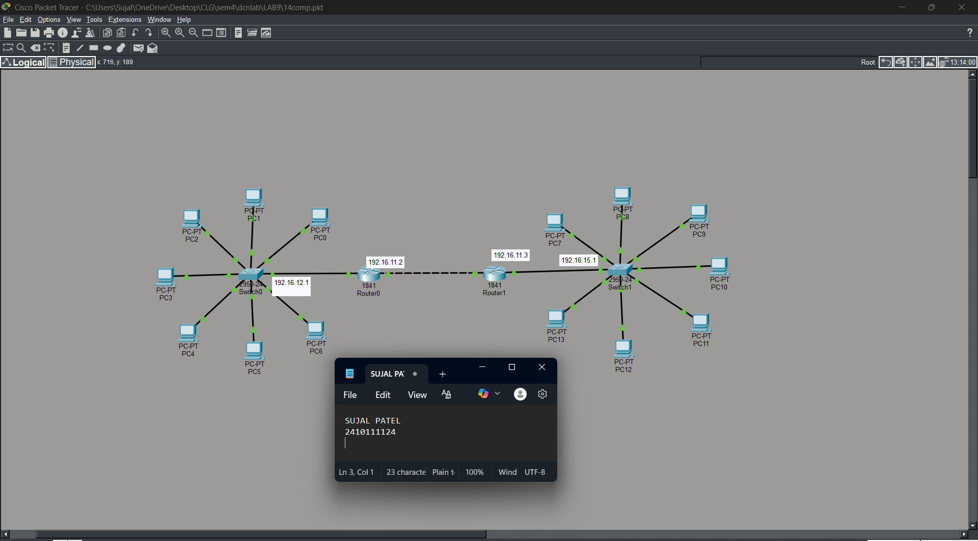
Figure 2B :- Simulation Diagram
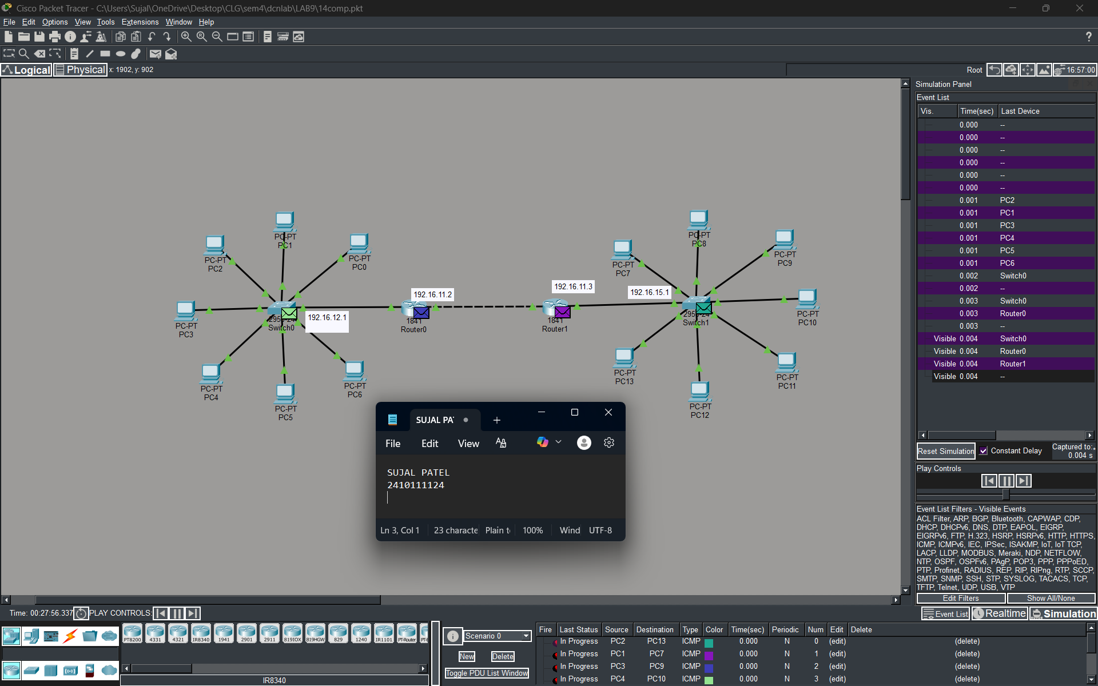
Figure 2C :- Analysis of message received
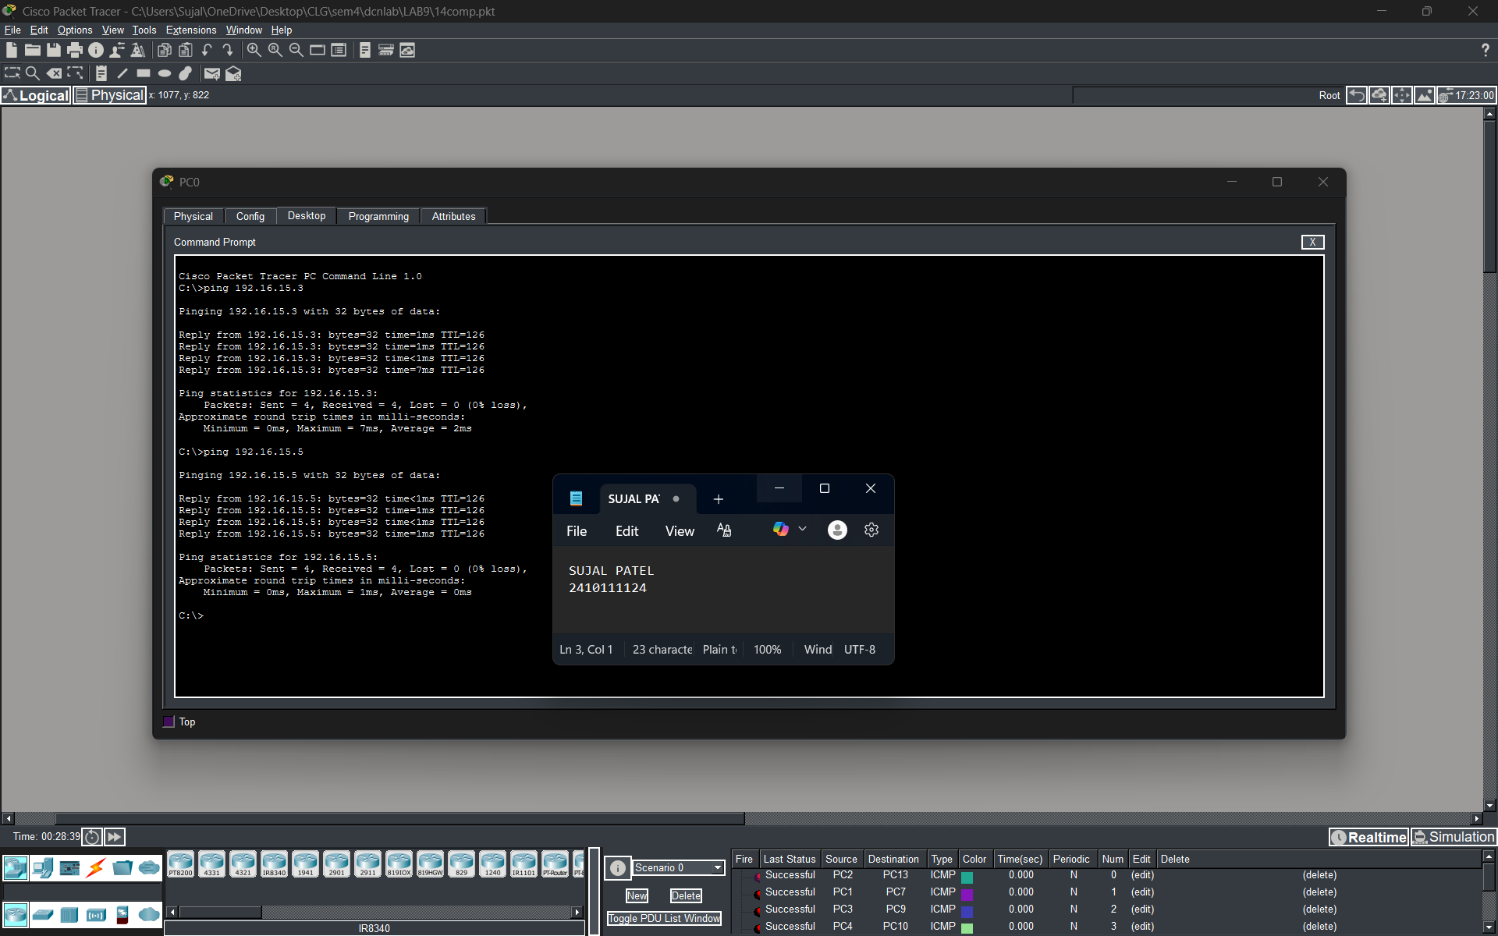
3.With 24 Computers
Level 3A :- Basic Diagram
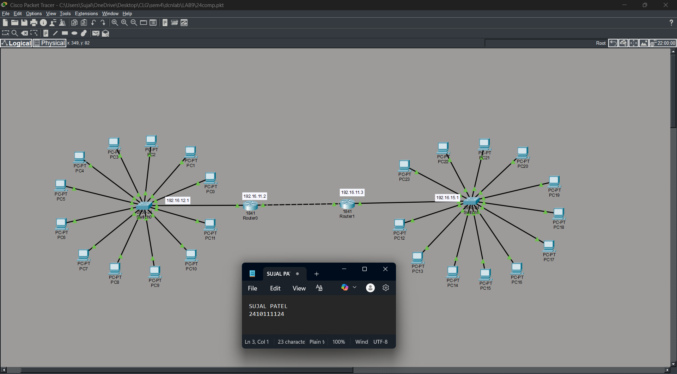
Level 3B : - Simulation Diagram
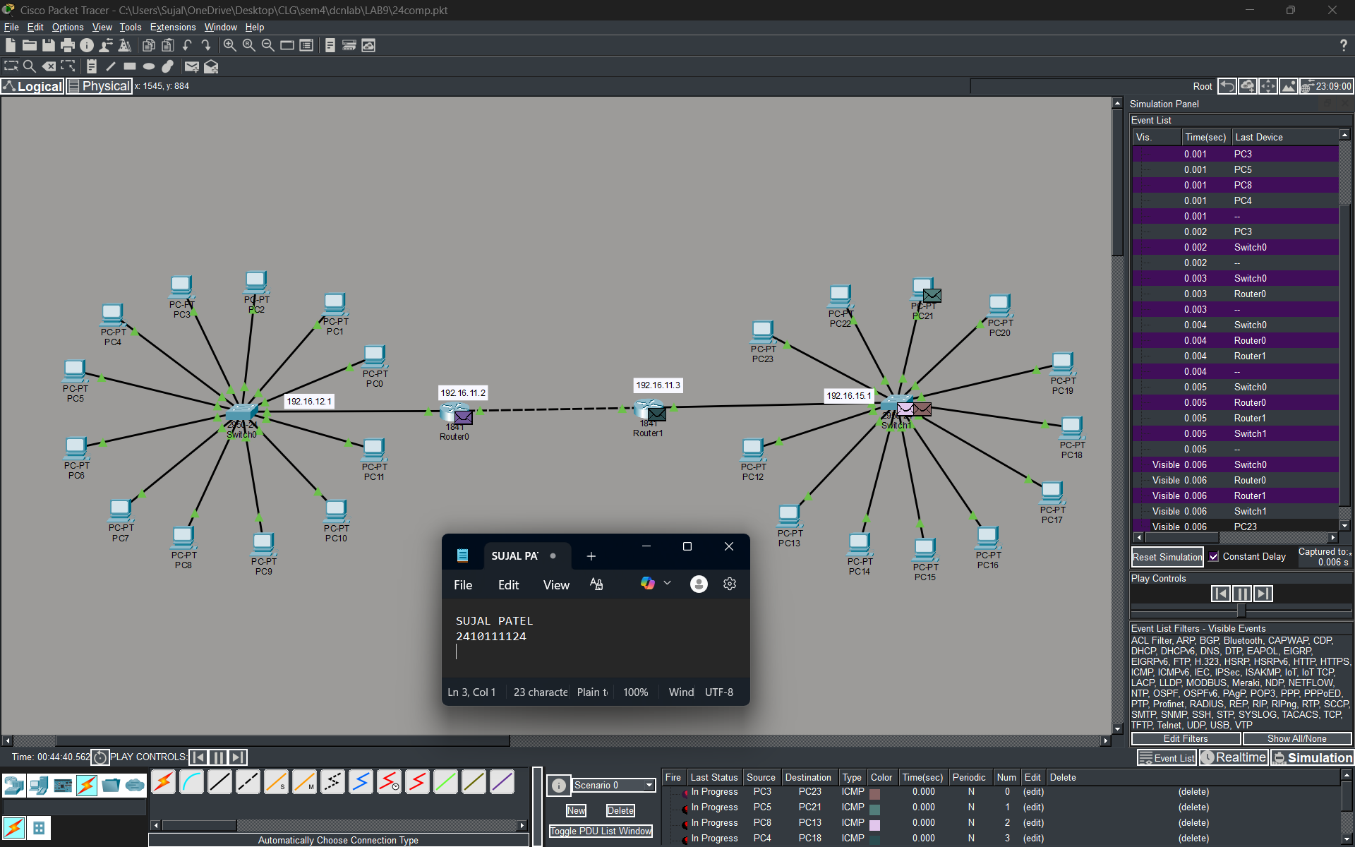
Level 3C :- Analysis of message received
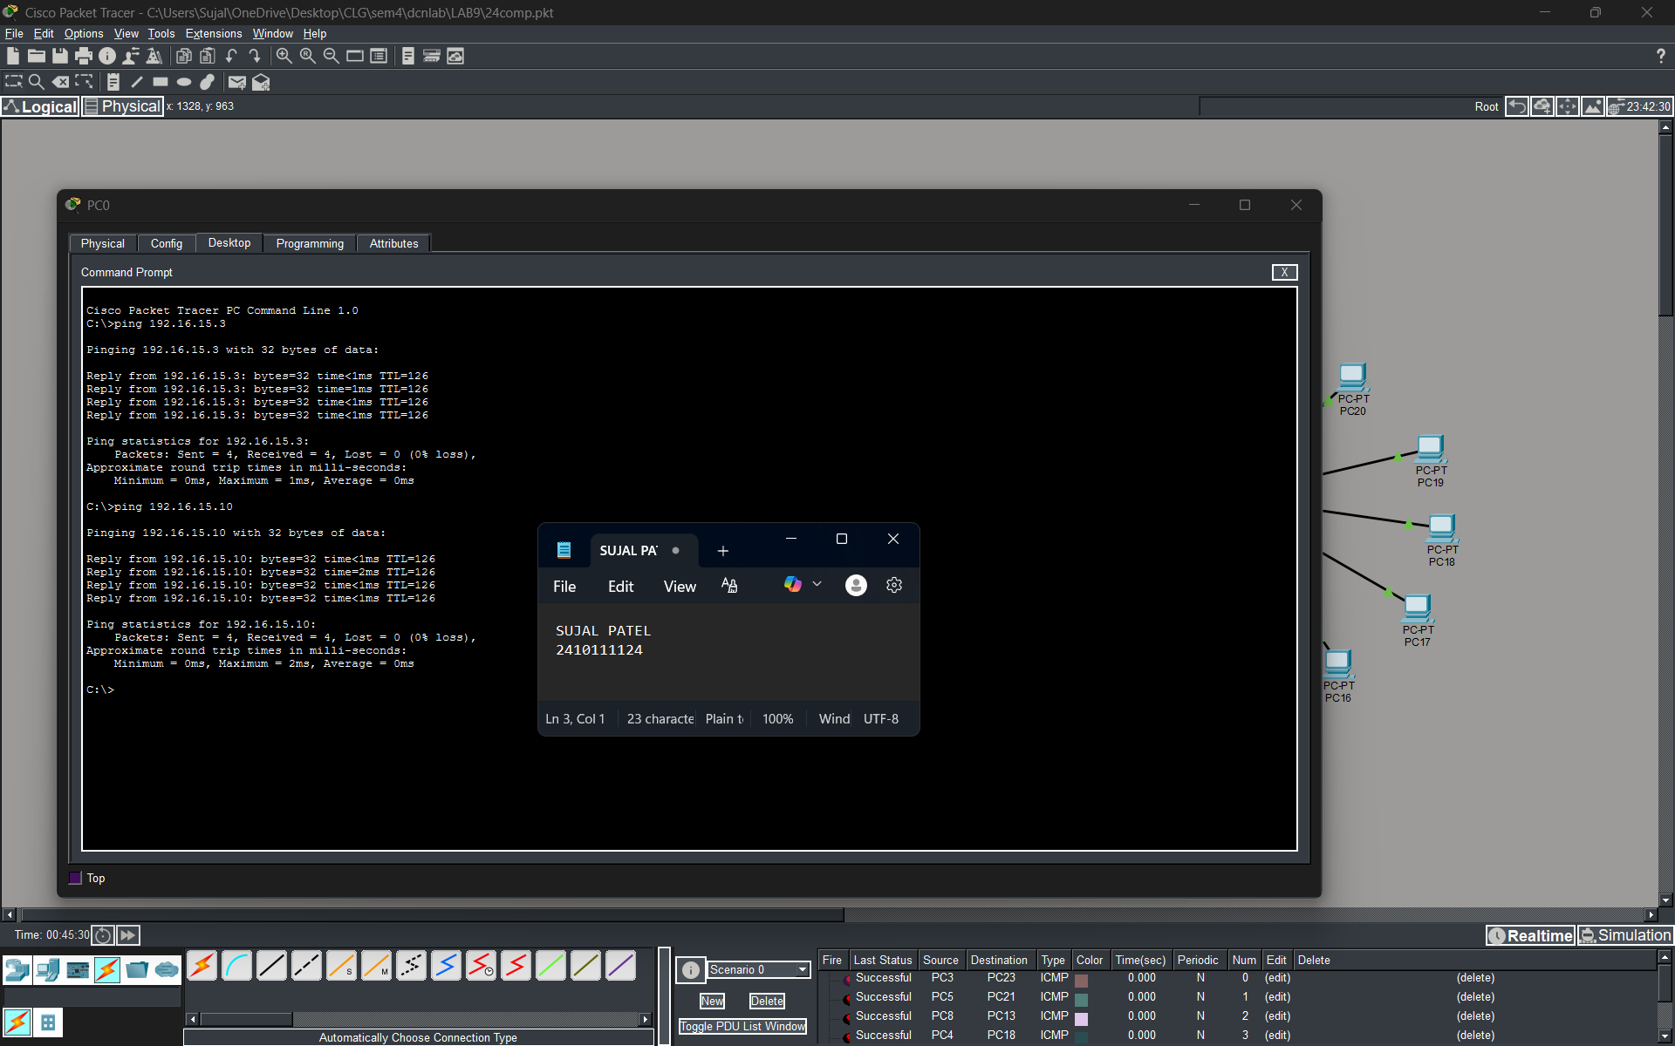
PROCEDURE:
- Cisco Packet Tracer was launched and a new project was created.
- The necessary number of PCs and switches were placed in the workspace.
- Certain number of PCs were connected to a switch.
- Each switch is connected to individual routers.
- The routers are interconnected.
- Static IP addresses within the same network were assigned to all PCs of one network.
- Default gateway address was assigned within respective networks.
- A router network was established.
- Static Routing Path was established.
- The network was allowed to stabilize in real-time mode.
- Message transmission was verified using simulation mode.

RESULTS:

The static routing setup was successfully validated. Devices across different subnetworks established reliable communication through the two routers. Packet-level analysis confirmed that traffic was accurately forwarded to the intended destination networks, demonstrating that the manually configured static routes were functioning correctly and that the routing tables were properly configured

POSSIBLE SOURCES OF ERROR:

- Incorrect IP address or subnet mask configuration.
- Entering the IP address in the default gateway field instead of the IPv4 address field.
- Improper or loose cable connections between devices.
- Testing the network before the network devices were fully initialized and ready.

CONCLUSION:

The network simulation using static routing in Cisco Packet Tracer was successfully completed. By manually configuring static routes on two interconnected routers, seamless communication was achieved between separate local area networks. This experiment reinforced fundamental networking principles, demonstrating how routers rely on routing tables to forward packets and highlighting the critical role of precise manual configuration in ensuring reliable end-to-end connectivity.
LEARNING OUTCOME:
- Designed and simulated a static routing network using Cisco Packet Tracer.
- Configured and analyzed static routes to understand how addresses are assigned and how routing decisions are made.

PRECAUTIONS:
- Ensure each PC has a unique IP address within the same subnet.
- Use appropriate cable types for device connections.
- Allow sufficient time for the network to stabilize before testing communication.

