Team Work Log: [26-02-2026]
Total Duration: 5 Hours per Member

Data & Infrastructure Group
Member | Task Breakdown | Hours
Rafa (VP) | Sourcing primary WHO dataset; vetting data for SDG 3 relevance; setting up the team shared drive and work-log tracker. | 5
Sruthi (DE) | Data profiling; handling missing values (NaNs) in the Sanitation/Mortality columns; type casting (ensuring years/numbers are correct). | 5
Vrushank (Doc) | GitHub repo initialization; organizing folder structure (/data, /notebooks); documenting Sruthi's preprocessing steps in README.md. | 5

Feature Engineering Group
Member | Task Breakdown | Hours
Avinash (EDA) | Setting up Jupyter environments; generating initial histograms to check the distribution of "Life Expectancy" across countries. | 5
Saayanth & Vrushank (FE) | Researching normalization techniques (Min-Max vs. Z-Score); preparing the "Status" column for encoding (Developed vs. Developing). | 5

Modeling & Management Group
Member | Task Breakdown | Hours
Vaastav (Lead) | Conducting the 1-hour kickoff meeting; defining the "Done" criteria for Day 1; reviewing GitHub commits for quality control. | 5
Sadiya (Model) | Researching "Multiple Linear Regression" assumptions; drafting the baseline model script to receive Saayanth’s features. | 5
Ravi (Eval) | Establishing the evaluation framework; writing the script for R^2 and RMSE calculation using scikit-learn. | 5

Hourly Milestone Timeline (General)
If a supervisor asks for a timestamped breakdown, here is how those 5 hours were spent:
- Hour 1: Sync & Sourcing. Vaastav leads the meeting; Rafa secures the CSV; Vrushank builds the Repo.
- Hour 2-3: Deep Processing. Sruthi cleans the data; Avinash begins plotting; Saayanth analyzes feature correlation.
- Hour 4: Integration. Vrushank ensures all code is committed; Sadiya and Ravi set up the model environment.
- Hour 5: Review & Logging. Vaastav and Rafa verify the day's output; final pushes to GitHub.
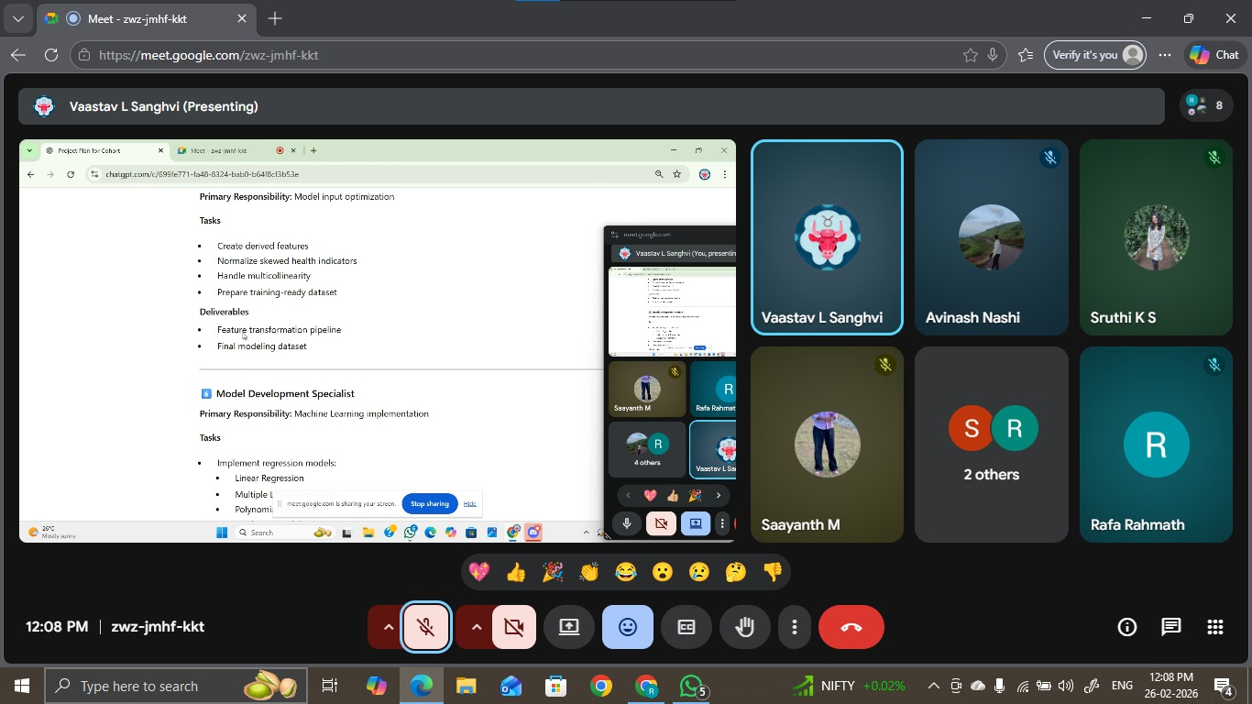

Team Work Log: [27-02-2026]
Total Duration: 5 Hours per Member Data & Infrastructure Group
Member | Task Breakdown | Hours
Rafa (VP) | Initiating Multi Linear Regression baseline; identifying feature insufficiency for complex variance; coordinating with Sruthi for dataset expansion. | 5
Sruthi (DE) | Urgent feature engineering; sourcing additional indicators from WHO to address model underfitting; merging new columns into the primary dataset. | 5
Vrushank (Doc) | Versioning new dataset iterations; updating data_dictionary.md to include new features; managing merge requests for modeling scripts. | 5

Feature Engineering Group
Member | Task Breakdown | Hours
Avinash (EDA) | Finalizing visual distributions; completing the EDA report with a focus on feature-target correlation to assist the modeling team. | 5
Saayanth & Vrushank (FE) | Scaling newly added features; ensuring normalization consistency across the expanded dataset. | 5

Modeling & Management Group
Member | Task Breakdown | Hours
Vaastav (Lead) | Working on EDA ; overseeing the pivot to expanded data sourcing; defining the technical blockers for Polynomial Regression. | 5
Sadiya (Model) | Drafting Linear Regression scripts; flagging low R^2 scores due to limited features; setting up Polynomial Regression architecture. | 5
Mahesh (Model) | Building and testing initial Regression models; documenting the "feature-thin" bottleneck and requesting additional variables. | 5
Ravi (Eval) | Updating evaluation scripts to handle R^2, MAE, and RMSE for the upcoming multi-model comparison. | 5

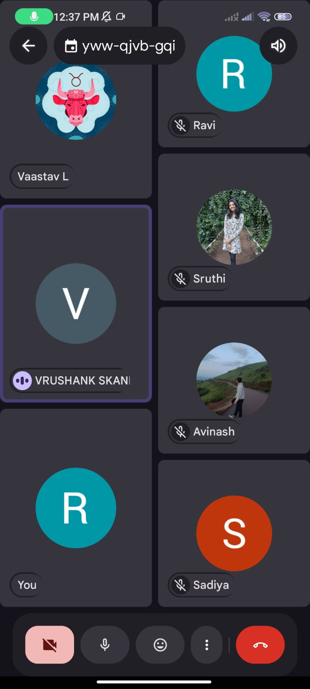

Team Work Log: [28-02-2026]
Total Duration: 5 Hours per Member

Data & Infrastructure Group
Member | Task Breakdown | Hours
Rafa (VP) | Completed Multi Linear Regression modeling; finalizing the baseline performance report for the team. | 5
Sruthi (DE) | Added more Features in the Dataset. Supporting model evaluation by preparing validation subsets; conducting research on advanced data imputation. | 5
Vrushank (Doc) | Documenting Rafa's modeling results; researching industry standards for regression documentation. | 5

Feature Engineering Group
Member | Task Breakdown | Hours
Avinash ,Vaastav (EDA) | EDA has been completed; transitioning to research on feature selection algorithms to support future iterations. | 5
Saayanth & Vrushank (FE) | Completing research on polynomial feature expansion; assisting with the evaluation of current model outputs. | 5

Modeling & Management Group
Member | Task Breakdown | Hours
Vaastav (Lead) | Leading the 1-hour team discussion; coordinating the transition from EDA to evaluation phases. | 5
Sadiya (Model) | Still working on linear and polynomial regression; refining model architecture to improve performance. | 5
Mahesh (Model) | Still working on linear and polynomial regression; troubleshooting bottlenecks in the polynomial script. | 5
Ravi (Eval) | Evaluating the Multi Linear Regression modeling; calculating performance metrics to compare against baseline. | 5

Hourly Milestone Timeline
- Hour 1: Sync & Strategy. 1-hour discussion meeting led by Vaastav to review the completion of EDA and delegate the evaluation tasks.
- Hour 2-3: Execution. Rafa finalizes Multi Linear Regression; Sadiya and Mahesh focus on complex regression scripts; Ravi begins evaluation.
- Hour 4: Research Phase. Remaining team members (Avinash, Sruthi, Vrushank) conduct research on optimization and documentation.
- Hour 5: Review. Verification of evaluation results; final updates to the project repository.

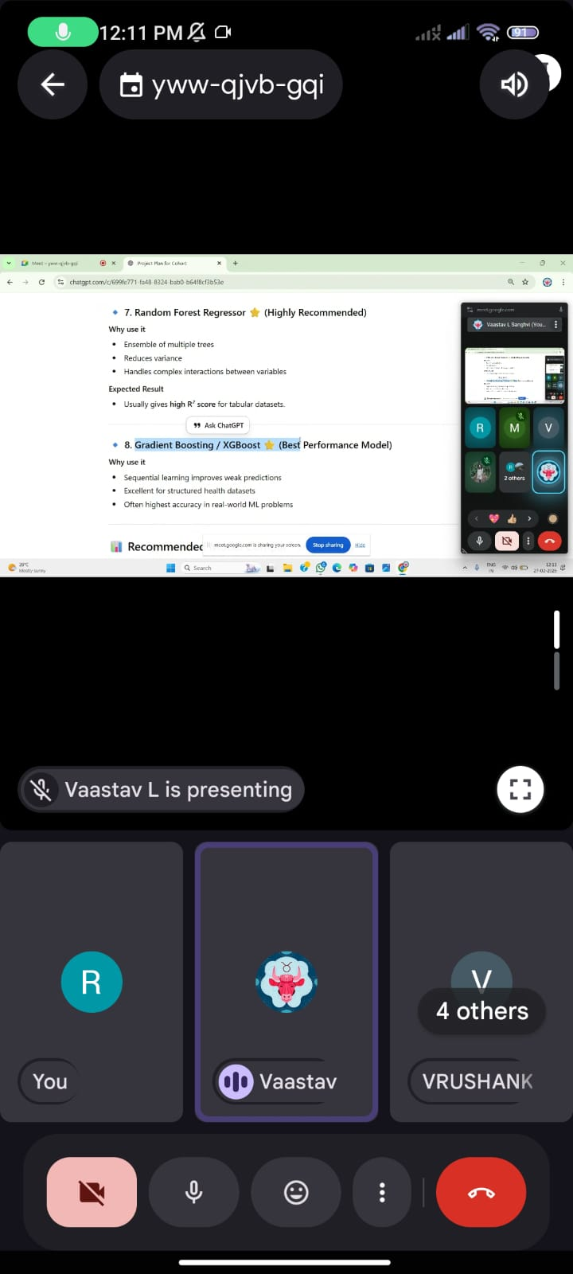
Team Work Log: [01-03-2026]
Total Duration: 5 Hours per Member

Data & Infrastructure Group
Member | Task Breakdown | Hours
Rafa (VP) | Completed Multi Linear Regression modeling; provided technical assistance to Mahesh for polynomial logic; finalizing baseline reports. | 5
Sruthi (DE) | Conducting research on advanced data imputation and supporting the transition to model validation subsets. | 5
Vrushank (Doc) | Conducting research on industry standards for regression documentation; updating the GitHub repository with new model results. | 5

Feature Engineering Group
Member | Task Breakdown | Hours
Avinash, Vaastav (EDA) | EDA has been completed ; currently conducting research on feature selection algorithms for future iterations. | 5
Saayanth & Vrushank (FE) | Conducting research on polynomial feature expansion techniques; assisting with the verification of new model outputs. | 5

Modeling & Management Group
Member | Task Breakdown | Hours
Vaastav (Lead) | Leading the 1-hour discussion meeting; provided technical guidance to help Mahesh complete his modeling tasks. | 5
Mahesh (Model) | Completed polynomial regression modeling with the collaborative help of Vaastav and Rafa. | 5
Sadiya (Model) | Still working on linear and polynomial regression; refining architecture to improve model performance. | 5
Ravi ,Issa (Eval) | Completed evaluating the Multi Linear Regression modeling; finalized performance metrics including R^2 and RMSE. | 5



Team Work Log: [02-03-2026]
Total Duration: 5 Hours per Member
Project Group: Data, Modeling, & Analytics

Data & Infrastructure Group
Member | Task Breakdown | Hours
Rafa (VP) | Completed Multi Linear Regression modeling; provided final technical sign-off on the baseline performance report. | 5
Sruthi (DE) | Conducting research on advanced data imputation; supporting final dataset versioning for the evaluation phase. | 5
Vrushank (Doc) | Conducting research on industry standards for regression documentation; maintaining the GitHub repository. | 5

Feature Engineering & Analytics Group
Member | Task Breakdown | Hours
Avinash (EDA) | EDA has been completed; transitioned to conducting research on feature selection algorithms for future iterations. | 5
Saayanth & Vrushank (FE) | Conducting research on polynomial feature expansion techniques; assisting with the verification of model outputs. | 5
Manoj (Analyst) | Working on the SDG analytics report; aligning model outcomes with Sustainable Development Goal targets. | 5
Harshita R (Analyst) | Working on the SDG analytics report; drafting the impact analysis of health indicators. | 5

Modeling & Management Group
Member | Task Breakdown | Hours
Vaastav (Lead) | Leading the 1-hour discussion meeting; providing technical guidance and overseeing the transition to the evaluation phase. | 5
Mahesh (Model) | Completed linear and polynomial regression modeling with collaborative team support. | 5
Sadiya (Model) | Completed linear and polynomial regression modeling; finalized architecture refinements to improve performance. | 5
Issa (Eval) | Completed Multi Linear model’s evaluation; finished the evaluation for both linear and polynomial regression models. | 5
Ravi (Eval) | Compiled the comprehensive Evaluation Report; finalizing metrics including R^2 and RMSE for all tested models. | 5

Hourly Milestone Timeline
- Hour 1: Sync & Strategy. 1-hour discussion meeting led by Vaastav to review the completion of EDA and delegate final evaluation and reporting tasks.
- Hour 2-3: Model Finalization. Rafa, Sadiya, and Mahesh complete all regression modeling; Issa begins the multi-model evaluation process.
- Hour 4: Analytics & Reporting. Ravi drafts the evaluation report; Manoj and Harshita R focus on the SDG analytics report.
- Hour 5: Research & Review. Remaining team members (Sruthi, Vrushank, Avinash, Saayanth) conduct research on optimization and documentation while final files are pushed to the repository.
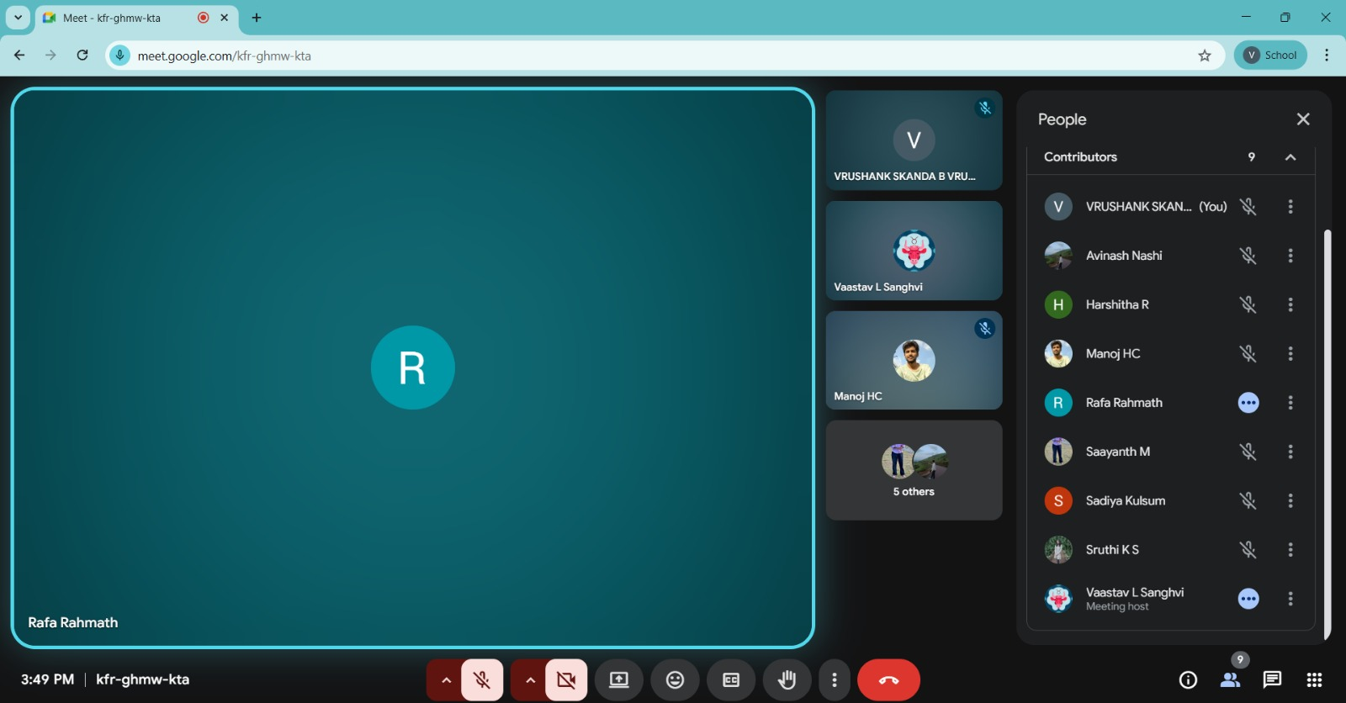

Team Work Log: [03-03-2026]
Total Duration: 5 Hours per Member Project Group: Data, Modeling, & Analytics

Data & Infrastructure Group
Member | Task Breakdown | Hours
Rafa (VP) | Completed Multi Linear Regression modeling; provided final technical sign-off on the baseline performance report. | 5
Sruthi (DE) | Supporting final dataset versioning for the evaluation phase; finalized advanced data imputation research. | 5
Vrushank (Doc) | Updated the GitHub README.md with final project details; completed documentation of industry standards for regression. | 5

Feature Engineering & Analytics Group
Member | Task Breakdown | Hours
Avinash (EDA) | EDA has been completed; finalized research on feature selection algorithms for future iterations. | 5
Saayanth (FE) | Assisting with the final verification of model outputs; completed research on polynomial feature expansion. | 5
Manoj (Analyst) | Completed the SDG analytics report; aligned model outcomes with Sustainable Development Goal targets. | 5
Harshita R (Analyst) | Completed the SDG analytics report; finalized the impact analysis of health indicators. | 5

Modeling & Management Group
Member | Task Breakdown | Hours
Vaastav | Leading the final 1-hour discussion meeting; overseeing the completion of the project. | 5
Mahesh (Model) | Completed linear and polynomial regression modeling with collaborative team support. | 5
Sadiya (Model) | Completed linear and polynomial regression modeling; finalized architecture refinements to improve performance. | 5
Issa (Eval) | Completed evaluation for Multi Linear, Linear, and Polynomial regression models. | 5
Ravi (Eval) | Compiled the comprehensive Evaluation Report; finalized R^2 and RMSE metrics for all tested models. | 5

Hourly Milestone Timeline
- Hour 1: Sync & Strategy. 1-hour discussion meeting led by Vaastav to review the completion of all technical tasks and delegate final reporting.
- Hour 2-3: Model & Evaluation Finalization. Rafa, Sadiya, and Mahesh finalize all regression modeling tasks; Issa completes the multi-model evaluation process.
- Hour 4: Analytics & Reporting. Ravi completes the evaluation report; Manoj and Harshita R finalize the SDG analytics report.
- Hour 5: Review & Project Wrap-up. Vrushank performs the final GitHub README update; the team verifies all results as the project is finished.

