🡺 your dictionary of compression token to string characters, one entry per line.

!and

@bitsy

#came

$itsy

&out

*rain

(spider

)spout

_the

+up

🡺 the compressed rhyme with the token substitutions,   
 i.e. the compressed text (not the sorted analysis list of words)

_ $ @ ( crawled + _ water )

down # _ * ! washed _ ( out

out # _ sun ! dried + all _ *

! _ $ @ ( went + _ ) again

🡺 how many characters are in the dictionary + compressed text and what is it as percentage of the original’s 187?

113 characters with spaces.

60% of the original’s 187.

🡺 **Now test your compression dictionary.** Reverse the process to see if your compression dictionary is accurate. Process dictionary items from the bottom up: find the compression character in the compressed data and replace it with the original string. **Paste the decompressed version below** – *even if it is not perfect*. **What modifications, if any, does the compression dictionary need to return the compressed data back into its original state?**

the itsy bitsy spider crawled up the water spout

down came the rain and washed the spider out

out came the sun and dried up all the rain

and the itsy bitsy spider went up the spout again

Compression data of text is needed to know what form the compressed text was, so it can be restored.

**🡺** Paste the image of the Windows Explorer .zip archive information.

Use the Snipping Tool ( + “snip”) to copy only the information seen above.

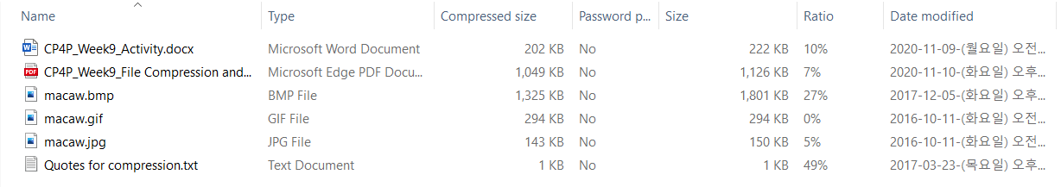

🡺 Files with the **lowest** ratios were compressed the **least**. Ratio indicates % of space saved.  
Which file types compressed the least? Why would that be? (10 pts)

Macaw.gif

In Macaw.gif, the GIF file format is a lossless compression format that uses a lossless compression algorithm, so no loss occurs during compression. The compression rate is so low that the color representation is not good.

🡺 Files with the **highest** ratios were compressed the **most**.   
Which file types compressed the most? Why would that be? (10 pts)

Quotes for compression.txt

If a text document file, which is a typical 'digital' format, is compressed into a 'loss compression format' and a part of the letter is lost, the contents of the document are severely damaged by itself.

The picture looks a little blurry or the sound quality is a little bad, but it cannot be compared to things that can be recognized or heard to some extent.

🡺 paste a screen shot of your backup results. (use the Screen Snip tool) **(10 points)**

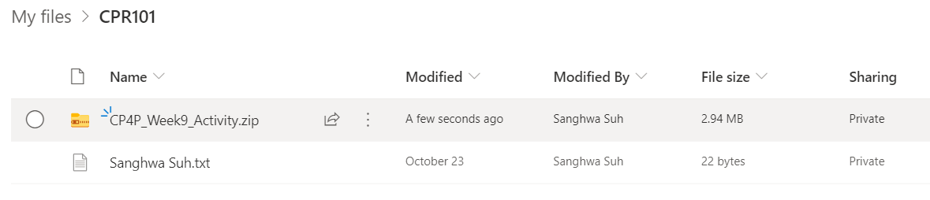

**Imagine your laptop just stopped working and could not be restarted**after you completed a great many hours of work today and yesterday.   
You need a backup & restore strategy. **(30 points)**

🡺 What is (or what should have been) your backup routine? How do you ensure your backup is current?

If I do not work in OneDrive or SharePoint libraries, for example, if I am using MS WORD, I will go into the save option and set up auto-save settings where it will be saved and every minute it will be saved automatically. If auto-save is off, I will save it passively by pressing ctrl +s. In case of OneDrive or SharePoint, all tasks are automatically saved and the backup is always up-to-date, but in case of working separately, I have to check the status of the backup by opening the file.

🡺 How does your backup routine address the three characteristics of a real backup and fulfill the 3-2-1 backup check?

After making 3 copies of the data, save the original to the internal hard disk and place the rest on the external hard disk or USB memory. The last one should be backed up using cloud services, which are physically separate locations

🡺 Now that you have a backup *but no laptop*, how will you access and work with the current version of your backed up files? What is your restore/recovery strategy?

Even without a laptop, backup files can be accessed by smart devices such as mobile phones and tablet PCs. I can retrieve a file from OneDrive and access it to another smart device without a laptop. But these are only possible when the Internet is connected. If the internet is not working, connect the USB to the device and bring up the file.

🡺 How long would this all take…and what if you a had a big assignment due tomorrow?

If I set automatic storage when I work on important files, I can back up them in seconds. Manual storage does not take that long. It depends on the computer's performance, but it takes less than five minutes at most. Especially if there is an important task the next day, I have to pay more attention to my backup files. I will save one on my hard disk and save it on One Drive at the same time. And finally, make additional backups to external hard or USB memory in case my computer crashes or not connected to the internet.