Homework 5

Intensity Processing

2020311381 Sanghyeok Choi

**Goal of Project** : Understanding on Intensity Processing

**Tools :** Gamma Correction, Histogram Equalization, RGB Color system, YCrCb Color system.

1. RGB Color system

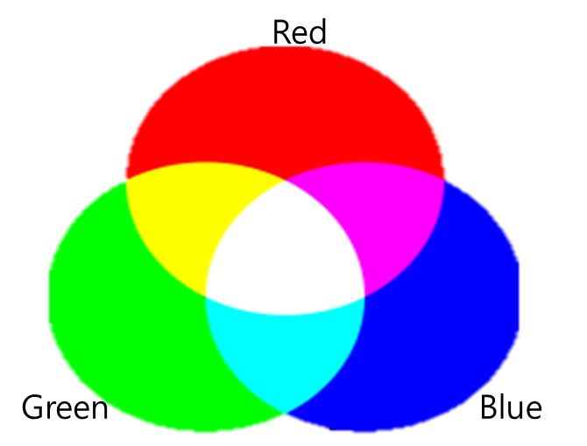

The RGB color system is an additive color model in which red, green, and blue light are added together in various ways to reproduce a broad array of colors. In color images, they use 3 different values in one pixel; correspond R,G, and B while gray scale images use only one value in one pixel. Each color can be present by combine correspond values of R,G and B.

2. Gamma Correction :

Gamma correction is nonlinear system. In this project, new pixel intensity define as = ( : Original intensity). When > 1, become smaller than 1, function become convex. That mean new image become brighter than original image. On the other hands, when < 1, become bigger than 1, function become concave. That mean new image become darker than original image.

3. Histogram Equalization :

Histogram equalization means making signal intensity’s distribution more uniform. Some images those intensities are focus on some values are hard to distinguish objects. So make intensity more equally. Then image’s contrast become bigger and it can be more easy to distinguish objects.

Let’s set there are 36 pixels in image, intensity values are only six values; 0,1,2,3,4,5. Number of pixels that correspond each intensity; 10,7,7,2,6,4.

|  |  |  |  |  |
| --- | --- | --- | --- | --- |
| Intensity  of input | # of pixels | Cumulative # of pixels | Normalized value  x Maximum intensity | Equalized intensity values |
| 0 | 10 | 10 |  | 1 |
| 1 | 7 | 17 |  | 2 |
| 2 | 7 | 24 |  | 3 |
| 3 | 2 | 26 |  | 4 |
| 4 | 6 | 32 |  | 4 |
| 5 | 4 | 36 |  | 5 |

Upper chart is histogram equalize method. Get cumulative number of pixels by ascendant of intensity. Now get CDF by divide total number of pixels in each cumulative number of pixels. Then multiply maximum intensity in each CDF. In this case, for make values integer, so round their values. Finally image distribution become 1,2,3,4,5 => 10,7,7,8,4. Original image’s distribution is 0,1,2,3,4,5 => 10,7,7,2,6,4 so number of intensity=3 was little but it become more equal to sum with intensity=4. But still it does not uniform. Anyway it makes more equal in distribution of intensity for watch more comfortable.

4. YCrCb Color system :

It is a family of color spaces used as a part of the color image pipeline in video and digital photography systems. Y is the luma component and CB and CR are the blue-difference and red-difference chroma components.

Now let’s see given function.

R,G and B is original image’s correspond color intensities. You can get Y, by given matrix. Then convert only Y by histogram equalization. Then get New image’s intensity by inverse transformation of matrix.

**Process :**

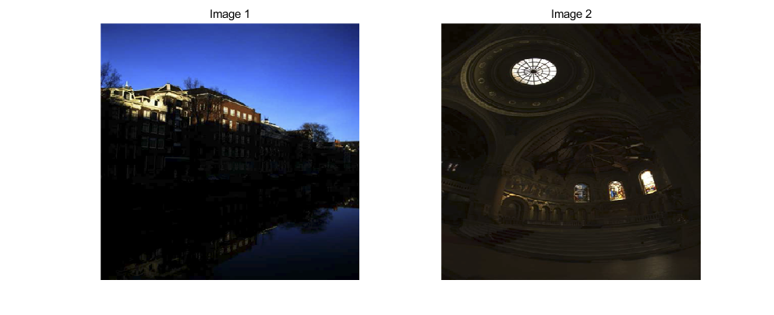

< Fig 1 >

< Fig 1 > is original images. I apply this method by “Matlab” tool. In Matlab, you can show 3D image by 8bit integer that intensity value is integer between 0~255. So you should fit 0 ~ 255 integer form by rounds . Both images are dark, so it shoud be brighter than original for watch more comfortable.

**Result :**

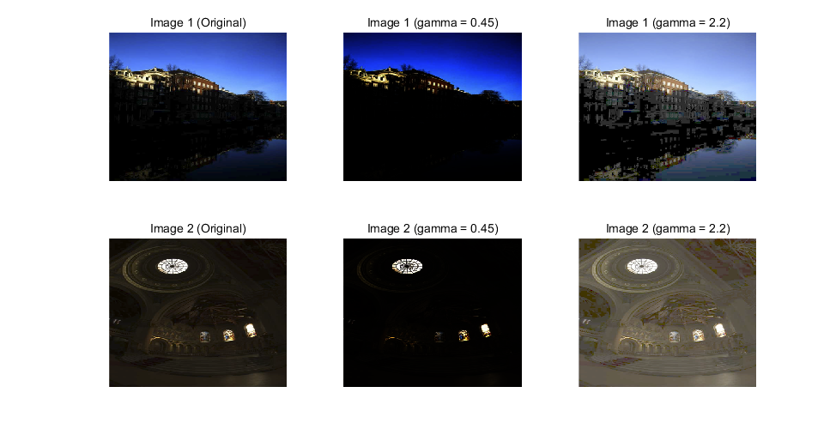

< Fig 2 >

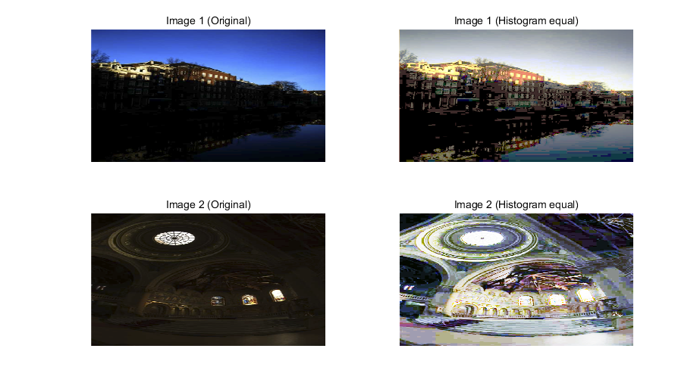

< Fig 3 >

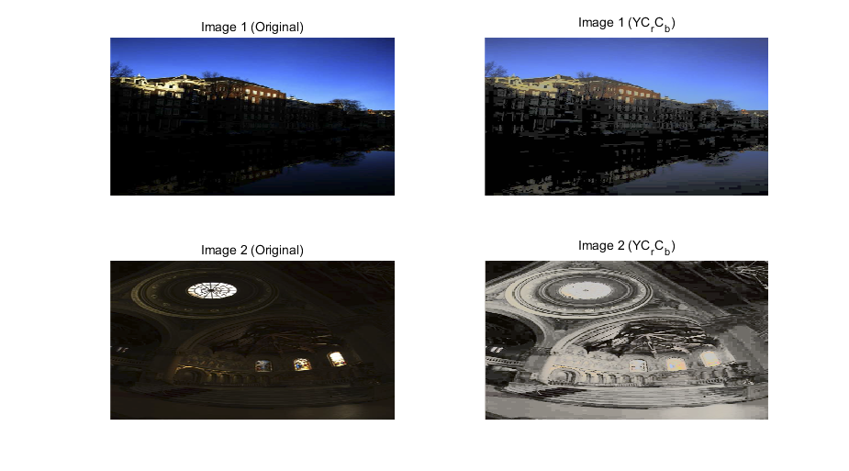

< Fig 4 >

< Fig 2 > is gamma correction. When is bigger than 1, image become brighter and when is smaller than 1, image become darker. As you see, When = 0.45, image become darker and = 2.2. Original images are dark so they need to be brighter. So when = 0.45, images are hard to distinguish while = 2.2 can distinguish objects more easy.

< Fig 3 > is Histogram equalization. Histogram equalization makes image intensity’s distribution more equal. Images can be distinguish much more than original images but color is weird. In image 1, sky’s color become gray and in image 2, it is totally different color.

< Fig 4 > is YCrCb method. It use histogram equalization method, so as histogram equalization, images can be distinguish much more than original images. Compare to histogram equalization, it does not use totally different color. In image1, sky and water still blue, in image 2 it seems gray scale, but image 2 is almost single color so it is not weird.

**Discussion :**

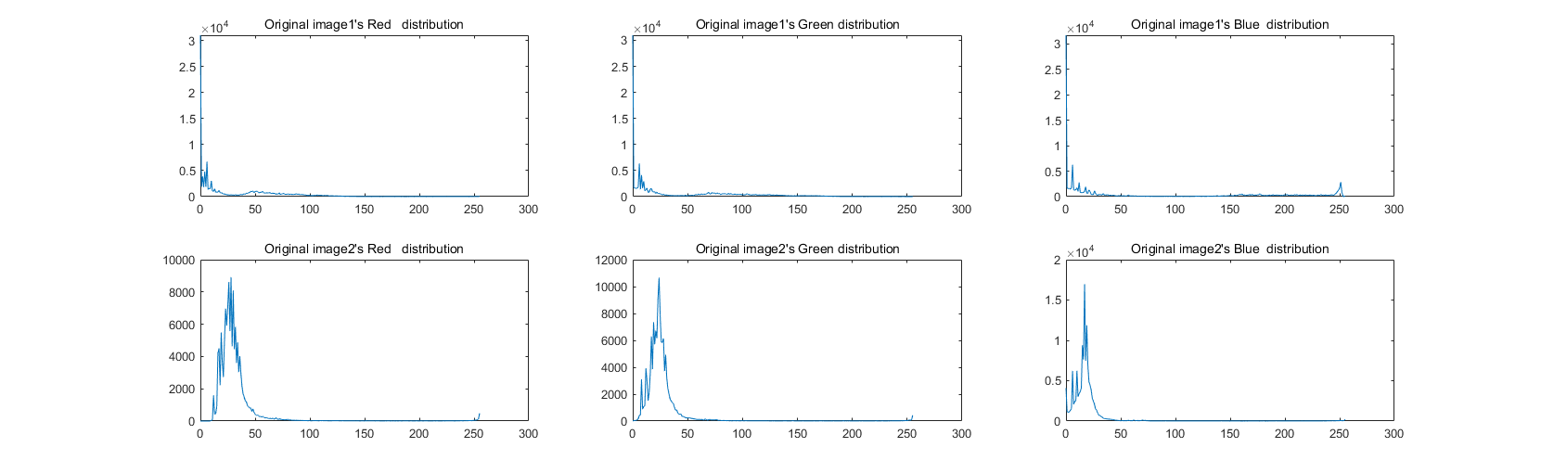

< Fig 5 >

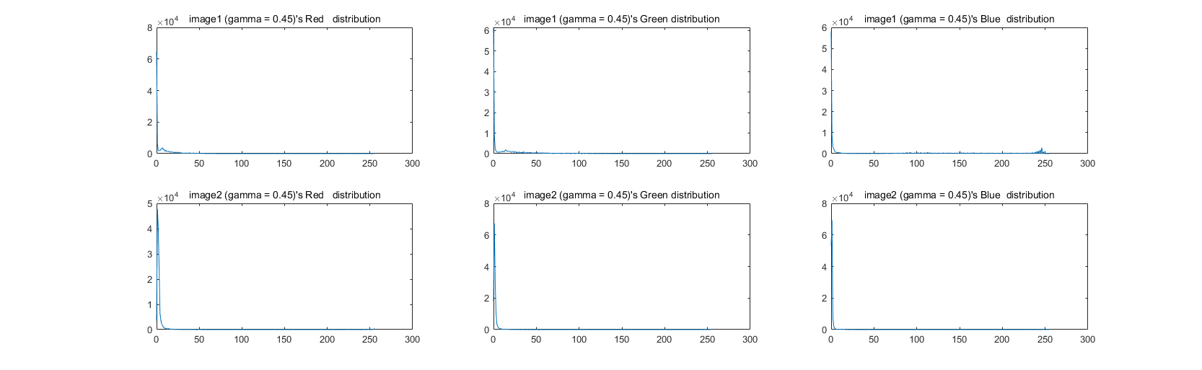

< Fig 6 >

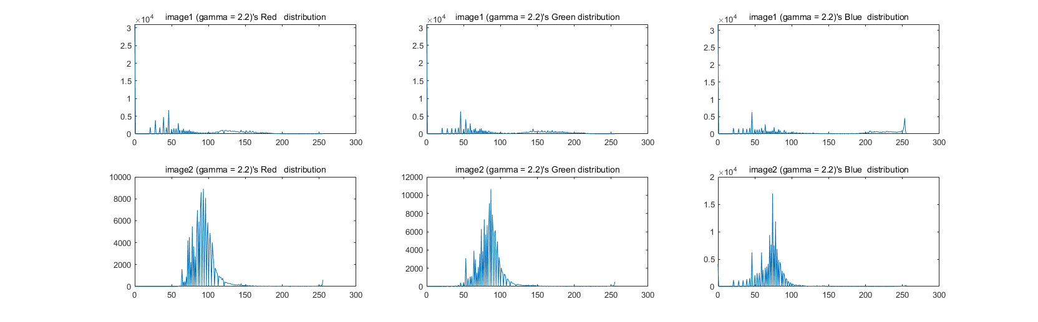

< Fig 7 >

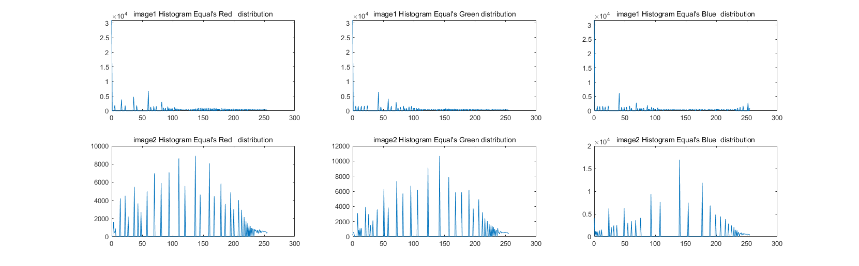

< Fig 8 >

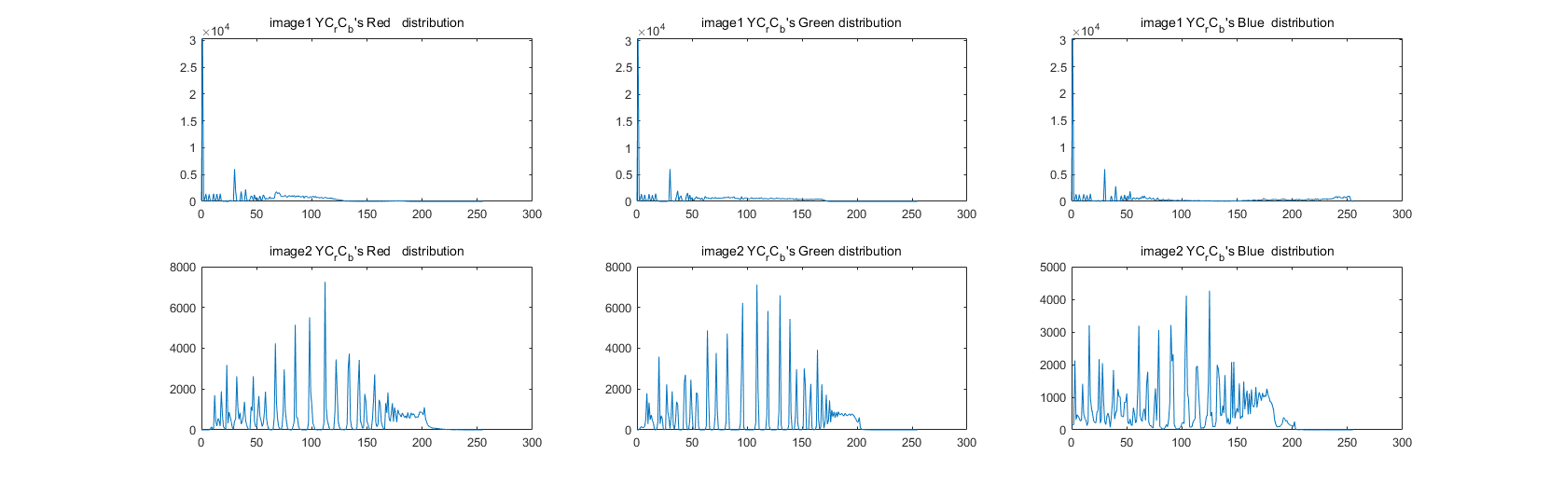

< Fig 9 >

< Fig 5 > ~ < Fig 9 > are histogram distribution. First row for image 1 or changed image 1, while second row for image 2 or changed image 2. Each column for correspond image’s R,G and B. < Fig 5 > for original images, < Fig 6 > for gamma correction that = 0.45, < Fig 7 > for gamma correction that = 2.2, < Fig 8 > for histogram equalization, < Fig 9 > for YCrCb.

When you see < Fig 8 > and < Fig 9 >, still distribution are focus on zero intensity in image1.

So distribution could not be uniform. Although it is not uniform, it still works. Also gamma correction works well but it need to prior information whether image is dark or bright. Histogram works well but color change to weird. YCrCb don’t need prior information and colors are not weird but it is complicate. So I think there are pros and cons in each methods.

**Reference :**

<https://en.wikipedia.org/wiki/RGB_color_model>

<https://en.wikipedia.org/wiki/Gamma_correction>

<https://en.wikipedia.org/wiki/YCbCr>