Buckle-driven, ultra-fast and compliant tourniquet
Kwanwoo, Minjun, Jaehun, Soeun, Sanghyun
Ⅰ. INTRODUCTION
Uncontrolled hemorrhage is a leading cause of preventable death in trauma and emergency care (1, 2). While arterial bleeding has received substantial attention—particularly in military settings—the majority of real-world bleeding events, especially in civilian environments, involve venous or mixed bleeding. These cases require moderate, sustained compression (3), not the high-pressure occlusion provided by arterial tourniquets like the Combat Application Tourniquet (CAT) (4).
Existing venous bleeding control methods are either ineffective, slow, or difficult to use under pressure. The direct pressure method, though effective in principle, demands constant manual compression for extended periods—rendering the rescuer immobilized and delaying transport or further intervention. The widely used Israeli bandage, a pressure dressing with a complex wrapping and hooking mechanism, is time-consuming and requires two hands, a calm setting, and practice to apply correctly—conditions rarely met in real emergencies (5).
There is a critical need for a fast, reliable, and user-friendly compression device specifically tailored for venous bleeding control. Our solution is a buckle-driven, one-handed tourniquet that enables pressure to be applied and locked in under 5 seconds—without the risk of over-compression or procedural complexity. Inspired by snap-through instability of venus flytraps (6), our design emphasizes speed, intuitiveness, and repeatable performance in high-stress, low-resource environments.

II. OBJECTIVES
The objective of this project is to develop a buckle-driven tourniquet specifically optimized for the rapid and safe control of venous bleeding, a clinical need that remains underserved by current hemorrhage control solutions. The device is engineered for deployment in under five seconds and enables one-handed operation, making it suitable for self-application or use by non-experts in high-stress or resource-limited environments. By eliminating the need for sustained manual pressure—as in the direct pressure method—and simplifying the complex wrapping steps of devices like the Israeli bandage, the design reduces both application time and user burden. A key innovation is the incorporation of a superabsorbent polymer (SAP) (7) component near the compression site, which passively increases local pressure as it swells in response to blood absorption. This adaptive feature enhances pressure maintenance and supports more reliable hemostasis in dynamic emergency settings.

III. PROJECT DESCRIPTION
Our work is divided into two major components: A. mechanical design and material integration, and B. experimental validation across simulated trauma scenarios.

A. Mechanical Design Overview
As seen in Figure 1 (c) the tourniquet comprises three main structural elements: the outer skin-contact layer, absorbent core, and the snapband-based pressure-actuation system.

- Outer Layer
A soft, hydrophilic textile is used to cover the outermost surface, ensuring comfort and skin compatibility. It provides a structural containment while allowing internal components to expand when required.

- Absorbent Core
The internal layer consists of dual gauze layer enveloping a sodium polyacrylate-embedded cotton core. When exposed to blood or other fluids, the superabsorbent polymer (SAP) swells significantly, which increases the radial pressure applied directly to the wound site. This mechanism enables pressure to adjust automatically in response to the bleeding severity.

- Snapband-Based Actuation
The mechanical heart of the device lies in the metallic snapband at the top layer. Upon application, the band rapidly wraps around the limb (activated by snap-through buckling), delivering immediate compression pressure. This design enables one-motion application (see Figure 2), suited for emergencies in remote or resource-limited environments like battlefields or disaster zones.

The final prototype shown in Figure 1 (a), (b) reflects these design decisions and displays our final prototype.

B. Experimental Validation
To verify the effectiveness of our design, four independent evaluations were conducted against two existing widely known solutions for treating venous bleeding (Israeli bandage, compression bandage):

- Application time
The application time of each tourniquet was measured. We conducted this test for 5 different participants from different backgrounds.

- Pressure Distribution Test
Using three equidistant pressure sensors around the limb (Figure 3 (a)), we quantified the distribution of compression near the target area. The tourniquet was applied to collect pressure data, the same pressure was repeated for the other two existing solutions for direct comparison (Figure 3 (b), (c)). The measured pressures were also evaluated in reference to the thresholds required for hemostasis, as outlined in Table 1.

- Leakage Test
Inspired by prior literature (8), Tygon tube with a lateral cut that mimics the wound was mounted to one’s arm to model venous bleeding (Figure 4 (b)). Then, water at 5 kPa pressure was introduced through the tube. The mass of leaked water—representing blood loss from the wound site—was measured before and after the application of our tourniquet to evaluate its effectiveness in controlling bleeding (Figure 4a).

- Usability & Comfort Survey
To assess user experience, we employed the Comfort Rating Scale (CRS) and System Usability Scale (SUS), which are standard tools for medical device evaluation (9, 10). To reduce potential bias, we conducted a survey with 10 participants from diverse backgrounds. As shown in Figure 5, the survey included both quantitative scales and open-ended items, providing comprehensive feedback for future improvement of the device.

Overall, the project was structured to address all anticipated challenges associated with tourniquet use in emergency scenarios—from rapid application and consistent pressure delivery to user comfort and effectiveness. Each experimental component was carefully selected to validate specific performance aspects of the design, ensuring that the final system is fast, easy but at the same time also effective.

IV. PRELIMINARY RESULTS
As mentioned above, we validated our buckle-driven, ultra-fast, and compliant tourniquet against two conventional solutions—Israeli bandage and compression bandage—based on four metrics: application time, compression pressure, leakage control, and user feedback. Tests were conducted with 10 participants (ages 23–29, limb circumference 14–32 cm).
As shown in Figure 6, our device achieved the shortest application time. The gap was largest among untrained users, highlighting its ease of use. Most participants managed to use the tourniquet successfully within the 5 seconds timeframe.
Using sensors at three anatomical points (ID1–ID3), we measured applied pressure (Figure 3 (a)). Although slightly lower than Israeli bandages, our device managed to exert pressures above the tolerance range of 4 – 8 kPa, which is sufficient for venous bleeding control (Figure 7).
Leakage test results confirmed that our device successfully sealed the wound site. As shown in Figure 8, no leakage was observed during compression, indicating uniform pressure and good skin contact.
CRS(Comfort Rating Scale) (9) and SUS (System Usability Scale) (10) surveys (Figures 9,10) revealed high ratings in comfort, ease of use, and confidence. At times, some reported that the snapping motion was slightly painful, but most favored our device for its speed. Qualitative feedback also included suggestions for larger sizes and stronger locking.

V. DISCUSSION & CONCLUSION
The study demonstrates that our buckle-driven, snap-through tourniquet meets its two core design goals—extreme speed and ease of application—while maintaining robust hemostatic performance and comfort. The mean application time was under 4 seconds, more than 30 times faster than conventional bandage-type pressure tourniquets. This advantage was also evident among untrained users, confirming the device’s suitability for self-application and for lay responders operating under stress.
Building on these findings, future work will focus on enhancing performance and expanding applicability. First, we will expand pressure and leakage testing to larger limbs, irregular wound geometries, and realistic field conditions (perspiration, limited visibility, motion). Second, we aim to optimize the conditions for self-pressurizing superabsorbent-polymer (SAP) layer that swells when in contact with blood, such that our device provides a more effective, adaptive, hands-free compression (11). Third, we aim design a modular longitudinal-and-parallel coupling system to accommodate a wider range of limb sizes, including thighs. Lastly, we plan to embed a buckling-triggered hemostatic-agent release and verify its biocompatibility and shelf life (12).
With the forementioned goals achieved, we expect our tourniquet to reduce preventable deaths from venous or mixed bleeding in both civilian mass-casualty events and military operations. Our future roadmap therefore focuses on (i) validating long-term pressure maintenance with the integrated SAP layer, (ii) scaling the modular design, (iii) refining controlled hemostatic-agent release, and (iv) conducting animal and human-factor trials under austere conditions. With these advancements, we envision a low-cost, training-agnostic tourniquet that makes effective venous hemorrhage control as instinctive as fastening a seatbelt—dramatically improving survival when every second counts.

.

Ⅵ. FIGURES

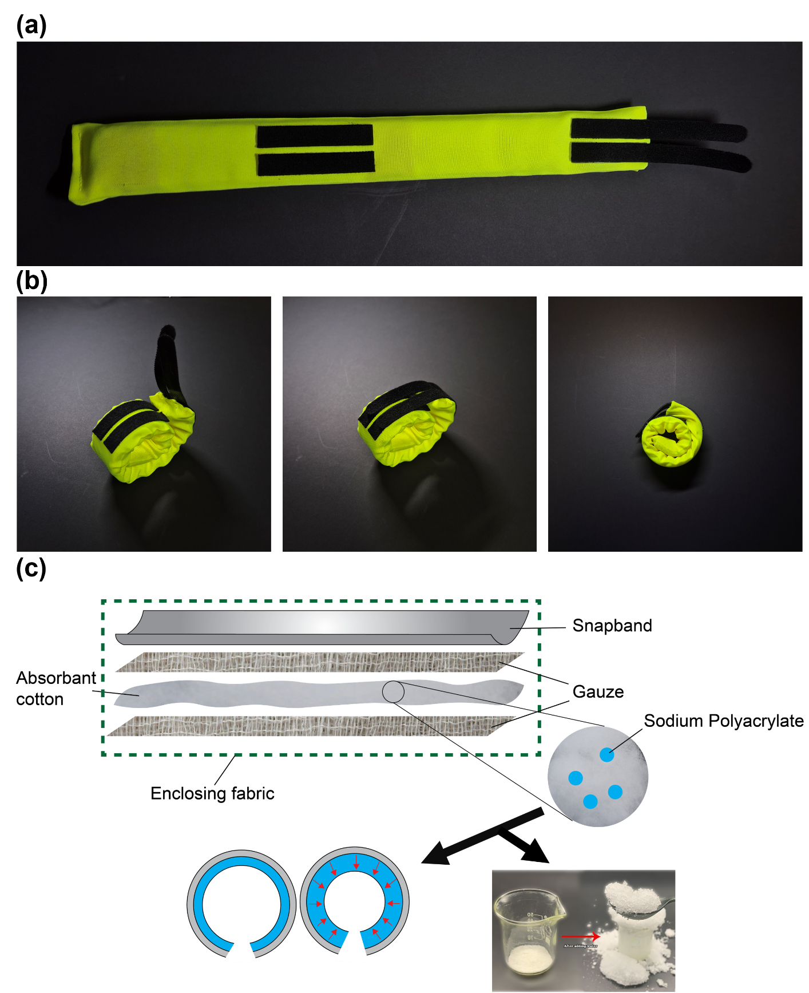
Figure 1. Design and structure of the buckle-driven, ultra-fast, and compliant tourniquet. (a) Tourniquet in its straightened form for application. (b) Sequential views of the rolled configuration, enabling compact storage and rapid deployment. (c) Cross-sectional schematic showing the multilayer structure, including a snapband for rapid rolling, absorbent cotton, gauze embedded with sodium polyacrylate for hygroscopic swelling, and the enclosing fabric. The bottom illustration shows the mechanism of radial contraction upon water absorption and an experimental demonstration of the swelling material.

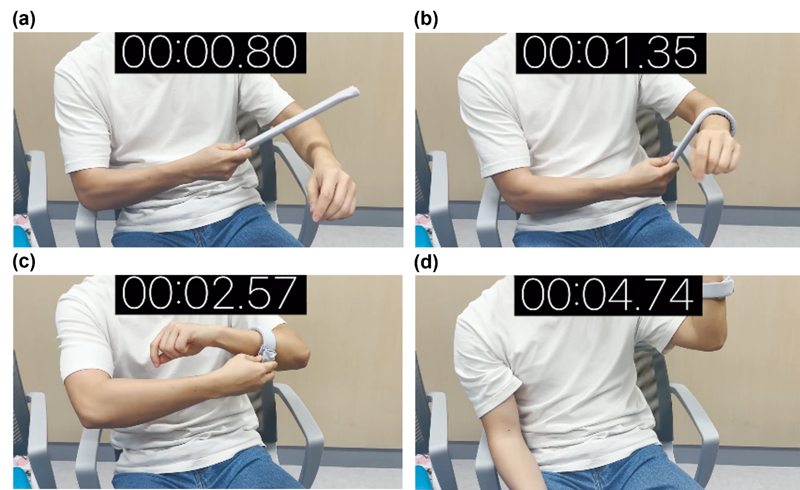
Figure 2. Application of buckle-driven, ultra-fast and compliant tourniquet ( in (a), (b), (c), (d) order )

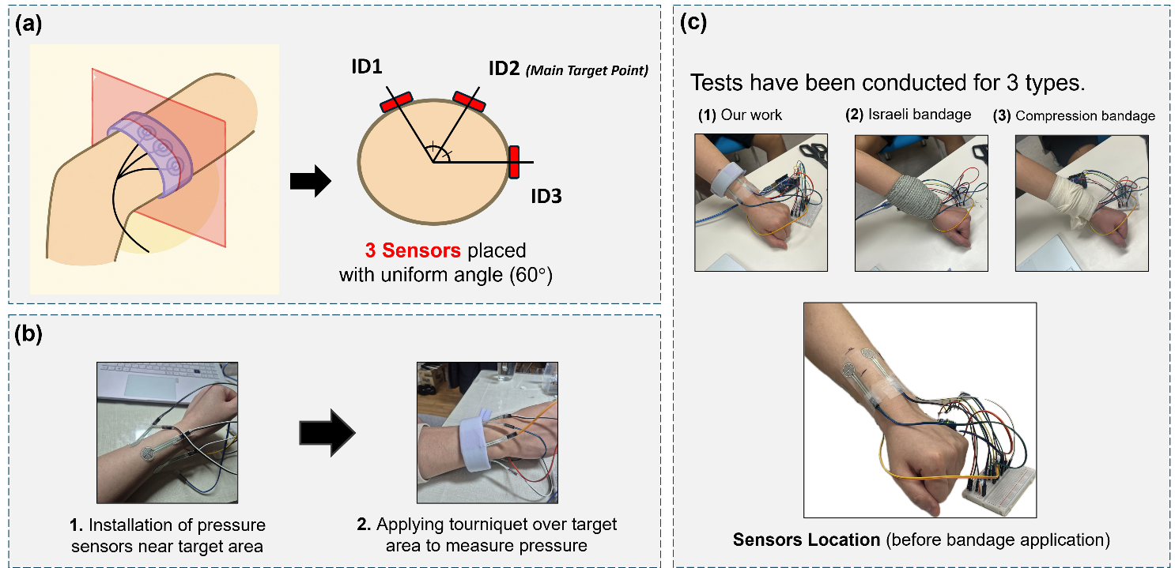

Figure 3. Experimental setup for evaluating pressure distribution test. (a) Schematic showing the placement of three pressure sensors evenly spaced at 60° intervals around the arm, with ID2 as the main target point. (b) Procedure for pressure measurement: sensors are first attached to the target region, followed by tourniquet or bandage application to evaluate applied pressure. (c) Pressure tests conducted on three different bandage types: our proposed design, Israeli bandage, and conventional compression bandage. Sensor placement is shown prior to bandage application.

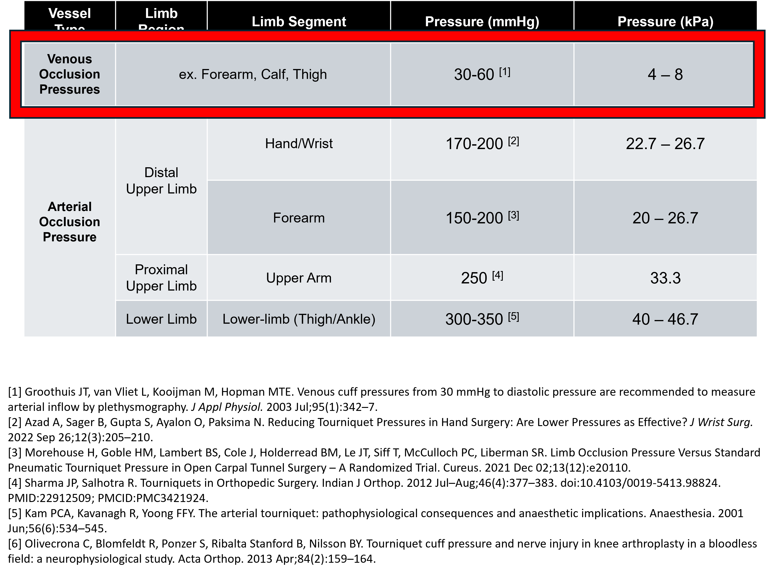
Table 1. Pressure Thresholds Required for Venous and Arterial Occlusion Summary of occlusion pressure ranges (in mmHg and kPa) required to restrict blood flow in various limb segments. Venous occlusion pressures typically range from 4–8 kPa, while arterial occlusion requires significantly higher pressures depending on limb region. References indicate clinically validated values from literature.

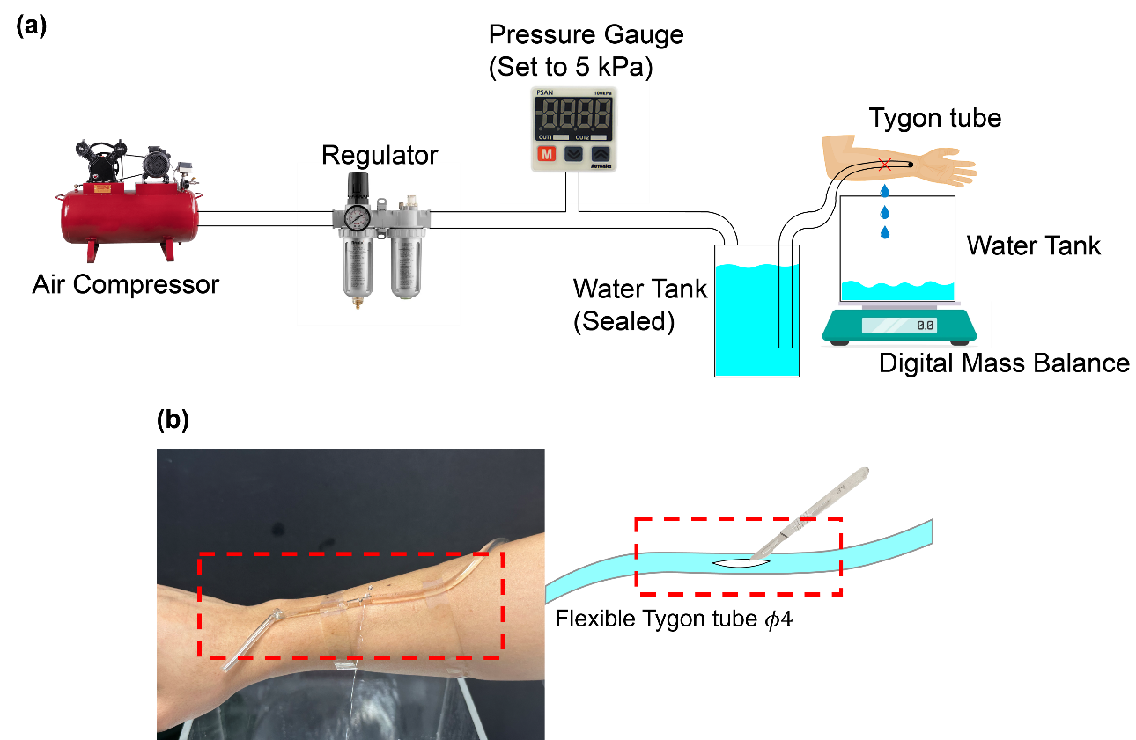
Figure 4. Leakage test setup and tubing application. (a) Schematic of the leakage test using a pressurized water flow through a simulated wound setup. (b) Flexible Tygon tubing used to fabricate an artificial blood vessel with an incision for wound simulation.
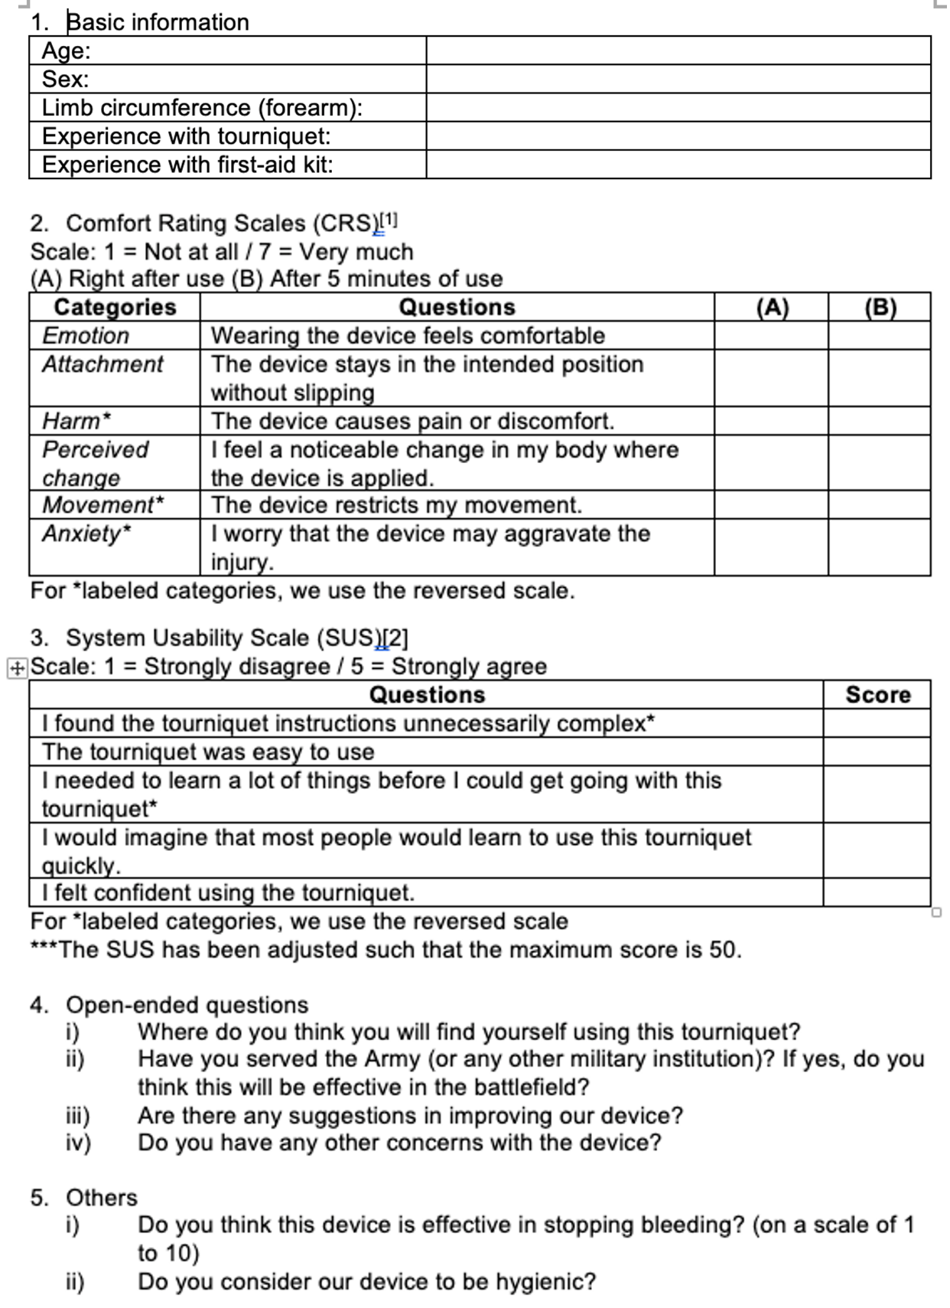
Figure 5. Survey structure for user evaluation. Survey form used to assess user experience through (1) basic demographic information, (2) Comfort Rating Scales (CRS) immediately after and 5 minutes after use, (3) System Usability Scale (SUS) questions, (4) open-ended qualitative feedback, and (5) additional evaluation of effectiveness and hygiene. Reversed scoring is applied for negatively worded items in CRS and SUS.
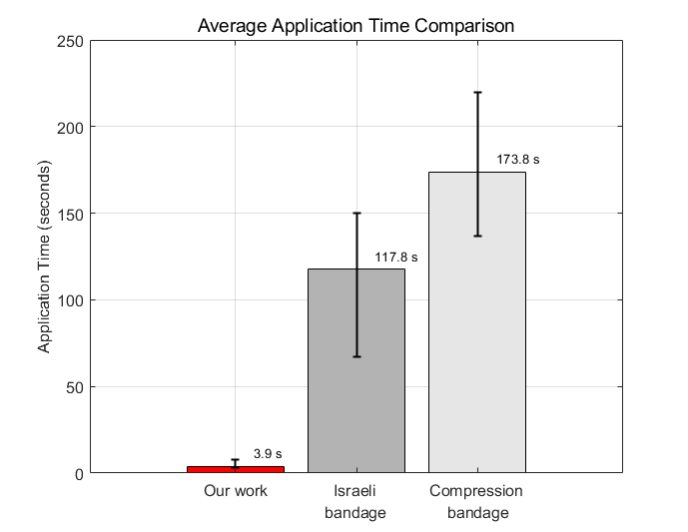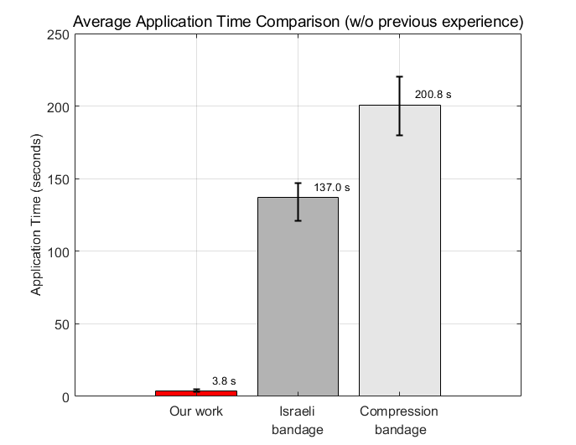
Figure 6. Application time comparison (Left) Average application time with users who had prior experience using each bandage. (Right) Average application time by users without any prior experience.
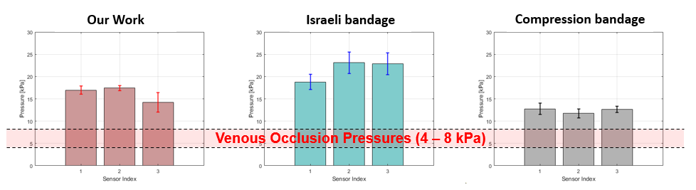
Figure 7. Compression test results for each bandage type. Pressure values at three sensor points show that our device consistently maintains pressures within the venous occlusion range (4–8 kPa), while the Israeli bandage tends to over-compress and the compression bandage under-compresses.

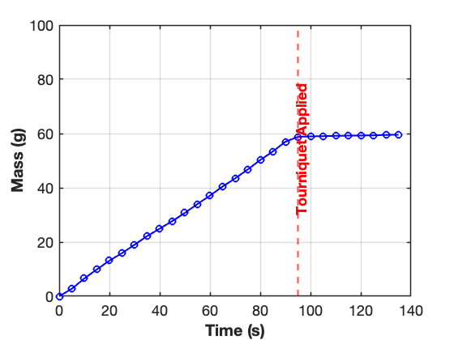
Figure 8. Leakage test result showing fluid mass over time. Water leakage was measured as mass accumulation over time. Upon application of the tourniquet at 95 seconds (red dashed line), leakage was effectively stopped, as indicated by the plateau in mass.
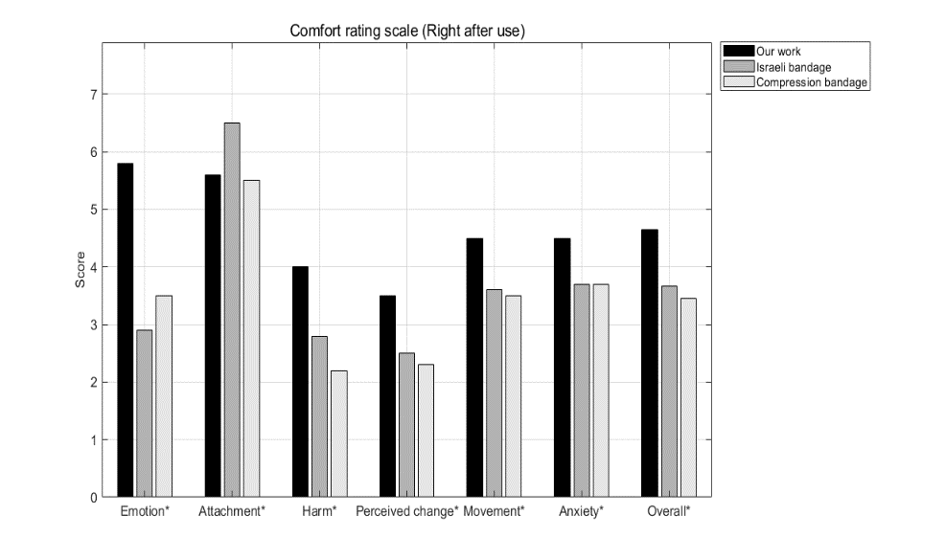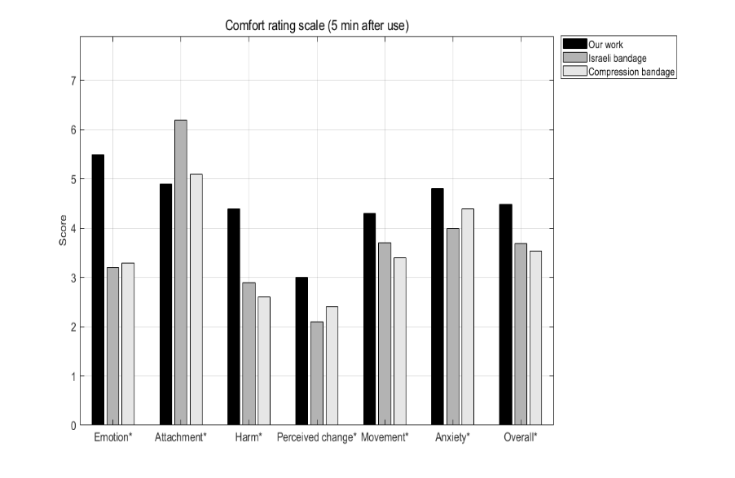
Figure 9. Comfort Rating Scale (CRS) results. User comfort was evaluated immediately after use (left) and 5 minutes post-application (right) across seven categories. Our device consistently outperformed both the Israeli and compression bandages, particularly in emotional response, perceived harm, and overall comfort.

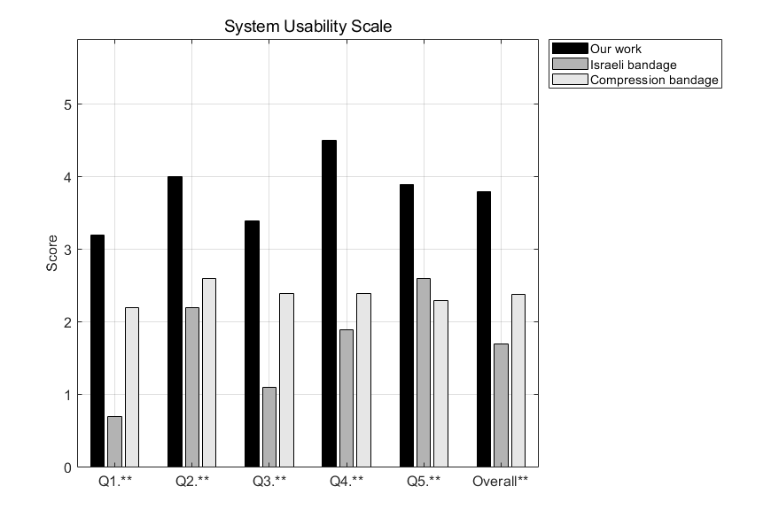
Q1. I found the tourniquet instructions unnecessarily complex
Q2. The tourniquet was easy to use.
Q3. I needed to learn a lot of things before I could get going with this tourniquet
Q4. I would imagine that most people would learn to use this tourniquet quickly.
Q5. I felt confident using the tourniquet.
Figure 10. System Usability Scale (SUS) results and survey questions. Bar graph shows SUS scores for each question and overall usability across three bandage types. Higher scores indicate better usability. The listed questions (Q1–Q5) represent a subset of the standardized SUS questionnaire, evaluating clarity, ease of use, learning curve, and user confidence.

Ⅶ. REFERENCES
1. R. Chang et al., Earlier time to hemostasis is associated with decreased mortality and rate of complications: results from the pragmatic randomized optimal platelet and plasma ratio trial. Journal of Trauma and Acute Care Surgery 87, 342-349 (2019).
2. B. J. Eastridge et al., Death on the battlefield (2001–2011): implications for the future of combat casualty care. Journal of trauma and acute care surgery 73, S431-S437 (2012).
3. J. T. Groothuis, L. van Vliet, M. Kooijman, M. T. Hopman, Venous cuff pressures from 30 mmHg to diastolic pressure are recommended to measure arterial inflow by plethysmography. Journal of applied physiology 95, 342-347 (2003).
4. A. Unlu et al., An evaluation of combat application tourniquets on training military personnel: changes in application times and success rates in three successive phases. BMJ Military Health 161, 332-335 (2015).
5. N. Shipman, C. S. Lessard, Pressure applied by the emergency/Israeli bandage. Military medicine 174, 86-92 (2009).
6. Y. Forterre, J. M. Skotheim, J. Dumais, L. Mahadevan, How the Venus flytrap snaps. Nature 433, 421-425 (2005).
7. U. A. Halyal, Sodium polyacrylate as a super absorbent. International Journal of Advanced Research in Science, Communication and Technology, 74-84 (2021).
8. D. Wu et al., Novel Biomimetic “Spider Web” Robust, Super‐Contractile Liquid Crystal Elastomer Active Yarn Soft Actuator. Advanced Science 11, 2400557 (2024).
9. E. J. M. Pearson, Comfort and its measurement–a literature review. Disability and Rehabilitation: Assistive Technology 4, 301-310 (2009).
10. J. Brooke, SUS-A quick and dirty usability scale. Usability evaluation in industry 189, 4-7 (1996).
11. A. Mahmoodzadeh et al., Biodegradable cellulose-based superabsorbent as potent hemostatic agent. Chemical Engineering Journal 418, 129252 (2021).
12. Y. Guo et al., Recent advances in the medical applications of hemostatic materials. Theranostics 13, 161 (2023).

