+



**DOCUMENTATION**

OF

**MATERIAL STUDY APP**

**INTRODUCTION**

Overview of Material study app

There are many material study apps available in the market, each with their unique features and functionality. Generally, these apps are designed to help students learn and study course material more efficiently and effectively by providing them with tools to organize their notes, create flashcards, take quizzes, and track their progress.

*Some of the common features of material study apps include:*

1.**Note-taking:** Many material study apps offer note-taking functionality, allowing students to create and organize their notes in a digital format. Some apps also support audio and video recordings to capture lectures and other study material.

2.**Flashcards:** Flashcards are a popular study tool used to memorize information. Material study apps often provide an easy way to create and review digital flashcards.

3. **Quizzes and Tests:** These apps may provide pre-made quizzes and tests to help students assess their knowledge of the subject matter. Additionally, some apps allow students to create their own quizzes and share them with others.

4.**Progress Tracking:** Material study apps often offer tracking features to help students monitor their progress and identify areas where they need to focus more attention.

5.**Collaboration:** Some apps allow students to collaborate with others, sharing notes, flashcards, and quizzes. This can be particularly useful for group projects or studying for exams together.

Some popular material study apps include Quizlet, Evernote, Anki, and StudyBlue. Ultimately, the best app for a student will depend on their specific needs and preferences.

Purpose of material study app

The purpose of material study apps is to help students learn and retain course material more efficiently and effectively. These apps provide tools and features to organize and streamline the studying process, making it easier for students to review and memorize information.

Material study apps are designed to enhance the learning experience by providing a digital platform that allows for easy note-taking, creation of flashcards and quizzes, progress tracking, and collaboration with other students. With these features, students can optimize their study time and improve their understanding of course material, leading to better academic performance.

Moreover, these apps can be especially useful for distance learning or self-paced courses, where students may not have regular access to their instructors or classmates. Material study apps offer a way for students to take control of their own learning and stay engaged with the material, even outside of the classroom.

Overall, material study apps are designed to support students' learning and help them achieve their academic goals.

Problem Definition & Design Thinking

* *Empathy Map*
* *Brainstorming & Ideation*

Ideation & Brainstorming Map

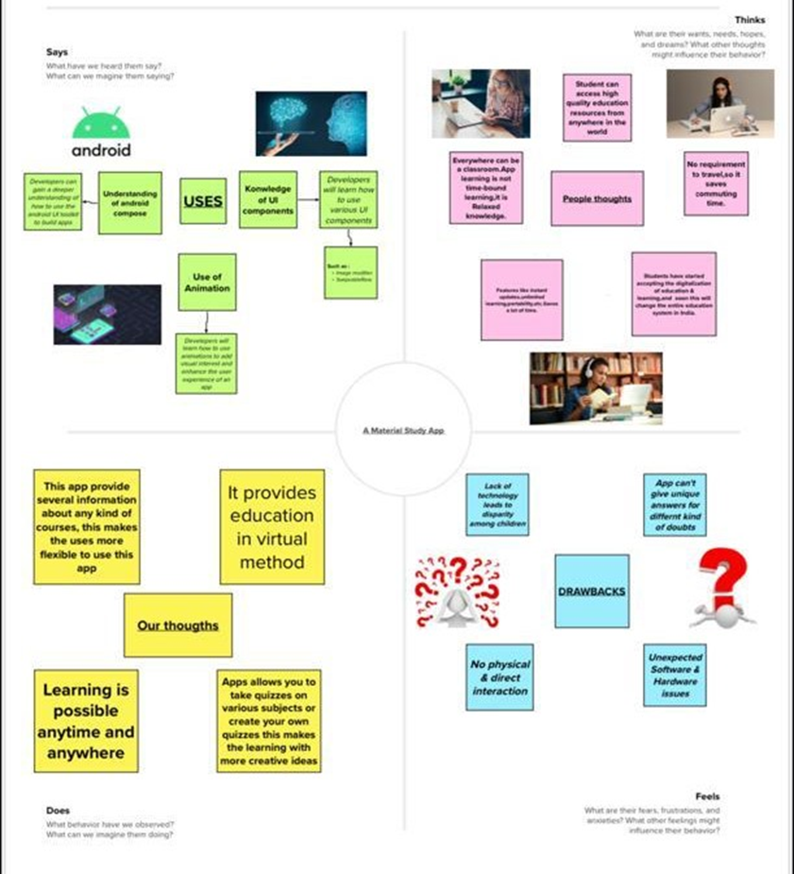Empathy Map :

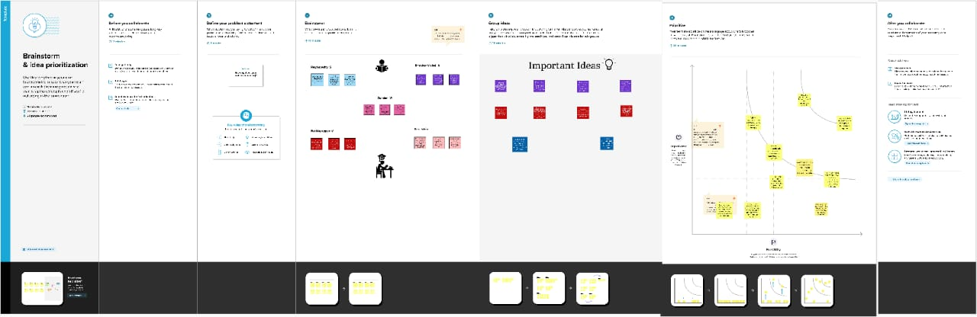Brainstorming & Ideation

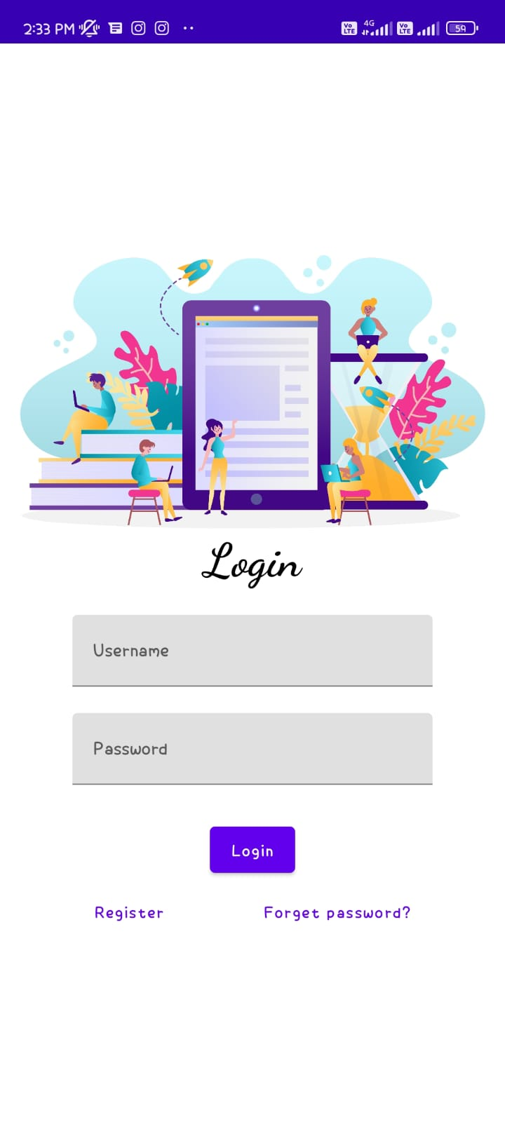Login Page :

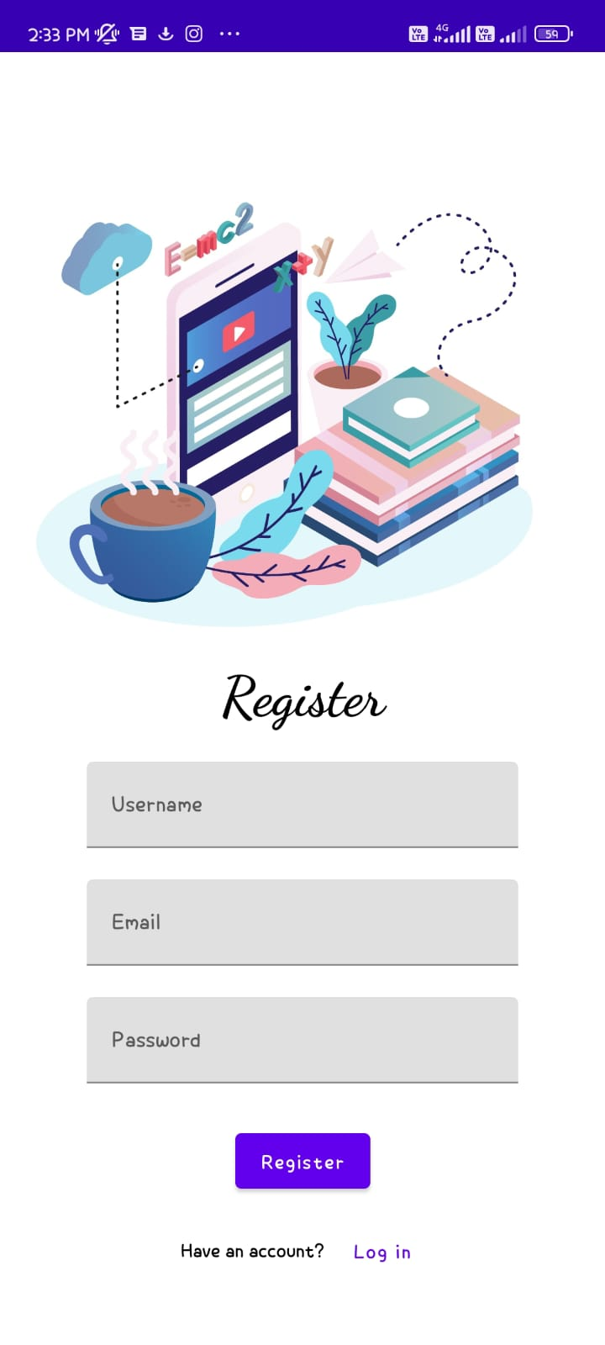Register Page :

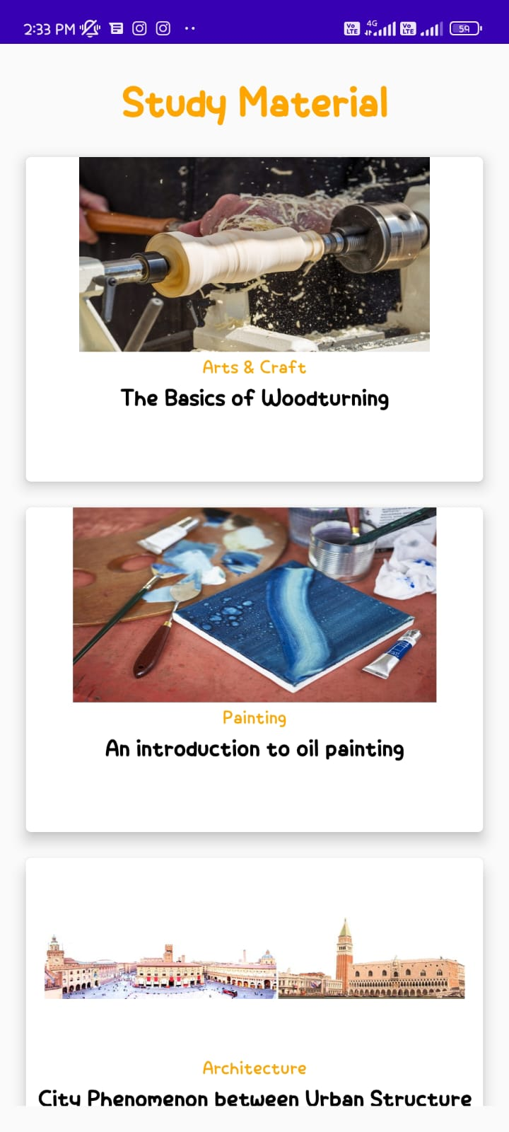 **Main Page :**

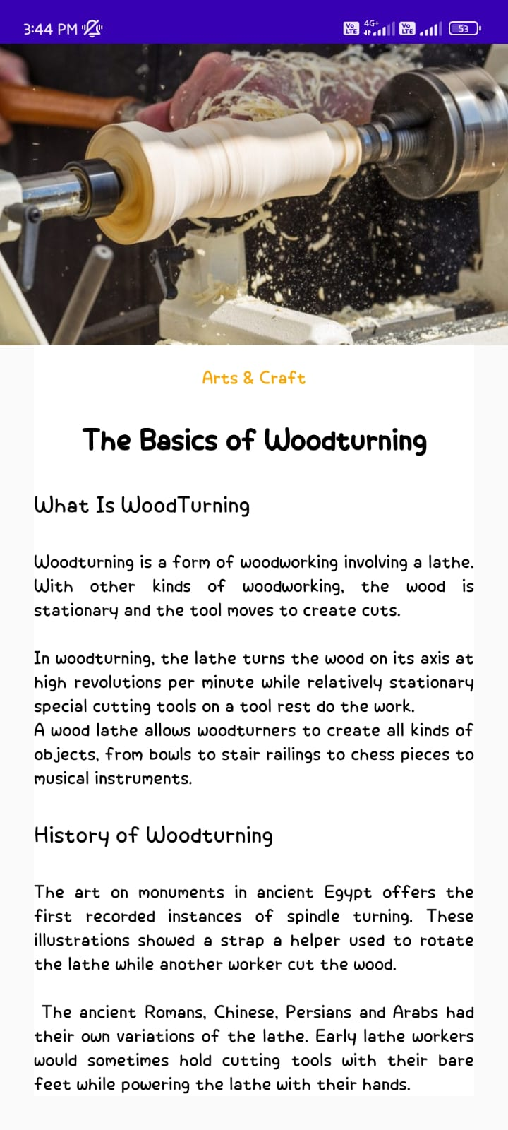**Book Page :**

**ADVANTAGES :**

*Material study apps offer several advantages to students:*

**Organization**: Material study apps provide a digital platform for students to organize their notes, flashcards, and quizzes in one place. This allows students to easily access their study materials, even when they are on the go.

**Efficiency:** With material study apps, students can study more efficiently by creating flashcards and quizzes to help them review information quickly. This allows students to focus on the areas where they need the most help and saves time compared to traditional study methods**.**

**Accessibility:** Material study apps are easily accessible on smartphones, tablets, and computers, making it convenient for students to study wherever they are.

**Collaboration**: Some material study apps allow for collaboration among students, which can help in group projects or studying for exams together.

**Personalization:** Material study apps can be personalized to fit each student's learning style and preferences. For example, students can adjust font sizes, colors, and backgrounds to make studying more enjoyable and effective.

**Progress tracking:** Material study apps provide progress tracking tools, allowing students to monitor their learning and adjust their studying methods accordingly. This can help students identify areas where they need more help and focus their attention on those areas.

Overall, material study apps offer several advantages to students, making studying more efficient, accessible, and personalized.

**DISADVANTANGES:**

In conclusion, material study apps offer several advantages to students, including organization, efficiency, accessibility, collaboration, personalization, and progress tracking. However, there are also potential disadvantages to consider, such as distractions, technical difficulties, limited interaction, cost, dependence on technology, and potential for cheating.

Overall, material study apps can be a useful tool for students to enhance their learning experience and achieve their academic goals. However, it is important to use them as a supplement to traditional study methods and be mindful of their potential drawbacks. By combining the benefits of material study apps with in-person interaction, active reading, and critical thinking, students can develop a well-rounded approach to studying that maximizes their potential for success.

**APPLICATIONS:**

*A material study app can have several applications, including:*

* Education: A material study app can be used as an educational tool for students to learn about different materials and their properties.
* Research: Material scientists and engineers can use a material study app to research and explore different materials, their properties, and their potential applications.
* Industry: Materials study apps can be used by professionals in various industries, such as construction, aerospace, and electronics, to identify and select the right materials for their projects.
* Design: Material study apps can also be used by designers to understand the behavior of different materials, their strengths, and weaknesses, and to make informed decisions when selecting materials for their designs.
* Sustainability: With growing concerns over the environmental impact of materials, a material study app can be used to explore sustainable alternatives and evaluate their impact on the environment.
* Innovation: Material study apps can foster innovation by providing a platform for researchers, designers, and industry professionals to collaborate and share ideas about new materials and their potential applications.

Overall, material study apps have the potential to revolutionize the way we study and use materials, leading to more sustainable, innovative, and efficient applications.

**CONCLUSION :**

In conclusion, material study apps offer several advantages to students, including organization, efficiency, accessibility, collaboration, personalization, and progress tracking. However, there are also potential disadvantages to consider, such as distractions, technical difficulties, limited interaction, cost, dependence on technology, and potential for cheating.

Overall, material study apps can be a useful tool for students to enhance their learning experience and achieve their academic goals. However, it is important to use them as a supplement to traditional study methods and be mindful of their potential drawbacks. By combining the benefits of material study apps with in-person interaction, active reading, and critical thinking, students can develop a well-rounded approach to studying that maximizes their potential for success.

**FUTURE SCOPE :**

*The future scope of material study apps is vast, as they continue to evolve and improve with advancements in technology and education. Here are some potential areas where material study apps may continue to expand and innovate:*

* Artificial intelligence: Material study apps may use AI to personalize learning even further, analyzing a student's study habits, strengths, and weaknesses to suggest new study materials and strategies.
* Virtual and augmented reality: As VR and AR technologies continue to advance, material study apps may incorporate these technologies to create immersive learning experiences that simulate real-world scenarios.
* Gamification: Material study apps may incorporate game-like features to make learning more engaging and enjoyable, such as rewarding students with points or badges for completing certain tasks or mastering certain skills.
* Social learning: Material study apps may continue to expand their collaboration features, allowing students to connect with peers and educators from around the world to exchange ideas and knowledge.
* Multilingual support: As the world becomes increasingly connected, material study apps may include support for multiple languages, allowing students to learn in their preferred language and improve their language skills at the same time.
* Accessibility: Material study apps may continue to improve accessibility for students with disabilities, such as providing features like text-to-speech or closed captions for video content.
* Overall, the future scope of material study apps is exciting and full of possibilities. With continued innovation and development, material study apps have the potential to transform the way students learn and improve educational outcomes for all.

**APPENDIX :**

* + - * If you're looking to create an appendix for a material study app, here are a few suggestions for what you could include:
      * Glossary of Terms: A glossary of technical terms, industry jargon and abbreviations used in the materials science field would be useful for users who are new to the subject.
      * Equations and Formulas: The app could provide a list of important equations and formulas used in materials science along with explanations of each formula and how it is used.
      * Material Properties: A table or list of material properties such as tensile strength, density, and thermal conductivity for different materials would be helpful for users to compare and contrast different materials.
      * Interactive Periodic Table: An interactive periodic table could be included in the app to allow users to learn about the elements, their properties and uses.
      * Case Studies: The app could include case studies that showcase the applications of materials science in different industries, such as aerospace, medicine, and electronics.
      * Quizzes and Exercises: To reinforce learning, the app could include quizzes and exercises that test the user's understanding of the material covered.
      * References: A list of references for further reading could be included in the app, allowing users to delve deeper into specific topics that interest them.

These are just a few suggestions for what you could include in an appendix for a material study app. Depending on the scope and focus of the app, there may be other useful resources you could include as well

***Source Code:***

***https://github.com/smartinternz02/Owl-M-A-Material-Design-Study-App***