**2.1 Introduction to Analysis**

According to Cambridge dictionary, Analysis is the process of examining something in an organized way or a particular study of something. Basically, analysis emphasizes on problem statement and requirement gathering rather than solving issues. It is the bridge between the information we have and the system that should actually work. In any project, analysis can be useful for identifying the structures of the system, its functionality, and data to be input, processed and output and the requirement specification like user, customer, performance and many more.

**Need for Analysis**

Sports management system is a project which has specific goals to be accomplished under certain time. Therefore, analysis has been conducted in order to complete the project on estimated time, allocated budget and specified requirements. Similarly, thorough analysis enables in determining the project progress and verifying what activities are finished, what costs the project has incurred and whether there are any problems experienced in equipment or functionality.

**2.2 Analysis Methodology**

Basically, methodology is the structured set of processes, methods, practices or procedures that needs to be followed while working in a task or project and in what order they should be performed. In general, it’s a strategic mode of data collection which outlines the certain step to be taken when collecting information, analyzing information and documenting the requirements.

As per the complexity of proposed system, organizational, social and user considerations, different methodologies can be applied. However I have decided to use the SSM throughout the analysis.

SSM has been chosen due to the following reasons.

* User involvement

During the development of the project, multiple user requirements and their feedback have to be considered which is generally supported by the SSM approach.

* Flexibility

All the requirements may not be specified at the beginning of the system development. Since SSM focuses on the user interaction, most of the requirements are well defined whereas the visual representation of big pictures helps to support the changes made in the future.

* Problems identification

The clear detailed and refined analysis of problem statements are undertaken as a part of the problem assessment and prioritization which are achieved in SSM over the other methodologies.

**Soft Approach to Information System Analysis (SSM)**

SSM is an approach to model the business processes and a measure for general problem solving and changes occurring in an organization. It recognizes that the user interaction is as important as the technical considerations. The primary use of SSM is to structure the complex, human situations and intervene the changes through the open discussion under the heterogeneous groups like customers, employees, developers, users etc. In contrary, SSM does not provide any framework for how the design looks like rather than it concerns with the knowledge and expertise for solving the problems.

The steps involved in SSM are:

1. **Produce rich picture**

Rich picture is the detailed visual representation of a whole system. Rich pictures are usually drawn by hand and may include the processes, structures, issues or development however there are no specific rules or guidelines for drawing the rich picture. It can be useful in following ways.

1. Better planning and understanding of a system
2. Improved visual communication
3. Identification of issues or problems likely to occur
4. Facilitates decision making

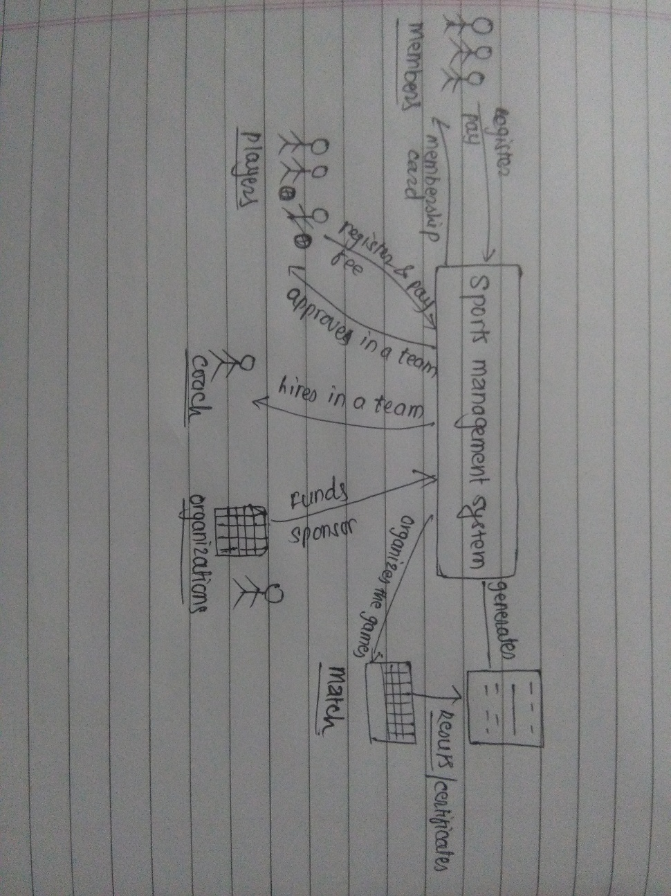

Figure 1: rich picture for sports management system

1. **Define root definition**

Root definition are the short textual statements which clarifies the system processes, problems and the functions of a potential system to be developed. Under this step, I have identified the major processes of the system corresponding to issue-based root definition.

|  |  |
| --- | --- |
| Processes | Problem |
| Players registration and payment | Manual record keeping system on paper or on excel. |
| Scheduling and event organization | Activities are performed as per the calendar and sometimes the program gets overlapped which are difficult to update and manage. |
| Communication among members and teams | Informal oral communication has been taking place due to which all members are not informed. |
| Generating reports, certificates etc. | Generally the generation of such reports are manual and often time consuming and costly. |
| Donation performances | There are no proper records of donors and transactions details taken place. |

Table 1: Issue-based root definition

1. **Produce conceptual model**

The conceptual model of the system has been constructed as per the rich picture and the root definition. Basically, how the system should function and what activities should be undertaken for the processes to take place are specified by the conceptual model.

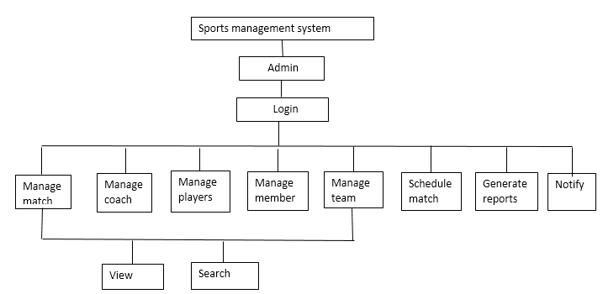

Figure 2: conceptual model for admin.

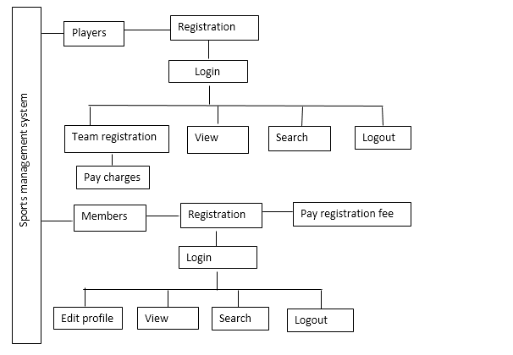

Figure 3: conceptual model for players and members.

**2.3 Feasibility study**

Feasibility study is the analytical program for identifying success of the projects. To some extent, feasibility study determines whether the solutions considered are compatible and useful for accomplishing the project requirements. The main objective of feasibility study is to develop the system that is acceptable to users, adaptable to change and responsive to the standards.

(<http://ecomputernotes.com/software-engineering/feasibilitystudy>)

Some of the advantages of undertaking feasibility studies are:

* Analysis whether the system meets the organizational and user requirements.
* Determine whether the project is supportive to the current technologies and can be implemented under the estimated time and budget.
* Determine whether the system can be integrated to other existing technologies.

The common feasibility studies performed during the analysis are:

1. **Technical feasibility**

Basically, it concerns whether the applied technologies meets the requirements or the goal is technically possible. Undergoing such study, it enables to conduct the following analysis for this project.

* Is the applied technology practical?

The respective system is going to be developed using PHP server-side language with collaboration to MySQL database which is confined by technical feasibility whether it is practical to use or not.

* Is the necessary technology being applied?

The analysis is made whether the system being developed meets the standards and gains the general acceptance. Moreover, it suggest if there the need of additional PCs, routers, WAN devices for interpreting the system.

* Is there the necessity of technical expertise?

The applied technology may not be familiar among all the users. Therefore, there might be the need of expertise or skills for implementing the system.

1. **Schedule feasibility**

Schedule study on sports management helps to analyse whether it can be completed on time and possess the time resources to undertake the project.

1. **Legal feasibility**

For a successful project, it is important that the project has fulfilled the legal and ethical requirements simultaneously. Applying such type of feasibility study in my project enables to analyse the legal requirements like copyright, licenses, ownership etc. and ethical requirements like health and safety, privacy, nepotism and many more.

1. **Operational feasibility**

On sports management project, the problems like user interaction, scheduling, communication etc. may occur and overlap. Sometimes there might be no audit reports of activities taken place. In such cases, operational feasibility studies helps to determine how well the issues can be solved and how far the project can sustain after the changes have been made.

1. **Economic feasibility**

For any initiation of the project, certain amount has to be estimated. Similarly, for the development of sports management system, the expenditure on hardware like laptop or pc with considerable memory storage, wireless/internet connectivity and on software like SQL database, windows operating system, text editor etc. have to be made. In such situation, economic feasibility study helps to determine the financial gains and cost made on hardware, software, training, and development team and so on.

**2.4 Software Requirement Specification (SRS)**

SRS is the comprehensive description of what the system will do and how the system is expected to perform. SRS helps to minimize the time and effort applied by the developers to attain certain desired goals. However, a good SRS interprets the system with the hardware, functionalities and users in a wide range of real-world situations.

The reasons behind performing SRS for sports management system are:

* The project can be completed on time and on budget.
* Testing can be performed efficiently.
* Provides the concrete evidences over the contractual disputes.
* Identifies the undiscovered scope and goals.

Some of the prevalent methodologies like brainstorming, flowchart, UML etc. can be applied for specifying the requirements. During the requirements identification in sports management system, I have undergone through different feasibility studies and the visual analysis like rich pictures.

Different types of requirements can be specified among them functional and non-functional requirements has been prioritized in this project.

**2.4.1 Functional requirements**

(geeksforgeeks.org)

These are the requirements that the end users specifically demands on a system. Such functionalities are pre-defined or contracted that the system should offer and are basically the functionalities expected by the user at the final product. In simpler form, these are the input given to the system, operations are performed and some output are experienced.

For example, sports management system is expected to have following functional requirements.

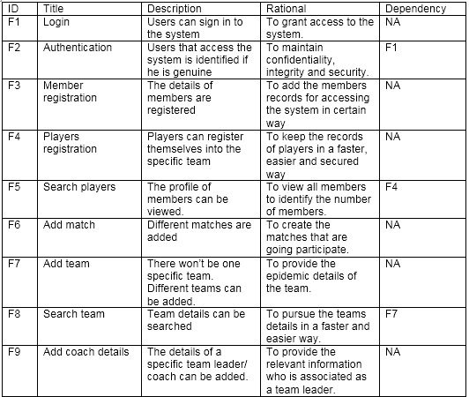

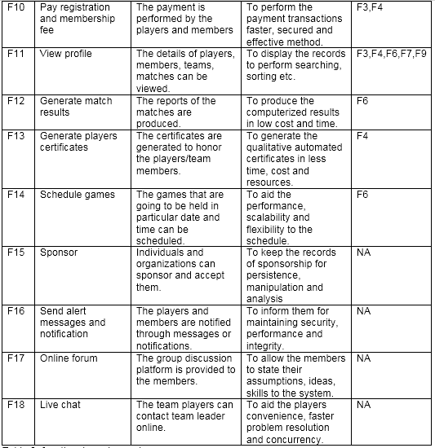

Table 2: functional requirements

**2.4.2 Non-functional requirements**

Non-functional requirements also called non-behavioral requirements are the quality constraints that must be satisfied as per the contract. The implementation of such functionalities differs as per the project.

The suspected non-functional requirements required for this project are tabulated below:

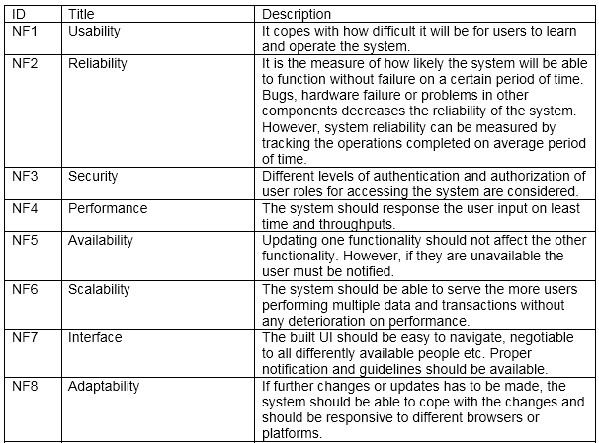

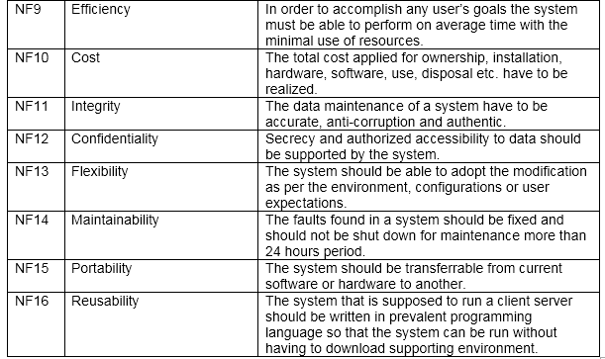

Table 3: Non-functional requirements

**2.4.3 Moscow prioritization:**

The acronym stands for must have, should have, could have and won’t have.

Moscow prioritization has been applied on this project due to the following reasons.

* Allocation of resources are determined as per the most important categories.
* Determine which category is most appropriate.
* Quick and easy to perform.
* Defines the priorities of project that are in progress.

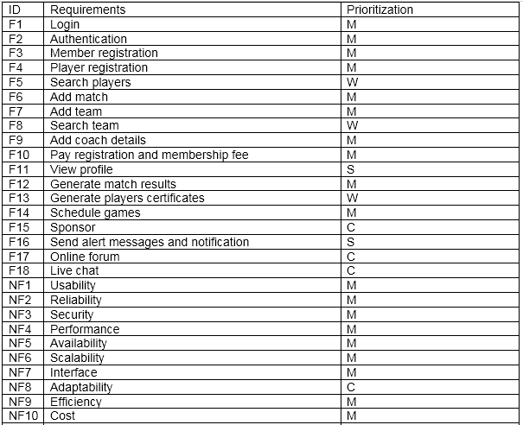

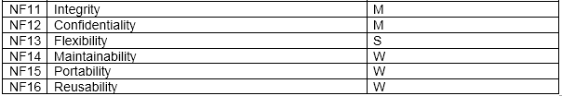

Table 4: Moscow prioritization.

**2.4.4 Hardware and software specification**

The minimum recommended hardware for sports management system are tabulated below:

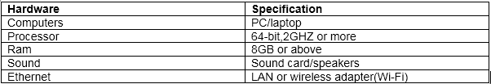

Table 5: Hardware specification.

Some of the software that will be required for the same system are specified below:

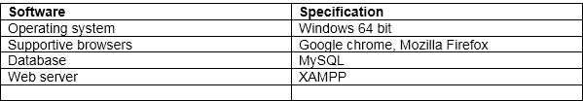

Table 6: Software specification

**2.5 Use Case**

A use case diagram is a graphic depiction of the interactions among the elements of a system. The use case diagram may be useful for gathering the requirements, identifying the external and internal factors influencing the system, depicting the interactions between the system and the actors and reverse and forward engineering.

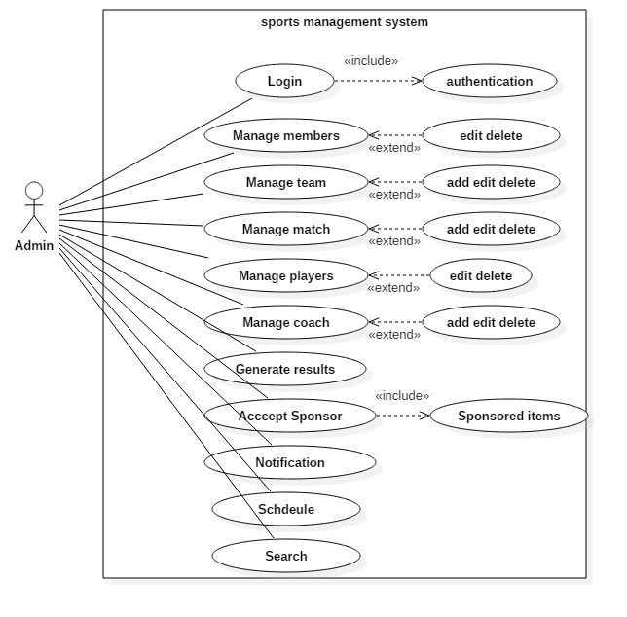

Figure 2: use case for admin

In sports management system, the admin before logging into the system is verified if he is authentic and then signs in to the system. Here, he manages the members where he can edit and delete the records followed by the players. Similarly, he can add, edit and delete the records of team, matches and coaches respectively. The results and certificates corresponding to the games and players are generated. However, the admin must notify the members and players after they have made the registration and should request for the payment of charges. Similarly, the games must be scheduled on specific time and should also react to the sponsored organizations simultaneously.

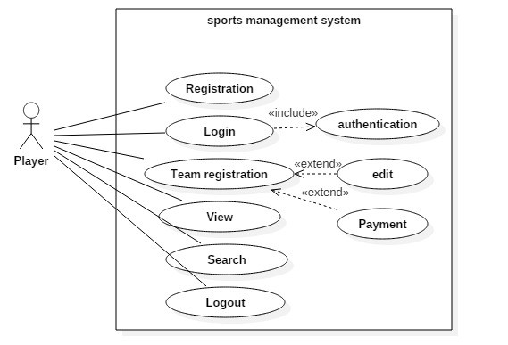

Figure 3: use case for player

Once the players has registered with their details, the system verifies their credentials and then only allows to login to the system. After logging, they can register themselves on to their favorite team however the charges are applied. The players are allowed to edit their profile, view the games, members, matches, coach details and also perform the searches eventually.

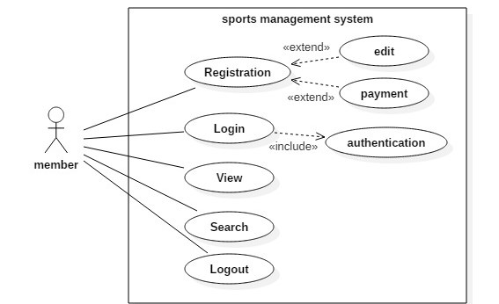

Figure 4: use case for member

Similarly, after performing the registration, members can login to the system followed by authentication. Members are also privileged to edit their profile but cannot delete them. They can also view the different profile details and perform the search activity.

**2.6 Initial Class diagram**

**Scenario:**

Sports is the delicate field where the number of matches, players, teams, team leader, members and many more needs to be handled. The matches that are going to be held should be scheduled in specific date and time. Similarly, the records of payment made by the players and members should also be kept. However, in the present context, there is still privilege of keeping records manually where there is maximum chances of data being lost. Therefore there is the need of developing a simple, efficient and effective sports management system.

The system will allow the players to register themselves in a particular team followed by member registration. Similarly, the system should permit to add, edit and delete the teams, matches, coach details, players and members. The system should be able to accept the registration and membership fee. The other features like scheduling the matches, generating reports and certificates, sending notification and searching should be embedded in the system. The profile details should be allowed to view by the players and members. The system should also possess platform for donating and accepting the sponsor to some extent.

For initializing the class diagram, natural language analysis (NLA) has been performed.

**NLA:**

Note: Only the nouns and verbs that are susceptible to be used in the class diagram has chosen.

|  |  |
| --- | --- |
| Noun | Verbs |
| Player | Register, add, edit, delete, view, search |
| Member | Register, add, edit, delete, view, search |
| Match | Add, edit, delete, schedule, view, search |
| Team | Register, add, edit, delete, view, search |
| Coach/ team leader | Add, edit, delete, view, search |
| Fee | Pay |
| Reports and certificates | Generate |
| Notification | Send |
| Sponsor | Sponsor , accept |

Table 7: NLA

**Class diagram:**

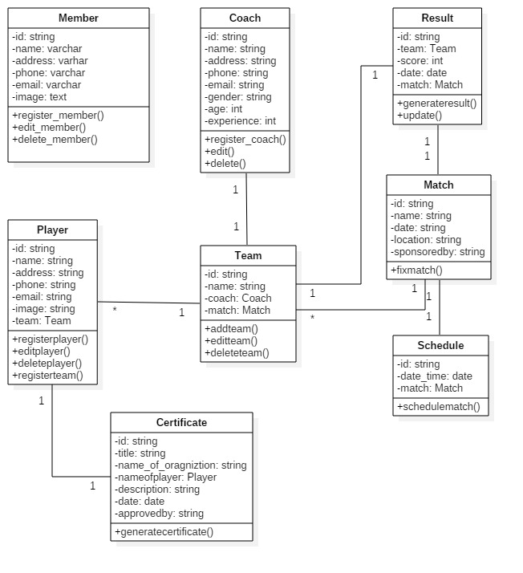

Figure 5: initial class diagram.