Contents

1.1 Introduction 2

1.2 Justification of the project 2

1.2.1 Background of the project 2

1.2.2. Problem statement 2

1.2.3 Description of the project 3

1.3 Features of the project 3

1.4 Overview of project 3

2.1 Scope 4

2.2 Limitation 4

2.3 Aims 4

2.5 Overview of project 5

Development of project 5

3.1 Description of methodology 5

3.2 Design Pattern 7

3.3 Architecture 7

4.1 Work Breakdown Structure 8

4.2 Milestone 9

4.3 Gantt chart 11

5. Risk management 13

6. Configuration management 15

7. Conclusion 16

8. References 16

# 1.1 Introduction

Sports management system is an approach for helping the amateur teams and leagues to organize their members, players, tournaments and many more. It’s a web-based application which introduces the scheduling, players registering, tournament organizing and even raising registration fund along with other some additional features. It can be beneficial over the manual and insecure records keeping system of information. In addition, it is an overall package of the secured, systematic and standardized services and features for managing the sports associated activities.

## 1.2 Justification of the project

A famous philosopher Plato has stated that ‘‘*Necessity… the mother of innovation*’’ which means there are certain purposes behind the development of any system. Similarly, this project can be useful in the following ways.

* Maintaining membership registration and credentials.
* Scheduling games and tournaments.
* Online registration and payment for players and members.
* Communication via email, notification or messages.
* Results management in various formats.
* Online donation management.

## 1.2.1 Background of the project

Sports has always fascinated the worlds’ population from ancient Olympics to the present century. Before, it used to be the medium for an entertainment and an advent to the leisure time but today due to the increasing industrialization, prevalent professionalism and global mass communication, the sports has gained its popularity and an inevitable success. Furthermore, there is the increment in the teams and players and has become a way of entertainment and profession eventually. Therefore, the sports management system is an utmost for managing such organizations.

## 1.2.2. Problem statement

As per the evaluation, it has been found that there is still the existence of keeping the records and information in a file. The typical problems that can arise due to the filing record keeping system are:

* Difficult to read and manage.
* High risk of data being lost, manipulated, stolen or decay.
* Searching data is time consuming.
* Editing and sharing data can be challenging.
* Unsystematic storage of large amount of data.

## 1.2.3 Description of the project

Every information can be useful for the recognition and legal evidence for an organization. Therefore such critical information must be accessible and kept secured. In addition, it can be a huge challenge for maintaining the records as per the diverse nature and size of the information. Hence, sports management system tends to replace the traditional way keeping the records in an easy, secured and convenient way.

# 1.3 Features of the project

The system is expected to perform following features:

1. The player needs to login to the system for registering into the particular team.
2. The member should also needs to register before being member.
3. The player and member can update their details.
4. Admin can add update and delete the teams, games and results.
5. The players and members are registered to particular teams only when admin confirms the registration.
6. Scheduling of game is managed by admin.
7. Separate section or forum is available where members can share their opinions.
8. Accept donation amount.
9. Accept registration payment from players and members.

# 1.4 Overview of project

The corresponding application developed will help in the systematic management of the teams, players, games, coaches, results, tournaments and secure communication between them. The system is expected to overcome the problems that has been prevailing in today’s practices i.e. filing record keeping system due to which the integrity, security and availability of thee information can be compromised. Therefore, the easier, faster, secured and systematic way of managing the information can be achieved by the use of this system.

# 2.1 Scope

The system will focus specifically on the registration, scheduling, games and tournament management, communication and billing features respectively. The organizations that has been organizing the games and tournaments annually is targeted to be used by this system. This system is supposed to provide the services to the amateur and professional level of national organizations.

# 2.2 Limitation

Although the system is expected to solve the existing issues, there are some features that the system will not take the responsibility of. Some of the limitations of the system are:

* The system will not look after the financial support and expenses of an organization.
* It will not take responsibility of any member or players who are disrespect to the organization or the team.
* The system will not promote or take side of any organization or the team.

# 2.3 Aims

The major aim of sports management system is to facilitate any organization or teams to manage their members, players, games, schedule, results or communication in an easy, simple, efficient and systematic way.

2.4 Objectives

To accomplish the aim of this project, following are the objectives to be fulfilled.

1. To allow the players and members to login and register.
2. To provide secure system for them to share their detail without any worries.
3. To make user friendly web based application.
4. To allow players to register themselves in simple, fast and efficient way.
5. To schedule the games or tournament being taken in different dates and teams involved playing against each other.
6. To print results in different formats.
7. To accomplish the donation performances.

# 2.5 Overview of project

Certain boundary of the system has limited its use since it has been developed as per the national consideration only i.e. it can be accessed by our country only. However, an ultimate aim of this project is to provide the services in a simple, systematic and effective way. Moreover, an advantage over the traditional way of keeping the records of membership details, player’s details, registration, results and achievements and many more can be attained using this system.

# Development of project

For distinct improvement in design, product management, project management or sound analysis, the implementation of development methodology plays the vital role. Such methodology ensures that every task are undertaken correctly and on time.

## 3.1 Description of methodology

The waterfall model also known as liner- sequential approach to the software development lifecycle emphasizes that each step of the development must be completed before moving on to the next step. Since waterfall model is non-iterative and restricts changes during the development, one should make sure that the goals are pre-defined and should have met requirements before moving on to the next step.

Sports management system is simple project which have specific requirements and predefined goals. Therefore, I have decided to use waterfall methodology.

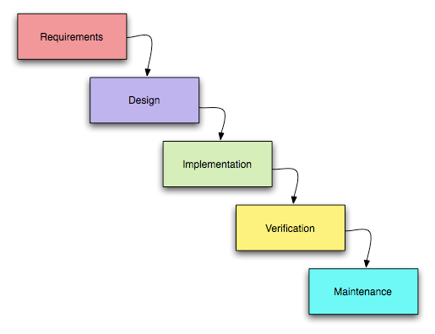(<https://www.tutorialspoint.com/sdlc/sdlc_waterfall_model.htm>)

Fig 1: waterfall model

Advantages of waterfall model are:

1. Simple and easy to follow, understand and arrange tasks.
2. Clearly defined stages enables tracking milestones and deadlines.
3. Process and results are well documented.
4. Each phases are processed and undertaken one at a time.

Disadvantages of waterfall model are:

1. Unsuitable for long ongoing and complex or object-oriented projects.
2. Risk and uncertainty is high.
3. Very difficult to accommodate the changing requirements.
4. Does not consider error correction.

## 3.2 Design Pattern

During the development of this project, the MVC pattern has been followed. The pattern is used to separate the application concerns into three different sections where model represents the business logic of the data, view represents the visualization of model i.e. it is the form interface displayed in the front end and handles input and output and the controller in MVC invokes the action methods that are used for handling the event in model and view. The reason behind using MVC pattern is that the project development will not be affected when modification is required.

( <https://www.tutorialspoint.com/design_pattern/mvc_pattern.htm>)

## 3.3 Architecture

Architecture is the discipline of creating the structures to be executed during the designing of thee system. Therefore, a three-tier architecture has been decided to be used in the development of this project. A three-tier architecture is a client-server software design pattern which consists of presentation tier, application tier and data tier.

(<https://searchsoftwarequality.techtarget.com/definition/3-tier-application>)

**Presentation tier:**

It is the tier occupying the top level of services and information of websites deployed via a website or web-based application. The presentation tier communicates with other tiers through API in a secured and intuitive manner.

**Application tier:**

Application tier also known as logic or the middle tier contains the business logic that supports the core functionality of an application. This is the layer where most of the processing works occur.

**Data tier:**

It is the storage tier where the direct read and write access to the database by the client components in a secure network is managed. E.g. MySQL, Microsoft SQL server, Mongo DB etc.

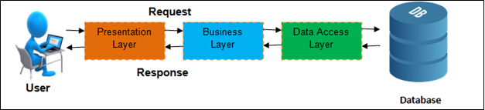

Fig2: Three tier architecture.

# 4.1 Work Breakdown Structure

According to Project Management Body of Knowledge (PMBOK), work breakdown structure is a deliverable oriented hierarchical decomposition of the work to be executed by the project team. Furthermore, WBS is a way of defining and organizing the team’s work into the manageable sections.

The Work Breakdown structure for sports league management system is shown below:

Sports management system

Proposal

Testing

Implementation

Design

Analysis

Documentation

Final document

Coding

Brainstorming

Introduction

Unit

Structural model

Scope

Final class diagram

Requirement gathering

Feasibility study

Blackbox

Development methodology

Analysis methodology

Project planning

System requirement specification

Behavioral Model

Activity diag.

Milestone

Gantt chart

Use case

Sequence diag.

Database design

Risk management

Configuration management

User Interface

Conclusion

Fig 3: Work break down structure

# 4.2 Milestone

Milestone in a project management is used to schedule the start and finish points and estimates how long will the project take to complete the major phases of development. Milestone can be useful in task management, responsibilities distribution, and estimation of time, cost and risk and so on. One of the best example of estimating milestone is Gantt chart.

|  |  |  |  |
| --- | --- | --- | --- |
| **Topic** | **Start Date** | **Deadline** | **No. of days** |
| Proposal | 26th march | 9th April | 15 |
| Analysis | 10th April | 8th May | 29 |
| Design | 9th May | 3rd June | 26 |
| Implementation | 4th June | 25th June | 20 |
| Testing | 26th June | 1st July | 6 |
| Documentation | 2nd July | 12th July | 11 |

Fig4: Milestone

|  |  |  |
| --- | --- | --- |
| Task No. | Task description | Deadline |
| 1. | **Proposal** | **9th April** |
| 2. | **Analysis** | **8th May** |
| i. | Brainstorming | 15th April |
| ii. | Requirement gathering | 20th April |
| iii. | Feasibility study | 25th April |
| iv. | Analysis methodology | 29th April |
| v. | System requirement specification | 5th May |
| vi. | Use case diagram | 8th May |
| 3. | **Design** | **3rd June** |
| i. | Structural model | 15th May |
| a) | Final class diagram | 15th May |
| ii. | Behavioral model | 23rd May |
| a) | Activity Diagram | 19th May |
| b) | Sequence diagram | 23rd May |
| iii. | Database design | 28th May |
| iv. | User interface design | 3rd June |
| 4. | **Implementation** | **25th June** |
|  | Coding | 25th June |
| 5. | **Testing** | **1st July** |
| i. | Unit | 28th July |
| ii. | Black box | 1st July |
| 6. | **Documentation** | **12th July** |
|  | Final document | 12th July |

Fig 5: Time estimation

# 4.3 Gantt chart

Gantt chart is a visual representation of scheduled task over time. It can be useful for managing the large projects and showing what task will be performed on a specific date. It also illustrates the starting and ending dates along with grouping of tasks in which they are linked to each other.

(<https://www.projectmanager.com/gantt-chart>)

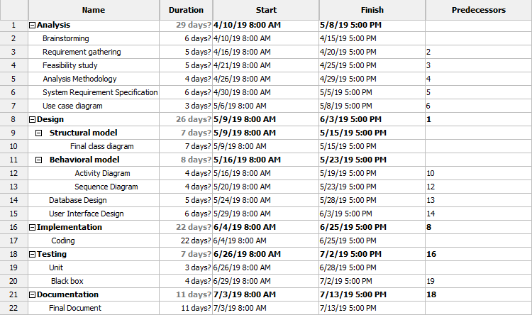

Fig 6: Gantt chart

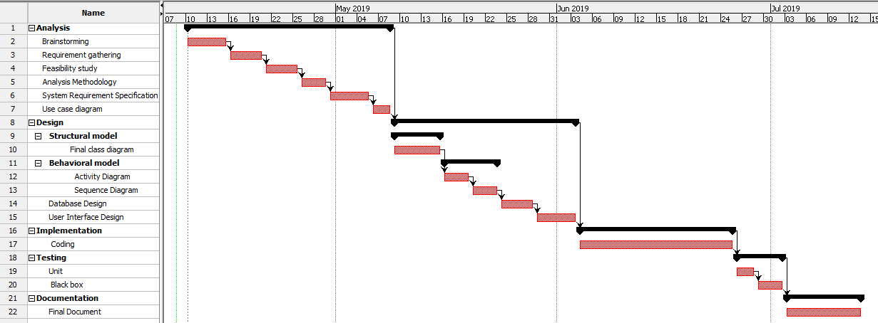

Fig 7: Gantt chart

# 5. Risk management

Risks can be anything that can impact the project’s performance, cost or time. Therefore the risk should be addressed before they become issues to the project’s development. Risk management is the process of identifying, analyzing and then responding to any risk that arises in the life cycle of the project development in-order to track and meet the project goals. In addition it can help in strategic plans and increases return of investment.

(<https://www.projectmanager.com/blog/risk-management-process-steps>)

The steps involved in the risk management are:

1. Identify the risk

A risk cannot be solves if individual doesn’t know what it is. This is the phase where the recognition and description of problems can be done which are prone in affecting the project. E.g. brainstorming.

1. Analyze the risk

Once the risks have been identified, the likelihood and consequences of each risks are determined. An understanding of the nature of the risk and its potential to affect the goals and objectives are analyzed during this phase.

1. Evaluate the risk

The risk magnitude generally the combination of likelihood and consequences are evaluated and decided whether the risk is acceptable or whether it is serious enough to warrant the treatment.

1. Treat the risk

Basically, it is also referred to Risk Response Planning where the highest ranked risks are accessed and set the plan to treat the risk to achieve the acceptable risk levels.

1. Monitor and review the risk

In this phase, the risks are monitored, tracked and reviewed.

The possible risks that might occur in my project has been represented in the following table based upon the level of likelihood and consequences.

|  |  |
| --- | --- |
| **LIKELIHOOD** | **VALUE** |
| LOW | 1 |
| MEDIUM | 2 |
| HIGH | 3 |

Fig 8: level of like likelihood with its value

|  |  |
| --- | --- |
| **CONSEQUENCES** | **VALUE** |
| VERY LOW | 1 |
| LOW | 2 |
| MEDIUM | 3 |
| HIGH | 4 |
| VERY HIGH | 5 |

Fig 9: level of consequences with its value

|  |  |  |  |  |  |
| --- | --- | --- | --- | --- | --- |
| **Risk No**. | **Risk** | **Likelihood** | **Consequences** | **Impact** | **Action** |
| 1. | Unqualified employee | 2 | 3 | 6 | Proper training and guidance |
| 2. | Changing requirements | 1 | 5 | 5 | Addressing the changes as required |
| 3. | Natural calamities | 1 | 4 | 4 | Proper backup or use of cloud |
| 4. | Time limitation | 2 | 3 | 6 | Scheduling and division of work |
| 5. | Unrealistic budget estimation | 2 | 4 | 8 | Proper Financial planning |
| 6. | Infeasible design | 1 | 5 | 5 | Designing as per the requirement |
| 7. | Phishing and fraud | 2 | 3 | 6 | Strong security |
| 8. | Incompatible hard- disk | 1 | 5 | 5 | Database backup |

Fig 10: calculation of risk based on likelihood and consequences.

# 6. Configuration management

This includes the project management plan and performance management baseline. Basically, configuration management is performed for arranging the files and folder systematically so that they can be accessed when necessary.

(<https://www.manageengine.com/network-configuration-manager/features.html>)

The features of configuration management are:

1. Automated configuration backup
2. Scheduling configuration backup
3. Database backup and disaster recovery
4. Baseline configuration

Different phases of project development like analysis, design, coding, testing, development and proposal are the particular folder where the works broken down are stored. Similarly, a different folder named *backup* is created to store all the copies of the files.

The configuration management for my project is shown below:

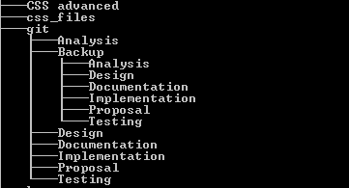

Fig 11: configuration management

# 7. Conclusion

In conclusion, the project ‘*Sports management system*’ is eligible for solving the traditional way of recording and registering the data in a viable, simple, systematic and efficient way. Since, the project is meant to be developed only for our country, therefore it has limited its scope in a certain way. In order to complete this project, I have undergone through multiple analysis, risk management, time estimation, work break down structure so that the project meets its goals and the features are attained successfully.

# 8. References