# Testing

Testing can be defined as an activity of evaluating the system if the actual result matches with the expected results so that the system is defect free. In simpler form, testing is the verification of application under the tests. Undergoing through testing helps to identify the missing requirements, errors or bugs simultaneously.

Some of the importance of performing testing are listed below:

* It ensures that the system does exactly what the user tends to do followed by quality.
* Undergoing testing helps to achieve the correct, reliable, effective, secured and efficient system along with the satisfied users.
* Testing can be useful for preventing time, cost and reputation from the non-tested inefficient systems.
* It maintains the stability of system.

Testing can be performed either manually or using the automated tools. Some of the types of testing are unit testing, integration testing, interface testing, regression testing, performance testing, stress testing, security testing, compatibility testing, acceptance testing, black and white box testing and many more.

For my project, I have performed the black box testing.

Black Box Testing

Black box testing, also known as fundamental testing concerns with what the system is supposed to do rather than how it works. This type of testing tests whether the operations and features of the system works correctly on which the internal structure/implementation or the design of the system is unknown to the tester.

<http://softwaretestingfundamentals.com/black-box-testing/>

The black box testing can be applicable to SMS in following ways:

* Identification of errors in data structures or database.
* Identification of behavioral/ performance errors and missing functions.
* Evaluation of interface to acceptance testing.

Some of the advantages of applying black box testing are:

* Tests performed on the behalf of user helps to identify the discrepancies of specifications.
* Tester does not need to worry about programming languages or how the software works.
* Tests could be performed as soon as the specification completes.

Some of the black box tests performed in SMS are discussed below:

|  |  |  |  |  |
| --- | --- | --- | --- | --- |
| Test -1: Registration validation | | | | |
| Pre-Condition: validation disables user to register | | | | |
| Test Case | Description | Expected Result | Actual Result | Remarks |
| 1 | Registration for new user | The data should be inserted into the database otherwise displays the error message if parameters doesn’t match or fields are empty. | The validation restricts user to sign up. | Pass |

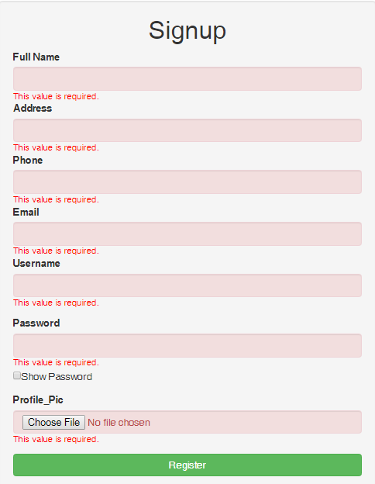

### Fig1: Registration validation

|  |  |  |  |  |
| --- | --- | --- | --- | --- |
| Test -2: Registration successful | | | | |
| Pre-Condition: registered successfully by user | | | | |
| Test Case | Description | Expected Result | Actual Result | Remarks |
| 2 | Registration for new user | The data should be inserted into the database otherwise displays the error message if parameters doesn’t match or fields are empty. | The acceptable values are stored in the database for successful user registration. | Pass |

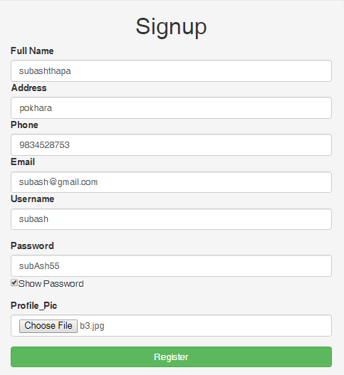

#### Fig2: Registration successful



User added

#### Fig 3: user registered in database

|  |  |  |  |  |
| --- | --- | --- | --- | --- |
| Test -3: Login successful | | | | |
| Pre-Condition: Logged in by user | | | | |
| Test Case | Description | Expected Result | Actual Result | Remarks |
| 3 | Login | The user who are registered can login to the system. | After the successful input, the users are logged in and are redirected to the dashboard. | Pass |

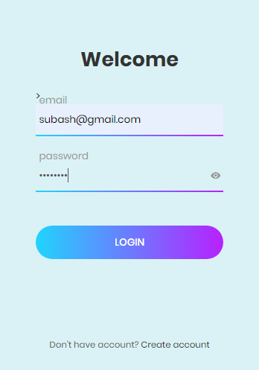

Fig 4: login successful

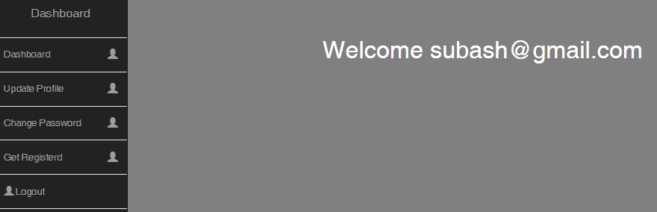

#### Fig5: user dashboard after login

|  |  |  |  |  |
| --- | --- | --- | --- | --- |
| Test -4: Edit profile | | | | |
| Pre-Condition: Edit their own profile | | | | |
| Test Case | Description | Expected Result | Actual Result | Remarks |
| 4 | User can edit their profile | The user can access their profile details and can make change and the details are updated. | The user details need to be updated in the database when changes are made. | Pass |

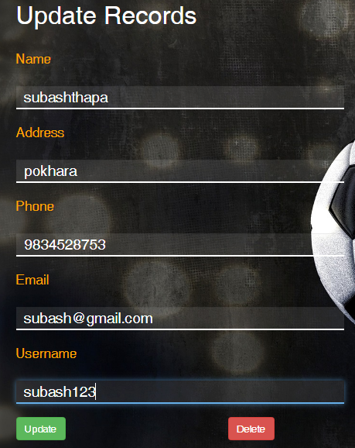

#### Fig 6: Edit user details

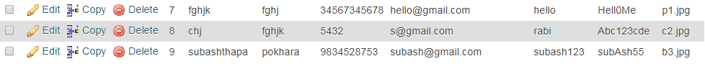

#### Fig 7: user details edit in database

|  |  |  |  |  |
| --- | --- | --- | --- | --- |
| Test -4: Change password | | | | |
| Pre-Condition: change user password | | | | |
| Test Case | Description | Expected Result | Actual Result | Remarks |
| 4 | User can change their password | The user should be able to change their password. | The user details need to be updated in the database when changes are made. | Pass |

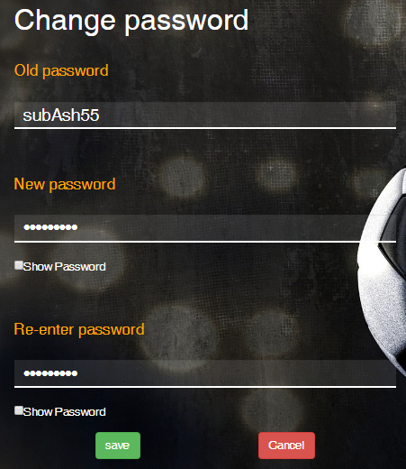

#### Fig 8: change password

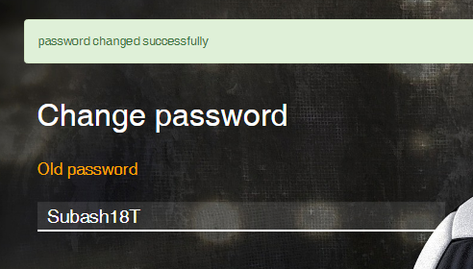

#### Fig 9: password changed successfully

|  |  |  |  |  |
| --- | --- | --- | --- | --- |
| Test -5: Getting registered into team | | | | |
| Pre-Condition: Registering into team by player | | | | |
| Test Case | Description | Expected Result | Actual Result | Remarks |
| 5 | Player can choose and register themselves into their favorite team. | The player should provide their details and choose their favorite team. | The player can register and stores the player and team details in database. | Pass |

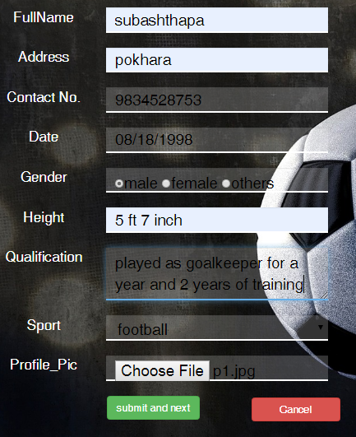

#### Fig 10: Profile details for getting registered.

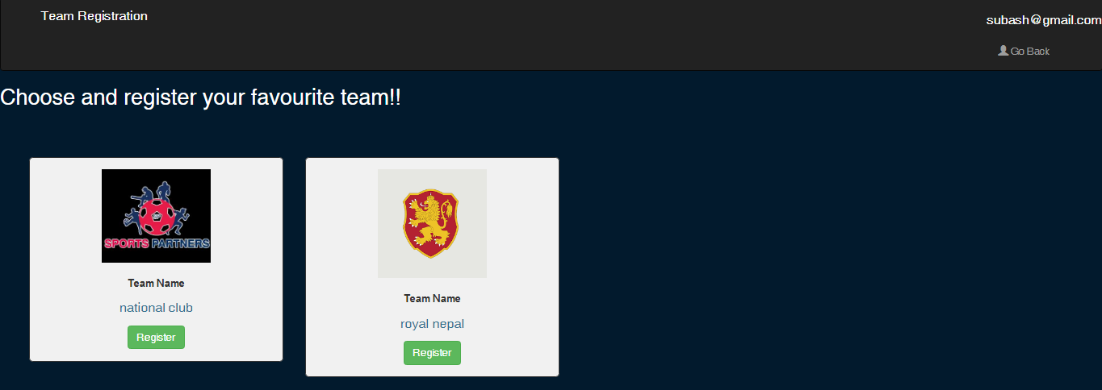

#### Fig 11: Getting registered into the team.



Added to database

Fig 12: successfully registered into team

|  |  |  |  |  |
| --- | --- | --- | --- | --- |
| Test -6: Forum validation | | | | |
| Pre-Condition: members involvement in online discussion | | | | |
| Test Case | Description | Expected Result | Actual Result | Remarks |
| 6 | Online forum discussion | The unregistered members are not allowed to post or comment. | The error message is displayed when unregistered member tends to post or comment. | Pass |

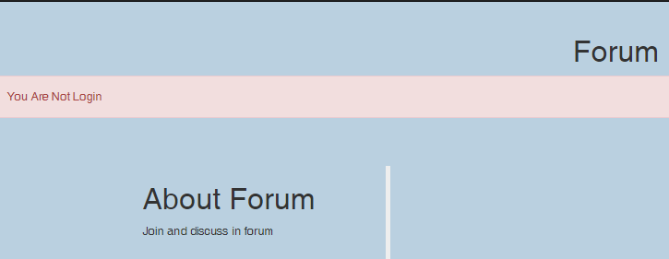

#### Fig 12: validation for forum

|  |  |  |  |  |
| --- | --- | --- | --- | --- |
| Test -7: Forum available | | | | |
| Pre-Condition: members involvement in online discussion | | | | |
| Test Case | Description | Expected Result | Actual Result | Remarks |
| 7 | Online forum discussion | The registered members will be able to post queries and comment over posts. | The queries posted by member will be displayed and could be commented by other members. | Pass |

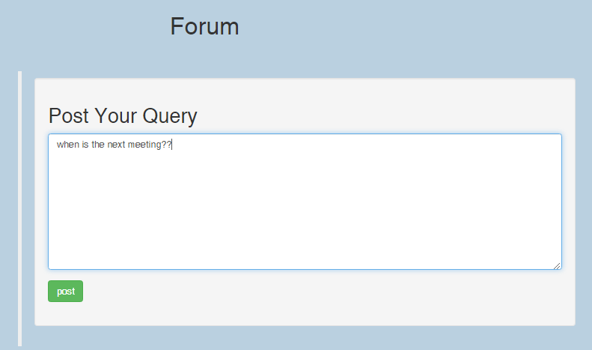

#### Fig 13: online forum discussion

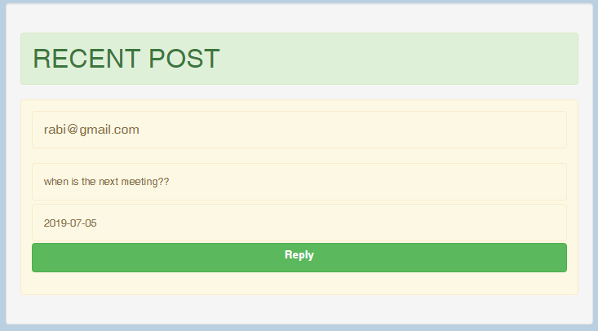

#### Fig 14: query posted successfully in forum

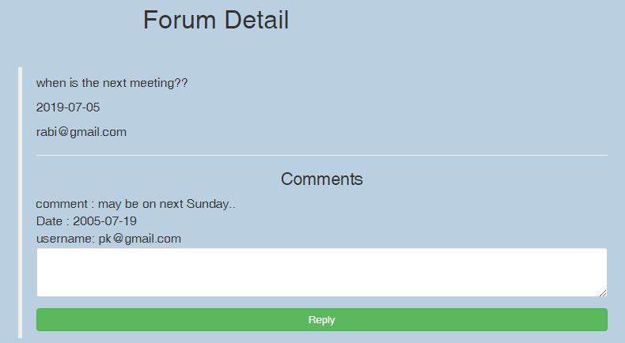

#### Fig 15: commented successfully on forum

|  |  |  |  |  |
| --- | --- | --- | --- | --- |
| Test -8: admin login | | | | |
| Pre-Condition: validates admin during login | | | | |
| Test Case | Description | Expected Result | Actual Result | Remarks |
| 8 | Validation for login | The admin cannot login when input credentials are wrong. | The error message is displayed when email or password is wrong. | Pass |

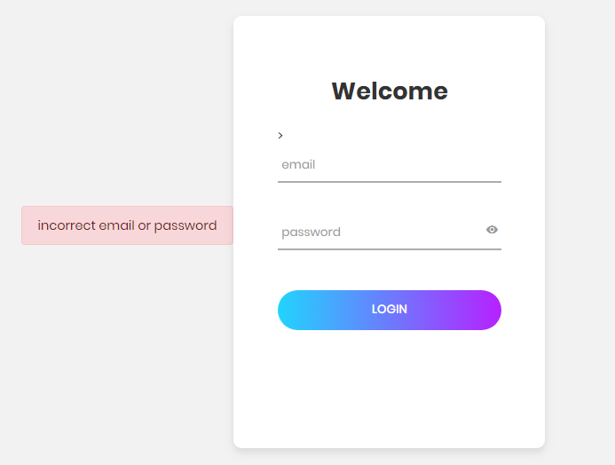

#### Fig 16: validation for login

|  |  |  |  |  |
| --- | --- | --- | --- | --- |
| Test -9: admin login successful | | | | |
| Pre-Condition: admin to get access into system | | | | |
| Test Case | Description | Expected Result | Actual Result | Remarks |
| 9 | Login successful | The admin can access the system when input parameters are correct. | The admin dashboard is displayed when login is successful. | Pass |



#### Fig 17: display dashboard when login successful.

|  |  |  |  |  |
| --- | --- | --- | --- | --- |
| Test -10: accept request | | | | |
| Pre-Condition: admin to accept or reject the request | | | | |
| Test Case | Description | Expected Result | Actual Result | Remarks |
| 10 | Admin accepts the request | The admin can accept or reject the request sent by the players for team registration. | The players will be registered as team member and notified through email when request is accepted. | Pass |

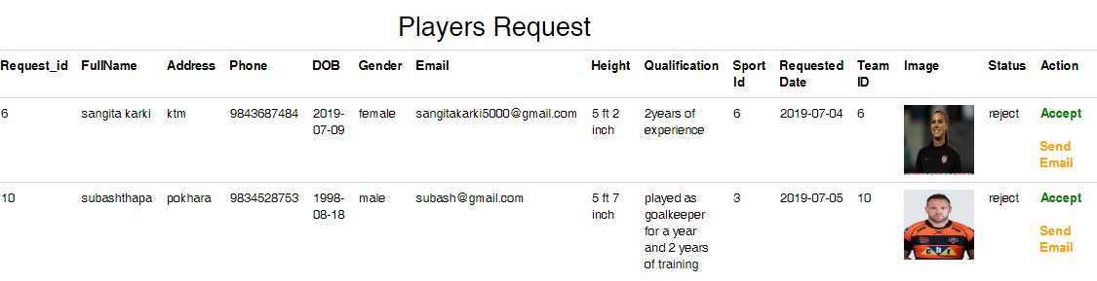

#### Fig 18: requests from players

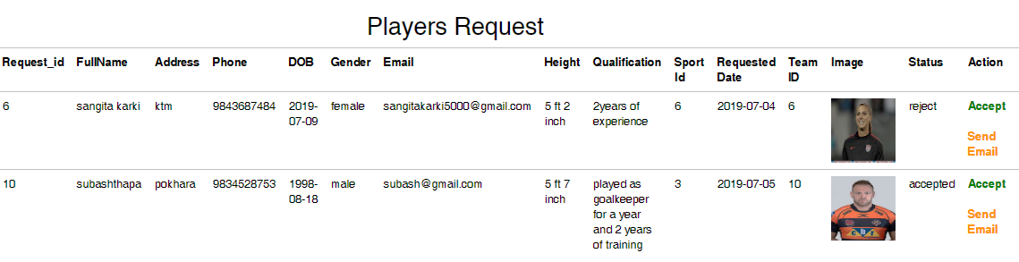

Request accepted

#### Fig 19: request accepted



#### Fig 20: accepted request saved as team member in database

|  |  |  |  |  |
| --- | --- | --- | --- | --- |
| Test -11: send email | | | | |
| Pre-Condition: send email to the accepted member | | | | |
| Test Case | Description | Expected Result | Actual Result | Remarks |
| 11 | Email | The admin can notify the accepted players through email. | The email has to be sent successfully to the player. | Pass |

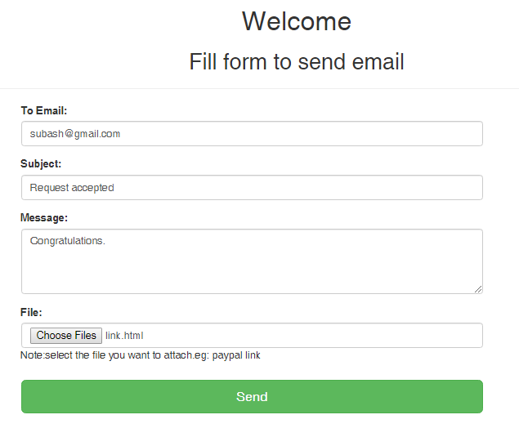

#### Fig 21: send email to players

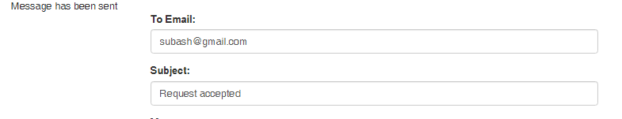

#### Fig 22: email sent successfully

|  |  |  |  |  |
| --- | --- | --- | --- | --- |
| Test -11: add sport | | | | |
| Pre-Condition: admin adds sport categories | | | | |
| Test Case | Description | Expected Result | Actual Result | Remarks |
| 11 | Add sport categories | The admin can add sport. | The added sport will be saved to database and displayed in the panel. | Pass |

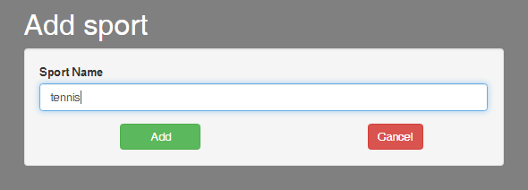

#### Fig 23: add sport

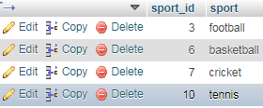

#### Fig 24: sport added in database

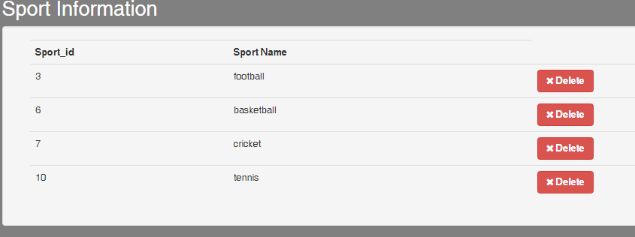

#### Fig 25: view added sports

|  |  |  |  |  |
| --- | --- | --- | --- | --- |
| Test -12: add coach | | | | |
| Pre-Condition: admin adds coach details | | | | |
| Test Case | Description | Expected Result | Actual Result | Remarks |
| 12 | Add coach details | The admin can add coach details | The coach details should be added into the database and is displayed in the panel. | Pass |

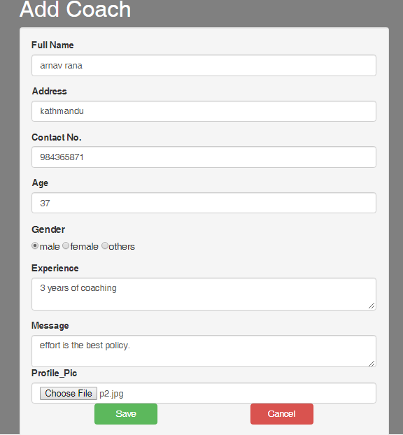

#### Fig 26: add coach

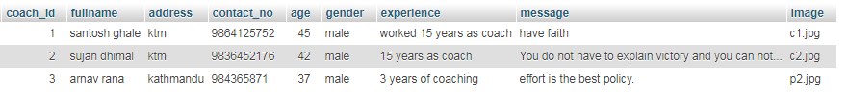

#### Fig 27: coach added in database

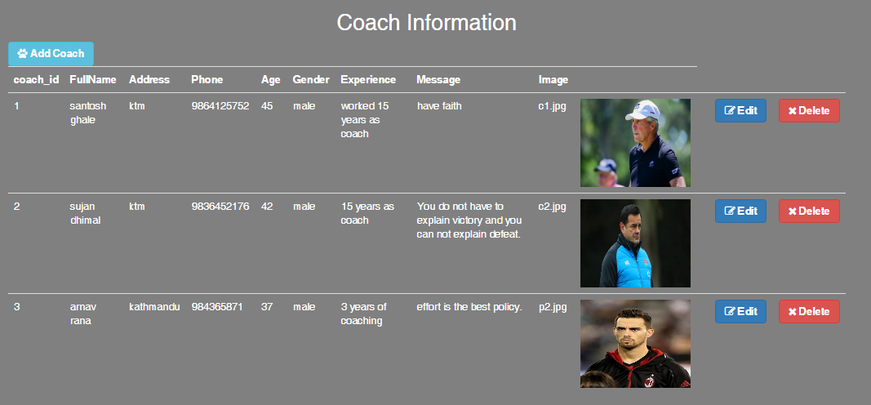

#### Fig 28: view added coach details

|  |  |  |  |  |
| --- | --- | --- | --- | --- |
| Test -13: Edit coach | | | | |
| Pre-Condition: admin edits coach profile | | | | |
| Test Case | Description | Expected Result | Actual Result | Remarks |
| 13 | Edit coach details | The coach details are edited by admin. | The edited details should be updated in the database. | Pass |

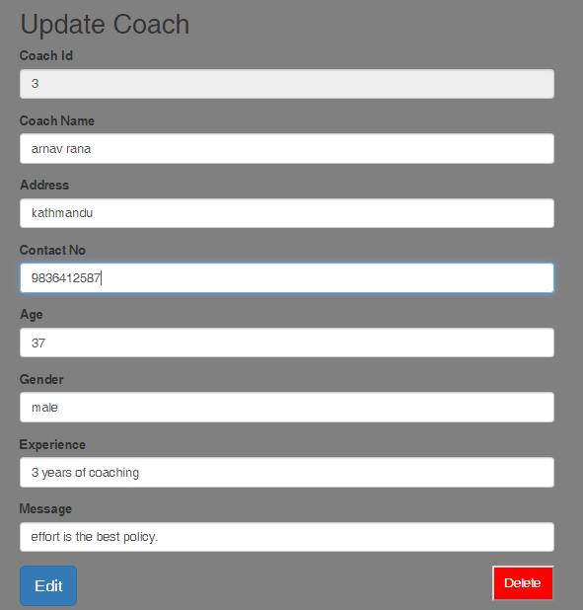

#### Fig 29: edit coach details

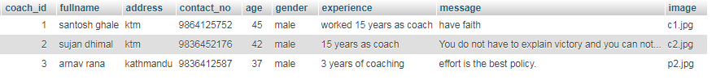

Phone number updated

#### Fig 30: coach details updated in database

|  |  |  |  |  |
| --- | --- | --- | --- | --- |
| Test -14: Delete coach | | | | |
| Pre-Condition: admin deletes coach profile | | | | |
| Test Case | Description | Expected Result | Actual Result | Remarks |
| 14 | Delete details | The coach details are deleted by admin. | The details should be deleted from database and dashboard | Pass |

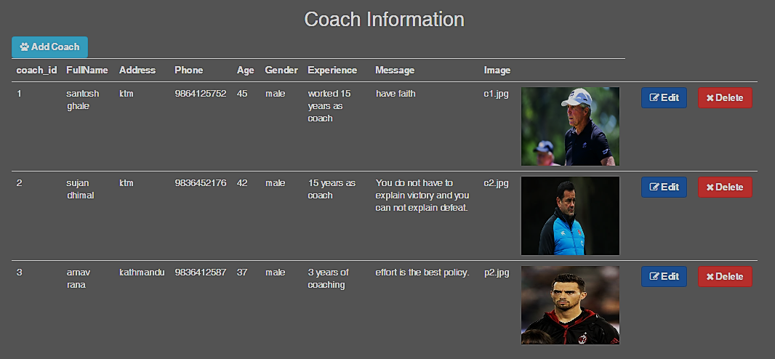

#### Fig 31: delete coach profile

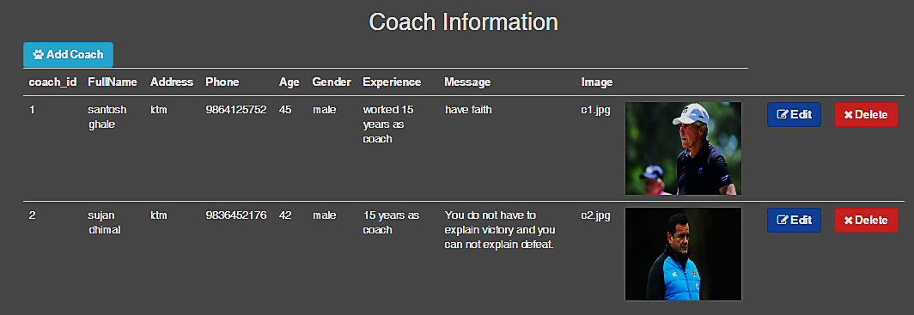

#### Fig 32: coach profile deleted

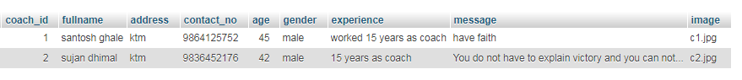

#### Fig 33: coach details deleted from database

|  |  |  |  |  |
| --- | --- | --- | --- | --- |
| Test -15: Add team | | | | |
| Pre-Condition: admin adds team | | | | |
| Test Case | Description | Expected Result | Actual Result | Remarks |
| 15 | Team addition | The teams are added by admin. | The added team should be added into the database. | Pass |

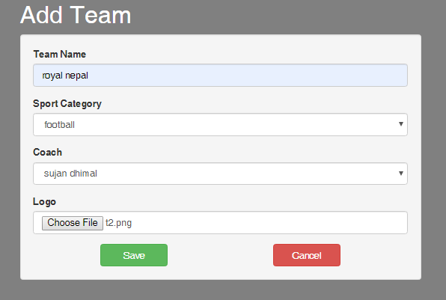

#### Fig 34: add teams

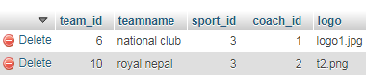

#### Fig 35: team added in database

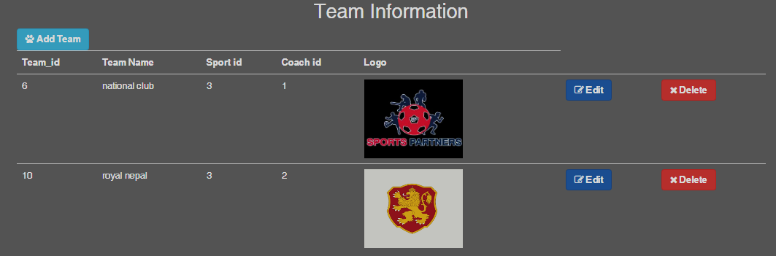

#### Fig 36: view added team