* DataType:

1. Numeric [int,float,complex] complex values-> 100+3j
2. List -> List is datatype which allwos multiple values and any type of data type  
   It is mutable can be modify

#List is datatype which allwos multiple values and any type of data type  
a = [1, 2, "sangita", 4, 5]  
print(a[0]) # 1  
print(a[2]) # sangita  
print(a[-1]) # 5 ...print value last index  
print(a[1:3]) # [2, 'sangita'] ...print sub set-index  
  
a.insert(3, "sadhu") # insert value at given index position  
print(a) # [1, 2, 'sangita', 'sadhu', 4, 5]  
  
a.append("abc") # insert value at the end of the List  
print(a) # [1, 2, 'sangita', 'sadhu', 4, 5, 'abc']  
  
a[2] = "SANGITA" # updating values at index 2  
print(a) # [1, 2, 'SANGITA', 'sadhu', 4, 5, 'abc']  
  
del a[0] # deleting value at 0th index  
print(a) # [2, 'SANGITA', 'sadhu', 4, 5, 'abc']

1. Tuple -> It is assign with () and which is immutable cannot modify it. Cannot do insert, update, delete, append operation

# Tuple is datatype which allwos multiple values and any type of data type but it is immutable cannot modify it  
a = (1, 2, "sangita", 4, 5)  
print(a[0]) # 1  
print(a[2]) # sangita  
print(a[-1]) # 5 ...print value last index  
print(a[1:3]) # [2, 'sangita'] ...print sub set-index

1. Dictionary -> which is nothing but HashMap in java
2. It is assign with {}
3. It works as key & value pair
4. 1st one is Key and 2nd one is Value
5. If we declare key as String and value as String has mention those in “ ”

dic = {"a": 2, 4: "bcd", "c": "Hello"}  
print(dic[4]) # bcd  
print(dic["c"]) # Hello

1. We can create Run time new Dictionary or adding values in new Dictionary

dict = {}  
dict["firstname"] = "Sangita"  
dict["lastname"] = "Sadhu"  
print(dict) # {'firstname': 'Sangita', 'lastname': 'Sadhu'}  
print(dict["firstname"]) # Sangita

* IF and ELESE condition

a = 10  
if a>5:  
 print("valid number")  
else:  
 print("invalid number")

a = 10  
if a>5:  
 print("valid number")  
else:  
 print("invalid number")  
  
print("out from the loop")

output:

valid number

out from the loop

* Function:

def ABC(name):  
 print("my name is "+name)  
  
def AddNumbers(a, b):  
 print(a+b)  
  
ABC("sangita")  
AddNumbers(2, 5)

output:

my name is sangita

7

Oops:

1. Create Object:

Create python file as Demo.py:

class Calculator:  
 num = 100  
   
 def getDemo(self):  
 print("I am executing")  
   
obj = Calculator() # creating object in python here new key word is not required  
  
obj.getDemo()

obj.num

1. To create class use class keyword
2. To create obj of class first come out from the class
3. To call method and variable of the class create object by using class name. Here new keyword is not required.

Calculator()

1. To call function and variable of the class write

obj = Calculator()

obj. method name and variable name

1. Create Constructor:

Def __init__(self):

1. In python create constructor using init

2. If we are not creating any constructor compiler will automatically will create default constructor while creating object

3. If we have constructor in class then that constructor will automatically execute 1st while creating object after that other functions will call.

class Calculator:  
 num = 100  
  
 def __init__(self, a, b):  
 self.firstName = a  
 self.secondName = b  
 print("I am called automatically when objecte is created")  
  
 def sumation(self):  
  
 return self.firstName+self.secondName+self.num  
  
  
obj = Calculator(2,5) # creating object in python here new key word is not required  
print(obj.sumation())  
  
obj1 = Calculator(4,5)  
print(obj1.sumation())

1. self keyword is nothing but object reference

2. class variable always will be constant

3. Instance variable will be varry based on the value passing through objs.

4. In python we cannot call variable by using the variable name inside function always have to use self.variable

5. self.firstName means in the obj firstName instance variable has been created

6. We have to use class name or self to call class variable also inside function

7. Self is like global or universal to call variable

1. Inheritance:

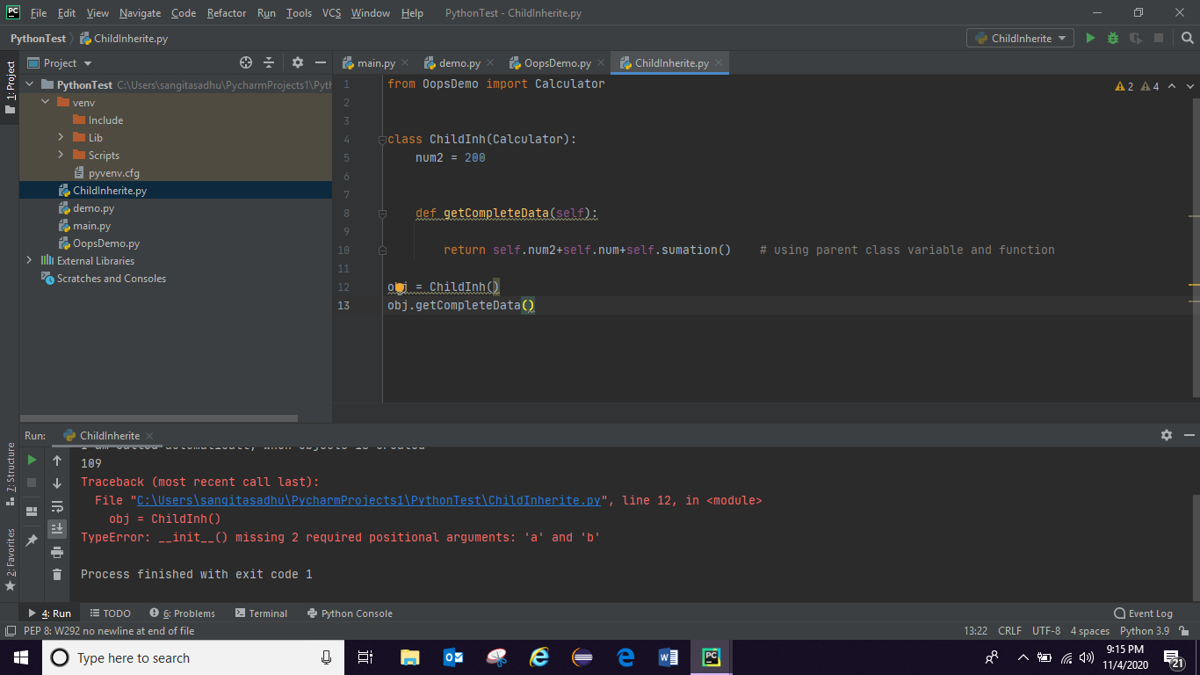

Now have to call parent class constructor from child class if we are using parent class’s any method where passing value through runtime:

OopsDemo.py: (Parent class Calculator)

class Calculator:  
 num = 100  
  
 def __init__(self, a, b):  
 self.firstName = a  
 self.secondName = b  
 print("I am called automatically when objecte is created")  
  
 def sumation(self):  
  
 return self.firstName+self.secondName+self.num  
  
  
obj = Calculator(2,5) # creating object in python here new key word is not required  
print(obj.sumation())  
  
obj1 = Calculator(4,5)  
print(obj1.sumation())

ChildInheritance.py (Child class ChildInh)

from OopsDemo import Calculator  
  
  
class ChildInh(Calculator):  
 num2 = 200  
 def __init__(self): # child class constructor  
 Calculator.__init__(self, 2, 4) # calling parent class constructor from child class if parent class constructor is not default one  
  
 def getCompleteData(self):  
  
 return self.num2+self.num+self.sumation() # using parent class variable and function  
  
obj = ChildInh()  
print(obj.getCompleteData())

OutPut:

I am called automatically when objecte is created

107

I am called automatically when objecte is created

109

I am called automatically when objecte is created

406

1. String:
2. Str.split(“ . ”), str.strip() , str.lstrip(), str.rstrip()
3. Search substring from String

Str2 in str return True or False

1. Concatenate two string
2. str = "RahulShettyAcademy.com"  
   str1 = "Consulting firm"  
   str2 = "RahulShetty"  
     
   print(str[1]) # a  
   print(str[0:5]) # Rahul [0 to n-1] to get substring  
     
   print(str+str1) # concatinate two String (RahulShettyAcademy.comConsulting firm)  
     
   # search string into another String  
   print(str2 in str) # it will true if substring is find in string -> True  
     
   # split String:  
   var = str.split(".")  
   print(var) # ['RahulShettyAcademy', 'com']  
   print(var[0]) # RahulShettyAcademy  
   print(var[1]) # com  
     
     
   #trim is use to remove white space at begining and end:  
     
   str4 = " great "  
   print(str4.strip())  
     
   #To remove begining or left white space:  
     
   print(str4.lstrip())  
     
   #To remove space from end or Right:  
   print(str4.rstrip())

OutPut:

a

Rahul

RahulShettyAcademy.comConsulting firm

True

['RahulShettyAcademy', 'com']

RahulShettyAcademy

com

great

great

great

Read Data from File:

Test.txt:

aaaa  
bbbb  
zzzz  
jjjj

file = open("Test.txt")  
  
# print(file.read()) # To read all the content present in the .txt  
  
# print(file.read(5)) # aaaa 1 space is counting for space  
# print(file.readline()) # after aaaa and one space printing bbbb  
# print(file.readline()) # zzzz  
  
# To read each content line by line  
line = file.readline()  
while line!="":  
 print(line)  
 line = file.readline()  
  
# Alternative way of To read each content line by line  
for line in file.readlines():  
 print(line)  
file.close()

* Exception Handling:
* SELENIUM:
* from selenium import webdriver  
    
  driver = webdriver.Chrome(executable_path="C:\\Users\\sangitasadhu\\Downloads\\chromedriver.exe")  
  driver.get("https://rahulshettyacademy.com/")  
  print(driver.title)  
  driver.get("https://rahulshettyacademy.com/angularpractice/")  
  driver.maximize_window()  
  print(driver.current_url)  
  driver.find_element_by_xpath("//label[contains(text(),'Name')]/following-sibling::input").send_keys("Sangita Sadhu")  
  driver.find_element_by_xpath("//label[contains(text(),'Email')]/following-sibling::input").send_keys("sangitasadhu345@gmail.com")  
  driver.find_element_by_css_selector("[type='password']").send_keys("Sangita@1")  
  driver.find_element_by_css_selector("[type='checkbox']").click()
* DropDown List:

dropdown = Select(driver.find_element_by_id("exampleFormControlSelect1"))  
dropdown.select_by_index(1)

dropdown.first_selected_opition

dropdown.is_multiple

dropdown.deselect_by_index

dropdown.deselect_by_value

dropdown_deselect_by_visible_text