TABLE OF CONTENT
NO | TITTLE | PAGES
1 | - Yara’s Cover Page | 1
2 | - About Yara | 2
3 | - Yara’s Goal | 2
4 | - Long-term Aim | 2
5 | - Yara’s Core Values | 3
6 | - Yara’s Services | 3–4
7 | - Quality Assurance & Sustainability | 5 –6
8 | - Key Accomplishments | 6 – 8
9 | - We’re Here to Help  -Main Office  -Contact Details  -Operating Hours for the Research Center | 9
10 | - Additional Features  -Yara’s Company Logo | 9
11 | - Conclusion | 10

Yara Beverages
Author: Sangitha A/P Murugan
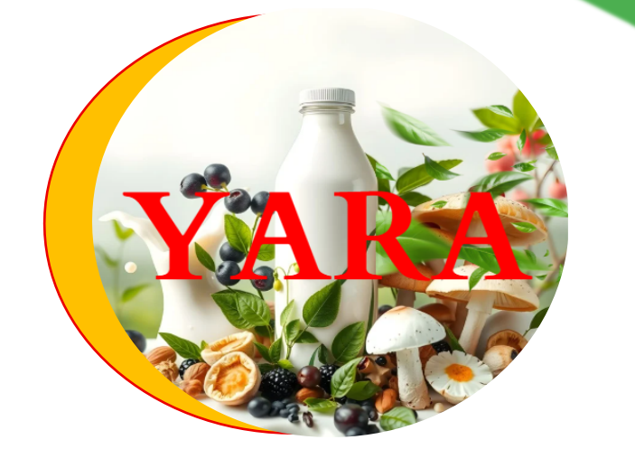
About Yara:
Yara Beverages, founded in 2006, has been an established company dedicated to developing an extensive selection of dairy as well as dairy-free drinks that combine centuries-old wisdom with modern nutritional technology. Our objective is to produce mouthwatering, health-focused products that meet the nutritional needs of everybody, but especially those facing particular medical concerns like diabetes. We are dedicated to sustainability, working from a solar-powered plant in Seberang Perai, Penang, and making certain that each bottle symbolizes our commitment to good health, new ideas, and conservation of the environment.

Yara’s Goal:
To nourish the needs of our consumers good health through supplying inventive, nutrient-rich, and tasty products that encourage healthy behaviors while encouraging environmentally friendly behaviors.

Long-term Aim:
To develop into the multinational beverage company known for our dedication to good health, environmentally friendly practices, and new ideas, motivating everyone to make smart nutritional decisions.

Yara’s Core Values:
- Interconnected Innovation: Creating products that assist all aspects of life while remaining accurate and compassionate.
- Green Farming: Joining forces with organic farming projects to improve the health of the soil.
- Responsive Wellness: Developing products that respond to varying nourishing requirements.
- Clearly Transformation: Guarantees clarity from seed to sip.

Yara’s Services:
- WisdomWell™ Corporate Healthcare Program
Our flagship offering delivers full wellness at work services via:
- Personalized beverage stations with monthly variations.
- Monthly nutrition classes and health coaching
- Thorough analysis of spending habits and well-being statistics.

- Senior Care Nutrition Partnership.
Professional dietary solutions for aged care institutions include:
- Customized low-sugar formulas
- Employee training and guidance in nutrition
- Personalized Dietary Management

- Yara’s Innovative technology Lab
A technological advancement centre that offers:
- Customized beverages formulation
- Surveys on market trends and consumer testing
- Expert Production Assistance

The products we sold includes:
- Plant-Based Milk Collection
- Bee Pollen Milk •
- Triple Berry Blend •
- Golden Years Nuts Milk
- Silver Sage Black Sesame •
- Gentle Green Tea Milk •
- Mushroom Master Blend

- Plant-Based Ice Cream Collection
Superfood Series
- Royal Bee Pollen Swirl •
- Triple Berry Paradise •
- Black Sesame Delight

Nutty Favorites
- Five-Nut Supreme •
- B12 Fortified Nut Fusion

Quality Assurance & Sustainability
- Quality Control Process
- Strict control procedures at each manufacturing phase
- Regular quality assurance improvements
- Third-party inspections of manufacturing facilities
- Supplier compliance monitoring

- Environmental Guidelines
- Eco-friendly supply chain management
- Environmental impact reduction initiatives
- Sustainable packaging solutions
- Carbon footprint monitoring

- Health & Safety Compliance
- Regular health & safety audits
- Compliance with international standards
- Employee safety training programs
- Product safety certifications

- Strategic Health Partnerships
- We actively collaborate with leading health organizations to:
- Validate best practices in beverage production
- Receive expert guidance on product safety
- Implement latest health guidelines
- Enhance product quality standards

- Continuous Improvement Practices
- Regular audits and quality checks
- Supplier evaluation program
- Environmental impact assessments
- Product safety reviews
- Customer feedback integration

- Sustainability Initiatives
- Zero-waste manufacturing goals
- Renewable energy utilization
- Water conservation programs
- Sustainable ingredient sourcing

Year | Achievement | Description
2025 | Global Reach | extended service to 10 different countries.
2024 | Breakthrough in Sugar Reduction | Developed a patented natural sweetening technique.
2023 | Launch WisdomWell™ Initiative | Collaborated with around 50 elderly welfare institutions.
Key Accomplishments:
Table 1
Table 1 summarizes the milk company's major accomplishments during the last many years, emphasizing noteworthy turning points in product innovation, global expansion, and social efforts.

Yara’s Monthly Products Sales Statices
Table 2

Table 2 shows the Yara’s Monthly Products Sales Statics, total sales, profit margin, and profit for the diverse milk and ice cream items supplied by Yara’s company between January and December. The data in this table compares the success of Yara’s core products, such as milk types and ice cream flavors, all throughout each month of the year.

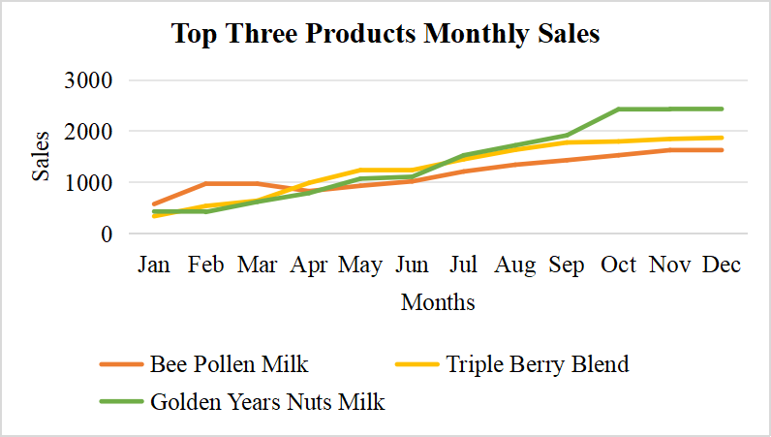
Figure 2

Figure 2 depicts the monthly sales figures for Yara's top three products including Bee Pollen Milk had the most sales, followed by Triple Berry Blend, while Golden Years Nuts Milk had the lowest sales of products within the top three.

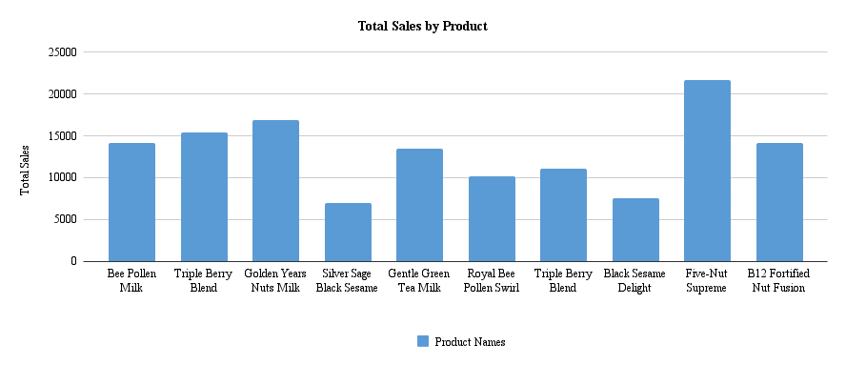
Figure 3

Figure 3 show a bar chart that depicts the monthly sales data for various milk and ice cream products, as well as their margins of profitability and overall earnings. It emphasizes product performance and enables for year-long evaluations of monthly developments.

We're Here to Help:

Main Office
6th Floor, Menara SEN,
No. 3, Jalan Bukit Mertajam,
13600 Penang, Malaysia.

Contact Details
connect@yarabeverages.com
011-12345678

Operating Hours for the Research Center

Monday - Friday: 9:00 AM - 6:00 PM
Tasting Room Availability: 10:00 AM - 4:00 PM

Additional Features:

Figure 4 shows Yara’s Company Logo

Conclusion:
Lastly, Yara Beverages is committed to delivering quality products through sustainable practices and excellent customer service. By emphasizing development and sustainability, Yara continues to value its customers, collaborators, and society. It is this spirit of quality control, reliability, and constant improvement that has made us a market leader in the beverage industry. We also embrace partnerships that will help us expand our coverage and achieve our goals.
10

