Applied Machine Learning and Deep Learning (MBA ZG582)
Assignment 2 | Phase 2: Machine Learning Phase
Bike-Buyer Propensity Modelling for Adventure Works Cycles
Course | MBA ZG582 - Applied Machine Learning and Deep Learning
Phase | Phase 2 - Model development, training, tuning and evaluation
Dataset | Microsoft AdventureWorks customer data (EdX DAT275x extract)
Records | 16404 unique customers after deduplication
Problem type | Supervised binary classification (purchase propensity)
Target | BikeBuyer - 33.25% positive
Features | 23 after selection
Split | 13123 train / 3281 test, stratified
Selected model | HistGradientBoosting (tuned)

1. Problem Statement and Business Context
Adventure Works Cycles sells bicycles and accessories to retail customers across six countries. The company runs direct marketing campaigns against its customer list, and faces the standard targeting trade-off: contacting the entire base wastes budget on people who will never buy, while contacting too narrowly leaves revenue uncollected. The business question is therefore not "who is a good customer" in the abstract, but specifically which customers should receive the next campaign.

1.1 Machine Learning Framing
The task is framed as supervised binary classification: predict BikeBuyer, whether a customer has purchased a bicycle, from demographic and household attributes. Classification is the correct framing because the underlying decision is itself binary - contact or do not contact - taken over a fixed customer list.
One point of nuance matters for how the model is evaluated. The deliverable is not really a yes/no label; it is a ranked propensity score, which the campaign then cuts at whatever depth the budget allows. That is why ROC-AUC, which scores the quality of the ranking independently of any single cut-off, is the primary metric and the tuning objective.

Element | Definition
Target variable | BikeBuyer - binary, 33.25% positive
Unit of analysis | one customer
Predictors | 23 demographic and household features after selection
Class balance | 1 : 2.01 - moderate imbalance
Primary metric | ROC-AUC - scores the ranking, independent of cut-off
Secondary metrics | F1, PR-AUC, precision, recall, balanced accuracy
Baselines | majority-class and stratified-random classifiers

1.2 Why Accuracy Alone Would Mislead
Because 66.8 per cent of customers do not buy, a model that predicts "nobody buys" scores 0.6675 accuracy while being entirely useless: its F1 is 0.0000 and its ROC-AUC is 0.5000. Both trivial baselines are trained and scored explicitly in Step 4 so that this is demonstrated rather than merely asserted, and so that every later result has an honest floor to be measured against.

2. Methodology
Step | Stage | Detail
1 | Dataset preparation | Join three tables, resolve duplicates, drop PII, derive age and ratios, ordinal + one-hot encoding
2 | Feature selection | Leakage exclusion, zero-variance filter, |r| > 0.95 redundancy filter, mutual information
3 | Stratified split | 80 / 20, class ratio preserved in both partitions
4 | Model training | 2 baselines + 6 candidate algorithms
5 | Hyperparameter tuning | RandomizedSearchCV (25 draws, StratifiedKFold) + validation curves
6 | Dimensionality reduction | PCA, models retrained on components
7 | Ensembles | Bagging, boosting, soft voting, stacking
8 | Comparison and selection | Ranked on hold-out ROC-AUC
9 | Diagnostics | Confusion matrix, ROC, PR, calibration, threshold optimisation
10 | Business interpretation | Decile lift and gains, campaign economics, sensitivity analysis

2.1 Why the Split Is Random Here
This dataset is a customer cross-section rather than a time series, so a random split is appropriate - there is no temporal ordering that a shuffle could violate. The split is stratified so that both partitions carry the same buyer proportion, which matters under class imbalance. This is a deliberate contrast with a forecasting problem, where a shuffled split would leak the future into the past and inflate the reported score.

3. Data Preparation and Feature Selection
Three files - customer demographics, the BikeBuyer flag and average monthly spend - are joined on CustomerID. The preparation stage is substantive rather than a formality, because the raw extract carries four genuine defects.

3.1 Duplicate Records
The extract repeats some CustomerIDs, and a blanket drop_duplicates() would be wrong because three distinct cases exist, each needing a different answer.
Case | Count | Treatment
Exact duplicate rows | 98 | Safe to drop - no information lost
Same ID, conflicting attributes | 17 | Keep the last record
Same ID, conflicting target | 4 | Keep the last record
The keep-last rule is applied consistently across all three tables so that customer, target and spend records stay aligned, reducing 16,519 raw rows to 16404 unique customers.

3.2 Other Cleaning and Feature Engineering
- Identifier and PII columns dropped - names, phone numbers and street addresses are unique labels rather than features, and carry no generalisable signal.
- Whitespace defect corrected - the value 'Bachelors ' ships with a trailing space and would otherwise encode as a level distinct from 'Bachelors', silently splitting one category into two.
- Age derived against a fixed 1998 reference date. AdventureWorks is a 1998-vintage sample database; computing age against today's date would add roughly 28 years to every customer and destroy the age signal.
- Education rank-encoded rather than one-hot. The five levels have a natural order, so ranking preserves that ordering for the linear models and gives the tree models a single splittable column instead of five sparse ones.
- Derived ratios added - income per child, cars per child, children away from home, log income - to express relationships the raw columns only imply.

3.3 Leakage Exclusion
AveMonthSpend is deliberately excluded from the predictors. It records what a customer spends with Adventure Works, so it is measured contemporaneously with - and is partly caused by - the bike purchase itself. Including it would leak the outcome into the features and inflate every score, and it would be unavailable at scoring time for a prospect who has not yet bought anything. Identifying this before modelling, rather than being pleased by an artificially high AUC afterwards, is the substantive judgement in this step.
The redundancy filter then removed MaritalStatus_S, which duplicated the engineered IsSingle flag exactly - a useful confirmation that the filter works.
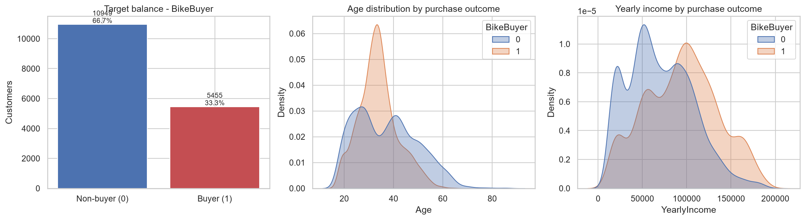
Figure 1: Target balance, and the age and income distributions split by purchase outcome.
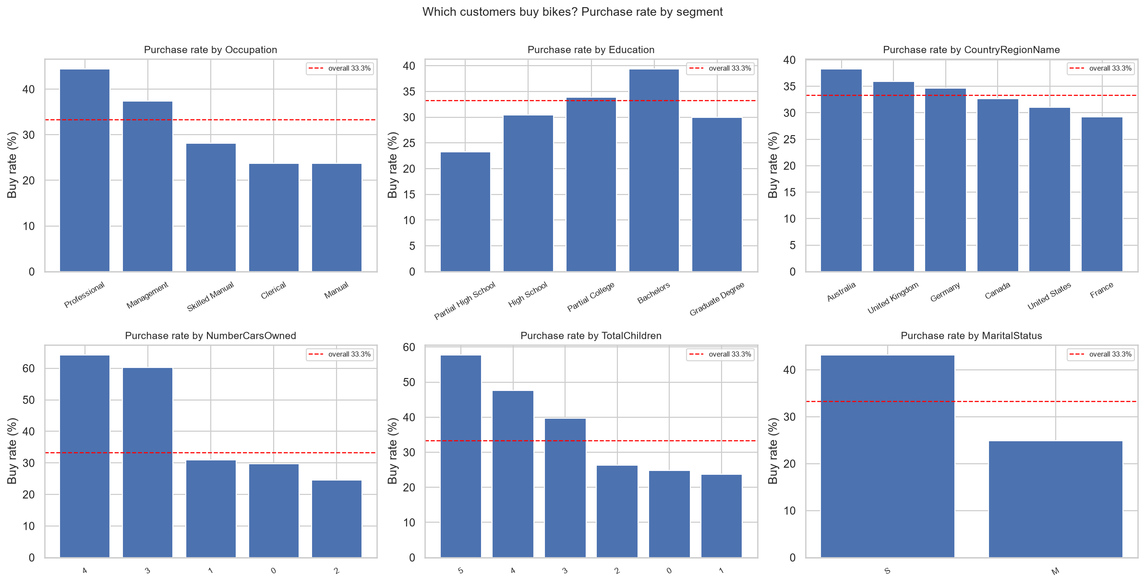
Figure 2: Purchase rate by segment against the overall base rate.
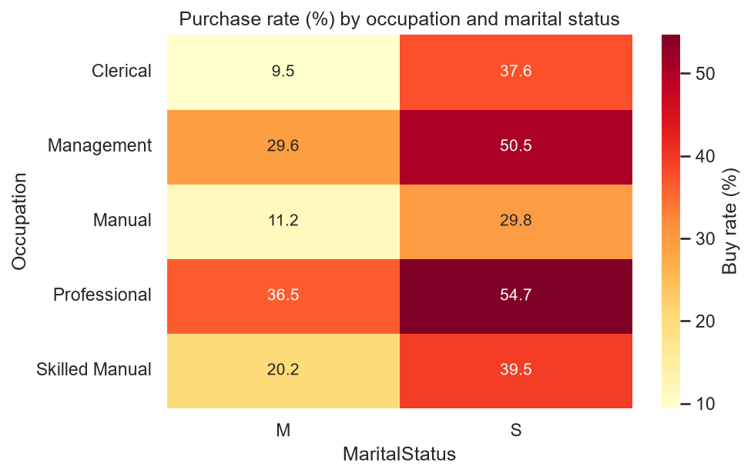
Figure 3: Purchase rate by occupation and marital status.

Occupation | Customers | BuyRate | MedianIncome | MedianAge
Professional | 4922 | 44.37 | 99058.0 | 35.134839151266256
Management | 2718 | 37.38 | 118781.0 | 48.14784394250513
Skilled Manual | 4038 | 28.11 | 66471.5 | 31.90965092402464
Clerical | 2597 | 23.72 | 49481.0 | 35.23613963039014
Manual | 2129 | 23.67 | 21722.0 | 29.26488706365503
Table 1: Customer profile and purchase rate by occupation.
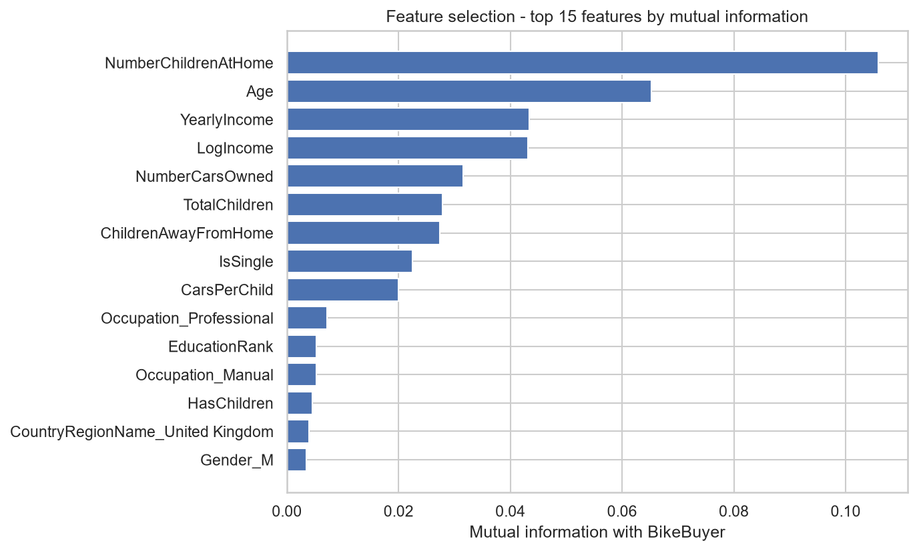
Figure 4: Top 15 features by mutual information with BikeBuyer.
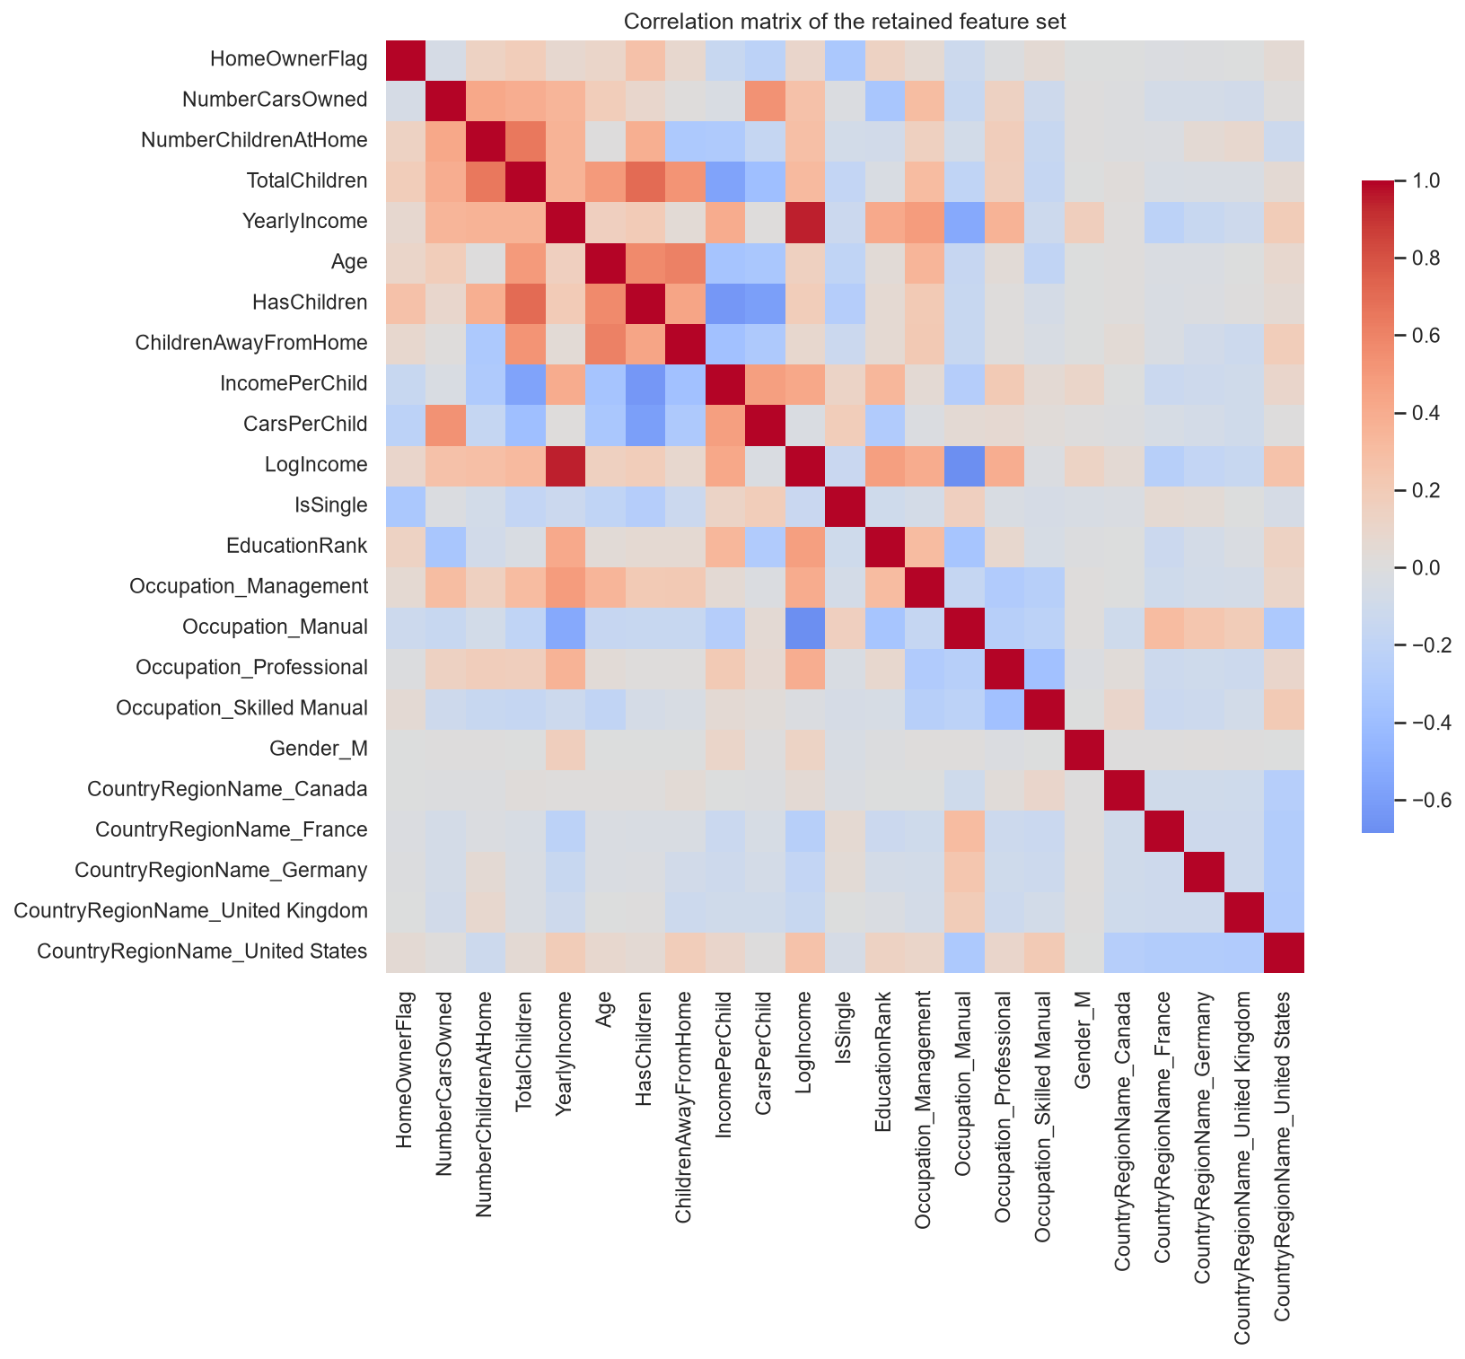
Figure 5: Correlation matrix of the retained feature set.

4. Model Development and Evaluation
Eight models were trained: two trivial baselines and six candidate algorithms spanning linear, instance-based, tree and ensemble families.
Model | Accuracy | BalancedAcc | Precision | Recall | F1 | ROC_AUC | PR_AUC
Baseline - Majority Class | 0.6675 | 0.5 | 0.0 | 0.0 | 0.0 | 0.5 | 0.3325
Baseline - Stratified Random | 0.5376 | 0.4789 | 0.3042 | 0.3034 | 0.3038 | 0.4789 | 0.3239
Logistic Regression | 0.7732 | 0.7225 | 0.693 | 0.571 | 0.6261 | 0.8295 | 0.7249
K-Nearest Neighbours | 0.7863 | 0.7374 | 0.7167 | 0.5912 | 0.6479 | 0.8335 | 0.7262
Decision Tree | 0.7796 | 0.7268 | 0.7105 | 0.5692 | 0.6321 | 0.8341 | 0.7227
Random Forest | 0.7824 | 0.7418 | 0.6929 | 0.6205 | 0.6547 | 0.8301 | 0.7243
Gradient Boosting | 0.7961 | 0.7472 | 0.7371 | 0.6013 | 0.6623 | 0.8576 | 0.7749
HistGradientBoosting | 0.7952 | 0.7475 | 0.7325 | 0.6049 | 0.6627 | 0.855 | 0.7714
Table 2: Untuned model performance on the stratified hold-out.
The majority-class baseline is the most instructive row in the table. It achieves 0.6675 accuracy - which would sound acceptable reported on its own - while scoring zero on F1 and 0.5 on ROC-AUC, because it never identifies a single buyer. Every subsequent claim in this report is therefore made on AUC and F1 rather than accuracy.

5. Hyperparameter Tuning
RandomizedSearchCV sampled 25 configurations per model under a 5-fold StratifiedKFold, which preserves the class ratio in every fold. Validation curves then swept individual parameters to show where over-fitting begins rather than only reporting the winning configuration.
Model | BestCV_ROC_AUC | BestParams
Random Forest | 0.8588 | {"n_estimators": 200, "min_samples_split": 20, "min_samples_leaf": 8, "max_features": 0.5, "max_depth": 6, "class_weight": null}
HistGradientBoosting | 0.8654 | {"min_samples_leaf": 40, "max_leaf_nodes": 15, "max_iter": 200, "max_depth": 4, "learning_rate": 0.03, "l2_regularization": 0.0}
Table 3: Best cross-validated configuration per model.
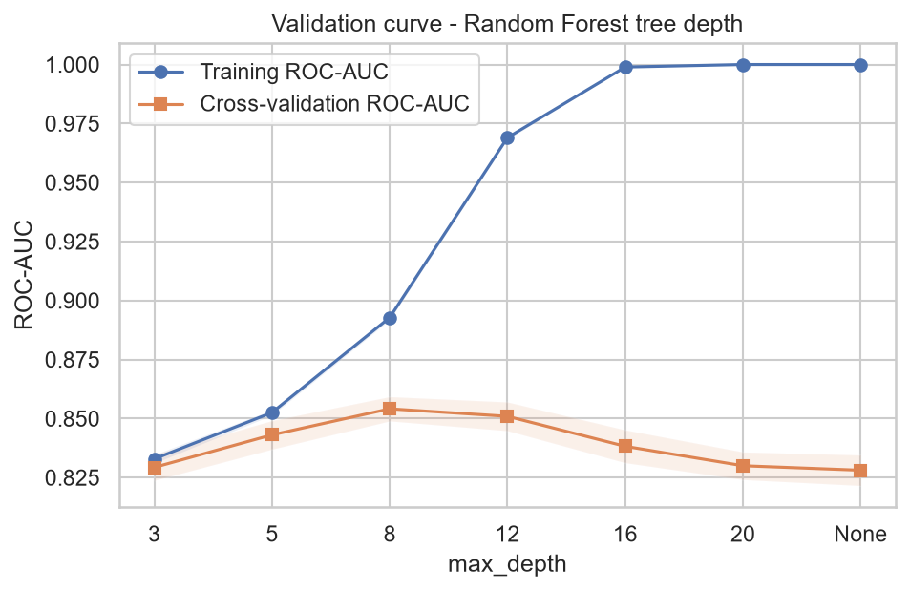
Figure 6: Validation curve - Random Forest tree depth.
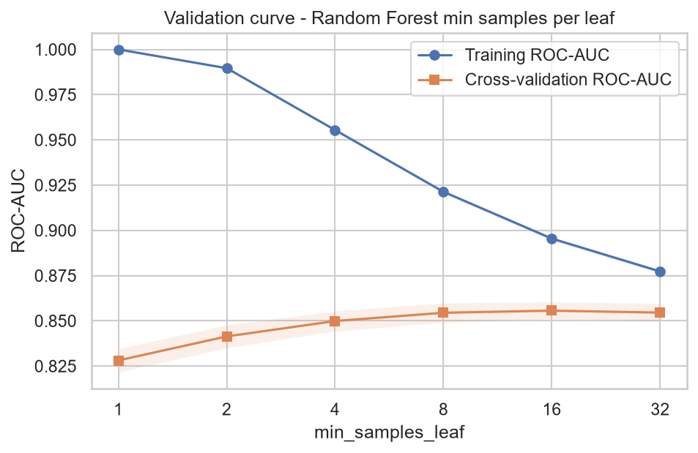
Figure 7: Validation curve - Random Forest minimum samples per leaf.
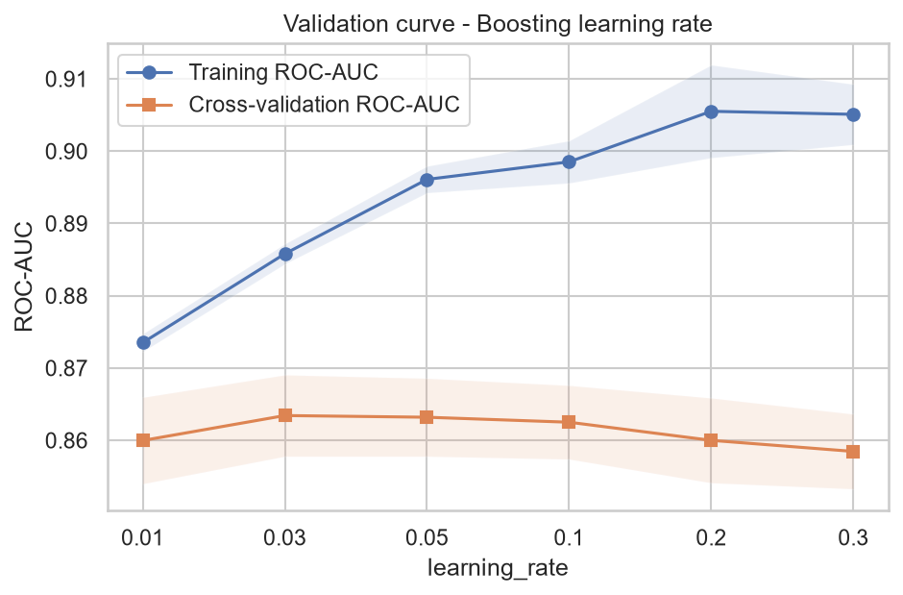
Figure 8: Validation curve - boosting learning rate.

6. Dimensionality Reduction (PCA)
PCA was fitted on the standardised training matrix. 15 components are needed to retain 95 per cent of the variance against 23 original features. Logistic Regression and Random Forest were retrained on the components and scored on the same hold-out.
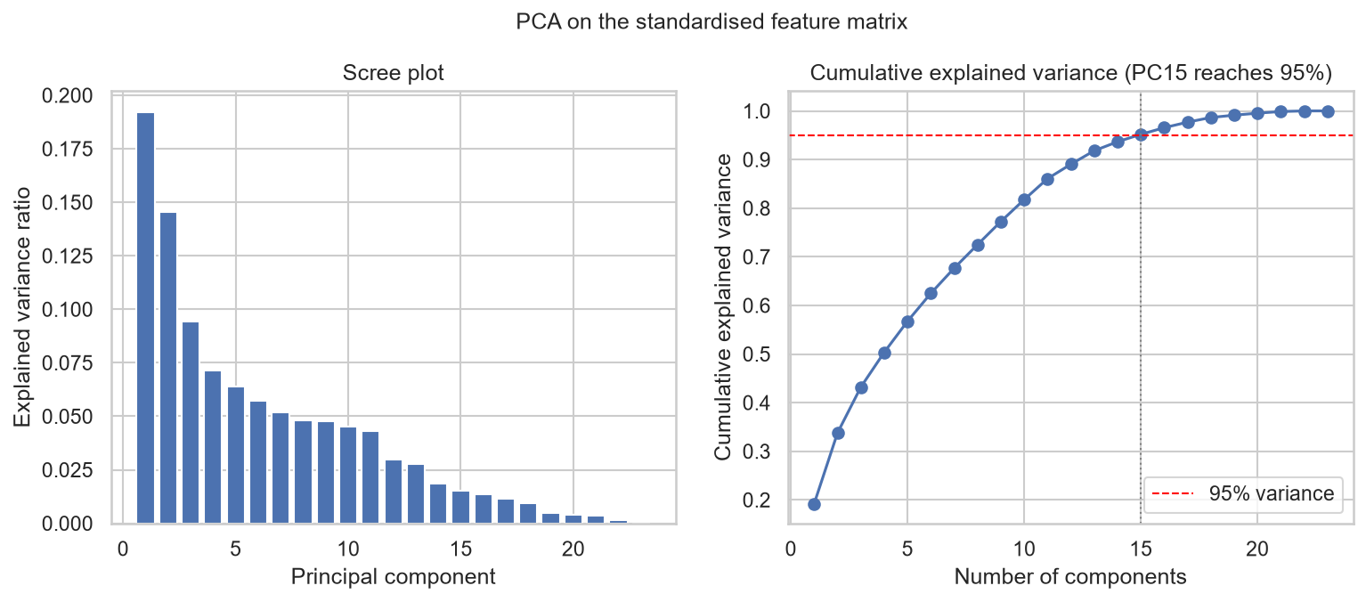
Figure 9: Scree plot and cumulative explained variance.
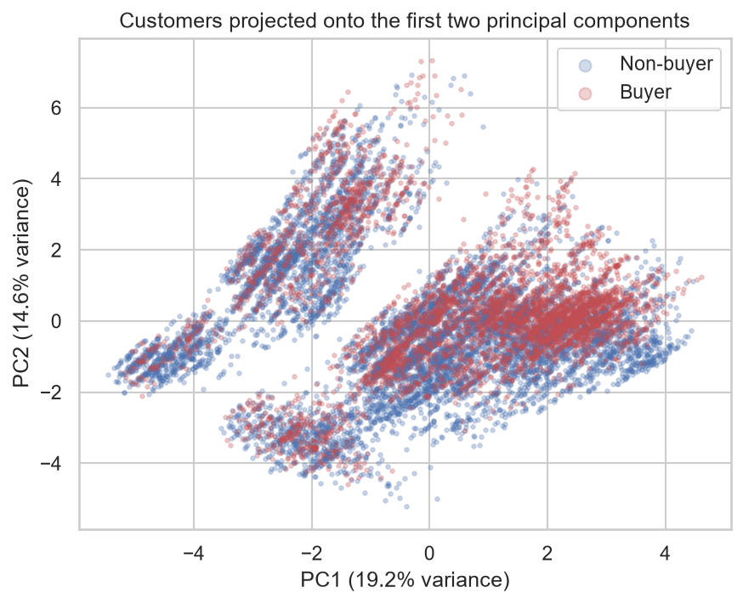
Figure 10: Customers projected onto the first two principal components, coloured by purchase outcome.
Model | Accuracy | BalancedAcc | Precision | Recall | F1 | ROC_AUC | PR_AUC
PCA(13) + Logistic Regression | 0.7726 | 0.7188 | 0.6976 | 0.5582 | 0.6202 | 0.8283 | 0.7238
PCA(13) + Random Forest | 0.7589 | 0.7189 | 0.6488 | 0.5995 | 0.6232 | 0.8153 | 0.707
PCA(15) + Logistic Regression | 0.7723 | 0.7179 | 0.6982 | 0.5555 | 0.6187 | 0.8276 | 0.7215
PCA(15) + Random Forest | 0.765 | 0.7258 | 0.6587 | 0.6086 | 0.6327 | 0.8163 | 0.7068
Table 4: Models retrained on principal components.
PCA does not improve performance here. The best PCA variant scores below its equivalent model on the full feature set, and the two-component projection shows the classes are not linearly separable in the reduced space. The explanation is structural: roughly half the matrix consists of orthogonal one-hot dummies and binary flags, which PCA cannot compress without discarding information. Interpretability is also lost - a marketing manager can act on 'customers with children at home' but not on 'principal component 4'. PCA is therefore documented as a completed experiment and is not adopted in the final pipeline.

7. Ensemble Techniques
Family | Implementation | Mechanism
Bagging | Random Forest | Parallel trees on bootstrap samples
Boosting | Gradient Boosting, HistGradientBoosting | Sequential trees, each correcting its predecessor
Voting | VotingClassifier (soft) | Averages predicted probabilities, preserving ranking information
Stacking | StackingClassifier | Logistic meta-model learns how to weight the base models
Soft voting was chosen over hard voting because the campaign consumes ranked probabilities rather than labels, and averaging probabilities preserves that ranking. For stacking, StratifiedKFold partitions the data cleanly, so scikit-learn's StackingClassifier can build its meta-features directly - a notable contrast with a time-series problem, where TimeSeriesSplit does not partition and a hand-built temporal stack would be required.

8. Model Comparison and Final Selection
Model | Accuracy | BalancedAcc | Precision | Recall | F1 | ROC_AUC | PR_AUC
HistGradientBoosting (tuned) | 0.7998 | 0.7527 | 0.7406 | 0.6123 | 0.6703 | 0.8606 | 0.7791
Stacking Ensemble | 0.7973 | 0.7491 | 0.7383 | 0.6049 | 0.665 | 0.8601 | 0.778
Gradient Boosting | 0.7961 | 0.7472 | 0.7371 | 0.6013 | 0.6623 | 0.8576 | 0.7749
HistGradientBoosting | 0.7952 | 0.7475 | 0.7325 | 0.6049 | 0.6627 | 0.855 | 0.7714
Voting Ensemble | 0.7891 | 0.7387 | 0.7254 | 0.5885 | 0.6498 | 0.8538 | 0.765
Random Forest (tuned) | 0.7888 | 0.7346 | 0.7336 | 0.5729 | 0.6433 | 0.8505 | 0.7629
Decision Tree | 0.7796 | 0.7268 | 0.7105 | 0.5692 | 0.6321 | 0.8341 | 0.7227
K-Nearest Neighbours | 0.7863 | 0.7374 | 0.7167 | 0.5912 | 0.6479 | 0.8335 | 0.7262
Random Forest | 0.7824 | 0.7418 | 0.6929 | 0.6205 | 0.6547 | 0.8301 | 0.7243
Logistic Regression | 0.7732 | 0.7225 | 0.693 | 0.571 | 0.6261 | 0.8295 | 0.7249
PCA(13) + Logistic Regression | 0.7726 | 0.7188 | 0.6976 | 0.5582 | 0.6202 | 0.8283 | 0.7238
Baseline - Majority Class | 0.6675 | 0.5 | 0.0 | 0.0 | 0.0 | 0.5 | 0.3325
Baseline - Stratified Random | 0.5376 | 0.4789 | 0.3042 | 0.3034 | 0.3038 | 0.4789 | 0.3239
Table 5: Full model comparison on the hold-out, ranked by ROC-AUC.
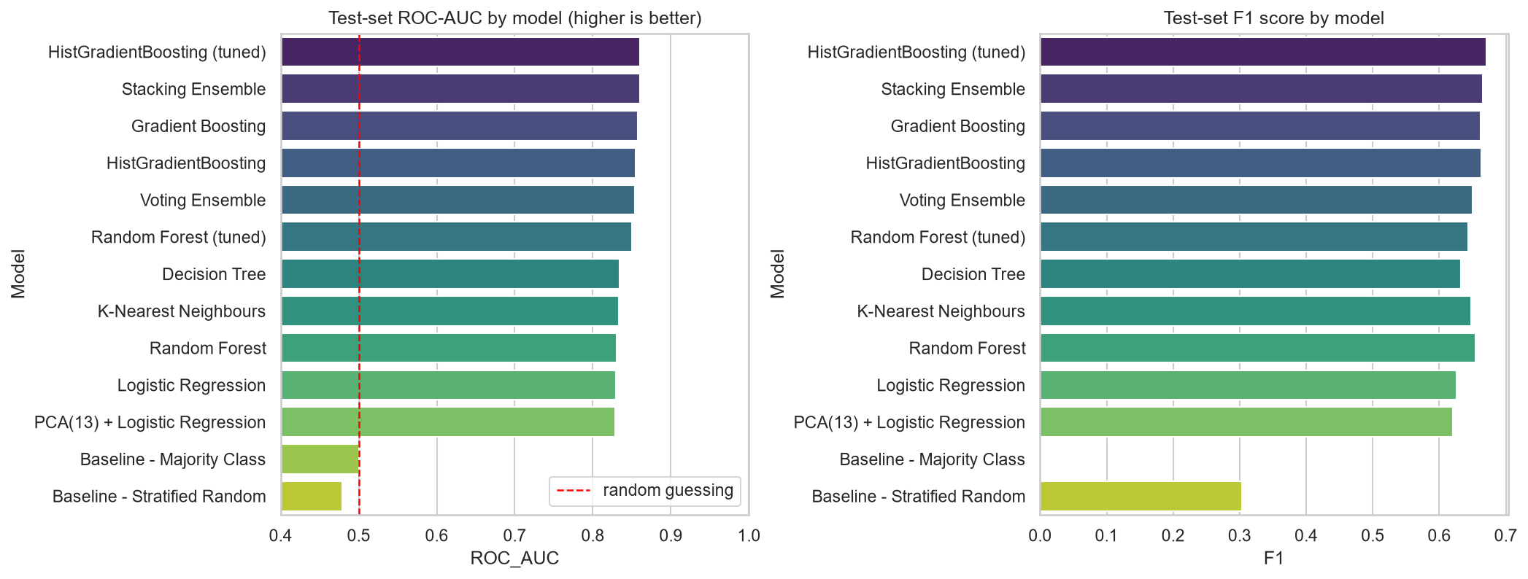
Figure 11: Test-set ROC-AUC and F1 by model.
Selected model: HistGradientBoosting (tuned)
- ROC-AUC 0.8606, PR-AUC 0.7791, F1 0.6703, accuracy 0.7998.
- Best ranking quality in the comparison, which is the property the campaign actually consumes.
- Trains in seconds and handles the mixed numeric and binary feature matrix natively, so periodic retraining is operationally trivial.
- Supports permutation importance, so the drivers behind a customer's score can be explained to a marketing stakeholder.
The margin over the next models is narrow - the stacking ensemble and plain gradient boosting sit within roughly half a point of AUC. Where differences are this small, the simpler and faster model is the defensible choice, and the tuned boosting model is both.

9. Diagnostics and Threshold Optimisation
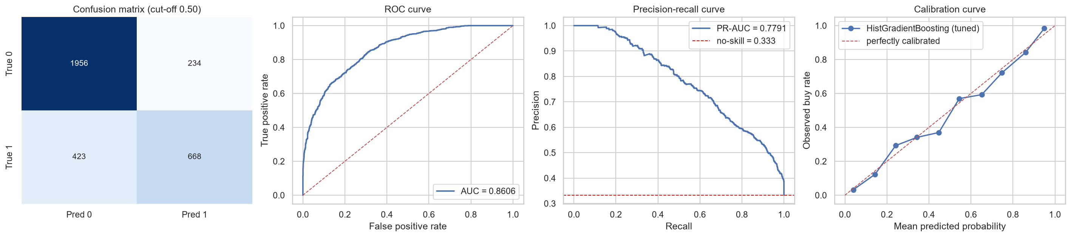
Figure 12: Confusion matrix, ROC curve, precision-recall curve and calibration curve for the selected model.
The precision-recall curve is the more informative of the two curves under class imbalance, since ROC can look flattering when the negative class dominates. The calibration curve matters because the campaign consumes predicted probabilities directly, so those probabilities need to mean what they claim.
The default 0.50 cut-off is a software default, not a business decision. Two alternatives were evaluated on the hold-out.
Threshold | Basis | Consequence
0.500 (default) | scikit-learn default | Highest accuracy, but recall of only 0.612 - most buyers are missed
0.290 (F1-optimal) | Balances precision and recall | Substantially higher recall at modest precision cost
0.050 (profit-optimal) | Maximises expected campaign profit | Contacts almost everyone - see Section 10
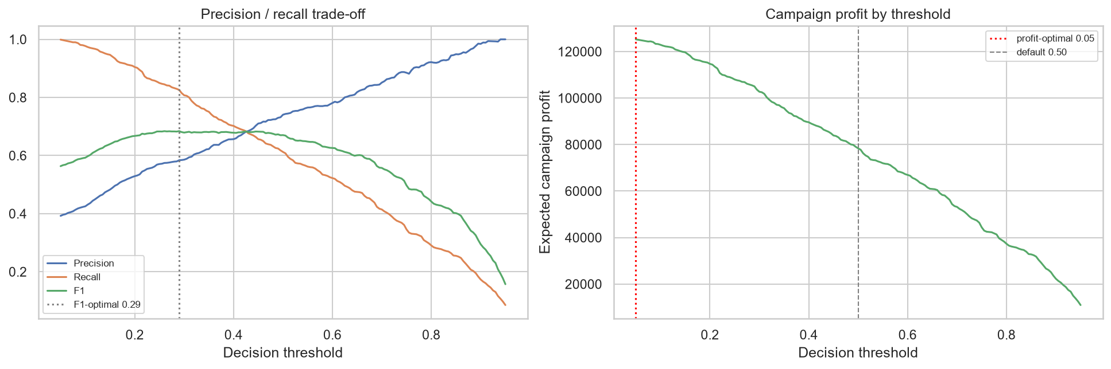
Figure 13: Precision-recall trade-off and campaign profit across decision thresholds.
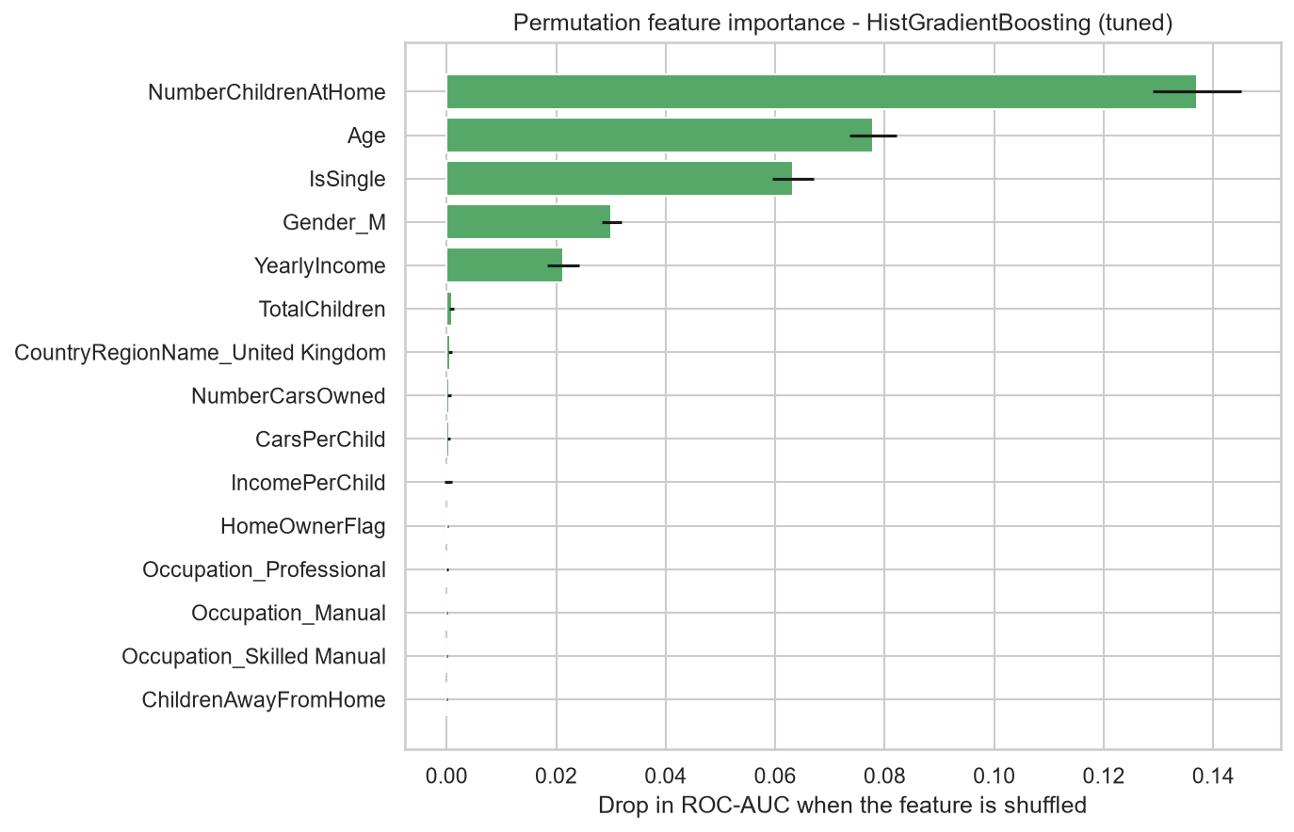
Figure 14: Permutation feature importance measured on the hold-out.
Strongest drivers of purchase propensity:
- NumberChildrenAtHome - reduces ROC-AUC by 0.1370 when shuffled
- Age - reduces ROC-AUC by 0.0779 when shuffled
- IsSingle - reduces ROC-AUC by 0.0633 when shuffled
- Gender_M - reduces ROC-AUC by 0.0301 when shuffled
- YearlyIncome - reduces ROC-AUC by 0.0213 when shuffled
- TotalChildren - reduces ROC-AUC by 0.0009 when shuffled

10. Business Interpretation
The model is converted into a campaign decision by ranking customers on predicted propensity, splitting them into ten equal groups, and comparing the buy rate in each against the base rate.
Decile | Customers | Buyers | BuyRate | MinProba | Lift | CumBuyers | CumCapture_% | Profit | CumProfit
1.0 | 329.0 | 304.0 | 92.4 | 0.819601540656684 | 2.78 | 304.0 | 27.9 | 35822.0 | 35822.0
2.0 | 328.0 | 225.0 | 68.6 | 0.636999495256999 | 2.06 | 529.0 | 48.5 | 26344.0 | 62166.0
3.0 | 328.0 | 176.0 | 53.66 | 0.4611101087921023 | 1.61 | 705.0 | 64.6 | 20464.0 | 82630.0
4.0 | 328.0 | 113.0 | 34.45 | 0.3510086802480336 | 1.04 | 818.0 | 75.0 | 12904.0 | 95534.0
5.0 | 328.0 | 114.0 | 34.76 | 0.2448008420243247 | 1.05 | 932.0 | 85.4 | 13024.0 | 108558.0
6.0 | 328.0 | 70.0 | 21.34 | 0.1743619635369648 | 0.64 | 1002.0 | 91.8 | 7744.0 | 116302.0
7.0 | 328.0 | 48.0 | 14.63 | 0.125922858714586 | 0.44 | 1050.0 | 96.2 | 5104.0 | 121406.0
8.0 | 328.0 | 30.0 | 9.15 | 0.0784811237425806 | 0.28 | 1080.0 | 99.0 | 2944.0 | 124350.0
9.0 | 328.0 | 11.0 | 3.35 | 0.0252494993905576 | 0.1 | 1091.0 | 100.0 | 664.0 | 125014.0
10.0 | 328.0 | 0.0 | 0.0 | 0.0016125502739332 | 0.0 | 1091.0 | 100.0 | -656.0 | 124358.0
Table 6: Decile lift and cumulative gains analysis.
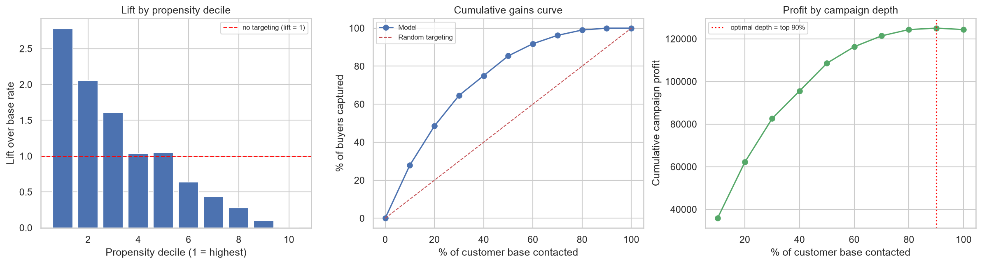
Figure 15: Lift by decile, cumulative gains curve, and profit by campaign depth.
- The top decile buys at 2.78 times the base rate - a genuinely strong separation.
- The top 30 per cent of the ranked base captures 64.6 per cent of all buyers.
- The bottom decile contains no buyers at all, so those contacts are pure cost.

10.1 An Honest Reading of the Campaign Economics
Under the stated assumptions - a contribution margin of 120 per sale against a contact cost of 2.00 - the targeted campaign returns only 0.53 per cent more profit than simply mailing everybody. That result should be reported plainly rather than buried.
Metric | MailEveryone | ModelTargeted
Contacts made | 3281.0 | 2953.0
Campaign profit | 124358.0 | 125014.0
Profit per contact | 37.9 | 42.33
Top-decile lift | 1.0 | 2.78
Table 7: Campaign economics, model-targeted versus mailing the entire base.
The reason is arithmetic, not a defect in the model. A customer is worth contacting whenever their purchase probability exceeds break-even = cost / margin = 1.67 per cent. Almost the entire customer base clears that bar, so blanket mailing is close to optimal and there is little profit for targeting to add.
Whether targeting pays is therefore a property of the campaign economics, not of the model. The sensitivity analysis below tests where the crossover lies.
CostPerContact | BreakEvenProb_% | OptimalDepth_% | MailAllProfit | TargetedProfit | ProfitGain | Uplift_%
1.0 | 0.83 | 90.0 | 127639.0 | 127967.0 | 328.0 | 0.26
2.0 | 1.67 | 90.0 | 124358.0 | 125014.0 | 656.0 | 0.53
5.0 | 4.17 | 80.0 | 114515.0 | 116475.0 | 1960.0 | 1.71
10.0 | 8.33 | 80.0 | 98110.0 | 103350.0 | 5240.0 | 5.34
20.0 | 16.67 | 60.0 | 65300.0 | 80860.0 | 15560.0 | 23.83
30.0 | 25.0 | 50.0 | 32490.0 | 62610.0 | 30120.0 | 92.71
40.0 | 33.33 | 50.0 | -320.0 | 46200.0 | 46520.0
60.0 | 50.0 | 30.0 | -65940.0 | 25500.0 | 91440.0
Table 8: Sensitivity of optimal campaign depth and profit uplift to the cost per contact.
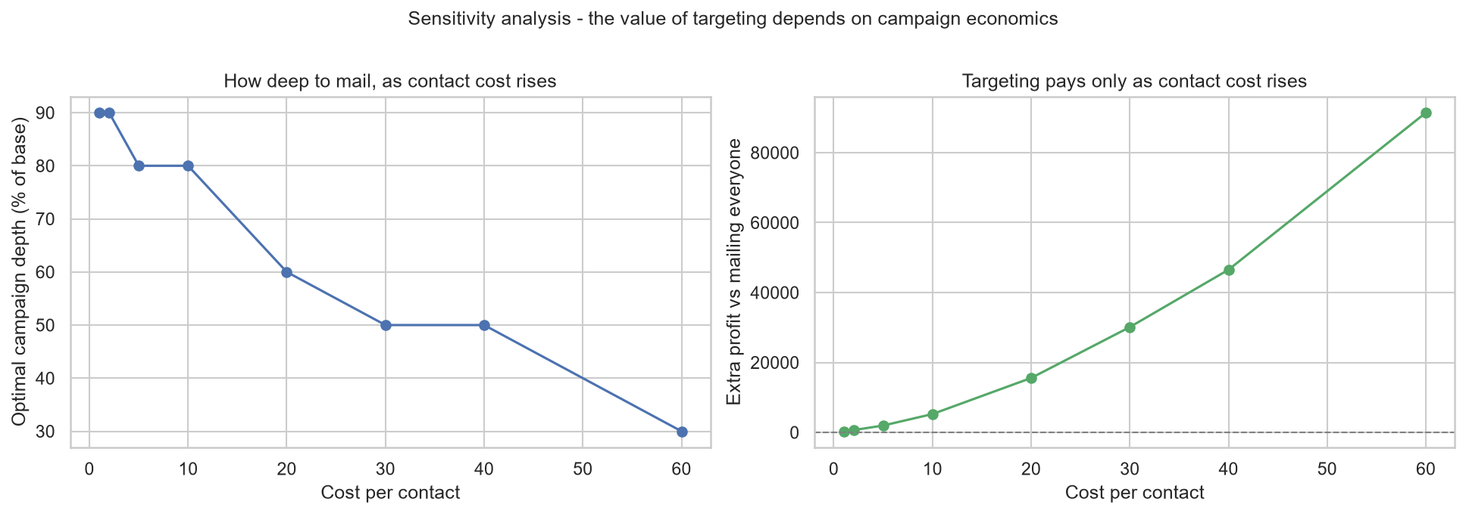
Figure 16: Optimal campaign depth and profit uplift as contact cost rises.
What this means in practice:
- For cheap channels - email, in-app messaging, SMS - the model should not be used to decide whom to exclude, because almost everyone is worth contacting. Its value there is efficiency: the same revenue is earned from roughly 10 per cent fewer contacts, which reduces list fatigue and unsubscribes.
- For expensive channels - printed catalogues, outbound calling, field visits - the economics invert and targeting becomes decisive. As contact cost rises, the optimal campaign depth falls and the profit uplift over blanket mailing grows substantially.
- The model's most durable value is as a ranking, not as a hard classifier. It tells the business the order in which to spend a budget of any size, which is a more useful output than a contact / do-not-contact label.

10.2 Segment Insight for Marketing
- Customers with children at home are the single strongest signal in the model, ahead of both income and age.
- Professionals buy at 44.4 per cent against 23.7 per cent for manual occupations - a spread of roughly two to one.
- Income matters, but less than household composition, which suggests creative and offer design should lead on family use cases rather than on price alone.

11. Conclusion and Next Steps
Phase 2 delivers a validated purchase-propensity model for Adventure Works Cycles. HistGradientBoosting (tuned) was selected on hold-out ROC-AUC of 0.8606, against 0.5000 for a majority-class baseline, and separates the top decile at 2.78 times the base purchase rate. The analysis also establishes the conditions under which that ranking is commercially worth acting on, which is a more useful conclusion than the accuracy figure alone.
Carried forward to Phase 3:
- Deep learning extension - a neural network with entity embeddings for the categorical fields, which can learn interactions the tree ensembles approximate by splitting.
- Probability calibration - isotonic or Platt scaling, so that predicted scores can be used directly in expected-value calculations.
- Cost-sensitive learning - training against the campaign profit function directly rather than optimising AUC and choosing a threshold afterwards.
- Richer features - purchase recency, frequency and monetary value, and campaign response history, which would very likely outperform demographics alone.
- A second target - AveMonthSpend is available on the same customer table, so a regression model could estimate customer value and combine with propensity to rank on expected revenue rather than probability of purchase.

Appendix A - Reproducibility
Item | Value
Notebook | AMLDL_Assignment2_AdventureWorks.ipynb
Pipeline script | aw_pipeline.py
Dataset | data/adventureworks/ - 3 CSVs, Microsoft AdventureWorks
Source | github.com/kdavenpo/AdventureWorks (EdX DAT275x extract)
Random seed | 42 (fixed throughout)
Figures | outputs/figures/ (16 plots)
Result tables | outputs/tables/ (15 files)
Stated assumptions | Margin per sale 120, cost per contact 2.00 - illustrative, not derived from the data
Git repository | https://github.com/SangithaV2024BC26670/amldl-assignment-2

