Concept Note: Customer Purchase-Propensity Modelling
Targeting Direct Marketing Campaigns at Adventure Works Cycles
Course Project - Applied Machine Learning and Deep Learning (MBA ZG582) | Phase 1
Dataset: Microsoft AdventureWorks customer data (DAT275x lab extract)

1. Problem Statement

1.1 Business Context
Adventure Works Cycles is a manufacturer and retailer of bicycles and cycling accessories, selling to individual consumers across six countries in North America, Europe and Australia. Like most consumer retailers, it acquires and retains customers partly through outbound direct marketing - catalogues, mailings and promotional offers sent to names on its customer list.
Direct marketing carries a structural tension. Contacting the entire customer base guarantees that every genuine prospect is reached, but spends budget on the majority who will not buy, and repeated irrelevant contact drives list fatigue and unsubscribes. Contacting too narrow a group protects budget but leaves revenue uncollected. With roughly one customer in three having purchased a bicycle, an untargeted campaign wastes the majority of its spend.
The commercial question is therefore not who is a valuable customer in the abstract, but specifically which customers should receive the next campaign, and how deep into the list the company should go for a given budget.

1.2 ML Problem Framing
This is framed as a supervised binary classification problem:
- Target variable (y): BikeBuyer - whether a customer has purchased a bicycle (1) or not (0). Binary, with 33.25 per cent positive cases.
- Features (X): customer demographic and household attributes - age, gender, marital status, education, occupation, yearly income, home ownership, number of cars owned, and children at home and in total, plus country of residence.
- Goal: rank customers by purchase propensity so that campaign spend is concentrated on the highest-scoring segments, maximising response per unit of marketing cost.
One point of framing deserves emphasis, because it determines how the model is evaluated. Although the target is a binary label, the operational deliverable is not a yes/no decision but a ranked propensity score, which the campaign then cuts at whatever depth the budget allows. The primary metric is therefore ROC-AUC, which measures the quality of that ranking independently of any particular cut-off, supported by F1 and precision-recall AUC for the minority class.
A secondary regression framing - predicting AveMonthSpend, the customer's average monthly spend - is available on the same customer table and would allow ranking on expected revenue rather than probability of purchase. It is noted as a natural extension but is out of scope for this concept note.

2. Dataset Description
The analysis uses the Microsoft AdventureWorks sample customer data, in the extract prepared for the Microsoft / EdX course DAT275x, Principles of Machine Learning. AdventureWorks is Microsoft's long-standing publicly available sample database for a fictional bicycle retailer, and is widely used for teaching and benchmarking. Three files are joined on CustomerID: customer demographics, the bike-purchase flag, and average monthly spend.

2.1 Dataset Summary
Attribute | Value
Source | Microsoft AdventureWorks sample database (DAT275x extract)
Public mirror | github.com/kdavenpo/AdventureWorks
Files | AdvWorksCusts.csv, AW_BikeBuyer.csv, AW_AveMonthSpend.csv
Raw rows | 16,519 per file
Unique customers | 16404 after deduplication
Raw attributes | 23 customer columns + 2 target columns
Modelling features | 23 after cleaning, engineering and selection
Target (classification) | BikeBuyer - 33.25% positive
Target (secondary) | AveMonthSpend - continuous, out of scope here
Class balance | 1 : 2.01 (moderate imbalance)
Geography | 6 countries - United States, Australia, United Kingdom, France, Germany, Canada
Age range | 17 - 87 years (median 34), as at 1 January 1998
Income range | 9,482 - 196,511 (median 76,125)
Missing values | None in any modelling column

2.2 Feature Dictionary
Feature | Type | Description
Age | Numeric (derived) | Derived from BirthDate against a fixed 1 Jan 1998 reference date
YearlyIncome | Numeric | Annual household income
NumberChildrenAtHome | Numeric | Children currently living at home (0-5)
TotalChildren | Numeric | Total children (0-5)
NumberCarsOwned | Numeric | Vehicles owned by the household (0-4)
HomeOwnerFlag | Binary | Owns their home (1) or not (0)
Education | Ordinal | Five ordered levels, Partial High School to Graduate Degree
Occupation | Nominal | Manual, Clerical, Skilled Manual, Professional, Management
Gender | Nominal | Male / Female
MaritalStatus | Nominal | Married / Single
CountryRegionName | Nominal | Country of residence (6 levels)
Derived ratios | Numeric | Income per child, cars per child, children away from home, log income

2.3 Data Quality Assessment
The extract is not clean on arrival, and the defects found are substantive rather than cosmetic. Identifying them is a material part of the project.
Issue | Detail | Treatment
Duplicate CustomerIDs | 115 IDs appear more than once - 98 exact duplicate rows, 17 with conflicting attributes, 4 with conflicting targets | Drop exact duplicates, then keep the last record per ID, applied consistently across all three tables
Whitespace defect | 'Bachelors ' carries a trailing space | Strip whitespace before encoding, else one category silently splits into two
Ordinal treated as nominal | Education has five naturally ordered levels | Rank-encode rather than one-hot, preserving the ordering
Date vintage | AdventureWorks is 1998-vintage data | Compute age against a fixed 1998 reference date, not the present day
Potential target leakage | AveMonthSpend is measured contemporaneously with the purchase | Excluded from the predictors - see Section 2.5
Identifier / PII columns | Names, phone numbers, street addresses | Dropped - unique labels carrying no generalisable signal

2.4 Exploratory Data Assessment (Highlights)
- The target is moderately imbalanced: 33.25 per cent of customers have bought a bicycle, so a naive model predicting 'nobody buys' would score roughly 67 per cent accuracy while identifying no buyers at all. Accuracy alone is therefore an unsafe metric for this problem.
- Household composition is by far the strongest signal, and the relationship is monotonic: the purchase rate climbs from 19.4 per cent for customers with no children at home to 83.9 per cent for those with five - a spread of more than four to one. This single variable outranks both income and age on mutual information with the target, and points the campaign's creative towards family use cases rather than price.
- Occupation separates strongly: professionals buy at 44.4 per cent against 23.7 per cent for manual occupations, a spread of roughly two to one.
- Buyers are younger on average than non-buyers (median 33.3 against 36.5 years) and have higher median income (96,084 against 65,957).
- Purchase rates vary by country, from 38.2 per cent in Australia to 29.2 per cent in France, so geography carries signal but less than household attributes.
- No missing values are present in any modelling column once identifier columns are dropped.
NumberChildrenAtHome | Customers | BuyRate
0.0 | 9924.0 | 19.44
1.0 | 2180.0 | 24.77
2.0 | 1455.0 | 59.04
3.0 | 1057.0 | 69.44
4.0 | 943.0 | 72.53
5.0 | 845.0 | 83.91
Table 1: Purchase rate by number of children at home - the strongest single relationship in the dataset.
Occupation | Customers | BuyRate | MedianIncome | MedianAge
Professional | 4922 | 44.37 | 99058.0 | 35.134839151266256
Management | 2718 | 37.38 | 118781.0 | 48.14784394250513
Skilled Manual | 4038 | 28.11 | 66471.5 | 31.90965092402464
Clerical | 2597 | 23.72 | 49481.0 | 35.23613963039014
Manual | 2129 | 23.67 | 21722.0 | 29.26488706365503
Table 2: Customer profile and purchase rate by occupation.
CountryRegionName | Customers | BuyRate
Australia | 3194 | 38.23
United Kingdom | 1709 | 35.93
Germany | 1577 | 34.62
Canada | 1398 | 32.69
United States | 6935 | 31.03
France | 1591 | 29.23
Table 3: Customer count and purchase rate by country.
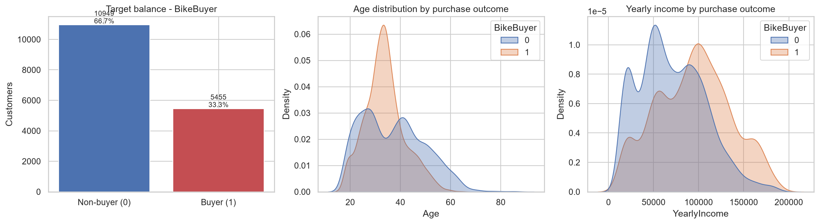
Figure 1: Target balance, and age and income distributions split by purchase outcome.
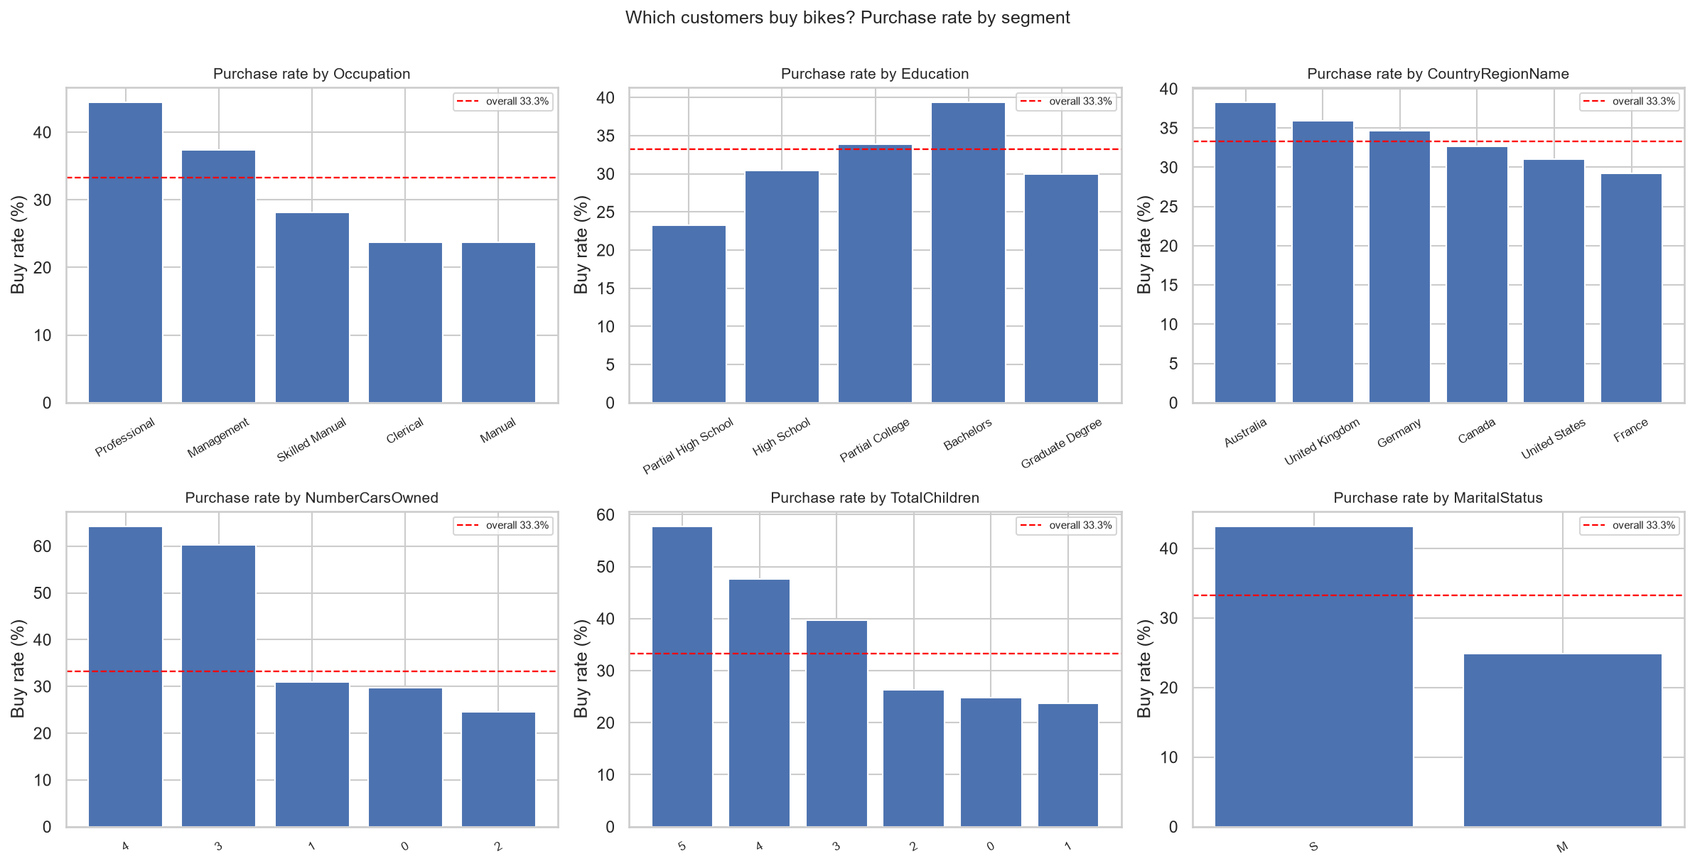
Figure 2: Purchase rate by segment against the overall base rate. Household and occupation attributes separate more strongly than geography.
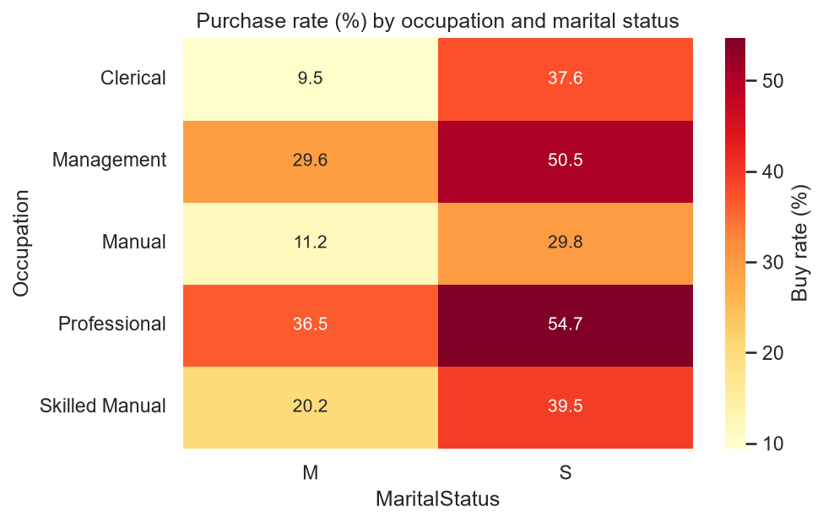
Figure 3: Purchase rate by occupation and marital status.

2.5 A Note on Target Leakage
AveMonthSpend records what a customer spends with Adventure Works. Because it is measured contemporaneously with - and is partly caused by - the bicycle purchase itself, including it as a predictor would leak the outcome into the feature set and inflate every reported score. It would also be unavailable at scoring time for a prospect who has not yet bought anything, so a model relying on it could not be deployed for its intended purpose. It is excluded from the predictors throughout, and retained only as a candidate target for the secondary regression framing.

3. Proposed Methodology

3.1 Candidate Algorithms
Algorithm | Why it fits | Role
Majority-class / random baselines | Establishes the honest floor. Demonstrates concretely that ~67% accuracy is achievable while identifying zero buyers. | Baseline
Logistic Regression | Fast, interpretable benchmark. Coefficients show the direction and size of each demographic effect, which communicates well to marketing stakeholders. | Interpretability benchmark
K-Nearest Neighbours | Instance-based comparator - tests whether similar customers simply behave similarly, without assuming a functional form. | Diagnostic
Decision Tree | Captures threshold effects and interactions in a form a non-technical audience can read directly. | Intermediate
Random Forest | Bagged ensemble; handles mixed numeric and categorical features, interactions and outliers robustly, and yields feature importances. | Ensemble (bagging)
Gradient Boosting / HistGradientBoosting | Sequential ensembles that typically lead on tabular classification; strong ranking quality, which is what the campaign consumes. | Primary candidate
Voting and Stacking ensembles | Combine complementary model families; soft voting preserves probability ranking, stacking learns optimal weights. | Ensemble (blending)

3.2 Evaluation Approach
- Stratified 80 / 20 train-test split, preserving the class ratio in both partitions. A random split is appropriate because this is a customer cross-section, not a time series.
- Five-fold StratifiedKFold cross-validation for hyperparameter tuning, via RandomizedSearchCV, supported by validation curves to locate the onset of over-fitting.
- Primary metric ROC-AUC; secondary metrics F1, PR-AUC, precision, recall and balanced accuracy. Accuracy is reported but never relied on alone.
- Decision-threshold optimisation rather than acceptance of the 0.50 default, evaluated against both F1 and expected campaign profit.
- Principal Component Analysis evaluated as a dimensionality-reduction experiment, with adoption decided on measured AUC rather than assumption.

3.3 Preliminary Model Results
An initial pass across the candidate algorithms gives the following hold-out performance, and confirms the framing is sound before the full Phase 2 build.
Model | Accuracy | F1 | ROC_AUC | PR_AUC
HistGradientBoosting (tuned) | 0.7998 | 0.6703 | 0.8606 | 0.7791
Stacking Ensemble | 0.7973 | 0.665 | 0.8601 | 0.778
Gradient Boosting | 0.7961 | 0.6623 | 0.8576 | 0.7749
HistGradientBoosting | 0.7952 | 0.6627 | 0.855 | 0.7714
Voting Ensemble | 0.7891 | 0.6498 | 0.8538 | 0.765
Random Forest (tuned) | 0.7888 | 0.6433 | 0.8505 | 0.7629
Decision Tree | 0.7796 | 0.6321 | 0.8341 | 0.7227
K-Nearest Neighbours | 0.7863 | 0.6479 | 0.8335 | 0.7262
Table 4: Preliminary hold-out performance, ranked by ROC-AUC.
The tuned boosting model leads at ROC-AUC 0.8606 with F1 0.6703, against 0.5000 for the majority-class baseline. Ranked by predicted propensity, the top decile of customers buys at 2.78 times the base rate, and the top 30 per cent of the list captures 64.6 per cent of all buyers - which is the result that makes the model commercially useful.
The strongest predictors are:
- NumberChildrenAtHome
- Age
- IsSingle
- Gender_M
- YearlyIncome

3.4 Deep Learning Extension (Future Scope)
The feature set is largely categorical, which suits a neural network with entity embeddings: each categorical level is mapped to a learned dense vector rather than a sparse one-hot column, allowing the network to discover which levels behave alike instead of forcing them all to be equidistant, as one-hot encoding does. Those learned vectors are also inspectable, so the resulting structure can be read and sense-checked by the marketing team rather than taken on trust. A feed-forward network over these embeddings is the planned Phase 3 extension, alongside probability calibration so that predicted scores can be used directly in expected-value calculations.

4. Business KPIs Impacted
- Campaign response rate - the share of contacted customers who purchase. Targeting the top decile rather than the whole list raises the achieved response rate by roughly 2.8 times.
- Cost per acquisition - marketing spend divided by customers acquired. Falls as low-propensity contacts are removed from the campaign.
- Marketing return on investment - measured as campaign profit against campaign cost, and the metric on which the optimal mailing depth is chosen.
- List fatigue and unsubscribe rate - fewer irrelevant contacts protects the long-term value of the customer list, a cost that a single-campaign profit calculation does not capture.
- Budget allocation efficiency - the model produces a ranking, so it tells the business the order in which to spend a budget of any size rather than a single fixed answer.
An important qualification, established during analysis and carried into Phase 2: whether targeting increases profit depends on the economics of the channel, not only on model quality. A customer is worth contacting whenever their purchase probability exceeds break-even = cost per contact divided by margin per sale. For cheap channels such as email that threshold is very low, most of the base clears it, and the model's value lies in efficiency rather than in profit uplift. For expensive channels such as printed catalogues or outbound calling, the threshold rises, optimal campaign depth falls sharply, and targeting becomes decisive.

5. Tools and Technologies
Category | Tools / Libraries
Language | Python 3.13
Data handling | Pandas, NumPy
Visualisation / EDA | Matplotlib, Seaborn
Modelling | Scikit-learn - LogisticRegression, KNeighbors, DecisionTree, RandomForest, GradientBoosting, HistGradientBoosting, Voting, Stacking
Model selection | RandomizedSearchCV, StratifiedKFold, validation_curve
Dimensionality reduction | Scikit-learn PCA
Interpretation | Permutation importance, calibration curves, decile lift analysis
Future DL extension | PyTorch - entity-embedding neural network (Phase 3)
Environment | Jupyter Notebook / Google Colab

6. Summary
This project applies supervised machine learning to direct-marketing targeting for Adventure Works Cycles, using Microsoft's publicly available AdventureWorks customer data - 16404 unique customers across six countries, described by 23 demographic and household features after cleaning and selection. The business problem is which customers to contact in the next campaign; the ML problem is binary classification of BikeBuyer, evaluated as a ranking task.
Exploratory analysis confirms genuine signal, concentrated in household composition, occupation and income rather than geography, and identifies several data-quality issues - duplicate records with conflicting values, a whitespace defect in a category level, an ordinal variable requiring rank encoding, and a target-leakage risk in AveMonthSpend - that make data preparation a substantive stage of the work rather than a formality.
A tuned gradient-boosting classifier is the recommended primary model, achieving ROC-AUC 0.8606 and separating the top propensity decile at 2.78 times the base purchase rate. Translated into campaign terms, the top 30 per cent of the ranked customer list captures 64.6 per cent of all buyers, allowing marketing budget to be concentrated where it earns a return and supporting measurable improvements in response rate, cost per acquisition and marketing ROI.

