|  |  |  |
| --- | --- | --- |
| TO-DO-LIST APPLICATION | | |
|  |  |  |
| Entity Relationship Diagrams | | |

# Overview

This Document shows the Entity Relationship diagrams used to model the database of the project and the relationship between each individual table/ entity.

The key used to represent the relationships between different entities in the database:



# ERD I – Drawn out at Start of Project

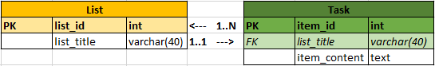

# ERD II – Drawn out at End of Project - FINAL

