**Motor control system**

Hardware connection

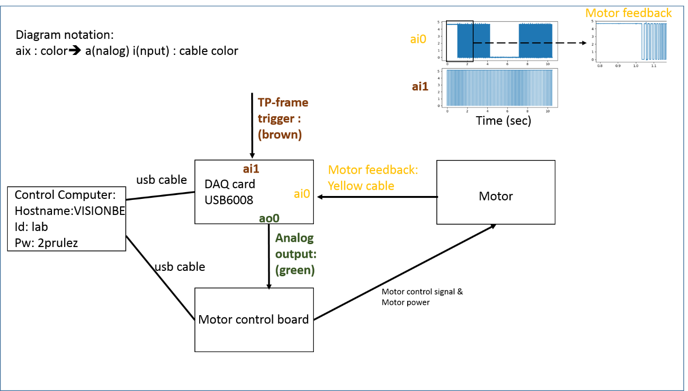

Hardware setting

|  |  |
| --- | --- |
| C:\Users\slee\Downloads\Photos\IMG_20190703_114121987.jpg | C:\Users\slee\Downloads\Photos\IMG_20190703_115709152.jpg |

**Software**

1. connect VISIONBE WITH id(lab) and password(2prulez)

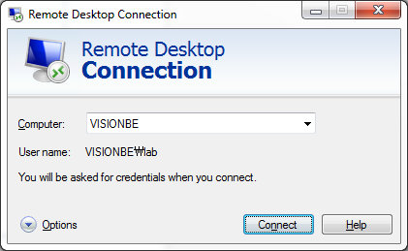

2. open ‘cmd’ and go to the directory C:\Pybehav

3.

**for Calibration, type ‘python dc\_motor.py Cal’**

For change of calibration parameter, change the file name of ‘DCmotor\_Cal.json’

After running the code, two pop-up windows are created.

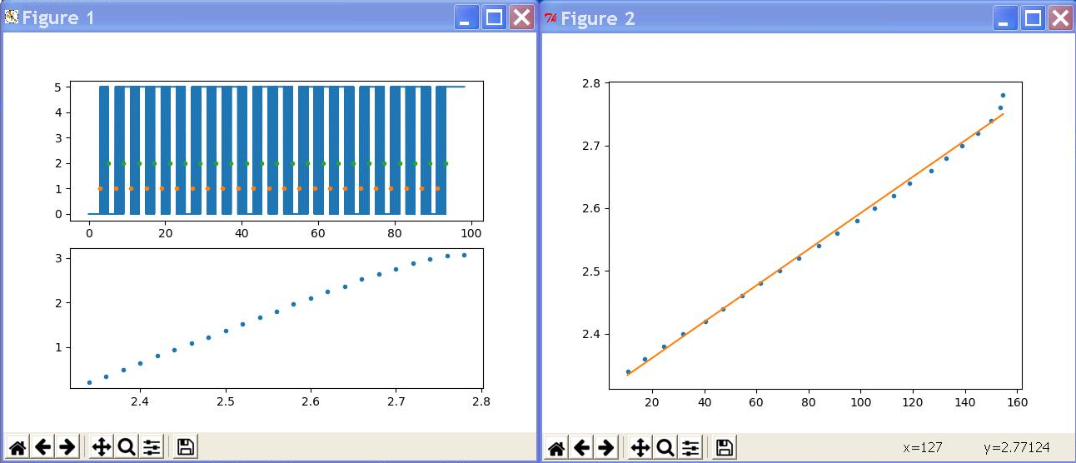

Figure 1 top shows the raw motor feedback signals specified in ‘DCmotor\_Cal.json’

Figure 1 bottom shows the calculated rotation (y) and applied voltage.

Figure 2 shows the linear function between speed (cm/sec) and voltage.

**If a user close the two windows, the slope (a) and the bias (b) will be shown in the bottom of the terminal.**

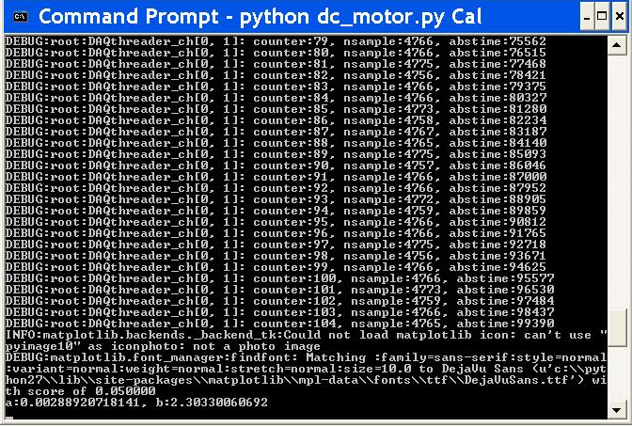

**for Running, type ‘python dc\_motor.py Run’**

For change of Run parameter, change the file name of ‘DCmotor\_Run.json’

**The most crucial part of this file is to properly set parameters (i.e., a, b) from the motor calibration and “wheel\_radius”. See above.**

**"speed\_to\_volt": {**

**"a": 0.00288920718141,**

**"b": 2.30330060692,**

**"speed\_max": 140**

**},**

**"wheel\_radius": 8,**

Based on your design of experiment, set the speed and block duration as follows:

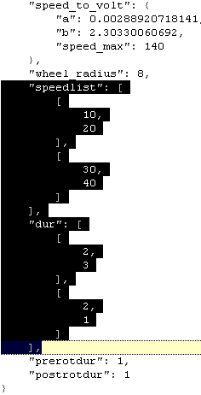

In this example, there are two ramping blocks. In the first block, motor-rotation starts at 10cm/sec and finishes at 20cm/sec during 2seconds, which is followed by 3 seconds of motor stop. In the second block, starts from 30cm/sec and ramping up to 40cm/sec during 2sec, which is followed by 1 second of motor stop.