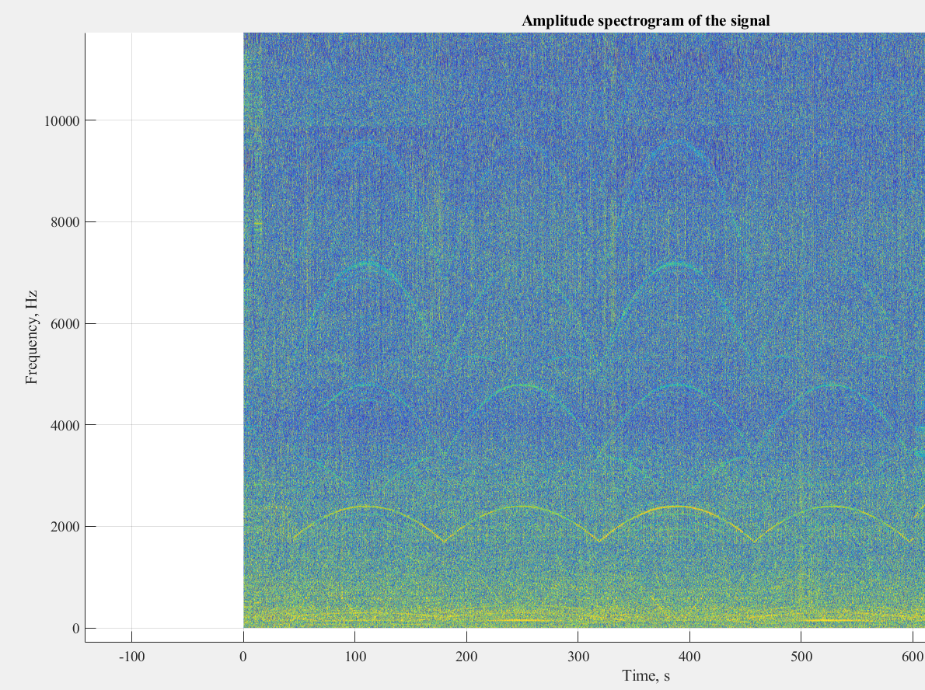

3600

2500

1500

* Distinct presence of 3 different frequencies from x, y, z direction motors and the presence of resonance frequencies
* 0-600 sec is a good place to work with.
* Interest is only on the lower frequency. We will neglect the higher frequency orders.
* However, we can see that there is another frequency spectrum of interest which is off by 90 degrees phase as seen in the spectrogram

|  |  |  |  |  |
| --- | --- | --- | --- | --- |
| G Code | travel feed rate | 4800 | mm/min |  |
|  | distance | 80 | mm/sec |  |
| G0 F9000 X44.680 Y49.652 Z0.500 | X | Y | distance | time(s) |
| ;TYPE:WALL-OUTER | 44.68 | 49.652 |  |  |
| G1 F2220 X61.103 Y64.439 E842.49732 | 61.103 | 64.439 | 22.0991 | 0.276239 |
| G1 X60.969 Y64.587 E842.50396 | 60.969 | 64.587 | 0.19965 | 0.002496 |
| G1 X44.547 Y49.800 E843.23896 | 44.547 | 49.8 | 22.09836 | 0.276229 |
| G1 X44.680 Y49.652 E843.24557 | 44.68 | 49.652 | 0.19898 | 0.002487 |
| G0 F9000 X43.810 Y50.624 | 43.81 | 50.624 | 1.304486 | 0.016306 |
|  |  |  |  |  |
|  |  |  |  |  |
|  | time for 1 degree |  | 0.573757 |  |

* 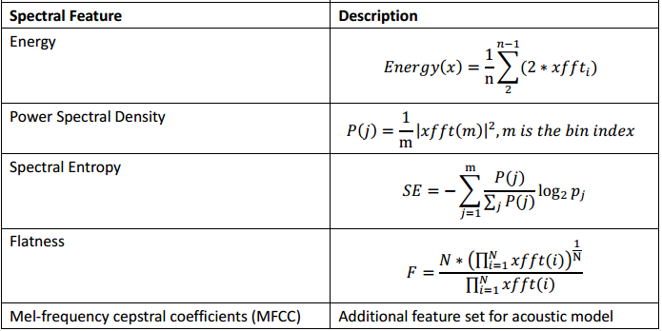**Feature determined(spectral)**
* 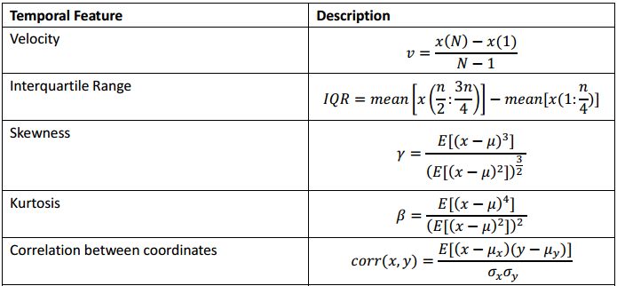**Temporal features**

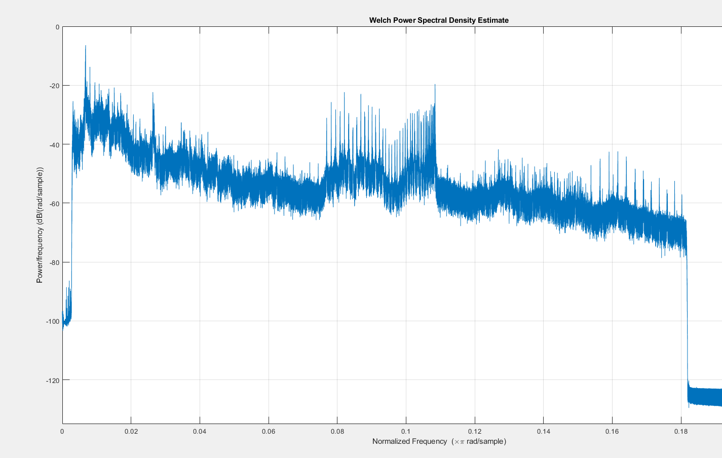

PWELCH

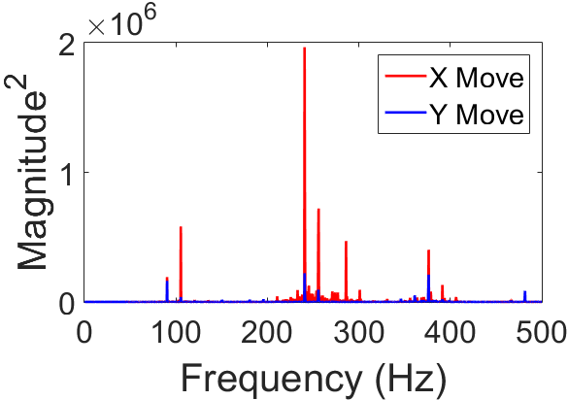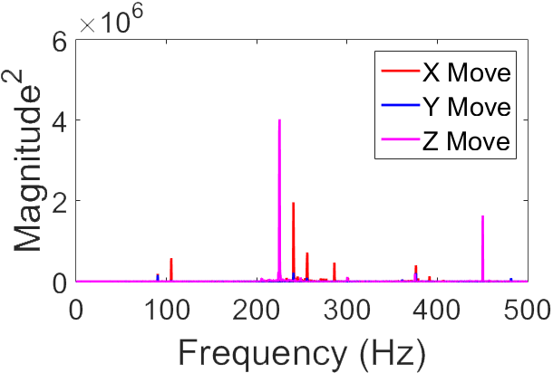**Expected frequencies**

**Extracted frequencies**

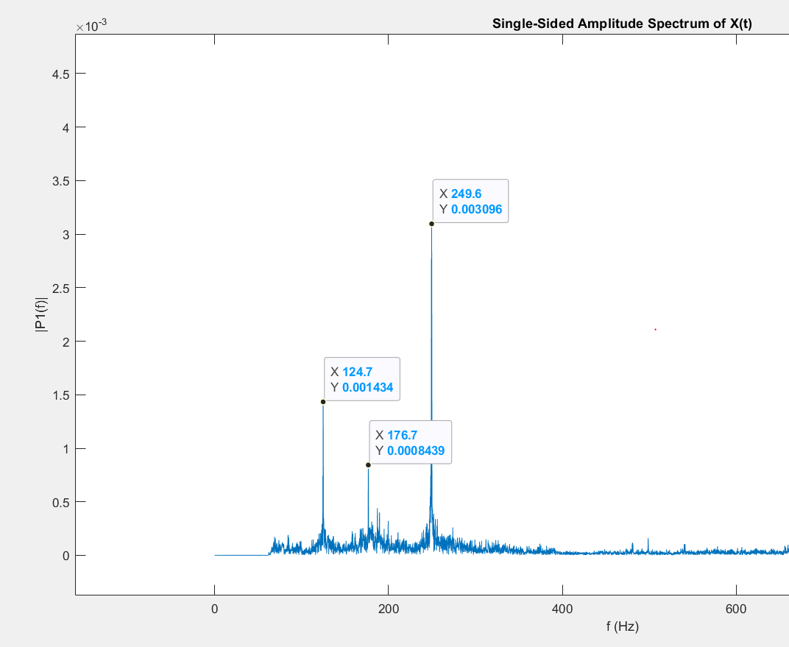

Y

