

भारतीय प्रौद्योगिकी संस्थान मुंबई

Indian Institute of Technology Bombay

SOM 624

Warehouse Operations

Course Assignment 4

Group 4

**Instructor :**  **By:**

Prof. Gajendra K Adil Mohan Krishna Katta 23M1523

Saurabh Mehra 23M1525

Yogesh R Jangid 23M1530

Sangram 23M1532

Jayant Kumar Jha 23M1730

**Question 1**

**Random Storage policy** :

Number of putaway, D = 914

Number of total picks, P = 4360

Average time for one way operation, tRandom = 11.54

Total time required for the random storage policy = 2* tRandom *D + 4*tRandom *P

= 11.54*2*914 + 11.54*2*2*4360

**TRandom = 222353 Seconds**

**Assumption :**  One product is kept in only one slot of the forward stock area, hence a total of 10 products in the forward reserve area.

**Heuristic 1** :

In this the products which have higher number of pick up are placed in the premium locations, so that we can quickly pick the required products. This intuitively reduces the travel time required for the S/R. The top products are ranked according to the number of picks.

The top 10 products according to the number of picks are

⇒ 5, 46, 36, 8, 44, 48, 56, 1, 20, 3.

These products will be assigned slots in the forward pick area, and these will be having shorter picking time.

Putaway time ⇒ **TPutaway** = 2 *x* tReserve *x* D

= 2*11.54*914 = **21095.12**

Picking Time :

Forward pick time ⇒ **TF =** sumj( 4 x tfForward x Pj )

= **17450.52**

Reserve area picking time ⇒ **TR** = 4 x tReserve x PR

= 4*12.02* **sumj(**PR j)

= **126306.2**

Internal replenishment time ⇒ **TReplanishment** = sum*j* (*cjReplanishment* x *dj*)

= **31950.21**

Total time taken by **heuristic 1** is given by ⇒ **TH1** = **TPutaway** + **TF**+**TR + TReplanishment**

**TH1** = 21095.12 + 17450.52 + 126306.2 + 31950.2

**TH1  = 196802.01 seconds**

**Heuristic 2** :

In this type of configuration the premium slots are assigned to the products having higher ratio of number of pick to the load. The products are arranged in the descending orders and the top products are assigned to the premium locations in order to reduce the time required to travel.

The top 10 products according to the ratio of number of picks to load are

⇒ 46, 20, 54, 32, 51, 40, 42, 35, 11, 44

These products will be assigned slots in the forward pick area, and these will be having shorter picking time, according to heuristic 2.

Putaway time ⇒ **TPutaway** = 2 *x* tReserve *x* D

= 2*11.54*914 = **21095.12**

Picking Time :

Forward pick time ⇒ **TF =** sumj( 4 x tfForward x Pj )

= **10276.96**

Reserve area picking time ⇒ **TR** = 4 x tReserve x PR

= 4*12.02* **sumj(**PR j)

= **158952.5**

Internal replenishment time ⇒ **TReplanishment** = sum*j* (*cjReplanishment* x *dj*)

= **599.4**

Total time taken by **heuristic 2** is given by ⇒ **TH2** = **TPutaway** + **TF**+**TR + TReplanishment**

**TH2** = 21095.12 + 10276.96 + 158952.5 + 599.4

**TH2  = 190923.96 seconds**

| **Random Storage policy** | **Heuristic 1** | **Heuristic 2** |
| --- | --- | --- |
| 222353 secs | 196802.2 secs | 190923.96 secs |

**Note**: Please refer the excel sheet for calculation

**Question 2**

By using the pulp modeler which uses CBC (Coin OR Branch and cut) inside to solve the integer programming. The coding language used to solve the IP is PYTHON in the Google Colab

The link for the colab is “[WareHosuse for the IP.ipynb](https://colab.research.google.com/drive/1RxkkBvKm52jY_OsV8ftq-C43rqn1buVY?usp=sharing)”

| **INDEX** | **1** | **2** | **3** | **4** | **5** |
| --- | --- | --- | --- | --- | --- |
| **2** | 20 | 54 | 50 | 14 | 3 |
| **1** | 46 | 8 | 48 | 44 | 56 |

This above is the representation of the product number in the forward area in dedicated slots.

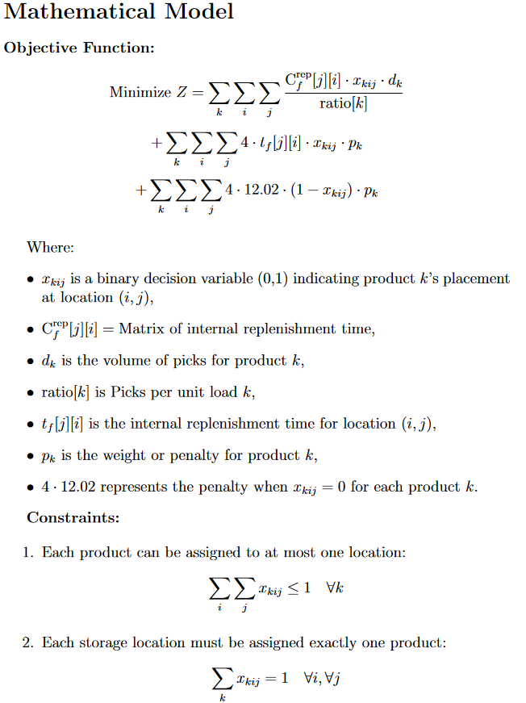

Comparing the results for the Heuristic 1, Heuristic 2 and the exact method using a mathematical model. The calculations are the same as that for heuristic 1 and 2. We got the optimal product number to which is to be kept in different slots in the forward area.

| **Random Storage policy** | **Heuristic 1** | **Heuristic 2** | **Mathematical model (by solver)** |
| --- | --- | --- | --- |
| 222353 secs | 196802.2 secs | 190923.96 secs | 180607.16 secs |

**Note**: Please refer the excel sheet for calculation

**Question 3**

**3a:**

Based on the chart, here we can say about the two heuristics (H1 and H2) and the optimization model:

**Heuristic 1 (H1) :**

H1 does better than random storage but is generally worse than both H2 and the optimization model. However, when the forward pick area gets bigger, especially with more columns than rows, H1 starts to perform almost the same as H2. The optimization model still performs better though.

**Heuristic 2 (H2)** **:**

H2 is better than H1 in most cases. But like H1, when the forward pick area gets bigger with more columns, the difference between H1 and H2 becomes smaller, and both start to give similar results.

**Optimization Model :**

The optimization model is consistently better than both H1 and H2. As the forward pick area gets larger, the gap between the optimization model and H1 gets even bigger, showing that the optimization model is much more effective, especially in larger areas.

**3b**

As the forward pick area becomes larger:

**Travel Time :**

Increasing the size of the forward pick area helps reduce travel time. H2 and the optimization model benefit more from this, but for H1, the travel time improvement becomes smaller as the area grows to a certain limit.

**Buffer Storage Capacity :**

A larger forward pick area means less space for buffer storage, which is the space used to keep products for restocking. This could limit how much product can be stored and might cause issues if not managed properly. The optimization model can help find the right balance between reducing travel time and keeping enough storage space for smooth operations.