**A PROJECT REPORT ON**

## “GESTURE AND VOICE HYBRID INTERFACE”

SUBMITTED TO THE SAVITRIBAI PHULE PUNE UNIVERSITY, PUNE IN THE PARTIAL FULFILLMENT OF THE REQUIREMENTS

FOR THE AWARD OF THE DEGREE

OF

**BACHELOR OF ENGINEERING IN**

**INFORMATION TECHNOLOGY**

**SUBMITTED BY**

#### **SAGAR SADAKE Exam No. B400070550**

#### **MOHIT CHINNI Exam No. B400070527**

#### **SANGRAM WABALE Exam No. B400070562**

#### **KANCHI SONKULE Exam No. B400070559**

### UNDER GUIDANCE OF PROF.S.G.KAMBLE

**DEPARTMENT OF INFORMATION TECHNOLOGY**



**PVG’s COLLEGE OF ENGINEERING AND TECHNOLOGY & G K PATE (WANI) INSTITUTE OF MANAGEMENT, PUNE.**

### 44, VIDYANAGARI, PARVATI, PUNE 411009

**2024-25**

**CERTIFICATE**

This is to certify that the project report entitled

### “GESTURE AND VOICE HYBRID INTERFACE”

**SUBMITTED BY**

#### **SAGAR SADAKE Exam No. B400070550**

#### **MOHIT CHINNI Exam No. B400070527**

#### **SANGRAM WABALE Exam No. B400070562**

#### **KANCHI SONKULE Exam No. B400070559**

are bonafide students of this institute, and the work has been carried out by them under the supervision of **Prof.S.G.Kamble**. The project report is approved for the partial fulfillment of the requirement of Savitribai Phule Pune University for the award of the degree of Bachelor of Engineering (Information Technology).

Prof.S.G.Kamble Dr.S.A.Mahajan

Internal Guide HOD

Dept. of Information Technology Dept. of Information Technology

Dr. M. R. Tarambale

External Examiner I/C Principal

Date: PVG’s COET GKPIOM, Pune

**Place:** Pune

**Date:**

# Acknowledgement

We take this opportunity to express our deep sense of gratitude to all those who have contributed towards the successful completion of our final year engineering project, *"Gesture and Voice Hybrid Interface"*.

First and foremost, we extend our sincere thanks to **Prof. S. G. Kamble**, our project guide, for his invaluable guidance, continuous encouragement, and insightful feedback throughout the duration of this project. His expert advice and timely support have been crucial to development of our work.

We are extremely grateful to the **Department of Information Technology**, as well as our institute, for providing us with the platform, infrastructure, and resources necessary for the successful execution of this project. We would also like to thank our respected faculty members for their constant support and motivation.

We would also like to extend our heartfelt gratitude to Dr. S. A Mahajan, Head of the Information Technology Department, PVGCOET & GKPIOM, Pune, for providing the essential resources, infrastructure, and a supportive environment that enabled us to successfully complete this project. We are especially grateful for his encouragement and trust in our capabilities.

Additionally, we express our sincere thanks to all the staff members of the Information Technology Department who assisted us, either directly or indirectly, throughout this endeavor. Lastly, we are profoundly grateful to our family and friends for their unwavering support, understanding, and encouragement during the course of this project.

#### **SAGAR SADAKE**

#### **MOHIT CHINNI**

#### **SANGRAM WABALE**

# KANCHI SONKULE

(***B.E INFORMATION TECHNOLOGY)***

# Abstract

The evolution of Human-Computer Interaction (HCI) has witnessed a significant shift from traditional input methods such as keyboards, mice, and touchscreens to more natural and intuitive modes of communication. Among these, gesture and voice-based interfaces are emerging as promising alternatives, offering hands-free, user-friendly, and accessible interaction with machines. This project, titled **"Gesture and Voice Interface,"** aims to design and develop a hybrid system that enables users to control and interact with a computer using hand gestures and voice commands, without the need for physical contact.

The gesture recognition component of the system leverages computer vision techniques and real-time video feed from a standard webcam. Using libraries such as **OpenCV** and **MediaPipe**, the system detects hand landmarks and interprets gestures like pointing, clicking, scrolling, and dragging. Simultaneously, the voice command module captures spoken input via a microphone and processes it using **speech recognition** techniques through Python-based libraries such as **SpeechRecognition** or **Google Speech-to-Text API**. Commands are recognized and mapped to corresponding system actions.

By combining both gesture and voice modalities, the system enhances the interactivity and accessibility of computing environments. It enables users to perform multiple tasks without relying on physical input devices, which is particularly beneficial for users with physical disabilities, in sterile or industrial settings, or in futuristic AR/VR applications where touch interaction may not be feasible.

This hybrid interface not only improves the user experience by offering a more natural and immersive way to interact with technology but also demonstrates the potential of multimodal systems in next-generation computing platforms. The system has been tested for various use cases, including cursor control, application launching, and browser navigation, showing promising results in terms of responsiveness, accuracy, and user satisfaction.

Overall, this project contributes to the growing field of intelligent interfaces by integrating gesture and voice recognition into a unified platform, paving the way for more intuitive, accessible, and touchless human-machine interactions.

**CONTENTS**

#### Introduction

* 1. Project Undertaken 9
  2. Objective 12

#### Background

* 1. Motivation 13
  2. Objectives 14

#### Literature Survey 15

#### Problem Statement 18

#### Project Requirements Specification

* 1. Functional Requirements 21
  2. Non-Functional Requirements 27
  3. User and System Requirements 31

1. *System Design* 24

#### Flowchart 27

#### High Level Design of the Project

* 1. Data Flow Diagram 28
  2. Architecture Diagram 29
  3. Use Case Diagram 30
  4. Class Diagram 31
  5. Activity Diagram 32
  6. Sequence Diagram 33

#### Implementation 34

* 1. Methodology 34
  2. Algorithm 35

#### Results 49

#### Project Plan 51

#### Future Scope 52

#### Summary 55

#### Conclusion 56

#### Reference 59

# List of Figures

1.1 System overview diagram 24

1.2 Flow Chart 27

1.3 System Architecture 29

 1.4 Level 0 DFD 28

1.5 Level 1 DFD 28

1.6 Use Case 30

1.7 Class Diagram 31

1.8 Activity diagram 32

1.9 Sequence Diagram 33

# List of Tables

|  |  |  |
| --- | --- | --- |
| * 1. Literature Survey | | 15 |
| 1.2 Project Requirement Specification | | 21 |
|  |
|  |

## Introduction

### 1.1 Project Undertaken

In the digital age, human-computer interaction (HCI) has evolved significantly beyond traditional interfaces like keyboards, mice, or touchscreens. As users demand more natural, seamless, and inclusive ways to interact with technology, multimodal interfaces—particularly those based on voice and gesture—are rapidly emerging as transformative innovations. Our project, titled **"Voice and Gesture Based Human-Computer Interaction System,"** addresses this evolution by combining two powerful modalities: hand gesture recognition and voice command processing.

The goal of this project is to develop an intelligent, touchless interface that enables users to control a computer system using only hand movements and voice instructions. By doing so, the system not only enhances user convenience but also becomes highly beneficial for differently-abled users, elderly individuals, or scenarios where touch-based interaction is impractical (such as during medical operations, industrial monitoring, or hands-free environments).

This system integrates a **gesture recognition module** powered by **MediaPipe**, a framework that detects and tracks 21 key landmark points on the hand in real-time using a webcam. These landmarks are analyzed using **OpenCV** to derive angles, distances, and finger positions, which are then classified into recognizable gestures like swipe, click, zoom, etc. For example, when a user pinches their fingers together, the system interprets it as a click operation, while spreading fingers can represent zooming in or out.

Parallelly, the **voice recognition module** uses the **SpeechRecognition API**, which records the user's voice using a microphone and converts it into text using **automatic speech recognition (ASR)**. The recognized text is then parsed through a **Natural Language Processing (NLP)** module to identify key action commands such as "open folder," "scroll down," or "close tab." These commands are mapped to specific operating system-level functions through libraries like **pyautogui** or **subprocess**.

For instance, the user may say "Open Google Chrome," and the system, upon recognizing and parsing the input, executes the command by launching the Chrome browser. Similarly, the user can move the cursor or scroll on the screen using their hand gestures. This parallel operation makes the system efficient, flexible, and user-friendly.

The entire architecture of the system is modular, consisting of:

1. **Video Capture Unit**: Continuously captures hand movements using a webcam.
2. **Hand Landmark Detection Module**: Utilizes MediaPipe to identify key points on the hand.
3. **Gesture Analysis Engine**: Applies rules and calculations to recognize specific gestures.
4. **Audio Input Unit**: Continuously listens to user voice commands.
5. **Speech-to-Text Converter**: Converts spoken language into machine-readable text.
6. **NLP Command Processor**: Extracts actions and keywords from the speech.
7. **Command Mapping Module**: Maps voice or gesture inputs to system operations.
8. **Action Executor**: Executes the required system-level task.

The application is developed in **Python** and leverages various open-source libraries, including:

* **MediaPipe**: For hand tracking and landmark recognition.
* **OpenCV**: For real-time video processing and gesture logic implementation.
* **SpeechRecognition**: For converting voice to text.
* **pyttsx3 / gTTS**: For text-to-speech feedback (optional enhancement).
* **pyautogui**: For performing mouse and keyboard automation tasks.

From a user’s perspective, the interaction is seamless and requires no physical touch. Users simply gesture with their hand or speak a command, and the system responds accordingly. This makes the interface highly adaptable in environments where hygiene, accessibility, or convenience is a priority.

The practical applications are vast. In **education**, the system can be used by teachers during online lectures to control slides or annotate screens without touching a device. In **smart homes**, users can control lighting, appliances, or music with simple gestures or voice commands. In **healthcare**, touchless interaction helps maintain sterility. In **public spaces**, such a system can serve as a touchless kiosk, reducing the risk of contamination.

Most importantly, this project aligns with the future of HCI where interaction with machines feels more human. It brings us closer to **Natural User Interfaces (NUIs)** that understand us better—making technology more accessible, responsive, and intelligent. The system's design also allows scalability and improvement, including future integration of AI for adaptive behavior, emotion recognition, and support for regional languages.

Overall, this project not only explores current technologies like computer vision and speech processing but also demonstrates their synergy in building smarter, safer, and more efficient human-machine interfaces.

### 1.2 Organization of Project Report

Section 1.2 contains background of the project. The background specifically mentions the motivation in the sense why we chose a rare topic such as coal mines and objectives of the project. Section 1.3 contains various hardware and software specifications required to implement the project. Section 1.4 states the design of the overall system with the help of various Unified Modeling Diagrams (UML diagrams). Sec- tion 1.5 specifies various implementation details of the project including technolo- gies used and algorithms of implementation. Section 1.6 demonstrates the results obtained after experimentation. Lastly, section 1.7 showcases future scope of our project and the conclusion.

## 2. Background

**2.1 Motivation**

Human-Computer Interaction (HCI) has evolved significantly over the past few decades, moving from punch cards and command-line interfaces to graphical user interfaces and touchscreens. However, traditional interaction methods such as the keyboard and mouse still dominate. While these devices are effective, they are not always practical in certain environments—such as hands-busy scenarios, industrial settings, or for individuals with physical disabilities.The motivation behind developing a Gesture and Voice Interface is rooted in the need for more **natural, intuitive, and accessible** methods of interacting with digital systems. Human beings naturally use **gestures and speech** in everyday communication, making them ideal candidates for creating a more seamless and immersive interaction experience. By leveraging computer vision and speech recognition technologies, it becomes possible to create a contactless and intelligent interface that mimics human behavior and enhances productivity, usability, and accessibility.Furthermore, the global push toward **touchless technologies**, accelerated by hygiene concerns (e.g., during the COVID-19 pandemic), has highlighted the importance of developing interfaces that do not require physical contact. Gesture and voice control are also crucial components in emerging technologies such as **Augmented Reality (AR), Virtual Reality (VR), robotics, and smart home systems**, making them highly relevant for future applications.

**2.2. Objectives**

The primary goal of this project is to design and implement a **hybrid interaction system** that uses both **hand gestures** and **voice commands** to control a computer or digital environment. This system aims to offer a more flexible and user-friendly alternative to conventional input devices. The specific objectives include:

* To **detect and interpret hand gestures** using a standard webcam and computer vision libraries such as **OpenCV** and **MediaPipe**, enabling functions like cursor movement, click events, and scrolling.
* To **integrate voice command recognition** using Python libraries such as **SpeechRecognition** or **Google Speech-to-Text API**, allowing users to control applications via spoken instructions.
* To develop a **real-time processing pipeline** that accurately captures, processes, and responds to both gesture and voice inputs with minimal latency.
* To create a **user interface (UI)** that demonstrates the effectiveness of this dual-input system in real-world use cases such as file navigation, application control, or web browsing.
* To evaluate the system’s **performance, accuracy, and user satisfaction**, especially in comparison to traditional input methods.
* To explore the potential for **assistive applications**, enabling users with mobility impairments to interact with computers more effectively.

**3. Literature Survey**

|  |  |  |  |
| --- | --- | --- | --- |
| Sr.No. | Title | Published  Year | Concept/Proposed work |
| 1. | AI Virtual Mouse: Revolutionizing Human–computer Interaction | 2024 | * AI-Powered Human-Computer Interaction: The AI Virtual Mouse eliminates the need for physical input devices by leveraging computer vision and deep learning models to recognize hand gestures and control cursor movements efficiently. * Enhanced Accessibility & Hygiene: This touchless interface significantly benefits users with disabilities and hygiene-sensitive environments like healthcare, reducing dependency on traditional hardware. |
| 2. | AI Virtual Mouse Using Hand Geatures | 2024 | * Integration with Existing Systems: The AI Virtual Mouse is designed to seamlessly integrate with current operating systems and applications, allowing users to adopt the technology without requiring significant changes to their existing workflows. * User-Friendly Calibration Process: The system includes an intuitive calibration process that adjusts to individual user characteristics, ensuring personalized and accurate gesture recognition for diverse users. |
| 3. | Virtual mouse using hand gestures | 2024 | * Enhanced Accessibility: The virtual mouse system leverages hand gesture recognition to control cursor movements, providing an alternative input method for individuals with mobility impairments, thereby promoting inclusivity in computing environments. * Integration with AR/VR Environments: By utilizing computer vision and machine learning algorithms, the system enables intuitive control over digital interfaces, enhancing user immersion in augmented reality (AR) and virtual reality (VR) applications. |
| 4. | Gesture and Voice Controlled Virtual Mouse | 2024 | * The research proposes a system that combines gesture and voice control to provide a more intuitive way of interacting with computers, especially for those with disabilities or difficulties using traditional input methods. * It utilizes advanced technologies like MediaPipe, TensorFlow, and OpenCV to interpret hand gestures and voice commands for seamless interaction. * The approach not only enhances accessibility for users with diverse abilities but also adds an element of enjoyment in activities like gaming. |
| 5. | Review on Touchless Virtual Mouse Technologies and A.I. Voice Assistants | 2023 | * The paper explores innovations in Human-Computer Interaction (HCI), specifically on two fronts: virtual mouse systems and AI-driven voice assistants. * The highlight is the Mouse less system, which utilizes infrared cameras and lasers to interpret hand gestures, allowing for mouse control without physical devices. |
| 6. | Gesture Controlled Virtual Mouse and Keyboard Using OpenCV | 2023 | * The research focuses on developing a gesture-controlled interface that leverages hand gestures, voice commands, and eye movements to interact with computers, reducing the need for physical contact. * The proposed system integrates a hybrid model for gesture control that combines voice, hand gestures, and eye movements to manage computer operations virtually. * A Convolutional Neural Network (CNN) is implemented using MediaPipe on top of Pybind11 to analyze inputs from hand and eye movements. |
| 7. | Voice Assistant and Gesture Controlled Virtual Mouse using Deep Learning Technique | 2023 | * The study integrates voice instructions with both static and dynamic hand gestures to manage input and output processes digitally, removing the need for hardware-based interactions. * The study utilizes CNN-like models and employs MediaPipe—a framework built on pybind11—to process and interpret hand gestures. |
| 8. | Design and Development of Gesture Recognition Based Virtual Mouse System | 2023 | * The study introduces an artificial intelligence-based virtual mouse system that allows for device-free computer control by utilizing computer vision and machine learning technologies * The study highlights the system's potential role in preventing the spread of COVID-19 by reducing physical contact with external devices in public spaces, such as airports. * The system is particularly useful in environments where minimizing contact with external devices is important, such as in medical facilities or public spaces. |

## 4. Problem Statement

In the digital era, human-computer interaction (HCI) is still largely dependent on traditional input devices such as keyboards and mice. Although these are effective and familiar, they pose accessibility, convenience, and hygiene challenges. These limitations become especially significant in scenarios involving users with disabilities, sterile or hazardous environments, and multitasking conditions that benefit from hands-free control.

With the increasing demand for natural and intuitive interfaces, touchless solutions are gaining traction. The widespread availability of webcams, microphones, and machine learning tools provides a solid foundation for systems capable of interpreting gestures and voice commands.

The "Gesture-Voice Hybrid Interface" project aims to address these limitations by creating a system that replaces physical input devices with hand gestures and voice commands. The solution employs OpenCV and MediaPipe for gesture recognition and integrates speech recognition APIs for processing voice commands, enabling seamless and touch-free control of computing tasks.

The goal is to provide a robust, accessible, and user-friendly interface compatible with systems equipped with a webcam and microphone. This interface enables cursor control, clicking, scrolling, and command execution without any physical contact.

The hybrid model significantly enhances user experience, proving especially beneficial in:

* Environments involving individuals with limited mobility or disabilities
* Healthcare and sterile conditions
* Smart classrooms or laboratories
* Industrial control systems
* Multitasking environments

It also helps reduce dependency on hardware peripherals, lowering both cost and maintenance requirements.

**4.1 Overall Problem Description:**

1. Traditional interfaces are not optimal for hands-free operation.
2. Physical interaction can be restrictive or unhygienic.
3. Accessibility remains a challenge for differently-abled individuals.
4. There is a need for natural, intuitive, and real-time interaction mechanisms.

**Problem Division into Modules:**

**Module 1: Gesture Recognition System**

* Captures real-time video feed using a webcam.
* Processes frames via OpenCV and MediaPipe to detect hand landmarks.
* Classifies gestures (e.g., open hand, pinch, swipe) based on landmarks.
* Maps gestures to control functions such as mouse movement and clicks

.

**Module 2: Voice Command System**

* Continuously listens for input through a microphone.
* Uses Python's SpeechRecognition and Google APIs to process voice.
* Recognizes specific commands and executes tasks like file operations and volume control.

**Module 3: Hybrid Interaction Layer**

* Integrates outputs from gesture and voice modules.
* Manages command priority and prevents conflicts.
* Synchronizes actions and provides module status updates.

**Module 4: User Interface & Accessibility Module**

* Displays gesture recognition feedback.
* Indicates active module (voice or gesture).
* Allows user configuration for commands and settings.
* Includes accessibility support features like screen reading.

**Module 5: Testing, Evaluation, and Optimization**

* Assesses system performance under various conditions.
* Analyzes latency, resource usage, and accuracy.
* Implements enhancements like gesture smoothing and noise filtering.

1. **Project Requirement Specification**
   1. **Functional and Non Functional Requirements**

**A. Functional Requirements**

|  |  |
| --- | --- |
| **ID** | **Requirement Description** |
| FR-01 | Detect hand gestures using a webcam in real time. |
| FR-02 | Recognize voice commands using a microphone. |
| FR-03 | Interpret gestures for mouse movements, clicks, and scrolling. |
| FR-04 | Interpret voice for keyboard functions and control commands. |
| FR-05 | Launch/stop gesture control via voice command. |
| FR-06 | Display real-time visual feedback for gesture detection. |
| FR-07 | Continuously capture and process webcam input. |
| FR-08 | Continuously listen and process voice input. |
| FR-09 | Provide confirmation (audio/visual) of recognized commands. |
| FR-10 | Seamlessly switch between gesture and voice modes. |
| FR-11 | Provide GUI for interaction and configuration. |
| FR-12 | Classify gestures using 21 hand landmarks (MediaPipe). |
| FR-13 | Execute file navigation and system control via voice. |
| FR-14 | Support neutral gesture to pause gesture recognition. |
| FR-15 | Allow command customization by users. |

**B. Non-Functional Requirements**

|  |  |
| --- | --- |
| ID | Requirement Description |
| NFR-01 | Latency between input and action should be <300ms. |
| NFR-02 | Achieve at least 90% accuracy under optimal lighting. |
| NFR-03 | Robust voice recognition under up to 30dB background noise. |
| NFR-04 | RAM usage should not exceed 1.5GB. |
| NFR-05 | Support both Windows and Linux OS. |
| NFR-06 | Maintain responsiveness on a dual-core processor. |
| NFR-07 | Interface should be accessible to users with disabilities. |
| NFR-08 | Provide error handling for unrecognized inputs. |
| NFR-09 | No personal data should be stored. |
| NFR-10 | System should be modular and extensible. |

**5.2 Description of Use Cases**

|  |  |
| --- | --- |
| Use Case ID | Use Case Title |
| UC-01 | Launch Gesture Recognition |
| UC-02 | Launch Voice Assistant |
| UC-03 | Execute Mouse Movement via Gesture |
| UC-04 | Perform Click via Gesture |
| UC-05 | Scroll Screen using Gesture |
| UC-06 | Minimize/Maximize Window via Voice |
| UC-07 | Launch Applications via Voice |
| UC-08 | Copy and Paste using Voice |
| UC-09 | Toggle Gesture/Voice Input Mode |
| UC-10 | Show Feedback on Gesture Error |
| UC-11 | Adjust Volume/Brightness with Gesture |
| UC-12 | Sleep/Wake Voice Assistant |

**5.3 Software and Hardware Requirements**

**A. Software Requirements**

|  |  |  |
| --- | --- | --- |
| ID | Component | Details |
| SW01 | Operating System | Windows 10+, Ubuntu 20.04+ |
| SW02 | Programming Language | Python 3.7+ |
| SW03 | IDE / Code Editor | PyCharm, VS Code |
| SW04 | Voice Recognition | SpeechRecognition 3.10.4 + Google API |
| SW05 | Audio Output | pyttsx3 |
| SW06 | GUI Framework | eel |
| SW07 | Webcam Interface | OpenCV 4.5.3.56 |
| SW08 | Hand Tracking | MediaPipe 0.10.11 |
| SW09 | Gesture Control Libraries | PyAutoGUI, pynput |
| SW10 | Web Search Integration | wikipedia, pycaw |
| SW11 | Deep Learning Libraries | TensorFlow Lite or PyTorch (optional) |
| SW12 | Package Management | Anaconda 1.12.3, pip |
| SW13 | Browser Support | Required for eel-based frontend |
| SW14 | Logging System | Python logging module |
| SW15 | Voice Assistant Integration | Google Assistant API or custom engine |

**B. Hardware Requirements**

|  |  |  |
| --- | --- | --- |
| ID | Component | Details |
| HW01 | Processor | Intel Core i3 or higher |
| HW02 | RAM | Minimum 8GB |
| HW03 | Storage | Minimum 2GB available space |
| HW04 | Webcam | 720p HD webcam |
| HW05 | Microphone | External/Built-in mic |
| HW06 | Display | Minimum resolution: 1280x720 |
| HW07 | Graphics Card (Optional) | NVIDIA GTX 1080 or better for enhanced tracking |
| HW08 | Internet Connection | Required for API access |
| HW09 | Audio Output | Headphones or speaker |
| HW10 | Ports & Connectivity | At least one available USB port |
| HW11 | Power Supply | Stable power for continuous operation |
| HW12 | Environmental Conditions | Adequate lighting for gesture detection |

**C. User Requirements**

|  |  |
| --- | --- |
| ID | Requirement Description |
| UR-01 | Users must operate system hands-free after activation. |
| UR-02 | Users must be able to start/stop modules easily. |
| UR-03 | Users must configure mappings as per preferences. |
| UR-04 | System must guide users with visual/audio cues. |
| UR-05 | The system must require minimal prior training. |
| UR-06 | Users must receive feedback on failure or ambiguity. |

**D. Existing System Limitations & Identified Problems**

|  |  |
| --- | --- |
| ID | Observation / Problem Description |
| PRB01 | Dependence on physical, touch-based devices. |
| PRB02 | Voice-only systems are inadequate for full control. |
| PRB03 | Gesture-only systems are sensitive to lighting and require exaggerated motion. |
| PRB04 | Lack of mature hybrid solutions combining gesture and voice. |
| PRB05 | Poor accessibility in current systems. |
| PRB06 | No fallback mechanism for overlapping or simultaneous inputs. |
| PRB07 | Limited support for user customization and modular upgrades. |

## 6. System Design

**System Architecture**: The architecture of the Gesture-Voice Hybrid Interface follows a modular and layered design, where each functional component is logically separated to ensure scalability, maintainability, and clarity of operation.

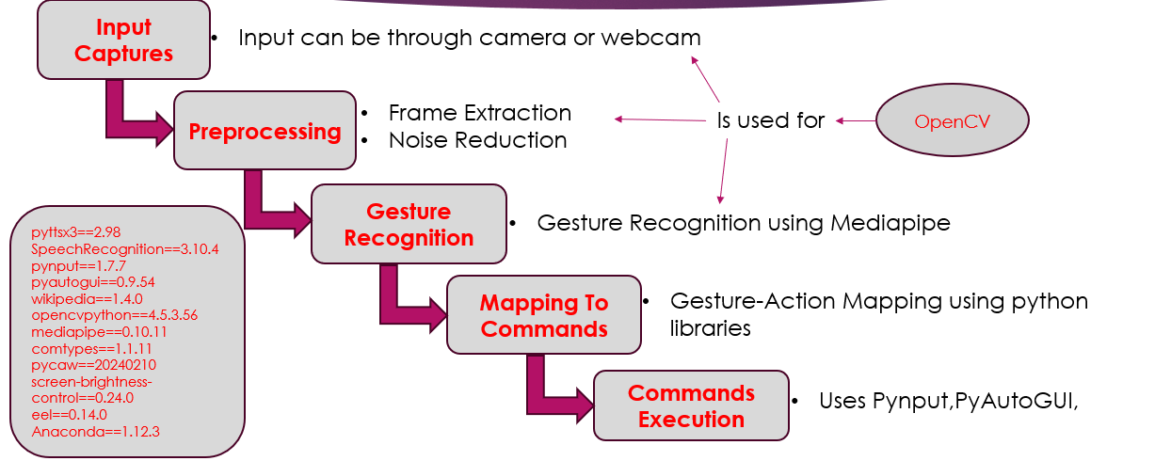

Figure 1.1: System overview diagram

**6.1 Component Design**

The system architecture is divided into multiple functional modules to ensure modularity, scalability, and ease of integration. Each module is responsible for a specific set of tasks as described below:

**A. Gesture Recognition Module**

This module is responsible for capturing and interpreting hand gestures in real-time to simulate mouse operations.

* Captures real-time video input using the webcam.
* Utilizes **MediaPipe** for extracting 21 hand landmarks from the video stream.
* Applies gesture recognition logic to detect predefined hand gestures such as:
  + **Open Hand** – Neutral state
  + **Fist** – Simulates mouse click
  + **Pinch** – Used for drag operations
  + **Two-Finger Spread** – Used for scroll functionality
* Maps detected gestures to corresponding mouse actions using the **PyAutoGUI** library.

**B. Voice Recognition Module**

This module enables voice-controlled system operations by interpreting spoken commands.

* Listens to user speech via a connected microphone.
* Processes audio input using the **SpeechRecognition** library integrated with the **Google Speech API**.
* Converts voice input to text and maps recognized phrases to predefined commands.
* Executes corresponding system functions or keyboard actions such as:
  + **Open Notepad**
  + **Search on Google**
  + **Increase/Decrease Volume**
  + **Minimize/Maximize Window**

**C. Integration Layer**

The integration layer serves as the communication and decision-making hub between modules.

* Synchronizes outputs from both gesture and voice recognition modules.
* Prevents conflicts between simultaneous commands from different input sources.
* Dynamically switches control between gesture and voice input modes based on context.
* Acts as the central logic engine for making execution decisions.

**D. GUI Feedback Interface**

The graphical interface provides real-time feedback and system transparency to the user.

* Displays current system status (e.g., gesture recognition active, voice listening).
* Logs and visualizes recognized commands and system actions.
* Shows gesture overlay on the camera feed using **OpenCV** for visual feedback.
* Includes access to system settings and customization options for user preferences.

**E. Action Execution Layer**

This layer is responsible for performing the final actions based on recognized inputs.

* Uses **pynput** to simulate keyboard and mouse inputs.
* Adjusts system volume using **pycaw**.
* Controls screen brightness with **screen_brightness_control**.
* Provides spoken feedback and confirmations using **pyttsx3**.
  1. **Flow Chart**

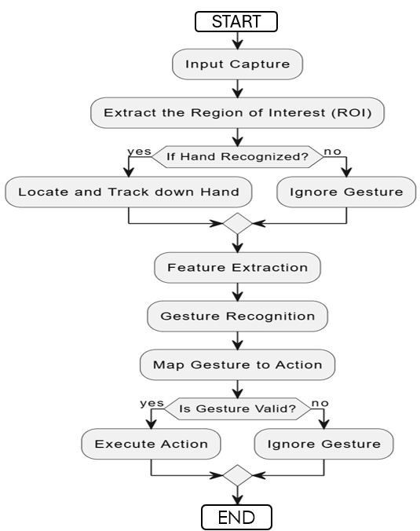

**Fig .Gesture Recognition and Action Mapping Workflow**

* 1. **High Level Design of the Project**

**8.1 Data Flow Diagram**

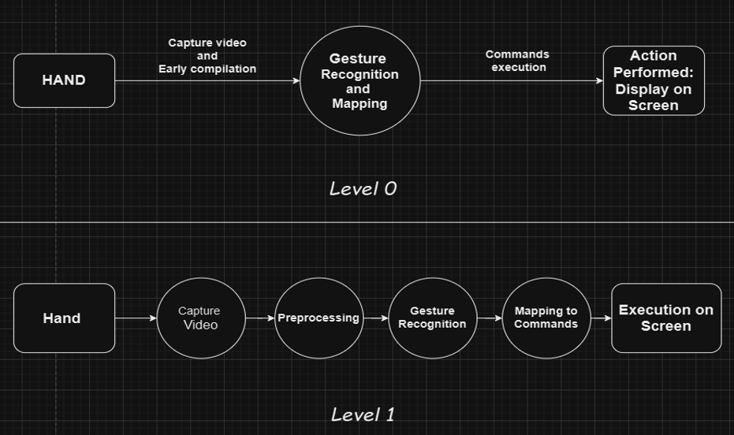

**8.2 Architecture Diagram**

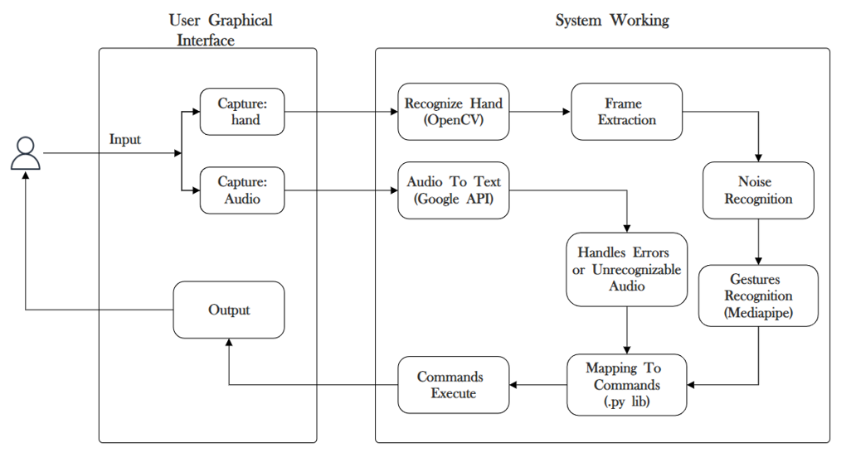

**8.3 Use Case Diagram**

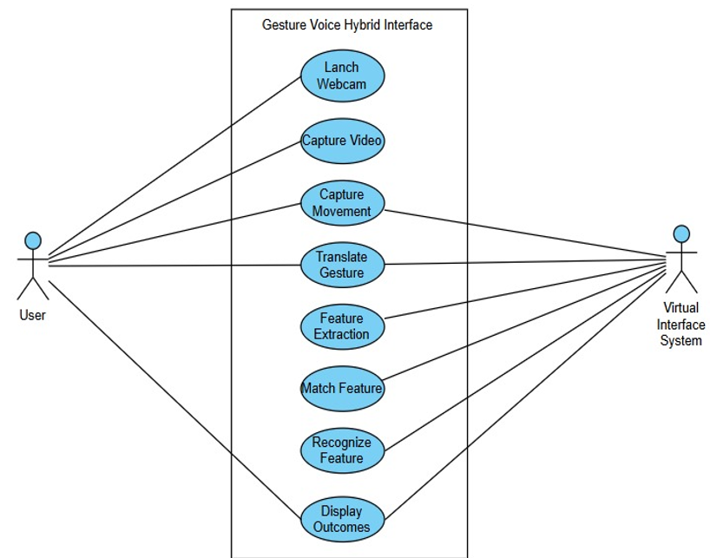

**8.4 Class Diagram**

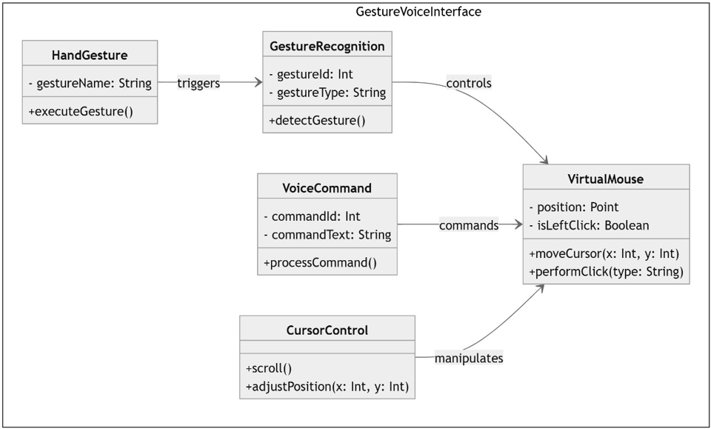

**8.5 Activity Diagram**

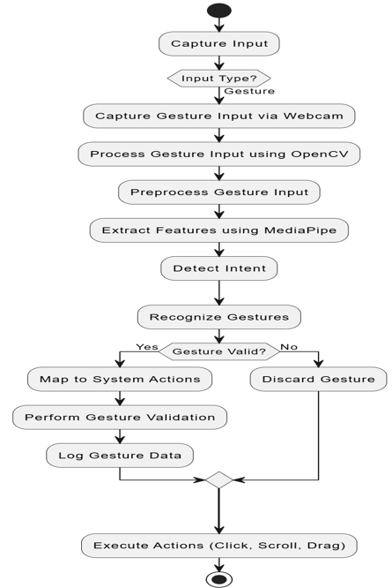

**8.6 Sequence Diagram**

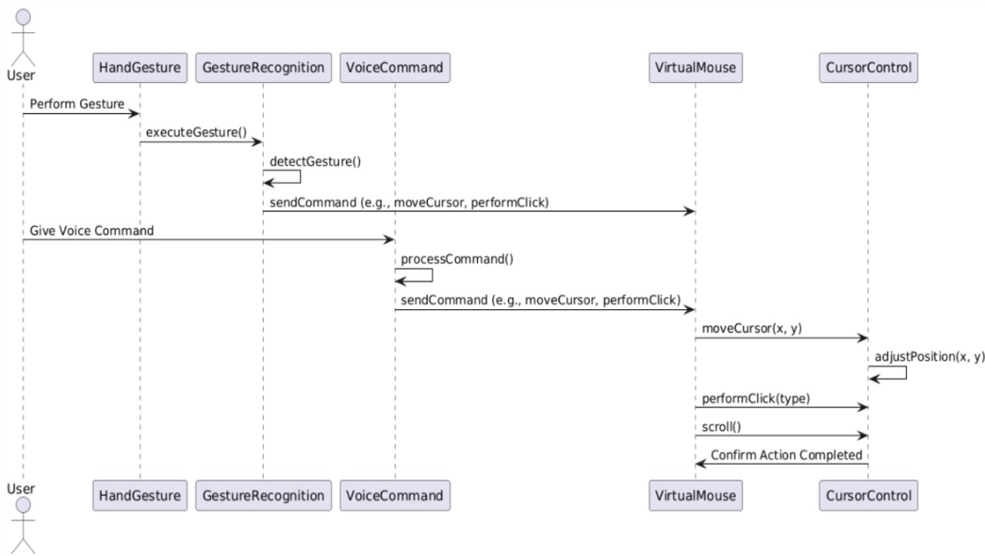

## Implementation

**9.1 Methodology**

The development of the *Gesture-Voice Hybrid Interface* follows a modular approach that leverages real-time computer vision and speech recognition technologies. The methodology is organized into several core phases to ensure clarity and efficiency during implementation.

**1. Problem Formulation**

The project aims to:

* Replace traditional mouse and keyboard input methods with intuitive hand gestures and voice commands.
* Develop a system that is accessible, hygienic, and efficient—particularly beneficial in touchless and assistive technology scenarios.

**2. Approach Selection**

To achieve the project objectives, the following technologies and tools were selected:

* **MediaPipe** for lightweight and accurate real-time hand landmark detection.
* **SpeechRecognition** integrated with the **Google API** for robust voice command interpretation.
* **PyAutoGUI** and **pynput** for simulating mouse and keyboard events.
* **Python** as the core programming language due to its flexibility and comprehensive library ecosystem.

**9.2 Algorithm**

The following steps outline the core algorithm used for real-time gesture recognition and response execution:

**Step 1: Initialize Libraries**

* Import required libraries such as OpenCV and MediaPipe.
* Initialize the webcam for continuous video capture.
* Load the MediaPipe hand tracking model.

**Step 2: Capture Video Input**

* Start the webcam feed.
* Continuously capture and read frames from the video stream.

**Step 3: Convert Image for Processing**

* Convert each captured frame from OpenCV’s default BGR format to RGB, as required by MediaPipe for processing.

**Step 4: Apply Hand Detection (Using MediaPipe)**

* Apply MediaPipe's hand tracking model to detect hands in the video frame.
* If a hand is detected, extract the 21 key hand landmarks.

**Step 5: Process Landmarks**

* Normalize the hand landmark coordinates relative to the video frame size.
* Calculate key measurements, such as the distance between thumb tip and index finger tip, to aid in gesture classification.

**Step 6: Classify Gesture**

* Compare extracted landmarks with predefined patterns to classify gestures like:
  + Open hand
  + Fist
  + Pinch
  + Two-finger spread
* Optionally, compute angles between finger joints to enhance accuracy.

**Step 7: Apply Gesture Recognition Logic**

* Store the recognized gesture in a tracking variable.
* Implement logic to smooth transitions and reduce noise or flickering caused by rapid hand movement between frames.

**Step 8: Display the Results**

* Overlay hand landmarks and gesture labels on the live video feed using OpenCV.
* Display the real-time video output along with visual feedback for the detected gesture.

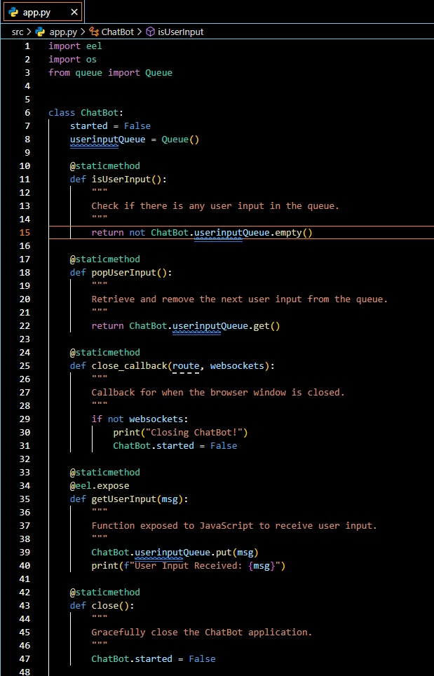

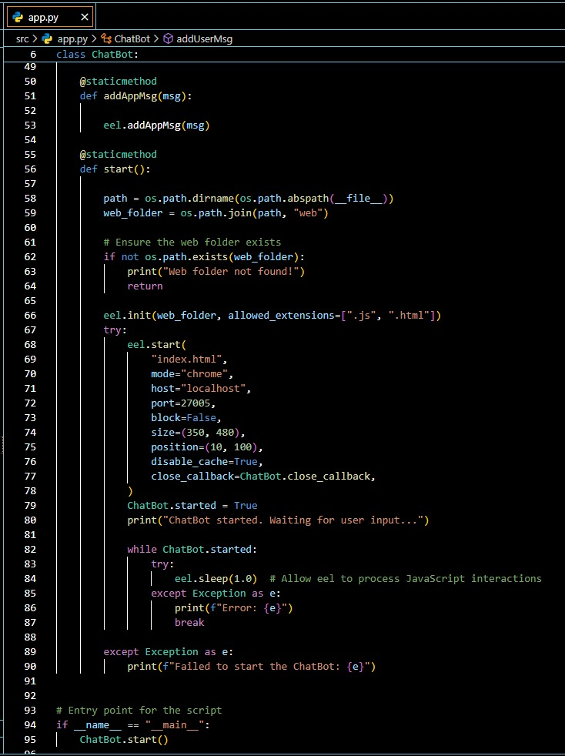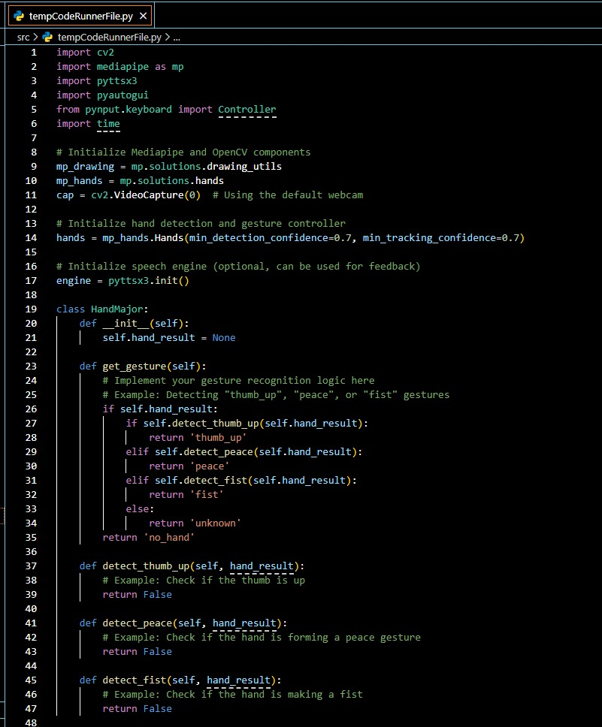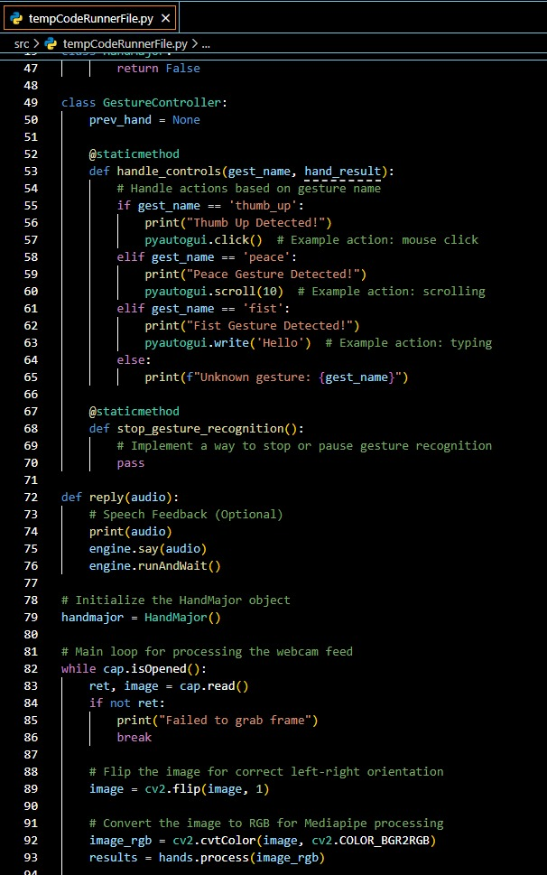

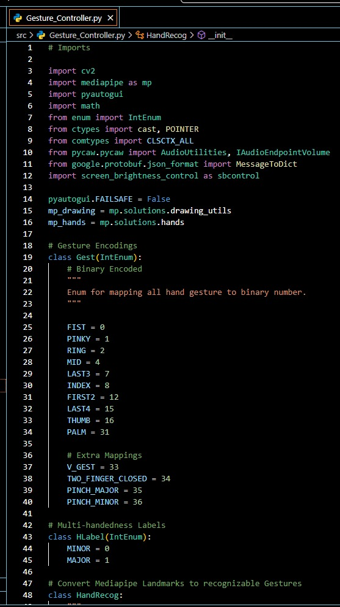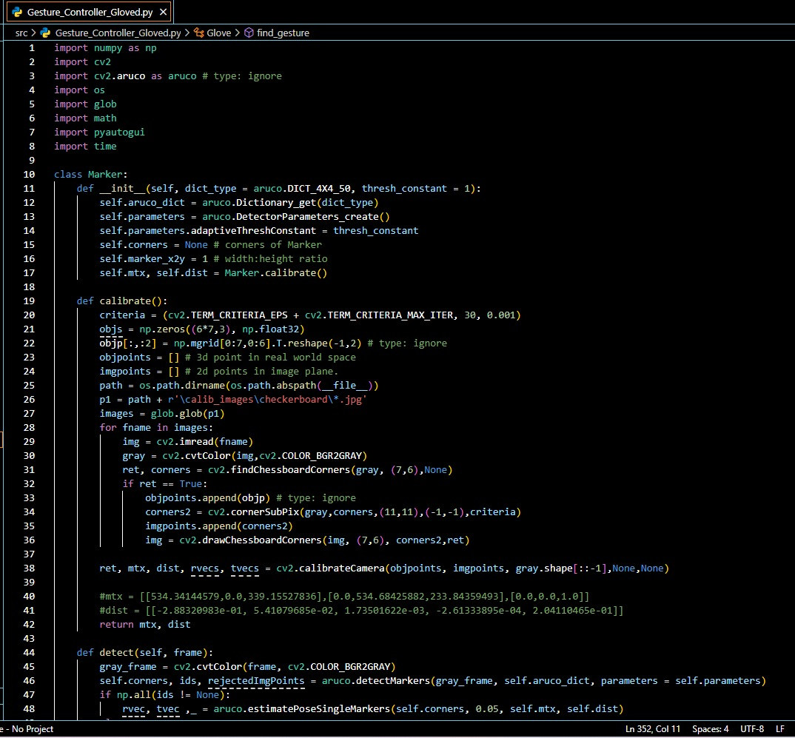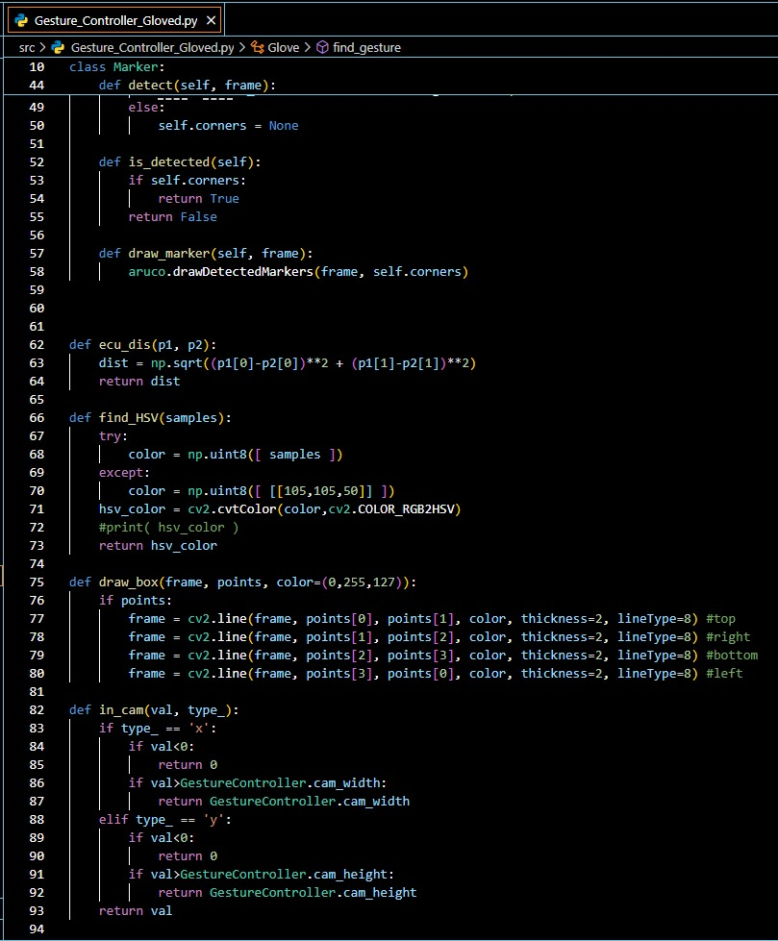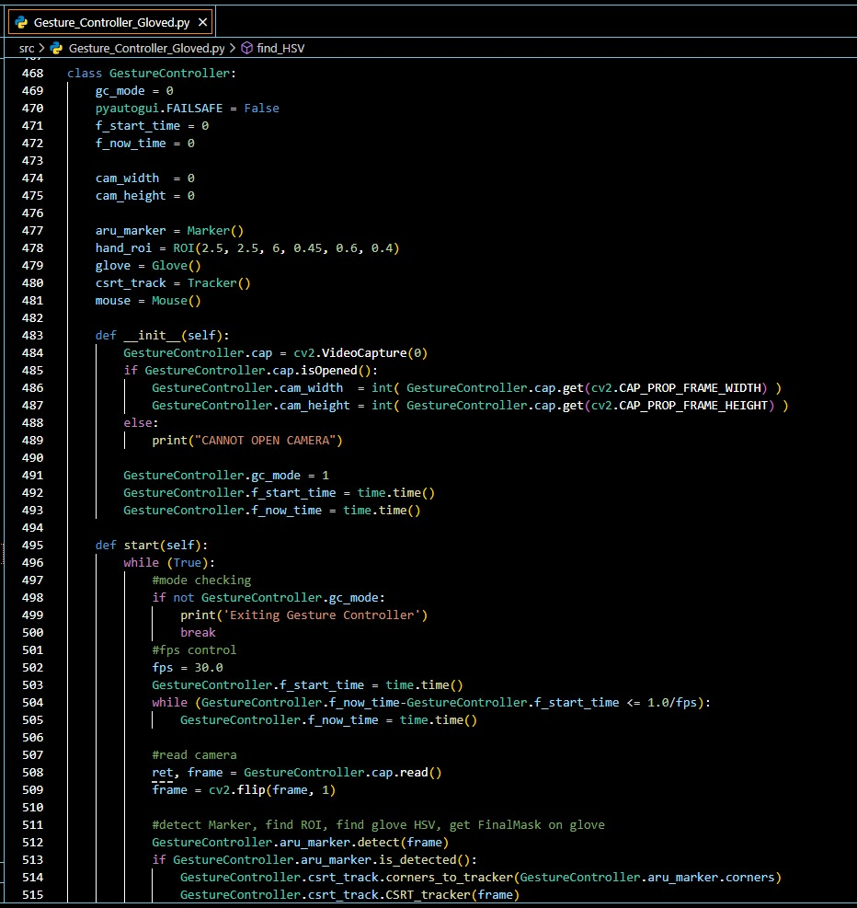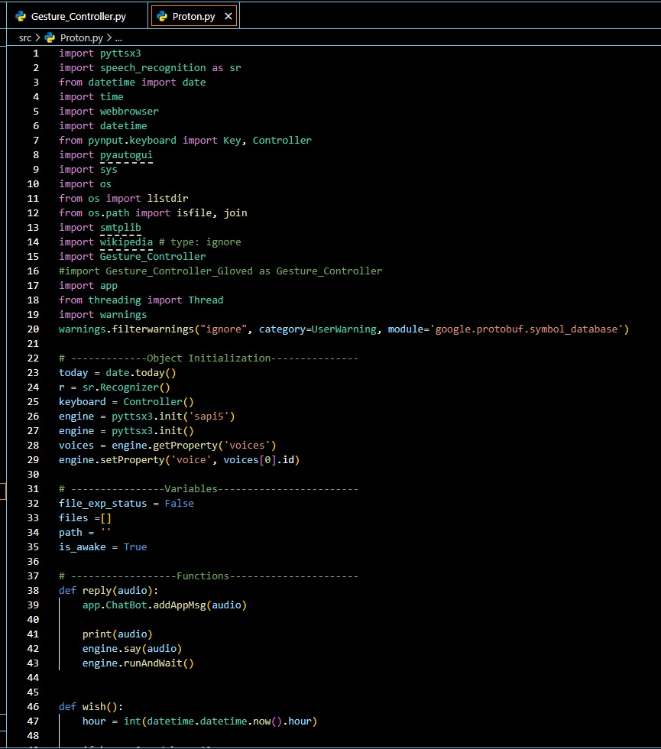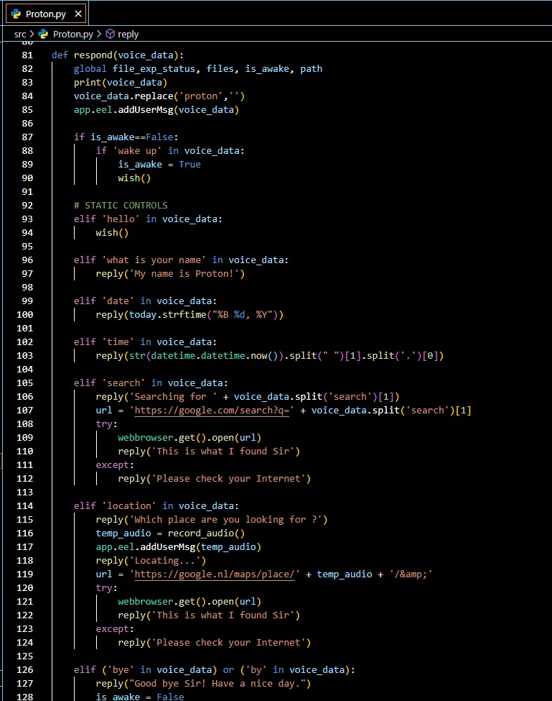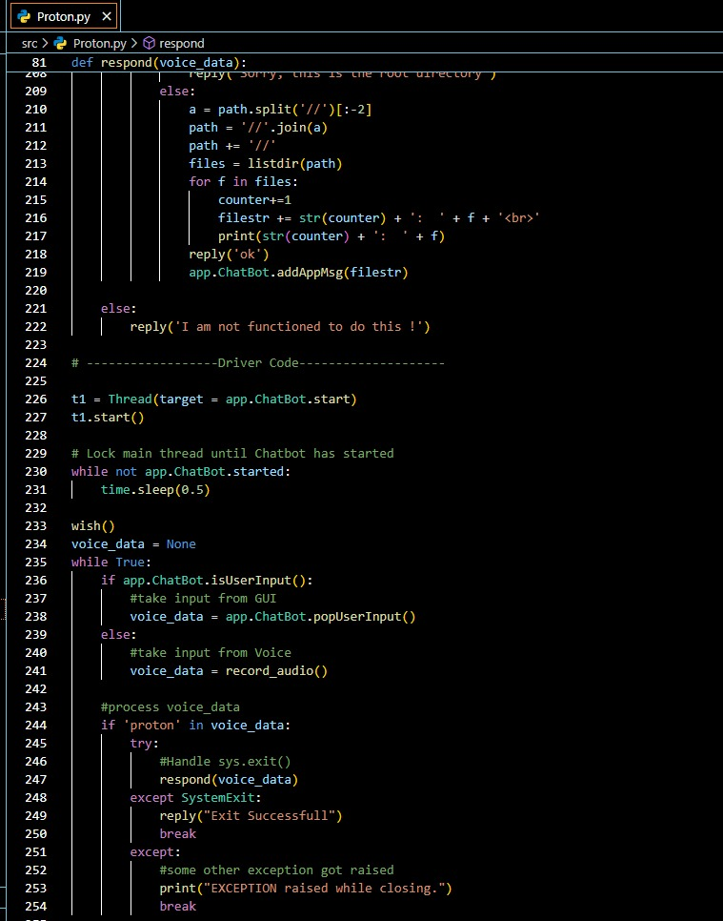

## 10. Results

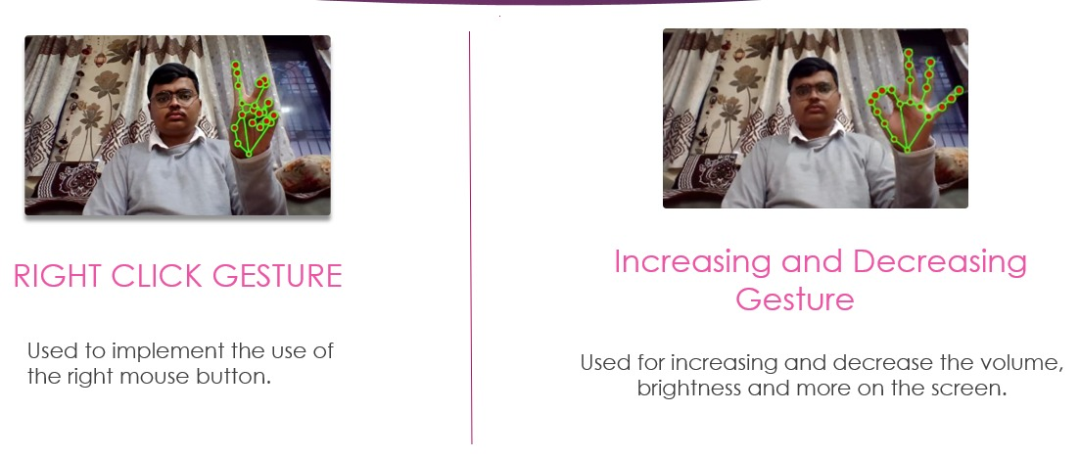

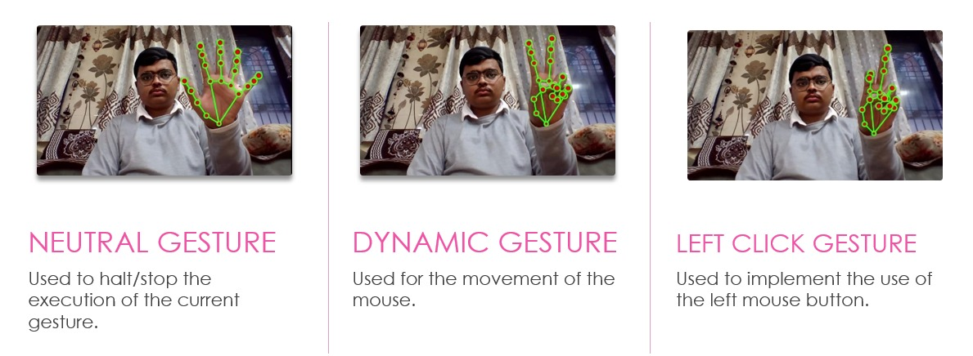

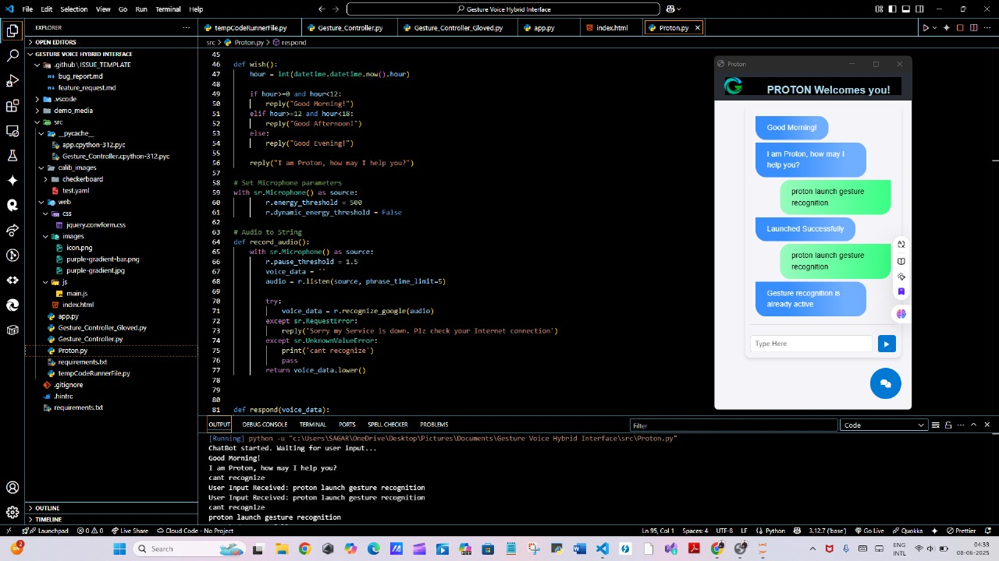

* + 1. **Project Plan**

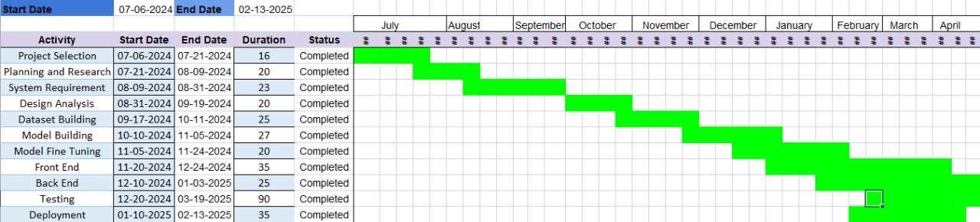

Fig: Project Plan

### ****Future Scope****

#### **1. Integration with Artificial Intelligence and Natural Language Processing (NLP)**

In the future, the system can be enhanced by integrating advanced AI and NLP models to better understand voice commands with natural human language. This would enable the interface to respond not just to fixed commands, but to more conversational and context-aware inputs. For example, a command like “Turn on the lights in the living room” could be interpreted intelligently based on current time, brightness, and user preferences.

#### 2. **Support for Multi-Lingual and Regional Language Inputs**

Currently, most voice interfaces support only a few major languages. By expanding the system to support multiple languages, especially Indian regional languages, the interface can be made more inclusive and accessible to rural populations and non-English speakers. This will significantly widen the user base and make the system truly global and user-friendly.

#### 3. **Gesture Personalization and Training Mechanism**

The future interface can allow users to **train custom gestures** using machine learning. For instance, a user could assign a unique hand gesture for opening a specific app or performing a system operation. This feature will make the system highly personalized and adaptable for diverse use cases, including for people with physical limitations who may use alternative forms of gestures.

#### 4. **Cross-Platform Compatibility and IoT Integration**

The gesture and voice interface can be extended to control various IoT devices such as smart TVs, smart lights, home security systems, and other connected appliances. Cross-platform compatibility across Windows, Linux, Android, and iOS will allow the system to be adopted in homes, offices, healthcare, and educational institutions seamlessly.

#### 5. **Application in AR/VR and Gaming Environments**

This hybrid interface has significant potential in the field of **Augmented Reality (AR)** and **Virtual Reality (VR)**. In immersive environments, where physical interaction is limited, gesture and voice control can act as primary input methods. This can be used in gaming, virtual training simulations, remote collaboration, and military applications.

#### 6. **Enhanced Accessibility for Differently-Abled Users**

The project can evolve into a **universal accessibility tool** for users with hearing, speech, or motor disabilities. For instance, individuals with speech impairments can use gesture-only modes, while those with physical disabilities can rely on voice-only commands. This supports the development of inclusive technology aligned with universal design principles.

#### 7. **Real-Time Cloud-Based Processing and Data Analytics**

With the integration of cloud computing, gesture and voice data can be processed in real time, enabling low-latency responses and remote access. Additionally, user interaction data can be analyzed to improve the system over time, through feedback loops, learning models, and usage pattern analytics.

#### 8. **Security and Authentication Using Biometric Gestures and Voice**

Incorporating biometric security using unique gesture patterns or voiceprints can make the system secure. For example, a specific hand gesture or phrase could serve as a secure login mechanism, replacing passwords and enhancing device protection in a touch-free way.

#### 9. **Deployment in Public Spaces and Smart Cities**

Gesture and voice interfaces can be deployed in smart city applications such as public kiosks, ATMs, ticket booking machines, and information terminals. This would reduce physical contact and improve hygiene, especially important in post-pandemic smart urban development.

#### 10. **Scalability through Machine Learning and Continual Learning**

Future versions of the system can use **deep learning** models to improve accuracy over time, adapting to different users, accents, hand shapes, and lighting conditions. It can also implement **continual learning** so that the interface improves its performance the more it is used, without needing full retraining.

**12. Summary**

This project aims to develop a software solution that enables **real-time control of digital systems using hand gestures and voice commands**, eliminating the need for traditional input devices like the mouse and keyboard. The interface captures user input through a webcam and microphone, processes it, and executes corresponding actions, allowing users to interact with computers in a natural and intuitive manner. The system is particularly designed to enhance accessibility and provide an alternative input method for differently-abled users.

The solution incorporates several key technologies:

* **Gesture Recognition:** Utilizes OpenCV and MediaPipe to detect hand landmarks and interpret predefined gesture patterns for tasks such as mouse control, clicking, and navigation.
* **Voice Command Processing:** Uses speech recognition libraries to convert spoken instructions into executable commands, allowing control over software applications and system functions.
* **Hybrid Control Mechanism:** Integrates gesture and voice input streams, enabling smooth switching or combined usage for a more flexible and responsive user experience.

The software is designed to be compatible with standard desktop environments and can be extended to smart devices. The project addresses the need for more natural and inclusive human-computer interaction, making technology more accessible for users with physical limitations and for environments where touchless control is preferred.

## Conclusion

The successful implementation of the **“Voice and Gesture Based Human-Computer Interaction System”** marks a significant advancement in the development of intuitive, accessible, and contactless control interfaces. By leveraging the capabilities of **MediaPipe**, **OpenCV**, **SpeechRecognition**, and other open-source libraries, this system has enabled seamless communication between users and machines through natural modes of interaction — namely, **voice commands** and **hand gestures**.

The **primary achievement** of this project lies in its ability to combine two distinct input modalities into a unified system. Gesture recognition enables users to perform tasks such as cursor movement, clicks, and scrolling with hand signals, while voice commands offer control over applications like opening files, switching tabs, or launching programs. This **dual-mode interaction** is not only efficient but also compensates for environmental limitations — for example, noisy surroundings may affect voice input, whereas gesture input remains functional. Similarly, if hand movement is not possible due to physical constraints, voice commands can still operate the system. This redundancy improves **robustness** and **user inclusivity**.

From an implementation perspective, the project is built on a **modular architecture**, allowing each component (gesture detection, voice recognition, command mapping, and execution) to function independently while maintaining communication through defined interfaces. This modularity enables easy enhancement or replacement of individual components without affecting the rest of the system. For instance, one could replace the current gesture model with a more advanced deep learning network or upgrade the voice recognition to a multilingual ASR model in future versions.

The **technological stack** used—primarily Python with libraries like MediaPipe for hand tracking, OpenCV for image processing, pyautogui for command execution, and SpeechRecognition for audio capture—ensures that the system remains **cross-platform**, open-source, and adaptable. The system does not require high-end hardware and works efficiently even with standard webcams and microphones, which makes it suitable for broad adoption in schools, homes, or public service kiosks.

In terms of **application**, the benefits of this project extend across multiple domains. In **educational environments**, instructors can interact with digital content without touching any surface, improving hygiene and convenience. In **healthcare**, sterile and touch-free control systems are critical, and this project provides a viable solution. In **assistive technology**, differently-abled users can perform digital tasks with ease, promoting independence and digital inclusion. Even in **home automation** or **gaming**, such interfaces offer futuristic and user-friendly alternatives to traditional control methods.

Another notable aspect of the system is its **real-time processing capability**. Great effort was made to ensure minimal latency in video capture, gesture detection, voice processing, and command execution. The system maintains high accuracy and speed, which is crucial for maintaining the user’s trust and satisfaction during use. Real-time feedback, especially visual or auditory cues, can also be added to further improve usability and system transparency.

Looking forward, the system offers vast opportunities for **future expansion**:

* Integration of **AI/ML models** to learn and adapt to personalized gestures.
* **Emotion detection** via facial analysis to enhance interactive feedback.
* **Multilingual support** for broader accessibility.
* **IoT integration** to control smart appliances.
* Use of **augmented reality (AR)** to display gesture trails and command overlays.

To conclude, the **Voice and Gesture Interface System** is a step toward making technology more human, intuitive, and responsive. It reflects how **human-computer interaction** is evolving from mechanical inputs to natural, effortless forms. This project not only demonstrates a working prototype but also lays the foundation for future innovations in **touchless interface technology**. It showcases the power of combining **computer vision**, **natural language processing**, and **real-time execution** to build systems that align with human behavior and expectations. It is not just a project—it's a move toward more intelligent and inclusive computing.

## 14. References

1. Y. Anuj Kumar; Anishkha Chaudhary; Anjani Singhal; Abhinav Dev; Arpit Jaiswal;” **Gesture and Voice Controlled Virtual Mouse: A Review” Publisher:**IEEE (Institute of Electrical and Electronics Engineers) April 2024
2. G. Zeng, Z. Li, and Y. Zhang, "Pororogan: An improved story visualization model on pororo-sv dataset," in ACM CSAI, 2019.
3. Y. Song, Z. R. Tam, H. Chen, H. Lu, and H. Shuai. "Character-preserving coherent story visualization," in ECCV, 2020.
4. M. N. Munjal and S. Bhatia, "A Novel Technique for Effective Image Gallery Search using Content Based Image Retrieval System," 2019 International Conference on

Machine Learning, Big Data, Cloud and Parallel Compating (COMITCon), Faridabad,

India, 2019, pp. 25-29, dor 10.1109/COMITCon.2019.8862206

1. Z. Chen, "Neural Language Models in Natural Language Processing, 2023 2nd International Conference on Data Analytics, Computing and Artificial Intelligence

(ICDACAI), Zakopane, Poland, 2023, pp. 521-524. doi::

10.1109/ICDACA159742.2023.00104

1. I. Carvalho, H. G. Oliveira and C. Silva, "The Importance of Context for Sentiment

Analysis in Dialogues," in IEEE Access, vol. 11. pp. 86088-86103, 2023. doi:

10.1109/ACCESS.2023.3304633.

1. B. Wang, F. Liu, X. Yang, M. Hu and D. Li, "Span extraction and contrastive learning for coreference resolution," 2022 International Conference on Intelligent Manufacturing,Advanced Sensing and Big Data (IMASBD), Guilin, China, 2022, pp. 98-103, doi:10.1109/IMASBD57215.2022.00023.
2. Duygu Altınok, Mastering spacy: An end-to-end practical guide to implementing NLP applications using the Python ccosystem. Packt Publishing, 2021.
3. J. Praveen Gujjar. H. R. Prasanna Kamar and M. S. Guru. Prasad, "Advanced NLP Framework for Text Processing." 2023 6th International Conference on Information

Systems and Computer Networks (ISCON), Mathura, India, 2023, pp. 1-3. doi:

10.1109/ISCON57294.2023.10112058

1. S. Kotagiri, A. Venkataramana and G. Kiran, "Blind Aid: State of the art for Scene

Text Detector and Text to Speech," 2022 International Conference on Advanced Computing technologies and Applications (ICACTA), Coimbatore, India, 2022, pp. 1-5, doi: 10.1109/ICACTA54488.2022.9753094.