|  |  |
| --- | --- |
|  |  |

Gesture And Voice Hybrid Interface

Satish Kamble, Sagar Sadake, Mohit Chinni, Sangram Wabale, Kanchi Sonkule

Department of Information Technology

Pune Vidyarthi Griha’s College of Engineering and Technology & G.K. Pate (Wani) Institute of Management, Pune, India 411009

Email: [satkam53@gmail.com](mailto:satkam53@gmail.com)

[sadakesagar9@gmail.com](mailto:sadakesagar9@gmail.com) , [mohit.chinni777@gmail.com](mailto:mohit.chinni777@gmail.com) , [sangramwabale9697@gmail.com](mailto:sangramwabale9697@gmail.com) , [kanchisonkule@gmail.com](mailto:kanchisonkule@gmail.com)

**Abstract**— **The ”Gesture Voice Hybrid Interface” project aims to revolutionize human-computer interaction by integrating hand gestures and voice commands to replace traditional input devices like keyboards and mice. By leveraging a simple webcam and advanced technologies such as OpenCV, MediaPipe, and Python, the system enables real-time gesture recognition and tracking, allowing users to perform standard computing tasks like moving the cursor, clicking, and scrolling using intuitive hand move- ments. This approach eliminates the reliance on physical devices, offering a wireless and more natural alternative to conventional input methods. Beyond improving user experience, this interface also addresses accessibility challenges, providing a hands-free solution for individuals with disabilities or limited mobility. By combining gesture control and voice commands, it creates a more inclusive and engaging way to interact with technology. Ultimately, the Gesture Voice Hybrid Interface represents a significant advancement in human-computer interaction, offering a seamless, device independent, and efficient alternative for users across various applications, from basic desktop navigation to more complex use cases in gaming, virtual reality, and assistive technologies.**

**Index Terms— Gesture recognition, Voice commands, Human- Computer Interaction (HCI), OpenCV, MediaPipe, Python.**

I. Introduction

The ”Gesture Voice Hybrid Interface” project envisions a transformative shift in human-computer interaction by re- placing conventional input devices, such as the mouse and keyboard, with a more intuitive and natural control system based on hand gestures and voice commands. Traditional input devices have long served as primary means for interacting with digital systems, but they often come with limitations, particularly for users with physical disabilities or those working in settings where touchless interaction is desirable. By leveraging a standard webcam and integrating advanced technologies like OpenCV and MediaPipe, this project creates a hybrid interface that combines gesture recognition and voice command capabilities to offer a seamless, hands-free computing experience. The system enables real-time recognition of hand gestures to perform actions like cursor movement, clicking, and scrolling. Voice commands further enhance functionality, allowing users to execute more complex operations without relying on physical devices. This dual approach not only enhances the overall user experience by providing a more fluid and responsive interaction with digital systems, but it also serves as a solution for accessibility, making digital tools more inclusive and accessible to individuals with limited mobility. Moreover, the touchless nature of this interface is well-suited for environments where hygiene is a priority, such as healthcare facilities, laboratories, and public spaces.

II. Why Hybrid Interface?

The motivation behind the ”Gesture Voice Hybrid Interface” project arises from a growing demand for more natural, inclusive, and hygienic methods of interacting with technology. Traditional input devices, such as keyboards and mice, have long been staples of human-computer interaction; however, they are often cumbersome, especially in accessibility con- texts, and require physical contact, which may not be ideal in environments where hygiene is critical. Settings like healthcare facilities, laboratories, and public workspaces highlight the limitations of conventional devices, as they can be challenging to sanitize and increase the risk of contamination. With the re- cent emphasis on hygiene and touchless interactions, the need for non-contact interfaces has become even more pressing. Additionally, traditional devices can present substantial barriers for individuals with disabilities, limiting access to computers and the broader digital landscape. Physical input devices often require a certain level of dexterity and hand coordination, which many individuals may not have due to various mobility or motor impairments. This challenge can result in a significant digital divide, where individuals who cannot use standard input devices are restricted in their ability to engage fully with technology, participate in online activities, or perform basic computing tasks. The motivation to create a system that addresses these challenges stems from the desire to make technology more accessible and inclusive, accommodating a broader spectrum of users and their unique needs.

III. Objectives

1)Develop a Gesture Recognition System: The core of the Gesture Voice Hybrid Interface is a real-time gesture recognition system that interprets hand movements using computer vision technologies like OpenCV and MediaPipe. This component allows the system to detect gestures such as pointing, swiping, and clicking through a standard webcam, enabling intuitive and natural interaction without physical contact. By leveraging these advanced tools, the system can deliver high accuracy and responsiveness in gesture detection, laying the foundation for a seamless user experience.

2)Integrate Voice Command Functionality: To create a truly hands-free interface, the system in- corporates voice command functionality using speech recognition technologies. Voice commands provide an alternative input method that complements gesture-based control, allowing users to perform various actions by simply speaking. This dual-modality design broadens the system’s versatility and supports accessibility, especially for users with limited mobility or in situations where physical contact with devices is impractical.

3)Design Seamless Hybrid Interaction: By combining gesture and voice inputs, the system offers a flexible and efficient control mechanism, allowing users to select the most appropriate input method based on the task. For example, users might use gestures for precise cursor control and voice commands for broader actions, such as opening applications or executing short- cuts. This hybrid approach enhances productivity and creates a more adaptable interaction style that can cater to diverse user needs and preferences.

4)Test and Validate the System: Rigorous testing and validation are essential to ensure the system’s effectiveness in real-world scenarios. Performance evaluations focus on measuring the accuracy, responsiveness, and reliability of gesture and voice recognition under different environmental conditions, such as varying lighting and noise levels. These tests help refine the system’s performance, ensuring that it can deliver a consistent and robust experience for users across a range of settings.

5)Create a User-Friendly Interface: A key aspect of the project is designing an intuitive, user-friendly interface that integrates smoothly with existing applications and operating systems. This interface should be clean and simple, minimizing the learning curve so users can quickly adapt to the new control methods.

The Gesture Voice Hybrid Interface project aims to replace traditional input devices with an intuitive system that combines hand gestures and voice commands. Motivated by the need for accessible, touchless, and inclusive technology, it addresses challenges faced by users with limited mobility and in hygiene sensitive settings. The project’s objectives include developing accurate gesture recognition, implementing voice command functionality, creating a seamless hybrid interaction, testing the system’s performance, and designing an easy-to-use interface. This approach seeks to enhance user experience, accessibility, and interaction efficiency across various applications.

IV. Background

As computing technology has evolved, so too have the ways we interact with it. Traditional input devices like keyboards and mice have been the standard for decades, but they are not always suitable for all users or environments. People with limited mobility may find these devices challenging to use, and in environments where hygiene is essential—such as hospitals or shared workspaces—touchless interfaces are increasingly preferred to reduce contamination risks. Gesture recognition technology uses computer vision to detect and interpret human movements, particularly hand gestures, as input commands. By utilizing frameworks like OpenCV and MediaPipe, developers can achieve high accuracy in gesture detection using only a standard webcam. This capability has opened doors for gesture-based controls in diverse fields, from gaming to virtual reality, as well as assistive technologies. Similarly, voice recognition allows for hands-free control through spoken commands

V. Human Computer Interaction

Human-Computer Interaction (HCI) is the field that focuses on designing, evaluating, and implementing computer systems that optimize the interaction between humans and computers. In the context of the Gesture Voice Hybrid Interface project, HCI principles are central to creating a seamless, intuitive system that allows users to interact with computers through hand gestures and voice commands, bypassing traditional input devices like keyboards and mice. By applying HCI concepts, the project aims to enhance user experience, improve accessibility, and create a more natural and efficient way of interacting with technology. This interface considers usability and accessibility, addressing challenges faced by individuals with disabilities or those in hygiene-sensitive environments, and thus represents a significant advancement in HCI. The project demonstrates how emerging technologies like com- puter vision and speech recognition can be leveraged to design interfaces that adapt to diverse user needs, making digital systems more inclusive and responsive.

VI. Computer Vision

Computer Vision is a field of artificial intelligence that en- ables computers to interpret and understand visual information from the world, such as images and video. In the context of the Gesture Voice Hybrid Interface project, computer vision plays a pivotal role in accurately detecting and tracking hand gestures in real time using a standard webcam. By leveraging powerful libraries like OpenCV and MediaPipe, the system processes visual data to identify and interpret specific hand movements, such as pointing, swiping, or fist-clenching, which are then translated into commands to control the computer. This eliminates the need for physical input devices, providing a more natural, intuitive way for users to interact with tech- nology. The accuracy and responsiveness of computer vision are crucial for ensuring that the system functions seamlessly, allowing for precise control over tasks like cursor movement and clicking

VII. Gesture Recognition

Gesture Recognition is a technology that enables computers to detect and interpret human hand and body movements as input commands. This technology is particularly relevant to the Gesture Voice Hybrid Interface project, as it allows for a hands-free, intuitive way of interacting with digital systems. By utilizing computer vision tools like OpenCV and MediaPipe, the project captures and processes real-time hand gestures to perform actions such as cursor movement, clicking, and scrolling. This replaces the need for traditional physical input devices, creating a more natural interaction experience.

VIII. Voice Assistant

Voice Recognition is a technology that allows computers to understand and process spoken language, converting it into text or commands. In the context of the Gesture Voice Hybrid Inter- face project, voice recognition plays a crucial role in enabling handsfree control, allowing users to interact with the system through spoken commands. By integrating speech recognition technologies, the system can interpret a wide range of voice inputs—such as opening applications, executing commands, or navigating through menus—making it an essential component of the hybrid interface. improving the overall user experience. Ultimately, voice recognition expands the flexibility and inclusivity of the Gesture Voice Hybrid Interface, enabling users to control their computers with greater ease and efficiency.

XI. Open CV

OpenCV (Open Source Computer Vision Library) is a powerful, open-source library designed to provide tools for image and video processing. In the Gesture Voice Hybrid Interface project, OpenCV is integral for real-time computer vision tasks, such as detecting and tracking hand gestures through a standard webcam. It offers efficient image manipulation and feature detection algorithms that enable precise recognition of gestures like pointing, swiping, and fist-clenching. OpenCV’s ability to handle various image processing tasks in real time makes it an essential tool for creating a responsive gesture recognition system. Its versatility and wide range of functions, including object tracking, edge detection, and motion analysis, ensure that the system can accurately interpret user inputs in dynamic environments, making it a core technology for this project.

X. Media Pipe

MediaPipe is a framework developed by Google that provides a collection of pre-trained machine learning models and pipelines designed for real-time multimedia processing. In the context of the Gesture Voice Hybrid Interface, MediaPipe is used for its hand tracking capabilities, which allow the system to recognize and track hand gestures with high precision. By leveraging MediaPipe’s hand landmark model, the system can detect key points of the hand, track finger movements, and map them to corresponding commands. This enhances the gesture recognition accuracy and provides a more natural and fluid user interaction. MediaPipe’s ability to run efficiently on a standard webcam further simplifies the implementation of gesture control, making it an indispensable component of the project.

XI. Python

Python is the programming language used to implement and integrate both OpenCV and MediaPipe, enabling the development of the Gesture Voice Hybrid Interface. Python is widely known for its simplicity, readability, and vast ecosystem of libraries, making it ideal for rapid development of machine learning and computer vision applications. By using Python, developers can easily integrate OpenCV and MediaPipe with other technologies, such as speech recognition libraries, to create a seamless hybrid interaction system. Python’s flexibility and extensive support for various libraries (such as PyAudio for speech recognition and Numpy for numerical operations) allow for the creation of a highly functional and efficient system. Furthermore, Python’s popularity in the fields of AI and computer vision ensures continuous support and resources, making it a perfect fit for developing a gesture and voice- driven interface.

XI. Voice Assistant Features

The voice assistant module in the Gesture-Voice Hybrid Interface extends system functionality by enabling natural language interactions. Through speech recognition and command parsing, users can perform complex tasks without physical input, enhancing accessibility and user convenience. Below is a detailed overview of key features:

1. **Launch/Stop Gesture Recognition**

The system allows users to enable or disable the gesture recognition module via simple voice prompts such as “Start gestures” or “Stop gestures.” This dynamic control facilitates mode switching without requiring manual input, especially useful in multitasking or accessibility scenarios.

2. **Google Search Integration**

By processing natural language queries like “Search for AI advancements 2024,” the voice module launches a browser and executes a search. Users can then navigate the results using gestures for scrolling or link selection, offering a seamless multimodal experience.

3. **File Navigation and Access**

Voice commands like “Open downloads folder” or “Find resume.pdf” allow users to explore file directories and open documents. Gestures can be used in conjunction for file selection, drag-and-drop actions, and window navigation.

4. **Google Maps Control**

Upon commands such as “Find coffee shops near me,” the system launches Google Maps and loads the relevant location. Users can zoom and pan the map using pinch and swipe gestures, allowing intuitive map interaction without keyboard or mouse.

5. **Date and Time Queries**

The voice assistant responds to informational prompts like “What’s the date today?” or “Tell me the time.” This ensures minimal cognitive load on users and provides quick auditory feedback while maintaining control over ongoing gesture-based tasks.

6. **Copy-Paste Operations**

Users can execute clipboard operations through commands like “Copy this paragraph” and “Paste in document.” When paired with gesture-based selection, this allows for full text manipulation without relying on conventional shortcuts.

7. **Sleep and Wake Modes**

Commands such as “Go to sleep” and “Wake up” activate a low-power mode for the voice module. This conserves system resources during inactivity while ensuring a quick reactivation through vocal cues.

8. **Application Launching**

Users can initiate applications with voice commands like “Open Photoshop” or “Start browser.” This functionality is especially helpful in sterile or inaccessible environments where physical input is not feasible.

9. **Volume and Brightness Control**

The system interprets commands like “Increase volume” or “Dim screen” and adjusts the respective settings. Fine-tuning can be achieved through accompanying hand gestures, such as rotating motions or swipe up/down.

10. **System-Level Commands**

System operations including “Shutdown,” “Restart,” and “Sleep” can be initiated through vocal input. Confirmation prompts ensure user safety, preventing accidental execution of critical commands.

XII. Experimental Setup and Implementation

**1.System Design**

**A. Architecture Overview**

The Gesture Voice Hybrid Interface is built using a modular, layered architecture for maintainability and scalability. It consists of five key modules:

* **Gesture Recognition Module:** Captures hand gestures using a webcam and processes them with OpenCV and MediaPipe to simulate mouse operations like movement, click, drag, and scroll.
* **Voice Recognition Module:** Captures audio input and translates spoken commands into executable actions using Python’s SpeechRecognition and Google Speech API.
* **Integration Layer:** Manages input from both gesture and voice modules, prioritizes actions, and prevents input conflicts.
* **GUI Feedback Interface:** Displays real-time visual and audio feedback about recognized commands, active modules, and allows for basic settings/configuration.
* **Action Execution Layer:** Simulates mouse/keyboard input and system-level tasks using PyAutoGUI and pynput, providing a hands-free control interface.

**2.** **Implementation**

**A. Tools and Libraries Used**

* **Programming Language: Python 3.7+**
* **Computer Vision: OpenCV 4.5.3, MediaPipe 0.10.11**
* **Speech Processing: SpeechRecognition, Google API, pyttsx3 (text-to-speech)**
* **Control Libraries: PyAutoGUI, pynput**
* **GUI: eel (web-based interface)**
* 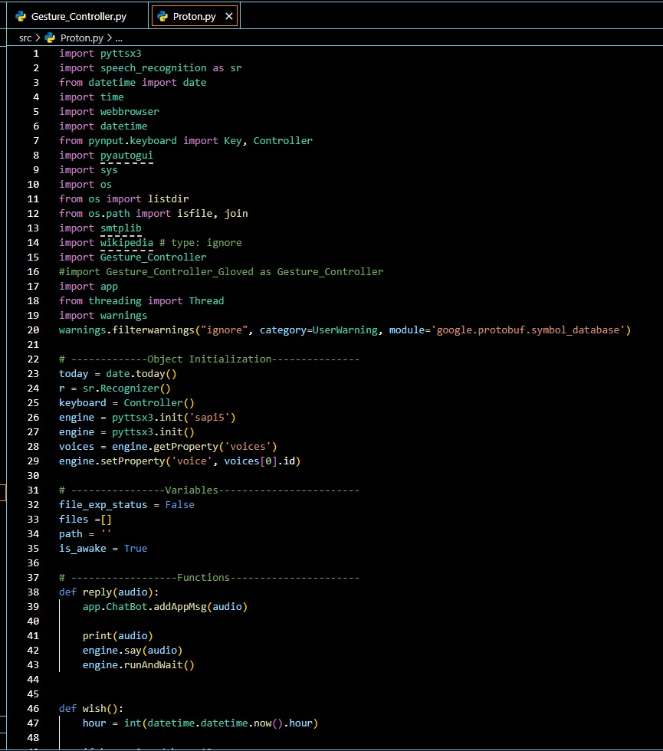**Optional Modules: pycaw (audio control), screen_brightness_control, TensorFlow Lite**

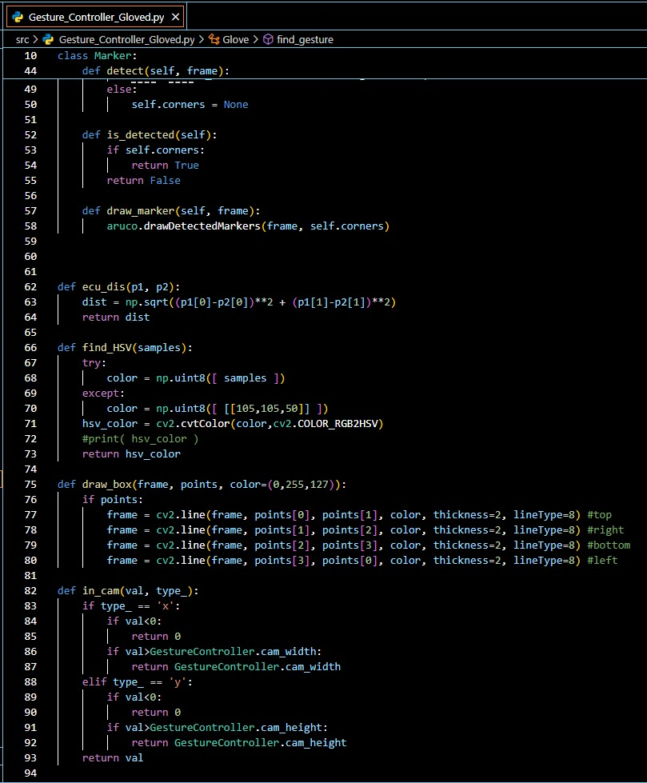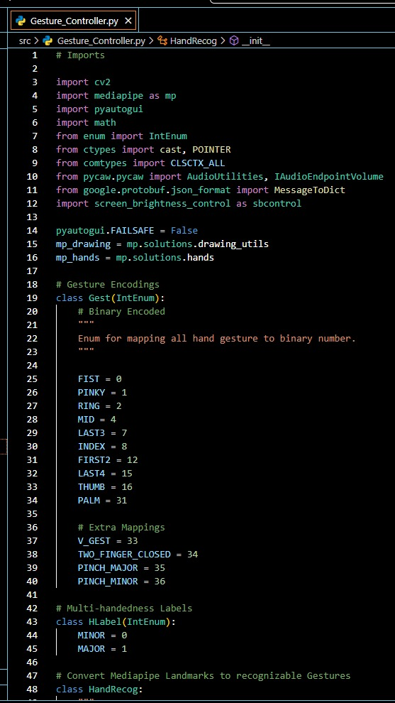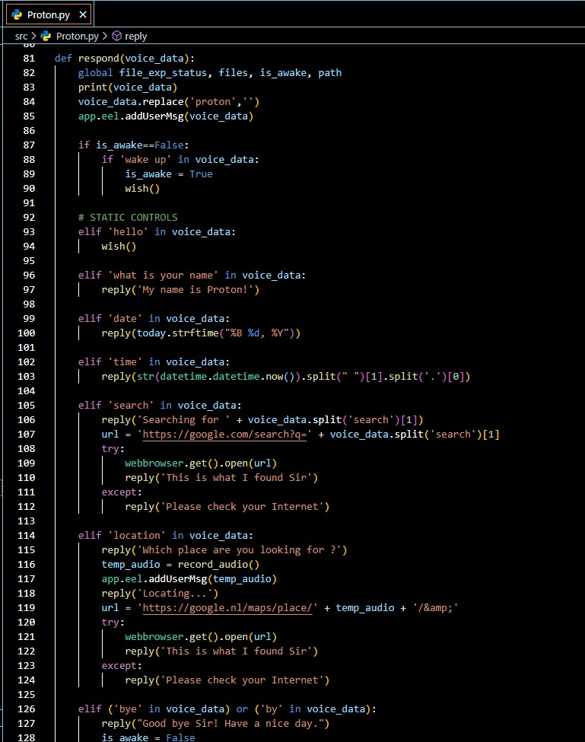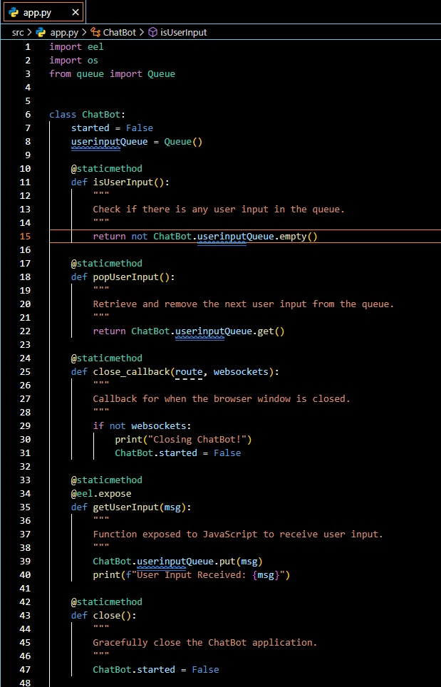

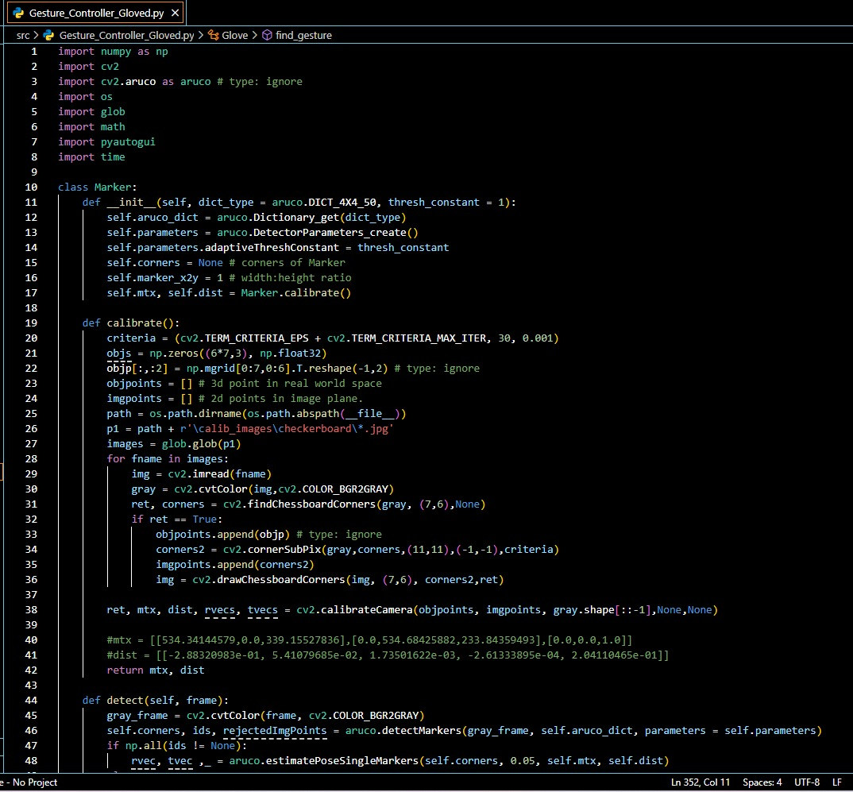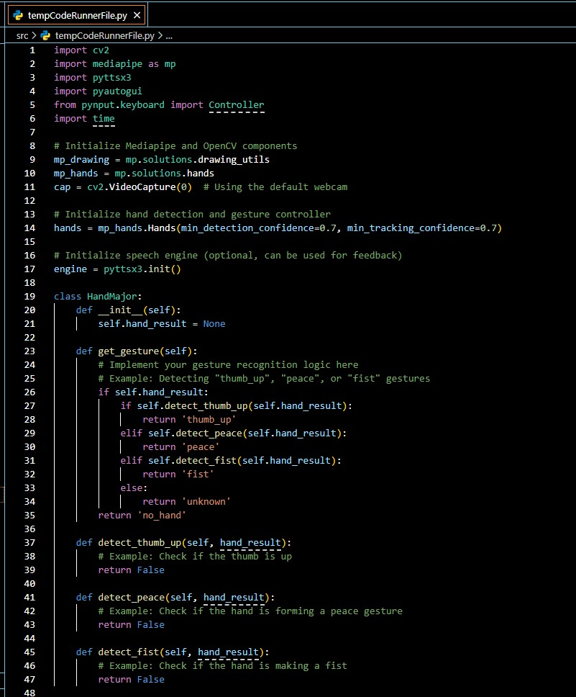

**B.Voice Recognition and Execution Workflow:**

1. Activate microphone and listen for command.

2. Use SpeechRecognition API to convert voice to text.

3. Parse command using keyword mapping.

4. Match to OS task (e.g., open browser, scroll down).

5. Execute command using subprocess or PyAutoGUI.

6. Provide feedback using TTS or GUI pop-up**.**

**XII. System Requirements**

**A. Functional Requirements**

FR-01 Detect hand gestures using a webcam in real time

FR-02 Recognize voice commands using a microphone

FR-03 Interpret gestures for mouse movements, clicks, and scrolling

FR-04 Interpret voice for keyboard functions and control commands

FR-05 Launch/stop gesture control via voice command

FR-06 Display real-time visual feedback for gesture detection

FR-07 Continuously capture and process webcam input

FR-08 Continuously listen and process voice input

FR-09 Provide confirmation (audio/visual) of recognized commands

FR-10 Seamlessly switch between gesture and voice modes

FR-11 Provide GUI for interaction and configuration

FR-12 Classify gestures using 21 hand landmarks (MediaPipe)

FR-13 Execute file navigation and system control via voice

FR-14 Support neutral gesture to pause gesture recognition

FR-15 Allow command customization by users

**B. Non-Functional Requirements**

NFR-01 Latency between input and action should be <300ms

NFR-02 Achieve at least 90% accuracy under optimal lighting

NFR-03 Robust voice recognition under up to 30dB background noise

NFR-04 RAM usage should not exceed 1.5GB

NFR-05 Support both Windows and Linux OS

NFR-06 Maintain responsiveness on a dual-core processor

NFR-07 Interface should be accessible to users with disabilities

NFR-08 Provide error handling for unrecognized inputs

NFR-09 No personal data should be stored

NFR-10 System should be modular and extensible

**C. Use Case Descriptions**

UC-01 Launch Gesture Recognition

UC-02 Launch Voice Assistant

UC-03 Execute Mouse Movement via Gesture

UC-04 Perform Click via Gesture

UC-05 Scroll Screen using Gesture

UC-06 Minimize/Maximize Window via Voice

UC-07 Launch Applications via Voice

UC-08 Copy and Paste using Voice

UC-09 Toggle Gesture/Voice Input Mode

UC-10 Show Feedback on Gesture Error

UC-11 Adjust Volume/Brightness with Gesture

UC-12 Sleep/Wake Voice Assistant

**D. Software Requirements**

SW01 Operating System: Windows 10+, Ubuntu 20.04+

SW02 Programming Language: Python 3.7+

SW03 IDE / Code Editor: PyCharm, VS Code

SW04 Voice Recognition: SpeechRecognition 3.10.4 + Google API

SW05 Audio Output: pyttsx3

SW06 GUI Framework: eel

SW07 Webcam Interface: OpenCV 4.5.3.56

SW08 Hand Tracking: MediaPipe 0.10.11

SW09 Gesture Control Libraries: PyAutoGUI, pynput

SW10 Web Search Integration: wikipedia, pycaw

SW11 Deep Learning Libraries: TensorFlow Lite or PyTorch (optional)

SW12 Package Management: Anaconda 1.12.3, pip

SW13 Browser Support: Required for eel-based frontend

SW14 Logging System: Python logging module

SW15 Voice Assistant Integration: Google Assistant API or custom engine

**E. Hardware Requirements**

HW01 Processor: Intel Core i3 or higher

HW02 RAM: Minimum 8GB

HW03 Storage: Minimum 2GB available space

HW04 Webcam: 720p HD webcam

HW05 Microphone: External/Built-in mic

HW06 Display: Minimum resolution 1280x720

HW07 Graphics Card (Optional): NVIDIA GTX 1080 or better

HW08 Internet Connection: Required for API access

HW09 Audio Output: Headphones or speaker

HW10 Ports & Connectivity: At least one available USB port

HW11 Power Supply: Stable power for continuous operation

HW12 Environmental Conditions: Adequate lighting for gesture detection

**F. User Requirements**

UR-01 Users must operate system hands-free after activation

UR-02 Users must be able to start/stop modules easily

UR-03 Users must configure mappings as per preferences

UR-04 System must guide users with visual/audio cues

UR-05 The system must require minimal prior training

UR-06 Users must receive feedback on failure or ambiguity

**G. Existing System Limitations and Identified Problems**

PRB01 Dependence on physical, touch-based devices

PRB02 Voice-only systems are inadequate for full control

PRB03 Gesture-only systems are sensitive to lighting and require exaggerated motion

PRB04 Lack of mature hybrid solutions combining gesture and voice

PRB05 Poor accessibility in current systems

PRB06 No fallback mechanism for overlapping or simultaneous inputs

PRB07 Limited support for user customization and modular upgrades

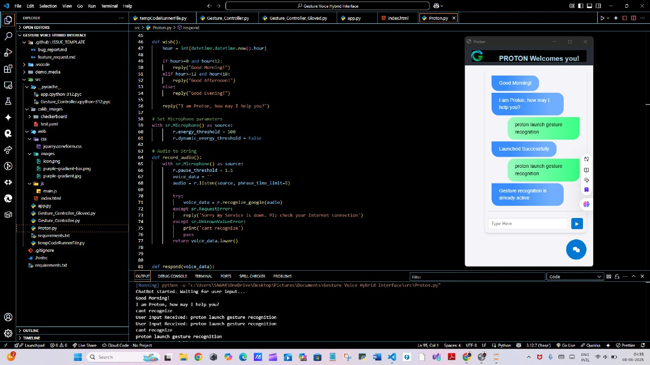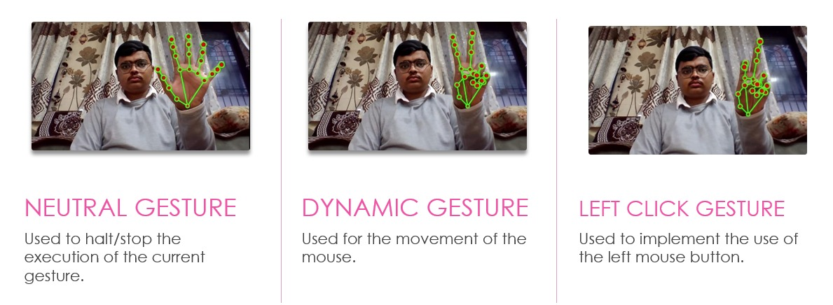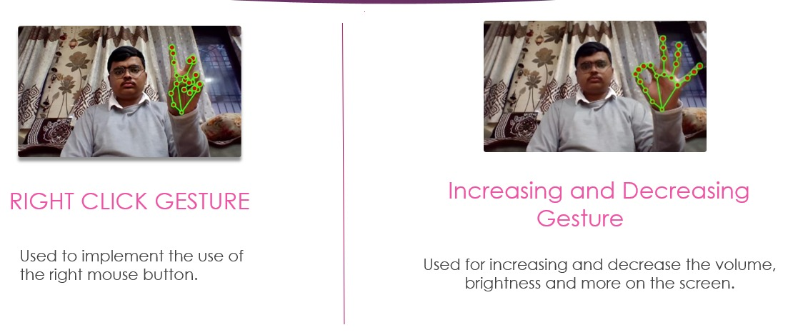**XIII.Results**

**XIV. Future Scope**

1. Integration with Artificial Intelligence and Natural Language Processing (NLP) In the future, the system can be enhanced by integrating advanced AI and NLP models to better understand voice commands with natural human language. This would enable the interface to respond not just to fixed commands, but to more conversational and context-aware inputs. For example, a command like “Turn on the lights in the living room” could be interpreted intelligently based on current time, brightness, and user preferences.

2. Support for Multi-Lingual and Regional Language Inputs Currently, most voice interfaces support only a few major languages. By expanding the system to support multiple languages, especially Indian regional languages, the interface can be made more inclusive and accessible to rural populations and nonEnglish speakers. This will significantly widen the user base and make the system truly global and user-friendly.

3. Gesture Personalization and Training Mechanism The future interface can allow users to train custom gestures using machine learning. For instance, a user could assign a unique hand gesture for opening a specific app or performing a system operation. This feature will make the system highly personalized and adaptable for diverse use cases, including for people with physical limitations who may use alternative forms of gestures.

4. Cross-Platform Compatibility and IoT Integration The gesture and voice interface can be extended to control various IoT devices such as smart TVs, smart lights, home security systems, and other connected appliances. Cross-platform compatibility across Windows, Linux, Android, and iOS will allow the system to be adopted in homes, offices, healthcare, and educational institutions seamlessly.

5. Application in AR/VR and Gaming Environments This hybrid interface has significant potential in the field of Augmented Reality (AR) and Virtual Reality (VR). In immersive environments, where physical interaction is limited, gesture and voice control can act as primary input methods. This can be used in gaming, virtual training simulations, remote collaboration, and military applications.

6. Enhanced Accessibility for Differently-Abled Users The project can evolve into a universal accessibility tool for users with hearing, speech, or motor disabilities. For instance, individuals with speech impairments can use gesture-only modes, while those with physical disabilities can rely on voiceonly commands. This supports the development of inclusive technology aligned with universal design principles.

7. Real-Time Cloud-Based Processing and Data Analytics With the integration of cloud computing, gesture and voice data can be processed in real time, enabling low-latency responses and remote access. Additionally, user interaction data can be analyzed to improve the system over time, through feedback loops, learning models, and usage pattern analytics.

8. Security and Authentication Using Biometric Gestures and Voice Incorporating biometric security using unique gesture patterns or voiceprints can make the system secure. For example, a specific hand gesture or phrase could serve as a secure login mechanism, replacing passwords and enhancing device protection in a touch-free way.

9. Deployment in Public Spaces and Smart Cities Gesture and voice interfaces can be deployed in smart city applications such as public kiosks, ATMs, ticket booking machines, and information terminals. This would reduce physical contact and improve hygiene, especially important in postpandemic smart urban development.

10. Scalability through Machine Learning and Continual Learning Future versions of the system can use deep learning models to improve accuracy over time, adapting to different users, accents, hand shapes, and lighting conditions. It can also implement continual learning so that the interface improves its performance the more it is used, without needing full retraining.

**XV. Literature Survey**

This literature review examines existing research in gesture recognition, voice command systems, and hybrid human computer interaction (HCI) interfaces, providing a foundation for the Gesture Voice Hybrid Interface project. Key technologies like OpenCV, MediaPipe, and the Google Speech API are reviewed to understand current capabilities and limitations in real-time gesture and voice recognition. Comparisons are made with established systems, such as Leap Motion and Microsoft Kinect, to highlight how this project aims to achieve accessible, costeffective functionality using only a standard webcam.

1)S. Patil et al., ”Review on Touchless Virtual Mouse Technologies and A.I. Voice Assistants,” IJPREMS, 2023. This paper reviews virtual mouse systems us- ing infrared cameras and AI-driven voice assistants. It highlights innovations in Human-Computer Interaction to eliminate physical devices. However, calibration difficulties and real-time delays remain critical challenges. DOI: 10.58257/IJPREMS33160.

2)M. Nazeer et al., ”Gesture Controlled Virtual Mouse and Keyboard Using OpenCV,” ICETCI, 2023. This research integrates hand gestures, voice commands, and eye movements for virtual interactions using CNNs and MediaPipe. It reduces hardware dependence but faces challenges like lighting variability and webcam resolution limitations. DOI: 10.58257/IJPREMS33160.

3)M. Raja et al., ”Voice Assistant and Gesture Controlled Virtual Mouse using Deep Learning,” ICSCDS, 2023. The study combines voice commands with gestures using CNN-like models and MediaPipe. It eliminates hardware dependency but struggles with real-time recognition and processing power demands. DOI: 10.1109/IC- SCDS56580.2023.10104619.

4)S. Srivastava et al., ”Gesture Recognition Based Vir- tual Mouse System,” CICTN, 2023. This system uses AI for contactless computer control, crucial during COVID-19. It highlights applications in public spaces but faces challenges like lighting-dependent ac- curacy and hardware optimization. DOI: 10.1109/CI- CTN57981.2023.10140390.

5)Y. Zhao et al., ”Mouse on a Ring: A Mouse Action Scheme Based on IMU,” IEEE Sensors Journal, 2021. An IMU-based wearable ring for mouse control enhances portability and versatility but encounters issues like gyroscope errors, ergonomic design, and environ- mental precision. DOI: 10.1109/JSEN.2021.3096847.

6)C. Jeon et al., ”Hand-Mouse Interface Using Virtual Monitor Concept,” IEEE Access, 2017. This paper presents a Kinect-based system mapping hand movements onto virtual monitors. Challenges include real- time responsiveness and erratic pointer behavior. DOI: 10.1109/ACCESS.2017.2768405.

7)A. Mujahid et al., ”Real-Time Hand Gesture Recognition Based on Deep Learning,” Applied Sciences, 2021. A touchless virtual mouse system uses gestures and deep learning for intuitive HCI. Privacy concerns and lighting- dependent performance are critical limitations. DOI: 10.3390/app11094164.

8)N. C., S. H. G., ”Virtual Mouse Using Hand Gesture,” IJCSPUB, 2023. This system utilizes OpenCV and MediaPipe for real-time gesture recognition. It improves accessibility but faces calibration and lighting challenges.

9)D. S. Deshmukh et al., ”Hand Gesture Controlled Vir tual Mouse Based on ML,” Yearbook of SSAG, 2023.Combining gestures and voice commands with AI improves accessibility but demands extensive datasets and calibration for real-time performance.

10)A. Kumar et al., ”Gesture and Voice Controlled Virtual Mouse,” IEEE, 2024. Integrates MediaPipe, TensorFlow, and OpenCV for intuitive gesture and voice-controlled interfaces. Dataset diversity and real-time performance remain challenges. DOI: 10.1109/ICDT61202.2024.10489054.

**XVI. Methodology**

1)Input Capture

- Description: Start by explaining the role of input capture in your interface. Describe how input can be collected using a camera or webcam to track hand gestures. - Technical Approach: Mention that video feed is continuously monitored to detect gestures, which are later translated into actions. - Challenges: Discuss potential challenges like frame rate limitations, lighting conditions, and occlusions, which might affect gesture recognition.

2)Preprocessing - Overview: Preprocessing involves cleaning up the video input for more accurate gesture detection. - Steps: - Frame Extraction: Describe how frames are captured at regular intervals to identify gestures effectively. - Noise Reduction: Highlight methods used to reduce background noise or irrelevant details, potentially using OpenCV for this purpose.

3)Gesture Recognition -Description: Explain that gesture recognition is the core functionality where gestures are identified and analyzed. - Tools and Libraries: Mediapipe: Describe how Mediapipe is used for tracking and recognizing hand gestures. Mention its ability to detect hand landmarks and classify gestures based on hand movements. - Challenges: Discuss how accuracy and response time impact user experience. Also, mention the lag issue you’ve encountered and any methods to mitigate it.

4)Mapping to Commands - Process: After recognizing gestures, they need to be mapped to specific commands-Tools and Libraries: - Mention how libraries like PyAutoGUI and Pynput are used to translate gestures into commands that interact with the operating system.

-Challenges: Emphasize the importance of accurate gesture-to-command mapping to ensure the intended action is executed. Address potential conflicts when gestures could be misinterpreted as different commands.

5)Command Execution -Execution Layer: This part of the pipeline involves executing the mapped command. Describe how Pynput and PyAutoGUI are used to sim- ulate keyboard and mouse actions based on recognized gestures. - Challenges: Discuss potential issues like accidental gestures leading to unwanted commands and any implemented solutions, such as gesture confirmation.

**XVII. Algorithm**

**Algorithm : Gesture Recognition using OpenCV and Media Pipe**

1:Initialize Libraries: Import necessary libraries: OpenCV, Media Pipe

2:Initialize the webcam for video capture using OpenCV

3:Load the Media Pipe hand tracking model

4:Capture Video Input: Start the webcam feed

5:while webcam is active do

6:Continuously read video frames from the webcam

7:Convert Image for Processing: Convert each captured frame from BGR (OpenCV default) to RGB format (required by Media Pipe)

8:Apply Hand Detection (Using MediaPipe): Use MediaPipe’s hand detection model to detect hands in the current frame

9:if hand is detected then

10:Extract the 21 key hand landmarks (joints)

11:Normalize hand landmark coordinates based on the size of the frame

12:Process Landmarks: Calculate relative distances between key landmarks

13:Calculate angles between finger joints for gesture recognition

14:Classify Gesture:

15:if distance between thumb and index finger tip is small then

16:Classify as ”pinch”

17:else if all finger tips are spread apart then

18:Classify as ”open hand”

19:else

20:Use additional conditions or ML model to classify gesture

21:end if

22:Store recognized gestures in a variable for further processing

23:Implement logic to handle continuous gesture recognition, including handling fluctuations between frames

24:end if

25:Display the Results: Draw hand landmarks and gesture label (e.g., ”open hand”) on the video frame using OpenCV

26:Show the video with landmarks and labels in real-time

27:end while

**XVIII. Architecture Diagram**

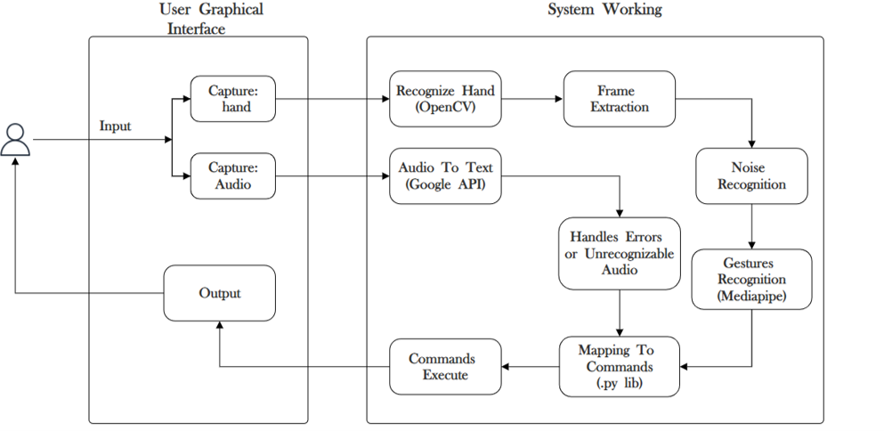

Fig. 1. System Architecture

**XIX. Conclusion**

In conclusion, the ”Gesture Voice Hybrid Interface” rep- resents a significant step forward in human-computer inter- action, combining gesture recognition and voice command functionalities to create a more intuitive and inclusive user experience. Leveraging advanced technologies like OpenCV, MediaPipe, and real-time hand-tracking, this project success- fully replaces traditional input devices with natural, touchless controls. Through this hybrid approach, users can seamlessly perform computing tasks without physical contact, making the system ideal for accessibility enhancement and use in hygiene-sensitive environments. Additionally, the system’s potential for integration into gaming, virtual reality, and assistive technology applications illustrates its broad applicability and capacity to impact diverse fields. By eliminating physical barriers to interaction, the Gesture Voice Hybrid Interface offers a powerful, flexible alternative for a more inclusive, efficient, and device-independent future in human-computer interfaces.

**XX. References**

1)S. Patil, S.Kanganolli, J.Deore, and K.Vartak, ”Re- view on Touchless Virtual Mouse Technologies and A.I. Voice Assistants,” International Journal of Progressive Research in Engineering and Management Science (IJPREMS), vol. 3, no. 3, pp. 160–167, 2023. DOI: 10.58257/IJPREMS33160.

2)M. Nazeer, S. A. G, A. Priyadarshini, C.C.B.Krishna, A. Anusha, and A.Amreen, ”Gesture Controlled Virtual Mouse and Keyboard Using OpenCV,” in Proc. Int. Conf. Emerging Techniques in Computational Intelligence (ICETCI), Hyderabad, India, 2023.

3)M. Raja, P. Nagaraj, P.Sathwik, K. M. A. Khan, N.M. Kumar, and U. S. Prasad, ”Voice Assistant and Gesture Controlled Virtual Mouse using Deep Learning Technique,” in Proc. Int. Conf. Sustainable Computing and Data Communication Systems (ICSCDS), Erode, India, 2023, pp. 156–161. DOI:10.1109/IC- SCDS56580.2023.10104619.

4)S. Srivastava, R. Tiwari, A. Garg, Rishu, and R. Tiwari, ”Design and Development of Gesture Recognition Based Virtual Mouse System,” in Proc. Int. Conf. Computational Intelligence, Communication Technology and Networking (CICTN), Ghaziabad, India, 2023, pp. 835–839. DOI:10.1109/CICTN57981.2023.10140390.

5)Y. Zhao, X. Ren, C. Lian, K. Han, L. Xin, and W. J. Li, ”Mouse on a Ring: A Mouse Action Scheme Based on IMU and Multi-Level Decision Algorithm,” IEEE Sensors Journal, vol. 21, no. 18, pp. 20512–20520, Sept.2021. DOI: 10.1109/JSEN.2021.3096847.

6)C. Jeon, O. Kwon, D. Shin, and D. Shin, ”Hand-Mouse Interface Using Virtual Monitor Concept for Natural Interaction,” IEEE Access, vol. 5, pp. 25181–25188, Dec. 2017. DOI:10.1109/ACCESS.2017.2768405.

7)A. Mujahid, M. J. Awan, A. Yasin, M. A. Mohammed,R. Damasevicius, and R. Maskeliunas, ”Real-Time Hand Gesture Recognition Based on Deep Learning,” Ap- plied Sciences, vol. 11, no. 9, p. 4164, 2021. DOI: 10.3390/app11094164.

8)N.C.,S.H.G.,V.S., and M.R., ”Virtual Mouse Using Hand Gesture,” IJCSPUB - International Journal of Current Science, vol. 13, no. 2, pp. 350–354, May 2023. Available: https://rjpn.org/IJCSPUB/papers/IJCSP23B1280.pdf.

9)D. S. Deshmukh, A. Bhardwaj, H. Mourya, M. Rawat, and P. Verma, ”Hand Gesture Controlled Virtual Mouse Based on ML and Computer Vision,” Yearbook of the Swedish Society for Anthropology and Geography, Dec. 2023.

10)A. Kumar, A. Chaudhary, A. Singhal, A. Dev, and A. Jaiswal, ”Gesture and Voice Controlled Virtual Mouse: A Review,” in Proc. IEEE Int. Conf. Data Technology (ICDT), Apr. 2024. DOI:10.1109/ICDT61202.2024.10489054.