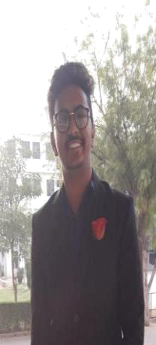
RESUME
૦Name :-
૦AGE :- 20 year
  - contect no:-

- occupation : ssc year 2015-16, pr rank- 86.34%

HSC year 2017-18 , pr rank -81.22 % ૦EMAIL ID :-
Address:-

SKILL :- MARKETING , EVENT MANAGEMENT ,GOOD IN MAGEMEMT

GOOD IN COMMUNICATION

HOBBY :- READING , PHOTOGRAPHY ,COOKING ,

PERSONALITY :- EXTROVERT , VOLUNTEER OF NSS , VOLUMTEER OF CENTRAL DEFANC
SERVICE , EXICETED ABOUT LEARN NEW THINGS

