**Danfer D’souza alias Debbie**

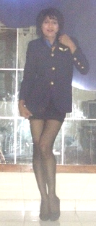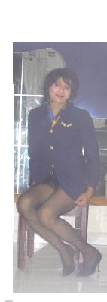Flat no 206**–** Malad(West) Mumbai– 4000 **056**

**PROFILE (LGBT)**

* **Fair Cute and lovely Person**
* **Energetic and open minded person**
* **Pleasing the Guest’s /Customers and boss by working late hours when required**
* **A Willing worker as not qualified but have proven myself through hard work**

**WORK EXPERIENCE**

***Excellent Guest House Housekeeping supervisor***

***( goa guest House )***

* ***In charge of cleaning and seeing all rooms are up to guest expectations handling all guest to***

***and from the hotel***

* ***Accommodating Personal requests of demanding guests when required sometimes***

***when the situation demands and working obertime during full occupancy and short staffed***

* ***Satisfying guests requirements needs so that he comes again***
* ***Responsible for any breakage or payments as management rules***

***Lalit Exports (Mumbai) Personal Assistant***

***( Ladies Grament )***

* ***Handling of all clients overseas (German European) and accompanying them to Hotel as and***

***when boss demanded as the order had to be received***

* ***The garment outfits had to be tried on and the clients and boss wanted me to as there was no***

***lady staff most of the times had even some of them printed in there foreign barouches***

* ***Handling and keeping of all orders up-to-date and seeing that the items dispatched was as***

***per the invoices***

***The Next thing to skin Stores in Charge.***

***Lingerie Boutique (Mumbai)***

* ***In charge of entire stock and invoices for all lingerie and had 2 staff under me Seeing to the***

***creative side of window displays***

* ***In charge of placing orders through the net with La senza / and Victoria’s secret/and Fredrick’s***

***of Hollywood***

* ***Keeping records of guest and improving customer service through my open minded nature***

**The Men's Bar (Goa)**

**Worked as a waitress and served drinks and food to european guest' worked night shifts and did accounting closing of the shifts. Maintained personal guest realtions with forigner guests so as to keep retain business.. As tough competition. Was appreciated by guests for great servive and tipped well..**

***Last Worked in a call centre temporary job till april end working on contract basis.***

***Also do private dance shows..as a hobby to earn extra income…***

***Staying as paying guest……..with relatives***

***EDUCATIONAL QUALIFICATION Boys High School, Goa, India 9th std pass***

* ***Presently pursuing further studies through correspondence***

**LANGUAGES**

* ***English, Hindi and Marathi (read , write & speak)***

***HOBBIES***

***Listening to music, dancing(doing shows),Making social Friends***

***PERSONAL DETAIL Nationality Indian Marital Status Single***

***Date of birth 6/6/1991***

***e-mail*** [***debbiehotlips1@gmail.com***](mailto:debbiehotlips1@gmail.com)

***Cell : please request on mail***

Since just 9th Standard pass due to fly passinh away at young age.. Lived with aunt and uncle and worked hard did odd jobs.. But good in english read and write.. And hindi..

Nees to work in a lgbt enviroment as a woman where i am accepted as a few past above jobs.. Which unfortunately closed..