HOME PAGE

* We can have something like the Home page of pacificalloy.com
* Pictures for the same shall be provided. PIC 1, PIC 2 & PIC 3 from Shutter stock

<https://www.shutterstock.com/search/foundry+industry?kw=shutterstock&c3apidt=p15797996695&gclid=Cj0KCQiAnaeNBhCUARIsABEee8WJB2ZGna1MI22PzG-GoVJ6DspY6M1z7e6Ywbs1iD_IKcEahlHQheUaAoUvEALw_wcB&gclsrc=aw.ds>

We specialize in Abrasion resistant High Chromium & Ni Hard castings

We manufacture Steel, Alloy steel, Mn Steel castings for wide applications.

Manufacturer of wear parts for various industries

Why us?

Specialization: Wear & tear is a problem, which affects every industry to some extent and we specialize in casting wear industry for the past 17 years. We offer Superior wear solutions to meet the most arduous, abrasive and high-impact duties experienced providing improved results and reduced costs.

Capabilities: Our production capacity is 1500 Mt per annum.

Quality Certification: With our ISO 9001: 2015 certification we provide high quality casting and services

Quality Policy & ISO Certification:

( Add quality Policy and scanned copy of certificate)

ISO 9001: 2015

Past Success:

A professional & organized company manufacturing with advance technology and equipment.

A proven & accurate process control with strict quality checks at each stage.

Experts handling engineering and sales.

ABOUT US:

RIDHI SIDHI- A Foundry was established in 2004 in Kolhapur, Maharashtra, India for manufacturing wear resistant parts looking at the huge potential. Today we are recognized as a leading casting manufacturer with required expertise & in-house facilities. We offer full service right from CAD design, simulation, pattern tooling, casting production, quality-controlled alloy composition, heat treatment and machining. Our customers value our excellent service and dedication to making their product better transforming us from a local to international provider of castings and services.

METALS MANUFACTURED:

RIDHI SIDHI is specialized in casting wear parts and produces parts in below metals along with steel.

* Ni-hard
* High chromium White Iron
* Mn Steel
* Alloy Steel
* Plain carbon Steel

INDUSTRIES SERVED: (We can attach respective pictures)

Wear parts required in following industries are manufactured by us:

Construction Equipment Industry:

* Concrete Mixer

Concrete mixers are subjected to heavy abrasive wear from aggregates under both dry and wet conditions. RIDHI SIDHI manufacturers high abrasion-resistant grades that improve the wear life. We cast wear parts required in Concrete mixers like, Paddles, Blades, Liners, Mixing arms, scrappers in NIHARD, High Chrome, Mn Steel & Low alloy steel.

Pics

* Mixing Blade 1
* Mixing Blade 2
* Central Mixing Arm
* Lateral Mixing Arm
* Central Shovel
* Mixing Shovel
* Wear Plate 1
* Wear Plate 2
* Crushers (Aggregates)

Aggregate processing Industry faces a lot of wear challenges where abrasion and Impact are equally important. Castings alloyed perfectly are manufactured by us

* 1
* 2
* 3
* Asphalt Mixers

Asphalt pug mill liners are manufactured for maximum wear life. Wear parts can be cast for extreme operations.

* Paddles
* Mixing Arms
* Liners
* Earth Moving Machinery

Tooth and adapters made from alloy steel, hardened and tempered to achieve the desired wear resistance and impact.

* Tooth points
* Adapters
* Sprocket
* Hydraulic Coupler
* Holder
* Crawlers

Track shoes with high strength alloyed steel castings, heat treated to insure toughness and durability

* Track Shoe 1
* Track Shoe 2
* Track Shoe 3
* Road Pavers

Augers used in Asphalt & Concrete paving machinery to spread the concrete uniformly across the surface to be paved made from High Chrome.

* Auger half
* Auger quarter
* WMM Mixers

Wear resistant paddles, arms & liners manufactured in different grades.

* Mixing Arms
* Mixing Paddles
* Agricultural Equipment industry

There is a huge requirement for high performance wear parts in farm machinery. Below are the wear parts we manufacture for few Agricultural machinery like plough parts, Points, Shanks etc.

* Shanks
* Rr

Pump Industry:

Pumps used for Sewage, slurry and dredging applications require abrasion resistant parts.

* High Chromium Impellers for dredging pumps
* High Chromium pump Housings

Power Industry:

There are various types of wear parts importantly used in Power plant operations.

* Disc
* Seat Gate
* Elbow

Cement & Steel Industry:

The right alloys make all the difference in wear life for parts used in steel & cement industry.

* Grade Bar
* Hammer
* Chute liners

Automobile :

Steel casting parts of hight quality are used in Automobile sector. We recently ventured in this sector.

* Saddle

General Engineering Industry:

Cast steel parts are produced with a wide range of properties used in general engineering industry.

* General Engg pics

INFRASTRUCTURE

**RIDHI SIDHI** is committed to the highest engineering performance in casting manufacturing. The in-house casting production technologies ensure the end product is manufactured to the best quality.

* DEVELOPMENT

The starting point of everything we make. All pattern tooling metallic & non- metallic are VMC cut.

* Pattern pic
* Core Box pic

We use

• Unigraphics- NX 10 3D Model Software by SIEMENS for modelling- Pic SIEMENS Unigraphics

• AUTOCAST X1- Casting Simulation Software for better results- PIC AUTCOAST

* PRODUCTION

Recently we improved our facility adding the newest production equipment having latest technology. Along with this we also strive to achieve excellence in product quality, production facilities, Customer service, continuous improvement in systems following the path of growth.

**Equipments (Production & Quality) / Infrastructure:**

* 250 KW Medium Frequency INDUCTOTHERM make IGBT technology Induction
  + furnaces with 2 No’s 300 Kg Crucibles. PIC 3
* SPECTROMAX – Germany spectrometer for accurate analysis of alloy
  + chemistry- Producing quality Metal PIC Spectrometer
* Automized Co2 sand Batch Mixers – For better quality moulding sand with
  + reclamation Plant for effective use of burnt sand.
* 25 Ton Sand hoppers for storage of fresh and reclaimed sand.
* Compaction Table for easy moulding with roller conveyors.
* Core & Mould Oven –For removal of moisture.
* 125 CFM Screw Air compressor with piping running all around the factory.
* Shot Blasting & full fledge Fettling shop
* Microscope and Image Analysis Software.- PIC 5
* Rockwell/ Brinell/Poldy Hardness testing facilities.
* Inspection Room with all dimensional Inspection instruments.
* HEAT TREATMENT

**In-House Heat treatment shop:**

* 1 ton PLC Controlled Electric Bogie type Heat Treatment Furnaces ( With Digital Graph Recorder) - 3 Nos
* Oil quenching tank with baffle and effective cooling & agitating system.
* Water Quenching tank- 30,000 Litres with cooling and agitating system.
* Air Quenching fans ( Axial Flow)- 2 nos for effective Air Quenching
* Heat Treatment Pics Folder- 3 Nos

**Work Force & Office infrastructure:**

* Metallurgist & Engineers to work right from the product development to production
* Trained & experienced workforce to follow & maintain the manufacturing process.
* 1200 Sq. Ft well equipped office with trained & experienced administration staff with dedicated meeting room having projector facility.
* Working in Systems in one thing and impart training to every personnel in our organization.

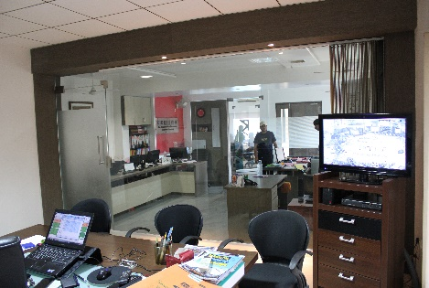 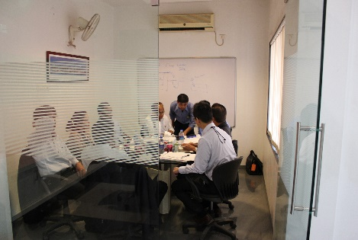 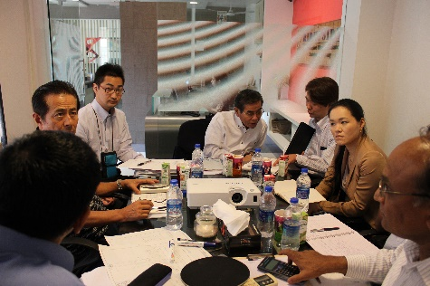

**VIEW OF OUR OFFICE MEETING ROOM JAPANESE CUSTOMERS VISITING US**

**EXHIBITIONS:**

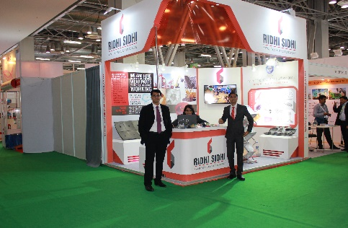 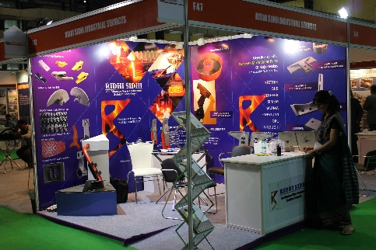 

**BAUMA- BC INDIA 2014- GREATER NOIDA CONCRETE INDIA 2014-MUMBAI STALL NO 485 & 486-HALL 2 UL**

**NOV 25TH -29TH-BANGALORE**

SOURCING:

RIDHI SIDHI is also in sourcing & supplying a wide variety of castings from India and supplying to the US & European market. The parts with pattern tooling is developed in-house and castings manufactured at approved foundries.

All castings can be delivered fully machined on CNC machines with excellent in-process and final quality control as per customers specifications.

The manufacturers we source from are well equipped, established and certified to ISO 9001-2015 and TS16949 systems. Castings manufactured conform to various international standards such as ISO, BS, ASTM, ANSI, DIN, JIS, etc.

We can be your right partner to procure quality casting as best prices.

CONTACT

ENQUIRY