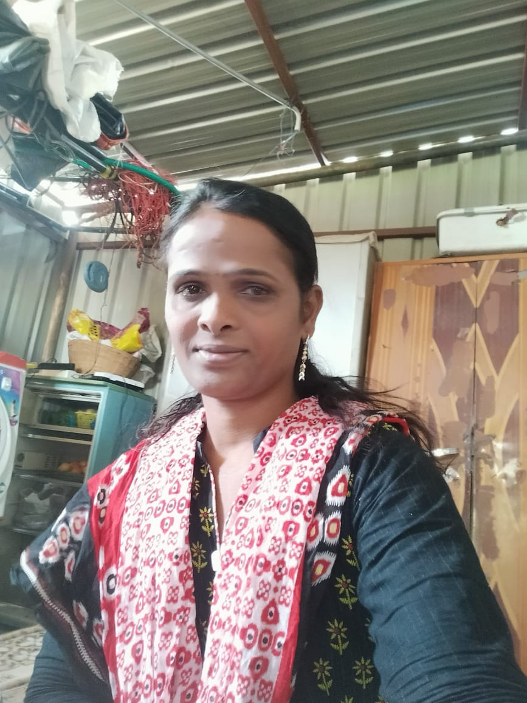

**SAMANTHA**

**Email:samantha84@gamil.com**

**Phone: 7569015091.**

**Objective**

* To use my knowledge of psychology and sociology to improve the lives of clients by offering them peace of mind and solutions to any type of condition, either mental or physical, that ails them.

**Educational Qualification**

|  |  |
| --- | --- |
| **Qualification** | **year** |
| **10th** | **2000-2001** |

**Personal Details**

Name : Samantha. kambalapalli

DOB : 18.10.1984

Father’s name : Malaya.k

Sex : Transgender