.Creating Database

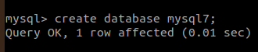

]

**1. Create the tables**

i)TABLE- PRODUCT_MASTER

mysql> CREATE TABLE PRODUCT_MASTER(

PRODUCTNO Varchar(6),

DESCRIPTION Varchar(15),

PROFITPERCENT float(4,2),

UNITMEASURE Varchar(10),

QTYONHAND INT(8),

REORDERLVL INT(8),

SELLPRICE float(8,2),

COSTPRICE float(8,2));

Query OK, 0 rows affected, 5 warnings (0.01 sec)



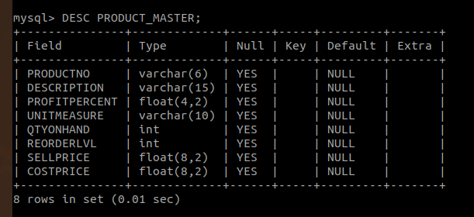

ii)TABLE- CLIENT_MASTER

mysql> CREATE TABLE CLIENT_MASTER(

-> CLIENTNO Varchar(6),

-> NAME Varchar(20),

-> ADDRESS1 Varchar(30),

-> ADDRESS2 Varchar(30),

-> CITY Varchar(15),

-> PINCODE INT(8),

-> STATE Varchar(15),

-> BALDUE float(10,2));

Query OK, 0 rows affected, 2 warnings (0.03 sec)

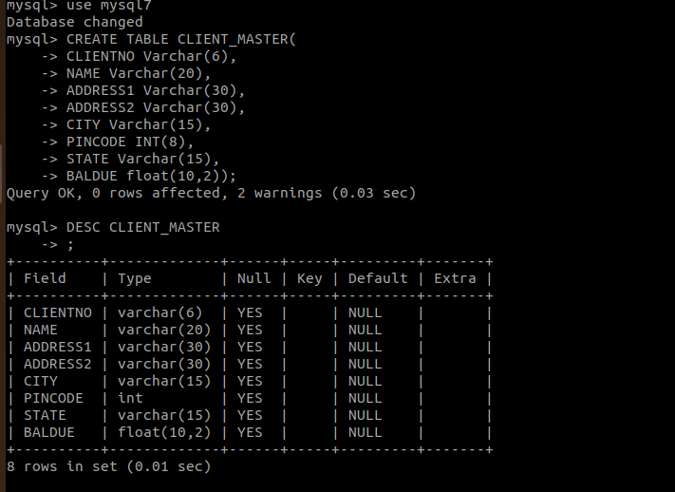

iii)TABLE- SALESMAN_MASTER

mysql> CREATE TABLE SALESMAN_MASTER(

-> SALESMANNO Varchar(6),

-> SALESMANNAME Varchar(20),

-> ADDRESS1 Varchar(30),

-> ADDRESS2 Varchar(30),

-> CITY Varchar(15),

-> PINCODE INT(8),

-> STATE Varchar(15));

Query OK, 0 rows affected, 1 warning (0.03 sec)

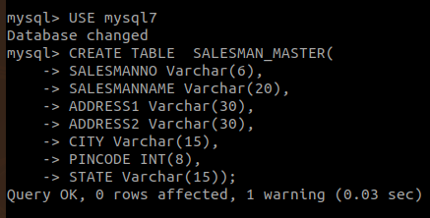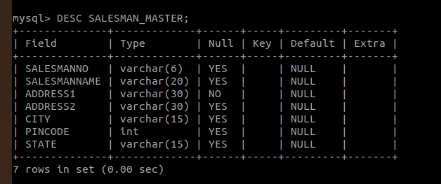

iv)TABLE- STUDENT

mysql> CREATE TABLE STUDENT(

-> SNO int(5),

-> SNAME Varchar(20),

-> AGE INT(5)

-> ,

-> SDOB DATE,

-> SMARK1 FLOAT(4,2),

-> SMARK2 FLOAT(4,2),

-> SMARK3 FLOAT(4,4));

Query OK, 0 rows affected, 5 warnings (0.03 sec)

