ADDING PRIMARY KEY AND NAMED CONSTRAINT WHILE CREATING A TABLE:

CREATE TABLE CLIENT_MASTER (

CLIENTNO Varchar(6),

NAME Varchar(20),

ADDRESS1 Varchar(30),

ADDRESS2 Varchar(30),

CITY Varchar(15),

PINCODE Int(8),

STATE Varchar(15),

BALDUE float(10,2),

PRIMARY KEY(CLIENTNO),

CONSTRAINT chk_client CHECK (CLIENTNO = 'C*')

);

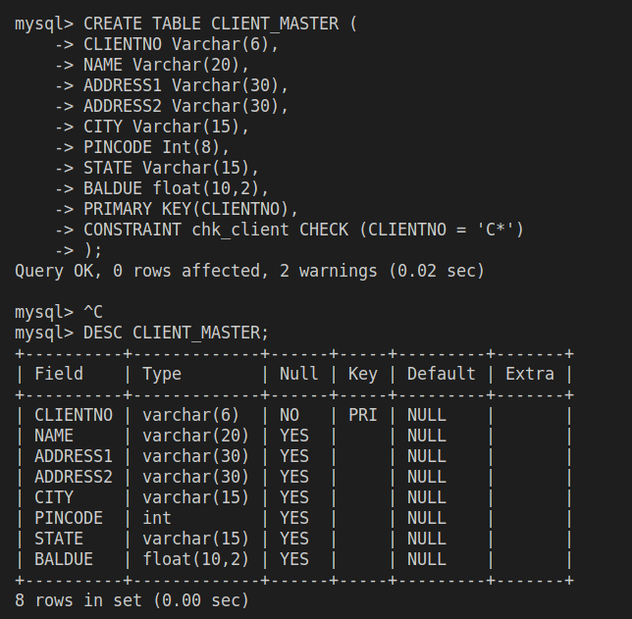

ADDING NOT NULL CONSTRAINT IN A COLUMN OF AN EXISTING TABLE:

ALTER TABLE CLIENT_MASTER

MODIFY COLUMN NAME Varchar(20) NOT NULL;

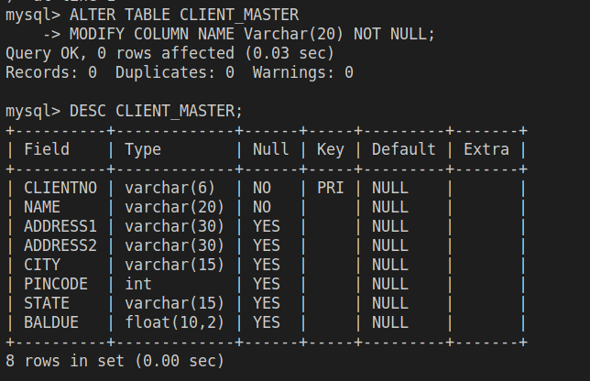

CREATING A TABLE WITH DEFINITION OF BOTH PRIMARY KEY AND CONSTRAINTS:

CREATE TABLE PRODUCT_MASTER (

PRODUCTNO Varchar(6),

DESCRIPTION Varchar(15) NOT NULL,

PROFITPERCENT float(4,2) NOT NULL,

UNITMEASURE Varchar(10) NOT NULL,

QTYONHOLD int(8) NOT NULL,

REORDERLVL int(8) NOT NULL,

SELLPRICE float(8,2) NOT NULL,

COSTPRICE float(8,2) NOT NULL,

PRIMARY KEY(PRODUCTNO),

CHECK (PRODUCTNO LIKE 'p*'),

CHECK (SELLPRICE != 0),

CHECK (COSTPRICE != 0)

);

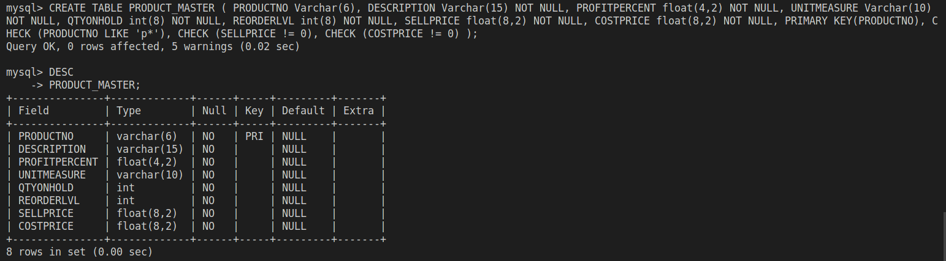

ADDING A PRIMARY KEY TO AN EXISTING TABLE:

ALTER TABLE SALESMAN_MASTER

ADD PRIMARY KEY(SALESMANNO);

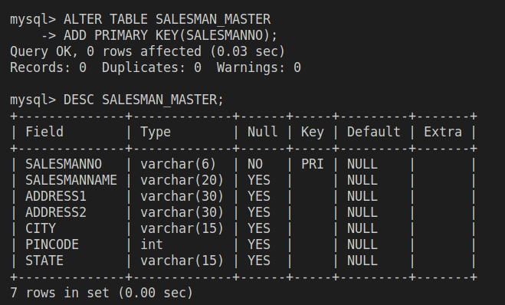

ADDING A CHECK TO AN ALREADY EXISTING TABLE:

ALTER TABLE SALESMAN_MASTER

ADD CHECK (SALESMANNO LIKE 'S%');

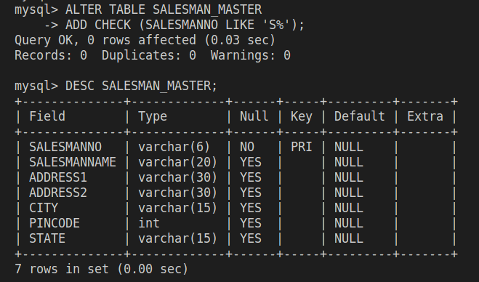

CHECK VIOLATION MESSAGES FOR TABLE ‘PRODUCT_MASTER’:

//(Name not starting with ‘p’) :

INSERT INTO PRODUCT_MASTER (PRODUCTNO, DESCRIPTION, PROFITPERCENT, UNITMEASURE, QTYONHOLD, REORDERLVL, SELLPRICE, COSTPRICE)

VALUES

('SWARM', 'ABC', 8.3, 'KG', 5, 6, 88, 78);



//(PROFITPERCENT AS NULL ENTRY) :

INSERT INTO PRODUCT_MASTER (PRODUCTNO, DESCRIPTION, PROFITPERCENT, UNITMEASURE, QTYONHOLD, REORDERLVL, SELLPRICE, COSTPRICE)

VALUES

('pRASH', 'ABC', NULL, 'KG', 5, 6, 88, 78);



//(COSTPRICE AS 0) :

INSERT INTO PRODUCT_MASTER (PRODUCTNO, DESCRIPTION, PROFITPERCENT, UNITMEASURE, QTYONHOLD, REORDERLVL, SELLPRICE, COSTPRICE)

VALUES

('pRASH', 'ABC', 8.2, 'KG', 5, 6, 88, 0);



CHECK VIOLATION MESSAGES FOR TABLE ‘CLIENT_MASTER’:

//(CLIENTNO not starting with ‘C’) :

INSERT INTO CLIENT_MASTER (CLIENTNO, NAME, ADDRESS1, ADDRESS2, CITY, PINCODE, STATE, BALDUE)

VALUES

('PRASH', 'XX', 'ABC', 'DAB', 'BNG', 560100, 'KTAKA', 55);



//(NAME AS NULL ENTRY) :

INSERT INTO CLIENT_MASTER (CLIENTNO, NAME, ADDRESS1, ADDRESS2, CITY, PINCODE, STATE, BALDUE)

VALUES

('CRASH', NULL, 'ABC', 'DAB', 'BNG', 560100, 'KTAKA', 55);



CHECK VIOLATION MESSAGES FOR TABLE ‘CLIENT_MASTER’:

//(SALESMANNO not starting with ‘S’) :

INSERT INTO SALESMAN_MASTER (SALESMANNO, SALESMANNAME, ADDRESS1, ADDRESS2, CITY, PINCODE, STATE)

VALUES

('PRASH', 'PRAKASH', 'ABC', 'DEF', 'BNG', 560100, 'KTAKA');



//(SALESMANNAME AS NULL ENTRY) :

INSERT INTO SALESMAN_MASTER (SALESMANNO, SALESMANNAME, ADDRESS1, ADDRESS2, CITY, PINCODE, STATE)

VALUES

('PRASH', NULL, 'ABC', 'DEF', 'BNG', 560100, 'KTAKA');



