**ClassAssignment2 report**

2015004302 곽상원

1. **What i implemented**
   1. Manipulating camera and grid plane used by ClassAssignment1
   2. Load an obj file and render it using glDrawArrays() & glDrawElements()
   3. Toggle wireframe / solid mode by pressing Z key
   4. Print out a file name and face informations of dropped obj file
   5. Using multiple light source
   6. Toggle [shading using normal data in obj file] / [forced smooth shading] by pressing S key
   7. Load & render a mesh that does not have the same number of vertices of all polygons using glDrawArrays() or glDrawElements()
2. **Screenshots with obj files**
   1. Alien_Animal.obj

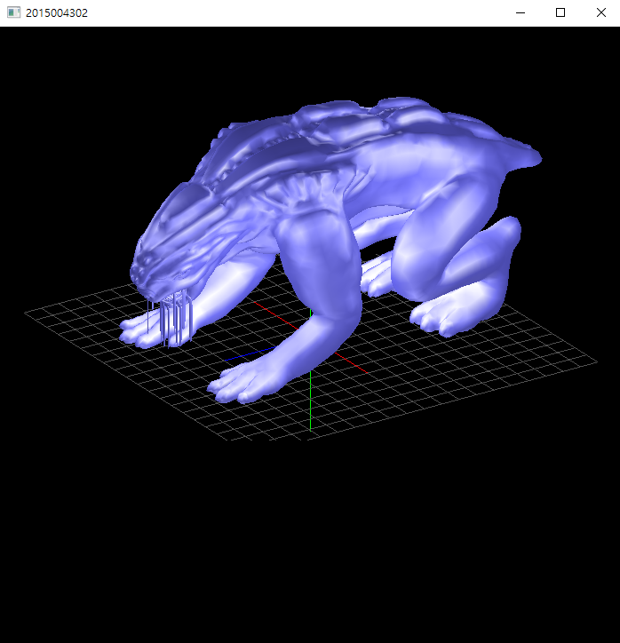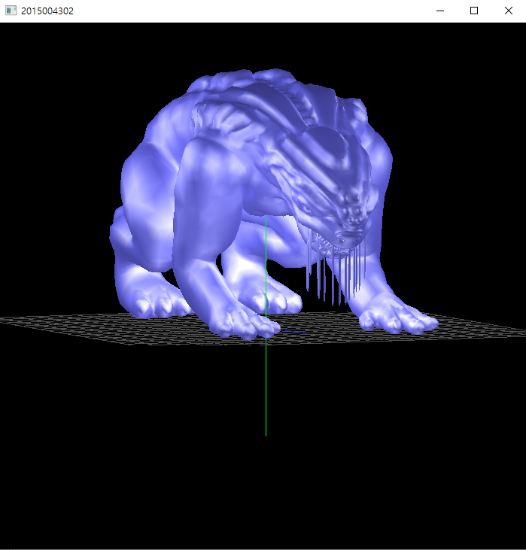

* 1. Handgun.obj

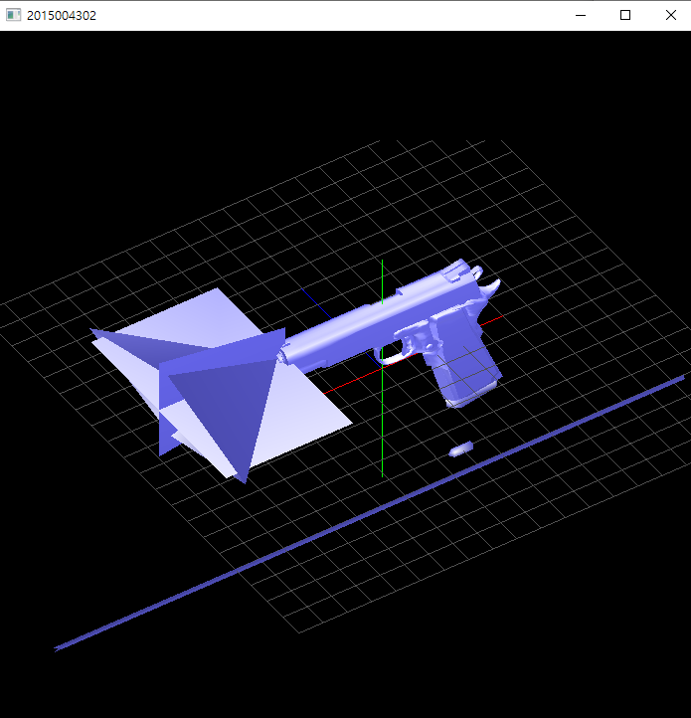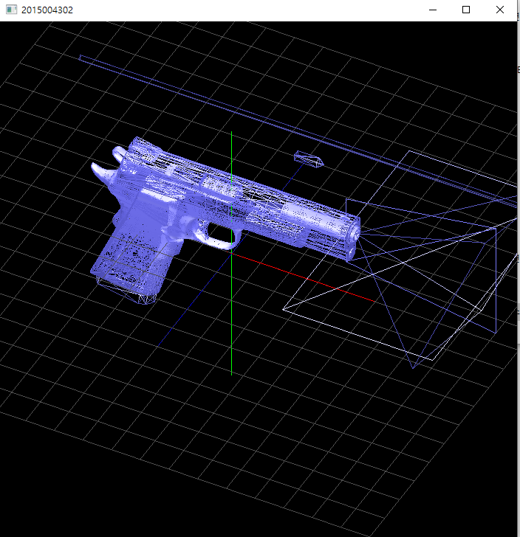

* 1. Shelby.obj

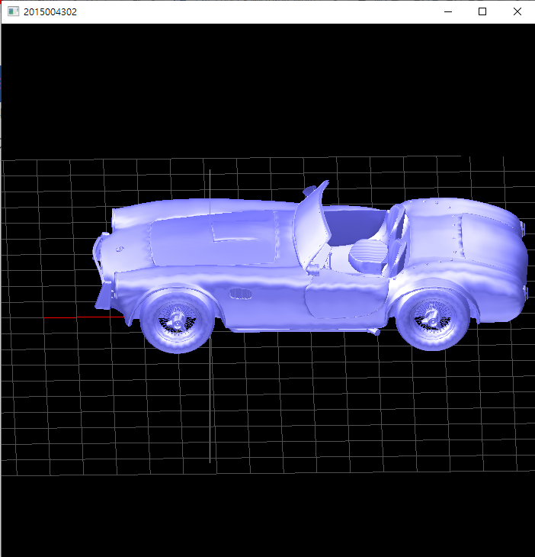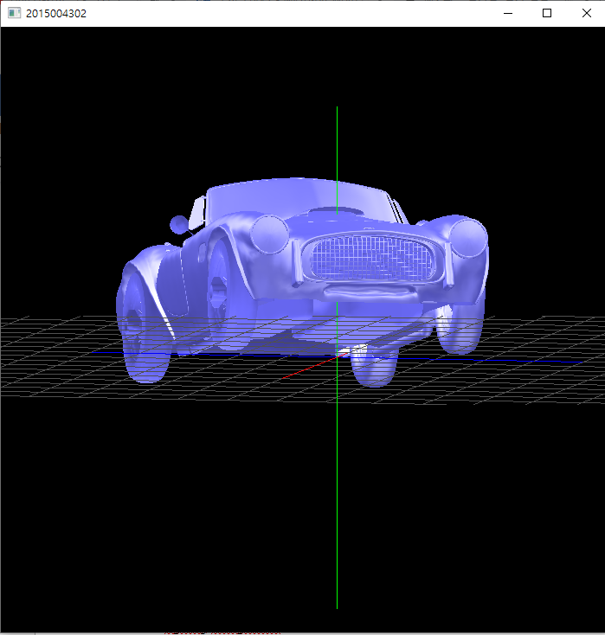

1. **Lighting configuration**
   * Using 5 light sources( GL_LIGHT0 ~ 4 )
   * 4 light sources are placed on (y_pos = 1.0) in square shape with directional light type and 1 light source is placed in (0, -1, 0) with point light type