**ClassAssignment3 report**

2015004302 곽상원

1. **What i implemented**
   1. Manipulating camera & grid plane
   2. Load a bvh file and render it
      1. Open a bvh file by drag-and-drop
      2. Read the bvh file and render the skeleton of the motion
      3. Animate the loaded motion if <spacebar> key is pressed
      4. Print out information of the bvh file to stdout
   3. Use a box to draw each body part instead of a line segment
2. **Screenshot**

Source: http://motion.hahasoha.net/

* 1. Dance(5_11.bvh)

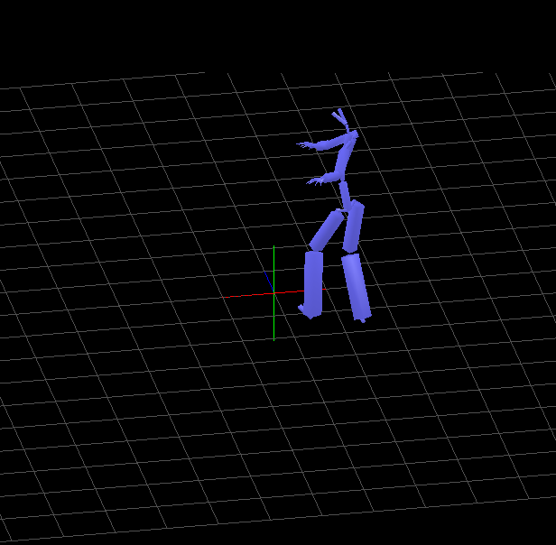 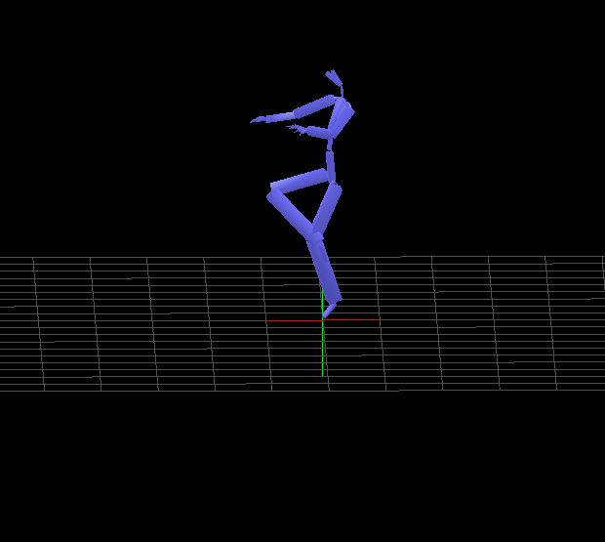

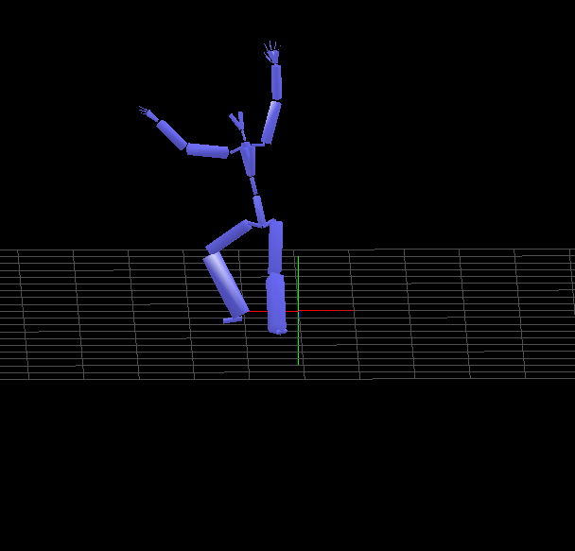

* 1. JumpTwist(85_01.bvh)

